Hotel Room Booking System
Day 1 – Requirements Document
Prepared by: Himangi Meena | Date: June 17, 2026

1. Project Links
GitHub Repository: https://github.com/himangimeena/hotel-room-booking-system.git
Trello Board: https://trello.com/b/hotel-room-booking-system

2. Trello Kanban Board
The project tasks have been planned and tracked using a Trello Kanban board as shown below:
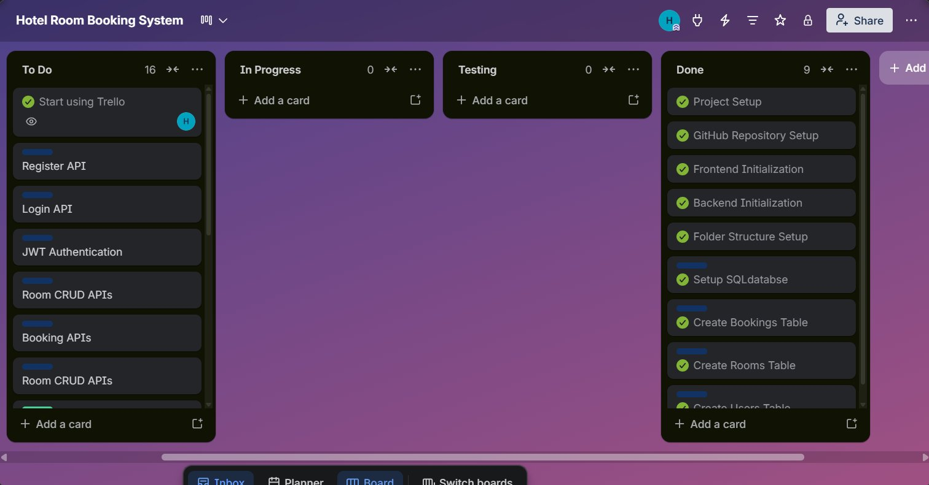

3. Project Overview

3.1 Project Name
Hotel Room Booking System

3.2 Problem Statement
Hotels often manage room reservations manually, which can lead to booking conflicts and inefficient record management. The Hotel Room Booking System provides a digital solution for managing rooms, bookings, and customers efficiently.

3.3 Users
- Customers
- Hotel Administrators

4. Functional Requirements

4.1 Customer
- Register account
- Login
- View available rooms
- Book a room
- View booking history
- Cancel booking

4.2 Admin
- Login
- Add room
- Edit room
- Delete room
- View all bookings

5. Non-Functional Requirements

5.1 Security
- Password hashing
- JWT authentication

5.2 Performance
- Fast room retrieval
- Optimized database queries

5.3 Scalability
- Can support multiple users and rooms

6. Assumptions & Constraints

6.1 Assumptions
- Internet connection is available
- Users provide valid information during registration

6.2 Constraints
- Limited development time
- Single developer project

contact@gradtopro.com

