|  |
| --- |
| **Assignment on : Renewable resources** |
|  |
|  |
|  |
|  |
|  |
|  |
|  |

**Content**

* Introduction
* History
* Renewable resources
  + Air
  + Sun
  + Water
* Renewable energy
  + Hydroelectric power
  + Biomass energy
  + Geothermal energy
  + Tidal energy
* Renewable energy in the home
  + Solar power
  + Geothermal heat pumps
  + Small wind systems

**Renewable resources**

● A renewable resourceis a natural resources which will replenish to replace the portion depleted by usage and consumption, either through natural reproduction or other recurring processes in a finite amount of time in a human time scale. Renewable resources are a part of Earth's natural environment and the largest components of its ecosphere. A positive life cycle assessment is a key indicator of a resource's sustainability.

●Definitions of renewable resources may also include agricultural production, as in sustainable agriculture and to an extent water resources.

● Another type of renewable resources is renewable energyresources. Common sources of renewable energy include solar, geothermal and wind power, which are all categorised as renewable resources.

**History**

● In 1962, Paul Alfred Weiss defined renewable resources as: "*The total range of living organisms providing man with life, fibres, etc.*

●Until the mid-1800s, wood was the source of nearly all of the nation's energy needs for heating, cooking, and lighting.

●From the late 1800’s until today, fossil fuels—coal, petroleum, and natural gas—have been the major sources of energy.

● Hydropower and wood were the most used renewable energy resources until the 1990s. Since then, the amounts and the percentage shares of total U.S. energy consumption from biofuels, geothermal energy, solar energy, and wind energy increased, and in 2019, the combined percentage share of these renewable energy sources was greater than the combined share of wood and hydro energy.

●The consumption of biofuels, geothermal, solar, and wind energy in the United States in 2019 was nearly three times greater than in 2000.

Examples

1. **Air**

▪Air is used for making energy from the ancient time.

▪Modern wind turbines towers above one of their ancestors. And old Wind mill used for pumping water.

▪These turbines are mounted at 100 feet or more above ground turbines catch the wind energy with their propeller like blades usually 2-3 blades are fixed on a shaft to form a rotor.

● **Wind energy**

▪ We have come a long way from old-fashioned wind mills. Today, turbines as tall as skyscrapers—with turbines nearly as wide in diameter—stand at attention around the world. Wind energy turns a turbine’s blades, which feeds an electric generator and produces electricity.

▪ Wind, which accounts for a little more than 6 percent of U.S. generation, has become the cheapest energy source in many parts of the country. Top wind power states include California, Texas, Oklahoma, Kansas, and Iowa, though turbines can be placed anywhere with high wind speeds—such as hilltops and open plains—or even offshore in open water

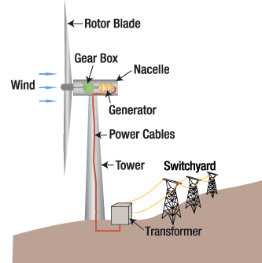

1. **Sun**

▪Sun energy is termed as solar energy.

▪Solar energy is a radiant light and heat from the sun that is harnessed using a range of ever evolving technologies such as solar heating, photo voltaics, solar thermal energy,etc.

▪A solar cell is the device that converts light directly into electricity using the photoelectric effect.

▪Uses of solar energy decrease pollution, global warming, keep fossil fuels price lower and affordable for public.

* **Solar energy**

▪ Humans have been harnessing solar energy for thousands of years—to grow crops, stay warm, and dry foods.

▪ According to the National Renewable Energy Laboratory, “more energy from the sun falls on the earth in one hour than is used by everyone in the world in one year.”

▪ Today, we use the sun’s rays in many ways—to heat homes and businesses, to warm water, or power devices.

▪Solar, photovoltaic(PV),cells are made from silicon or other materials that transform sunlight directly into electricity. Distributed solar systems generate electricity locally for homes and businesses, either through rooftop panels or community projects that power entire neighborhoods.

▪Solar farms can generate power for thousands of homes, using mirrors to concentrate sunlight across acres of solar cells. Floating solar farms—or “floatovoltaics”—can be an effective use of wastewater facilities and bodies of water that aren’t ecologically sensitive

**▪**But nearly a third of all new generation capacity came from solar in 2017, second only to natural gas.

▪Solar energy systems don’t produce air pollutants or greenhouse gases, and as long as they are responsibly sited, most solar panels have few environmental impacts beyond the manufacture processes

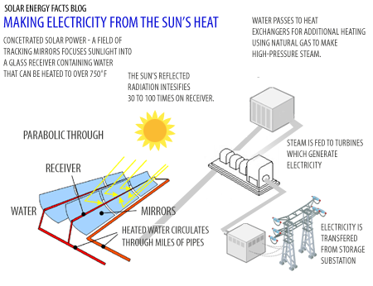

1. **Water**

▪Water can be considered as a renewable material when carefully control usage, treatment and release a followed.

▪It is estimated that 22% of the world wide water is used in industries.

▪Major industrial uses include hydroelectric dams, thermal electric power plant which use water for cooling. Ore and oil refineries which used water for chemical process water is used in renewable power generation.

**Renewable energy**

● Renewable energy, often referred to as clean energy, comes from natural sources or processes that are constantly replenished. For example, sunlight or wind keep shining and blowing, even if their availability depends on time and weather.

● While renewable energy is often thought of as a new technology, harnessing nature’s power has long been used for heating, transportation, lighting, and more. Wind has powered boats to sail the seas and windmills to grind grain. The sun has provided warmth during the day and helped kindle fires to last into the evening. But over the past 500 years or so, humans increasingly turned to cheaper, dirtier energy sources such as coal and fracked gas.

● Now that we have increasingly innovative and less-expensive ways to capture and retain wind and solar energy, renewables are becoming a more important power source, accounting for more than one-eighth of U.S. generation. The expansion in renewables is also happening at scales large and small, from rooftop solar panels on homes that can sell power back to the gridto giant offshore wind farms. Even some entire rural communities rely on renewable energy for heating and lighting.

● As renewable use continues to grow, a key goal will be to modernize America’s electricity grid, making it smarter, more secure, and better integrated across region

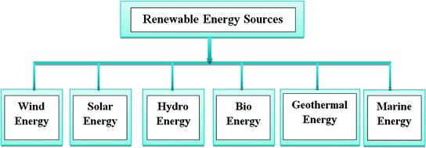

**Other Alternative Energy Sources**

1. **Hydroelectric Power**

Hydropower is the largest renewable energy source for electricity in the United States, though wind energy is soon expected to take over the lead Hydropower relies on water—typically fast-moving water in a large river or rapidly descending water from a high point—and converts the force of that water into electricity by spinning a generator’s turbine blades.

Nationally and internationally, large hydroelectric plants—or mega-dams—are often considered to be nonrenewable energy. Mega-dams divert and reduce natural flows, restricting access for animal and human populations that rely on rivers. Small hydroelectric plants (an installed capacity below about 40 megawatts), carefully managed, do not tend to cause as much environmental damage, as they divert only a fraction of flow.

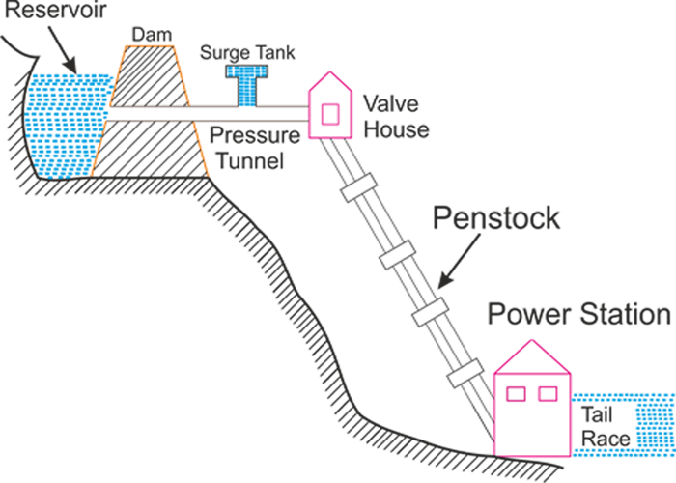

1. **Biomass Energy**

Biomass is organic material that comes from plants and animals, and includes crops, waste wood, and trees. When biomass is burned, the chemical energy is released as heat and can generate electricity with a steam turbine.

Biomass is often mistakenly described as a clean, renewable fuel and a greener alternative to coal and other fossil fuels for producing electricity. However, recent science shows that many forms of biomass—especially from forests—produce higher carbon emissions than fossil fuels. There are also negative consequences for biodiversity. Still, some forms of biomass energy could serve as a low-carbon option under the right circumstances. For example, sawdust and chips from sawmills that would otherwise quickly decompose and release carbon can be a low-carbon energy source.

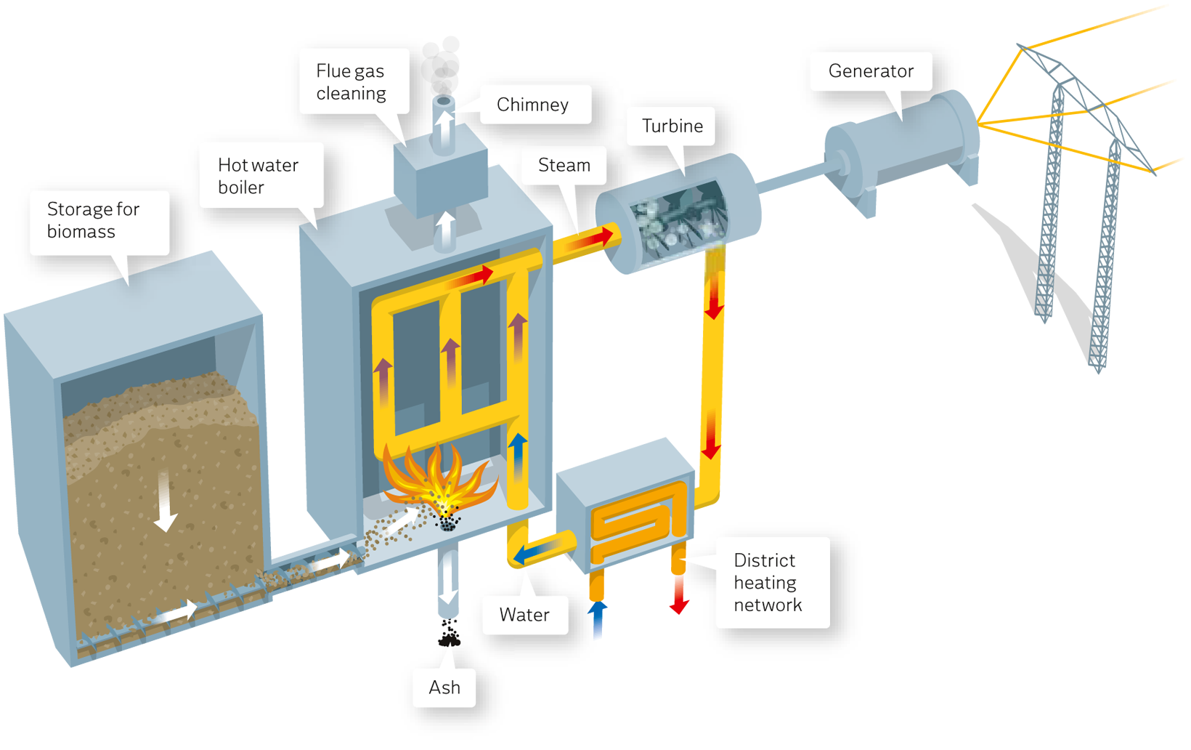

1. **Geothermal Energy**

If you have ever relaxed in a hot spring, you’ve used geothermal energyThe earth’s core is about as hot as the sun’s surface, due to the slow decay of radioactive particles in rocks at the center of the planet. Drilling deep wells brings very hot underground water to the surface as a hydrothermal resource, which is then pumped through a turbine to create electricity. Geothermal plants typically have low emissions if they pump the steam and water they use back into the reservoir. There are ways to create geothermal plants where there are not underground reservoirs, but there are concerns that they may increase the risk of an earthquake in areas already .considered geological hot spots

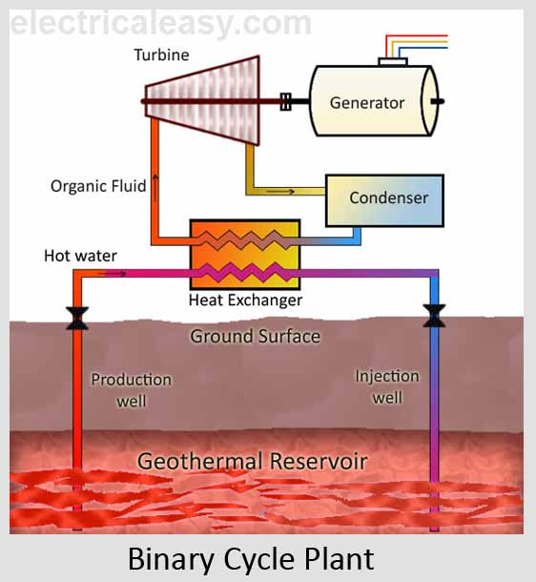

#### Tidal energy

Tidal and wave energy is still in a developmental phase, but the ocean will always be ruled by the moon’s gravity, which makes harnessing its power an attractive option. Some tidal energy approaches may harm wildlife, such as tidal barrages which work much like dams and are located in an ocean bay or lagoon. Like tidal power, wave power relies on dam-like structures or ocean floor–anchored devices on or just below the water surface.

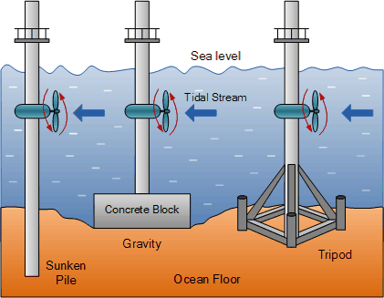

**Renewable Energy in the Home**

1. **Solar Power**

At a smaller scale, we can harness the sun’s rays to power the whole house—whether through PV cell panels or passive solar home design.  Passive solar homes are designed to welcome in the sun through south-facing windows and then retain the warmth through concrete, bricks, tiles, and other materials that store heat.

Some solar-powered homes generate more than enough electricity, allowing the homeowner to sell excess power back to the grid. Batteries are also an economically attractive way to store excess solar energy so that it can be used at night. Scientists are hard at work on new advances that blend form and function, such as solar skylights and roof shingles.

1. **Geothermal Heat Pumps**

Geothermal technology is a new take on a recognizable process—the coils at the back of your fridge are a mini heat pump, removing heat from the interior to keep foods fresh and cool. In a home, geothermal or geoexchange pumps use the constant temperature of the earth (a few feet below the surface) to cool homes in summer and warm houses in winter—and even to heat water.

Geothermal systems can be initially expensive to install but typically pay off within 10 years. They are also quieter, have fewer maintenance issues, and last longer than traditional air conditioners.

1. **Small Wind Systems**

A backyard wind farm? Boats, ranchers, and even cell phone companies use small wind turbines regularly. Dealers now help site, install, and maintain wind turbine for homeowners, too—although some DIY enthusiasts are installing turbines themselves. Depending on your electricity needs, wind speeds, and zoning rules in your area, a wind turbine may reduce your reliance on the electrical grid.