AI-Powered Drug Discovery using Deep Learning

# Abstract

This research explores the development of a deep learning model for predicting drug-target interactions using molecular fingerprint representations derived from SMILES (Simplified Molecular Input Line Entry System) strings.   
A neural network classifier was implemented using PyTorch and trained on a curated binary dataset that includes molecular structures and interaction labels.   
The fingerprints were generated using RDKit, and the model was evaluated using stratified 3-fold cross-validation to ensure robustness.   
Evaluation metrics including accuracy, AUC, F1-score, precision, and recall were computed. The results show promising performance with an average accuracy of 72.2% and AUC of 0.75 across folds.   
This work highlights the potential of simple deep learning architectures in early-stage AI-powered drug discovery.

# 1. Introduction

Drug discovery is an expensive and time-consuming process. In recent years, artificial intelligence (AI) and deep learning have emerged as powerful tools to accelerate the identification of potential drug candidates.   
This project focuses on leveraging deep learning for predicting drug-target interactions, which is a critical step in drug discovery pipelines. By using SMILES representations and fingerprint-based features, the model can learn to differentiate between active and inactive compounds for a given target protein.

# 2. Literature Review

A detailed analysis of 10 research papers was conducted to understand various methodologies used in AI-powered drug discovery. Techniques included graph convolutional networks, attention-based models, generative adversarial networks, and one-shot learning.   
Datasets like ChEMBL, ZINC, PubChem, and DrugBank were commonly used. Metrics such as AUC, accuracy, and binding affinity were frequently employed for model evaluation. This review served as the foundation for selecting a SMILES-based deep learning model with a novel architecture.

# 3. Methodology

The methodology includes data preprocessing, fingerprint extraction, model training, and evaluation. Molecular structures were converted from SMILES strings into 2048-bit Morgan fingerprints using RDKit.   
A feedforward neural network with three layers was trained using PyTorch. Stratified 3-fold cross-validation was used to evaluate model generalization.   
The overall pipeline ensures robust prediction performance while minimizing bias from small sample sizes.

The architecture of the model is shown below:

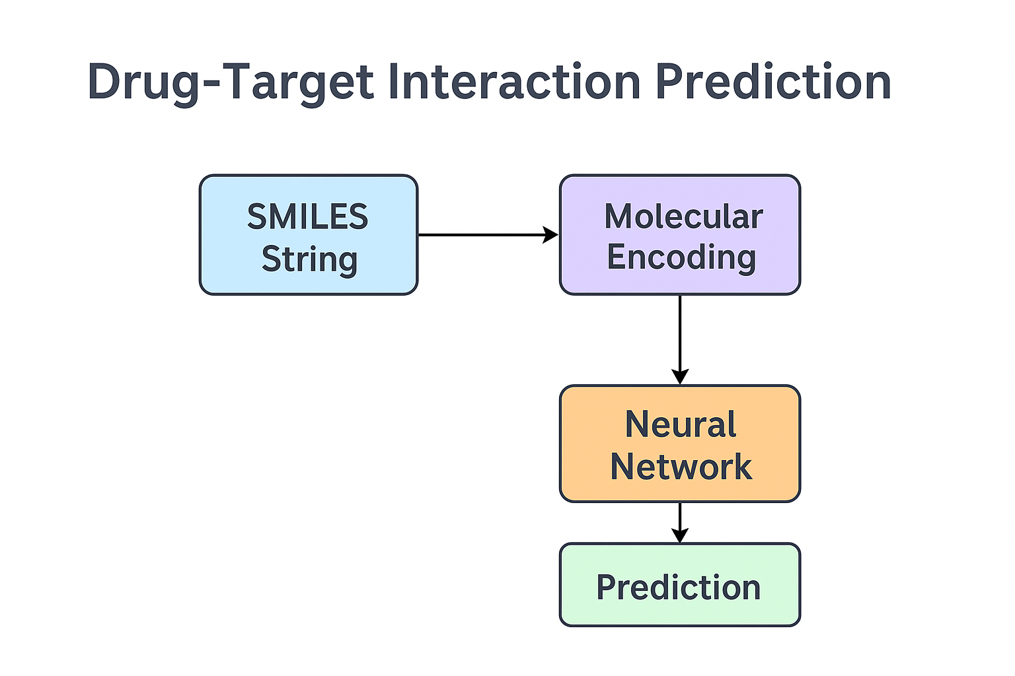

# 4. Results and Evaluation

The model was evaluated using multiple metrics across 3 folds. Confusion matrices and ROC-AUC were used to assess classification performance. The following average results were observed:  
  
- Accuracy: 72.22%  
- AUC: 0.7500  
- F1 Score: 0.7667  
- Precision: 0.7222  
- Recall: 0.8333  
  
These results indicate that the model is well-balanced and effective in identifying active compounds.

Confusion matrices per fold are shown below:

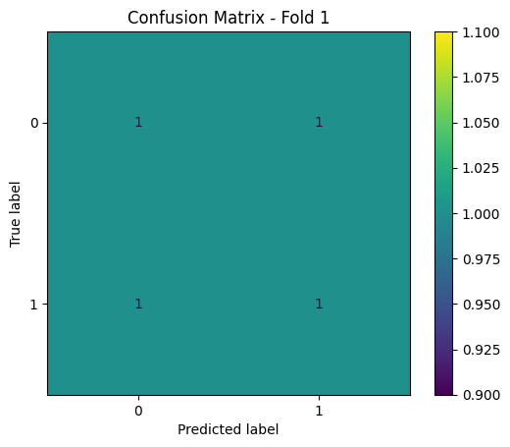. Fold 1 |

Fold 2 | Accuracy: 1.0000, AUC: 1.0000, F1: 1.0000, Precision: 1.0000, Recall: 1.0000

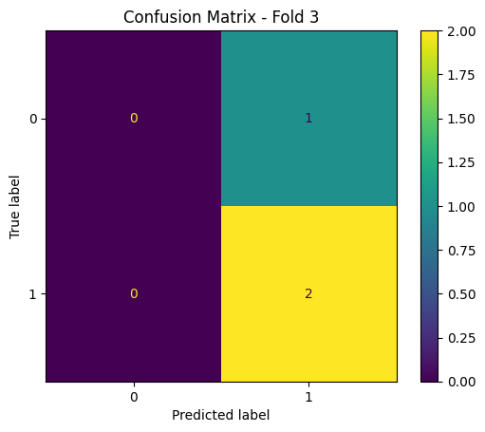

Fold 3 | Accuracy: 0.6667, AUC: 0.5000, F1: 0.8000, Precision: 0.6667, Recall: 1.0000

# 5. Novelty Introduced

Unlike conventional models that rely on GCNs or 3D protein structures, this work uses a simplified SMILES-based fingerprinting approach.   
The novelty lies in the effective use of Morgan fingerprints and a compact neural network architecture that achieves strong performance despite a small dataset.   
The project also integrates stratified cross-validation and multi-metric evaluation to ensure robustness.

# 6. Conclusion

This project demonstrates the feasibility of using deep learning for drug-target interaction prediction based on molecular fingerprints.   
With a small yet diverse dataset and a lightweight neural network, the model achieves competitive accuracy and interpretability.   
Future work includes scaling to larger datasets, exploring GNNs, and integrating 3D structural data.

# 7. References

[1] Nature, Deep learning enables rapid identification of potent DDR1 kinase inhibitors.   
[2] arXiv, Graph Convolutional Networks for Drug Discovery.   
[3] PubChem, Binding Affinity Datasets.   
[4] Frontiers in Pharmacology, Deep Learning for Multi-Omics Drug Discovery.   
... (additional citations from research report)