**OPENCART**

**Functional Requirement Specification (FRS)**

project

MADE BY-

Himani Adhikari

Date- 25th December 2023

Overview-OpenCart is an open-source e-commerce platform that allows businesses to set up and manage their online stores. It's written in PHP and uses a MySQL database to store information. OpenCart provides a user-friendly interface, a variety of extensions, and a robust set of features to help merchants build and operate their online stores. OpenCart has an extensive amount of features that gives you a strong hold over the customization of your store. The application will include features such as user registration and login, product catalogue, shopping cart, checkout, payments gateway integration, and order management.

WEBSITE TOOLS

* Homepage = This is the first page, a customer interacts with and this page defines the presentation of the whole website. It needs to be user friendly along with highlighting the owner’s product.

Mock screen- Given below is an example of how the interface of homepage looks.

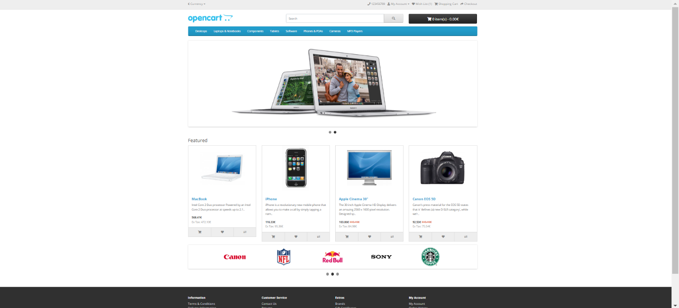

The header

will be displayed at the top of the page, on every page of the store not just on the home page.



The header consists of the following options:

• Store logo: Clicking on this logo will direct the customer back to the home page of the store.

• Currency block: The customer can select which currency the store's products will be in by clicking on any of the currency icons.

• Shopping Cart: Displays the number of items purchased, and the total price of the order. Clicking on the button will containing all of products added to the cart and an option to "View Cart" or "Checkout".

• Search box: The customers can type in the search box to search for a product within the store's product categories.

• Links: Links the customer to the Home page, Wish List, My Account, Shopping Cart, and Checkout.

• Telephone: Company telephone number.

• My Account: Customer can register or login from here.

TOP MENU

Like the header, the top menu will be displayed on every page. When the customer's mouse is dragged over a category, a drop-down menu will display the sub-categories for that parent category. When a parent category is clicked, the customer will be directed to the category page, which displays all the products within that category.



Slideshow

The slideshow displays several product banners of your choice byalternating the images in a slideshow. After a certain amount of time, one banner will shift to the the next banner on its own. Banners in this slideshow are useful for highlighting certain products to be easily accessible by the customer and When the banner is clicked on, the customer will be directed to the product on the banner's page. This section is only seen on Homepage.

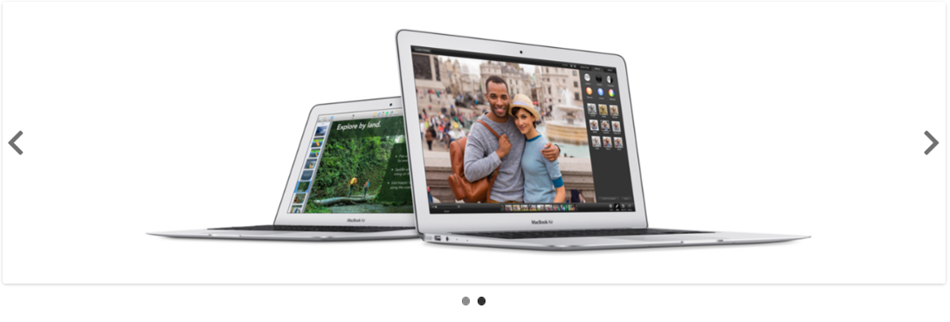

Featured Product

This Section contains specific products strategically placed depending on the season, festivities or discounts. Products showcased here have price , introduction ,name and add to cart option ,add to wishlist and product comparison option.

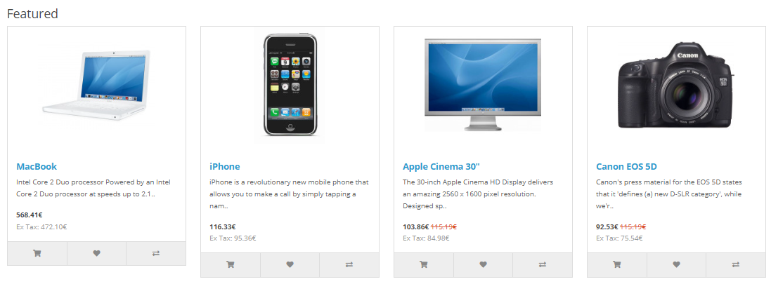

Footer

This is placed on every page and not just homepage. It consists of links to relevant pages. The section are Information, Customer service, Extras and My Account.

Product Page

Product Image: It can be displayed under the product name. Alongside different angles of product images is given. Clicking on the image will enlarge the image to see it in detail.

Description: below the images ,description of the product is given.

Specification: On the right side of the Image , product specification is given – availability , price, model no. etc. is given.

Cart- From here the customer can add the item in his cart and choose quantity and even compare the similar products.

Review tab- This enables customer to give review on the given product.

Related products: products relating to the given product ( either type is similar or company ) are displayed below along with add to cart icon and wish list icon.

Category product listings

Category product listings enable customers to browse products similar to other products within the same category. This is especially helpful for customers looking to compare products, a feature that will be explained under Categories .It can be accessed from the top menu, when a customer clicks on one of the parent categories. Also, on product pages a customer can access the category product listing page by clicking on a category on the left side category block.

Product Compare

The "Add to Compare" feature in the product section allows the customer to compare the different specifications, features, and price of a number of products he might be interested in. The customer is given the option to add one of the compared products to the cart if they want to. Pressing "Continue" will bring the user back to the home page. Product comparison icon is present at many place allowing user to compare products from anywhere.

Shopping Cart page

This page contains overview of the selected item- product name, specification, quantity, model, total price including all types of tax. There are extra things like - adding gift voucher, use coupon code, estimate shipping & taxes, before heading to the checkout. The "Continue Shopping" button links back to the homepage.

Checkout

Once a product has been added to the cart, the customer can continue to the checkout to make their product purchase. The Checkout page can be accessed in the header section of every page (found under the search box). Customer checkout using OpenCart is a simple process that can be completed in 6 steps.

1. Step 1: Checkout options

The customer can log into or register their account (as explained above), or select guest checkout.

2. Step 2: Billing details

Personal details including "First Name", "Last Name", "E-mail", and "Telephone" are filled into a form. It also requires the customer's address details.

3. Step 3: Delivery details in Billing Details,

the user can check a box to indicate that the delivery details and billing details are the same. This will cause it to skip over this step to Delivery Method. If the delivery details are different from the billing details the customer can enter this information in a form in this section.

4. Step 4: Delivery method

A method of shipping is selected here. A comment box is added for the customer to add comments about their order.

5. Step 5: Payment method;

The customer selects their method of payment here and may add comments in the comment box.

6. Step 6: Confirm order

In this last step, the customer will see an overview of their purchase; including the product description, quantity, and price (with tax & shipping).

Order history- This page shows status of the item ordered . Their order id that can be used if order get misplaced or damaged. order date , amount of product everything is mentioned. It also contains a view icon which give details how you have ordered that item

