Lab program 6:

Create a package CIE which has two classes- Student and Internals. The class Personal has

members like usn, name, sem. The class internals has an array that stores the internal marks

scored in five courses of the current semester of the student. Create another package SEE

which has the class External which is a derived class of Student. This class has an array that

stores the SEE marks scored in five courses of the current semester of the student. Import the

two packages in a file that declares the final marks of n students in all five courses

Program: 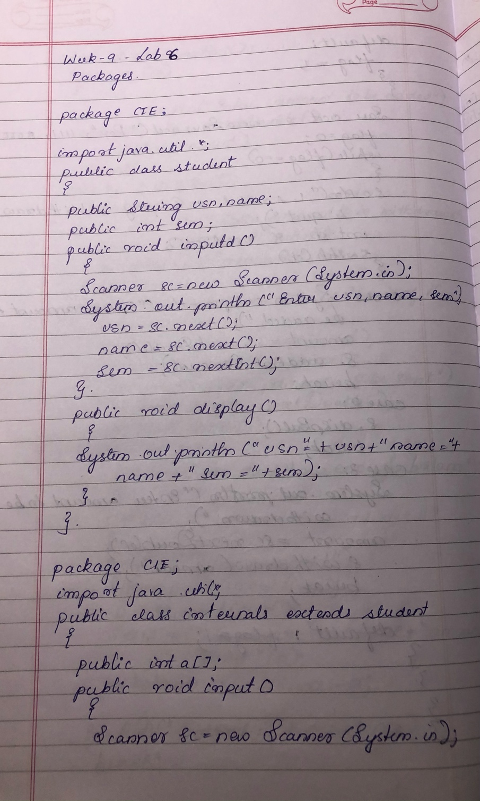

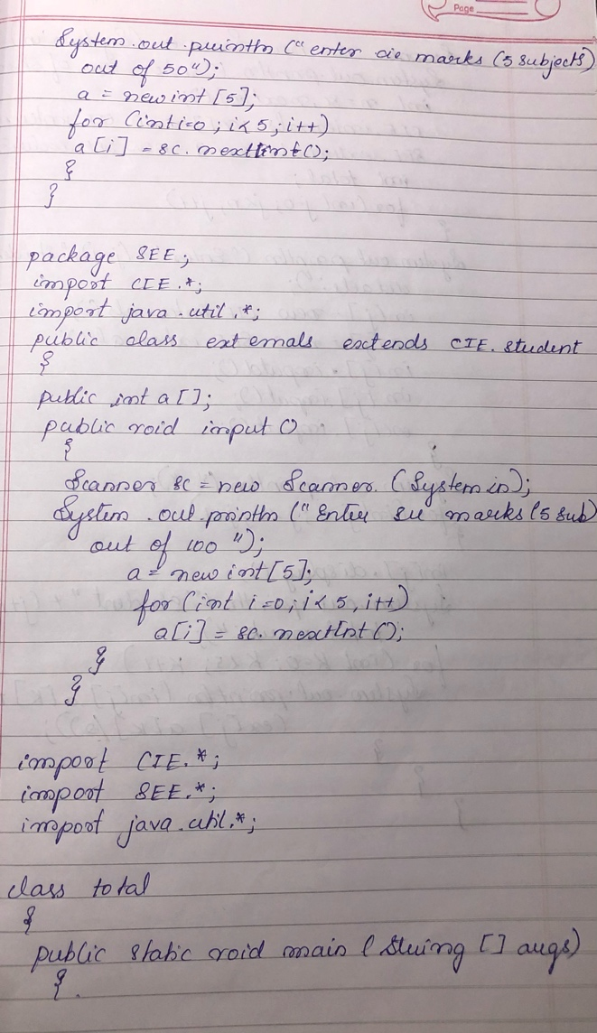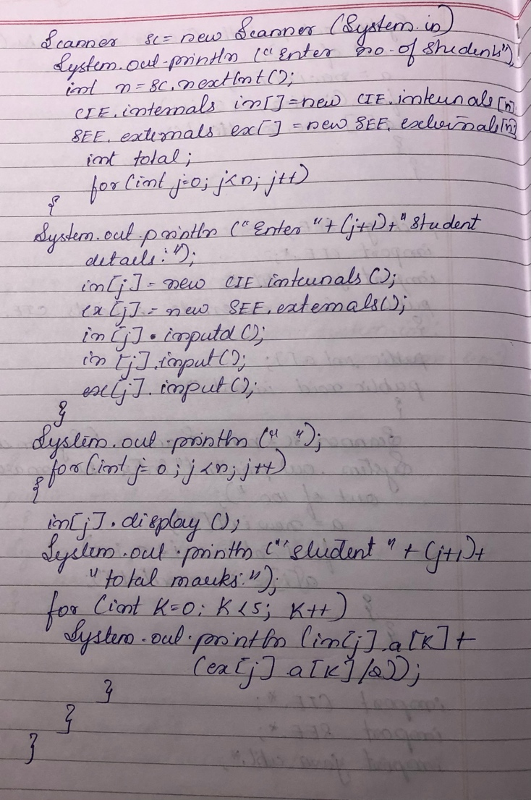

Output:

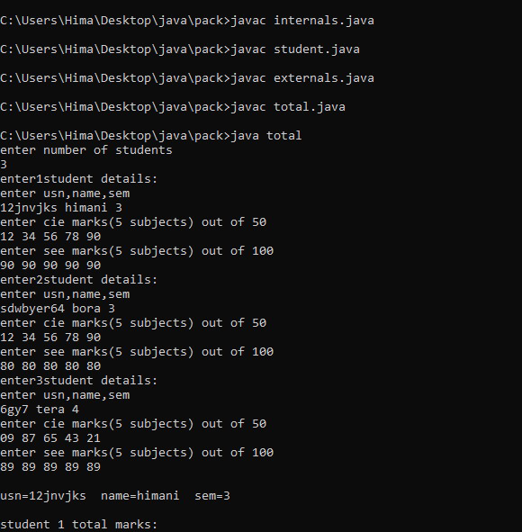

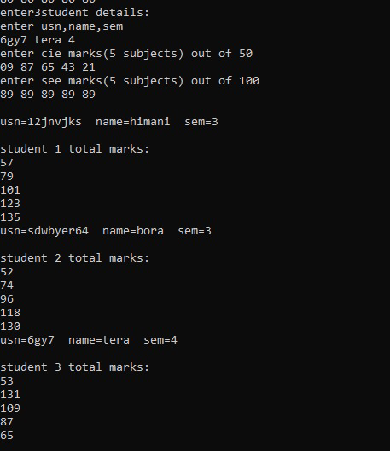

Lab program 7:

Write a program to demonstrate generics with multiple object parameters.

Program:

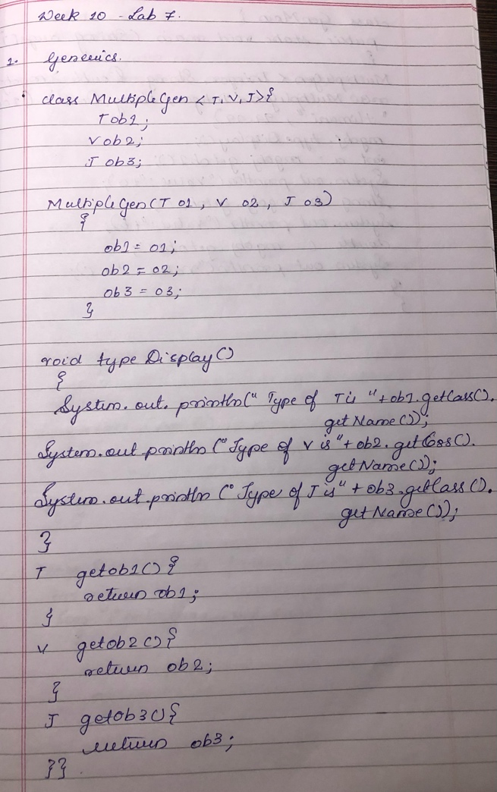

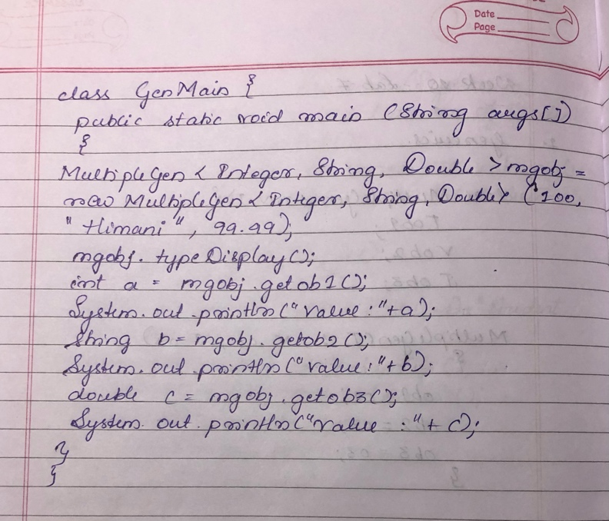

Output:

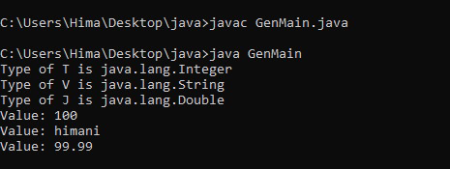

Program8:

Write a program that demonstrates handling of exceptions in inheritance tree. Create a base

class called “Father” and derived class called “Son” which extends the base class. In Father

class, implement a constructor which takes the age and throws the exception Wrong Age( )

when the input age<0. In Son class, implement a constructor that cases both father and son’s

age and throws an exception if son’s age is >=father’s age.

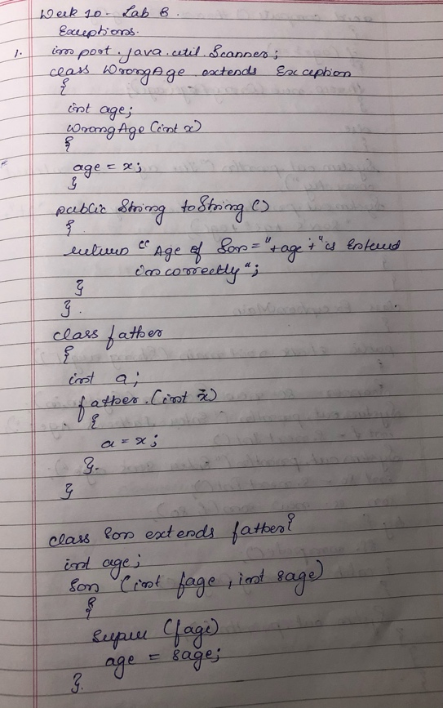Program:

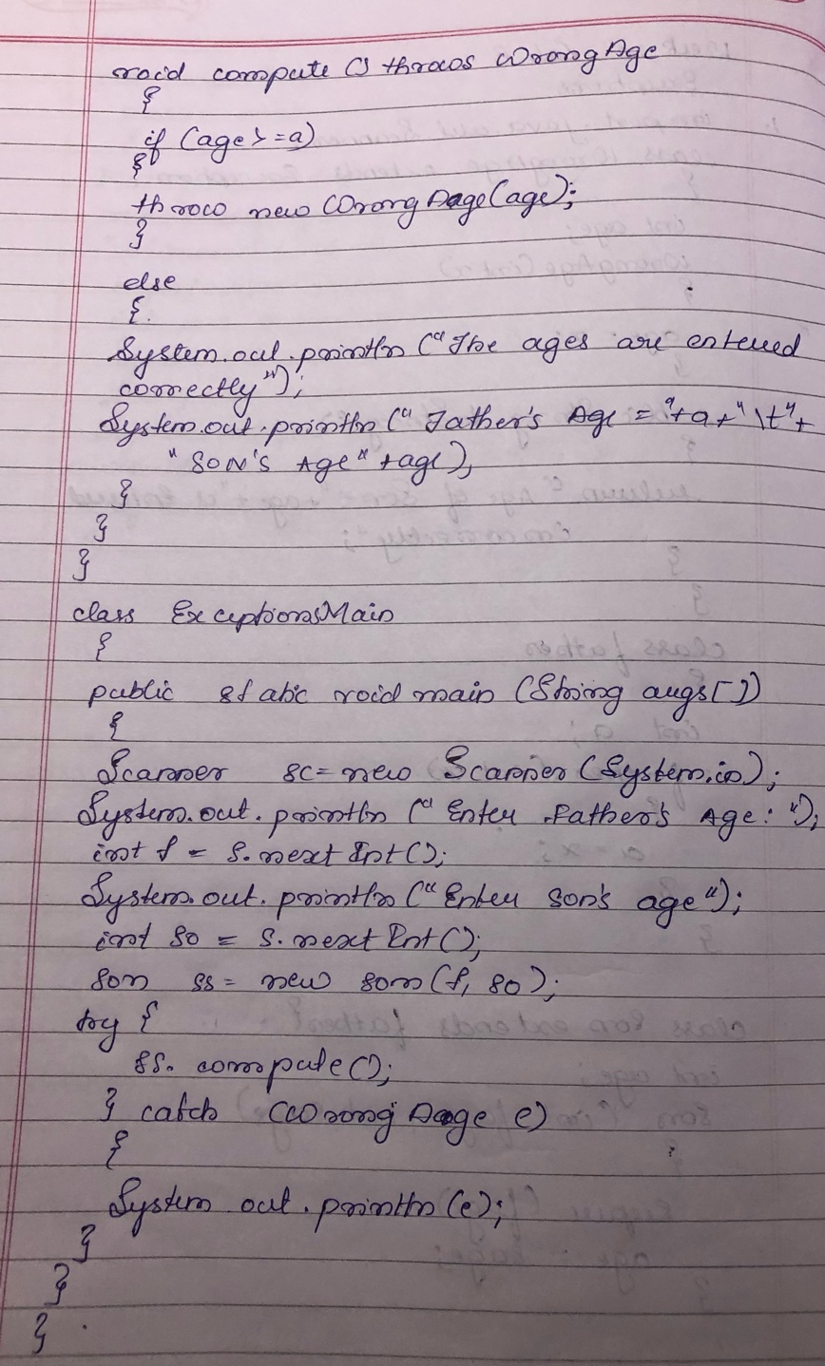

Output :

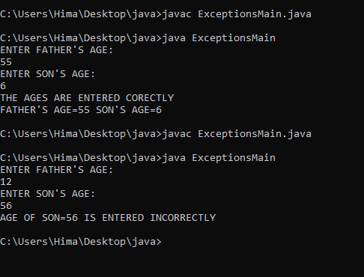

Lab program 9:

Write a program which creates two threads, one thread displaying “BMS College of

Engineering” once every ten seconds and another displaying “CSE” once every two seconds.

Program :

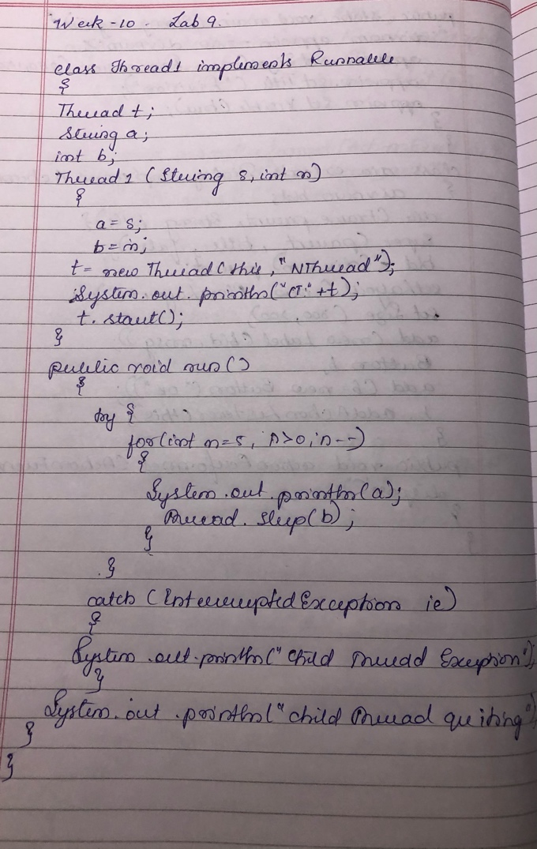

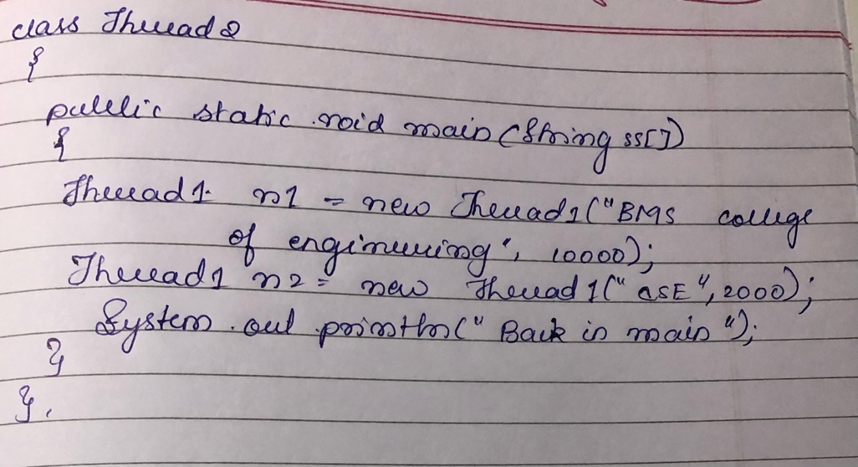

Output :

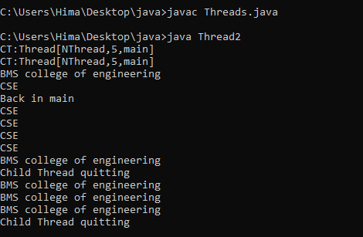

Lab program 10:

Write a program that creates a user interface to perform integer divisions. The user enters two

numbers in the text fields, Num1 and Num2. The division of Num1 and Num2 is displayed in

the Result field when the Divide button is clicked. If Num1 or Num2 were not an integer, the

program would throw a NumberFormatException. If Num2 were Zero, the program would

throw an Arithmetic Exception Display the exception in a message dialog box

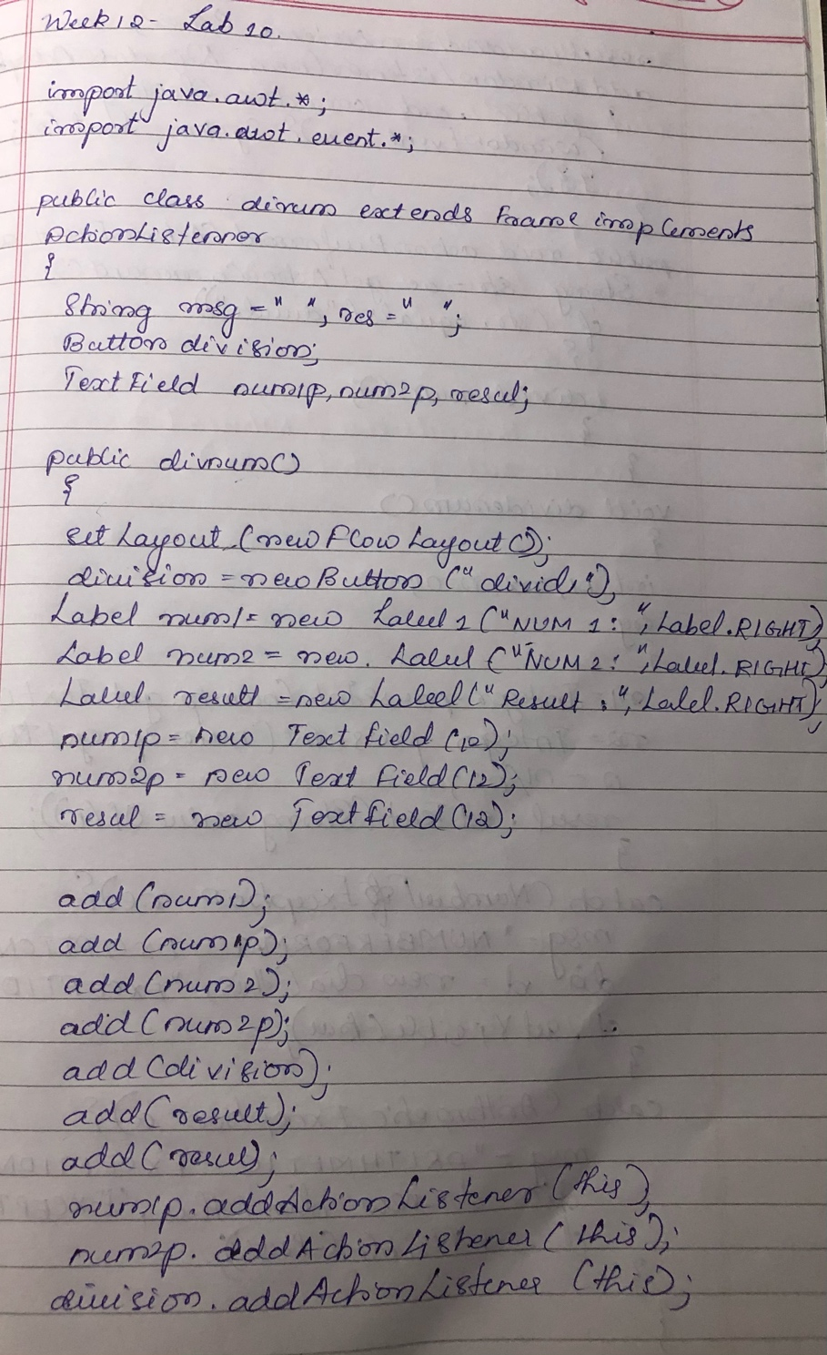

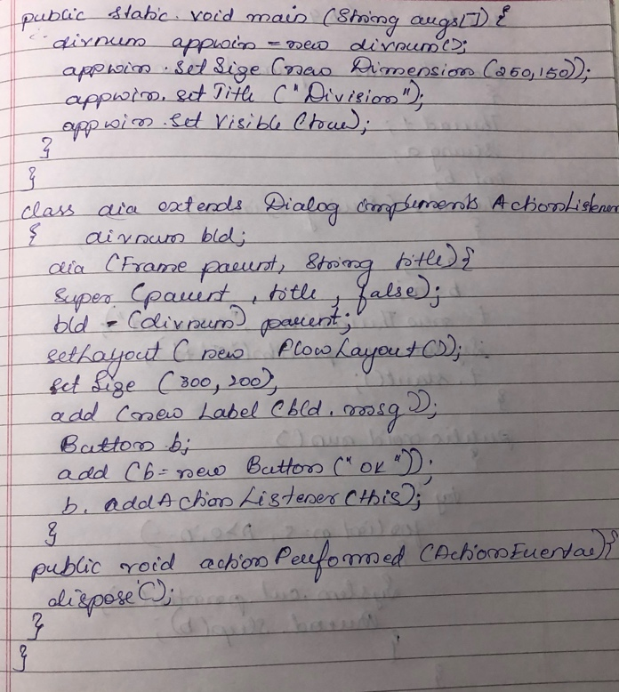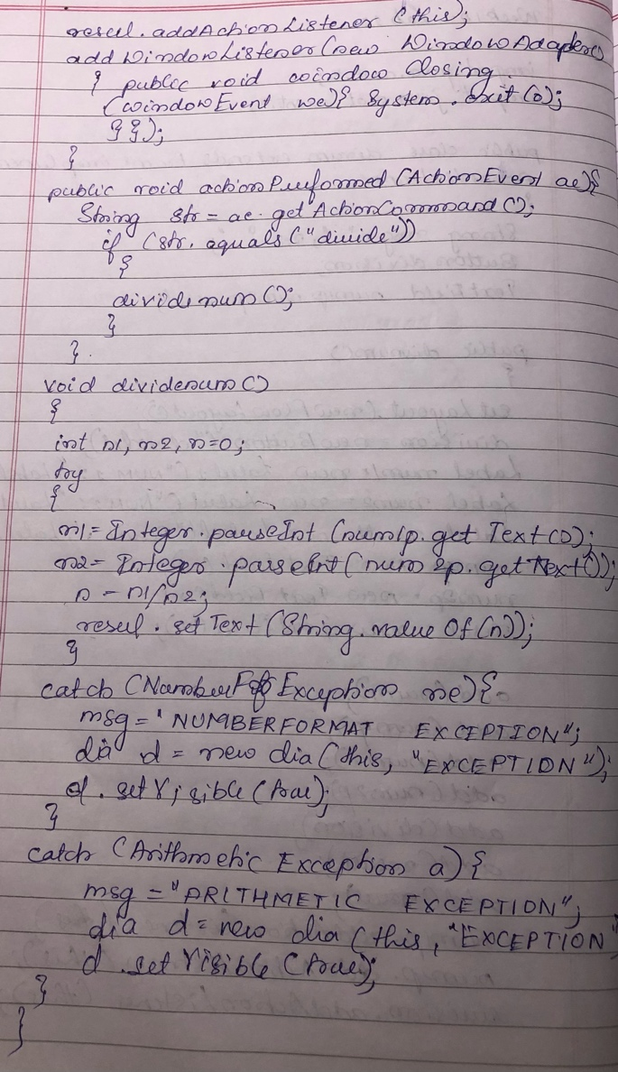

Output:

