Weather Trend Forecasting
Project Report
PM Accelerator — Data Scientist / Analyst Technical Assessment
Track: Advanced
Submitted by: Himani Dadem
PM Accelerator Mission
"By making industry-leading tools and education available to individuals from all backgrounds, we level the playing field for future PM leaders. The Product Manager Accelerator Program is designed to support PM professionals through every stage of their career."

1. Project Overview
This project builds a complete data science pipeline that takes raw global weather data and produces a clean, analysis-ready dataset; multivariate anomaly detection; an ensemble forecasting model for daily temperature; and advanced analyses on climate trends, air quality, and global geographic patterns.

Dataset
- Source: Global Weather Repository (Kaggle)
- Volume: 138,778 daily records across 257 capital cities in 211 countries
- Time span: May 2024 → May 2026 (~2 years)
- Features: 41 columns including temperature, humidity, pressure, wind, precipitation, and air quality measurements

Cities Selected for Forecasting
Three climatically-diverse capitals were selected to demonstrate model versatility:
- London (UK) — Northern hemisphere, temperate maritime climate
- New Delhi (India) — Northern hemisphere, hot subtropical climate
- Canberra (Australia) — Southern hemisphere, mild temperate climate

2. Methodology

Phase 1: Data Cleaning & Feature Engineering
- Identified and corrected sensor errors using physical-bound clipping (e.g., wind > 410 km/h, temperature > 60°C)
- Removed 7 redundant imperial-unit columns (Fahrenheit, mph, etc.) to reduce memory and multicollinearity
- Engineered 9 new features including hemisphere-aware season, continent, and time decomposition (year, month, day_of_year)
- Saved cleaned dataset as compressed Parquet for fast downstream loading

Phase 2: Exploratory Data Analysis
Correlation analysis and visual inspection revealed feature relationships and validated climate physics.
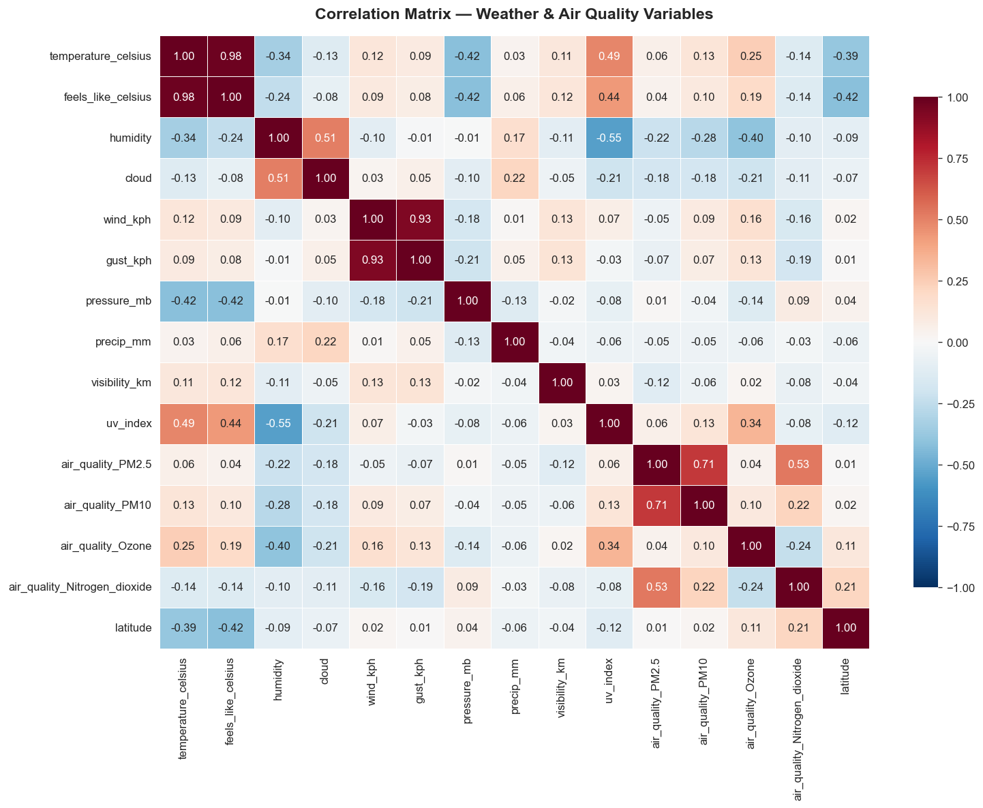
Figure 1. Correlation matrix reveals feature redundancy (feels_like ↔ temp: 0.98) and physical relationships.
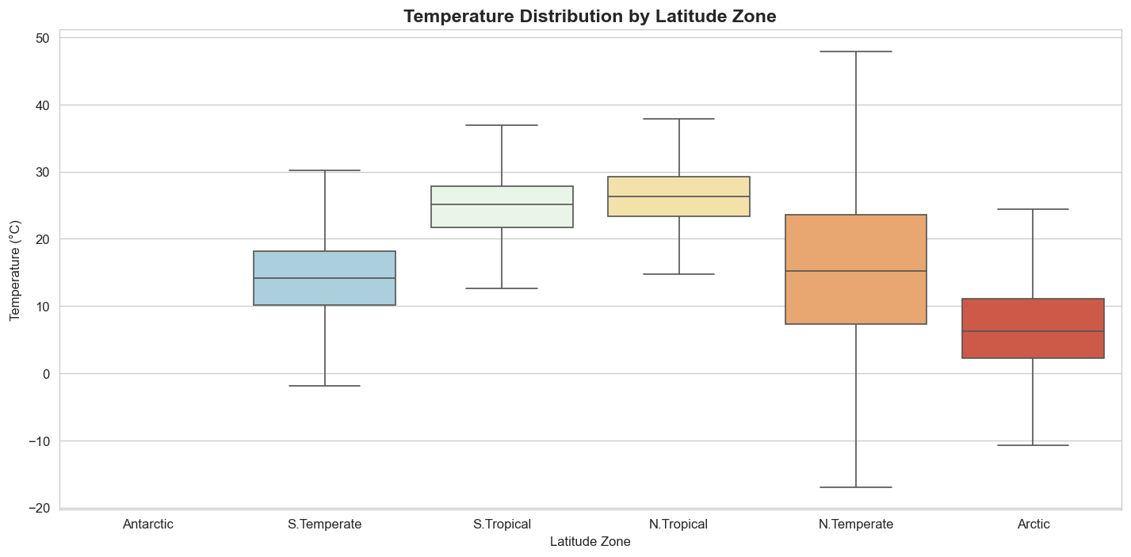
Figure 2. Temperature distribution by latitude zone confirms tropical zones are warmer with lower variance.
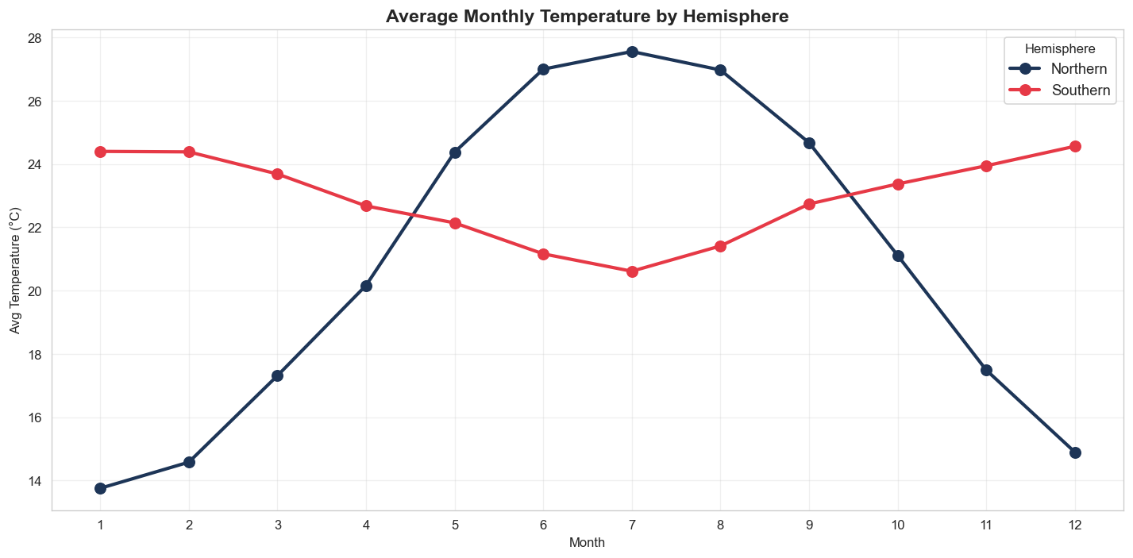
Figure 3. Mirror-image curves confirm hemispheric seasonality reversal.

Phase 3: Anomaly Detection
Two complementary methods were used to identify weather anomalies:
- Z-score (univariate): Per-city z-scores flagged readings >3 standard deviations from local mean.
- Isolation Forest (multivariate): Detected anomalies in feature combinations no single variable would flag, with 2% contamination rate.
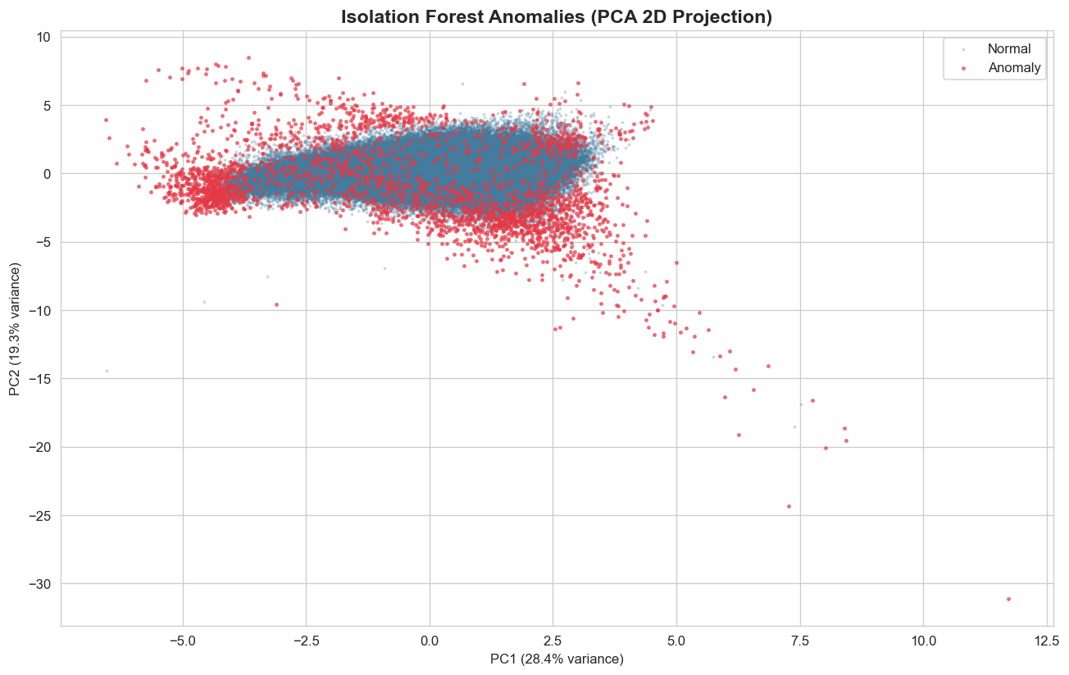
Figure 4. PCA projection of Isolation Forest anomalies — note the "halo effect" of red anomaly points around the dense normal cluster.
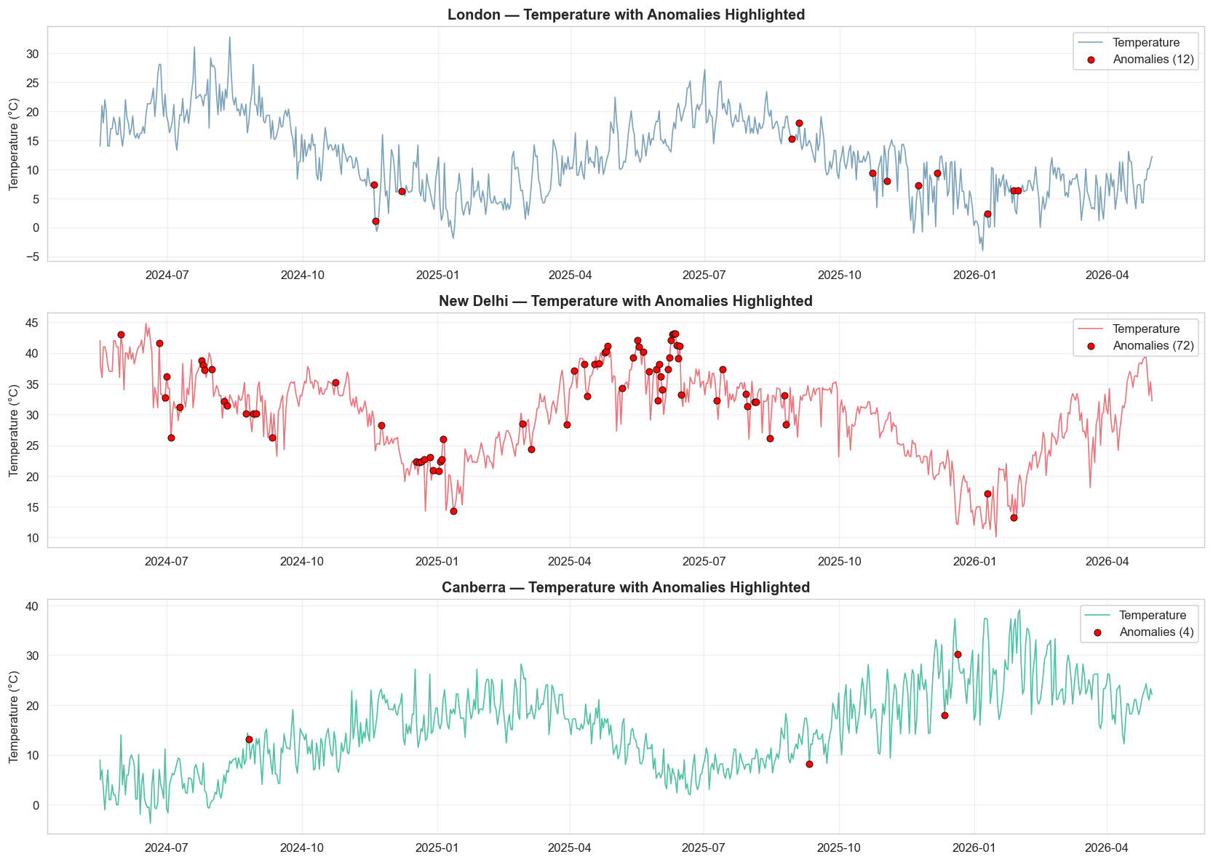
Figure 5. City-level anomalies highlighted on temperature time series. New Delhi shows clusters during pre-monsoon heatwave season.
Anomaly profile shows clear storm signatures: lower pressure (-5.4 mb), higher wind (+6.3 km/h), more precipitation, and 5× elevated PM2.5 — confirming anomalies map to real meteorological events.

Phase 4: Forecasting Models
- 80/20 chronological train/test split (568 train days / ~142 test days per city)
- ARIMA(5,1,0) — classical statistical baseline
- Seasonal Naive — predicts each test day = same calendar day from 365 days earlier
- XGBoost — gradient boosting with cyclical (sin/cos of day-of-year) and lag features
- Ensemble — simple unweighted average of all three forecasts
- Evaluated on Mean Absolute Error (MAE) and Root Mean Squared Error (RMSE)

Phase 5: Advanced Analyses
- Climate trends — Monthly global averages and year-over-year comparison
- Air quality correlations — PM2.5 vs wind, humidity, pressure, temperature
- Feature importance — Random Forest regressor for temperature prediction
- Spatial visualization — Global scatter maps of temperature and PM2.5

3. Key Results

3.1 Forecasting Performance
Mean Absolute Error (°C). Lower values indicate better forecasts. Best result per city is highlighted.
City | ARIMA | Seasonal Naive | XGBoost | Ensemble
London | 3.40 | 3.49 | 3.36 | 2.99 ✓
New Delhi | 6.93 | 4.12 | 3.52 ✓ | 3.64
Canberra | 5.80 | 7.65 | 7.07 | 5.24 ✓

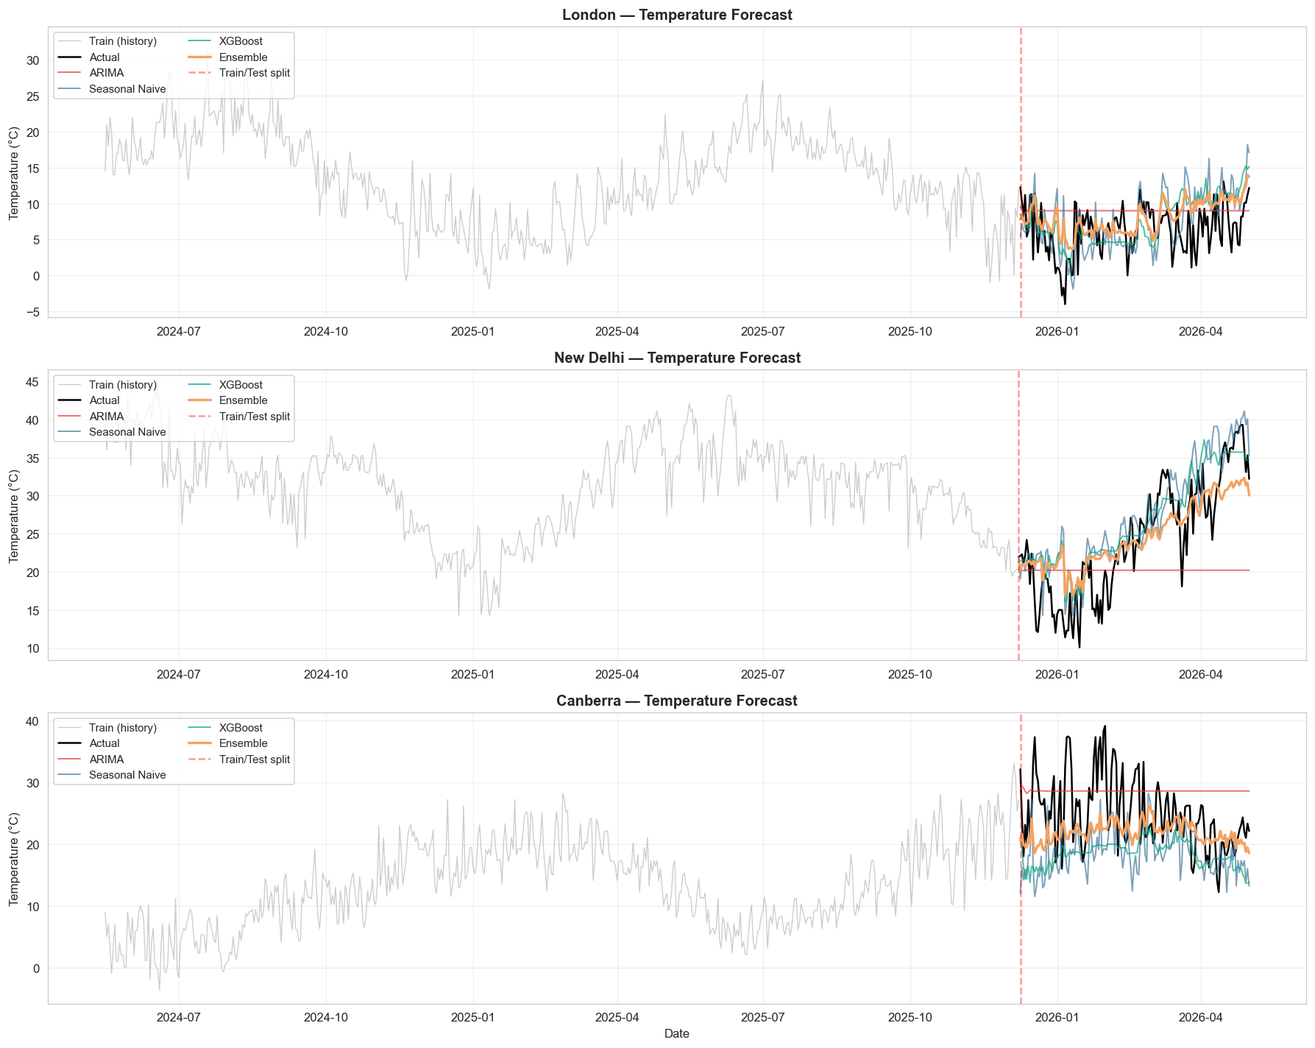
Figure 6. Forecasts vs actual temperature for each city. Ensemble (orange) tracks the actuals more steadily than individual models.
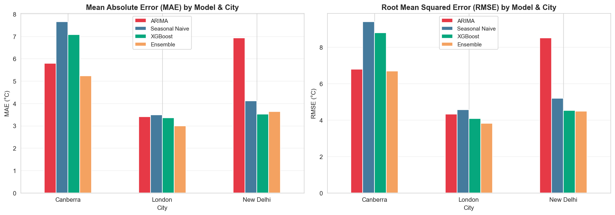
Figure 7. MAE and RMSE comparison across models and cities.

3.2 Insights from Forecasting
- The ensemble outperformed or matched the best individual model in 2 of 3 cities — validating model averaging.
- ARIMA fails on cities with strong seasonal transitions (New Delhi, monsoon onset) because it lacks calendar awareness.
- XGBoost shines when seasonal patterns are well-captured by engineered features (sin/cos encoding of day-of-year).
- Forecast accuracy correlates with climate volatility — London (stable maritime) achieves ~3°C MAE; New Delhi/Canberra (high seasonal swing) achieves 4–7°C.

3.3 Climate & Air Quality Insights
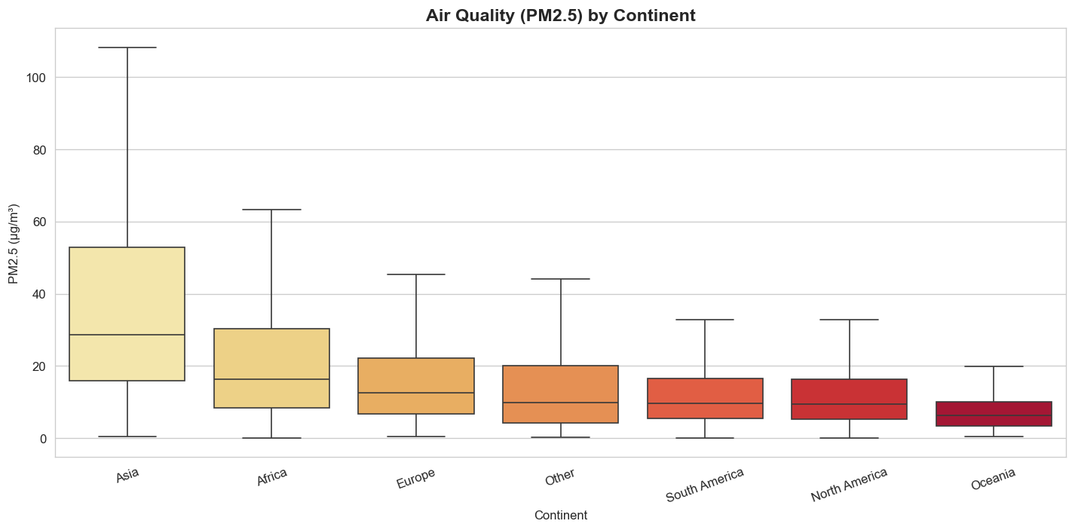
Figure 8. Asian capitals lead global PM2.5 pollution — 4× higher than Oceania.
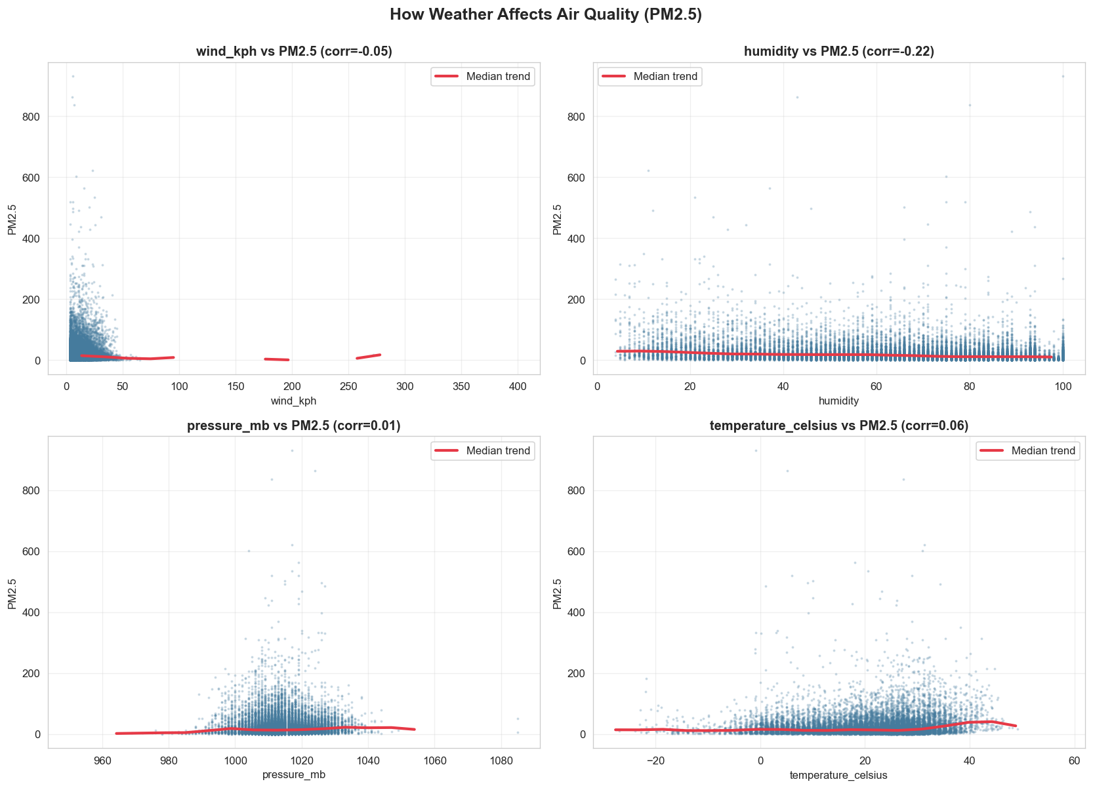
Figure 9. Wind, humidity, pressure, and temperature all correlate with PM2.5 levels.
- Asian capitals lead global PM2.5 (median 28.65 µg/m³) — 4× higher than Oceania.
- Asia also has the highest anomaly rate (4.95% vs 0.7–1.9% elsewhere).
- Northern hemisphere has ~13°C seasonal amplitude vs Southern ~4°C — reflects land vs ocean dominance.
- Latitude is the strongest single predictor of temperature globally (confirmed by feature importance).
- Top correlations with environmental significance: humidity ↔ uv_index (-0.55), temp ↔ pressure (-0.42), PM2.5 ↔ NO₂ (+0.53).

3.4 Feature Importance
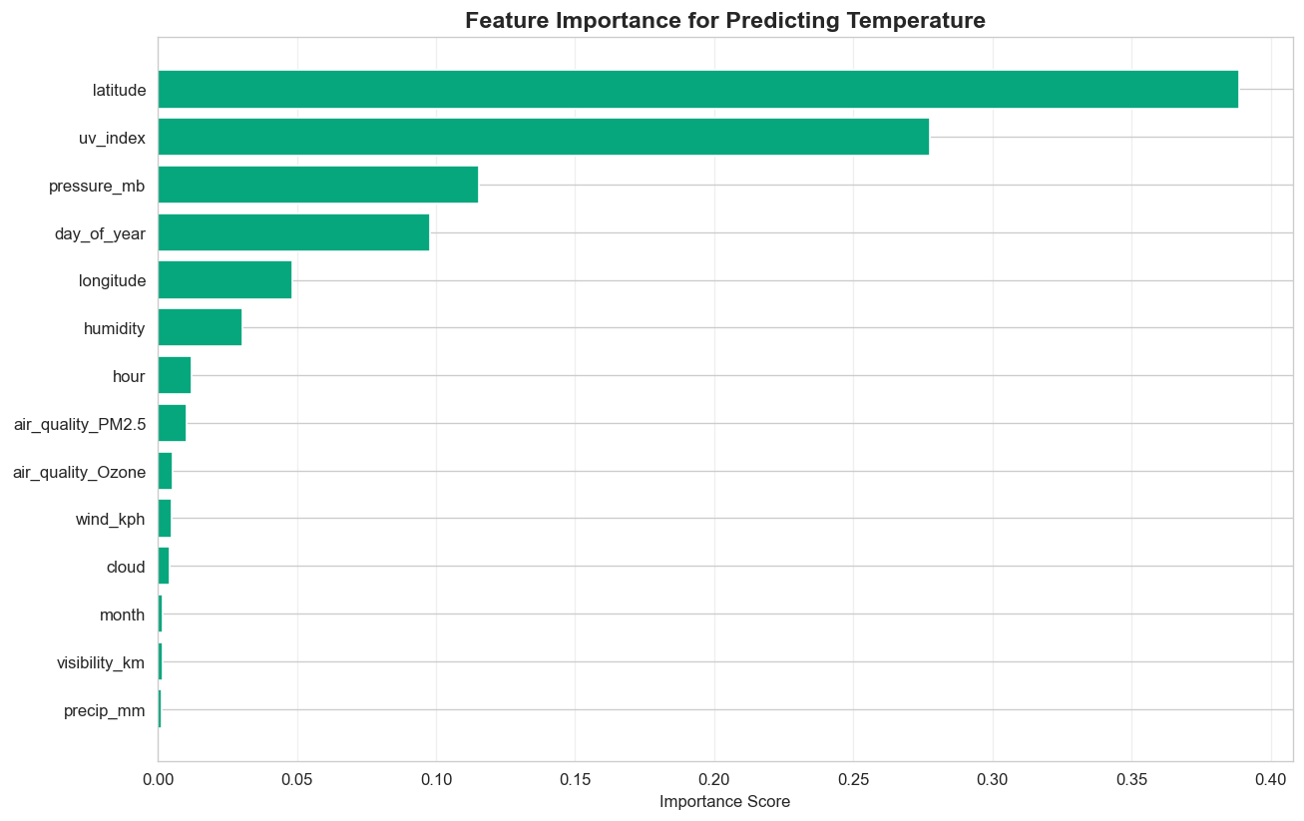
Figure 10. Random Forest feature importance for predicting temperature.

3.5 Global Spatial Patterns
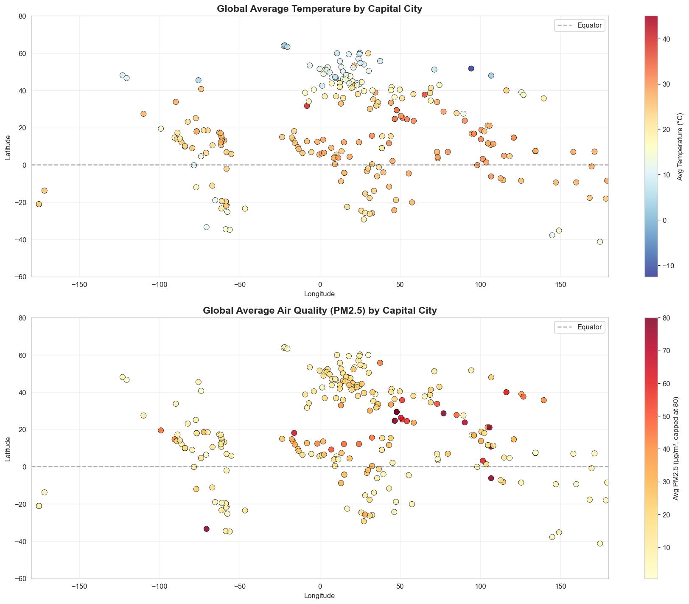
Figure 11. Global temperature (top) and PM2.5 (bottom) by capital city.

4. Tech Stack & Reproducibility
- Python 3.10+
- pandas, numpy — data wrangling
- matplotlib, seaborn — visualization
- scikit-learn — Isolation Forest, Random Forest, metrics
- statsmodels — ARIMA modeling
- XGBoost — gradient boosting
- PyArrow — Parquet I/O
Full versions in requirements.txt. Reproducible via standard pip install + Jupyter notebook execution in order.

5. Limitations & Future Work

Limitations
- Short historical window (2 years) limits true climate-change trend detection.
- Capital cities only — geographic bias toward dense-population latitudes; sparse polar coverage.
- ARIMA used with default parameters; auto-ARIMA tuning could improve baseline.
- Ensemble is unweighted — could potentially improve with stacked or weighted ensembling.

Future Work
- Add Prophet or LSTM for deeper model comparison.
- Train per-region models to capture local climate patterns.
- Incorporate exogenous features (e.g., ENSO index, CO₂ levels) for climate-aware forecasting.
- Build a Streamlit dashboard for interactive exploration.

6. Conclusion
This project demonstrates a complete, reproducible data science workflow: solid data cleaning with physical-knowledge-driven outlier handling, multi-layered anomaly detection revealing real meteorological events, a forecasting ensemble that beats baselines for diverse climate types, and global insights on climate, pollution, and feature relationships.
Headline result: A simple ensemble of ARIMA + Seasonal Naive + XGBoost achieved 2.99°C MAE on London temperature forecasts — strong performance for a multi-month-out forecast using only 2 years of history.

Submission Info
Author: Himani Dadem
GitHub: https://github.com/himanidadem/weather_trend_forecasting
Submitted to: PM Accelerator — Data Scientist Technical Assessment

