EXPERIMENT No. | EXPERIMENT NAME | PAGE NO. | DATE OF EXPERIMENT | DATE OF SUBMISSION
1 | Problem Statement for the Suggested System | 1
2 | Requirement Analysis and Software Requirement Specification (SRS) | 9
3 | ER Diagram for Risk-Aware DevSecOps Release Gate | 28
4 | Function-Oriented Diagrams: Data Flow Diagram (DFD) and Structure Chart | 33
5 | User's View Analysis: Use Case Diagram | 38
6 | Structural View Diagrams: Class Diagram and Object Diagram | 41
7 | To draw the behavioral view diagram: State-chart diagram, Activity diagram. | 43

INDEX

RISK-AWARE DEVSECOPS RELEASE GATE

EXPERIMENT-1

Write down the problem statement for a suggested system of relevance.

1.1 Description of the Suggested System:
The proposed system, Risk-Aware DevSecOps Release Gate, is a Python-based security assessment system developed to check the security of code changes submitted through GitHub Pull Requests. The main objective of the system is to identify potential security risks before the changes are merged into the main codebase.
The system takes the URL of a GitHub Pull Request as input and retrieves the details of the changes made in the Pull Request using the GitHub REST API. It then performs different security checks on the changed code. These checks include detecting accidentally exposed secrets, identifying known vulnerabilities in project dependencies, checking for insecure IAM wildcard permissions, and performing static code analysis using SonarQube Cloud.
The results obtained from these checks are analyzed to determine the overall risk associated with the Pull Request. Based on the identified issues and their severity, the system generates a final security verdict. It can also provide the reasons for the identified risks and recommendations that can help the developer resolve the issues. The basic working of the system can be represented as:

The proposed system aims to integrate security checks into the development workflow and reduce the chances of insecure code being merged into a project. By bringing security checks closer to the development and code-review process, the system follows the principles of DevSecOps, where security is considered throughout the software development lifecycle rather than only at the final stage.

1.2 Features of the Suggested System:
The major features of the Risk-Aware DevSecOps Release Gate are:
- GitHub Pull Request Analysis
The system accepts a GitHub Pull Request URL and retrieves the relevant Pull Request details and code changes using the GitHub REST API.
- Secret Detection
The system scans newly added code for accidentally exposed sensitive information such as API keys, tokens, and other credentials using the detect-secrets library.
- Dependency Vulnerability Scanning
Project dependencies modified through the Pull Request are checked against the OSV (Open Source Vulnerabilities) API to identify known security vulnerabilities.
- IAM Wildcard Detection
The system checks applicable Terraform and IAM configuration files for overly broad permissions, particularly wildcard (*) values in Action and Resource fields.
- Static Code Analysis
The system integrates SonarCloud to analyze the code for bugs, vulnerabilities, code smells, and other code-quality issues.
- Risk Assessment
The findings from different security checks are considered to assess the overall security risk associated with the Pull Request.
- Security Verdict
Based on the identified risks, the system generates a final ALLOW or BLOCK verdict. The verdict is decided by mandatory security blocking conditions, while the numerical risk score measures the overall risk.
- Reason and Recommendation
The system can provide the reasons behind identified security issues and recommendations for addressing them, helping developers understand and resolve the reported problems.
- Automated Security Checking
Multiple security checks are combined into a single workflow, reducing the need to perform each check manually.
- DevSecOps Integration
Security is incorporated into the development and code-review process, allowing potential issues to be identified before code is merged into the main codebase.

1.3 Challenges in the Existing System:
In a conventional software development process, security checking is often performed using separate tools or during different stages of the development lifecycle. Although these tools are useful, using them independently can create several challenges:
- Multiple Separate Security Tools
Different security issues may require different tools for detection. Managing secret scanning, dependency checking, IAM configuration checking, and code analysis separately can make the security process more complex.
- Manual Review of Code Changes
Developers or reviewers may need to manually inspect Pull Requests to identify potential security problems. This can be time-consuming and may result in some issues being overlooked.
- Security Issues Detected Late
If security checks are performed after code has already been merged or deployed, fixing the issues can require additional development effort and may delay the release process.
- Difficulty in Prioritizing Security Findings
Security tools can generate a large number of findings. Without a combined assessment, it can be difficult for developers to determine which issues require immediate attention.
- Lack of a Single Security Verdict
When the results of different security checks are available separately, developers may have to interpret the results themselves to decide whether a Pull Request should be merged.
- Inconsistent Security Checks
When security verification depends mainly on manual review or individually configured tools, the checks performed may vary between different Pull Requests or developers.
- Limited Explanation for Developers
Some security tools primarily report technical findings without presenting them as a simple overall assessment. Developers may therefore need additional effort to understand the impact and appropriate corrective action.
- Integration with the Development Workflow
Security activities that are not properly integrated with the Pull Request and code-review process can become a separate task rather than an integral part of software development.
These challenges create a need for a system that combines multiple security checks and provides a clear risk-based assessment of a Pull Request before it is merged.

1.4 Functional and Non-Functional Requirements:
1. Functional Requirements
Functional requirements describe the operations and features that the proposed system should perform.
- GitHub Pull Request Input
The system shall accept a valid GitHub Pull Request URL as input.
- Pull Request Data Retrieval
The system shall retrieve Pull Request details and changed files using the GitHub REST API.
- Code Change Analysis
The system shall identify and analyze the relevant code changes introduced through the Pull Request.
- Secret Detection
The system shall scan the changed code for potentially exposed secrets, credentials, API keys, and tokens.
- Dependency Vulnerability Detection
The system shall identify project dependencies present in the Pull Request and check them for known vulnerabilities using the OSV API.
- IAM Permission Analysis
The system shall detect potentially excessive IAM permissions, including wildcard (*) values in applicable Action and Resource configurations.
- Static Code Analysis
The system shall use SonarCloud to perform static analysis of the project code and identify relevant code-quality and security issues.
- Risk Assessment
The system shall analyze the findings generated by the different security checks and assess the overall risk associated with the Pull Request.
- Verdict Generation
The system shall generate a final security verdict (ALLOW or BLOCK) according to the mandatory security blocking conditions.
- Reason and Recommendation Generation
The system shall provide reasons for important findings and recommendations where applicable, allowing developers to understand and address the identified issues.

2. Non-Functional Requirements
Non-functional requirements describe the quality attributes and constraints of the proposed system.
- Security
The system should handle security-related information carefully and should not unnecessarily store the source code or sensitive information obtained during analysis.
- Reliability
The system should provide consistent results when the same Pull Request is analyzed under the same conditions.
- Performance
The system should complete the security analysis within a reasonable amount of time without unnecessary processing.
- Usability
The system should provide clear and understandable output so that developers can easily interpret the security verdict and findings.
- Maintainability
The system should have a modular structure so that additional security checks or analysis tools can be added in the future.
- Scalability
The system should be designed so that its security-checking capabilities can be extended to handle larger projects and additional Pull Requests.
- Compatibility
The system should work with GitHub Pull Requests and support the technologies and file formats required by the implemented security checks.
- Extensibility
The system should allow additional vulnerability scanners, code-analysis tools, or security rules to be integrated without requiring major changes to the complete system.
- Accuracy
The system should minimize incorrect security findings and provide meaningful results based on the output of the integrated security tools.
- Privacy
The system should process Pull Request data only for the purpose of security analysis and avoid unnecessary permanent storage of the analyzed code.

1.5 Cost Analysis:
The Risk-Aware DevSecOps Release Gate is designed as a low-cost security assessment system. The project primarily uses free and open-source software, APIs used for security analysis, and freely available development tools. Therefore, the additional software cost required to develop the prototype is minimal.

Table 1: Cost Analysis of the Proposed System
Component | Purpose | Estimated Cost
Python | Application development | ₹0
Git & GitHub | Source code management and Pull Requests | ₹0
GitHub REST API | Retrieval of Pull Request information | ₹0*
detect-secrets | Secret detection | ₹0
OSV API | Dependency vulnerability checking | ₹0
SonarQube Cloud | Static code analysis | ₹0**
Visual Studio Code | Development environment | ₹0
Windows/Linux environment | Development and testing | Existing system
Internet Connection | API access and cloud-based analysis | Existing expense
Total Additional Cost | — | ₹0

* Subject to GitHub API usage limits and applicable GitHub policies.
** Based on the free features/plan used for the project.
The project does not require dedicated hardware or paid security software for its basic implementation. The existing computer system and internet connection can be used for development, testing, and execution. Hence, the additional software cost for developing the prototype is approximately ₹0.
Although the prototype has been developed with minimal additional cost, a production-level implementation may involve additional expenses such as cloud hosting, increased API usage, premium security-analysis features, storage, monitoring, and maintenance.

1.6 Future Scope:
The Risk-Aware DevSecOps Release Gate can be extended from a Pull Request security assessment tool into a complete security-controlled CI/CD and deployment workflow. The following enhancements can be considered in future development:
- Integration with GitHub Pull Request Workflow
The security gate can be integrated directly with GitHub so that every Pull Request is automatically analyzed before it is allowed to proceed towards merging. This would make security verification a mandatory part of the Pull Request workflow.
- Webhook-Based CI/CD Integration
Webhooks can be used to automatically notify a CI/CD system whenever a Pull Request is created, updated, or approved. The security verdict generated by the system can then be passed to a Jenkins pipeline for further processing.
- Automated Jenkins Pipeline
Jenkins can be used to manage the subsequent stages of the CI/CD pipeline, including testing, building, security verification, and preparation of the application for deployment. The deployment stage can be configured to proceed only when the required security and approval conditions are satisfied.
- AWS Deployment Integration
The pipeline can be extended to deploy the approved application to AWS infrastructure. This can provide a complete workflow from code submission and security assessment to controlled cloud deployment.
- Role-Based Deployment Authorization
A role-based authorization mechanism can be introduced to ensure that not every developer has permission to deploy an application. Developers can be allowed to create and modify Pull Requests, while deployment permissions can be restricted to authorized roles such as a Team Lead or Release Manager.
- Team Lead Approval as Final Authority
The final production deployment decision can remain with the authorized Team Lead. Even if the automated security checks and CI/CD pipeline are successful, the production deployment can require explicit approval from the designated authority. This provides an additional human approval layer for critical deployments.
- Database-Based Access Control
A database can be introduced to maintain information about users, roles, repositories, deployment permissions, and approval status. The system can verify whether the person requesting or approving a deployment has the required authorization before allowing the deployment to proceed.
- Audit Trail and Deployment History
The system can maintain an audit record of Pull Requests, security findings, approvals, deployment decisions, and deployment timestamps. This would help organizations track who approved a deployment and provide better accountability.
- Centralized Security and Deployment Dashboard
A web-based dashboard can be developed to allow developers and authorized team members to view Pull Request security results, pipeline status, approval requests, and deployment history from a single interface.
- Multi-Repository Support
The system can be extended to support multiple GitHub repositories and development teams, allowing organizations to apply a common security and deployment-control process across their projects.
The future system can therefore provide an end-to-end controlled workflow:

This approach would combine automated security checks with human authorization, ensuring that security-sensitive changes are evaluated before merging and that production deployment is performed only by authorized personnel.
EXPERIMENT- 2

DO REQUIREMENT ANALYSIS AND DEVELOP SOFTWARE REQUIREMENT SPECIFICATION SHEET (SRS) FOR THE SUGGESTED SYSTEM.

What is Requirement Analysis?
Requirement analysis is the process of determining user expectations for a new or modified system, by eliciting, analysing, documenting and validating stakeholder needs. It resolves conflicts between stakeholders, discovers system boundaries, and translates a vague, informal problem statement (Experiment 1) into precise, verifiable requirements. The output of this process is the SRS document below, which is the contract of understanding between the developers and the client/end-user.

1 Introduction

The Risk-Aware DevSecOps Release Gate is a software application designed to assess the security risks associated with software changes submitted through GitHub Pull Requests (PRs) before they are released. It analyzes potential security problems in the code and gives one of three verdicts: ALLOW, WARNING or BLOCK.

Unlike a system that simply counts security issues, the Release Gate evaluates their severity and potential impact to calculate an overall risk score. It performs automated checks for exposed secrets, insecure Identity and Access Management (IAM) permissions, vulnerable software dependencies, and code quality issues.

The purpose of this Software Requirement Specification (SRS) document is to define the functional and non-functional requirements of the system. It describes what the application must do and serves as a reference for students, teachers, developers, and testers involved in understanding, developing, and evaluating the system.

1.1 Purpose
The objectives of the Release Gate are:
- To identify security vulnerabilities in proposed code changes.
- To detect accidentally exposed secrets and credentials.
- To identify risky IAM permissions.
- To detect known vulnerabilities in software dependencies.
- To analyze code quality and security issues using SonarCloud.
- To calculate a risk score based on security findings.
- To generate an appropriate release verdict.
- To provide understandable findings and recommendations to help developers improve security.
The Release Gate does not fix vulnerabilities automatically or deploy software

1.2 Scope
The scope of the project is to automate preliminary security assessment of GitHub Pull Requests before the changes are released.
The system accepts a GitHub Pull Request URL and retrieves relevant information using the GitHub REST API. It then performs the configured security checks and displays the results through a Flask-based web interface.
The major features are:
- GitHub Pull Request information retrieval.
- Secret detection using detect-secrets.
- IAM permission analysis for potentially dangerous wildcard permissions.
- Dependency vulnerability detection using OSV.dev.
- Code quality and security analysis using SonarCloud.
- Risk scoring and severity assessment.
- Release verdict generation.
- Display of security findings and recommendations.
The system is intended to assist developers in identifying risks early. It does not replace manual security reviews or guarantee that the software is completely free from vulnerabilities.

1.3 Definitions, Acronyms, Abbreviations
Term | Definition
SRS | Software Requirement Specification
DevSecOps | Development, Security and Operations
PR | Pull Request — a request to merge code changes into a repository.
GitHub | A platform for hosting and managing source code.
API | Application Programming Interface — enables communication between software applications.
REST API | Representational State Transfer API used for communication between systems over HTTP.
IAM | Identity and Access Management — manages permissions and access to resources.
CVE | Common Vulnerabilities and Exposures — a system for identifying publicly known security vulnerabilities.
OSV | Open Source Vulnerabilities — a database and service providing information about vulnerabilities in open-source software.
CI/CD | Continuous Integration and Continuous Delivery/Deployment.
Flask | A lightweight Python web framework used to develop the application's web interface and backend.
Python | The programming language used to develop the application.
detect-secrets | A tool used to detect potential secrets, such as passwords and API keys, in source code.
SonarCloud | A cloud-based service used to analyze code quality and identify potential security issues.
Dependency | An external library or package required by a software application.
Vulnerability | A weakness in software that may be exploited to affect its security.
Secret | Sensitive information, such as an API key, password, or access token, that must be protected.
Risk Score | A numerical value representing the assessed security risk of a Pull Request.
Severity | The degree of seriousness of a security issue.
Release Gate | A mechanism that evaluates software changes and determines whether they can proceed toward release.
ALLOW | A verdict indicating that the changes satisfy the configured release-gate conditions.
WARNING | A verdict indicating that the changes require attention or review.
BLOCK | A verdict indicating that the changes must not proceed under the configured security policy.
SAST | Static Application Security Testing — analyzing source code to identify potential security weaknesses without executing the application.
HTTP/HTTPS | Hypertext Transfer Protocol / Hypertext Transfer Protocol Secure, used for communication between systems.
UI | User Interface — the part of the application through which users interact with the system.

1.4 Overview
This document describes the product perspective, system interfaces, product functions, user characteristics, constraints, assumptions, functional requirements, performance requirements, database requirements, and software quality attributes.
The application consists of a web interface, a Flask backend, a GitHub integration module, security-checking modules, a risk assessment component, and a results display component.

1.4.1 Functional Overview
The main functional workflow of the system is:
- The user enters a GitHub Pull Request URL.
- The system validates the URL.
- The application retrieves Pull Request details and changed files through the GitHub REST API.
- The system performs the configured security checks.
- The findings are collected and classified according to their severity.
- The risk assessment component calculates the risk score.
- The release gate determines the verdict according to the configured rules.
- The application displays the assessment results, findings, and recommendations.
System workflow:
GitHub PR URL → PR Information Retrieval → Security Scanning → Risk Assessment → Release Verdict → Results Display
The system uses a combination of security tools and predefined rules to provide a consolidated assessment.

1.4.2 User Experience
The application provides a simple web-based interface developed using Flask and HTML templates.
The user enters a Pull Request URL in the input field and submits it for assessment. An optional checkbox allows the user to request detailed reasons and recommendations.
The results page presents the Pull Request information, risk assessment, final verdict, and relevant security findings. The interface is designed to make the results understandable even to users who are not security specialists.
The system aims to provide a clear and convenient experience with minimal user input.

2 Product Perspective
The Risk-Aware DevSecOps Release Gate is a standalone web application that integrates with external development and security services.
It acts as a security assessment layer between code development and the release decision. The application does not itself host the source-code repository; it retrieves the necessary information from GitHub and uses external services where required.

2.1 System Interfaces
The system communicates with users through a web interface and interacts with external APIs and scanning tools to perform its operations.

2.1.1 Software Interfaces
The software interfaces used by the application are:
- Python: Main programming language used for application logic.
- Flask: Provides web routes and handles user requests.
- GitHub REST API: Retrieves Pull Request details and changed-file information.
- detect-secrets: Identifies potential secrets in the scanned code changes.
- OSV.dev API: Checks supported software dependencies for known vulnerabilities.
- SonarCloud: Performs code quality and security analysis (including SAST).
- HTML and CSS: Provide the structure and presentation of the web interface.
- Python Requests: Sends HTTP requests to external services.
- python-dotenv: Loads configuration values from environment variables and configuration files.
The application depends on the availability and correct configuration of these tools and services.

2.1.2 User Interfaces
The system provides a browser-based interface with the following elements:
- A text field for entering the GitHub Pull Request URL.
- A submission button to start the assessment.
- A checkbox for displaying detailed reasons and recommendations.
- A results page showing Pull Request information and the final verdict.
- Sections or cards presenting findings from different security checks.
- Error messages when the supplied URL or an external service request fails.
The interface should be simple, readable, and easy to navigate.

2.1.3 Hardware Interfaces
- The application does not require any specialized hardware.
- It can run on a standard computer or laptop with sufficient memory, processing capability, and network connectivity. A web browser is required to access the interface.
- A server or cloud-based virtual machine may also be used if the application is deployed remotely.
2.1.4 Communication Interfaces
- The application communicates with the GitHub REST API, OSV.dev API, and SonarCloud using HTTPS.
- The browser communicates with the Flask application using HTTP during local development or HTTPS when deployed.
- Data is exchanged with external services in JSON format.
- API tokens are transmitted securely and are never displayed to the user.
2.1.5 Memory Constraints
- Minimum Requirements: 4 GB RAM, 1 GB of free disk space, and Python 3.10 or higher are recommended.
- Memory Usage: Memory consumption increases with the number of changed files and the size of the repository.
- Data Handling: Large source files and sensitive content should not be kept in memory longer than necessary.
2.1.6 Operations
- Start the Flask application.
- Open the application in a web browser.
- Enter a valid GitHub Pull Request URL and submit it.
- Wait for the security checks to complete.
- Review the risk score, final verdict, security findings, and recommendations.
- Fix the identified issues and resubmit the updated Pull Request for reassessment.
2.1.7 Site Adaptation Requirements
- Configure the GitHub token, SonarCloud token, organization, and project key using environment variables.
- Install the required Python packages and tools, such as Flask, detect-secrets, Requests, and python-dotenv.
- Ensure that the computer has network access to the required external APIs.
- No specialized or site-specific hardware is required for local execution.

2.2 Product Functions
The major functions of the product are:
- Pull Request Retrieval: Fetches relevant Pull Request details and changed-file information from GitHub.
- Secret Detection: Scans relevant code changes for potential exposed secrets.
- IAM Analysis: Identifies potentially dangerous wildcard permissions in supported IAM-related files.
- Dependency Scanning: Checks supported dependencies against known vulnerability information from OSV.dev.
- Code Analysis: Uses SonarCloud to obtain code quality and security analysis results.
- Risk Assessment: Assigns risk values based on the severity and type of findings.
- Verdict Generation: Produces an ALLOW or BLOCK decision according to the mandatory blocking conditions.
- Results Presentation: Displays the assessment, findings, and recommendations through the web interface.
- Error Handling: Identifies failures in required operations and prevents an unsuccessful assessment from being treated as a successful security check.

2.3 User Characteristics
The primary users of the system are:
- Software Developers: Submit Pull Requests and review security findings.
- DevOps Engineers: Use the results to support secure development and release practices.
- Security Reviewers: Examine identified vulnerabilities and recommended corrective actions.
- Project Evaluators or Administrators: Configure the application and review its operation when necessary.
Users should have basic knowledge of software development and GitHub. Advanced cybersecurity knowledge is not mandatory to operate the interface, although understanding the findings is useful for remediation.
The current application does not require a separate user registration or role-management system.

2.4 Constraints
The system has the following constraints:
- A valid and accessible GitHub Pull Request URL is required.
- Access to private repositories depends on appropriate GitHub permissions.
- External API availability and rate limits may affect processing.
- Dependency scanning is limited to supported package ecosystems and manifests.
- Secret detection and IAM analysis depend on the configured scanning rules.
- SonarCloud analysis depends on correct project configuration and service availability.
- The application may take longer to process large Pull Requests.
- The final verdict depends on the implemented risk-scoring and blocking rules.
- API credentials must be configured securely.
- The system does not automatically fix vulnerabilities or deploy software.

2.5 Assumptions and Dependencies
The system operates under the following assumptions:
- The user provides a valid GitHub Pull Request URL.
- The Pull Request and its changed files are accessible to the configured GitHub credentials.
- Required Python libraries and scanning tools are installed correctly.
- External services are reachable through the network.
- The supported dependency files contain sufficient information for vulnerability checks.
- SonarCloud is correctly configured for the repository being assessed.
- The configured risk-scoring rules represent the intended security policy.
- Users review findings and apply corrective actions when necessary.
The system depends on GitHub, OSV.dev, SonarCloud, Python, Flask, and the configured security tools for its operation.

3 Specific Requirements
This section defines the detailed requirements that the application must satisfy.

3.1 External Interfaces
The system interacts with the following external interfaces:
1. GitHub REST API
The interface retrieves Pull Request metadata, repository information, changed-file details, and related information required for assessment.
2. OSV.dev API
The interface queries vulnerability information for supported software dependencies and returns matching vulnerability records.
3. SonarCloud
The application uses SonarCloud to obtain configured code quality and security analysis results.
4. Local Scanning Tools
The application invokes configured tools and modules to detect potential secrets and risky IAM permissions.
5. Web Browser
The browser allows users to submit Pull Request URLs and view the assessment results.
All external requests should be handled with appropriate validation, timeouts, and error handling.

3.2 Functional Requirements : The functional requirements describe the operations the system must perform.

3.2.1 User Management
The current system is designed for direct use through a web interface and does not implement a separate user account management module.
The relevant requirements are:
- UR-01: The system shall allow a user to access the application through a web browser.
- UR-02: The system shall accept a GitHub Pull Request URL as input.
- UR-03: The system shall validate the submitted URL before attempting to retrieve Pull Request information.
- UR-04: The system shall display an appropriate message when the submitted URL is invalid or the Pull Request cannot be retrieved.
- UR-05: The system shall provide an optional facility to display detailed reasons and recommendations.
- UR-06: The system shall not require user registration or login for the current implemented workflow.

3.2.2 Core System Operations
FR-01: Pull Request Information Retrieval
The system shall retrieve the required Pull Request details and changed-file information using the GitHub REST API.
FR-02: Secret Detection
The system shall scan the relevant code changes for potential secrets using the configured secret-detection tool.
FR-03: IAM Permission Analysis
The system shall inspect supported IAM-related files for potentially dangerous wildcard permissions, including unrestricted actions or resources where applicable.
FR-04: Dependency Vulnerability Detection
The system shall identify supported dependencies in the relevant changed files and query OSV.dev for known vulnerabilities.
FR-05: Code Quality and Security Analysis
The system shall obtain code analysis results through the configured SonarCloud integration.
FR-06: Finding Classification
The system shall classify identified findings according to the severity information available from the scanners and vulnerability sources.
FR-07: Risk Score Calculation
The system shall calculate a numerical risk score using the configured weights, severity levels, and risk multipliers.
Severity weights: BLOCKER/CRITICAL = 10 points, HIGH = 7, MEDIUM/MODERATE/MAJOR = 4, LOW/MINOR = 2 and Unknown/Unclassified = 0. IAM wildcard findings are treated as HIGH severity (7 base points); secret, dependency and SonarCloud findings use their reported severity.
Diminishing impact: within each scanner category the 1st finding contributes 100% of its base points, the 2nd 75%, the 3rd 50%, the 4th 35% and the 5th and later findings 20%.
A failed SonarCloud Quality Gate adds 5 additional risk points. Final Risk Score = sum of all finding contributions + Quality Gate penalty, rounded to the nearest whole number and capped at 100.
FR-08: Risk Assessment
The system shall interpret the calculated score and identified findings to determine the overall risk associated with the Pull Request. The risk level is classified as LOW (0–20), MEDIUM (21–40), HIGH (41–70) or CRITICAL (71–100).
FR-09: Release Verdict
The system shall generate an ALLOW or BLOCK release verdict according to the mandatory security blocking conditions. The numerical risk score does not independently determine the verdict.
The possible verdicts are:
- ALLOW: No mandatory blocking condition is detected.
- BLOCK: At least one mandatory blocking condition is met, or a failure prevents a reliable security assessment.
The mandatory blocking conditions are:
- Security scanner execution failure
- Any secret detected
- Any IAM wildcard detected
- Critical dependency vulnerability
- High dependency vulnerability
- Medium/Moderate dependency vulnerability
- SonarCloud execution failure
- SonarCloud Quality Gate failure
- Any SonarCloud finding
Design principle: the Risk Score is the quantitative risk measurement, whereas the Final Verdict is the security policy decision.
FR-10: Results Display
The system shall display the Pull Request information, change summary, scan execution information (start time and duration), scan results, risk assessment, risk score calculation details, mandatory block conditions and the final verdict on the results page.
FR-11: Recommendations
When detailed output is requested and recommendations are available, the system shall display relevant information to help the user understand and remediate the findings.
FR-12: Error Handling
The system shall handle errors arising from invalid input, inaccessible Pull Requests, API failures, scanner failures, and unavailable external services.
A failed required security check shall not be silently treated as a successful check.
FR-13: Result Consistency
The displayed verdict shall correspond to the findings and risk assessment produced by the current assessment.

3.3 Performance Requirements
The application should provide reasonable performance for typical Pull Requests while accounting for external scanning operations.

3.3.1 Response Time
- PR-01: The application should validate a submitted URL and initiate processing without unnecessary delay.
- PR-02: For a small Pull Request with responsive external services, the system should aim to display results within approximately 30 seconds.
- PR-03: The system shall use suitable timeouts for external API requests to reduce indefinite waiting.
- PR-04: The application shall provide understandable feedback when processing fails or takes longer than expected.
The actual response time may vary depending on the size of the Pull Request, repository access, SonarCloud processing, and network conditions. The target is an intended performance objective, not a guaranteed response time.

3.3.2 Load Handling
- PR-05: The application should process typical Pull Requests without excessive memory or CPU consumption.
- PR-06: The system should handle API pagination within its configured limits.
- PR-07: The application should avoid unnecessary repeated requests to external services.
- PR-08: Large Pull Requests may require additional processing time.
- PR-09: The current synchronous implementation is intended for limited use and demonstration; concurrent large-scale workloads may require future performance improvements.

3.4 Logical Database Requirements
The current application does not require a persistent database for its core workflow. Assessment data is processed and presented during the request, rather than being stored in a dedicated database.
The logical data requirements are described below for clarity.

3.4.1 Data Model
The system uses the following logical data groups:
1. Pull Request Information
- Repository owner
- Repository name
- Pull Request number
- Pull Request title
- Source and target branches
- Head commit identifier
- Changed-file information
- Change summary (files changed, lines added, lines deleted, commits)
2. Security Findings
- Finding type
- Affected file
- Line number, when available
- Severity
- Finding description
- Recommended corrective action, when available
3. Risk Assessment
- Identified findings
- Severity-based risk contributions
- Overall risk score
- Category-wise risk scores
- Risk classification
- Final release verdict
4. Scan Information
- Security checks performed
- Scan status
- Relevant errors or warnings
- Scan start time and duration
- Available scanner results
These data groups represent the logical information processed by the application. They do not imply that the current system maintains persistent database tables.

3.4.2 Data Integrity
The system shall maintain the consistency and correctness of the information used to produce its assessment.
The requirements are:
- DB-01: The Pull Request information shall correspond to the submitted repository and Pull Request.
- DB-02: Findings shall be associated with the relevant file or scan result wherever the information is available.
- DB-03: The risk score shall be calculated using the configured risk-assessment rules.
- DB-04: The final verdict shall be consistent with the configured decision policy.
- DB-05: Missing or invalid scan results shall not be represented as confirmed successful scans.
- DB-06: Sensitive source-code line content and credentials shall not be unnecessarily included in the displayed findings.
- DB-07: API credentials and other sensitive configuration values shall be handled securely.

3.5 Design Constraints
The design and implementation of the system are subject to the following constraints:
- The backend shall use Python and Flask.
- The application shall use the GitHub REST API to retrieve Pull Request information.
- Secret detection shall use the configured detect-secrets tool.
- IAM analysis shall follow the implemented wildcard-permission detection rules.
- Dependency vulnerability checking shall use OSV.dev for the supported dependency formats.
- Code analysis shall use the configured SonarCloud integration.
- Risk assessment and verdict generation shall follow the implemented rules.
- The web interface shall display results in a clear and understandable format.
- External API credentials shall be provided through configuration or environment variables as appropriate.
- The current implementation shall not be assumed to provide persistent scan history, automatic remediation, user accounts, or automatic deployment unless those features are implemented separately.

3.6 Software System Attributes
The software system attributes describe the quality characteristics expected from the application.

3.6.1 Reliability
Reliability refers to the ability of the system to operate correctly and handle errors appropriately.
The requirements are:
- REL-01: The system shall validate user input before processing.
- REL-02: The system shall handle external API failures and scanner errors.
- REL-03: The system shall avoid generating a misleading successful verdict when a required security check fails.
- REL-04: The system shall produce consistent risk assessments for the same findings and configuration.
- REL-05: The system should provide meaningful error messages to help users understand unsuccessful assessments.
- REL-06: The system should recover from ordinary request failures without requiring a complete application restart.

3.6.2 Usability
Usability refers to the ease with which users can operate and understand the application.
The requirements are:
- USE-01: The web interface shall be simple and easy to navigate.
- USE-02: The Pull Request URL input field shall be clearly identifiable.
- USE-03: The application shall present the final verdict prominently.
- USE-04: Findings shall be organized by relevant security-check categories.
- USE-05: The application shall use understandable descriptions for findings and recommendations.
- USE-06: Error messages shall clearly communicate problems with input or processing.
- USE-07: The interface should use consistent formatting and readable text.

3.7 Other Requirements
Security Requirements
- The application shall protect API credentials from unnecessary exposure.
- Credentials shall not be hard-coded into source code or displayed in assessment results.
- The system shall avoid exposing sensitive source-code content unnecessarily.
- The application should use HTTPS for external API communication.
- Access to private repositories shall depend on authorized credentials and permissions.
Maintainability Requirements
- The application should use separate modules for GitHub integration, secret detection, IAM analysis, dependency scanning, code analysis, and risk assessment.
- The code should be organized so that individual checks can be updated independently.
- Configuration values should be maintained separately from the main application logic wherever practical.
Portability Requirements
- The application should run on a supported system with the required Python environment, packages, scanning tools, and configuration.
- The system should be capable of local execution for development and demonstration.
Future Enhancements
The following features may be considered for future versions:
- Integration with automated CI/CD release pipelines.
- Persistent storage of assessment history.
- User authentication and role-based access control.
- Notifications for failed security checks.
- Automatic remediation suggestions or patches.
- Cloud deployment and support for larger concurrent workloads.
These features are proposed enhancements and are not considered part of the current implementation unless developed separately.

Conclusion
The Risk-Aware DevSecOps Release Gate provides a structured approach to identifying security risks in GitHub Pull Requests. It integrates secret detection, IAM permission analysis, dependency vulnerability scanning, and code quality analysis into a single workflow. By calculating a risk score and generating a release verdict, the system helps developers identify potential security problems before release. The SRS defines the requirements, interfaces, constraints, and quality attributes needed to understand and evaluate the application. The project demonstrates how security checks can be integrated into the software development lifecycle to support the principles of DevSecOps.

EXPERIMENT-3

TO DRAW ER DIAGRAM FOR RISK-AWARE DEVSECOPS RELEASE GATE
ER Diagrams are composed of entities, relationships, attributes, and cardinality. Entities are things of interest in a database, relationships are connections between entities, attributes are descriptors of entities, and cardinality indicates how many entities can be related to each other. ER Diagrams also depict entity categories, entity keys, recursive relationships, attribute categories, and descriptive attributes.

ER Diagram Components and Features
Entities: Things of interest in a database, such as customers, products, or orders.
Relationships: Connections between entities, such as a customer ordering a product.
Attributes: Descriptors of entities, such as a customer's name or a product's price.
Cardinality: Indicates how many entities can be related to each other.

ER Diagram Features
Entity categories: Strong, weak, and associative entities.
Entity keys: Super, candidate, and primary keys.
Recursive relationships: The same entity participates more than once in the relationship.
Attribute categories: Simple, composite, derived, single-value, and multivalue attributes. Descriptive attributes: Properties of a relationship, not of an entity
Strong Entity: An entity that exists independently of other entities and has its own primary key.
Weak Entity: An entity whose existence depends entirely on a parent strong entity and cannot be uniquely identified by its own attributes alone.
Associative Entity: An entity used to link other entities together and break down complex relationships into a structured middle table.
Primary Key: A unique attribute chosen to distinctively identify each record in a table.
Candidate Key: A minimal set of attributes that can uniquely identify a record, serving as an alternative to the primary key.
Super Key: Any set of one or more attributes that collectively allows the unique identification of a record.
Simple Attribute: An atomic property that cannot be subdivided into smaller components.
Composite Attribute: An attribute that can be broken down into smaller, independent sub-parts.
Single-Value Attribute: An attribute that holds only one value for a specific record.
Multivalue Attribute: An attribute that can store a collection or array of multiple values for a single record.
Derived Attribute: An attribute whose value is dynamically calculated from other stored attributes rather than saved statically.
Descriptive Attribute: A property that belongs directly to a relationship diamond itself rather than to an entity rectangle.

The ER diagram below (Chen notation) shows the logical data model of the Risk-Aware DevSecOps Release Gate. The entities represent the analysed Pull Request and its changed files, each assessment run, the results of the four scanners (Secrets, IAM, Dependency/OSV and SonarCloud), the individual findings with their risk contributions, the category-wise risk scores, and the recommendations. The current application processes this data in memory (see SRS section 3.4); the model shows how the same data would be stored if persistence is added. Rectangles are entities, ellipses are attributes (underlined for primary keys and dashed for derived attributes), and diamonds are relationships with their cardinality (1 or N). Foreign keys are not drawn as attributes because the relationship diamonds show those links.

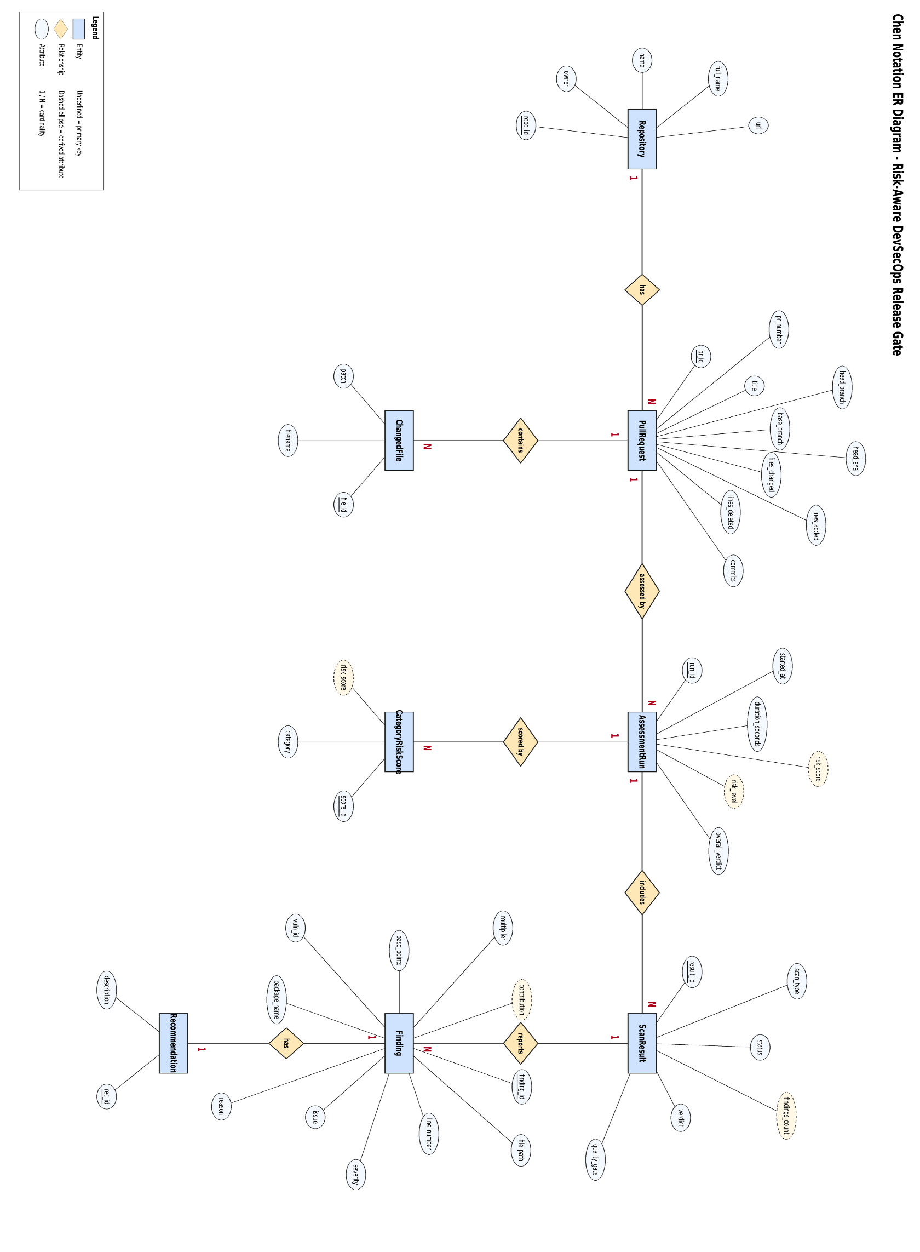

Entities and their Attributes
- Repository Entity: It has repo_id, owner, name, full_name and url, in which repo_id is the primary key.
- Pull Request Entity: It has pr_id, repo_id, pr_number, title, head_branch, base_branch, head_sha, files_changed, lines_added, lines_deleted and commits, in which pr_id is the primary key and repo_id is the foreign key.
- Changed File Entity: It has file_id, pr_id, filename and patch, in which file_id is the primary key and pr_id is the foreign key.
- Assessment Run Entity: It has run_id, pr_id, started_at, duration_seconds, risk_score, risk_level and overall_verdict, in which run_id is the primary key and pr_id is the foreign key. The overall_verdict can be ALLOW or BLOCK, and risk_level can be LOW, MEDIUM, HIGH or CRITICAL.
- Scan Result Entity: It has result_id, run_id, scan_type, status, findings_count, verdict and quality_gate, in which result_id is the primary key and run_id is the foreign key. The scan_type can be Secrets, IAM, Dependency or SonarCloud, and quality_gate is used only for SonarCloud.
- Finding Entity: It has finding_id, result_id, file_path, line_number, severity, issue, reason, package_name, vuln_id, base_points, multiplier and contribution, in which finding_id is the primary key and result_id is the foreign key. Package_name and vuln_id are used only for dependency findings; base_points, multiplier and contribution record how the finding affected the risk score.
- Category Risk Score Entity: It has score_id, run_id, category and risk_score, in which score_id is the primary key and run_id is the foreign key. The category can be secrets, iam, dependencies or sonarqube.
- Recommendation Entity: It has rec_id, finding_id and description, in which rec_id is the primary key and finding_id is the foreign key.

Relationship between Entities:
Relationship | Cardinality | Explanation
Relationship | Cardinality | Explanation
Repository has Pull Request | 1 : N | One repository can have many pull requests; each pull request belongs to one repository.
Pull Request contains Changed File | 1 : N | A pull request changes one or more files (7 files in the test run).
Pull Request assessed by Assessment Run | 1 : N | Each time the gate is run for a pull request a new run with its own score and verdict is produced.
Assessment Run includes Scan Result | 1 : N | A run aggregates the Secrets, IAM, Dependency and SonarCloud results.
Assessment Run scored by Category Risk Score | 1 : N | The category scores (for example secrets 26.0, iam 18.2) add up to the final risk score.
Scan Result reports Finding | 1 : N | A scanner may report many findings, or none.
Finding has Recommendation | 1 : 1 | A recommendation is shown for a finding when detailed output is requested.

- One repository can have multiple pull requests, but each pull request belongs to one repository, so the relationship is 1:N.
- One pull request contains multiple changed files, but each changed file belongs to one pull request, so the relationship is 1:N.
- One pull request can be assessed multiple times (every re-run creates a new assessment run), but each run belongs to one pull request, so the relationship is 1:N.
- One assessment run includes one scan result for each of the four scanners, so the relationship is 1:N (four results per run).
- One assessment run has one risk score for each scanner category, so the relationship is 1:N (four category scores per run).
- One scan result can report multiple findings, but each finding belongs to one scan result, so the relationship is 1:N.
- Each finding can have one recommendation, and each recommendation belongs to one finding, so the relationship is 1:1.

EXPERIMENT-4

To perform the function oriented diagram: Data Flow Diagram (DFD) and Structured chart.

Data Flow Diagrams (DFD) are used to represent the sequence of process steps and flow of information using a graphical representation or visual representation rather than a textual description. DFDs can range from simple overviews to complex, granular representations of a system or process with multiple levels, starting with level 0. The following are the three levels of DFDs:
1. Level 0 DFD:- Also known as a "context diagram," this is the highest level and represents a very simple, top-level view of the system being represented. It shows the major processes, data flows, and data stores in the system, without providing any details about the internal workings of these processes. It is designed to be an at-a-glance view, showing the system as a single high-level process, with its relationship to external entities. It should be easily understood by a wide audience, including stakeholders, business analysts, data analysts, and developers.
2. Level 1 DFD:- This level provides a more detailed breakout of pieces of the context level diagram. It breaks down the system's single process node into subprocesses. Each sub-process is depicted as a separate process on the level 1 DFD. The data flows and data stores associated with each sub-process are also shown.
3. Level 2 DFD:- This level goes one step deeper into parts of level 1. It may require more text to reach the necessary level of detail. It breaks processes down into more detailed sub-processes. Each process on the level 2 DFD is depicted with a detailed description of its input, processing, and output. The data flows and data stores associated with each process are also shown. The choice of DFD level depends on the complexity of the system and the level of detail required to understand the system. Higher levels of DFD provide a broad overview of the system, while lower levels provide more detail about the system's processes, data flows, and data stores. A combination of different levels of DFD can provide a complete understanding of the system.

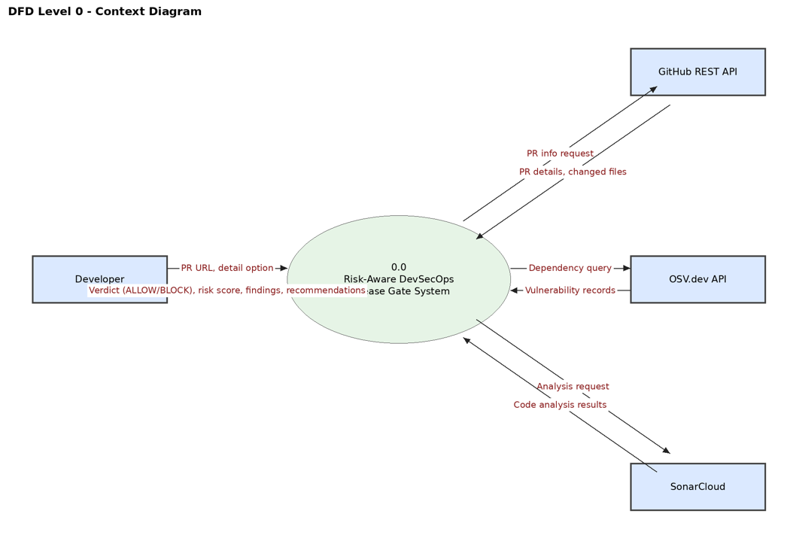
Level 0 (context diagram): the Release Gate System is shown as a single process. The Developer sends the PR URL and the detail option and receives the verdict (ALLOW/BLOCK), risk score, findings and recommendations. The system exchanges data with three external systems: GitHub REST API (PR details and changed files), OSV.dev (vulnerability records) and SonarCloud (code analysis results).
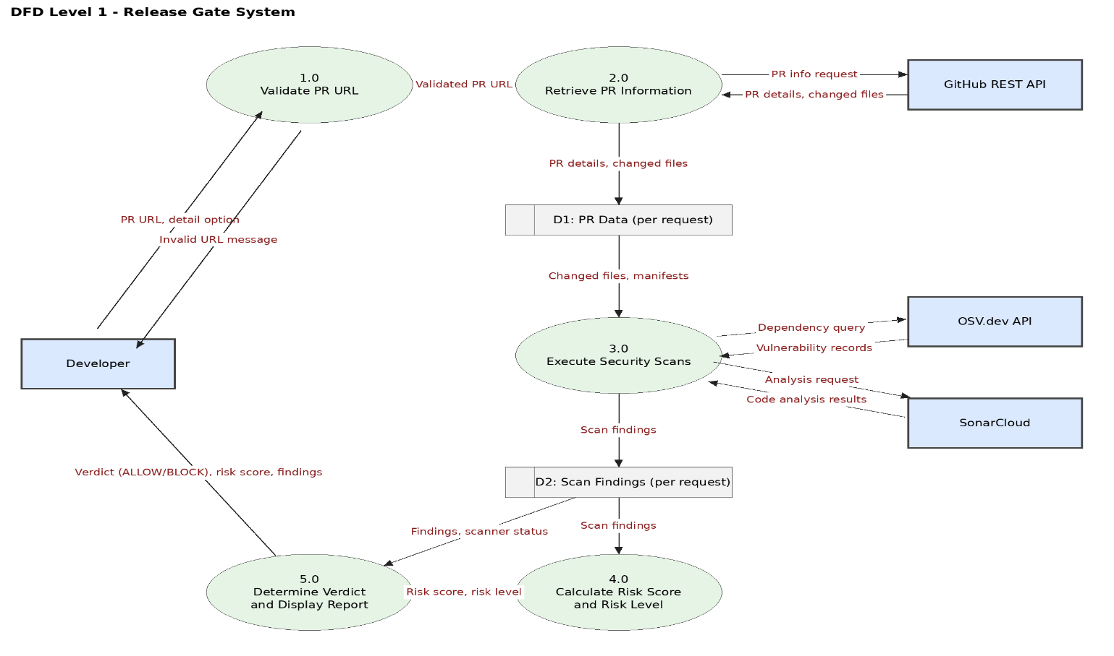
Level 1: the system is divided into five processes – 1.0 Validate PR URL, 2.0 Retrieve PR Information, 3.0 Execute Security Scans, 4.0 Calculate Risk Score and Level, and 5.0 Determine Verdict and Display Report. D1 (PR Data) and D2 (Scan Findings) are per-request data stores held in memory.
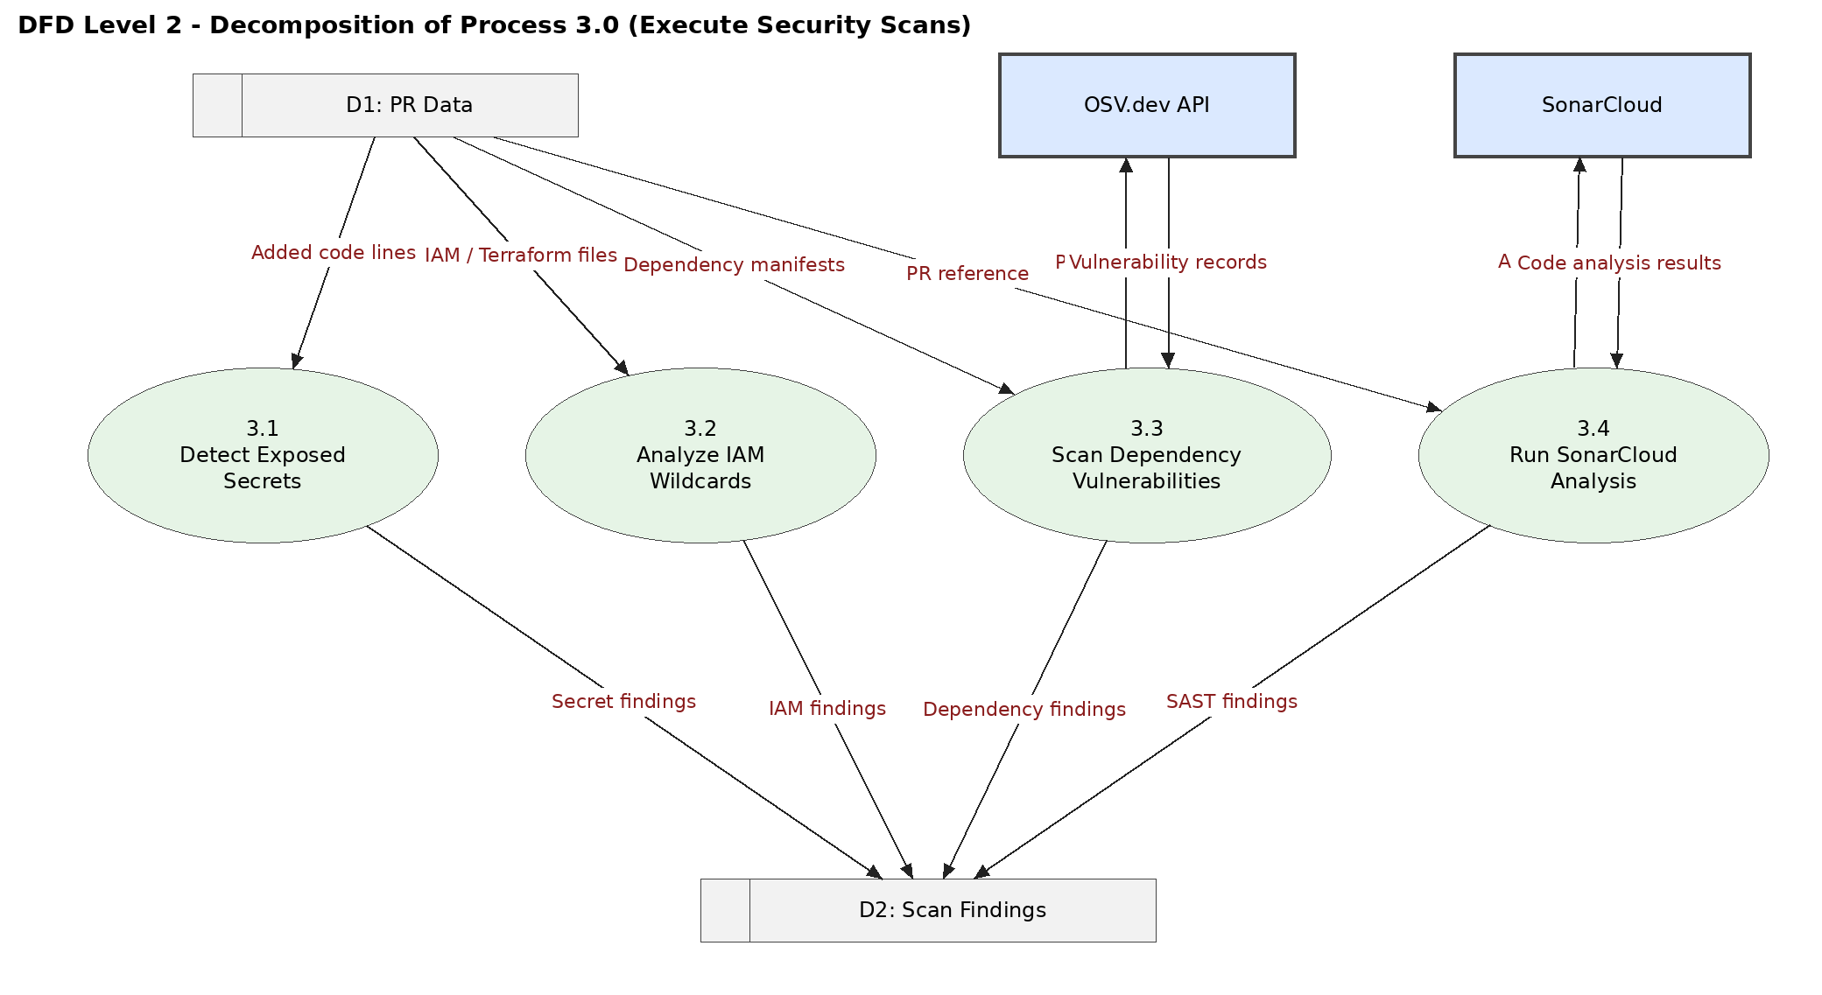
Level 2: process 3.0 is decomposed into four scanners – 3.1 Detect Exposed Secrets, 3.2 Analyze IAM Wildcards, 3.3 Scan Dependency Vulnerabilities (using OSV.dev) and 3.4 Run SonarCloud Analysis. All read the PR data from D1 and write their findings to D2.

LEVEL 3:
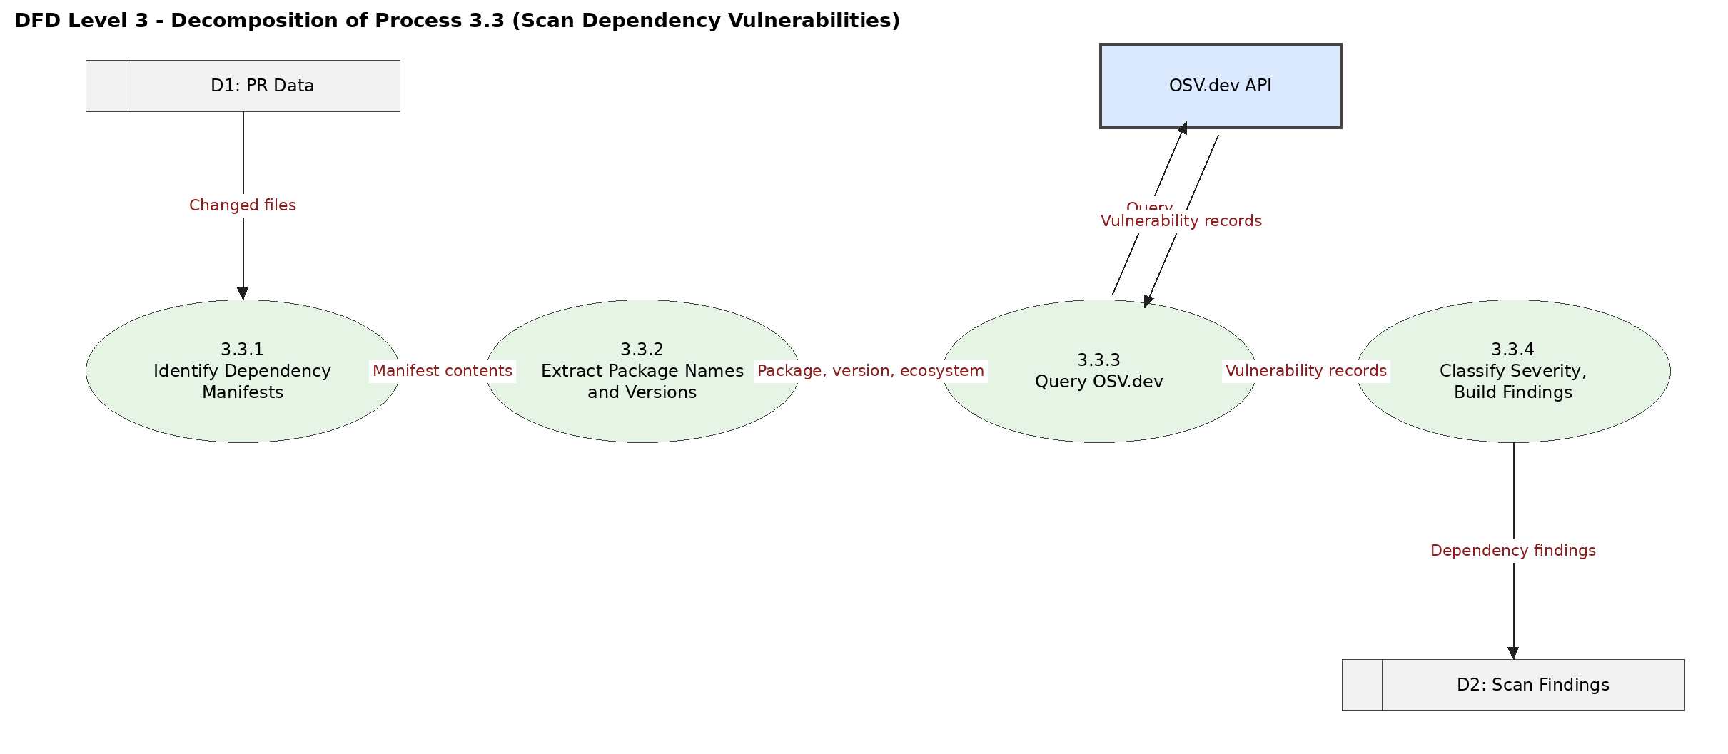
Level 3: process 3.3 is decomposed into 3.3.1 Identify Dependency Manifests, 3.3.2 Extract Package Names and Versions, 3.3.3 Query OSV.dev and 3.3.4 Classify Severity and Build Findings.
STRUCTURE CHART:
The structure chart shows the module hierarchy of the project. index() in app.py receives the request, validates the URL and calls run_security_gate() in main.py, which controls GitHub data retrieval (github_client.py), the four scanners in the checks package (secrets.py, iam.py, cve.py, sonarqube.py), the risk and verdict functions (verdict.py) and report preparation.
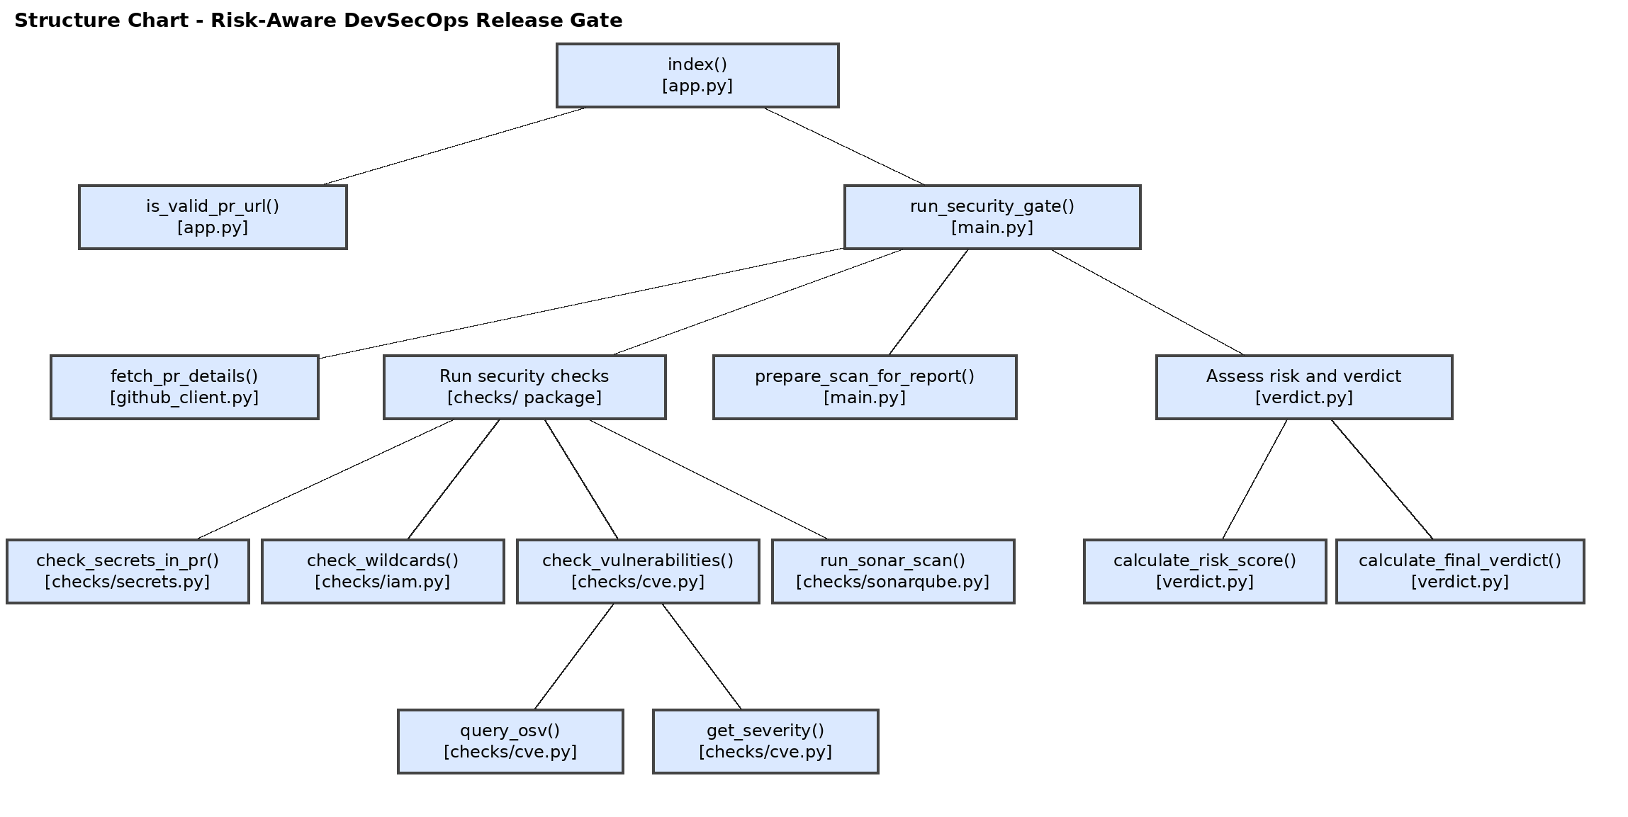

EXPERIMENT-5

To perform the user’s view analysis for the suggested system: Use case diagram
Software Used: StarUML
Theory: Use case diagrams are a type of behavioral diagram that show the interactions between a system and its users, or actors. They are used to represent and model the functionality of a system. The main purpose of a use case diagram is to capture the functional requirements of a system. They are often used during the analysis and design phases of software development. The components of a use case diagram are:
Actor: An actor is a person or entity that interacts with the system to achieve a goal. Actors can be people, organizations, or external systems.
System: The system is the software or hardware that is being modeled. The system is represented by a rectangle in a use case diagram.
Use Case: A use case is a sequence of interactions between an actor and the system that results in the actor achieving a goal. Use cases are represented by ellipses in a use case diagram.
Relation: A relation shows how two actors or use cases interact with each other. Relations can be communication relations or association relations. Communication relations are shown by lines with arrows. Association relations are shown by lines with diamonds.
Generalization: A generalization relation shows that a use case is a more specialized version of another use case. Generalization relations are shown by lines with an open triangle at the end. Include: An include relation shows that one use case includes the functionality of another use case. Include relations are shown by dashed lines with an "include" label at the end.
Exclude: An exclude relation shows that one use case excludes the functionality of another use case. Exclude relations are shown by dashed lines with an "exclude" label at the end.

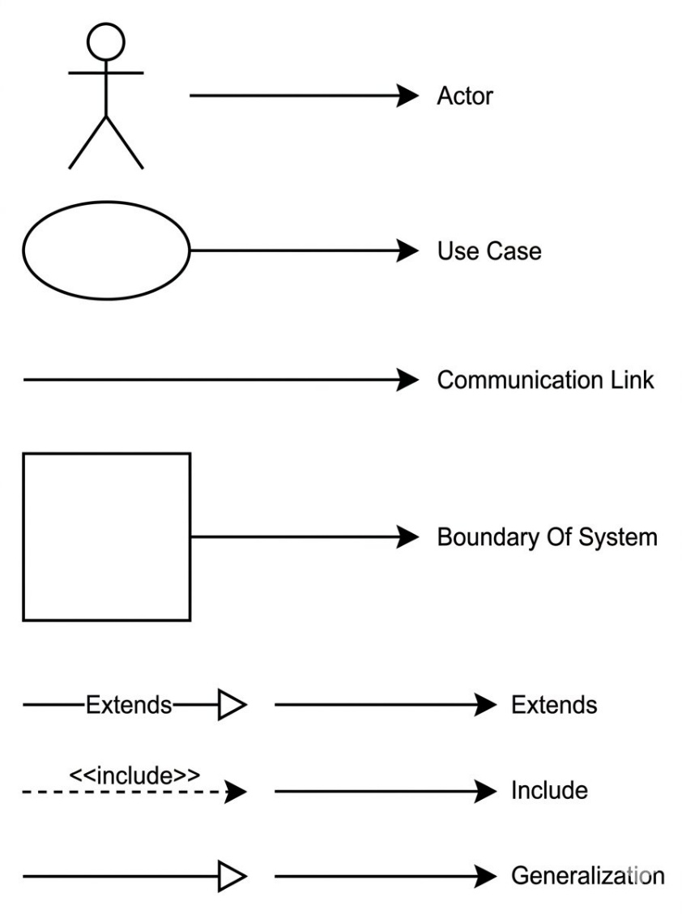

The use case diagram shows the Developer as the primary actor, who submits a PR URL and views the verdict, findings, reasons and recommendations. GitHub REST API, OSV.dev and SonarCloud are secondary (system) actors. "Submit PR URL" includes validation, PR retrieval, the security scans, risk calculation and verdict generation, and "Run Security Scans" includes the four scanners. "Show Error Message" extends URL validation, and "View Reasons and Recommendations" extends "View Verdict and Findings" when the detail option is selected.

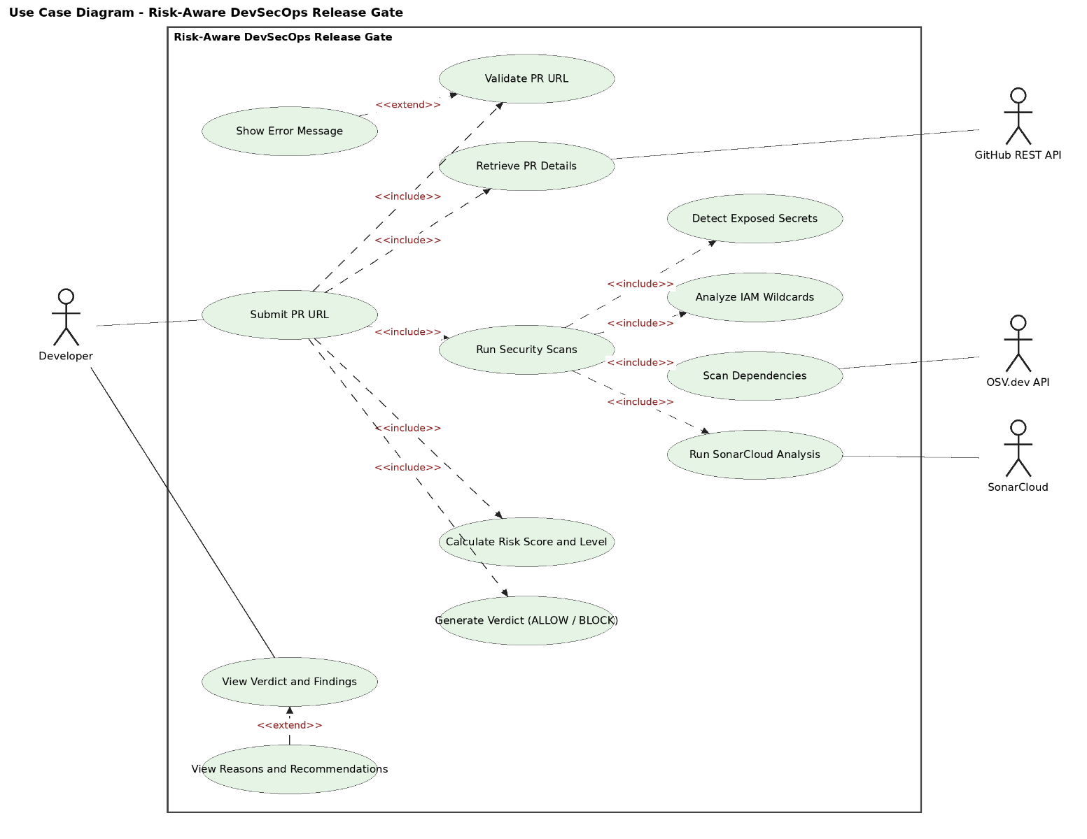
EXPERIMENT-6

To draw the structural view diagram for the system: Class diagram, object diagram.
A class diagram is a type of UML structural diagram that represents the structure of a system at the level of classes and interfaces. It shows the features, constraints, and relationships (associations, generalizations, dependencies, etc.) between classes and interfaces. Class diagrams are widely used in object-oriented systems as they can be directly mapped with object-oriented languages. An object diagram, on the other hand, is a type of UML structural diagram that represents a snapshot of the structure of a system at a specific moment in time. It shows the instance specifications of classes and interfaces (objects), slots with value specifications, and links (instances of association) between objects. Object diagrams can be considered as instance-level class diagrams, as they show the relationships between objects without representing the classes themselves. They are useful for explaining smaller portions of a system when the system class diagram is complex or for modeling recursive relationships.

📌 Note on System Diagrams:
This project is built using functions, not Object-Oriented classes. Because of this, the Class and Object diagrams shown below are just samples to show how the system is organized:
The Class Diagram: simply shows how different code files and functions are separated.
The Object Diagram: simply shows how data packages and dictionaries look in memory during a sample run.

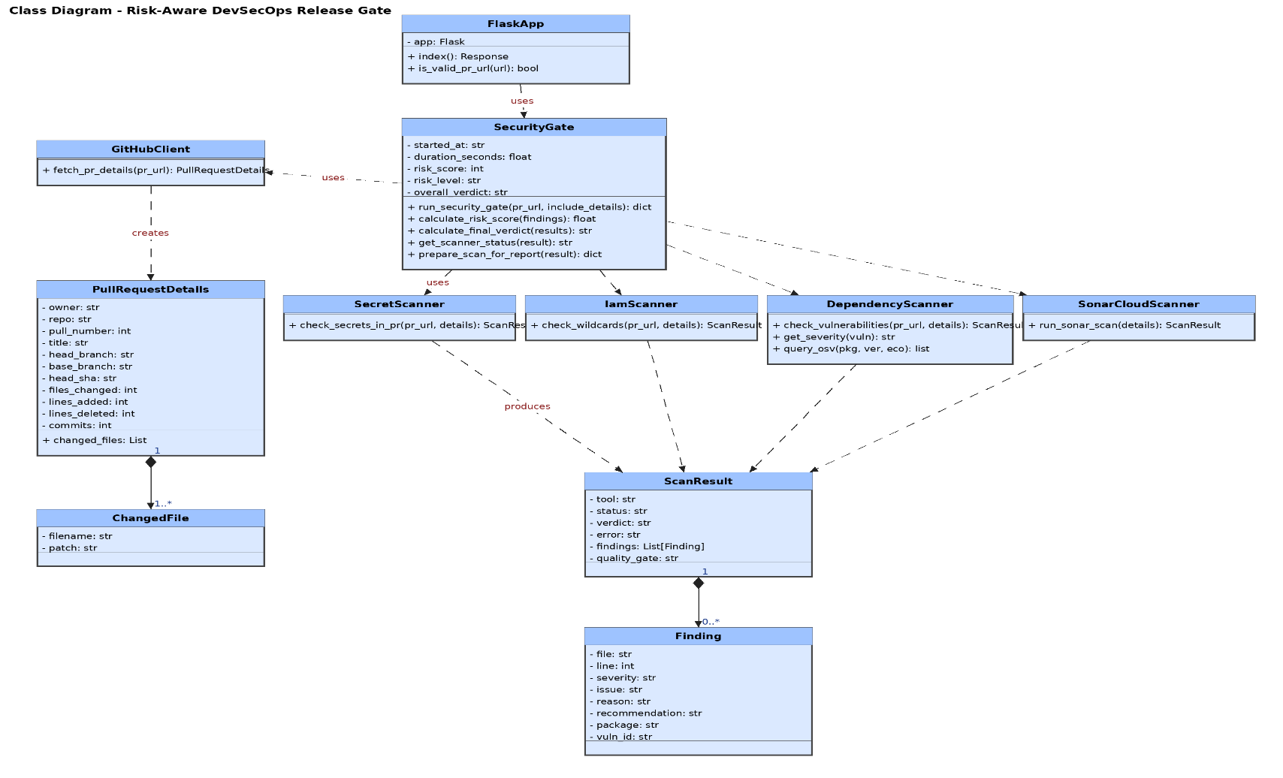

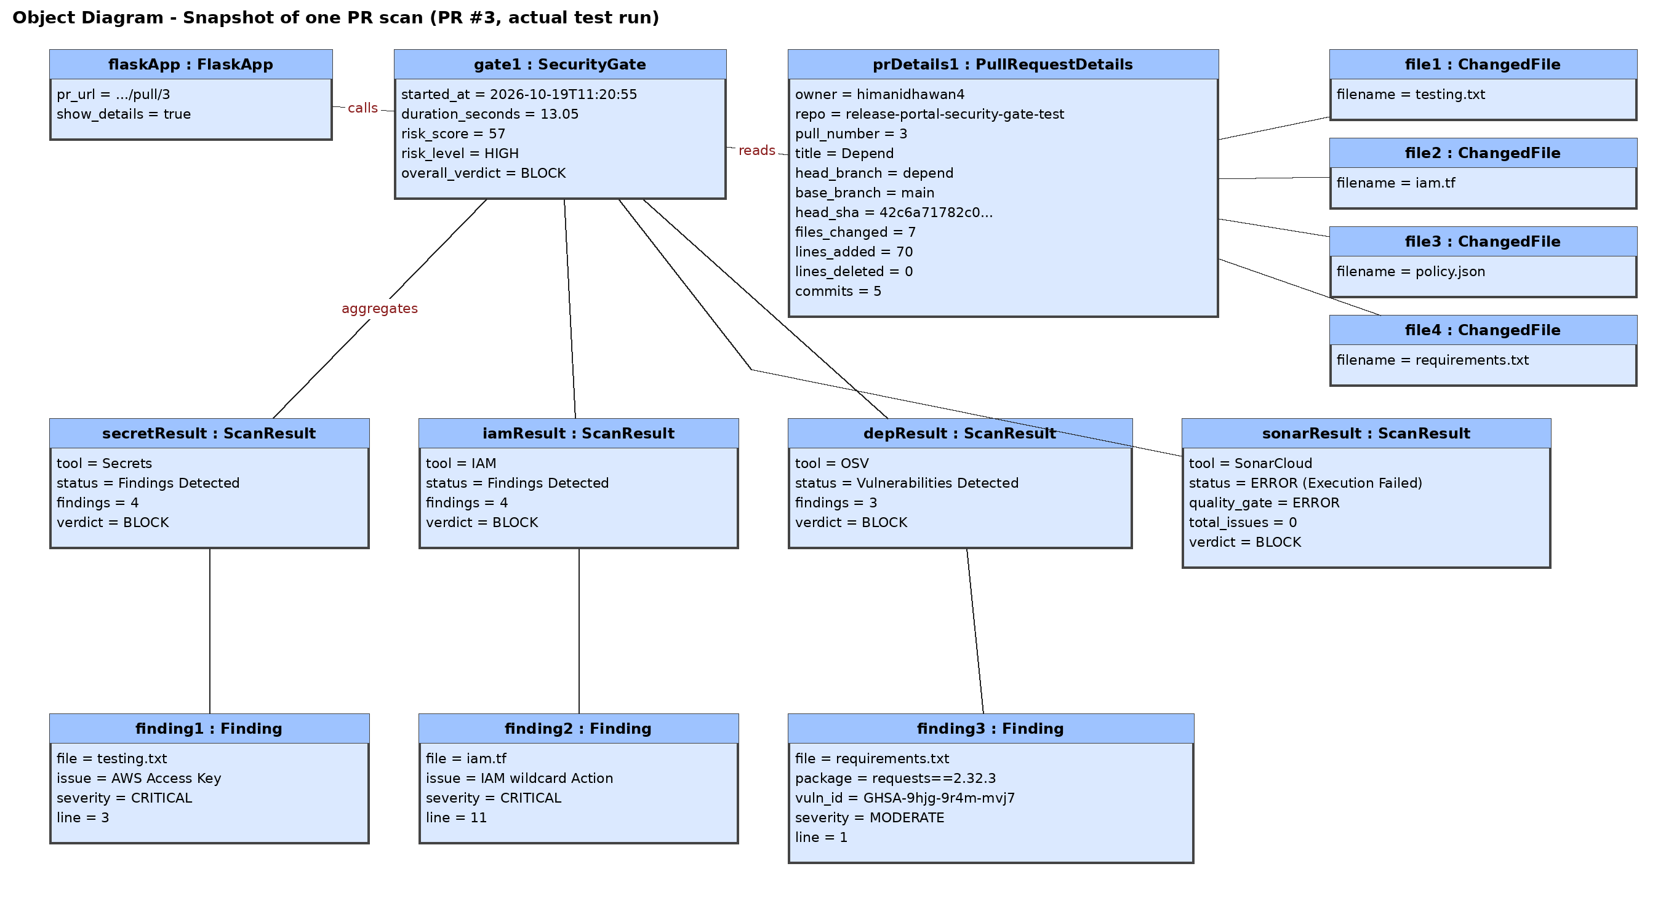

EXPERIMENT-7

Aim:- To draw the behavioral view diagram: State-chart diagram, Activity diagram.

Software Used :- Star UML

Theory:-
State chart Diagram :-
These terms are often used interchangeably. So simply, a state diagram is used to model the dynamic behavior of a class in response to time and changing external stimuli. We can say that each and every class has a state but we don't model every class using State diagrams. We prefer to model the states with three or more states.

Activity Diagram :-
In UML, the activity diagram is used to demonstrate the flow of control within the system rather than the implementation. It models the concurrent and sequential activities.
The activity diagram helps in envisioning the workflow from one activity to another. It put emphasis on the condition of flow and the order in which it occurs. The flow can be sequential, branched, or concurrent, and to deal with such kinds of flows, the activity diagram has come up with a fork, join, etc.
Often described as an object-oriented flowchart, it consists of activities made up of actions and operations used to model behavioral diagrams.

STATE-CHART DIAGRAM:
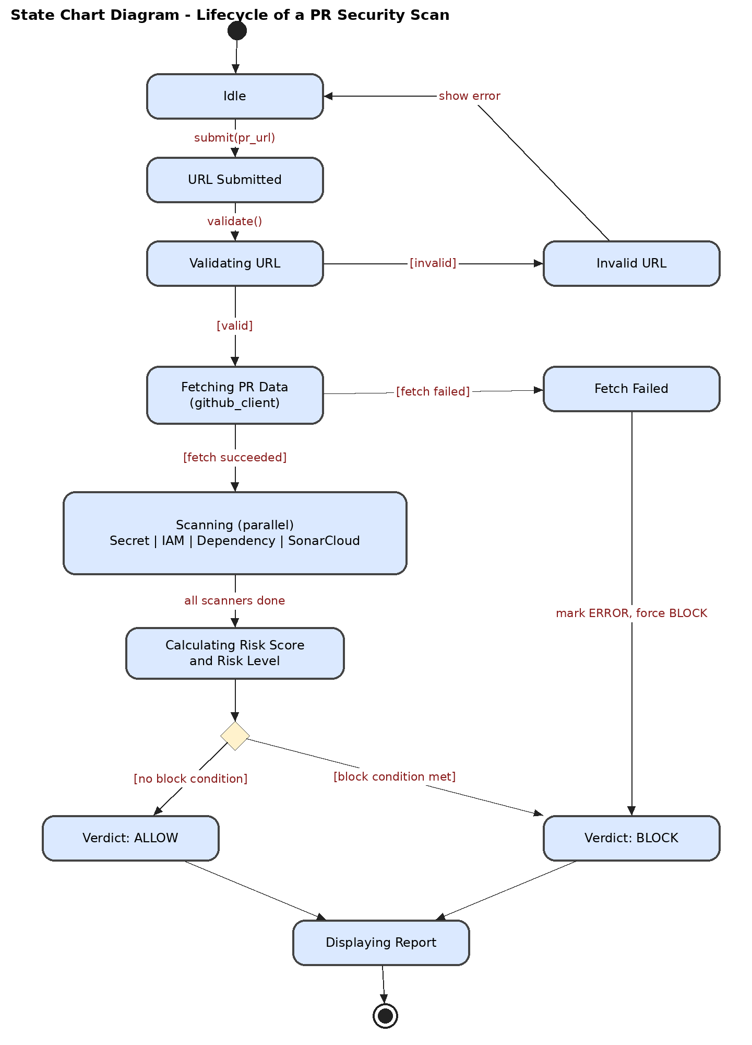

State-Chart Diagram Analysis:
This diagram models the operational lifecycles and dynamic status transitions of a single Pull Request vulnerability scan. The system begins in an Idle state until a user provides a target string via the submit_pr_url() function. It transitions to Validating URL; if validation fails, it reaches the Invalid URL terminal exception loop. If valid, it enters Fetching PR Data to process API payloads via github_client.py. A network drop transitions the process to a secure Fetch Failed error handling state. Once data is secured, the engine enters a parallel composite operational state (Scanning) where Secret, IAM, Dependency, and SonarCloud filters run simultaneously. Upon synchronization (all scanners done), it shifts to Calculating Risk Score where conditional checks route the execution context to its final structural results: Verdict: BLOCK or Verdict: ALLOW.

ACTIVITY DIAGRAM

Activity Diagram Analysis:
The activity diagram details the behavioral flow of control and processing logic within our procedural system modules. Upon initialization (Enter PR URL), a decision diamond branches out invalid requests to an immediate termination error. Successful pathing triggers the execution of external API collection sequences. If an API timeout or data fault occurs (Fetch successful? = failed), control automatically bypasses core scanner engines and forces a high-priority security override (Force Verdict = BLOCK) to ensure pipeline safety. In normal execution paths, control reaches a horizontal Fork Bar, splitting the program into 4 concurrent scanning threads to minimize performance delay. These processes join back at a Join Bar into a synchronized thread where risk scores are mathematically calculated and branched via threshold evaluations to generate, format, and display the final security report.

