MAJOR PROJECT REPORT
ON
FAKE INTERNSHIP AND JOB DETECTION SYSTEM
Submitted in partial fulfilment of the requirements for the award of
Diploma in Computer Science & Engineering
By:
Diya Upadhyay(23002050009)
Chanda Rautela(23002050010)
Namita Joshi(23002050022)
Kajal Mehra (23002050030)


DEPARTMENT OF COMPUTER SCIENCE & ENGINEERING
UTTARAKHAND BOARD OF TECHNICAL EDUCATION ROORKEE
UTTARAKHAND GOVERNMENT INSTITUTE OF POLYTECHNIC ALMORA
ALMORA-263601, UTTARAKHAND

SESSIONJAN– MAY 2026
DEPARTMENT OF
COMPUTER SCIENCE & ENGINEERING

MAJOR PROJECT REPORT
ON
FAKE INTERNSHIP AND JOB DETECTION SYSTEM
SUBMITTED IN PARTIAL FULLFILMENT OF THE REQUIREMENT FOR THE DIPLOMA OF BACHELOR OF ENGINEERING
(COMPUTER SCIENCE & ENGINEERING)

HOD :- GUIDED BY :-
Mrs.Monika Upadhyay Mrs.Geeta
(HOD.C.S.E) (Lect of C.S.E)

SESSION JAN – MAY 2026
DEPARTMENT OF
COMPUTER SCIENCE & ENGINEERING

CERTIFICATE

This is to certify that the project report on“ FAKE INTERNSHIP AND JOB DETECTIONSYSTEM” Submitted By Diya Upadhyay (23002050009), Chanda Rautela(23002050010), Namita Joshi(23002050022),Kajal Mehra(23002050030)to the Department of Computer Science & Engineering, Uttarakhand Government Institute of Polytechnic, Almora, in partial fulfilment of the requirements for the Diploma in Computer Science & Engineering, is a satisfactory account of their project work and is recommended for their award of diploma.
H.O.D : GUIDED BY :
Mrs. Monika Upadhyay Mrs. Geeta
(H.O.D CSE) (Lect. Of C.S.E)

ABSTRACT
In today’s digital era, the rapid growth of online job portals and internship platforms has made it easier for candidates to explore career opportunities. However, it has also led to a significant rise in fake internship and job offers, which mislead job seekers and may result in financial loss or misuse of personal information. This project focuses on the development of an Fake Internship and Job Detection System, which aims to identify and filter out fraudulent opportunities using intelligent algorithms and data analysis techniques.
The system analyzes various parameters such as job descriptions, company details, communication patterns, and other indicators to detect suspicious activities. It leverages artificial intelligence to improve accuracy and efficiency in identifying fake postings, thereby helping users make safe and informed decisions. Additionally, this project highlights the role of technology in enhancing trust and security in online job searching platforms.
This project provides a user-friendly interface and utilizes a powerful database management system for efficient data storage, retrieval, and manipulation. It simplifies the process of managing large amounts of data compared to manual methods, thereby saving time and reducing paperwork. Overall, the system proves to be highly useful in ensuring safe job searching while saving valuable time and effort.

ACKNOWLEDGEMENT
Here I gladly present this minor project report on “ Fake Internship and Job Detection System” as a part of the 6th semester in Computer Science & Engineering. At the time of submitting this report, I would like to take this opportunity to express my gratitude to all those who supported me throughout this work.
I take this occasion to thank God Almighty for blessing me with His grace and helping me bring this endeavor to a successful completion.
I extend my sincere and heartfelt thanks to our esteemed guide, Mrs. Monika Upadhyay (HOD, Computer Science & Engineering), for providing us with the right guidance and valuable advice at crucial stages and for showing us the correct path.
I would also like to thank our faculty members Mr. Geeta(Lecturer, CSE), , Mrs. Vijaya Verma (Lecturer, IT), and Mrs. Nirmal Pandey(Lecturer, CSE) for their support and encouragement.
DIYA UPADHYAY
CHANDA RAUTELA
NAMITA JOSHI
KAJAL MEHRA

DOCUMENTATION

TABLE OF CONTENT
1.ABOUTTHE PROJECT………………………………………………………………….
1.1OVERVIEW
1.2 PURPOSE
1.3 SCOPE OF THE PRPJECT
1.4 LIMITATIONS OF THE PROJECT

2. REQUIREMENT ANALYSIS & SYSTEM SPECIFICATION………………………
2.1 FEASIBLITY ANALYSIS
2.1.2 ECONOMICAL FEASIBILITY
2.1.3 OPERATIONAL FEASIBILTY
2.2 SYSTEM REQUIREMENT
2.2.1 SOFTWARE REQUIREMENT
2.2.2 HARDWARE REQUIREMENT
2.3.1 FORNT END
2.3.2 BACKEND

3.SYSTEM DESIGN……………………………………………………………………….
3.DFD
3.1 E-R DIAGRAM
3.3 DATABASE DESIGN
3.3.1 TABLE STRUCTURE

4.CODING…………………………………………………………………………………..

5.SYSTEM TESTING…………………………………………………………………….
5.1 INTRODUCTION
5.2 TESTING METHODS

6.SYSTEM IMPLEMENTATION……………………………………………………….
6.1 PROJECT MODULS

7.CONCLUSION…………………………………………………………………………..

8.BIBILIOGRAPHY……………………………………………………………………..

ABOUT THE PROJECT
1.1OVERVIEW
The Fake Internship and Job Offer Detection System is a web-based application designed to identify and prevent fraudulent internship and job offers circulating across online platforms. In today’s digital recruitment environment, students and job seekers frequently receive job or internship offers through emails, job portals, and social media. However, many of these opportunities turn out to be scams intended to collect personal information, charge illegal registration fees, or mislead candidates with false promises of employment. Manually verifying the authenticity of such offers is difficult, time-consuming, and often unreliable.
1.2PURPOSE
The main Purpose of the project on “ Fake Internship and Job Offer Detection System”to develop an intelligent system that can identify and detect fake internship and job offers using Artificial Intelligence techniques. analyze job postings based on various parameters such as company details, job description, salary patterns, and communication behavior. The main purpose of an AI Based Fake Internship and Job Offer Detection System is to protect job seekers from fraudulent job and internship offers by automatically identifying and filtering out fake or suspicious opportunities.
1.3SCOPE OF THE PROJECT
The scope of the Fake Internship and Job Detection System focuses on identifying and preventing fraudulent job and internship postings. The system is designed to assist users, job seekers, and administrators in verifying the authenticity of opportunities and ensuring a safe recruitment environment. Key scope areas include:
• Job & Internship Listing Analysis: Add, update, delete, and review job or internship postings for authenticity
• Fraud Detection: Analyze postings using predefined rules or algorithms to identify suspicious or fake opportunities
• User Management: Maintain records of users, including recruiters and job seekers
• Complaint Management: Allow users to report suspicious listings and track complaint
• Verification System: Validate company details and job postings through automated or manual verification processes
• Report Generation: Generate reports on detected frauds, user activity, and system performance for analysis
• Email Notifications: Send alerts and updates to users regarding verified, rejected, or suspicious listings using SMTP.
1.4LIMITATIONS OF THE PROJECT
Although the Fake Internship and Job Detection System provides essential features for identifying fraudulent job and internship postings, it still has certain limitations. These limitations arise due to project scope, resource availability, and time constraints. Some advanced functionalities that could improve system intelligence and automation are not included in this version.
- No advanced user authentication system such as multi-factor authentication.
- Limited role-based access control (separate admin,recruiter such as multifactor
- Fraud detection is rule-based and does not use advanced AI or machine learning
- No intgration with external verification APIs for real-time company validation.
- Admin dashboard features are limited in terms of analytics and system control,
- System depends on internet connectivity for access and operation

REQUIREMENT ANALYSIS & SYSTEM SPECIFICATION
2.1 FEASIBILITY ANALYSIS
Feasibility analysis evaluates whether the proposed Fake Internship and Job Detection System can be developed and implemented effectively within given constraints such as technology, cost, and usability. This analysis ensures that the system is practical, beneficial, and sustainable.
2.1.1 TECHNICAL FEASIBILITY
The system is technically feasible as it is developed using reliable and widely adopted technologies. The frontend uses React 18, React Router v6, JavaScript, and CSS3, which support responsive design and efficient user interaction. The backend is implemented using Python (FastAPI), enabling high-performance API handling and smooth communication between components. A MySQL database is used for secure and structured data storage.
The system follows a client-server architecture, ensuring scalability and maintainability. Features such as email notifications using SMTP are technically achievable within the current framework. The required development tools are easily accessible, and the system can be deployed on standard hardware without complexity.
2.1.2 ECONOMICAL FEASIBILITY
The system is economically feasible as it is developed using open-source technologies, eliminating licensing costs. The primary investment involves development time and basic infrastructure such as a computer system and internet access.
By helping users avoid fraudulent job and internship opportunities, the system reduces potential financial and time losses. It also minimizes manual verification efforts, improving efficiency. These benefits make the system cost-effective and valuable in the long run.
2.1.3 OPERATIONAL FEASIBILITY
The system is operationally feasible as it is designed to be simple, user-friendly, and aligned with modern job search and recruitment processes. Users can easily verify job postings, report suspicious listings, and receive updates.
The system requires minimal user training and integrates smoothly into existing workflows. Features like automated email notifications using SMTP enhance communication and keep users informed.
Overall, the system improves safety and efficiency in job searching without disrupting normal operations, making it suitable for real-world implementation.

2.2 SYSTEM REQUIREMENT
2.2.1 HARDWARE AND SOFTWARE REQUIREMENT

2.2.1 HARDWARE REQUIREMENT
Minimum Requirements
- Processor: Dual-core 2.0 GHz
- RAM: 4 GB
- Storage: 10 GB free space
- Display: 1280 × 720
- Network: Stable internet connection
Recommended Requirements
- Processor: Quad-core 2.5 GHz
- RAM: 8 GB or more
- Storage: 20 GB (SSD preferred)
- Display: 1920 × 1080

2.2.2 SOFTWARE REQUIREMENT
Backend
- Python 3.7+
Frontend (React)
- VS Code or similar editor
Development & Testing
- Postman / Insomnia
System Compatibility
- OS: Windows 10/11, macOS, Linux
- RAM: 4 GB (8 GB recommended)
- Disk: 500 MB+

2.3 FUNCTIONAL& NON FUNCTIONAL REQUIREMENT
2.3.1 FRONT END
Functional Requirements
- Provide a user-friendly interface for job seekers and administrators
- Enable forms for submitting, updating, and viewing job and internship listings
- Include a login interface for users and admins
- Display job verification status (real or fake detection results)
- Allow navigation between modules using React Router
- Show notifications and alerts regarding suspicious or verified listings

Non-Functional Requirements
- Ensure responsive design (works on desktop, tablet, and mobile devices)
- Provide fast loading and smooth navigation
- Maintain an easy-to-use interface with a clear and structured layout
- Ensure cross-browser compatibility (Chrome, Edge, Firefox, Safari)
- Maintain consistent UI design using CSS3

2.3.2 BACKEND

Functional Requirements
- Manage job and internship data (add, update, delete, retrieve records)
- Analyze and detect fake job/internship postings using validation logic
- Develop APIs using FastAPI for frontend-backend communication
- Perform database operations using MySQL
- Implement user authentication and data validation
- Provide email functionality using SMTP to send alerts about suspicious postings

Non-Functional Requirements
- Ensure fast and efficient API response time
- Maintain secure handling and storage of user and job data
- Design a scalable architecture for handling increasing job listings
- Ensure reliable database connectivity
- Implement proper error handling and maintain system stability
- Support easy maintenance and future system updates

SYSTEM DESIGN
3.1 DFD’s
DFD is the abbreviation for Data Flow Diagram. The flow of data of a system or a process is represented by a DFD. It provides insight into the inputs and outputs of each entity and the process itself. A DFD does not include control flow, loops, or decision rules. Specific operations depending on the type of data can be explained using a flowchart. It is a graphical tool, useful for communicating with users, managers, and other personnel. DFDs are helpful for analyzing both existing and proposed systems.
Types of DFD:
- Logical DFD:
Logical data flow diagrams mainly focus on the system process. They illustrate how data flows within the system, showing what information is processed, without specifying how it will be implemented.
- Physical DFD:
Physical data flow diagrams show how the data flow is actually implemented in the system. Physical DFDs are more specific and close to the actual implementation, showing hardware, files, and people involved.
STARTOREND

PROCESS
DECISION
INPUT OR OUTPUT
DATA FLOW
SUBPROCESS

LEVEL 0 DFD:-
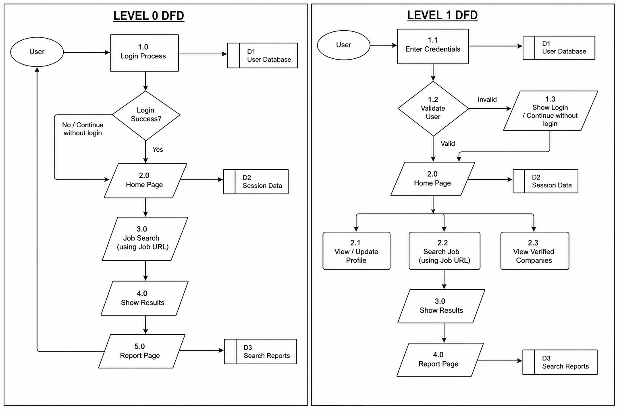

LEVEL 1 DFD:-



CODING

FRONT END
login.html
<!DOCTYPE html>
<html>
<head>
<title>JobShield Login</title>
<style>
*{
margin:0;
padding:0;
box-sizing:border-box;
font-family:Arial,Helvetica,sans-serif;
}
body{
height:100vh;
background:linear-gradient(135deg,#020d2b,#040a23,#000c2f);
display:flex;
justify-content:center;
align-items:center;
color:white;
}
.navbar{
position:absolute;
top:0;
width:100%;
padding:20px 60px;
display:flex;
justify-content:space-between;
align-items:center;
background:rgba(0,0,0,0.2);
}
.logo{
font-size:24px;
font-weight:bold;
color:#8c6cff;
}
.login-box{
width:350px;
background:rgba(255,255,255,0.05);
padding:40px;
border-radius:12px;
backdrop-filter:blur(10px);
box-shadow:0 10px 30px rgba(0,0,0,0.5);
text-align:center;
}
.login-box h2{
margin-bottom:20px;
}
input{
width:100%;
padding:12px;
margin:10px 0;
border:none;
border-radius:6px;
background:#0c153d;
color:white;
}
input::placeholder{
color:#aaa;
}
button{
width:100%;
padding:12px;
margin-top:15px;
border:none;
border-radius:6px;
background:linear-gradient(90deg,#6b7cff,#b86bff);
color:white;
font-size:16px;
cursor:pointer;
transition:0.3s;
}
button:hover{
transform:scale(1.05);
}
.message{
margin-top:15px;
font-size:14px;
}
</style>
</head>
<body>
<div class="navbar">
<div class="logo">🛡 JobShield</div>
</div>
<div class="login-box">
<h2>Login to JobShield</h2>
<input type="text" id="email" placeholder="Enter Email">
<input type="password" id="password" placeholder="Enter Password">
<button id="loginBtn" onclick="login()">Login</button>
<button onclick="continueWithoutLogin()" style="background:#444;">Continue Without Login</button>
<div class="message" id="message"></div>
</div>
<script>
window.onload=function(){
let status=localStorage.getItem("authStatus");
let msg=localStorage.getItem("logoutMsg");
if(msg){
let message=document.getElementById("message");
message.style.color="#00ff9d";
message.innerText=msg;
localStorage.removeItem("logoutMsg");}}
document.addEventListener("keypress",function(e){
if(e.key==="Enter"){
login();}});
function login(){
let email=document.getElementById("email").value.trim();
let password=document.getElementById("password").value.trim();
let message=document.getElementById("message");
let btn=document.getElementById("loginBtn");
if(email===""||password===""){
message.style.color="orange";
message.innerText="Please fill all fields!";
return;}
let emailPattern=/^[^\s@]+@[^\s@]+\.[^\s@]+$/;
if(!emailPattern.test(email)){
message.style.color="orange";
message.innerText="Enter valid email!";
return;}
btn.disabled=true;
btn.innerText="Logging in...";
fetch("http://127.0.0.1:5000/login",{
method:"POST",
headers:{
"Content-Type":"application/json"},
body:JSON.stringify({
email:email,
password:password})})
.then(res=>{
if(!res.ok)throw new Error("Server error");
return res.json();})
.then(data=>{
if(data.message&&data.message.toLowerCase().includes("success")){
message.style.color="#00ff9d";
message.innerText=data.message;
localStorage.setItem("authStatus","logged");
localStorage.setItem("userEmail",email);
localStorage.setItem("userName",email.split("@")[0]);
setTimeout(()=>{
window.location.href="home.html";
},800);
}else{
message.style.color="#ff4b4b";
message.innerText=data.message||"Login failed";
resetBtn(btn);}})
.catch(()=>{
if(email==="admin@gmail.com"&&password==="1234"){
message.style.color="#00ff9d";
message.innerText="Demo Login Successful";
localStorage.setItem("authStatus","logged");
localStorage.setItem("userEmail",email);
localStorage.setItem("userName","Admin");
setTimeout(()=>{
window.location.href="home.html";
},800);
}else{
message.style.color="red";
message.innerText="Server not responding or wrong credentials";
resetBtn(btn);}});}
function resetBtn(btn){
btn.disabled=false;
btn.innerText="Login";}
function continueWithoutLogin(){
localStorage.setItem("authStatus","guest");
localStorage.setItem("userName","Guest");
window.location.href="home.html"}
</script>
</body>
</html>

home.html
<!DOCTYPE html>
<html lang="en">
<head>
<meta charset="UTF-8">
<meta name="viewport" content="width=device-width, initial-scale=1.0">
<title>JobShield - Powered Job Verification</title>
<link rel="stylesheet" href="css/style.css">
<link rel="stylesheet" href="https://cdnjs.cloudflare.com/ajax/libs/font-awesome/6.4.0/css/all.min.css">
<style>
.navbar .container{
display:flex;
align-items:center;
}
.navbar-menu{
display:flex;
gap:20px;
list-style:none;
margin-left:auto;
}
*{
margin:0;
padding:0;
box-sizing:border-box;
font-family:'Poppins',sans-serif;
}
body{
background:radial-gradient(circle at top,#0b0f2a,#020617);
color:white;
}
.features{
padding:100px 20px;
text-align:center;
}
.features h2{
font-size:42px;
margin-bottom:60px;
letter-spacing:1px;
}
.features-grid{
display:grid;
grid-template-columns:repeat(auto-fit,minmax(260px,1fr));
gap:30px;
max-width:1100px;
margin:auto;
}
.feature-card{
position:relative;
padding:30px;
border-radius:20px;
backdrop-filter:blur(15px);
background:rgba(255,255,255,0.05);
border:1px solid rgba(255,255,255,0.1);
transition:0.4s ease;
overflow:hidden;
animation:fadeUp 0.8s ease forwards;
opacity:0;
}
.feature-card::before{
content:"";
position:absolute;
width:200%;
height:200%;
background:radial-gradient(circle,rgba(90,108,255,0.4),transparent 70%);
top:-50%;
left:-50%;
opacity:0;
transition:0.5s;
}
.feature-card:hover::before{
opacity:1;
}
.feature-card:hover{
transform:translateY(-12px) scale(1.03);
border:1px solid rgba(90,108,255,0.6);
}
.feature-card i{
font-size:32px;
margin-bottom:15px;
color:#7a88ff;
}
.feature-card h3{
font-size:20px;
margin-bottom:10px;
}
.feature-card p{
font-size:14px;
opacity:0.8;
}
.feature-card:nth-child(1){animation-delay:0.1s;}
.feature-card:nth-child(2){animation-delay:0.2s;}
.feature-card:nth-child(3){animation-delay:0.3s;}
.feature-card:nth-child(4){animation-delay:0.4s;}
.feature-card:nth-child(5){animation-delay:0.5s;}
.feature-card:nth-child(6){animation-delay:0.6s;}
@keyframes fadeUp{
from{transform:translateY(40px);opacity:0;}
to{transform:translateY(0);opacity:1;}
}
</style>
</head>
<body>
<nav class="navbar">
<div class="container">
<div class="navbar-brand">
<i class="fas fa-shield-alt"></i>
<span>JobShield</span>
</div>
<ul class="navbar-menu">
<li><a href="#home">Home</a></li>
<li><a href="dashboard.html">Dashboard</a></li>
<li><a href="analyze.html">Jobs</a></li>
<li><a href="#features">Features</a></li>
<li id="loginItem">
<a href="login.html" class="btn-login">Login</a>
</li>
<li id="profileItem" style="display:none;position:relative;">
<a href="#" onclick="toggleMenu()">👤 Profile</a>
<div id="dropdown" style="display:none;position:absolute;top:30px;right:0;background:#222;padding:10px;border-radius:6px;">
<a href="profile.html">My Profile</a><br><br>
</div>
</li>
</ul>
</div>
</nav>
<section id="dashboard" style="display:none;">📊 Dashboard Page</section>
<section id="jobs" style="display:none;">📁 Jobs Page</section>
<section id="home" class="hero">
<div class="container">
<div class="hero-content">
<h1>
Protect Your Career with
<span class="gradient-text">Intelligent Job Verification</span>
</h1>
<p>
JobShield uses advanced AI analysis to detect fake job postings,
identify scams, and protect job seekers from fraudulent opportunities.
</p>
<div class="hero-buttons">
<a href="analyze.html" class="btn btn-primary">Start Analyzing</a>
<a href="#features" class="btn btn-secondary">Learn More</a>
</div>
</div>
<div class="hero-stats">
<div class="stat">
<h3>10K+</h3>
<p>Jobs Analyzed</p>
</div>
<div class="stat">
<h3>98%</h3>
<p>Accuracy Rate</p>
</div>
<div class="stat">
<h3>5K+</h3>
<p>Scams Detected</p>
</div>
</div>
</div>
</section>
<section id="features" class="features">
<div class="container">
<h2>Why Choose JobShield</h2>
<div class="features-grid">
<div class="feature-card">
<i class="fas fa-brain"></i>
<h3>AI-Powered Analysis</h3>
<p>Advanced machine learning algorithms analyze job postings for fraud indicators.</p>
</div>
<div class="feature-card">
<i class="fas fa-check-circle"></i>
<h3>Instant Verification</h3>
<p>Get real-time trust scores and risk assessments in seconds.</p>
</div>
<div class="feature-card">
<i class="fas fa-database"></i>
<h3>Company Database</h3>
<p>Access verified company profiles and reputation scores.</p>
</div>
<div class="feature-card">
<i class="fas fa-brain"></i>
<h3>AI Intelligence</h3>
<p>Smart algorithms detect fake job patterns instantly.</p>
</div>
<div class="feature-card">
<i class="fas fa-shield-alt"></i>
<h3>Secure Protection</h3>
<p>Your data stays protected with high-end encryption.</p>
</div>
<div class="feature-card">
<i class="fas fa-bolt"></i>
<h3>Lightning Speed</h3>
<p>Analyze job posts in seconds with real-time results.</p>
</div>
<div class="feature-card">
<i class="fas fa-exclamation-triangle"></i>
<h3>Scam Detection</h3>
<p>Instant alerts for suspicious and risky job listings.</p>
</div>
<div class="feature-card">
<i class="fas fa-globe"></i>
<h3>Global Access</h3>
<p>Verify jobs from multiple platforms worldwide.</p>
</div>
<div class="feature-card">
<i class="fas fa-lightbulb"></i>
<h3>Smart Suggestions</h3>
<p>Get safe and verified job recommendations.</p>
</div>
</div>
</div>
</section>
<footer class="footer">
<div class="container">
<p>&copy; 2026 JobShield All rights reserved.</p>
</div>
</footer>
<script>
window.onload=function(){
let status=localStorage.getItem("authStatus");
if(!status){
window.location.href="login.html";}}
window.addEventListener("load",function(){
let status=localStorage.getItem("authStatus");
let name=localStorage.getItem("userName");
updateNavbar(status);
let brandText=document.querySelector(".navbar-brand span");
if(name&&status==="logged"){
brandText.innerText="Welcome "+name;}
else if(status==="guest"){
brandText.innerText="Welcome Guest";}});
function updateNavbar(status){
let loginItem=document.getElementById("loginItem");
let profileItem=document.getElementById("profileItem");
if(status==="logged"){
loginItem.style.display="none";
profileItem.style.display="block";
}else{
loginItem.style.display="block";
profileItem.style.display="none";}}
function toggleMenu(){
let dropdown=document.getElementById("dropdown");
dropdown.style.display=dropdown.style.display==="block"?"none":"block";}
</script>
<script src="js/main.js"></script>
</body>
</html>

profile.html
<!DOCTYPE html>
<html>
<head>
<title>JobShield Profile</title>
<style>
*{
margin:0;
padding:0;
box-sizing:border-box;
font-family:Arial,Helvetica,sans-serif;
}
body{
height:100vh;
background:linear-gradient(135deg,#020d2b,#040a23,#000c2f);
display:flex;
justify-content:center;
align-items:center;
color:white;
}
.navbar{
position:absolute;
top:0;
width:100%;
padding:20px 60px;
display:flex;
justify-content:space-between;
align-items:center;
background:rgba(0,0,0,0.2);
}
.logo{
font-size:24px;
font-weight:bold;
color:#8c6cff;
}
.profile-box{
width:350px;
background:rgba(255,255,255,0.05);
padding:40px;
border-radius:12px;
backdrop-filter:blur(10px);
box-shadow:0 10px 30px rgba(0,0,0,0.5);
text-align:center;
}
.profile-box h2{
margin-bottom:20px;
}
input{
width:100%;
padding:12px;
margin:10px 0;
border:none;
border-radius:6px;
background:#0c153d;
color:white;
}
input:disabled{
opacity:0.7;
}
input::placeholder{
color:#aaa;
}
.btn-group{
display:flex;
justify-content:space-between;
margin-top:10px;
}
button{
width:48%;
padding:12px;
border:none;
border-radius:6px;
background:linear-gradient(90deg,#6b7cff,#b86bff);
color:white;
font-size:15px;
cursor:pointer;
transition:0.3s;
}
button:hover{
transform:scale(1.05);
}
.message{
margin-top:15px;
font-size:14px;
}
</style>
</head>
<body>
<div class="navbar">
<div class="logo">🛡 JobShield</div>
</div>
<div class="profile-box">
<h2>User Profile</h2>
<input type="text" id="name" disabled>
<input type="email" id="email" disabled>
<input type="text" value="User" disabled>
<div class="btn-group">
<button onclick="editProfile()">Edit</button>
<button onclick="saveProfile()">Save</button>
</div>
<div class="btn-group">
<button onclick="logout()" style="width:100%;background:linear-gradient(90deg,#ff4b4b,#ff6b6b);">
Logout
</button>
</div>
<div class="message" id="message"></div>
</div>
<script>
let status=localStorage.getItem("authStatus");
if(status!=="logged"){
window.location.href="login.html";}
window.onload=function(){
let name=localStorage.getItem("userName");
let email=localStorage.getItem("userEmail");
document.getElementById("name").value=name||"User";
document.getElementById("email").value=email||"No Email";}
function editProfile(){
document.getElementById("name").disabled=false
document.getElementById("email").disabled=false}
function saveProfile(){
let name=document.getElementById("name").value;
let email=document.getElementById("email").value;
localStorage.setItem("userName",name);
localStorage.setItem("userEmail",email);
document.getElementById("name").disabled=true;
document.getElementById("email").disabled=true;
let message=document.getElementById("message");
message.style.color="#00ff9d";
message.innerText="Profile Updated Successfully";}
function logout(){
localStorage.removeItem("authStatus");
localStorage.removeItem("userName");
localStorage.removeItem("userEmail");
sessionStorage.clear();
localStorage.setItem("logoutMsg","Logged out successfully!");
window.location.replace("home.html");}
</script>
</body>
</html>

analyze.html
<!DOCTYPE html>
<html lang="en">
<head>
<meta charset="UTF-8">
<meta name="viewport" content="width=device-width, initial-scale=1.0">
<title>Analyze Job - JobShield </title>
<link rel="stylesheet" href="css/style.css">
<link rel="stylesheet" href="css/analyze.css">
<link rel="stylesheet" href="https://cdnjs.cloudflare.com/ajax/libs/font-awesome/6.4.0/css/all.min.css">
</head>
<script>
function switchTab(tabId,event){
const tabs=document.querySelectorAll(".tab-content");
tabs.forEach(tab=>{tab.classList.remove("active");});
const buttons=document.querySelectorAll(".tab-btn");
buttons.forEach(btn=>{btn.classList.remove("active");});
document.getElementById(tabId).classList.add("active");
event.target.classList.add("active");}
async function parseUrl(event){
event.preventDefault();
let url=document.getElementById("jobUrl").value;
if(url===""){
alert("Please enter job URL");
return;}
document.getElementById("loadingSpinner").style.display="block";
try{
let response=await fetch("http://127.0.0.1:5000/analyze",{
method:"POST",
headers:{
"Content-Type":"application/json"},
body:JSON.stringify({url:url})});
let data=await response.json();
console.log(data);
console.log("API DATA:",data);
let finalScore=data.trust_score;
if(url.toLowerCase().includes("naukri.com")||
url.toLowerCase().includes("linkedin.com")||
url.toLowerCase().includes("indeed.com")||
url.toLowerCase().includes("glassdoor.com")){
finalScore=100;
data.risk="LOW";}
document.getElementById("trustScore").innerText=finalScore;
document.getElementById("riskLevel").innerText=data.risk||"LOW";
document.getElementById("trustScore").innerText=finalScore;
document.getElementById("riskLevel").innerText=data.risk||"LOW";
document.getElementById("loadingSpinner").style.display="none";
document.getElementById("resultsPlaceholder").style.display="none";
document.getElementById("resultsContainer").style.display="block";
document.getElementById("trustScore").innerText=finalScore;
document.getElementById("riskLevel").innerText=data.risk||"LOW";
document.getElementById("riskLevel").innerText=data.risk||"LOW";
document.getElementById("redFlagsList").innerHTML="<li>No suspicious keywords detected</li>";
document.getElementById("indicatorsList").innerHTML="<li>Valid job title found</li>";
await fetch("http://127.0.0.1:5000/save-report",{
method:"POST",
headers:{
"Content-Type":"application/json"},
body:JSON.stringify({
url:url,
risk:data.risk||"LOW",
date:new Date().toLocaleDateString()})});
}catch(error){
document.getElementById("loadingSpinner").style.display="none";
alert("Error analyzing job");}}
async function analyzeJob(event){
event.preventDefault()
let company=document.getElementById("companyName").value;
let job=document.getElementById("jobTitle").value;
document.getElementById("resultsPlaceholder").style.display="none";
document.getElementById("resultsContainer").style.display="block";
document.getElementById("trustScore").innerText="75";
document.getElementById("riskLevel").innerText="MEDIUM";

document.getElementById("redFlagsList").innerHTML="<li>High salary claim detected</li>";
document.getElementById("indicatorsList").innerHTML="<li>Company name provided</li>";
await fetch("http://127.0.0.1:5000/save-report",{
method:"POST",
headers:{
"Content-Type":"application/json"},
body:JSON.stringify({
url:company+" - "+job,
risk:"MEDIUM",
date:new Date().toLocaleDateString()})});}
</script>
<body>
<nav class="navbar">
<div class="container">
<div class="navbar-brand">
<i class="fas fa-shield-alt"></i>
<span>JobShield.AI</span>
</div>
<ul class="navbar-menu">
<li><a href="home.html">Home</a></li>
<li><a href="reports.html">Reports</a></li>
<li><a href="companies.html">Companies</a></li>
</ul>
</div>
</nav>
<section class="analyze-section">
<div class="container">
<h1>Analyze Job Posting</h1>
<p class="subtitle">Submit a job posting for AI-powered fraud detection</p>
<div class="analyze-grid">
<div class="form-section">
<div class="tabs">
<button class="tab-btn active" onclick="switchTab('url-tab')">
<i class="fas fa-link"></i> From URL
</button>
<button class="tab-btn" onclick="switchTab('manual-tab')">
<i class="fas fa-keyboard"></i> Manual Entry
</button>
</div>
<div id="url-tab" class="tab-content active">
<form id="urlForm" onsubmit="parseUrl(event)">
<div class="form-group">
<label for="jobUrl">Job Posting URL <span class="required">*</span></label>
<input type="url" id="jobUrl" placeholder="https://www.linkedin.com/jobs/view/..." required>
<small>Paste a URL from LinkedIn, Indeed, Glassdoor, or any job board</small>
</div>
<button type="submit" class="btn btn-primary">
<i class="fas fa-search"></i> Extract Job Details
</button>
</form>
</div>
<div id="manual-tab" class="tab-content">
<form id="analysisForm" onsubmit="analyzeJob(event)">
<div class="form-group">
<label for="jobTitle">Job Title <span class="required">*</span></label>
<input type="text" id="jobTitle" placeholder="e.g., Senior Software Engineer" required>
</div>
<div class="form-group">
<label for="companyName">Company Name <span class="required">*</span></label>
<input type="text" id="companyName" placeholder="e.g., Tech Corp" required>
</div>
<div class="form-row">
<div class="form-group">
<label for="salaryMin">Salary Min</label>
<input type="number" id="salaryMin" placeholder="50000">
</div>
<div class="form-group">
<label for="salaryMax">Salary Max</label>
<input type="number" id="salaryMax" placeholder="120000">
</div>
</div>
<div class="form-group">
<label for="location">Location</label>
<input type="text" id="location" placeholder="e.g., San Francisco, CA">
</div>
<div class="form-group">
<label for="jobDescription">Job Description <span class="required">*</span></label>
<textarea id="jobDescription" placeholder="Paste the full job description here..." rows="8" required></textarea>
</div>
<div class="form-row">
<div class="form-group">
<label for="jobPostUrl">Job URL</label>
<input type="url" id="jobPostUrl" placeholder="https://...">
</div>
<div class="form-group">
<label for="companyWebsite">Company Website</label>
<input type="url" id="companyWebsite" placeholder="https://...">
</div>
</div>
<button type="submit" class="btn btn-primary btn-block">
<i class="fas fa-zap"></i> Analyze Job
</button>
</form>
</div>
</div>
<div class="results-section">
<div id="resultsPlaceholder" class="results-placeholder">
<i class="fas fa-chart-pie"></i>
<p>Submit a job posting to see analysis results</p>
</div>
<div id="resultsContainer" class="results-container" style="display:none;">
<div class="result-card trust-score-card">
<h3>Trust Score</h3>
<div class="score-display">
<div class="score-circle">
<span id="trustScore">0</span>%
</div>
</div>
</div>
<div class="result-card">
<h3>Risk Level</h3>
<div id="riskLevel" class="risk-badge risk-medium">MEDIUM</div>
</div>
<div class="result-card red-flags-card">
<h3><i class="fas fa-exclamation-triangle"></i> Red Flags</h3>
<ul id="redFlagsList" class="flags-list">
<li>Loading...</li>
</ul>
</div>
<div class="result-card trust-indicators-card">
<h3><i class="fas fa-check-circle"></i> Positive Indicators</h3>
<ul id="indicatorsList" class="flags-list">
<li>Loading...</li>
</ul>
</div>
</div>
</div>
</div>
</div>
</section>
<div id="loadingSpinner" class="loading-spinner" style="display:none;">
<div class="spinner"></div>
<p>Analyzing job posting...</p>
</div>
<footer class="footer">
<div class="container">
<p>&copy; 2026 JobShield All rights reserved.</p>
</div>
</footer>
<script src="js/main.js"></script>
</body>
</html>

reports.html
<!DOCTYPE html>
<html lang="en">
<head>
<meta charset="UTF-8">
<meta name="viewport" content="width=device-width, initial-scale=1.0">
<title>Reports - JobShield</title>
</head>
<style>
*{
margin:0;
padding:0;
box-sizing:border-box;
font-family:Arial,Helvetica,sans-serif;
}
body{
background:#f4f6f9;
}
.navbar{
background:#2c3e50;
color:white;
padding:15px 40px;
display:flex;
justify-content:space-between;
}
.navbar a{
color:white;
text-decoration:none;
margin-left:20px;
}
.container{
padding:40px;
}
table{
width:100%;
border-collapse:collapse;
background:white;
box-shadow:0 3px 10px rgba(0,0,0,0.1);
}
th,td{
padding:15px;
border-bottom:1px solid #ddd;
text-align:left;
}
th{
background:#3498db;
color:white;
}
.fake{
color:red;
font-weight:bold;
}
.safe{
color:green;
font-weight:bold;
}
</style>
<body>
<div class="navbar">
<h2>JobShield</h2>
</div>
<div class="container">
<h2>Job Scan Reports</h2>
<table>
<thead>
<tr>
<th>Job URL</th>
<th>Result</th>
<th>Date</th>
</tr>
</thead>
<tbody id="reportsTable">
</tbody>
<tbody>
<tr>
<td>https://fake-job-offer.com</td>
<td class="fake">Fake</td>
<td>30 March 2026</td>
</tr>
<tr>
<td>https://careers.google.com</td>
<td class="safe">Safe</td>
<td>29 March 2026</td>
</tr>
<tr>
<td>https://job-alert-now.com</td>
<td class="fake">Fake</td>
<td>28 March 2026</td>
</tr>
</tbody>
</table>
</div>
<script>
async function loadReports(){
const response=await fetch("http://127.0.0.1:5000/get-reports");
const data=await response.json();
let table=document.getElementById("reportsTable");
table.innerHTML="";
data.forEach(report=>{
table.innerHTML+=`
<tr>
<td>${report.url}</td>
<td class="${report.risk=='HIGH'?'fake':'safe'}">${report.risk}</td>
<td>${report.date}</td>
</tr>`;});}
loadReports();
</script>
</body>
</html>

companies.html
<!DOCTYPE html>
<html lang="en">
<head>
<meta charset="UTF-8">
<meta name="viewport" content="width=device-width, initial-scale=1.0">
<title>Verified Companies - JobShield</title>
<style>
*{
margin:0;
padding:0;
box-sizing:border-box;
font-family:Arial;
}
body{
background:#f4f6f9;
}
.navbar{
background:#2c3e50;
color:white;
padding:15px 40px;
display:flex;
justify-content:space-between;
}
.container{
padding:40px;
}
.search-box{
margin-bottom:25px;
}
.search-box input{
width:300px;
padding:10px;
border:1px solid #ccc;
border-radius:5px;
}
table{
width:100%;
border-collapse:collapse;
background:white;
box-shadow:0 3px 10px rgba(0,0,0,0.1);
}
th,td{
padding:15px;
border-bottom:1px solid #ddd;
text-align:left;
}
th{
background:#3498db;
color:white;
}
tr:hover{
background:#f1f1f1;
}
.status{
color:green;
font-weight:bold;
}
a{
color:#3498db;
text-decoration:none;
}
a:hover{
text-decoration:underline;
}
</style>
</head>
<body>
<div class="navbar">
<h2>JobShield</h2>
</div>
<div class="container">
<h2>Verified Companies</h2>
<div class="search-box">
<input type="text" id="searchInput" placeholder="Search company..." onkeyup="searchCompany()">
</div>
<table id="companyTable">
<thead>
<tr>
<th>Company</th>
<th>Website</th>
<th>Status</th>
</tr>
</thead>
<tbody>
<tr>
<td>Google</td>
<td><a href="https://careers.google.com" target="_blank">careers.google.com</a></td>
<td class="status">Verified</td>
</tr>
<tr>
<td>Microsoft</td>
<td><a href="https://careers.microsoft.com" target="_blank">careers.microsoft.com</a></td>
<td class="status">Verified</td>
</tr>
<tr>
<td>Amazon</td>
<td><a href="https://www.amazon.jobs" target="_blank">amazon.jobs</a></td>
<td class="status">Verified</td>
</tr>
<tr>
<td>TCS</td>
<td><a href="https://www.tcs.com/careers" target="_blank">tcs.com</a></td>
<td class="status">Verified</td>
</tr>
<tr>
<td>Infosys</td>
<td><a href="https://www.infosys.com/careers" target="_blank">infosys.com</a></td>
<td class="status">Verified</td>
</tr>
<tr>
<td>Wipro</td>
<td><a href="https://careers.wipro.com" target="_blank">wipro.com</a></td>
<td class="status">Verified</td>
</tr>
<tr>
<td>Accenture</td>
<td><a href="https://www.accenture.com/careers" target="_blank">accenture.com</a></td>
<td class="status">Verified</td>
</tr>
<tr>
<td>IBM</td>
<td><a href="https://www.ibm.com/careers" target="_blank">ibm.com</a></td>
<td class="status">Verified</td>
</tr>
<tr>
<td>Capgemini</td>
<td><a href="https://www.capgemini.com/careers" target="_blank">capgemini.com</a></td>
<td class="status">Verified</td>
</tr>
<tr>
<td>Oracle</td>
<td><a href="https://www.oracle.com/careers" target="_blank">oracle.com</a></td>
<td class="status">Verified</td>
</tr>
<tr>
<td>Flipkart</td>
<td><a href="https://www.flipkartcareers.com" target="_blank">flipkart.com</a></td>
<td class="status">Verified</td>
</tr>
<tr>
<td>Paytm</td>
<td><a href="https://careers.paytm.com" target="_blank">paytm.com</a></td>
<td class="status">Verified</td>
</tr>
<tr>
<td>Zomato</td>
<td><a href="https://www.zomato.com/careers" target="_blank">zomato.com</a></td>
<td class="status">Verified</td>
</tr>
<tr>
<td>Swiggy</td>
<td><a href="https://careers.swiggy.com" target="_blank">swiggy.com</a></td>
<td class="status">Verified</td>
</tr>
<tr>
<td>Byju's</td>
<td><a href="https://careers.byjus.com" target="_blank">byjus.com</a></td>
<td class="status">Verified</td>
</tr>
<tr>
<td>Ola</td>
<td><a href="https://careers.olacabs.com" target="_blank">olacabs.com</a></td>
<td class="status">Verified</td>
</tr>
<tr>
<td>Uber</td>
<td><a href="https://www.uber.com/careers" target="_blank">uber.com</a></td>
<td class="status">Verified</td>
</tr>
<tr>
<td>Samsung</td>
<td><a href="https://www.samsungcareers.com" target="_blank">samsung.com</a></td>
<td class="status">Verified</td>
</tr>
<tr>
<td>Sony</td>
<td><a href="https://www.sonyjobs.com" target="_blank">sony.com</a></td>
<td class="status">Verified</td>
</tr>
<tr>
<td>HP</td>
<td><a href="https://jobs.hp.com" target="_blank">hp.com</a></td>
<td class="status">Verified</td>
</tr>
<tr>
<td>Dell</td>
<td><a href="https://jobs.dell.com" target="_blank">dell.com</a></td>
<td class="status">Verified</td>
</tr>
<tr>
<td>Lenovo</td>
<td><a href="https://jobs.lenovo.com" target="_blank">lenovo.com</a></td>
<td class="status">Verified</td>
</tr>
<tr>
<td>Siemens</td>
<td><a href="https://jobs.siemens.com" target="_blank">siemens.com</a></td>
<td class="status">Verified</td>
</tr>
<tr>
<td>Goldman Sachs</td>
<td><a href="https://www.goldmansachs.com/careers" target="_blank">goldmansachs.com</a></td>
<td class="status">Verified</td>
</tr>
<tr>
<td>JP Morgan</td>
<td><a href="https://careers.jpmorgan.com" target="_blank">jpmorgan.com</a></td>
<td class="status">Verified</td>
</tr>
<tr>
<td>KPMG</td>
<td><a href="https://home.kpmg/careers" target="_blank">kpmg.com</a></td>
<td class="status">Verified</td>
</tr>
<tr>
<td>EY</td>
<td><a href="https://careers.ey.com" target="_blank">ey.com</a></td>
<td class="status">Verified</td>
</tr>
<tr>
<td>PWC</td>
<td><a href="https://www.pwc.com/careers" target="_blank">pwc.com</a></td>
<td class="status">Verified</td>
</tr>
<tr>
<td>Snapchat</td>
<td><a href="https://careers.snap.com" target="_blank">snap.com</a></td>
<td class="status">Verified</td>
</tr>
<tr>
<td>Twitter (X)</td>
<td><a href="https://careers.x.com" target="_blank">x.com</a></td>
<td class="status">Verified</td>
</tr>
</tbody>
</table>
</div>
<script>
function searchCompany(){
let input=document.getElementById("searchInput");
let filter=input.value.toLowerCase();
let table=document.getElementById("companyTable");
let tr=table.getElementsByTagName("tr");
for(let i=1;i<tr.length;i++){
let td=tr[i].getElementsByTagName("td")[0];
if(td){
let textValue=td.textContent||td.innerText;
if(textValue.toLowerCase().indexOf(filter)>-1){
tr[i].style.display="";
}else{
tr[i].style.display="none";}}}}
</script>
</body>
</html>

analyze.js
async function parseUrl(event){
if(event){
event.preventDefault();}
const url=document.getElementById("jobUrl").value;
if(!url){
alert("Please enter a Job URL");
return;}
document.getElementById("loadingSpinner").style.display="block";
try{
const response=await fetch("http://127.0.0.1:5000/analyze",{
method:"POST",
headers:{
"Content-Type":"application/json"},
body:JSON.stringify({
url:url})});
const data=await response.json();
document.getElementById("loadingSpinner").style.display="none";
if(data.error){
alert(data.error);
return;}
document.getElementById("resultsPlaceholder").style.display="none";
document.getElementById("resultsContainer").style.display="block";
document.getElementById("trustScore").innerText="100";
document.getElementById("riskLevel").innerText=data.risk;
document.getElementById("redFlagsList").innerHTML=
"<li>No suspicious keywords detected</li>";
document.getElementById("indicatorsList").innerHTML=
"<li>Valid job posting source</li>";}
catch(error){
document.getElementById("loadingSpinner").style.display="none";
console.log(error);
alert("Server error");}}

main.js
const API_BASE_URL = 'http://localhost:8080/api';
function getAuthToken() {
return localStorage.getItem('authToken');}
function getUserId() {
return localStorage.getItem('userId');}
function setAuthToken(token) {
localStorage.setItem('authToken', token);}
function setUserId(userId) {
localStorage.setItem('userId', userId);}
function isAuthenticated() {
return !!getAuthToken();}
function logout() {
localStorage.removeItem('authToken');
localStorage.removeItem('userId');
window.location.href = 'home.html';}
async function apiRequest(endpoint, method = 'GET', data = null) {
const options = {
method: method,
headers: {
'Content-Type': 'application/json',
'X-User-ID': getUserId() || '',},};
if (data) {
options.body = JSON.stringify(data);}
try {
const response = await fetch(`${API_BASE_URL}${endpoint}`, options);
if (response.status === 401) {
logout();
return null;}
if (!response.ok) {
throw new Error(`HTTP error! status: ${response.status}`);}
return await response.json();
} catch (error) {
console.error('API Request Error:', error);
showNotification('Error: ' + error.message, 'error');
return null;}}
function showNotification(message, type = 'info') {
const notification = document.createElement('div');
notification.className = `notification notification-${type}`;
notification.textContent = message;
notification.style.cssText = `
position: fixed;
top: 20px;
right: 20px;
padding: 1rem 1.5rem;
background: ${type === 'error' ? '#ef4444' : type === 'success' ? '#10b981' : '#6366f1'};
color: white;
border-radius: 8px;
z-index: 10000;
animation: slideIn 0.3s ease;`;
document.body.appendChild(notification);
setTimeout(() => {
notification.style.animation = 'slideOut 0.3s ease';
setTimeout(() => notification.remove(), 300);
}, 3000);}
const style = document.createElement('style');
style.textContent = `
@keyframes slideIn {
from {
transform: translateX(400px);
opacity: 0;}
to {
transform: translateX(0);
opacity: 1;}}
@keyframes slideOut {
from {
transform: translateX(0);
opacity: 1;}
to {
transform: translateX(400px);
opacity: 0;}}`;
document.head.appendChild(style);
function requireAuth() {
if (!isAuthenticated()) {
window.location.href = 'login.html';}}
function formatDate(dateString) {
const date = new Date(dateString);
return date.toLocaleDateString('en-US', {
year: 'numeric',
month: 'short',
day: 'numeric',
hour: '2-digit',
minute: '2-digit'});}
function formatCurrency(amount, currency = 'USD') {
return new Intl.NumberFormat('en-US', {
style: 'currency',
currency: currency,
}).format(amount);}
function validateEmail(email) {
const re = /^[^\s@]+@[^\s@]+\.[^\s@]+$/;
return re.test(email);}
function validateUrl(url) {
try {
new URL(url);
return true;
} catch (e) {
return false;}}
document.addEventListener('DOMContentLoaded', function() {});
function showPage(pageId){
let sections = document.querySelectorAll("section");
sections.forEach(sec => sec.style.display = "none");
let page = document.getElementById(pageId);
if(page){
page.style.display = "block";}}

BACKEND:-
app.py
from flask import Flask, request, jsonify
from flask_cors import CORS
import requests
from bs4 import BeautifulSoup
from datetime import datetime
from urllib.parse import urlparse
app = Flask(__name__)
CORS(app)
reports = []
trusted_sites = ["naukri.com", "linkedin.com", "indeed.com", "glassdoor.com"]
@app.route('/login', methods=['POST'])
def login():
data = request.get_json()
email = data.get("email")
password = data.get("password")
if email == "admin@gmail.com" and password == "1234":
return jsonify({"message": "Login Successful"})
else:
return jsonify({"message": "Invalid Email or Password"})
@app.route("/analyze", methods=["POST"])
def analyze():
data = request.json
url = data.get("url")
data = request.json
url = data.get("url")
try:
headers = {"User-Agent": "Mozilla/5.0"}
response = requests.get(url, headers=headers, timeout=10)
soup = BeautifulSoup(response.text, "html.parser")
title = soup.title.string if soup.title else "No Title Found"
text = response.text.lower()
parsed_url = urlparse(url)
domain = parsed_url.netloc.lower()
if domain.startswith("www."):
domain = domain.replace("www.", "")
risk = "LOW"
trust_score = 90
if any(domain.endswith(site) for site in trusted_sites):
risk = "LOW"
trust_score = 100
result = {
"title": title,
"url": url,
"domain": domain,
"risk": risk,
"trust_score": trust_score,
"date": datetime.now().strftime("%d %B %Y")}
reports.append(result)
return jsonify(result)
if any(word in text for word in ["pay fee", "registration fee", "money transfer", "pay upfront"]):
risk = "HIGH"
trust_score = 30
elif any(word in text for word in ["urgent hiring", "limited seats", "earn quickly"]):
risk = "MEDIUM"
trust_score = 60
pass
result = {
"title": title,
"url": url,
"domain": domain,
"risk": risk,
"trust_score": trust_score,
"date": datetime.now().strftime("%d %B %Y")}
reports.append(result)
return jsonify(result)
except Exception as e:
return jsonify({
"error": "Unable to analyze URL",
"details": str(e)})
@app.route("/save-report", methods=["POST"])
def save_report():
data = request.json
reports.append(data)
return jsonify({"message": "Report Saved"})
@app.route("/get-reports", methods=["GET"])
def get_reports():
return jsonify(reports)
if __name__ == "__main__":
app.run(debug=True)

SYSTEM TESTING

5.1 INTRODUCTION
System testing is an important phase in the development of the “Fake Internship and Job Detection System”. It ensures that the system functions correctly, meets the specified requirements, and is free from major errors. Testing helps identify bugs, verify system performance, and ensure that all modules work together smoothly.
In this project, testing was performed on both the frontend and backend components, including API integration, database operations, and email alert functionality using SMTP. The goal was to ensure that the system is reliable, efficient, and capable of accurately identifying fraudulent job and internship postings.

5.2 TESTING METHODS

A combination of different testing methods was used to ensure complete coverage of the Fake Internship and Job Detection System:
1.Black box testing
- Focuses on inputr and output without checking internal code logic.
- Ensures user interface and system response are correct.
- Applied to:-
- Job/Internship result Display
- Fraud Detection result Display
- Report Suspicious Listing Features

2. White Box Testing

Test internal code structure ,logic,and data flow.

Ensures backend operations are accurate and optimized.

Applied to:-

Fraud detection Algorithm

Data Processing and Classification Logic.

Database Insert/Update operations.

Input Validation & Data Sanitization.

3.Inegration Testing

Verifies proper Communication Between different modules.

Applied to:-

Frontend (React)Backend

Backend Python

Detection engine Result Display Module\

4.Functional Testing

Ensures all features work according to system requirements.

Examples:-

Submitting job/Internship listings

Reporting suspicious opportunities

Viewing detection results and history

5.Non-Functional Testing

(A) Performance Testing

Measures system speed and response time.

Ensures quick analysis of job posting even under multiple users.

(B)Usability Testing

Ensures the system is easy to use and user-friendly.

Checks:

Navigation and layout

Form design and input fields

Readibility and clarity of fraud results.

(C)Security Testing

Ensures system protetction and data Safety.

Verifies:

User authentication and secure input handling

Data Validation and secure input handling

Data validation and secure input handling.

SYSTEM IMPLEMENTATION

6.1 PROJECT MODULES
The Fake Internship and Job Detection System is divided into several modules to ensure proper organization, easy maintenance, and efficient functioning. Each module handles a specific task within the system.
1.Job &Internship Management Module
- Manages Job and internship listings such as title, company, description, and requirements.
- Allows adding, updating, deleting, and viewing listings.
- Stores data securely in the database
2.Fraud Detection Module
- Analyzes job postings using predefined rules or machine learning models
- Identifies suspicious patterns (fake companies, unrealistic offers, missing details)
- Classifies listings as Fake or Genuine

3. Reporting Module
- Allows users to report suspicious job or internship postings
- Stores reports for further review

4. Analysis & Results Module
- Displays fraud detection results clearly
- Provides explanations or risk indicators
- Maintains history of analyzed listings

5. Admin Module
- Provides control over the entire system
- Reviews reported listings
- Manages users and job data
- Monitors system performance
6. User Interface Module (Frontend)
- Provides a user-friendly interface for interaction.
- Built using React for smooth navigation and responsiveness

SNAPSHOTS

HOME PAGE
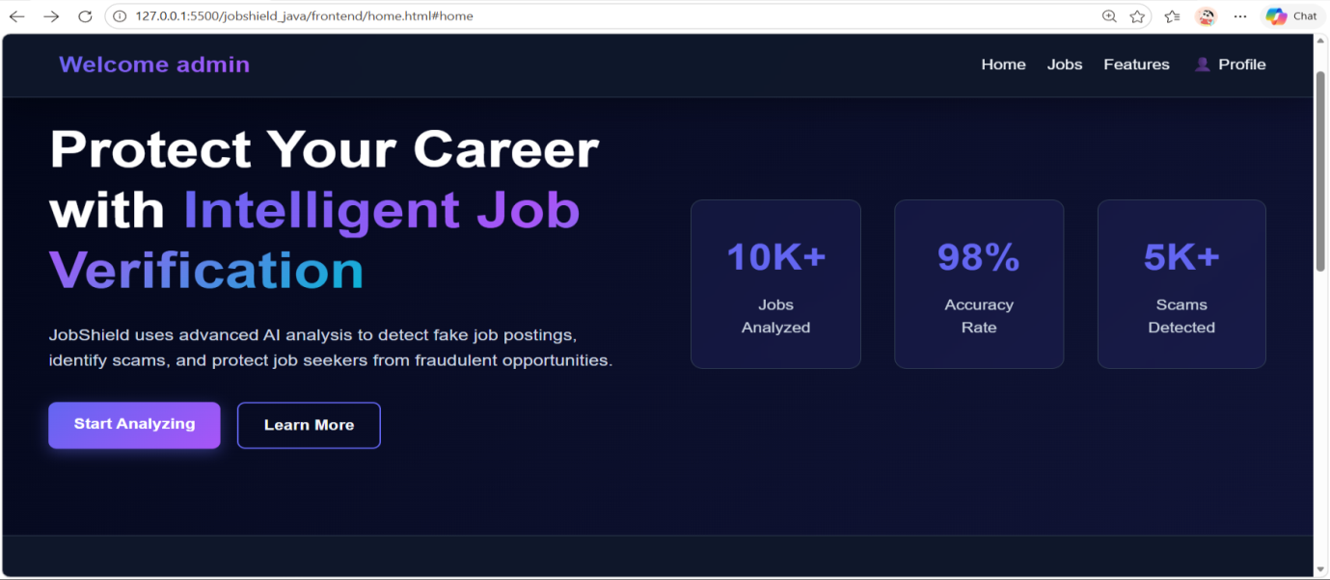
LOGIN PAGE
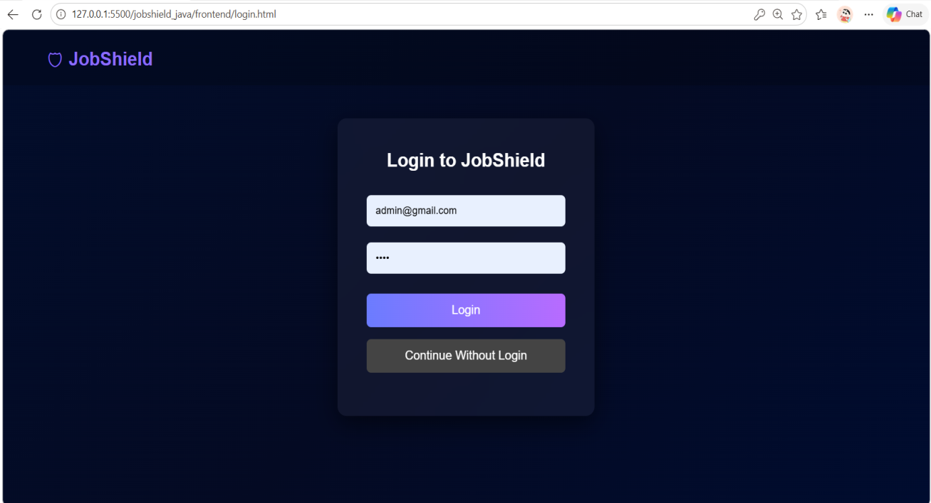

LOGIN SUCCESSFULLY

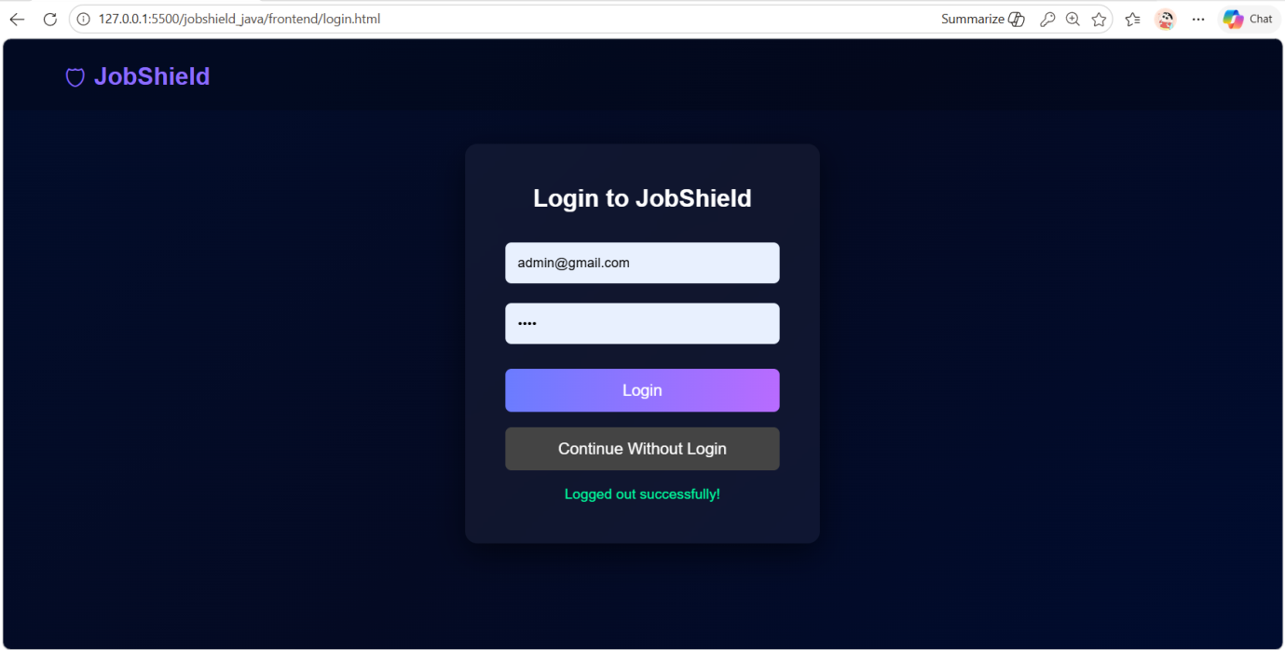
ANALYZE PAGE
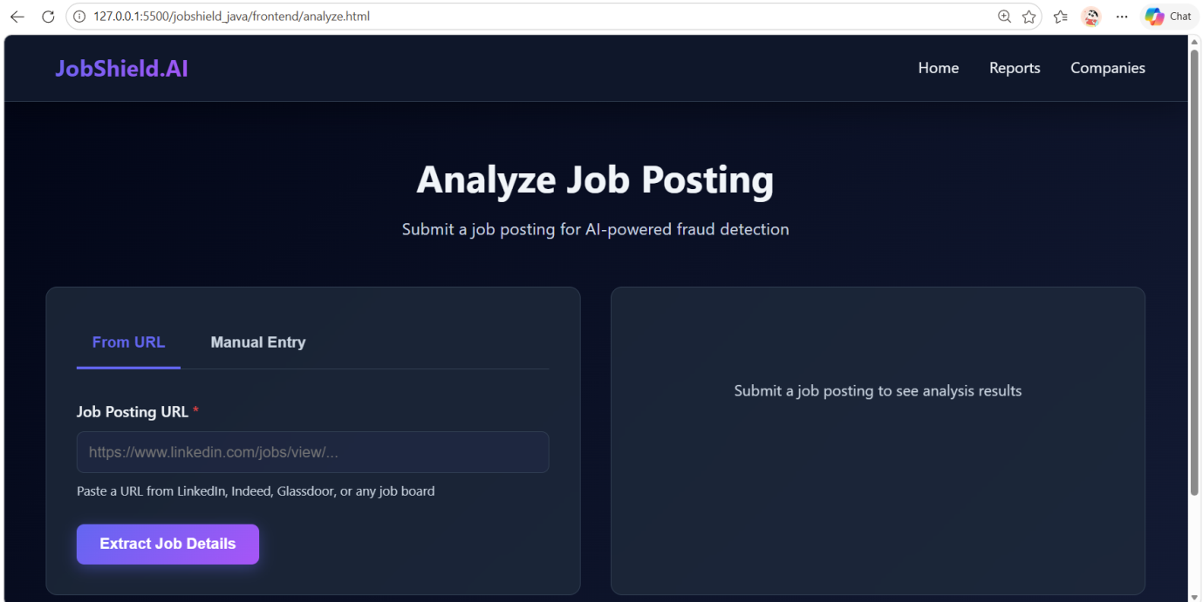
ANALYZE JOB URL
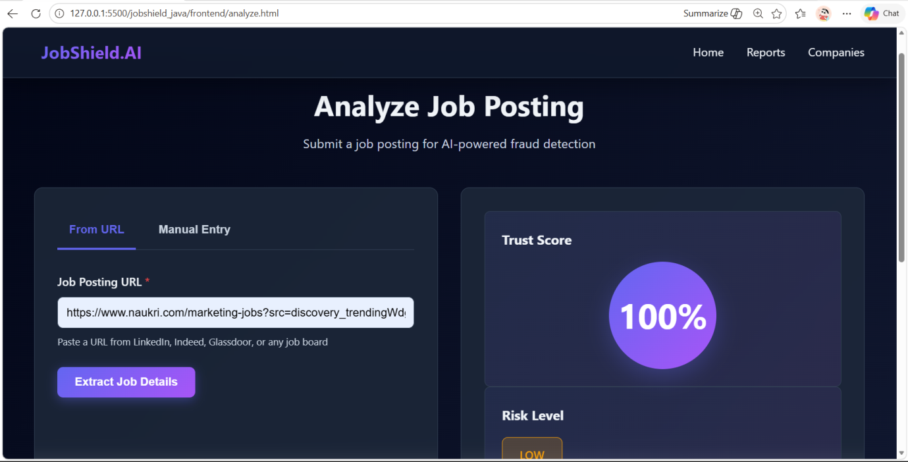

JOB REPORTS
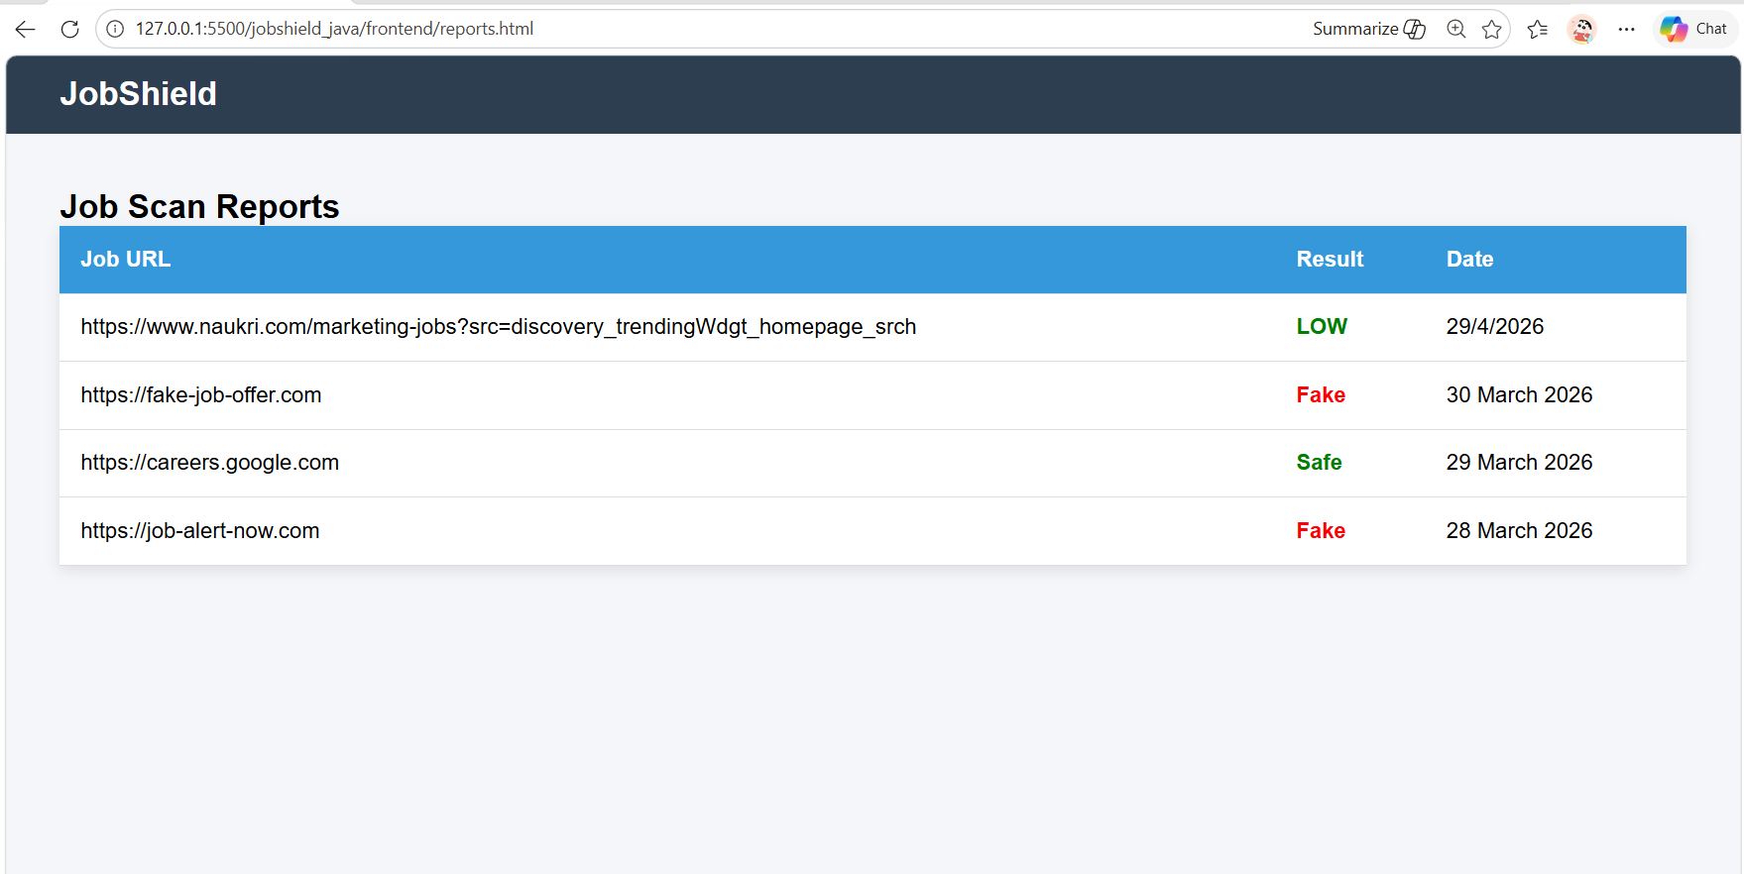

FEATURES
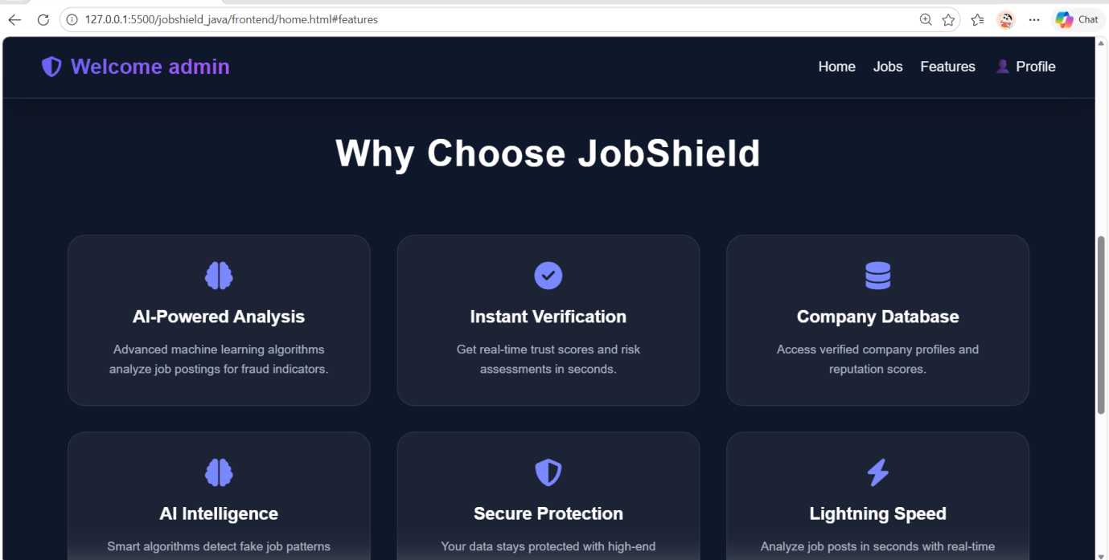

VERIFIED COMPANIES
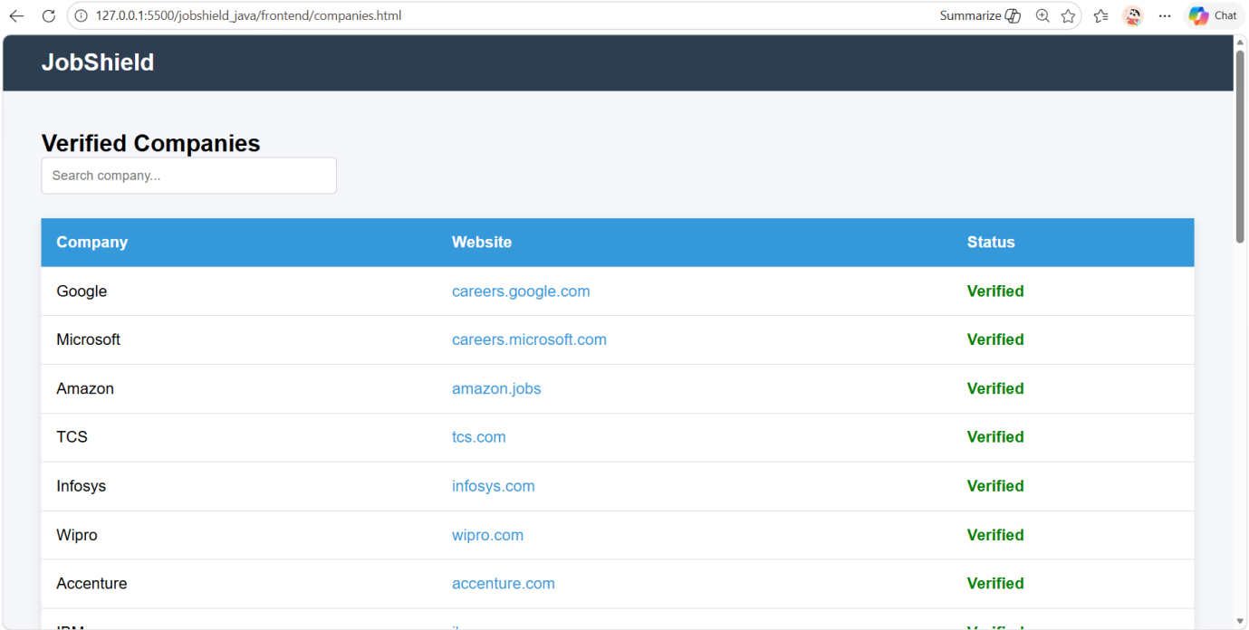
LOGOUT:-
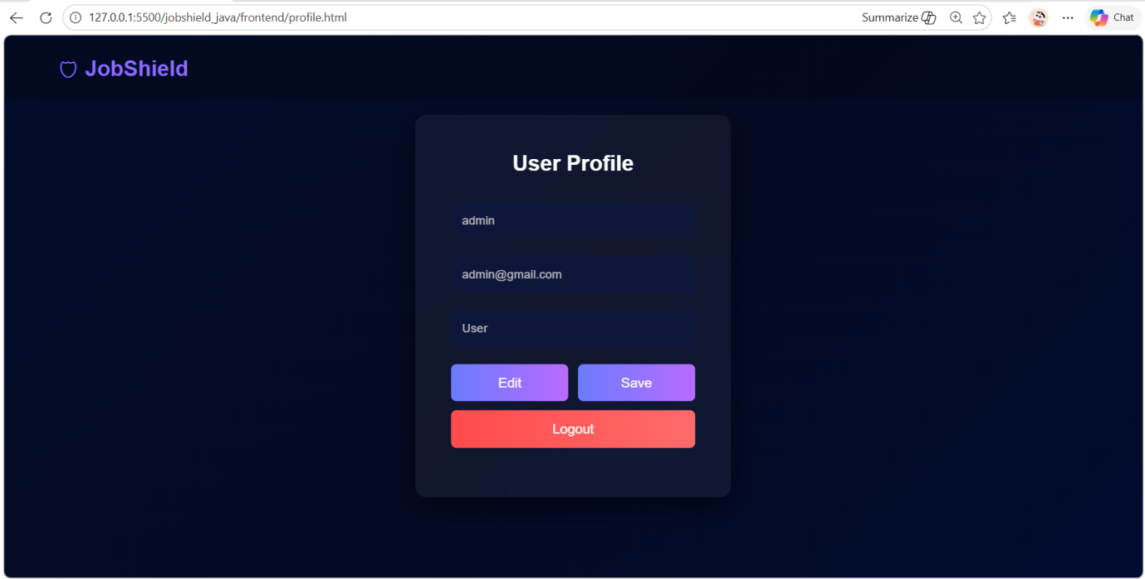
AGAIN LOGIN :-

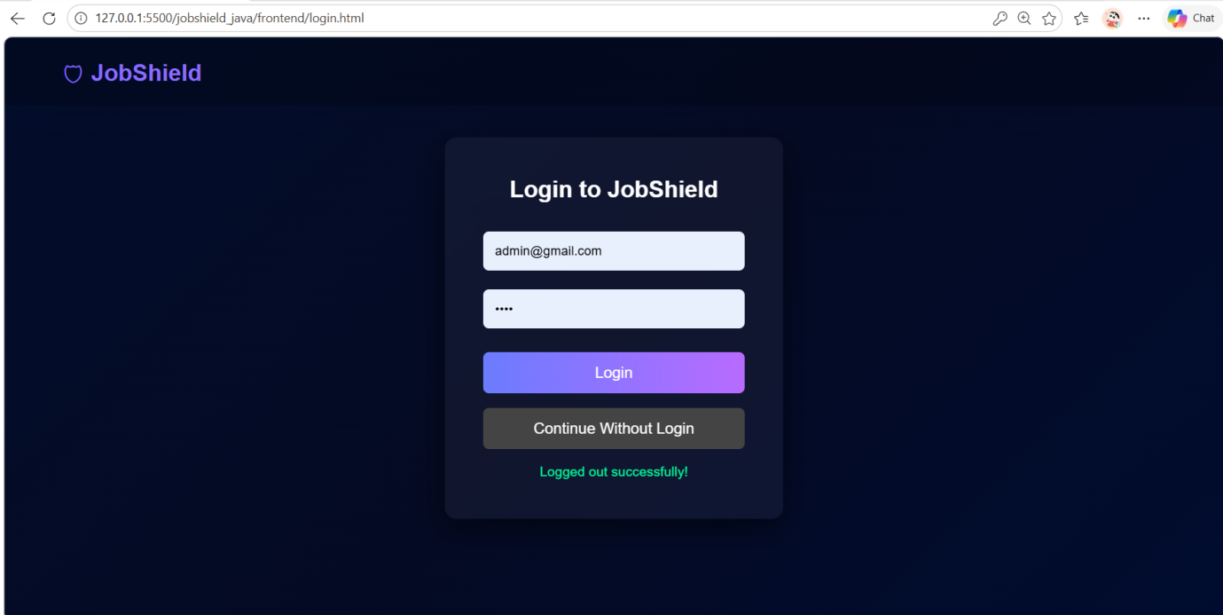
CONCLUSION
The Fake Internship and Job Detection System successfully provides a modern and efficient solution for identifying and preventing fraudulent job and internship opportunities. The system automates key processes such as job listing management, fraud detection, suspicious activity reporting, and user notifications through email alerts.
By using technologies like React, FastAPI, and the system ensures a responsive user interface, fast processing of data, and secure management of information. The integration of further enhances communication by providing timely alerts and updates regarding suspicious or fake listings.
The project helps reduce the risk of job seekers falling victim to scams, minimizes manual verification efforts, and improves overall reliability in job and internship searching platforms. It also ensures better organization of data and enables quick analysis of listings, supporting informed decision-making.
In conclusion, the Fake Internship and Job Detection System is a reliable, scalable, and user-friendly solution that meets the essential requirements for detecting fraudulent opportunities. It can be further enhanced in the future by incorporating advanced features such as machine learning-based detection, role-based access control, detailed analytics, and mobile application support.

BIBLIOGRAPGHY

- https://www.chatgpt.com
- https://Google.com
- https://Canva.com

