**1)Given the participants' score sheet for your University Sports Day, you are required to find the runner-up score. You are given N scores. Store them in a list and find the score of the runner-up.**

if __name__ == '__main__':

   n = int(input())

   arr = map(int, input().split())

   print(sorted(list(set(arr)))[-2])

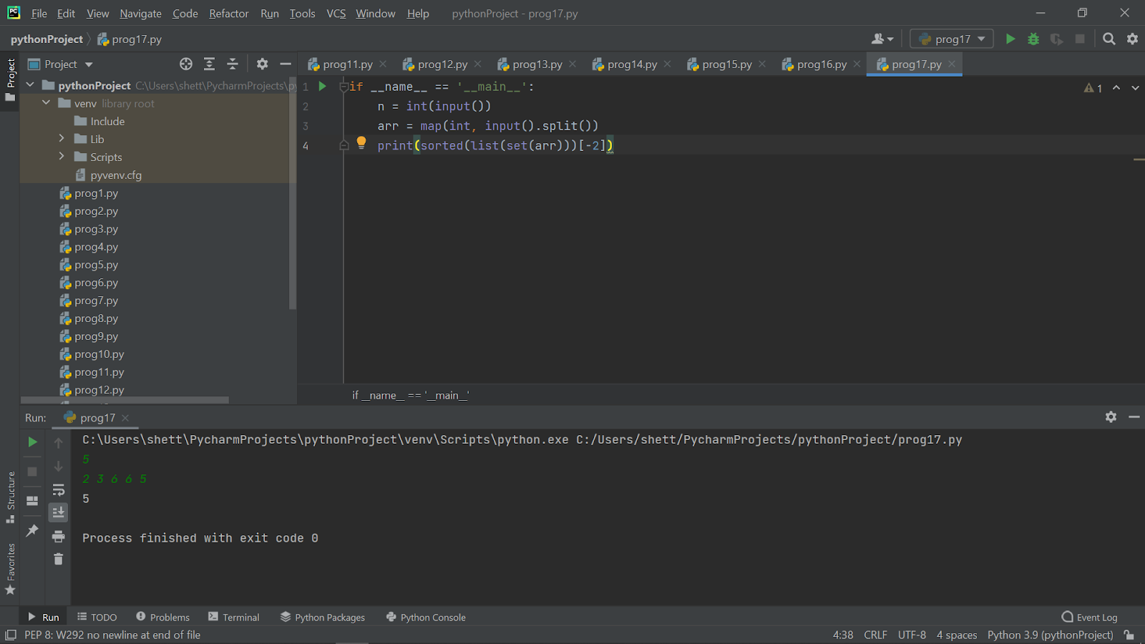

**2)Rotate a given String in the specified direction by specified magnitude.**

**After each rotation make a note of the first character of the rotated String, After all rotation are performed the accumulated first character as noted previously will form another string, say FIRSTCHARSTRING.**

**Check If FIRSTCHARSTRING is an Anagram of any substring of the Original string.**

**If yes print "YES" otherwise "NO". Input**

**The first line contains the original string s. The second line contains a single integer q. The ith of the next q lines contains character d[i] denoting direction and integer r[i] denoting the magnitude**

word = 'FIRSTCHARSTRING'

commands = [

   ('L', 2),

   ('R', 3),

   ('L', 1),

]

from collections import deque

q = deque(word)

for direction, magnitude in commands:

 if direction == 'L':

   q.rotate(-magnitude)

 else:

   q.rotate(magnitude)

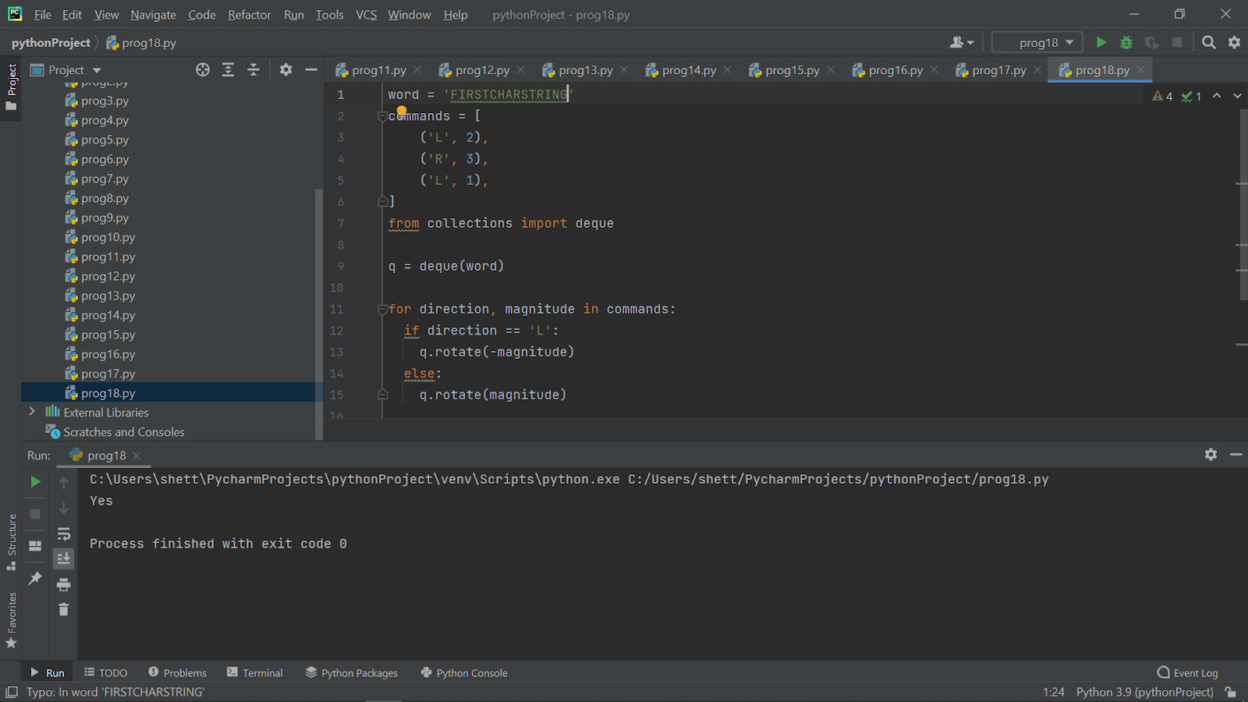

word = 'CARRACE'

commands = [

   ('L', 2),

   ('R', 2),

   ('L', 3),

]

from collections import deque

q = deque(word)

for direction, magnitude in commands:

 if direction == 'L':

   q.rotate(-magnitude)

 else:

   q.rotate(magnitude)

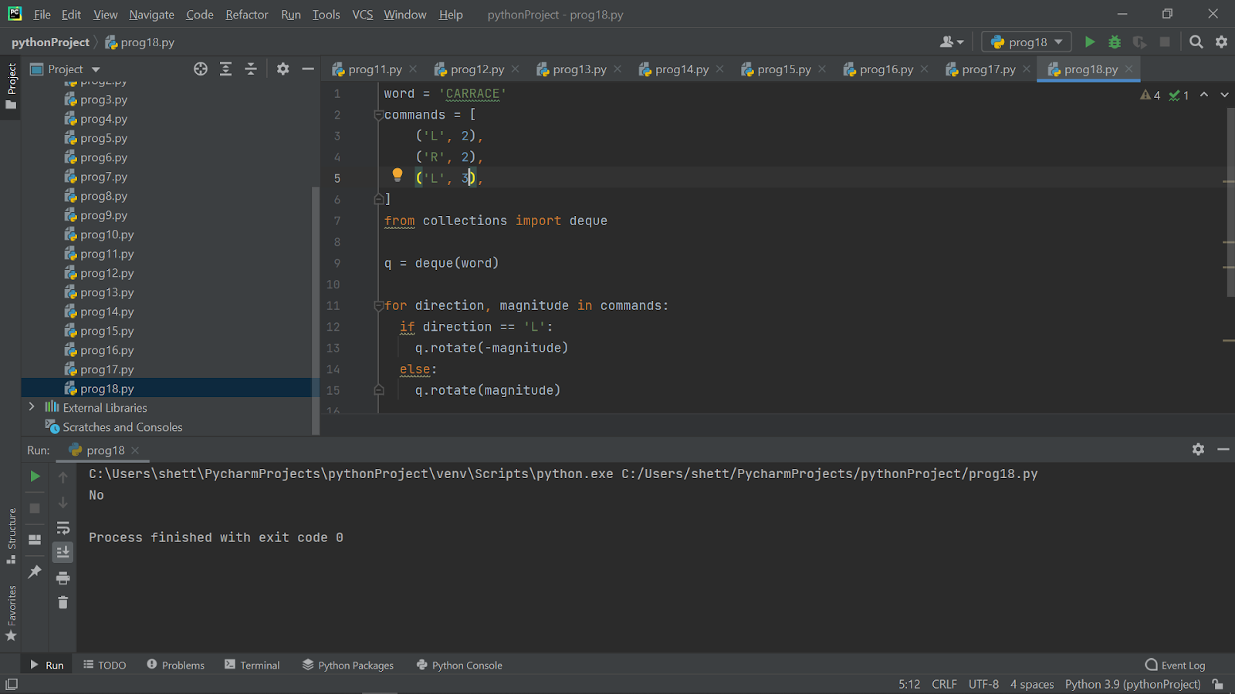

**3)it is strictly increasing in the beginning; after that it is constant; after that it is strictly decreasing.**

**The first block (increasing) and the last block (decreasing) may be absent. It is allowed that both of this blocks are absent.**

**For example, the following three arrays are a hill: [5,7,11,11,2,1], [4,4,2], [7],**

**but the following three are not unimodal: [5,5,6,6,1], [1,2,1,2], [4,5,5,6].**

**Write a program that checks if an array is a hill.**

def isMonotonic(A):

return (all(A[i] <= A[i + 1] for i in range(len(A) - 1)) or

all(A[i] >= A[i + 1] for i in range(len(A) - 1)))

A = [4,4,2]

print(isMonotonic(A))

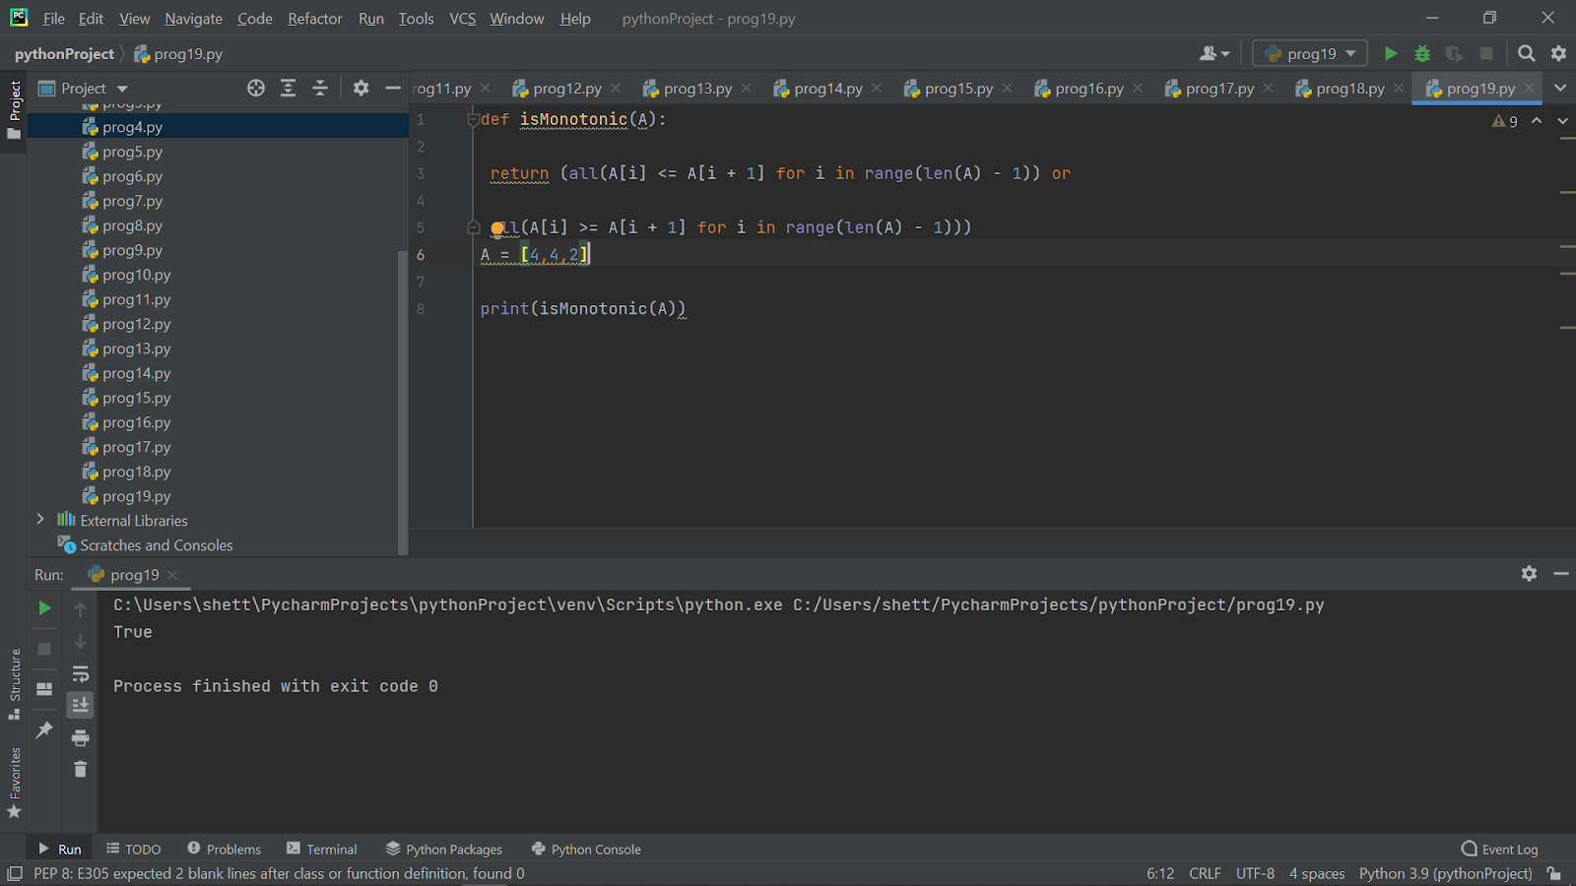

def isMonotonic(A):

return (all(A[i] <= A[i + 1] for i in range(len(A) - 1)) or

all(A[i] >= A[i + 1] for i in range(len(A) - 1)))

A = [1,2,1,2]

print(isMonotonic(A))



**4)A little girl living in a village craves some rava idli even though she has had rava idli for the last 346514534 days in a row !! (Strange, you might think. But its normal down here)**

**At the idli shop there are two types of Rava Idli's available.**

**One goes for Rs.A per piece and the other goes for Rs.B per piece.**

**The girl has a total of K rupees.**

**What is the maximum number of rava idlis that she can have?**

n=int(input())

for i in range (n):

a,b,k=(map(int,input().split()))

if a>=b:

print(k//b)

else:

print(k//a)

**5)Python program to remove Nth occurrence of the given word. Given a list of words in Python, the task is to remove the Nth occurrence of the given word in that list.**

**def RemoveIthWord(lst, word, N):**

   newList = []

   count = 0

   for i in lst:

       if (i == word):

           count = count + 1

           if (count != N):

               newList.append(i)

       else:

           newList.append(i)

   lst = newList

   if count == 0:

       print("Item not found")

   else:

       print("Updated list is: ", lst)

   return newList

list = ["Python", "for", "developers", "professionals", "developers"]

word = "developers"

N = 2

RemoveIthWord(list, word, N)

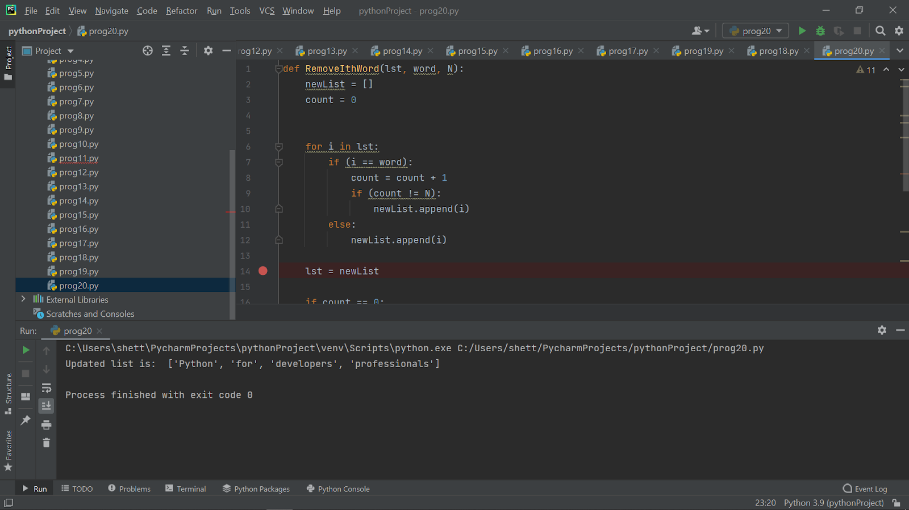

**6)Reverse words in a given String in Python**

**We are given a string and we need to reverse words of given string ?**

def rev_sentence(sentence):

   words = sentence.split(' ')

   reverse_sentence = ' '.join(reversed(words))

    return reverse_sentence

if __name__ == "__main__":

   input = "think career in IT think dlithe"

   print(rev_sentence(input))

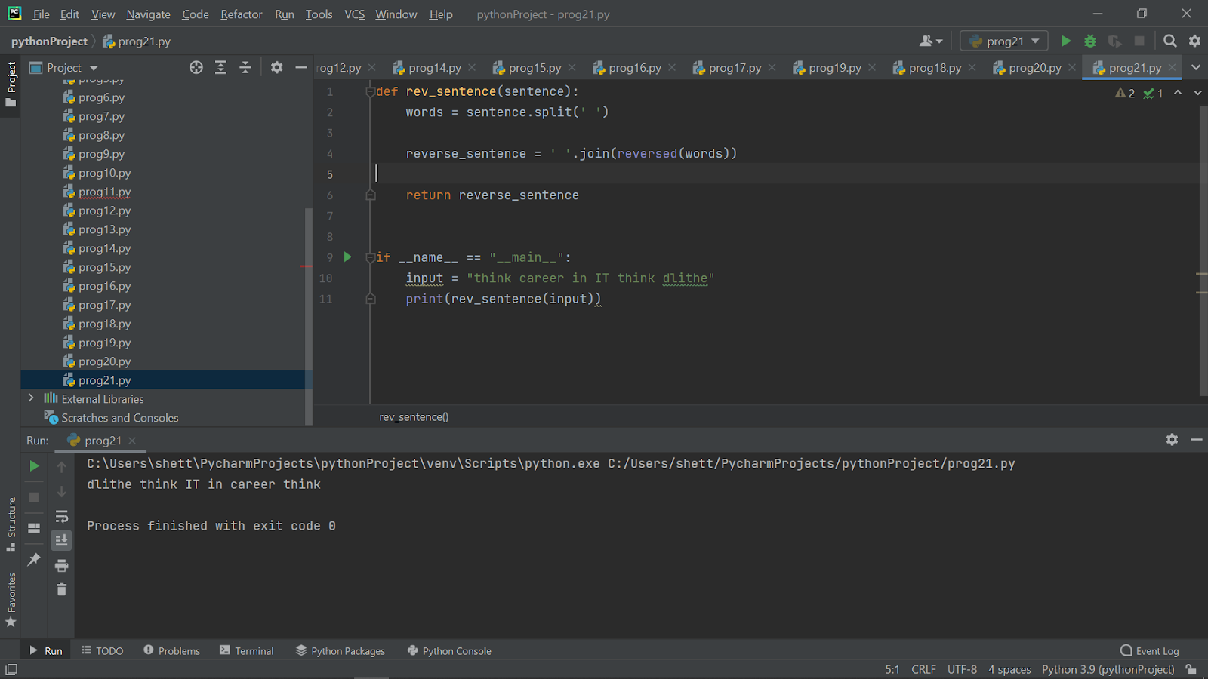

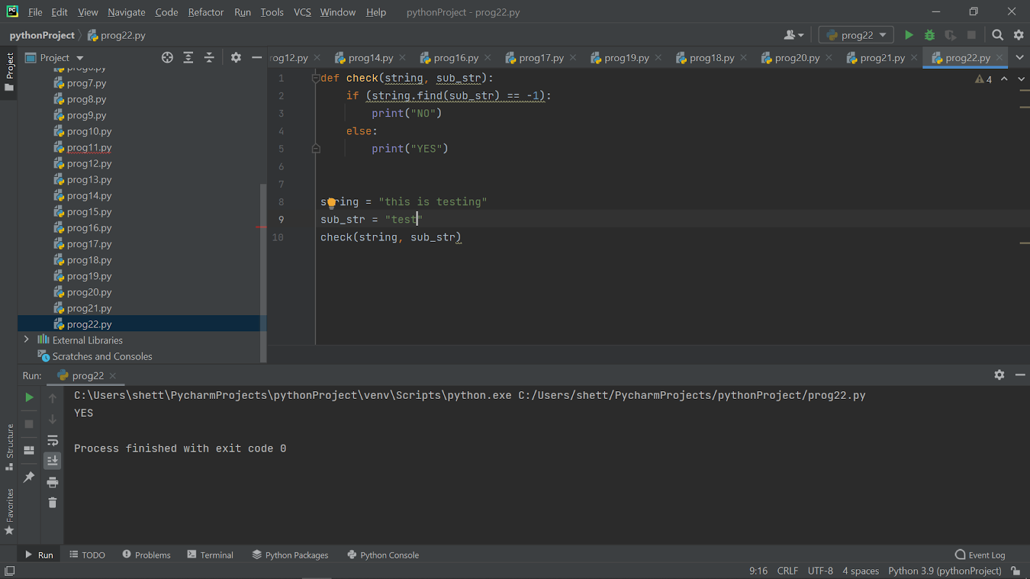

**8)Python program to print even length words in a string**

**Given a string. The task is to print all words with even length in the given string.**

def printWords(s):

   s = s.split(' ')

   for word in s:

       if len(word) % 2 == 0:

           print(word)

s = "This is a python language"

printWords(s)

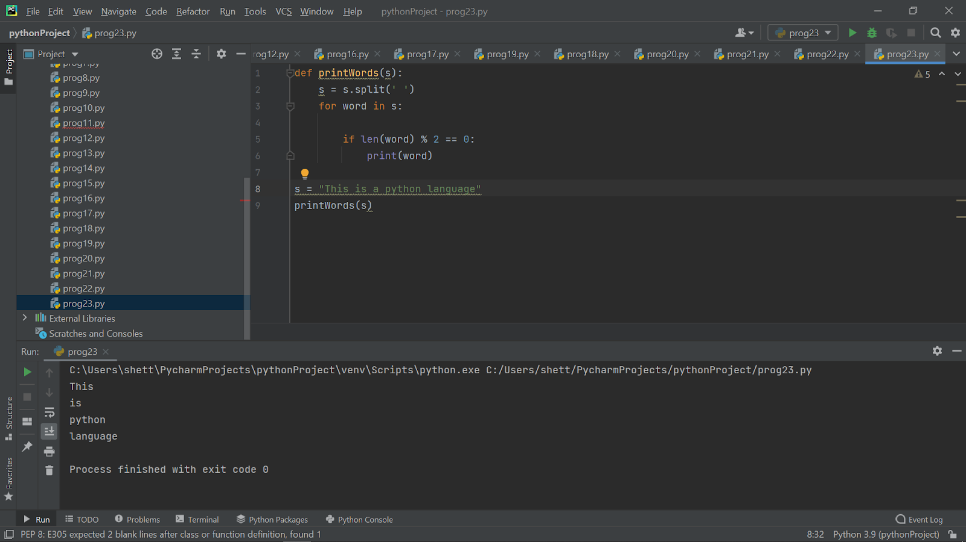

**10)Program to check if a string contains any special character**

**Given a string, the task is to check if that string contains any special character (defined special character set). If any special character found, don’t accept that string.**

import re

def run(string):

   regex = re.compile('[@_!#$%^&*()<>?/\|}{~:]')

   if (regex.search(string) == None):

       print("String is accepted")

   else:

       print("String is not accepted.")

if __name__ == '__main__':

   string = "Python$For$Developers"

   run(string)

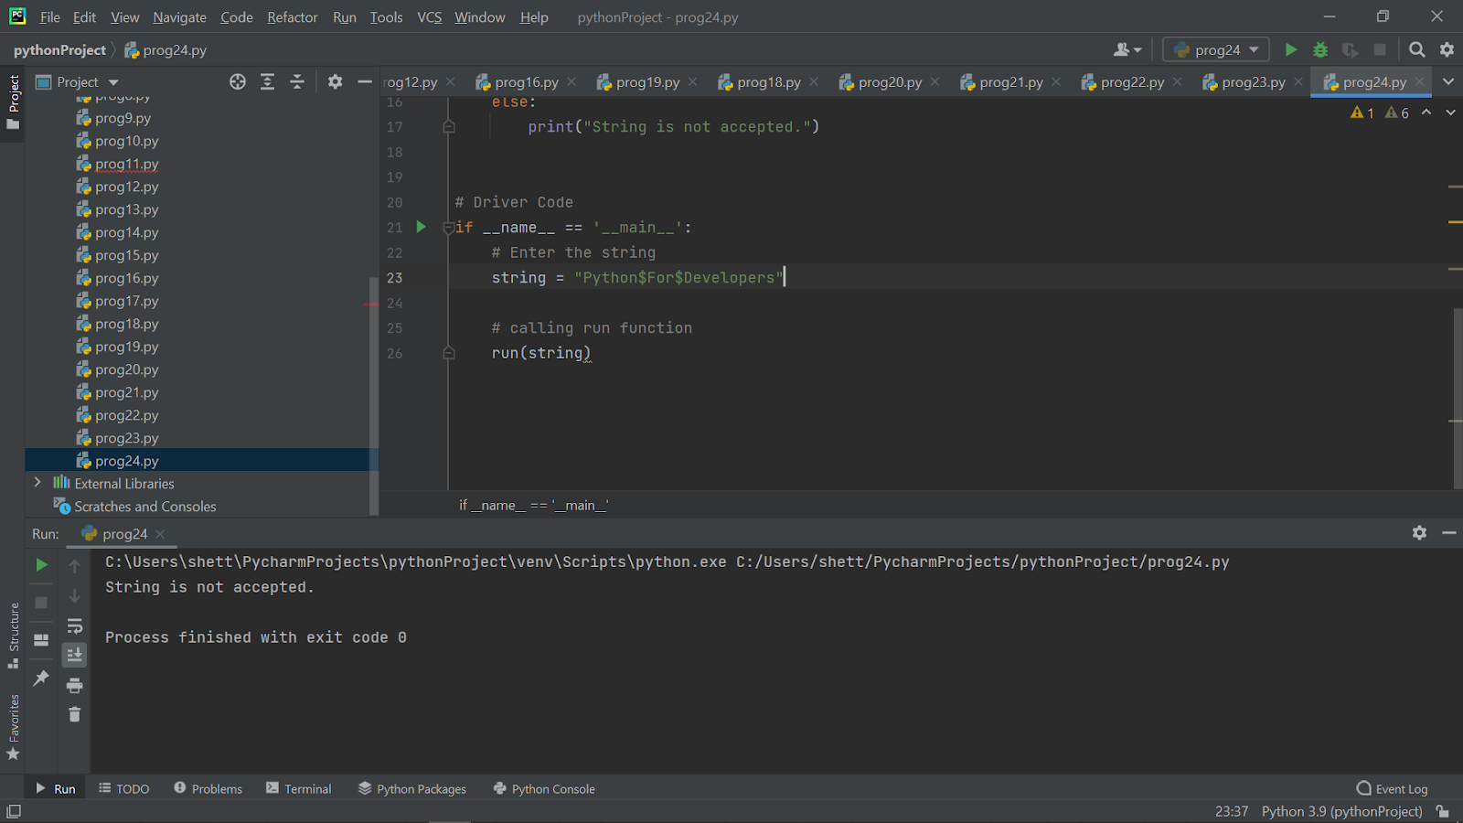

import re

def run(string):

   regex = re.compile('[@_!#$%^&*()<>?/\|}{~:]')

   if (regex.search(string) == None):

       print("String is accepted")

   else:

       print("String is not accepted.")

if __name__ == '__main__':

   string = "Python For Developers"

   run(string)

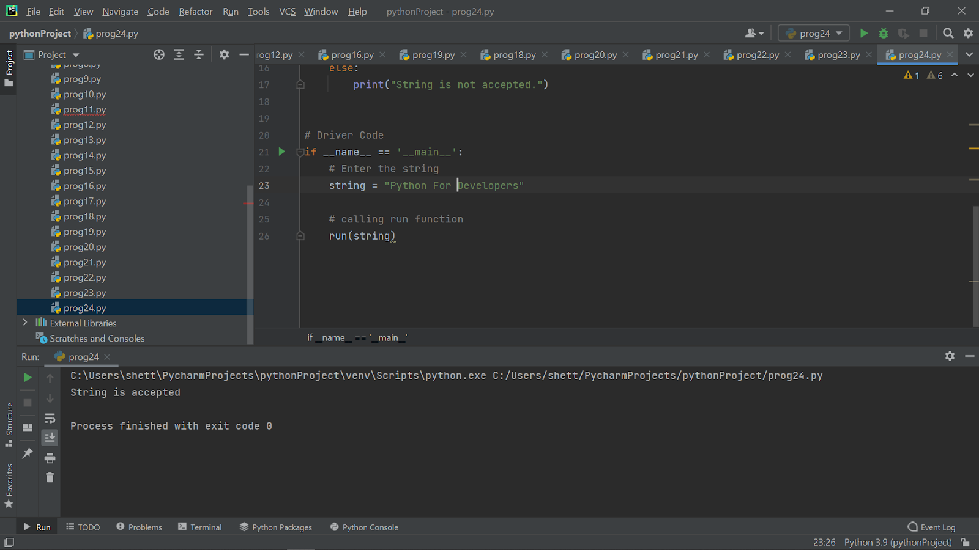

**1)A little girl living in a village craves some rava idli even though she has had rava idli for the last 346514534 days in a row !! (Strange, you might think. But its normal down here)**

**At the idli shop there are two types of Rava Idli's available.**

**One goes for Rs.A per piece and the other goes for Rs.B per piece.**

**The girl has a total of K rupees.**

**What is the maximum number of rava idlis that she can have?**

n=int(input())

for i in range (n):

a,b,k=(map(int,input().split()))

if a>=b:

print(k//b)

else:

print(k//a)

**2)You are given a positive integer . Print a numerical triangle of height  like the one below:**

**1**

**22**

**333**

**4444**

**55555**

**......**

**Can you do it using only arithmetic operations, a single for loop and print statement?**

for i in range(1,int(input())):

print(int(i * 10**i / 9))

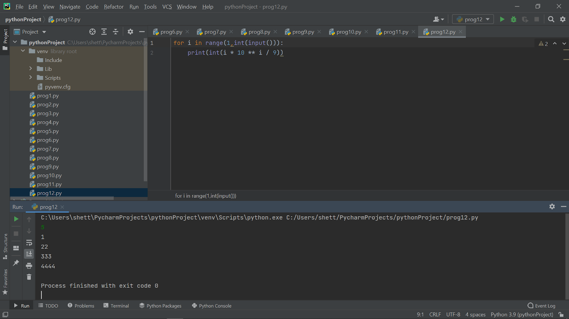

**3)You are given a rectangular board of M×N squares. Also you are given an unlimited number of standard domino pieces of 2×1 squares. You are allowed to rotate the pieces. You are asked to place as many dominoes as possible on the board so as to meet the following conditions:**

**1.Each domino completely covers two squares.**

**2.No two dominoes overlap.**

**3.Each domino lies entirely inside the board. It is allowed to touch the edges of the board.**

**Find the maximum number of dominoes, which can be placed under these restrictions.**

m, n = input().split()

print(int((int(m)*int(n))/2))

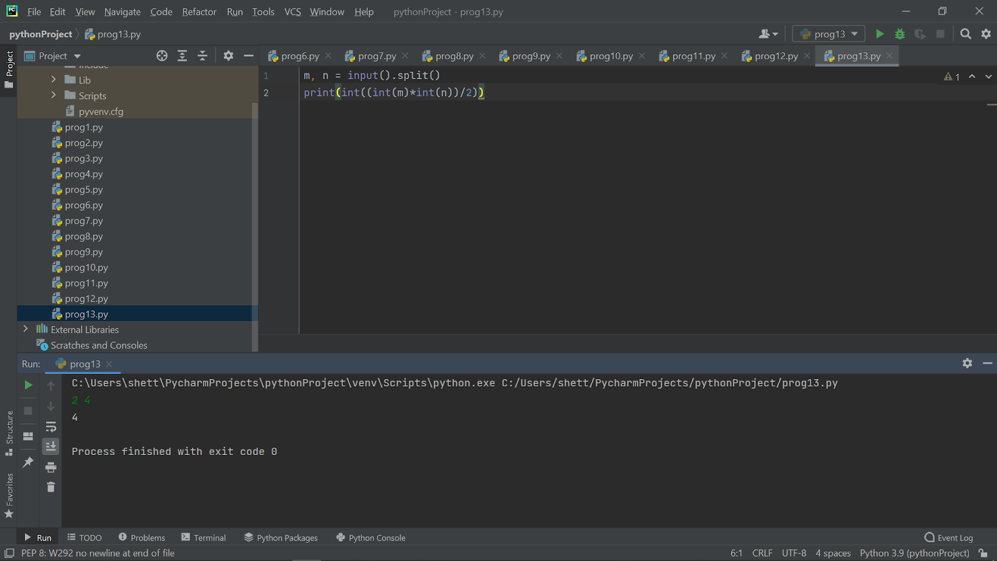

**4)Given an integer,n, perform the following conditional actions:**

**If n is odd, print Weird If n is even and in the inclusive range of 2 to 5, print Not Weird If n is even and in the inclusive range of 6 to 20, print Weird If n is even and greater than 20, print Not Weird**

n = int(input())

if n % 2 == 1:

    print("Weird")

elif n % 2 == 0 and 2 <= n <= 5:

    print("Not Weird")

elif n % 2 == 0 and 6 <= n <= 20:

    print("Weird")

else:

    print("Not Weird")

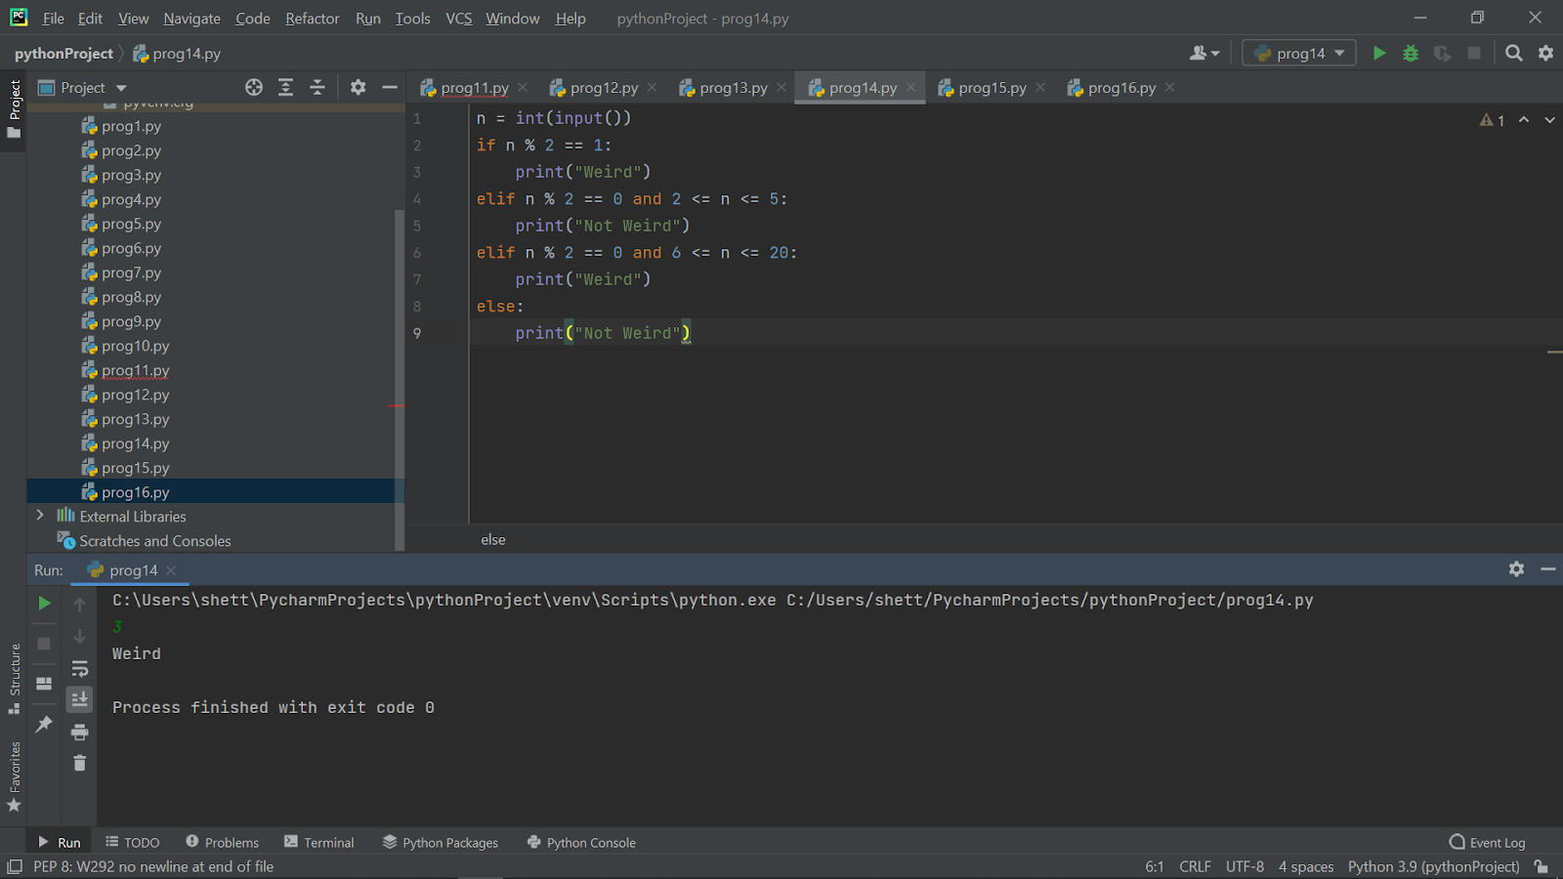

**5)Print the below mentioned pattern for any “n” value, where “n” indicates number of rows:**

**a)1   5**

**2 4**

**3**

n=int(input())

for i in range(1, n//2 + 2):

    for j in range(1, n + 1):

        if j==i or j==n - i + 1:

            print(j, end="")

        else:

            print(" ",end="")

    print()

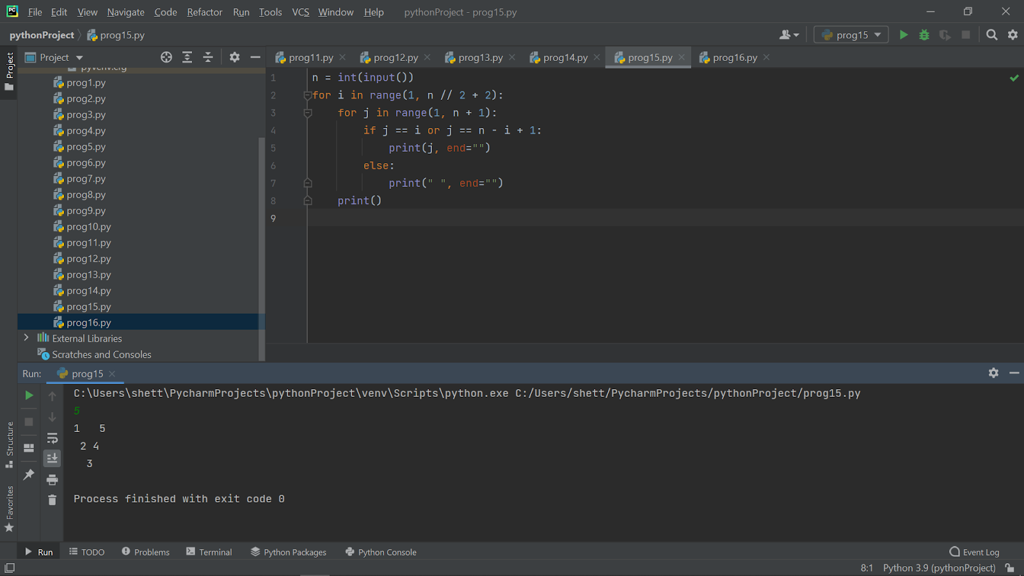

**b)**

**1**

**2**

**3**

**4**

**5**

n=int(input())

for i in range(1, n + 1):

   for j in range(1, n + 1):

       if j==i:

           print(j, end="")

       else:

           print(" ",end="")

   print()

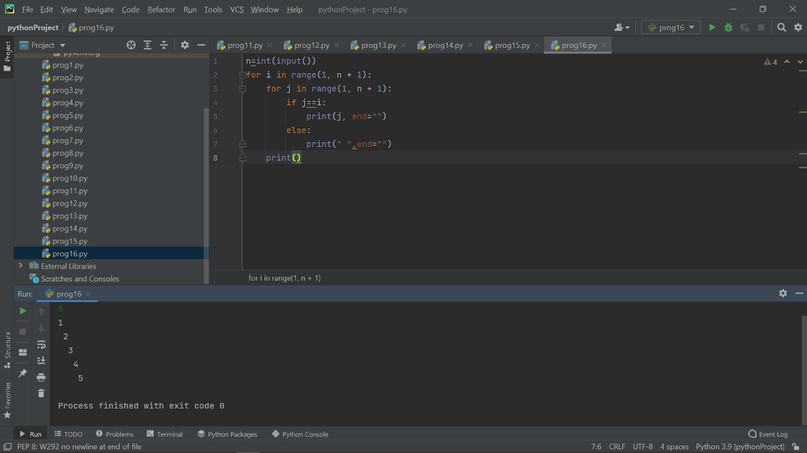

**1)Given an integer,n, perform the following conditional actions:**

**If n is odd, print Weird**

**If n is even and**

**in the inclusive range of 2 to 5, print Not Weird**

**If n is even and in the inclusive range of 6 to 20, print Weird**

**If n is even and greater than 20, print Not Weird**

n = int(input())

if n % 2 == 1:

    print("Weird")

elif n % 2 == 0 and 2 <= n <= 5:

    print("Not Weird")

elif n % 2 == 0 and 6 <= n <= 20:

    print("Weird")

else:

    print("Not Weird")

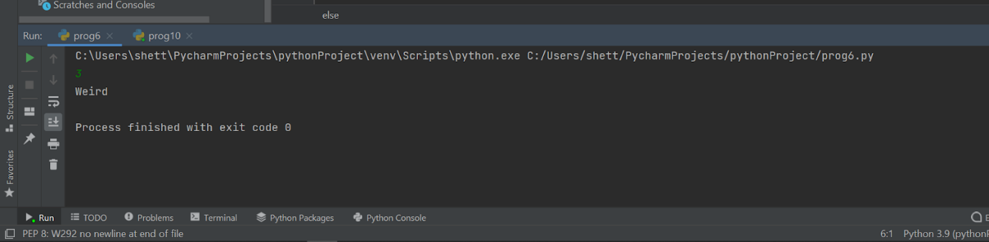

**2)Read three integers from the keyboard a,b,c, d and those values in the following order.**

**max > mid1 > mid2 > min**

w = int(input())

x = int(input())

y = int(input())

z = int(input())

a1 = min(w, x, y, z)

a3 = max(w, x, y, z)

a2 = (x + y + z) - a1 - a3

print(w,x,z,y,sep=">")

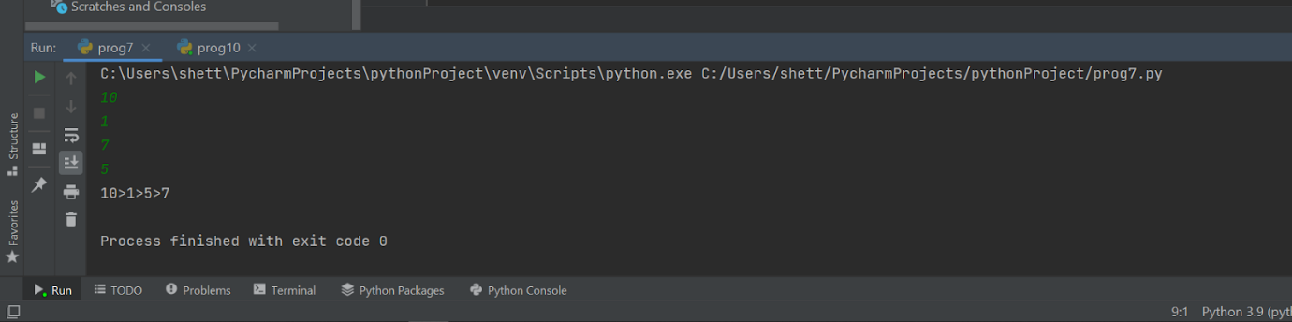

**3)Write a program to calculate the EB Bill.**

**The tariff rate for all division is the same. Karnataka electricity board single slaps for the domestic LT supply such as for 0 to 30 units the per-unit cost will be ? 3.75/-, from 31 to 100 the per-unit cost will be ? 5.20, from 101 to 200, the per-unit cost will be ? 6.75 and above 201 units you have to pay ? 7.8 per unit.**

**Additionally, the consumer will pay fixed charges as ? 60/- and electricity tax of 5% extra.**

units = int(input(" Please enter Number of Units you Consumed : "))

if(units <= 30):

    amount = units * 3.75

    surcharge = 60

elif(units <= 100):

    amount = 130 + ((units - 30) * 5.20)

    surcharge = 70

elif(units <= 200):

    amount = 130 + 162.50 + ((units - 100) * 6.75)

    surcharge = 80

else:

    amount = 130 + 162.50 + 526 + ((units - 200) * 7.8)

    surcharge = 110

total = amount + surcharge

print("\nElectricity Bill = %.5f"  %total)

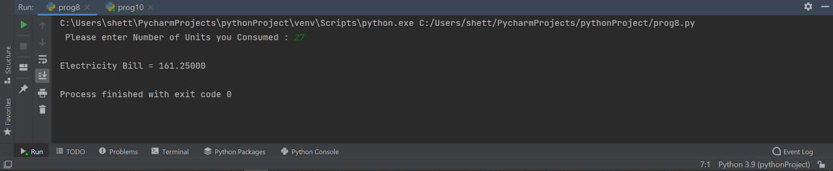

**4)Write a program to calculate the grade. The grade should be calculated in the following method.**

**Constraints**

**Score should be in between 1 to 100**

**Score**

**>= 90 --> Grade O**

**>= 80 --> Grade A+**

**>= 70 --> Grade A**

**>= 60 --> Grade B+**

**>= 50 --> Grade B**

**< 50 No Grade**

print("Enter Marks Obtained in 5 Subjects: ")

markOne = int(input())

markTwo = int(input())

markThree = int(input())

markFour = int(input())

markFive = int(input())

tot = markOne+markTwo+markThree+markFour+markFive

avg = tot/5

if avg>=90:

    print("Your Grade is o")

elif avg>=80:

    print("Your Grade is A+")

elif avg>=70:

    print("Your Grade is A")

elif avg>=60:

    print("Your Grade is B+")

elif  avg>=50:

    print("Your Grade is B")

elif avg<50:

    print("NO GRADE")

else:

    print("invalid")

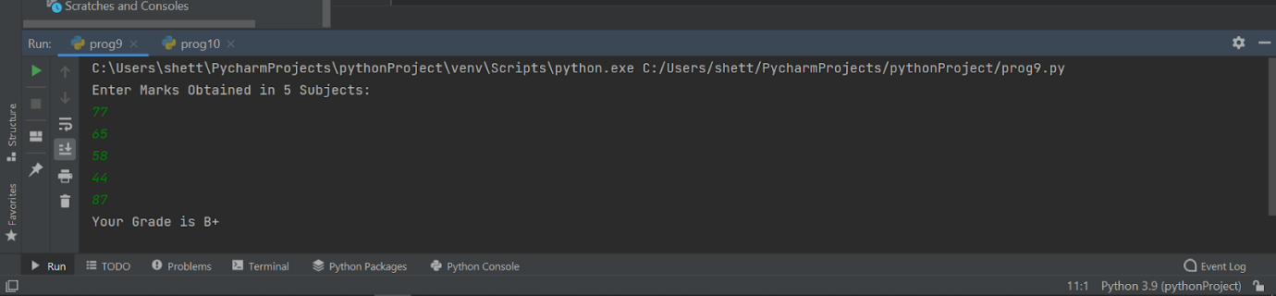

**5)An extra day is added to the calendar almost every four years as February 29, and the day is called a leap day. It corrects the calendar for the fact that our planet takes approximately 365.25 days to orbit the sun. A leap year contains a leap day.**

**In the Gregorian calendar, three conditions are used to identify leap years:**

**The year can be evenly divided by 4, is a leap year, unless:**

**The year can be evenly divided by 100, it is NOT a leap year, unless:**

**The year is also evenly divisible by 400. Then it is a leap year.**

**This means that in the Gregorian calendar, the years 2000 and 2400 are leap years, while 1800, 1900, 2100, 2200, 2300 and 2500 are NOT leap years. Source**

**Task**

**Given a year, determine whether it is a leap year. If it is a leap year, print YES or NO.**

def is_leap(year):

    leap = False

    if year % 400 == 0:

        leap = True

    elif year % 100 == 0:

        leap = False

    elif year % 4 == 0:

        leap = True

    return leap

year = int(input())

print (is_leap(year))

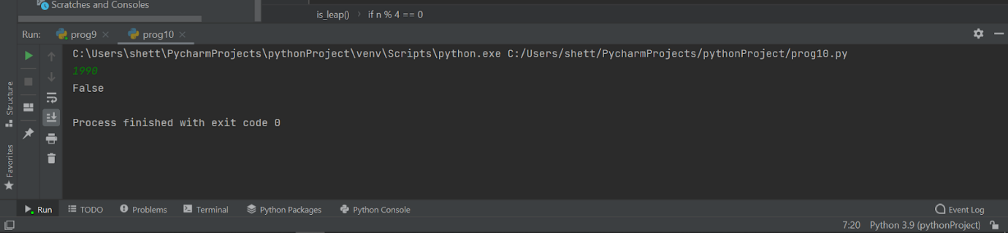

**1)Write a program to calculate simple interest,formula to calculate simple interest : PNR/100.**

P = float(input("Enter the principal amount : "))

N = float(input("Enter the number of years : "))

R = float(input("Enter the rate of interest : "))

SI = (P * N * R)/100

print("Simple interest : {}".format(SI))

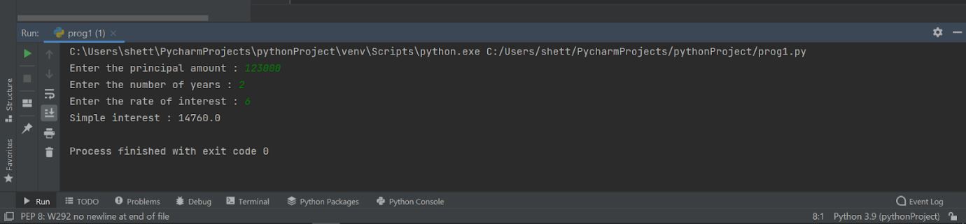

**2)Write a program to find sum and average of 3 values**

a = int(input())

b = int(input())

c = int(input())

sum = a + b + c

avg = sum / 3

print('Sum of all 3 Numbers is  {}'.format(sum))

print('Average of all 3 Numbers is  {}'.format(avg))

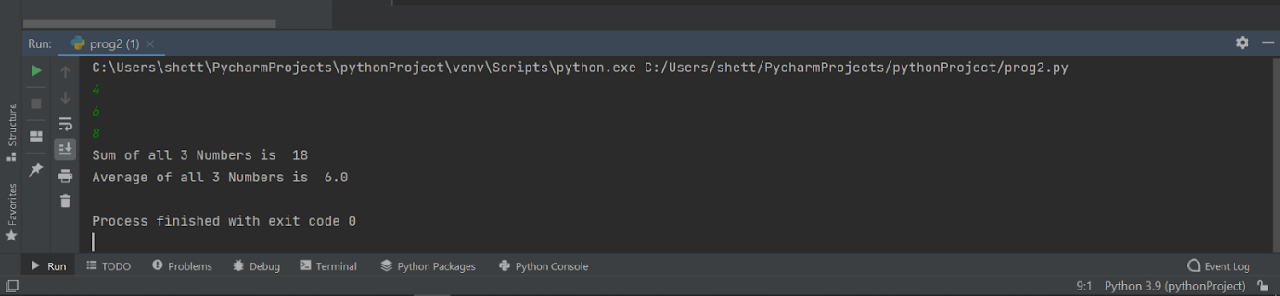

**3)Write a program to perform the following task.**

**The provided code stub reads two integers from STDIN,  and . Add code to print three lines where:**

**The first line contains the sum of the two numbers.**

**The second line contains the difference of the two numbers (first - second).**

**The third line contains the product of the two numbers.**

a = int(input())

b = int(input())

if 1<=a<=10**10 and 1<=b<=10**10:

 sum = a+b

 difference = a-b

 product = a*b

 print(sum)

 print(difference)

 print(product)

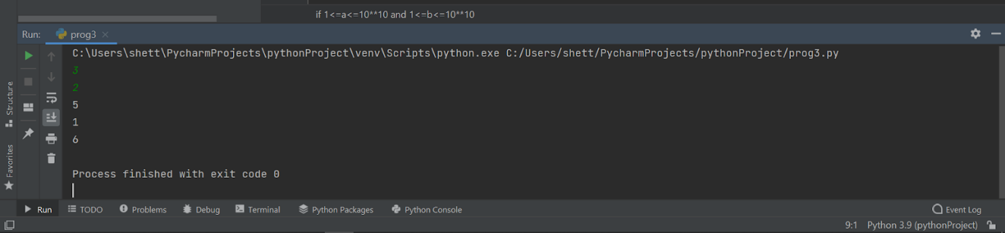

**4)Read three integers from the keyboard a,b,c and those values in the following order.**

**max > mid > min**

a=int(input())

b=int(input())

c=int(input())

x=max(a,b,c)

y=min(a,b,c)

z=(a+b+c)-x-y

print(x,z,y,sep=">")

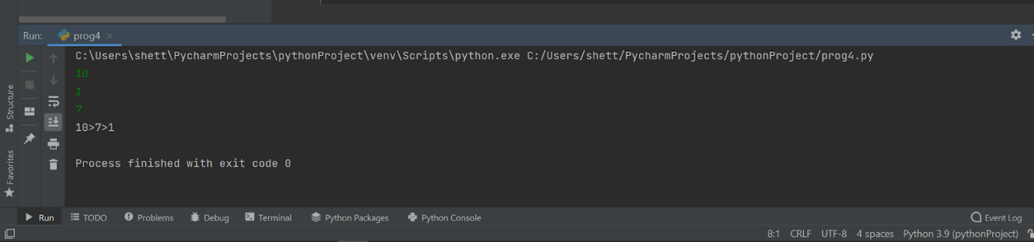

**5)Read four values from the keyboard a,b,c,d and print the result of a^b + c^d in single line.**

a = int(input())

b = int(input())

c = int(input())

d = int(input())

print ( a ** b + c ** d )

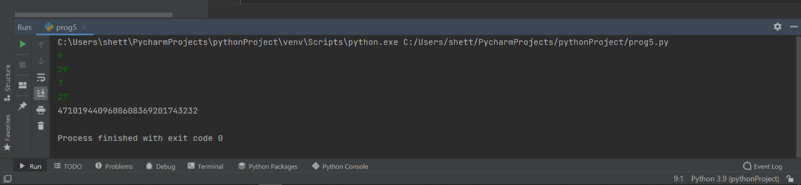

Q1:  Some prime numbers can be expressed as a sum of other consecutive prime numbers.  
  
  
  
  
For example  
  
5 = 2 + 3,  
  
17 = 2 + 3 + 5 + 7,  
  
41 = 2 + 3 + 5 + 7 + 11 + 13.  
  
Your task is to find out how many prime numbers which satisfy this property are present in the range 3 to N subject to a constraint that summation should always start with number 2.  
  
Write code to find out the number of prime numbers that satisfy the above-mentioned property in a given range.  
  
  
  
  
Input Format: First line contains a number N  
  
  
  
  
Output Format: Print the total number of all such prime numbers which are less than or equal to N.  
  
  
  
  
Constraints: 2<N<=12,000,000,000

num = int(input())

arr = []

sum = 0

count = 0

if num > 1:

for i in range(2, num + 2):

for j in range(2, i):

if i % j == 0:

break

else:

arr.append(i)

def is_prime(sum):

for i in range(2, (sum // 2) +2):

if sum % i == 0:

return False

else:

return True

for i in range(0, len(arr)):

sum = sum + arr[i]

if sum <= num:

if is_prime(sum):

count = count + 1

print(count)

