PROJECT REPORT
Summer Training — Power BI

Project Title | College Placement Analysis Dashboard
Student Name | Himani Verma
Roll Number | 2405039451
Course & Batch | B.Tech — 2028
Department | Computer Science and Engineering
Institute | Chandigarh Group of Colleges - CCE
Training Period | [08/06/2026] to [06/07/2026]
Submission Date | [01/07/2026]
Guided By | Ms. Ashima and Ms. Mandeep

1. Declaration

I hereby declare that the project report entitled "College Placement Analysis Dashboard" submitted in partial fulfilment of the Summer Training Programme is an original piece of work carried out by me. The data used in this report has been collected from publicly available sources. The dashboards, visuals shown in this report have been independently created by me in Microsoft Power BI Desktop.

I further confirm that this report or any part of it has not been submitted previously for any academic award.

Signature: ___________________________
Name: Himani Verma
Date: [01/ 07/ 2026]

2. Abstract

This project presents a College Placement Analytics Dashboard developed using Microsoft Power BI to analyze student placement performance and support data-driven decision-making for placement cells and college management. The dashboard helps identify placement trends, evaluate branch-wise performance, and monitor important placement metrics.
The dataset used contains approximately 12,000 student records with key fields such as Student ID, Branch, Degree, Gender, CGPA, Placement Status, Package (LPA), and Company Type. The data was cleaned and transformed using Power Query to ensure accuracy and consistency.
Various DAX measures were created to calculate KPIs including Placement Rate, Average Package, Highest Package, Total Students, and Average Placed CGPA. The dashboard includes multiple interactive visuals such as KPI cards, bar charts, pie charts, treemaps, histograms, scatter plots, and slicers to facilitate detailed analysis.
The final dashboard provides insights into placement distribution, package trends, company hiring patterns, and the relationship between CGPA and placement outcomes, enabling institutions to improve their placement strategies and student performance.

3. Introduction

3.1 Background
This project belongs to the domain of Educational Analytics, specifically Placement Analytics, which focuses on analyzing student placement performance and recruitment outcomes in higher education institutions. Colleges and universities generate large volumes of placement-related data, including student academic performance, placement status, salary packages, and company recruitment trends.
Data visualization plays a crucial role in this domain by converting complex placement data into easy-to-understand charts, graphs, and key performance indicators. Visual dashboards help stakeholders quickly identify trends, compare branch-wise performance, monitor placement rates, and evaluate the effectiveness of placement activities.
Educational institutions and placement cells commonly use dashboards to support strategic decision-making. These dashboards enable placement officers and management to identify underperforming areas, improve training initiatives, strengthen industry collaborations, and develop strategies to enhance student employability and overall placement outcomes

3.2 Problem Statement
The primary users of this dashboard are placement officers, college management, and training and placement coordinators who are responsible for monitoring and improving student placement performance. Previously, placement-related information such as branch-wise placement rates, package distributions, and company hiring trends was scattered across spreadsheets and reports, making analysis time-consuming and inefficient.
This dashboard centralizes all placement data into a single interactive platform, providing real-time insights into key metrics such as placement rate, average package, and student performance indicators. With these insights, decision-makers can easily identify underperforming branches, evaluate recruitment trends, and design targeted training and placement strategies to improve overall placement outcomes and student employability.

3.3 Objectives
- Connect to and clean the raw dataset using Power Query.
- Design a star schema data model with proper relationships.
- Create meaningful DAX measures (minimum 3 custom measures).
- Build an interactive dashboard with at least 5 different visual types.
- Enable drill-through or cross-filtering for deeper analysis.
- Publish the final report to Power BI Service.
- Analyze branch-wise placement performance and identify trends in student employability.
- Evaluate the relationship between students' CGPA and placement outcomes.
- Compare salary packages offered across different company types and academic branches.
- Provide placement officers with actionable insights to improve placement strategies and training programs.
- Develop an interactive and user-friendly dashboard for quick and efficient decision-making.

4. Dataset Description

4.1 Data Source

Source Name | Kaggle
Dataset Name | Indian_Student_Placement_Dataset_2025
File Format | CSV
Number of Records | 11,997 rows
Number of Columns | 16 columns
Time Period Covered | Not specified in the dataset
Download Link | https://www.kaggle.com/code/shubhampandey2004/student-placement-predict/input

4.2 Key Fields / Columns
List and describe the important columns used in your analysis:

Column Name | Data Type | Description / Role in Analysis
Student ID | Text | Unique identifier for each student record.
Branch | Text | Student's academic branch (CSE, AIML, CYS, etc.) used in slicers and branch-wise analysis.
Degree | Text | Degree pursued by the student (B.Tech, BCA, MCA, etc.) used for filtering and comparisons.
Gender | Text | Used to analyze placement trends across different genders
CGPA | Decimal | Academic performance indicator used in correlation and scatter plot analysis.
Placement Status | Text | Indicates whether a student is placed or not placed; used for KPI calculations and charts.
Package (LPA) | Decimal | Salary package offered to placed students; used to calculate average and highest package.
Company Type | Text | Categorizes recruiting companies (Product, Service, Startup, etc.) for placement trend analysis.

4.3 Data Quality Issues & Cleaning Steps
The raw dataset contained several data quality issues that were identified and resolved using Power Query in Microsoft Power BI.
- Removed duplicate rows — duplicate student records were identified using the Remove Duplicates feature and removed to maintain data accuracy.
- Handled null values — the Package (LPA) and Company Type columns contained blank values for unplaced students. Missing package values were replaced with 0, while missing company types were replaced with "Not Applicable".
- Changed data types — columns such as CGPA and Package (LPA) were converted to Decimal Number, while categorical fields like Branch, Degree, and Placement Status were converted to Text data type.
- Filtered rows — records containing invalid or incomplete student information were removed from the dataset.
- Standardized text values — inconsistencies in categorical fields such as branch names and company types were corrected to ensure uniform analysis.
- Renamed columns — column names were modified to improve readability and maintain consistency across the data model.
These transformations improved data quality and ensured accurate calculations and visualizations in the dashboard

5. Data Modelling

5.1 Schema Design
Describe the data model you built. State whether you used a Star Schema or Snowflake Schema. List the Fact table and Dimension tables:

Schema Type | Star Schema
Fact Table | Placement_Fact — contains measurable values such as Package (LPA), Placement Status, CGPA, and other numerical metrics used for analysis.
Dimension Table 1 | Student_Dim — Student ID, Gender, Degree, and other student-related attributes.
Dimension Table 2 | Branch_Dim — Branch Name (CSE, AIML, CYS, ECE, etc.) used for branch-wise analysis and filtering.
Dimension Table 3 | Company_Dim — Company Type (Product, Service, Startup, etc.) used for recruitment trend analysis.
Dimension Table 4 | Placement_Dim — Placement Status (Placed/Not Placed) used for KPI calculations and visualizations.
Relationships | All dimension tables joined to Fact table on [Key Column]; One-to-Many; Single filter direction

5.2 Model Diagram
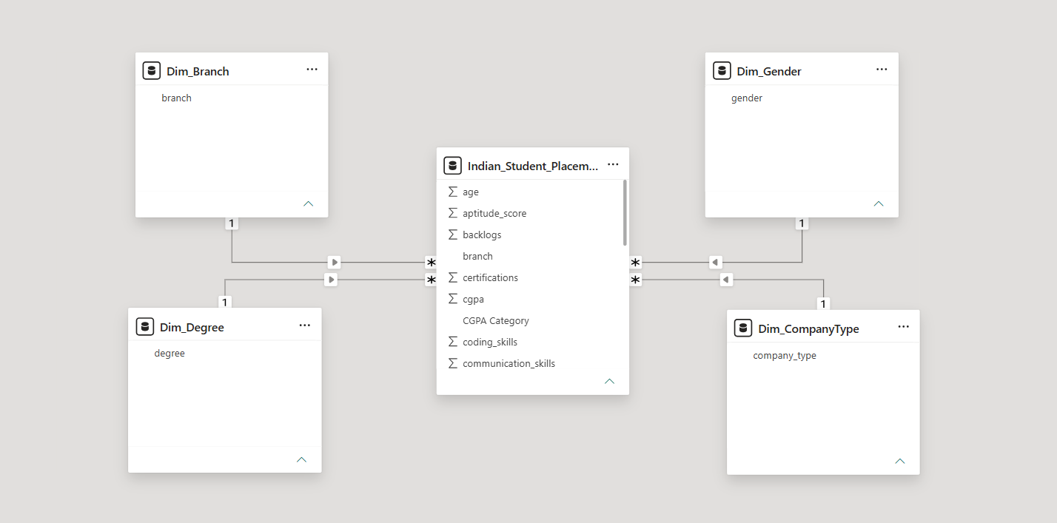

6. Dashboard & Visuals

Describe each page / view in your Power BI report. Include a screenshot of each page.

6.1 Page 1 — Placement Statistics and Trends
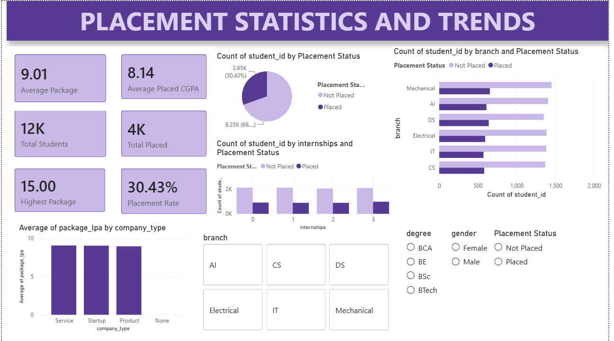
Visuals used on this page:
- KPI Cards — Average Package (LPA), Average Placed CGPA, Total Students, Total Placed Students, Highest Package (LPA), Placement Rate (%)
- Pie Chart — Placement Distribution (Placed vs Not Placed)
- Stacked Bar Chart — Placement by Branch and Placement Status
- Column Chart — Average Package by Company Type
- Slicers — Branch, Degree, Gender, Placement Status
Key insights from this page:
- This page provides an overall overview of the placement performance of students across different branches and degree programs.
- It highlights important metrics such as placement rate, average package offered, highest package received, and average CGPA of placed students.
- Interactive slicers allow users to analyze placement trends based on branch, degree, gender, and placement status.

6.3 Drill-through Page
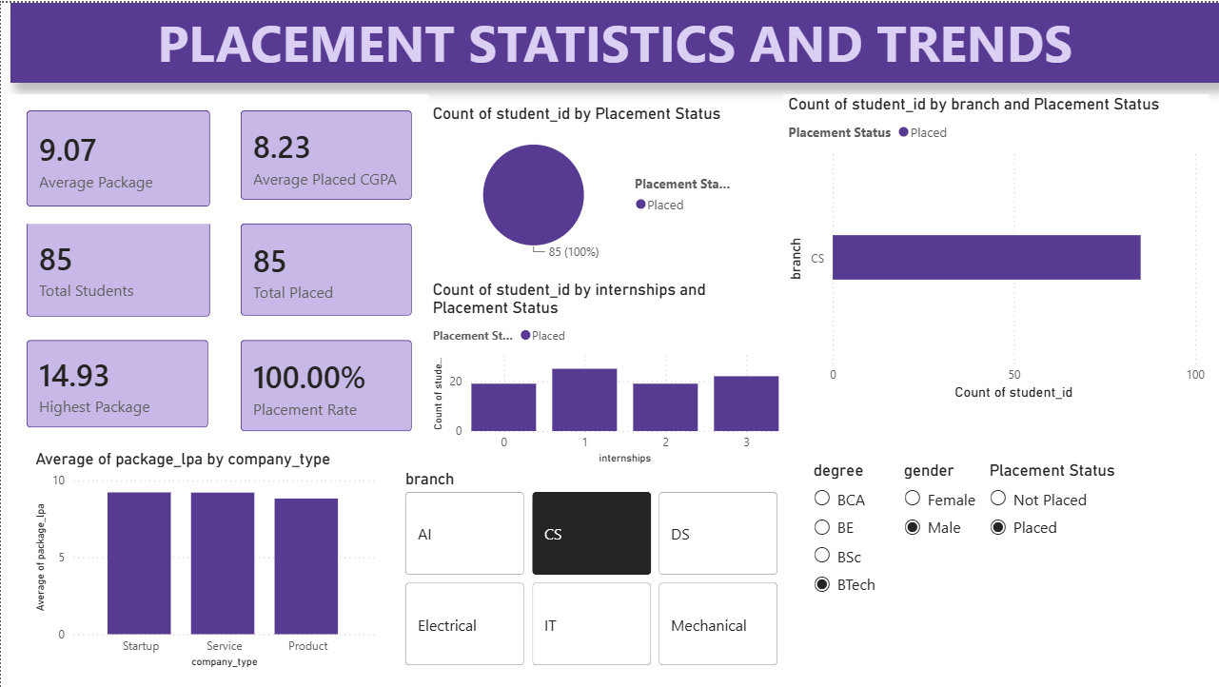
Interactive filters used:
- Branch
- Degree
- Gender
- Placement Status
What this functionality provides:
- Users can dynamically filter the dashboard to analyze placement trends for specific student groups.
- Selecting a value in any slicer automatically updates all related visuals and KPI cards on the page.
- This enables detailed and interactive analysis without requiring separate drill-through pages.

7. Key Findings & Insights

Summarise the top insights your dashboard revealed. Write each insight as a clear, factual statement supported by data. Aim for at least 5 insights.

- Finding 1: The overall placement rate of the institution was 30.43%, with 3,652 students placed out of a total of 12,000 students, indicating significant scope for improving employability and placement preparedness among students.
- Finding 2: The average salary package offered to placed students was 9.01 LPA, while the highest package offered reached 15 LPA, highlighting the availability of high-paying opportunities for top-performing candidates.
- Finding 3: Students with higher CGPA values generally secured better salary packages, indicating a positive relationship between academic performance and placement outcomes.
- Finding 4: Students possessing internships and additional certifications demonstrated better placement performance compared to students without practical experience or industry-recognized credentials.
- Finding 5: Placement opportunities varied considerably across different branches, suggesting that branch specialization plays a significant role in employability and recruitment trends.
- Finding 6: Product-based companies offered higher average salary packages compared to service-based companies and startups, making them the most lucrative employment option for placed students.
- Finding 7: The package distribution analysis revealed that most students received offers within a moderate salary range, while only a small proportion secured premium salary packages.
- Finding 8: Interactive filtering by branch, degree, gender, and placement status enabled deeper analysis of placement trends and helped identify specific student segments requiring additional support and training.

8. Learnings & Challenges

8.1 Skills Learned
- Learned to clean, transform, and prepare raw placement data using Power Query in Power BI.
- Gained experience in performing data analysis using Excel, Pandas, and NumPy for handling structured datasets efficiently.
- Developed skills in creating DAX measures such as Total Students, Total Placed, Placement Rate, Average Package, and Highest Package.
- Learned to design interactive and user-friendly dashboards using KPI cards, charts, slicers, and cross-filtering in Power BI.
- Created visualizations using Matplotlib and Seaborn to analyze placement trends, package distributions, and feature correlations.
- Understood the importance of data preprocessing, aggregation, and visualization in deriving meaningful insights from raw data.
- Learned to build relationships between different data entities and implement a simple star schema data model.
- Improved skills in presenting analytical findings through professional reports and dashboards.

8.2 Challenges Faced

- Challenge 1: Data Cleaning and Preparation
Some columns contained values that required preprocessing and type conversion before analysis could be performed effectively. This was resolved using Power Query transformations and Pandas data cleaning techniques.
- Challenge 2: Choosing Appropriate Aggregations
Initially, fields such as student_id, cgpa, and package_lpa were aggregated incorrectly using Sum or Count in visualizations. This was resolved by understanding when to use Count, Average, Maximum, and Don't Summarize options in Power BI.
- Challenge 3: Creating Meaningful Visualizations
Selecting the most appropriate chart type for each analysis was challenging, especially for package distributions and placement trends. This was addressed by experimenting with different visualizations and choosing those that conveyed insights most effectively.
- Challenge 4: DAX Measure Creation
Writing DAX measures for KPIs such as Placement Rate and Average Package initially produced incorrect results due to filter context issues. This was resolved through a better understanding of CALCULATE, COUNT, AVERAGE, and DIVIDE functions.
- Challenge 5: Dashboard Layout and Design
Organizing multiple KPIs, charts, and slicers into a clean and readable dashboard layout required several iterations to achieve a balance between functionality and visual appeal.
- Challenge 6: Handling Package Distribution
The package histogram initially showed a large concentration of students with 0 LPA, making the visualization less informative. This issue was resolved by applying filters to include only placed students in the package analysis.

9. Conclusion

This project successfully addressed the problem of analyzing and understanding student placement trends using data analytics and business intelligence tools. The College Placement Analytics Dashboard provides valuable insights into placement rates, salary packages, branch-wise performance, and the impact of factors such as CGPA, internships, and certifications on employability. The interactive dashboard enables placement cells, faculty members, and students to make informed decisions using dynamic filters and visualizations instead of relying on static reports or spreadsheets. The project also demonstrated the end-to-end workflow of data cleaning, transformation, analysis, and visualization using Excel, Pandas, NumPy, Matplotlib, Seaborn, and Power BI. Given additional time, features such as predictive placement analysis, drill-through pages, and machine learning models for placement prediction could be incorporated to further enhance the usefulness and capabilities of the dashboard.

10. References

• Microsoft Power BI Documentation
• Dataset Source — Student Placement Prediction Dataset (Kaggle)
• DAX Reference Guide
• Power Query M Language Reference
• Pandas Documentation
• NumPy Documentation
• Matplotlib Documentation
• Seaborn Documentation
END OF REPORT

