**CHAPTER-1**

**INTRODUCTION**

* 1. **Definition of Image**

Data representing a two-dimensional scene. A digital image is composed of pixels arrange in a rectangular array with a certain height and width. Each pixel may consist of one or more bits of information, representing the brightness of the image at that point & possibly including color information encoded as RGB triples.

Picture a visual representation(of an object or scene or person or abstraction) produced on a surface, “they showed us the pictures of their wedding” a movie is a series of image projected so rapidly that the eye integrates them.

Effective indexing and retrieving desired image in a large image database in the bases of features such as color, text & shape that can be automatically extracted from the image themselves.

* 1. **Image Processing**

The analysis of a picture using techniques that can identify shades, color & relationship that cant be perceived by the human eye. Image processing is used to solve identification problems such as in forensic medicine or in creating weather maps from satellite pictures. It deals with images in bitmapped graphics format that have been scanned in or captured with digital camers.

Any image improvement such as refining a picture in a paint program that has been scanned or entered from the video source.

There are two types of methods used for image processing namely, analogue and digital image processing. Analogue image processing can be used for the hard copies like printouts and photographs. Image analysts use various fundamentals of interpretation while using these visual techniques. Digital image processing techniques help in manipulation of the digital images by using computers. The three general phases that all types of data have to undergo while using digital technique are pre-processing, enhancement, and display, information extraction.

In this lecture we will talk about a few fundamental definitions such as image, digital image, and digital image processing. Different sources of digital images will be discussed and examples for each source will be provided. The continuum from image processing to computer vision will be covered in this lecture. Finally we will talk about image acquisition and different types of image sensors.

* 1. **Image Retrieval & Information Retrieval**

Since the 1970’s Image Retrieval has become a very active research topic, with two major research communitites, database managaement& computer vision. One is text-based & another is visual based. Text-based Image Retrieval has become very popular since 1970s, which involves annotating the image with keywords, and used Text based Database Management System(DBMS) to retrieve the images. In text- based image retrieval system,keywords of semantic information are attached to the images.

They can be typed manuallyor by extractying the caption of the images. It is veery efficient for simple and small image databases, since the whole database can be described by just few hundred of keywords. But in the 1990s, several large leaps in the development of processor, memory and storage made the size of image database grow ddramatically. As the image database & image size grow, there will be more images having different contents and the images having rich contents can’t be described by only several semantic keywords. The demand of labor on annotating the image also rises dramatically.

Retrieval Image providing eefective and efficient tool querying large image database. Information retrieval provides the textual represeantation of images. It requires the text description to the respective images.

Recent technology development in various fields has made large digital image database practically. Well organized database and efficient browsing, storing and retrieval algorithms are very important in such systems. Image retrieval techniques were developed to aid these components.

Also the keywords are very dependent on the observer’s interest and they are subjective. Caption are not always precisely describing the pictures.

Indexing and searching a large image database via keywords are time consuming and inefficient. So we are using a technique known as Image processing through Fourier Convolutional Neural Networks.

* 1. **Brain Tumor**

A brain tumor is a collection, or mass, of abnormal cells in your brain. Your skull, which encloses your brain, is very rigid. Any growth inside such a restricted space can cause problems. Brain tumors can be cancerous (malignant) or noncancerous (benign). When benign or malignant tumors grow, they can cause the pressure inside your skull to increase. This can cause brain damage, and it can be life-threatening. Brain tumors are categorized as primary or secondary. A primary brain tumor originates in your brain. Many primary brain tumors are benign. A secondary brain tumor, also known as a metastatic brain tumor, occurs when cancer cells spread to your brain from another organ, such as your lung or breast.

**SYMPTOMS-** The most common symptoms of brain tumor are-

* vomiting
* blurred vision or double vision
* seizures (especially in adults)
* weakness of a limb or part of the face
* a change in mental functioning,confusion

The brain tumor can be easily get into the knowledge of doctor by using the technique known as segmentation in which several images of brain are used and examined by the various deep learning algorithm of soft computing. This technique is necessary since, now a days Doctors are even confused as the MRI scan is not clear.

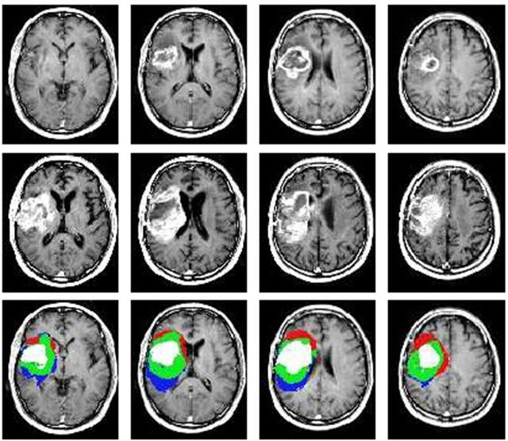

Fig 1: brain tumour analysis

* 1. **Segmentation Of Brain Tumor**

The segmentation of computer aided plays a very crucial role in Computer Aided Brain Tumor Disease diagnosis. Basically, it will depend on the doctor’s subjective experience regarding the disease. This will provide different results of the segmentation based on the different professional knowledge. Each & every individual in this world have different shapes & gray level similarity of their brain.

There are different techniques that can be applied to solve this particular problem that are- Region Growing method, Level set method, Fuzzy Clustering method, Machine Learning method. Most of these methods require manual intervention for segmenting the brain tumor.

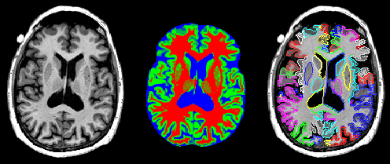

Fig 2: segmentation of human brain

In Region growing method, the user have to manually select the seed point in the image. If the seed point is set in the area of normal tissue then it will be incorrect.There can exist a possibility of oversegmentation due to the occurance of noise & intensity inhomogenity.

The method Fuzzy Clustering is similar to Region Growing but in this it will combines with the other methods- K-means & C-means but still the knowledge of data distribution is required.

Distribution can be considered as Good performance if it will be close to real data distribution.

Another technique that is in demand now a days is Machine Learning. It includes Neural Network & Support Vector Machine(SVM). Accuracy will depend on the correct combination of layers & right choice of feature vectors.

In recent years, deep learning attracted increasing attention in the field of machine learning. Previous work have shown that the deep learning-based CAD system can provide doctors with an objective computerized diagnosis result as reference & it will help to avoid errors.

In this , we will discuss the concept of deep learning that has been proposed to address above challenges. To segment brain tumors, this method fust extracts image patches from medical images and treats the gray level of image patches as the input of the deep learning framework. The Stacked Denoising Auto-Encoder (SDAE), which is one of the deep learning frameworks, will automatically learn the high level latent representation for future classification. Then, the classification result will be mapped into a binary image. Finally, the post-processing step will be adopted to achieve the final segmentation result. In this way, the process of extracting features for the brain tumor can be eliminated.

* 1. **Convolutional Neural Network**

Convolutional Neural Networks (CNNs) are a popular, state-of-theart, deep learning approach to computer vision with a wide range of application in domains where data can be represented in terms of three dimensional matrices.

However, there are increasingly larger datasets to which we wish to apply deep learning and, in the case of deep learning, a growing desire to increase the depth of the networks used in order to achieve better results . This not only increases memory utilisation requirements, but also computational complexity.

Using FCNN images are processed and represented using the Fourier domain to which a convolution mechanism is applied in a manner similar to that used in the context of more traditional CNN techniques. The proposed approach offers the advantage that it reduces the complexity, especially in the context of larger images, and consequently provides for significant increase in network efficiency. The underlying intuition given by the Convolution Theorem which states that for two functions κ and u, we have F(κ ∗ u) = F(κ) F(u) (1) where F denotes the Fourier transform, ∗ denotes convolution. This allows for convolution to be calculated more efficiently using Fast Fourier Transforms (FFTs).

**Pooling**

Convolutional networks may include local or global pooling layers, which combine the outputs of neuron clusters at one layer into a single neuron in the next layer. For example, *max pooling* uses the maximum value from each of a cluster of neurons at the prior layer. Another example is *average pooling*, which uses the average value from each of a cluster of neurons at the prior layer

**Fully connected**

Fully connected layers connect every neuron in one layer to every neuron in another layer. It is in principle the same as the traditional multi-layer perceptron neural network ([MLP](https://en.wikipedia.org/wiki/Multilayer_perceptron)).

**Weights**

CNNs share weights in convolutional layers, which means that the same filter (weights bank) is used for each receptive field in the layer; this reduces memory footprint and improves performance.

* 1. **Semantic Segmentation basics and overview**

Semantic segmentation describes the process of associating each pixel of an image with a class label, (such as flower, person,road, sky, ocean, or car).

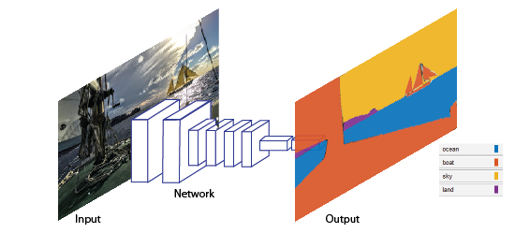

Fig 3: Semantic Segmentation overview

Applications for semantic segmentation include:

* Autonomous driving
* Industrial inspection
* Classification of terrain visible in satellite imagery
* Medical imaging analysis

### Train a Semantic Segmentation Network

The steps for training a semantic segmentation network are as follows:

1. [Analyze Training Data for Semantic Segmentation](https://www.mathworks.com/help/vision/ug/semantic-segmentation-examples.html#mw_44be2a2e-ec6b-4a03-9470-ea945f74515e)

2. [Create a Semantic Segmentation Network](https://www.mathworks.com/help/vision/ug/semantic-segmentation-examples.html#mw_6ab02754-d2fa-4330-8bea-3eeec77279da)

3. [Train A Semantic Segmentation Network](https://www.mathworks.com/help/vision/ug/semantic-segmentation-examples.html#mw_c2dc3c5f-86f8-4835-be60-9799bfe66ced)

4. [Evaluate and inspect the results of semantic segmentation](https://www.mathworks.com/help/vision/ug/semantic-segmentation-examples.html#mw_9ca2a7be-c8c2-4bbf-b168-128261d1be7d)

5. [Import Pixel Labeled Dataset For Semantic Segmentation](https://www.mathworks.com/help/vision/ug/semantic-segmentation-examples.html#mw_3f922f31-adfb-4b75-9572-2eb93054c83b)

### Label Training Data for Semantic Segmentation

You can use the [**Image Labeler**](https://www.mathworks.com/help/vision/ref/imagelabeler-app.html) app to interactively label pixels and export the label data for training. The app can also be used to label rectangular regions of interest (ROIs) and scene labels for image classification.

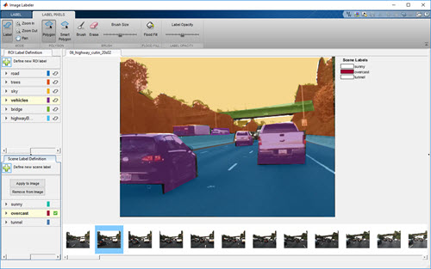

Fig 4: Label training data for semantic segmentation

* 1. **MRI (Magnetic resonance imaging) Scan**

Magnetic resonance imaging is a [medical imaging](https://en.wikipedia.org/wiki/Medical_imaging) technique used in [radiology](https://en.wikipedia.org/wiki/Radiology) to form pictures of the [anatomy](https://en.wikipedia.org/wiki/Anatomy) and the physiological processes of the body in both health and disease. [MRI scanners](https://en.wikipedia.org/wiki/Physics_of_magnetic_resonance_imaging#MRI_scanner) use strong [magnetic fields](https://en.wikipedia.org/wiki/Magnetic_field), [electric field gradients](https://en.wikipedia.org/wiki/Electric_field_gradient), and [radio waves](https://en.wikipedia.org/wiki/Radio_wave) to generate images of the organs in the body. MRI does not involve [X-rays](https://en.wikipedia.org/wiki/X-rays) and the use of [ionizing radiation](https://en.wikipedia.org/wiki/Ionizing_radiation), which distinguishes it from [CT or CAT scans](https://en.wikipedia.org/wiki/CT_scan). Magnetic resonance imaging is a [medical application](https://en.wikipedia.org/wiki/Nuclear_magnetic_resonance#Medicine) of [nuclear magnetic resonance](https://en.wikipedia.org/wiki/Nuclear_magnetic_resonance) (NMR). NMR can also be used for *imaging* in other [NMR applications](https://en.wikipedia.org/wiki/Nuclear_magnetic_resonance#Applications) such as [NMR spectroscopy](https://en.wikipedia.org/wiki/Nuclear_magnetic_resonance_spectroscopy).

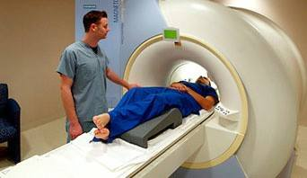

Fig 5: MRI scanning machine

While the hazards of X-rays are now well-controlled in most medical contexts, MRI may still be seen as a better choice than CT. MRI is widely used in hospitals and clinics for [medical diagnosis](https://en.wikipedia.org/wiki/Medical_diagnosis), [staging](https://en.wikipedia.org/wiki/Cancer_staging) of disease and follow-up without exposing the body to [radiation](https://en.wikipedia.org/wiki/Ionizing_radiation).

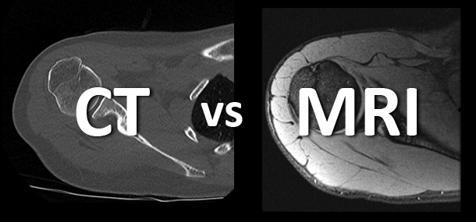

Fig 6: CT scan vs MRI scan

However, MRI may often yield different diagnostic information compared with CT. There may be risks and discomfort associated with MRI scans. Compared with CT scans, MRI scans typically take longer and are louder, and they usually need the subject to enter a narrow, confining tube.

MRI was originally called 'NMRI' (nuclear magnetic resonance imaging) and is a form of NMR, though the use of 'nuclear' in the acronym was dropped to avoid negative associations with the word. Certain [atomic nuclei](https://en.wikipedia.org/wiki/Atomic_nucleus) are able to absorb and emit [radio frequency](https://en.wikipedia.org/wiki/Radio_frequency)energy when placed in an external [magnetic field](https://en.wikipedia.org/wiki/Magnetic_field). In clinical and research MRI, [hydrogen atoms](https://en.wikipedia.org/wiki/Hydrogen) are most often used to generate a detectable radio-frequency signal that is received by antennas in close proximity to the anatomy being examined. Hydrogen atoms are naturally abundant in people and other biological organisms, particularly in [water](https://en.wikipedia.org/wiki/Properties_of_water) and [fat](https://en.wikipedia.org/wiki/Lipid). For this reason, most MRI scans essentially map the location of water and fat in the body. Pulses of radio waves excite the [nuclear spin](https://en.wikipedia.org/wiki/Nuclear_spin) energy transition, and magnetic field gradients localize the signal in space. By varying the parameters of the [pulse sequence](https://en.wikipedia.org/wiki/Pulse_sequence), different contrasts may be generated between tissues based on the [relaxation](https://en.wikipedia.org/wiki/Relaxation_(NMR)) properties of the hydrogen atoms therein.

## Common uses of the procedure:

MR imaging of the body is performed to evaluate:

* organs of the chest and abdomen—including the heart, [liver](https://www.radiologyinfo.org/en/glossary/glossary.cfm?gid=27), [biliary tract](https://www.radiologyinfo.org/en/glossary/glossary.cfm?gid=664), [kidneys](https://www.radiologyinfo.org/en/glossary/glossary.cfm?gid=152), [spleen](https://www.radiologyinfo.org/en/glossary/glossary.cfm?gid=237), bowel, [pancreas](https://www.radiologyinfo.org/en/glossary/glossary.cfm?gid=189), and adrenal glands.
* pelvic organs including the bladder and the reproductive organs such as the uterus and ovaries in females and the prostate gland in males.
* blood vessels (including MR Angiography).
* lymph nodes.

Physicians use an MR examination to help diagnose or monitor treatment for conditions such as:

* tumors of the chest, abdomen or pelvis.
* diseases of the liver, such as cirrhosis, and abnormalities of the bile ducts and pancreas.
* inflammatory bowel disease such as [Crohn’s disease](https://www.radiologyinfo.org/en/info.cfm?pg=crohns-disease) and ulcerative colitis.
* heart problems, such as congenital heart disease.
* malformations of the blood vessels and inflammation of the vessels (vasculitis).
* a fetus in the womb of a pregnant woman.

**The equipment used:**

The traditional MRI unit is a large cylinder-shaped tube surrounded by a circular magnet. You will lie on a moveable examination table that slides into the center of the magnet.

Some MRI units, called [short-bore systems](https://www.radiologyinfo.org/en/glossary/glossary.cfm?gid=673), are designed so that the magnet does not completely surround you. Some newer MRI machines have a larger diameter bore which can be more comfortable for larger size patients or patients with claustrophobia. Other MRI machines are open on the sides (open MRI). Open units are especially helpful for examining larger patients or those with claustrophobia. Newer open MRI units provide very high quality images for many types of exams.

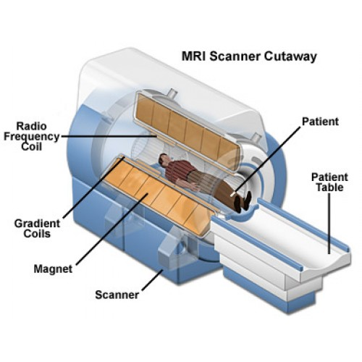

Fig 7: MRI scan machine internal view

Older open MRI units may not provide this same image quality. Certain types of exams cannot be performed using open MRI. For more information, consult your radiologist.

The computer workstation that processes the imaging information is located in a separate room from the scanner.

## The Procedure:

Unlike conventional x-ray examinations and computed tomography (CT) scans, MRI does not utilize ionizing radiation. Instead, radiofrequency pulses re-align hydrogen atoms that naturally exist within the body while you are in the scanner without causing any chemical changes in the tissues. As the hydrogen atoms return to their usual alignment, they emit different amounts of energy that vary according to the type of body tissue from which they come. The MR scanner captures this energy and creates a picture of the tissues scanned based on this information.

The magnetic field is produced by passing an electric current through wire coils in most MRI units. Other coils, located in the machine and in some cases, placed around the part of the body being imaged, send and receive radio waves, producing signals that are detected by the coils. The electric current does not come in contact with the patient.

A computer then processes the signals and generates a series of images, each of which shows a thin slice of the body. The images can then be studied from different angles by the interpreting radiologist.

Frequently, the differentiation of abnormal (diseased) tissue from normal tissues is better with MRI than with other imaging modalities such as x-ray, CT and ultrasound.

**CHAPTER-2**

**LITERATURE SURVEY**

A literature survey or a literature review in a project report is that section which shows the various analyses and research made in the field of your interest and the results already published, taking into account the various parameters of the project and the extent of the project.

It is the most important part of your report as it gives you a direction in the area of your research. It helps you set a goal for your analysis - thus giving you your problem statement.

**2.1 Literature Review**

A literature review is both a summary and explanation of the complete and current state of knowledge on a limited topic as found in academic books and journal articles. The focus and perspective of your review and the kind of hypothesis or thesis argument you make will be determined by what kind of review you are writing. One way to understand the differences between these two types is to read published literature reviews or the ﬁrst chapters of theses and dissertations in your own subject area. Analyse the structure of their arguments and note the way they address the issues.

The whole process of reviewing includes:

a. Searching for literature  
b. Sorting and prioritising the retrieved literature  
c. Analytical reading of papers  
d. Evaluative reading of papers  
e. Comparison across studies  
f. Organising the content  
g. Writing the review

* 1. **Deep Learning With Segmentation Method**

In recent years, deep learning attracted increasing attention in the field of machine learning. Previous works have shown that the deep learning-based CAD system can provide doctors with an objective computerized diagnosis result as a reference, and it also can help doctors to avoid some errors in diagnosing and treating [17-22]. Particularly, Havaei et.al.have successfully integrated the Convolutional Neural Networks (CNN) into the Deep Neural Networks based segmentation framework for segmenting the brain tumor in MR images.

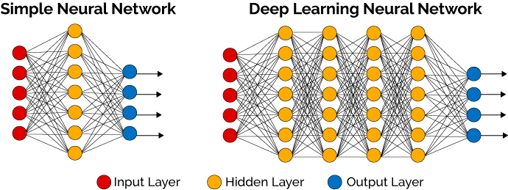

Fig 8: Comparison between Simple and Deep Learning Neural Network

In the paper, a novel coarse-to-fme method, which is based on the concept of deep learning, has been proposed to address above challenges. To segment brain tumors, this method fust extracts image patches from medical images and treats the gray level of image patches as the input of the deep learning framework. The Stacked Denoising Auto-Encoder (SDAE), which is one of the deep learning frameworks, will automatically learn the high level latent representation for future classification. Then, the classification result will be mapped into a binary image. Finally, the post-processing step will be adopted to achieve the final segmentation result. In this way, the process of extracting features for the brain tumor can be eliminated. Another advantage of this proposed method is that a prior knowledge is not needed to assume the nonlinear data distribution.

The result of image segmentation is a set of segments that collectively cover the entire image, or a set of [contours](https://en.wikipedia.org/wiki/Contour_line) extracted from the image . Each of the pixels in a region are similar with respect to some characteristic or computed property, such as [color](https://en.wikipedia.org/wiki/Color), [intensity](https://en.wikipedia.org/wiki/Luminous_intensity), or [texture](https://en.wikipedia.org/wiki/Image_texture). Adjacent regions are significantly different with respect to the same characteristics. When applied to a stack of images, typical in [medical imaging](https://en.wikipedia.org/wiki/Medical_imaging), the resulting contours after image segmentation can be used to create [3D reconstructions](https://en.wikipedia.org/wiki/3D_reconstruction) with the help of interpolation algorithms like [Marching cubes](https://en.wikipedia.org/wiki/Marching_cubes).

* 1. **Image Processing Through Artificial Neural Network**

Auto-Encoder is one type of the Artificial Neural Network. It consists of the three layers- input layer, hidden layer, output layer. Every layer in ANN is trained to minimize a reconstruction cross-entropy. The user have to provide the input vector x€[o,1]^d, and first map it to a latent representation y€[0,1]^d through a deterministic mapping y=fo(x) =sigm (Wx+ b), parameterized by Θ={W, b}. W is weight matrix & b is bias vector. The resulting latent representation y is then mapped back to a reconstructed vector Z E [0, it by another deterministic mapping z=go'(x)=sigm(W'y+b') with Θ'={W',b'}. Thus each training sample xi is mapped to a corresponding latent representation y, and a reconstruction vector zi.

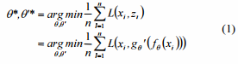

Where L is the reconstruction cross- entropy:



It is basically carried out by the stochastic gradient descent.

In order to improve its ability the software must require a clean fresh input rathen than partially destroyed input that is obtained from the previous step. This will first corrupts the initial input x to obtain the partially destroyed version x’ . The auto-encoder will be trained to ' fill-in' these artificially introduced ' blanks' . The corrupted input X l is then mapped to a hidden representation y=fo(x') =sigm (Wx'+b) , and then reconstructs hidden representation y to z=ge.(x)=sigm(W'y+b'). Similarly, parameters are also trained to minimize the average reconstruction error L(x,z), but the difference is that z is now a deterministic function of X l and the objective function now becomes:



**PreTraining&FineTraining-**

It include various steps as follows-

**Step 1**: Training the first layer as an auto-encoder to minimize the average reconstruction error.

**Step 2**: The first hidden layer's representation is used as the input of the second hidden layer, and trained to be the second auto-encoder. Then the third layer will be trained in the same way.

**Step 3**: After a few layers have been trained, the last hidden layer output will be treated as the input of the output layer.

This technique is known as pre-training. Now we can also use fine training.

Fine Training involves the the output from the output layer must be applied as an input to the input layer.

The procedure of a deep network, which employs the denoising auto-encoder, can be simply considered to minimize the objective function in Eq. (3) instead of the objective function in Eq. (1).

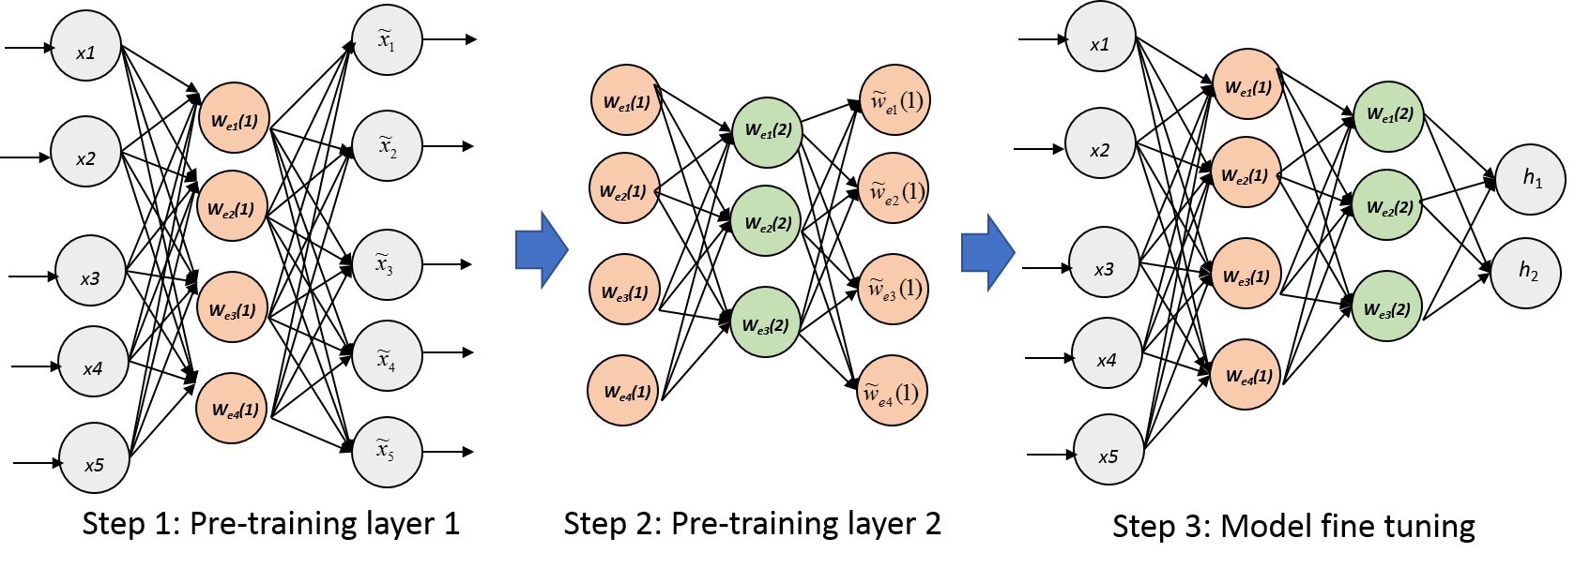

Fig. 9. A deep architecture of our multi-layer stacked denoising auto-encoder network & the two-step parameter optimization scheme.

* 1. **Tumor Detection Using Feed Forward Neural Network**

In this, the MRI data along with the class-label, the method fIrst extracts image patches from the preprocessed MR images. The gray level of image patches is input into the deep network, and then is trained by adopting the SDAE.The output of this step is used as an input to the next step.In order to reduce the computation complexity, we first crop image based on the brain size in MRI, and then adjust image brightness and contrast to keep the consistency of images. For each image patch, the class-label of the central point is regarded as the class-label of whole image patch.

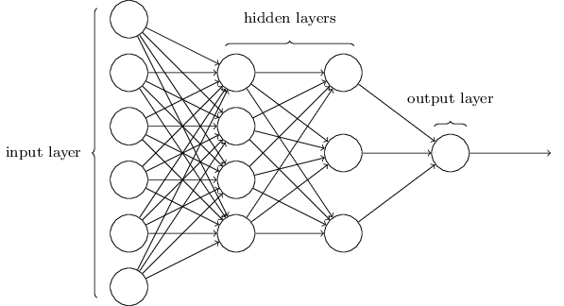

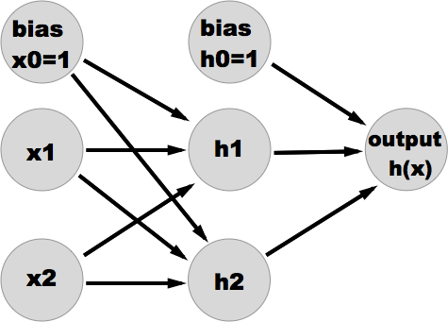

Fig 10. FFNN with n inputs and 1 output

After this step, it will proceed to the next step where it will be treated as in input to the multiple hidden layers. we put the output from the 1st hidden layers as the input for the 2nd denoising auto-encoder and train it. The following hidden layers will be trained in the same way. We adopt the SDAE to initialize a Feed Forward Neural Network(FFNN). Thus, we further optimize this network by employing the backpropagation with the method of the stochastic gradient descent, and apply this new network to classify image patches of the test image. Finally, we treat the class-label of image patch as the class-label of its center point, and map it back to the original test image to generate a binary image for representing the primal segmentation result.

Now we will consider the post processing of this image. Due to the strong contrast between the tumor and the surrounding tissue, we first draw a gradation histogram for all points which have been treated as the tumor, and then according to the gray level distribution, we will select an intermediate gray level and directly apply this gray level to divide points which have been classified as the tumor. If a point's gray level is less than the intermediate gray level, we will regard that this point is belonging to the normal tissue.In order to eliminate the remaining speckles and fill in these cavities, a morphological filter including close and open operation is applied. The close operation can smooth the outline of image, fuse the narrow gap and fill in the hole.

**2.5 Brain Tumor detection using Convolutional Neural Network**

GLIOMAS are the brain tumors with the highest mortality rate and prevalence. The accurate segmentation of gliomas and its intra-tumoral structures is important not only for treatment planning, but also for follow-up evaluations. However, manual segmentation is time-consuming and subjected to inter- and intra-rater errors difficult to characterize.

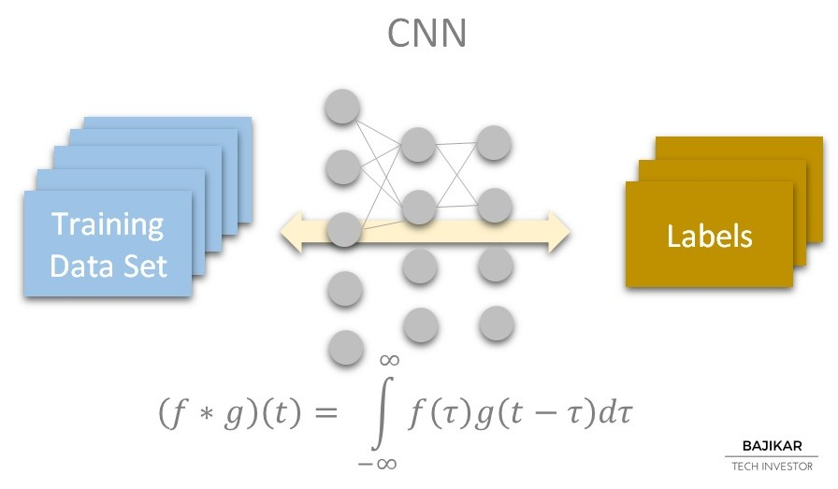

Fig 11: CNN Input and output set analysis

In this paper, inspired by the groundbreaking work of Simonyan and Zisserman on deep CNNs, we investigate the potential of using deep architectures with small convolutional kernels for segmentation of gliomas in MRI images. Simonyan and Zisserman proposed the use of small 3 3 kernels to obtain deeper CNNs. With smaller kernels we can stack more convolutional layers, while having the same receptive field of bigger kernels.At the same time, it has the advantages of applying more non-linearities and being less prone to overfitting because small kernels have fewer weights than bigger kernels.

We also investigate the use of the intensity normalization method proposed by Nyúl*et al.* as a pre-processing step that aims to address data heterogeneity caused by multi-site multi-scanner acquisitions of MRI images. The large spatial and structural variability in brain tumors are also an important concern that we study using two kinds of data augmentation.

**CHAPTER-3**

**PROBLEM FORMULATION**

Brain tumor segmentation is an important task in medical image processing. Manual segmentation of the brain tumors for cancer diagnosis, from large amount of MRI images generated in clinical routine, is a difficult and time consuming task. There is a need for automatic brain tumor image segmentation.

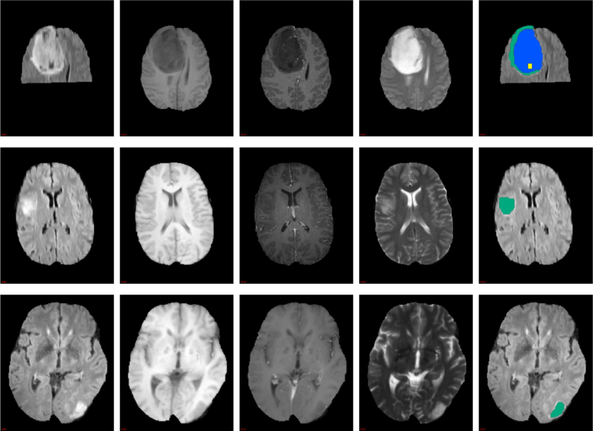

Fig 12: The task in image processing is to semantic

segmentation of brain MRI to detect tumor

In the image above the image classification model takes a single image and creates its multiple semantic images so that it will become easy to find the tumor present in brain along with its size,color. Accordingly noise have to be removed so that our detection will be correct.

**3.1 Challenges**

Since the task of recognizing a visual concept is relatively trivial for a human to perform, it is considering the challenges involved from the perspective of a Computer Vision algorithm. As we present list of challenges below,keep in mind the raw representation of images using semantic segmentation:

* **Viewpoint variation**- A single instance of an object can be oriented in many ways with respect to the camera.
* **Scale variation**- Visual classes often exhibit variation in their size(size in real world,not only in terms of their extent in the image)
* **Deformation**- Many objects of interest are not rigid bodies and can be deformed in extreme ways.
* **Occlusion**- The objects of interest can be occluded. Sometimes only a small portion of an object(as little as few pixels)could be visible.
* **Illumination condition**- The effects of illumination are drastic on the pixel level.
* **Noise-** The noise will effect the result to a great extent.
* **Accuracy-** Now a days results of MRI are not very accurate that can satisfy the doctors.

**CHAPTER-4**

**PROPOSED WORK**

Recent performances of deep learning methods, specifically Convolutional Neural Networks (CNNs), in several object recognition and biological image Segmentation26 challenges increased their popularity among researches. In contrast to traditional classification methods, where hand crafted features are fed into, CNNs automatically learn representative complex features directly from the data itself. Due to this property, research on CNN based brain tumor segmentation mainly focuses on network architecture design rather than image processing to extract features.

There are three main stages:

* pre-processing,
* classification via FCNN
* post-processing.

**4.1 Preprocessing**

In order to reduce the computation complexity, we firstcrop image based on the brain size inMRI, and then adjustimage brightness and contrast to keep the consistency ofimages.Technologies in preprocessing procedure mainlyinclude brightness transforming and histogram processing.After that, we regard the manual segmentation as the groundtruth, and set a label for each point in the image based on theground truth. Then we extract the smaller image patch with thesize of 25x25 for each MR image. For each image patch, theclass-label of the central point is regarded as the class-label ofwhole image patch.

All points' gray level is connected to along vector and forms a 625 dimensions gray level sequence.This long vector is used as the input vector. According to thisway, no additional features are required.

**4.2 Fourier Convolution Neural Network(FCNN)**

The FCNN was implemented using the deep learning frameworks Keras and Theano. Theano is the machine learning backend of Keras. This backend was used to code the Fourier layers. The Theano FFT function Theano was used to convert our training and test data.

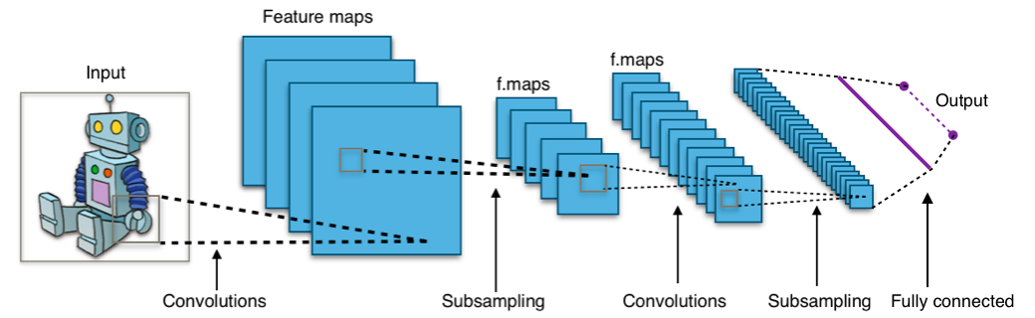

Fig 13: A standard FCNN network model

The Theano FFT function is a tensor representation of the multi-dimensional CooleyTukey algorithm. This function is the n-dimensional discrete Fourier transform over any number of axes in an m-dimensional array by using FFT. The multi-dimensional discrete Fourier transform used is defined as:

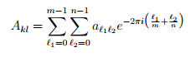

where the image is of size m × n. The comparative methods of spatial convolution and max-pooling used throughout this paper relate to Keras and Theano’s implementations. To demonstrate the ability of the FCNNs implementation of all the core CNN layers in the Fourier domain we use the network architectures shown in supplementary.

**4.2.1 Fourier Convolution Layer**

In traditional CNNs discrete convolutions between the images uj and kernel functions κi are carried out using the sliding window approach. That is, a window the size of the kernel matrix is moved across the image. The convolution is computed as the sum of the Hadamard product of the image patch with the kernel:

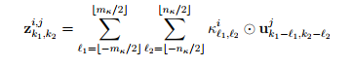

which results in an (mu − mκ) × (nu − nκ) image z since the image is usually re-sized to avoid including boundary artefacts in calculations. At each point (k1, k2), there are mknkoperations required and so (mu − mκ+1)(nu − nκ+1)mknk operations are needed for a single convolution.

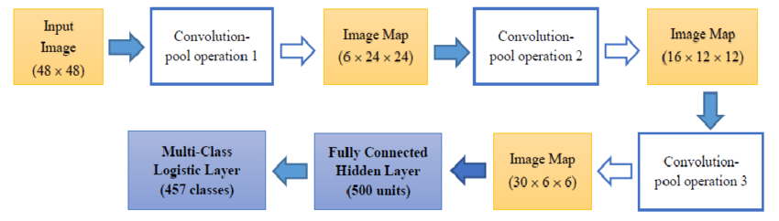

Fig.14: The FCNN Model for feature classification

With respect to the proposed FCNN the Nk complex Fourier kernels are initialised using glorotinitialisation. The parameter n is equivalent to the number of kernel filters in the spatial network. Glorotinitialisation was adopted because it is more efficient than doing FFT transformations of spatial kernels as this would require lots of FFTs during training to update the numerous convolution kernels. The weights for our Fourier convolution layer are defined as our initialised Fourier kernels. Hence, the Fourier kernels are trainable parameters optimised during learning, using back propagation, to find the best Fourier filters for the classification task with no FFT transformations relating to the convolution kernels required. Another benefit of Fourier convolutions is not only the speed of the convolutions, but that we can perform pooling during the convolution phase in order to save more computation cost.

A novel element of our convolution kernels is that, because they remain in the Fourier domain throughout, they have the ability to learn the equivalent of arbitrarily large spatial kernels limited only by initial image size. The image size is significantly larger than the size selected by spatial kernels. That is, our Fourier kernels which match the image size can learn a good representation of a 3 × 3 spatial kernel or a 5 × 5 spatial kernel depending on what aids learning the most. This is a general enhancement of kernel learning in neural networks as most networks typically learn kernels of a fixed size, reducing the ability of the network to learn the spatial kernel of the optimal size. In the Fourier domain, we can train to find not only the optimal spatial kernel of a given size but the optimal spatial kernel size and the optimal spatial kernel itself.

**4.2.2 Fourier Pooling Layer**

In the Fourier domain, the image data is distributed in a differ manner to the spatial. This allows us to reduce the data size by the same amount that it would be reduced by in the spatial domain but retain more information. High frequency data is found towards the centre of a Fourier matrix and low frequency towards the boundaries. Therefore, we truncate the boundaries of the matrices as the high frequency Fourier data contains more of the spatial information that we wish to retain. Our Fourier pooling layer shown in Figure 1, operates as follows. Given a complex 3 dimensional tensors of X × Y × Z dimensions, and AN arbitrary pool size variable relating to the amount of data we wish to retain. For x ∈ X,:

xy min = (0.5 − pool size 2 ) × Y,

xy max = (0.5 + pool size 2 ) × Y (6)

xz min = (0.5 − pool size 2 ) × Z,

xz max = (0.5 + pool size 2 ) × Z (7)

This method provides a straightforward Fourier pooling layer for our FCNN. It has a minimal number of computation operations for the GPU to carry out during training. The equivalent method in the spatial context is max-pooling, which takes the maximum value in a k×k window where k is a chosen parameter. For example if k = 2, max-pooling reduces the data size by a quarter by taking the maximum value in the 2×2 matrices across the whole data.

Similarly, in our Fourier pooling we would take

pool size = 0.25 which,

using equations 6 and 7,gives us:

xy min = 0.375 × Y, xy max = 0.625 × Y

xz min = 0.375 × Z, xz max = 0.625 × Z (9)

which also reduces our data by a quarter.

**4.3 Post Processing**

Some small clusters may be erroneously classified as tumor.To deal with that, we impose volumetric constrains by removingclusters in the segmentation obtained by the CNN thatare smaller than a predefined threshold .

The small kernels used in neural networks mean that when training on larger images the amount of memory required to store all the convolution kernels on the GPU for parallel training is no longer viable. Using the Nvidia K40c GPU and a spatial convolution with 3 × 3 kernels the feed forward process of our network architecture cannot run a batch of images once image size approaches 2 9 . The proposed Fourier convolution mechanism requires less computational memory when running in parallel. The memory capacity is not reached using the Fourier convolution mechanism until images of a size four times greater to the maximum size using the spatial domain are arrived at. This is due to the operational memory required for spatial convolution compared to the Fourier convolution. The FCNN is able to train much larger images of the same batch size because the kernels are initialised in the Fourier domain, we initialise a complex matrix with the size matching the image size. Our convolutions are matrix multiplications and we are not required to pass across the image in a sliding window fashion, where extra storage is needed. The only storage we require is for the Fourier kernels, which are the same size as the images.

**CHAPTER-5**

**SYSTEM DESIGN**

In this system some useful methods are applied to achieve an expected result. These methods are ordered according their usage. The overall process flow of the proposed system is shown below:

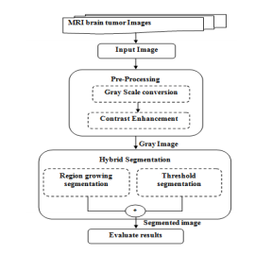

Fig.15: The FCNN Model for feature classification

**5.1 Pre-Processing**

The input images are abnormal brain tumor MRI images. Even the MRI image having high definition in visualizing soft tissues, there is a need of contrast enhancement . Before this, gray scale conversion is needed because it reduces complexity than color image. Practically, the MRI images are enhanced using the combinations of contrast, median filter and stationary wavelet methods gave better result for segmentation.

The aim of pre-processing is an improvement of the image data that suppresses unwanted distortions or enhances some image features important for further processing.

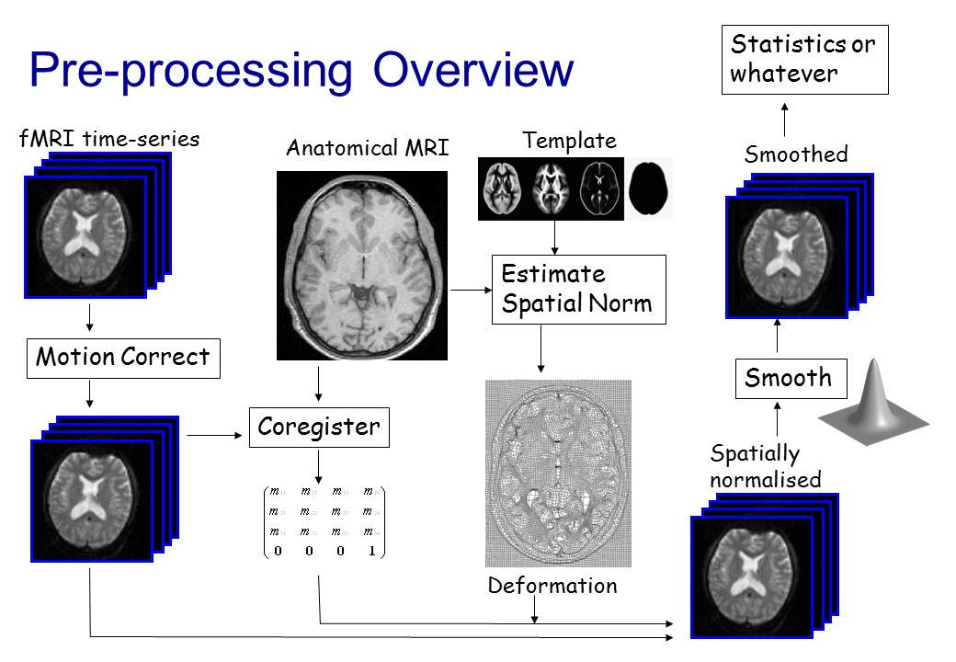

Fig16. Preprocessing overview

**5.2 Hybrid Segmentation Approach**

Hybrid segmentation is a prime method and an appealing approach to attaining the targeted brain tumor image segmentation. The major problem in single seed region growing is inability to expose the holes in the tumor. So this problem is revealed by this hybrid segmentation technique. The expected result can be done by the combined techniques of single seed region growing and single threshold segmentation. The performance of this proposed hybrid technique result depends on similarity measures used by the method and its implementation. Before proceeding to the performance evaluation part, a brief methodology of the hybrid segmentation algorithms is given below:

**5.2.1. Seed Region Growing**

This technique is accomplished by using single seed point . A single seed point or pixel is taken and all the neighboring pixels are related to this seed forms the region r. The following criteria involved in the region growing segmentation:

1. Seed point should be selected automatically.

2. Seed point must have minimum distance with its neighbor pixels.

3. For a predictable region, at least one seed should be generated to produce the region.

4. Seeds of different regions should be disconnected.

During implementation, the minimum pixel distance is taken as a default process. The region is iteratively grown by evaluating all non-distributed neighboring pixels to the region. The variation between the value of pixel intensity and the mean of region is used as a measure of similarity. The pixel with the minimum difference measured is allocated to the particular region. This process stops when the intensity variation between region mean and new region become larger than a certain seed. Finally the output image is given by combining both the regions. Thus the segmented image using single seed region growing is formed as a binary image. From the process which are less working favorable with the region growing segmentation so, to improve its performance by using threshold segmentation. Finally performance is analyzed by the appropriate measures.

**5.2.2. Threshold segmentation method**

Threshold is one of the image segmentation methods which are predominantly used to selecting an appropriate threshold value T, the gray image can be converted into binary image. The outcome should contain the entire decisive information about the objects position and shape. The threshold value (T) is obtained from the gray image and it can be classified into black (0), and White (1). The global threshold is used and the objective function is

**g(x, y) = 1 𝑖𝑓 𝑓𝑥, 𝑦>𝑇**

**0 𝑖𝑓 𝑓𝑥, 𝑦 ≤ 𝑇**

Where 𝑓𝑥, 𝑦 is an input image, g(x,y) threshold/segmented image, T threshold value.

The process of threshold segmentation is:

1. Initial estimate of threshold T.

2. Perform segmentation using T

(i) P1, pixels brighter than T

(ii) P2, pixels darker than T.

3. Apply average intensities m1 and m2 of P1 and P2.

4. Compute new threshold value

**T(new)** = 𝒎𝟏+𝒎𝟐 /𝟐

5. If │T – T(new)│˃ΔT, repeat step 2.

Where m1 and m2 are mean of intensities, P1 and P2 is a probability of brighter and darker pixels and T and T(new) are the thresholds. While it is natural and convergence, it can get enclosed in local mean and results can differ considerably depending on the thresholds. It can be obtaining the significant result when its combined with region growing segmentation.

The hybrid segmentation is the combination of Single seed region growing and threshold based segmentation which has been proposed to segment brain tumor images. This can be helped to improve the results of region growing segmentation. The new hybrid method is applied on several images and experiment results of performance are compared and analyzed with the ground truth image. In this work, comparative analysis of various performance metrics have been obtainable. It gives a clear decision from the experiments and performance that evaluating algorithms on an image data set leads to different ranking depending on the metrics chosen**.**

**5.2.3. Gray Scale Image**

In [photography](https://en.wikipedia.org/wiki/Photography), [computing](https://en.wikipedia.org/wiki/Computing), and [colorimetry](https://en.wikipedia.org/wiki/Colorimetry), a grayscale or greyscale [image](https://en.wikipedia.org/wiki/Image) is one in which the value of each [pixel](https://en.wikipedia.org/wiki/Pixel) is a single [sample](https://en.wikipedia.org/wiki/Sample_(signal))representing only an *amount* of light, that is, it carries only [intensity](https://en.wikipedia.org/wiki/Luminous_intensity) information. Images of this sort, also known as [black-and-white](https://en.wikipedia.org/wiki/Black-and-white) or monochrome, are composed exclusively of shades of [gray](https://en.wikipedia.org/wiki/Grey), varying from black at the weakest intensity to white at the strongest.

Grayscale images are distinct from one-bit bi-tonal black-and-white images, which in the context of computer imaging are images with only two [colors](https://en.wikipedia.org/wiki/Color), [black](https://en.wikipedia.org/wiki/Black) and [white](https://en.wikipedia.org/wiki/White) (also called *bilevel* or [*binary images*](https://en.wikipedia.org/wiki/Binary_image)). Grayscale images have many shades of gray in between.

Grayscale images can be the result of measuring the intensity of light at each pixel according to a particular weighted combination of frequencies (or wavelengths), and in such cases they are [monochromatic](https://en.wikipedia.org/wiki/Monochromatic_light) proper when only a single [frequency](https://en.wikipedia.org/wiki/Frequency) (in practice, a narrow band of frequencies) is captured. The frequencies can in principle be from anywhere in the [electromagnetic spectrum](https://en.wikipedia.org/wiki/Electromagnetic_spectrum) (e.g. [infrared](https://en.wikipedia.org/wiki/Infrared), [visible light](https://en.wikipedia.org/wiki/Visible_spectrum), [ultraviolet](https://en.wikipedia.org/wiki/Ultraviolet), etc.).

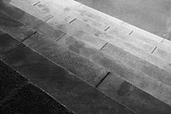

Fig 17: Grayscale image due to intensity of light

A [colorimetric](https://en.wikipedia.org/wiki/Colorimetry) (or more specifically [photometric](https://en.wikipedia.org/wiki/Photometry_(optics))) grayscale image is an image that has a defined grayscale [colorspace](https://en.wikipedia.org/wiki/Colorspace), which maps the stored numeric sample values to the achromatic channel of a standard colorspace, which itself is based on measured properties of human vision.

If the original color image has no defined colorspace, or if the grayscale image is not intended to have the same human-perceived achromatic intensity as the color image, then there is no unique mapping from such a color image to a grayscale image.

**5.2.4 K-Means Clustering**

*k*-means clustering is a method of [vector quantization](https://en.wikipedia.org/wiki/Vector_quantization), originally from [signal processing](https://en.wikipedia.org/wiki/Signal_processing), that is popular for [cluster analysis](https://en.wikipedia.org/wiki/Cluster_analysis) in [data mining](https://en.wikipedia.org/wiki/Data_mining). *k*-means clustering aims to [partition](https://en.wikipedia.org/wiki/Partition_of_a_set) *n* observations into *k* clusters in which each observation belongs to the [cluster](https://en.wikipedia.org/wiki/Cluster_(statistics)) with the nearest [mean](https://en.wikipedia.org/wiki/Mean), serving as a prototype of the cluster.

The problem is computationally difficult ([NP-hard](https://en.wikipedia.org/wiki/NP-hardness)); however, there are efficient [heuristic algorithms](https://en.wikipedia.org/wiki/Heuristic_algorithm) that are commonly employed and converge quickly to a [local optimum](https://en.wikipedia.org/wiki/Local_optimum). These are usually similar to the [expectation-maximization algorithm](https://en.wikipedia.org/wiki/Expectation-maximization_algorithm) for [mixtures](https://en.wikipedia.org/wiki/Mixture_model) of [Gaussian distributions](https://en.wikipedia.org/wiki/Gaussian_distribution) via an iterative refinement approach employed by both *k*-means and Gaussian Mixture Modeling.

The algorithm has a loose relationship to the [*k*-nearest neighbor classifier](https://en.wikipedia.org/wiki/K-nearest_neighbor), a popular [machine learning](https://en.wikipedia.org/wiki/Machine_learning) technique for classification that is often confused with *k*-means because of the *k* in the name.

**Initialisation Methods-**

Commonly used initialization methods are Forgy and Random Partition.[[9]](https://en.wikipedia.org/wiki/K-means_clustering#cite_note-hamerly-9) The Forgy method randomly chooses k observations from the data set and uses these as the initial means. The Random Partition method first randomly assigns a cluster to each observation and then proceeds to the update step, thus computing the initial mean to be the centroid of the cluster's randomly assigned points. {\displaystyle m_{i}^{(t+1)}={\frac {1}{|S_{i}^{(t)}|}}\sum _{x_{j}\in S_{i}^{(t)}}x_{j}}

**CHAPTER-6**

**IMPLEMENTATION**

**6.1 Software Requirements**

MATLAB is a high-performance language for technical computing. It integrates computation, visualization, and programming in an easy-to-use environment where problems and solutions are expressed in familiar mathematical notation. Typical uses include:

* Math and computation
* Algorithm development
* Modeling, simulation, and prototyping
* Data analysis, exploration, and visualization
* Scientific and engineering graphics
* Application development, including Graphical User Interface building

The MATLAB application is built around the MATLAB scripting language. Common usage of the MATLAB application involves using the Command Window as an interactive mathematical [shell](https://en.wikipedia.org/wiki/Command_line_interface) or executing text files containing MATLAB code.

**Structures**

MATLAB has structure data types. Since all variables in MATLAB are arrays, a more adequate name is "structure array", where each element of the array has the same field names. In addition, MATLAB supports dynamic field names (field look-ups by name, field manipulations, etc.). Unfortunately, MATLAB JIT does not support MATLAB structures, therefore just a simple bundling of various variables into a structure will come at a cost.

**Functions**

When creating a MATLAB function, the name of the file should match the name of the first function in the file. Valid function names begin with an alphabetic character, and can contain letters, numbers, or underscores. Functions are often case sensitive.

**Function handles**

MATLAB supports elements of [lambda calculus](https://en.wikipedia.org/wiki/Lambda_calculus) by introducing function handles, or function references, which are implemented either in .m files or anonymous/nested functions.

Classes and object-oriented programming

MATLAB supports [object-oriented programming](https://en.wikipedia.org/wiki/Object-oriented_programming) including classes, inheritance, virtual dispatch, packages, pass-by-value semantics, and pass-by-reference semantics. However, the syntax and calling conventions are significantly different from other languages. MATLAB has value classes and reference classes, depending on whether the class has handle as a super-class (for reference classes) or not (for value classes).

**6.2 OTHER REQUIREMENTS**

This project requires

* Ram 4GB
* Processor Core-i3
* CUDA®-enabled NVIDIA® GPU with compute capability 3.0 or higher
* Images of MRI scan for detection of brain tumor

**6.3 SOURCE CODE**

The Brain tumor segmentation to detect in which part of brain is suffering from tumor and accuracy along with error is given by the code written below:-

**CODE-**

%ROI ,Segement GLCM feature

clearall;

closeall;

clc;

file='.../CTScans/1/';

for file = 1:1

fname = [num2str(file) '.jpg'];

% read and normalize image (grayscale)

I = double(imread('1.jpg'));

I=I(:,:,1);

I = (I - min(I(:))) / (max(I(:)) - min(I(:)));

% construct simple initialization for gaussian noise with gray scaling (figure:1)

[M,N] = size(I);

u0 = zeros(M,N);

u0(ceil(M/4):floor(3*M/4), ceil(N/4):floor(3*N/4)) = 1; % central square init

FontSize = 10;

initImage = imread(fname);

initImage = imread('D:\Brain tumor\Benign\2.jpg');

initImage = initImage(:,:,1);

figure(1);

imshow(initImage);

title('Input');

[rows, columns] = size(initImage);

initImage = (initImage);

initImage = wiener2(initImage,[10 10]);

figure(2);

imshow(initImage);

title('Weiner filtered Image');

% Set parameters apply on eular matrix for min max that cover gray scale image

% means firstly apply gray the we have to apply eular matrix on binary

% image

switch file

case 1

lambda = [7.5 6.5];

beta = 0.12;

tau_u = 15;

gamma = 0.2;

alpha = 600;

rho = 0.75;

tau_L = 2*rho;

case 2

lambda = [2 2];

beta = 2;

tau_u = 10;

gamma = 0.12;

alpha = 275;

rho = 0.75;

tau_L = 2*rho;

case 3

lambda = [2 2];

beta = 2;

tau_u = 10;

gamma = 0.12;

alpha = 1000;

rho = 0.75;

tau_L = 2*rho;

case 4

lambda = [1 1];

beta = 0.1;

tau_u = 100;

gamma = 0.1;

alpha = 500;

rho = 0.75;

tau_L = 2*rho;

case 5

lambda = [1 1];

beta = 0.1;

tau_u = 100;

gamma = 0.12;

alpha = 200;

rho = 0.75;

tau_L = 2*rho;

case 6

lambda = [1 1];

beta = 15;

tau_u = 25;

gamma = 0.05;

alpha = 1000;

rho = 0.75;

tau_L = 2*rho;

end

% run all four models

% for type = {'CV', 'CVX', 'CVB', 'CVXB'}

for type = {'CVB', 'CVXB'}

%I=initImage;

% actual processing

[mu, u, X, S, B, i] = CVXB( I, u0, lambda, alpha, beta, gamma, rho, tau_u, tau_L, type{1} );

% % figure('Name', [fname ' - ' type{1}]);

% figure(3);

% % subplot(231);

imagesc( u ); title( 'Gray Scale Image' ); axis tight; axis off;

figure(3);

% %subplot(232);

imagesc( X ); title( 'Skull Detection' ); colormapgray; axis tight; axis off;

figure(5);

%subplot(233);

imagesc( (S - min(S(:)))/(max(S(:))-min(S(:))) ); title( 'kmeans' ); colormapgray; axis tight; axis off;

figure(6);

% subplot(234);

imagesc( (B - min(B(:)))/(max(B(:))-min(B(:))) ); title( 'Enhanced Image' ); colormapgray; axis tight; axis off;

figure(7);

% subplot(235);

Iseg = hsv2rgb( cat(3, zeros(M,N), u, 0.25+0.75*I) );

image(Iseg ); title('Clustering using Kmeans'); axis tight; axis off;

figure(8);

%subplot(236);

Iseg0 = hsv2rgb( cat(3, zeros(M,N), u0, 0.25+0.75*I) );

image( Iseg0 );

title(' Area of interest ');

[B, A] = imhist(initImage);

C=A.*B;

D=A.*A;

E=B.*D;

n=sum(B);

Mean=sum(C)/sum(B);

var=sum(E)/sum(B)-Mean*Mean;

std= (var)^0.5;

thresholdValue = Mean+0.5*std;

bwImage = initImage>thresholdValue;

% figure(7)

% imshow(bwImage)

% title('binary image');

img_dil = imdilate(bwImage , strel('arbitrary', 20));

% figure(9)

% imshow(img_dil);

% title('dilated image');

bwImage = imerode(img_dil , strel('arbitrary', 20 ));

% figure(10)

% imshow(bwImage);

% title('Threshold level');

bigMask = bwareaopen(bwImage, 2000);

finalImage = bwImage;

finalImage(bigMask) = false;

bwImage=bwareaopen(finalImage,55);

% figure(9)

% imshow(bwImage)

labeledImage = bwlabel(bwImage, 8);

RegionMeasurements = regionprops(labeledImage, initImage, 'all');

Ecc = [RegionMeasurements.Eccentricity];

RegionNo = size(RegionMeasurements, 1);

allowableEccIndexes = (Ecc< 0.98);

keeperIndexes = find(allowableEccIndexes);

RegionImage = ismember(labeledImage, keeperIndexes);

bwImage=RegionImage;

figure(11)

imshow(RegionImage)

title('Mask Seeded Region Growing ');

%%%%%

GLCM2 = graycomatrix(RegionImage,'Offset',[2 0;0 2]);

Feature_Extraction_Using_GLCM = Untitled3(GLCM2,0)

%disp('Feature Extraction Using GLCM',num2str(stats));

clearlabeledImage;

clearRegionMeasurements;

clearRegionNo;

labeledImage = bwlabel(bwImage, 8);

RegionMeasurements = regionprops(labeledImage, initImage, 'all');

[B,t] = simplefit_dataset;

net = feedforwardnet(10);

net = train(net,B,t);

% view(net)

y = net(B);

perf = perform(net,y,t);

end

end

figure(12)

imshow(initImage);

title('Final detection', 'FontSize', FontSize);

axisimage;

holdon;

boundaries = bwboundaries(bwImage);

numberOfBoundaries = size(boundaries, 1);

for k = 1 : numberOfBoundaries

thisBoundary = boundaries{k};

plot(thisBoundary(:,2), thisBoundary(:,1), 'r', 'LineWidth', 3);

end

holdoff;

RegionMeas = regionprops(labeledImage, initImage, 'all');

RegionNo = size(RegionMeas, 1);

textFontSize = 14;

labelShiftX = -7;

RegionECD = zeros(1, RegionNo);

rng('default')

disp('Starting Execution')

n=100;m=4;

actual=round(rand(1,n)*m);

predict=round(rand(1,n)*m);

% [c_matrix,Result]= confusionmat(actual,predict)

[c_matrixp,Result]= confusionmat(actual,actual);

disp('Getting Values')

Accuracy=Result.Accuracy

Error=Result.Error

Sensitivity=Result.Sensitivity

Specificity=Result.Specificity

Precision=Result.Precision

FalsePositiveRate=Result.FalsePositiveRate

F1_score=Result.F1_score

MatthewsCorrelationCoefficient=Result.MatthewsCorrelationCoefficient

Kappa=Result.Kappa

disp('_________________________________________')

disp('_________________________________________')

disp('_________________________________________')

disp('_________________________________________')

% %%

%Multiclass

disp('Confusion Matrix')

n=100;m=2;

actual=round(rand(1,n)*m);

predict=round(rand(1,n)*m);

[c_matrix,Result,RefereceResult]= confusionmat(actual,predict);

%

% %DIsplay off

% % [c_matrix,Result,RefereceResult]= confusionmat(actual,predict,0)

%%

%Two Class

disp('_________________________________________')

disp('_________________________________________')

disp('_________________________________________')

disp('_________________________________________')

disp('Accuracy of Proposed Method')

n=100;m=1;

actual=round(rand(1,n)*m);

predict=round(rand(1,n)*m);

% [c_matrix,Result]= confusionmat(actual,predict)

[c_matrix,Result]= confusionmat(actual,predict);

fprintf(1,'Region number Area Perimeter Cancer Detected Centroid Diameter\n');

for k = 1 : RegionNo

RegionArea = RegionMeas(k).Area;

RegionPerimeter = RegionMeas(k).Perimeter;

RegionCentroid = RegionMeas(k).Centroid;

RegionECD(k) = sqrt(4 * RegionArea / pi);

fprintf(1,'#%2d %11.1f %8.1f %8.1f %8.1f % 8.1f\n', k, RegionArea, RegionPerimeter, RegionCentroid, RegionECD(k));

text(RegionCentroid(1) + labelShiftX, RegionCentroid(2), num2str(k), 'FontSize', textFontSize, 'FontWeight', 'Bold');

end

**CHAPTER-7**

**RESULT ANALYSIS**

On the execution of the code provided in Chapter-6, it will take the the image of brain tumor whose address is given in the code in “.jpg” format and it will segment that image in different forms.

It will provide perform segmentation in following steps.

* Input image is provided.

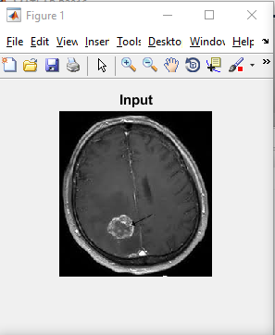

Fig 18: Input image to the executed code

* After taking image as an input, it will be converted into gray scale image as shown below

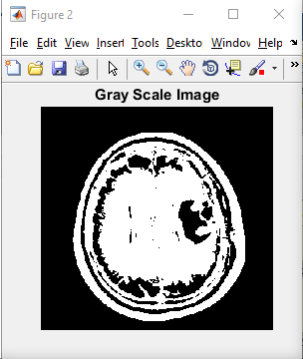

Fig 19: Gray Scale Image

* Next step output will be given is of SKULL DETECTION.

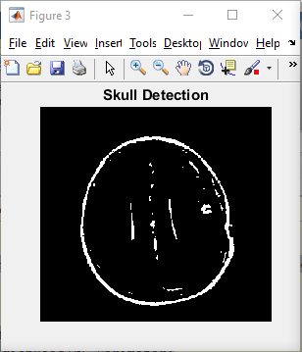

Fig 20: Skull Detection

* K-Means clustering technique used in further step to obtain the next image.

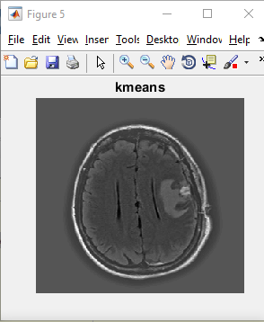

Fig 21: k-means

* Now the main aim is to obtain ENHANCED IMAGE.

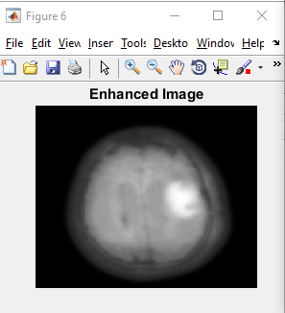

Fig 22: Enhanced Image

* When all the segmented images are obtained then clustering have to be performed . In this image it uses K-MEANS CLUSTERING.

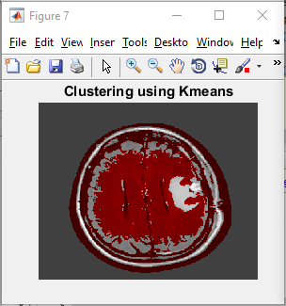

Fig 23 : Clustering Using Kmeans

* After clustering, the image display the red color mark on the area in which we have to work further.

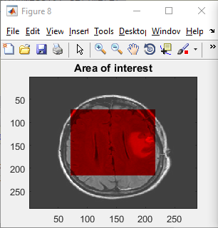

Fig 24: Area Of Interest

* Now the mark in the output is compared with other images in the database that is differ from normal brain images so that Tumor can be detected along with the region in which it is growing.

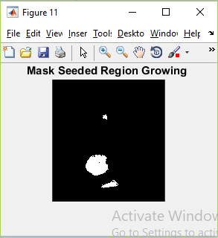

Fig 25: Mask Seeded Region Growing

* In the final stage the part is detected and marked which contains Tumor.

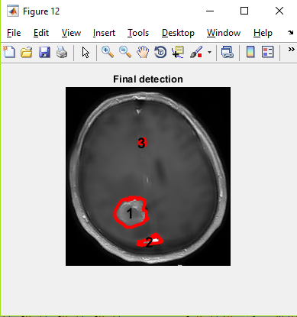

Fig 26: Final Tumor Detection

* Now the FCNN technique will begin to check the accuracy, error & other parameters in the result.

In the beginning we have to take the 5 samples.

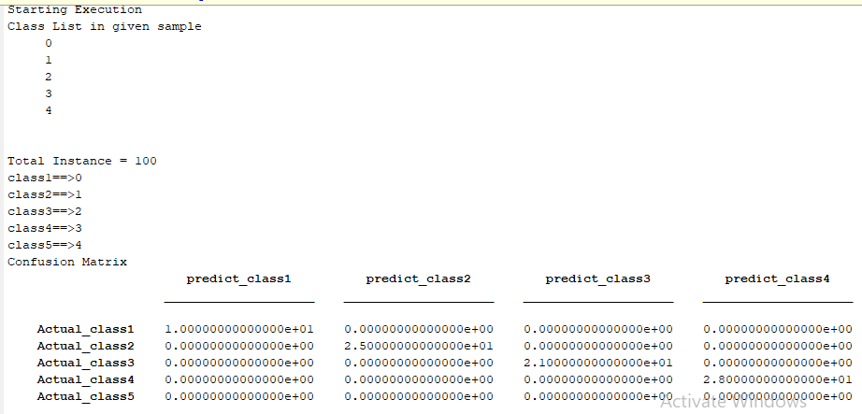

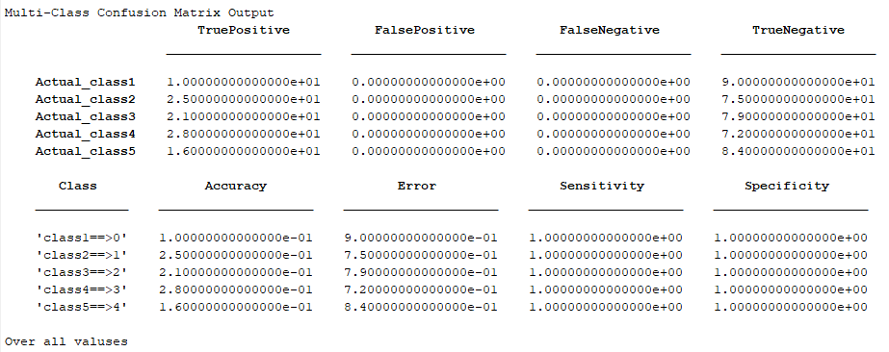

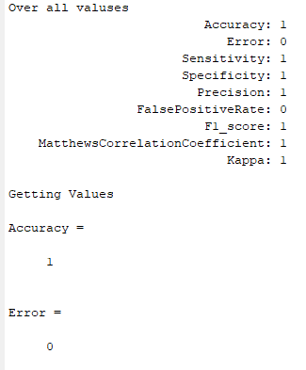

Table 1: 5 Training Samples

In this case we have to work on 3 samples i.e. given by

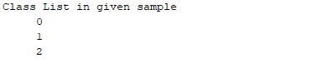

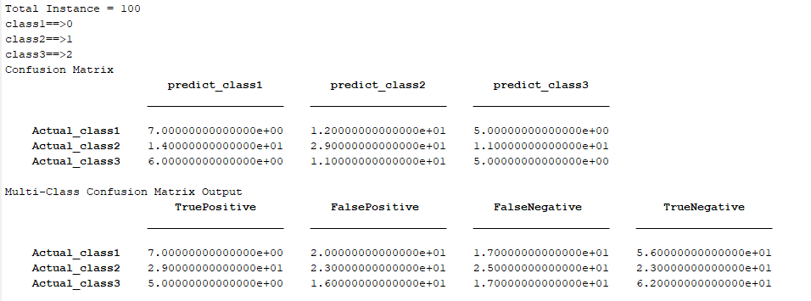

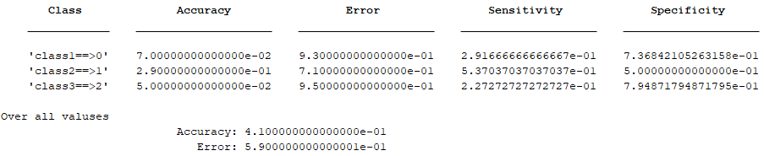

Table 2: 3 Training Samples

**In the last stage on 2 samples, in which one will contain tumor and another will do not contain tumor.**

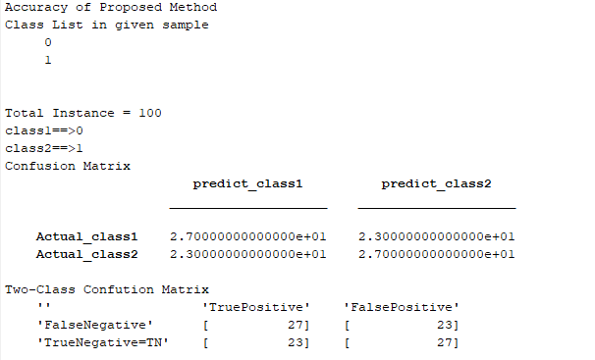

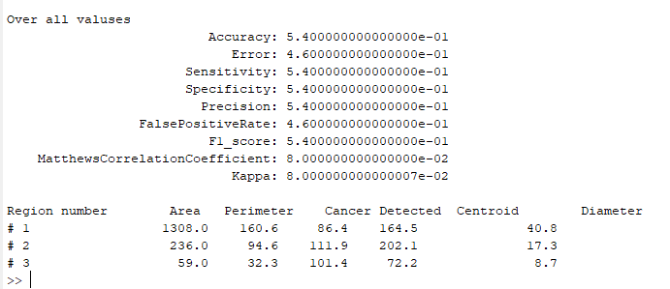

Table 3: 2 Training Samples

**CHAPTER 8**

**CONCLUSION AND FUTURE WORK**

**8.1 CONCLUSION**

Segmentation of brain image is imperative in surgical planning and treatment planning in the field of medicine. In this work, we have proposed a computer aided system for brain MR image segmentation for detection of tumor location using K - means clustering algorithm followed by morphological filtering. We were able to segment tumor from different brain MRI images from our database.

This provide a novel deep learning based algorithm for segmenting the brain tumor. However, the deep learning algorithm not only can automatically segment the brain tumor, but also can learn a deep nonlinear network, realizes the approximation of complex function,and describes the input data distribution. In this paper, we integrate the Stacked Denoising Auto Encoder into the segmentation procedure, and combine it with the preprocessing and post-processing steps so as to improve the segmentation result. The proposed method has the ability to achieve higher classification accuracy and obtain a good matching rate between the segmentation result and the ground truth.

**8.2 FUTURE WORK**

In order to improve the proposed method and to apply theprovided prototype into the real situation of segmenting thebrain tumor, there are some future works need to be done. Firstof all, only the gray level is put into the deepnetwork as the input, in future, we can employ more features,such as texture features, as the input of the deep network. Inaddition, more brain tumor MRI data is needed to becontinuously collected. More data benefit not only ourproposed method, but also for other tumor classification system.After all, a clinical validation should be further given.

**REFERENCES**

1. Balasubramanian, c.; Ramasamy, K.; Srinivasagan, K.; Rama-krishnan,K., **Automatic Segmentation of Brain Tumor from MR Image Using Region Growing Technique**. *Journal of Pattern Recognition & Image Processing 2013, 4 (3), 273-282*
2. Clarke, 1.; Velthuizen, R.; Camacho, M.; Heine, J.; Vaidyanathan, M.; Hall, 1.; Thatcher, R.; Silbiger, M., **MRI segmentation: methods and applications**. *Magnetic resonance imaging 1995, 13 (3), 343-368.*
3. Kharat, K. D.; Kulkarni, P. P.; Nagori, M., **Brain tumor classification using neural network based methods**. *International Journal of Computer Science and Informatics 2012, I (4).*
4. Lenvine, M.; Shaheen, S., **A modular computer vision system for image segmentation.** *IEEE Trans. on Pattern Analysis and Machine Intelligence 1981,3 (5), 540-557*.
5. Menze, B. H.; Jakab, A; Bauer, S.; Kalpathy-Cramer, J.; Farahani, K.; Kirby, J.; Burren, Y.; Porz, N.; Siotboom, 1.; Wiest, R., **The multimodal brain tumor image segmentation benchmark (BRATS*).*** *Medical Imaging, IEEE Transactions on 2015, 34 (10), 1993-2024.*
6. Mohamed Fathima, M.; Manimegalai, D.; Thaiyalnayaki, S**. In Automatic detection of tumor subtype in mammograms based On GLCM and DWT features using SVM,** *Information Communication and Embedded Systems (ICICES), 2013 International Conference on, IEEE: 2013; pp 809-813*.
7. Rana, R.; Bhdauria, H.; Singh, A. **In: Brain tumour extraction from MRI images using bounding-box with level set method**, *Contemporary Computing (IC3), 2013 Sixth International Conference on, IEEE: 2013; pp 319-324*.
8. Selvakumar, 1.; Lakshmi, A; Arivoli, T**. In: Brain tumor segmentation and its area calculation in brain MR images using K-mean clustering and Fuzzy C-mean algorithm,** *Advances in Engineering, Science and Management (ICAESM), 2012 International Conference on, IEEE: 2012; pp 186-190*.
9. Sridhar, D.; Murali Krishna, I. V. **In: Brain tumor classification using discrete cosine transform and probabilistic neural network,** S*ignal Processing Image Processing & Pattern Recognition (ICSIPR), 2013 International Conference on, IEEE: 2013; pp 92-96.*
10. Yamasaki, T.; Chen, T.; Yagi, M.; Hirai, T.; Murakami, R**. In: GrowCutbased fast tumor segmentation for 3D magnetic resonance images,** *SPIE Medical Imaging, International Society for Optics and Photonics: 2012; pp 831434-831434-8.*
11. D. Ciresan et al., “**Deep neural networks segment neuronal membranes in electron microscopy images,”** *in Adv. Neural Inform. Process. Syst., 2012, pp. 2843–2851.*
12. M. Havaei et al., **Brain tumor segmentation with deep neural networks 2015 [Online].** Available: <http://arxiv.org/abs/1505.03540>, ArXiv:1505.03540v1
13. R. Meier et al., “**Appearance-and context-sensitive features for brain tumor segmentation,**” *in MICCAI Brain Tumor Segmentation Challenge (BraTS), 2014, pp. 20–26*.
14. D. N. Louis et al., “**The 2007 who classification of tumours of the central nervous system,**” A*ctaNeuropathologica, vol. 114, no. 2, pp. 97–109, 2007.*
15. X. Glorot and Y. Bengio, “**Understanding the difficulty of training deep feedforward neural networks,**” *in Proc. Int. Conf. Artif. Intell. Stat., 2010, pp. 249–256*
16. G. Urban et al., “**Multi-modal brain tumor segmentation using deep convolutional neural networks**,” *MICCAI Multimodal Brain Tumor Segmentation Challenge (BraTS), pp. 1–5, 2014*
17. V. Rao, M. Sharifi, and A. Jaiswal, “**Brain tumor segmentation with deep learning**,”*MICCAIMultimodal Brain Tumor Segmentation Challenge (BraTS), pp. 56–59, 2015.*
18. Wu, G.; Kim, M.; Wang, Q.; Gao, Y.; Liao, S.; Shen, D., **Unsupervised deep feature learning for deformable registration of MR brain images*.*** *In Medical Image Computing and Computer-Assisted InterventionMlCCAI 2013, Springer: 2013; pp 649-656*.