**Question 1**

Write a python program that takes two numbers as the input such as X and Y and print the result of X^Y(X to the power of Y) ?

**Answer 1**

x = int(input("Enter Value of x"))

y = int(input("Enter Value of y"))

print("X^Y is:", pow(x,y))

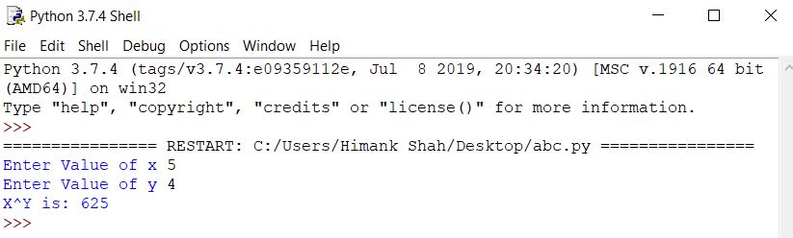

**Question 2**

Write a Python program to print the numbers in the list which are divisible by 3?

**Answer 2**

x = int(input("Enter range of list"))

lst=[]

for i in range(1,x):

if i%3==0:

lst.append(i)

print(lst)

