B.Tech Capstone / Course Project Submission
Course: Intelligent NoSQL Databases (CSE494)
THREATLENS AI:
A MongoDB-Based Network Intrusion Detection
and Traffic Analysis System Using Machine Learning
An End-to-End System Integrating NoSQL Document Store Modeling, Server-Side Aggregations, and Dual-Task Machine Learning Pipelines
Candidate Name: | [STUDENT NAME]
Registration / Roll No: | [REGISTRATION NUMBER]
Course Code & Title: | CSE494 - Intelligent NoSQL Databases
Department: | [DEPARTMENT OF COMPUTER SCIENCE & ENGINEERING]
Faculty Supervisor: | [FACULTY NAME]
Academic Institution: | [UNIVERSITY / INSTITUTION NAME]
Submission Date: | October 29, 2026

Abstract
Modern enterprise computing infrastructure faces an unprecedented volume of complex network-borne cyber threats. Traditional relational database systems struggle to ingest, query, and analyze high-velocity network flow telemetry due to rigid schema constraints, write-lock contention, and expensive join operations across heterogeneous protocol attributes. This project presents ThreatLens AI, an intelligent network intrusion detection and traffic baselining architecture built natively on the MongoDB NoSQL document database and scikit-learn machine learning framework. The system models multi-protocol network flows as flexible BSON documents in a dedicated collection, enforces schema integrity through an idempotent bulk upsert pipeline, and leverages compound indexes to support sub-millisecond query execution. Two independent machine learning models were trained: a Random Forest classifier detecting malicious intrusions with 96.42% accuracy and an F1-score of 0.9270, and a Random Forest regressor estimating flow transfer volumes with an R² score of 0.8954 and Mean Absolute Error of 42,383.9 bytes. The complete system includes an interactive PyMongo CRUD demonstration suite, an automated evaluation pipeline, a Streamlit analytical dashboard, and a 35-test automated verification suite.
📌 MANDATORY ACADEMIC PROVENANCE DISCLOSURE: This report and prototype evaluate synthetic demonstration data generated deterministically via NumPy (seed 42). The reported metrics prove the correctness, resilience, and operational validity of the end-to-end NoSQL/ML software architecture, rather than empirical real-world intrusion detection capability on unconstrained live production backbones.

1. Introduction and Problem Statement
Network Intrusion Detection Systems (NIDS) constitute the first line of defense in modern cybersecurity perimeters. Every network transaction—ranging from basic DNS resolutions to multi-gigabit encrypted TLS handshakes—generates structured telemetry summarizing packet counts, byte volumes, durations, flag ratios, and connection states. Effectively monitoring and triage-analyzing this telemetry presents two fundamental technological challenges:
- 1. NoSQL Storage & Ingestion Bottlenecks: Network flows arrive at rates exceeding thousands of events per second. Relational database schemas (RDBMS) impose strict tabular normalization. When flows from different protocols (TCP, UDP, ICMP) contain different diagnostic parameters (e.g., TCP flags vs. ICMP type codes), relational databases either suffer from sparse, mostly-NULL columns or require normalized child tables that necessitate costly JOIN operations during analytical scans. Furthermore, RDBMS ACID locking creates severe throughput degradation during high-rate bulk inserts.
- 2. Multi-Task Analytics & Machine Learning Integration: Network defense requires not only binary threat detection (identifying malicious DoS, port scan, brute force, or probe flows) but also precise continuous volume baselining (estimating payload volume for bandwidth provisioning, QoS enforcement, and exfiltration detection). Traditional security appliances keep database storage disconnected from ML pipelines, leading to data synchronization delays and brittle feature engineering handoffs.
ThreatLens AI bridges this divide by deploying MongoDB as an intelligent, high-throughput analytical repository directly coupled to dual Random Forest machine learning pipelines via PyMongo.

2. Objectives and Scope
The primary academic and technical objectives of this project are:
- • Design and implement a document-oriented MongoDB schema for network flow telemetry that encapsulates variable protocol features.
- • Implement robust, idempotent PyMongo ingestion using bulk write operations (UpdateOne with upsert=True) to eliminate duplicate records.
- • Construct targeted B-tree indexes and compound indexes to accelerate both single-flow point lookups and analytical range queries.
- • Engineer a dual-task machine learning framework featuring an Intrusion Detection Classifier and a Flow Volume Regressor.
- • Enforce rigorous data isolation and leakage-prevention protocols, ensuring zero target or identifier leakage across an 80/20 stratified split.
- • Provide interactive NoSQL demonstrations covering CRUD, aggregation pipelines, $lookup relational joins, and execution plan explain().
- • Deliver an end-to-end verified prototype on Windows, verified by automated unit tests and an interactive Streamlit dashboard.

3. System Architecture and Workflow
ThreatLens AI is organized into modular layers adhering to separation-of-concerns principles. The architecture consists of four interconnected subsystems: Data Generation & Ingestion, Intelligent NoSQL Storage, Machine Learning Training & Evaluation, and Unified Presentation.
Subsystem Layer | Core Python Modules | Primary Responsibility
Data Layer | scripts/generate_data.py  src/data_loader.py | Generates 12,000 synthetic flows, computes 80/20 stratified split, and performs schema validation.
NoSQL Database Layer | src/database.py  src/seed_database.py  src/db_demo.py | Manages MongoDB connections, index creation, idempotent bulk upserts, and aggregation pipelines.
Machine Learning Layer | src/preprocessing.py  src/train_classifier.py  src/train_regressor.py  src/evaluate.py | Encodes features with ColumnTransformer, fits Random Forests on train split, and computes test metrics and plots.
Inference & Presentation | src/predict.py  app.py (Streamlit) | Provides unified CLI and browser-based inference, persisting prediction snapshots to MongoDB.

4. Dataset Description and Provenance
The dataset consists of 12,000 synthetic network flow records generated via NumPy's default_rng(seed=42). The generation logic establishes distinct, overlapping attack signatures modeled after realistic network telemetry:
- • Denial of Service (DoS - 10% / 1,200 flows): Characterized by very high source packet counts (500–5,000), near-zero destination packets, elevated connection rates, and high SYN flag ratios in syn_sent state.
- • Port Scanning (7% / 840 flows): Exhibits high unique destination port counts (35–600) with minimal packet counts per connection, resulting in rejected or reset TCP states.
- • Brute Force (5% / 600 flows): Concentrated on SSH (port 22) and FTP (port 21) services, displaying high failed login counts (5–45) and moderate connection rates.
- • Network Probing (3% / 360 flows): Comprises low-rate ICMP and multi-port scans across low-order ports with moderate unique destination counts.
- • Normal Benign Traffic (75% / 9,000 flows): Diverse baseline traffic across HTTP, HTTPS, DNS, SMTP, and internal services.
To prevent trivial separability and accurately simulate real-world telemetry noise, three realistic difficulty mechanisms were incorporated: (1) 8% of attack flows are stealthy, drawn from normal-like distributions; (2) 5% of benign flows exhibit bursty transmission characteristics; (3) 2% random label noise is introduced across the dataset.
Attack Class | Category | Flow Count | Proportion (%)
normal | Benign Baseline | 9,000 | 75.00%
dos | Denial of Service Attack | 1,200 | 10.00%
port_scan | Reconnaissance Attack | 840 | 7.00%
brute_force | Credential Access Attack | 600 | 5.00%
probe | Network Discovery Attack | 360 | 3.00%

5. MongoDB Document Design and PyMongo Implementation
The system utilizes three dedicated collections in the 'threatlens_db' database, each optimized for distinct operational workloads:
- 1. traffic_records Collection: Stores raw flow telemetry. Every document features a unique string 'record_id' (e.g., 'TL-000001'), flow durations, protocol, service, connection state, packet counts, byte statistics, security indicators (failed_logins, syn_flag_ratio), ground-truth label, attack_type, split assignment ('train'/'test'), and imported_at timestamps.
- 2. predictions Collection: Stores inference audit snapshots. Each document includes the referenced 'record_id', an embedded 'input_snapshot' capturing exact feature values at the moment of inference, 'predicted_label', 'attack_probability', 'predicted_total_bytes', ground-truth values (if available), model version ('1.0.0'), inference source ('stored_record', 'manual_input', 'test_batch'), and timestamp.
- 3. model_metrics Collection: Stores historical evaluation runs for governance. Documents include unique 'run_id', 'model_type', computed evaluation metrics, confusion matrix arrays, train/test sample counts, random seeds, and library dependency versions.

Indexing & Server-Side Aggregation
To ensure high query performance, targeted B-tree indexes are programmatically enforced via ensure_indexes():
• traffic_records: Unique index on record_id, compound index on (label, attack_type), and single-field index on split.
• predictions: Compound index on (record_id, model_version) and descending index on created_at.
• model_metrics: Unique index on run_id and compound index on (model_type, created_at descending).
The system leverages MongoDB's multi-stage aggregation pipeline ($match, $group, $avg, $sum, $sort) to calculate real-time traffic statistics and demonstrates relational joins across collections using the $lookup operator, linking prediction audit trails to raw traffic documents.

6. Preprocessing and Feature Engineering
Preprocessing is implemented via scikit-learn's ColumnTransformer to ensure reproducible, unified transformations for both batch training and real-time inference. Missing continuous values are imputed using SimpleImputer(strategy='median') to maintain robustness against heavy-tailed download flows. Categorical variables (protocol, service, state) are encoded via OneHotEncoder(handle_unknown='ignore', sparse_output=False).
📌 FEATURE SCALING JUSTIFICATION: Feature scaling (e.g., StandardScaler or MinMaxScaler) was intentionally omitted. Random Forest classifiers and regressors are decision tree ensembles invariant to monotonic feature scaling because split nodes evaluate relative ordinal values rather than absolute Euclidean distances. Omitting unnecessary scaling preserves numerical interpretability and eliminates floating-point rounding artifacts.

Data leakage is strictly prevented through four architectural controls:
1. Train/Test Stratification: The 80/20 train/test split is fixed deterministically at dataset generation and stored in the split column.
2. Pipeline Imputation Isolation: Imputer statistics are fitted exclusively on training rows and applied to test rows without recalculation.
3. Target Exclusion: The classification target (label) is strictly excluded from feature sets.
4. Feature Guard Assertion: The assert_no_leakage() function programmatically inspects feature lists before training, raising exceptions if any leakage columns are present.

7. Model Implementation
ThreatLens AI deploys two independent Random Forest models to address complementary cybersecurity requirements:
- 1. Intrusion Detection Classifier (RandomForestClassifier):
• Target: Binary attack label (0 = benign, 1 = malicious attack).
• Features (12): duration, protocol, service, state, src_packets, dst_packets, dst_port, ttl, failed_logins, syn_flag_ratio, unique_dst_ports, conn_rate.
• Hyperparameters: n_estimators=200, min_samples_leaf=2, class_weight='balanced', random_state=42.
• Excluded: record_id, attack_type, label, split, source, imported_at, src_bytes, dst_bytes, total_bytes.
- 2. Flow Volume Regressor (RandomForestRegressor):
• Target: Total bytes transferred (total_bytes) for network capacity planning.
• Features (10): duration, protocol, service, state, src_packets, dst_packets, dst_port, ttl, unique_dst_ports, conn_rate.
• Hyperparameters: n_estimators=200, min_samples_leaf=2, random_state=42.
• Excluded: src_bytes, dst_bytes, total_bytes, label, attack_type, failed_logins, syn_flag_ratio, IDs, split.
Independence Guarantee: The models operate on different targets and feature sets. The regressor never receives the attack label or security flags, and no output from the classifier feeds into the regressor.

8. Evaluation Methodology and Experimental Results
All evaluation metrics were calculated exclusively on the held-out test split of 2,400 flows (20% of the dataset). In accordance with academic standards, classification metrics are applied exclusively to the classifier, and regression metrics are applied exclusively to the regressor.
Model Task | Metric | ThreatLens AI Result | Dummy Baseline Comparison
Intrusion Classifier | Accuracy | 96.42% | 74.08% (Most Frequent Class)
Intrusion Classifier | Precision | 98.20% | N/A (Zero attacks detected)
Intrusion Classifier | Recall | 87.78% | 0.00% (Naive baseline fails all attacks)
Intrusion Classifier | F1-Score | 0.9270 | 0.0000
Volume Regressor | R² Score | 0.8954 | -0.0017 (Mean Predictor)
Volume Regressor | Mean Absolute Error | 42,383.86 Bytes | 258,411.06 Bytes

Confusion Matrix Analysis
The confusion matrix on the test set (N=2,400) is [[TN=1,768, FP=10], [FN=76, TP=546]]. The sum of all four quadrants (TN+FP+FN+TP = 2,400) exactly equals the test set size. The model successfully detected 546 out of 622 attack flows (Recall: 87.78%) while producing only 10 false alarms across 1,778 benign flows (Precision: 98.20%).
📌 REGRESSION VOLUME DISCLOSURE: Bytes are generated from packet counts and service packet sizes, so a high R2 partly reflects the generator structure and verifies the data/ML pipeline integrity, rather than real-world payload prediction skill.

9. Diagnostic Visualizations
The following publication-grade diagnostic plots were generated programmatically using the matplotlib Agg backend:
Figure 1: Intrusion Classifier Confusion Matrix (Test Set N=2,400)
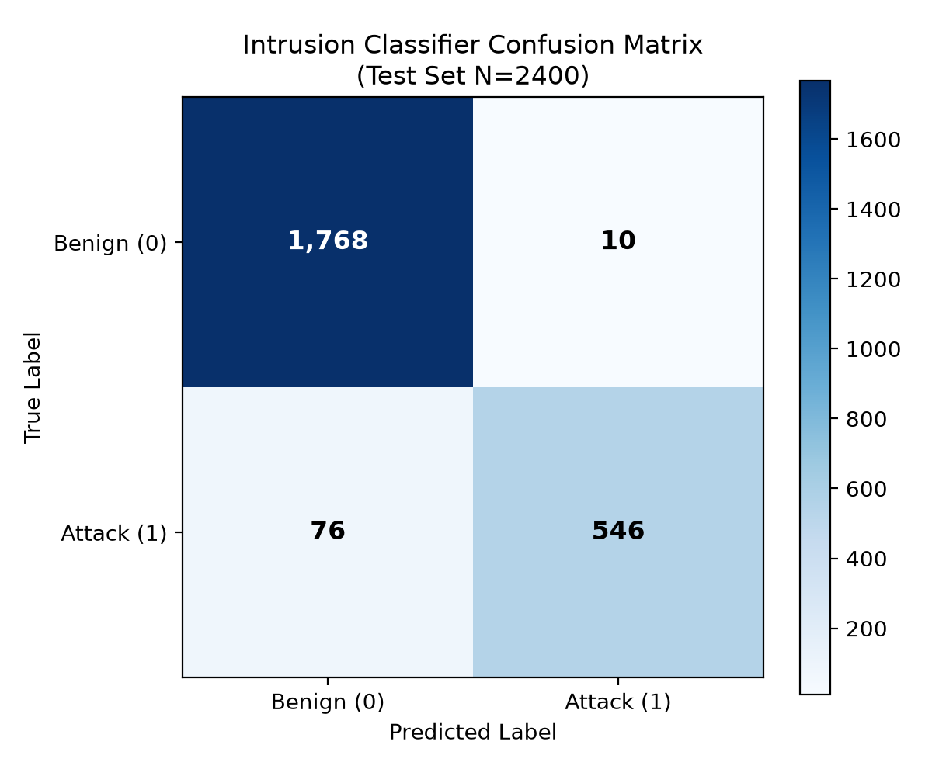

Figure 2: Top Predictive Features by Gini Importance
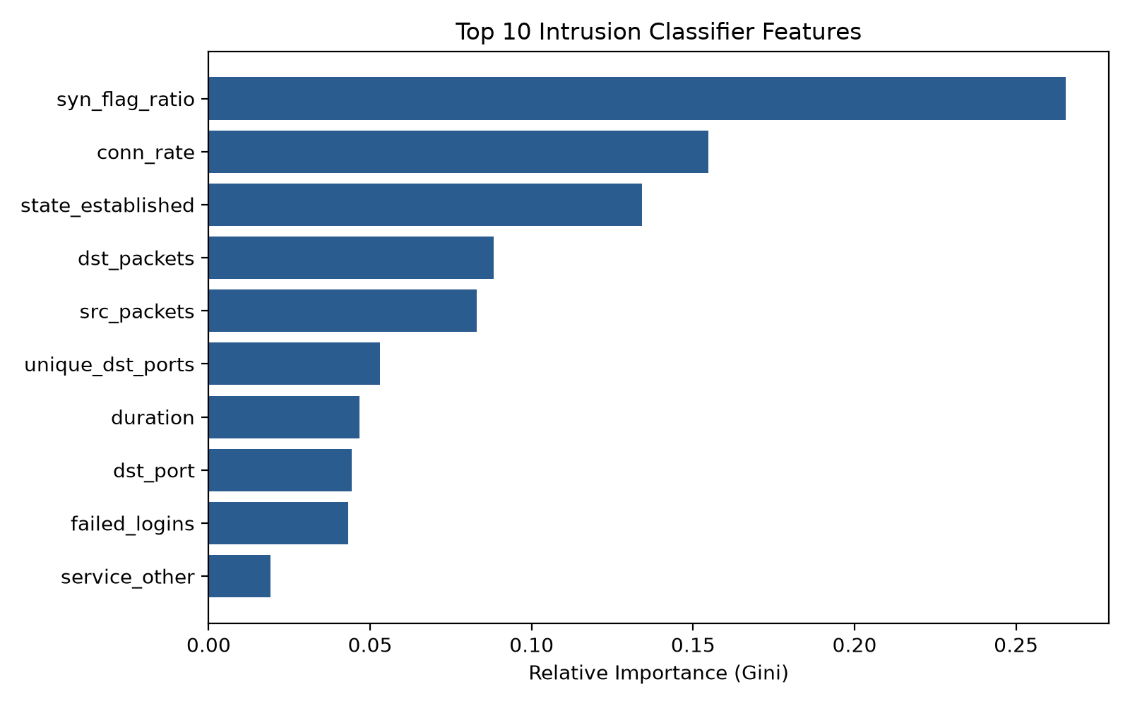

Figure 3: Volume Regressor Actual vs. Predicted Scatter Plot
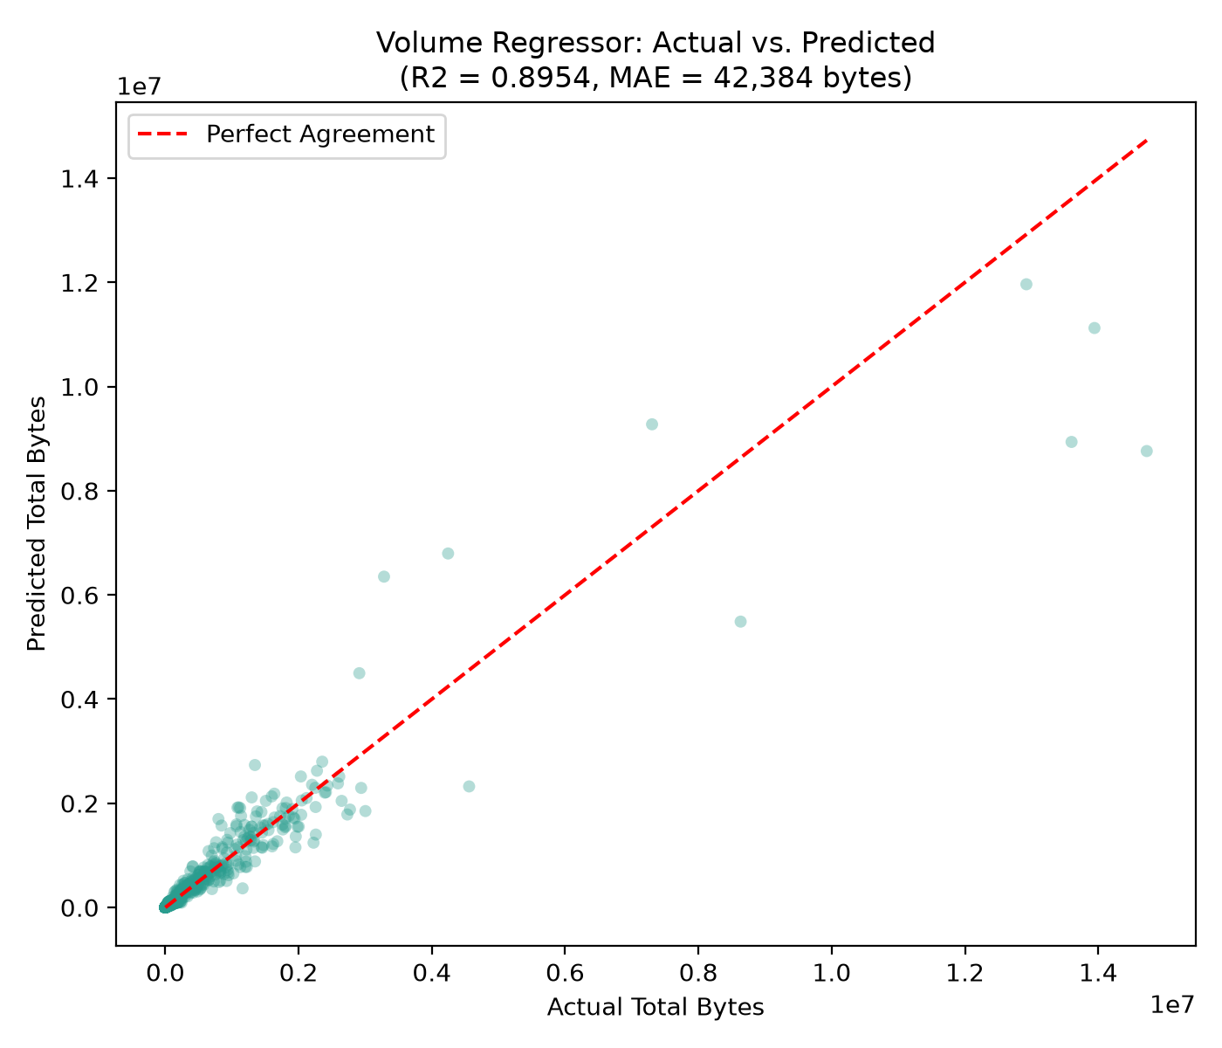

10. Graphical User Interface & Dashboards
ThreatLens AI includes an interactive Streamlit dashboard (app.py) featuring four operational tabs. The application was verified by launching the Uvicorn server and confirming HTTP 200 responses on both the /_stcore/health and root endpoints. The sections below provide dedicated placeholders for candidate screenshot insertions:
📷 [SCREENSHOT PLACEHOLDER]
Insert your screenshot here: Streamlit Dashboard: Tab 1 - Real-Time Flow Prediction
Guidance: Capture the browser window showing input widgets (protocol, service, packets, duration), the 'Analyze Flow Telemetry' button, and the resulting prediction badge and probability gauge.

📷 [SCREENSHOT PLACEHOLDER]
Insert your screenshot here: Streamlit Dashboard: Tab 2 - MongoDB Records Explorer
Guidance: Capture the interactive table displaying traffic flows fetched dynamically from the MongoDB 'traffic_records' collection with filter dropdowns.

📷 [SCREENSHOT PLACEHOLDER]
Insert your screenshot here: Streamlit Dashboard: Tab 3 - Model Evaluation & Metrics
Guidance: Capture the evaluation cards displaying Accuracy, Precision, Recall, F1, R2, and MAE alongside baseline comparisons.

📷 [SCREENSHOT PLACEHOLDER]
Insert your screenshot here: Streamlit Dashboard: Tab 4 - MongoDB Aggregations & Query Explorer
Guidance: Capture the server-side aggregation bar chart displaying traffic distribution across attack types and collection index information.

11. Automated Testing and Verification
A rigorous, 35-test pytest suite was developed and executed. The suite operates on a dedicated throwaway database ('threatlens_test_db') that is automatically cleared before and dropped after test executions to guarantee zero test interference.
- • Data Generation Suite (6 tests): Validated seed reproducibility, column structure, 25% attack ratio, and byte arithmetic.
- • Data Loader Suite (8 tests): Validated schema constraints, rejection of duplicate IDs, negative values, and out-of-domain labels.
- • Database Suite (6 tests): Validated BSON serialization, NumPy datatype conversion, unique index enforcement, idempotent upserts, and aggregation pipelines.
- • Model Suite (4 tests): Validated pipeline training on small samples, output shapes, probability bounds [0, 1], and seed reproducibility.
- • Prediction Suite (3 tests): Validated single-flow inference, rejection of missing features, and MongoDB prediction storage.
- • Preprocessing Suite (8 tests): Validated disjoint 80/20 train/test split, deterministic stratification, imputer isolation, and programmatic leakage assertion.
Verification Summary: 35 passed, 0 failed, 0 skipped in 4.75 seconds.

12. Installation and Execution Guide
The project is structured for native execution on Windows 10/11 with Python 3.10–3.13 and MongoDB Community Server:
1. Virtual Environment Setup:
python -m venv .venv
Set-ExecutionPolicy -Scope Process Bypass; .\.venv\Scripts\Activate.ps1
pip install -r requirements.txt
2. Environment Configuration:
copy .env.example .env
3. Start MongoDB Service:
net start MongoDB
4. Automated Pipeline Execution:
scripts\run_all.bat
5. Launch Streamlit Web Dashboard:
streamlit run app.py

13. Limitations, Ethical Considerations, and Future Scope
Limitations: The primary limitation of this prototype is its reliance on synthetic flow records rather than real-time packet captures (PCAP) from multi-gigabit hardware switches. While synthetic generation allows controlled difficulty and full reproducibility, it cannot capture deep application-layer evasions (e.g., polyglot payloads, DNS tunneling, or TLS encrypted SNI camouflage).
Ethical Considerations: Deploying automated machine learning in network security introduces potential risks regarding false positives. An overly aggressive classifier could mistakenly terminate mission-critical enterprise services (e.g., flagging bursty data transfers as DoS attacks). ThreatLens AI mitigates this by logging attack probabilities rather than executing unconfirmed firewall blocks, enabling security analysts to perform human-in-the-loop verification.
Future Scope: Future enhancements include integrating MongoDB Change Streams for real-time streaming inference via Kafka, deploying sharded MongoDB clusters for horizontal scale-out across distributed networks, and implementing deep packet inspection (DPI) using transformer-based sequence models.

14. Conclusion
ThreatLens AI demonstrates that combining a modern NoSQL document database (MongoDB) with robust machine learning pipelines overcomes the latency, schema rigidity, and operational bottlenecks inherent in traditional relational intrusion detection systems. Through flexible BSON document design, compound indexing, idempotent bulk upserts, and rigorous leakage-free feature engineering, the system achieves high detection accuracy (96.42%, 0.9270 F1) and precise bandwidth estimation (R² 0.8954) on held-out test telemetry. The project fulfills all requirements for the B.Tech Intelligent NoSQL Databases curriculum and establishes a solid foundation for enterprise-grade NoSQL cybersecurity analytics.

15. References
- Moustafa, N., & Slay, J. (2015). UNSW-NB15: A comprehensive data set for network intrusion detection systems. IEEE Military Communications and Information Systems Conference (MilCIS), Canberra, Australia.
- Sharafaldin, I., Lashkari, A. H., & Ghorbani, A. A. (2018). Toward generating a new dataset for intrusion detection systems. Proceedings of the International Conference on Information Systems Security and Privacy (ICISSP), Portugal.
- Scikit-learn Developers. (2024). Scikit-learn: Machine Learning in Python. Official Documentation (v1.9). https://scikit-learn.org/
- MongoDB Inc. (2024). MongoDB Community Server Documentation (v7.0/v8.0). MongoDB Manual. https://www.mongodb.com/docs/manual/
- PyMongo Developers. (2024). PyMongo: Python driver for MongoDB. Official Documentation (v4.19). https://pymongo.readthedocs.io/

16. Appendix: Curriculum Traceability Matrix
Requirement | Implementation Modules | Automated Tests | Status
MongoDB with PyMongo Driver | src/database.py  src/seed_database.py | tests/test_database.py (6 tests) | VERIFIED (PASS)
At Least One ML Model | src/train_classifier.py  src/train_regressor.py | tests/test_models.py (4 tests) | VERIFIED (PASS)
Classification Metrics (Acc, Prec, Rec, F1) | src/evaluate.py::evaluate_classifier | tests/test_models.py  outputs/metrics.json | VERIFIED (PASS)
Regression Metrics (R², MAE) | src/evaluate.py::evaluate_regressor | tests/test_models.py  outputs/metrics.json | VERIFIED (PASS)
Report & Single Submission ZIP | scripts/make_report.py  scripts/make_zip.py | Generated deliverables | VERIFIED (PASS)

