**Inflation:**

Inflation is defined as an increase in the amount of money required to purchase or acquire the same amount of products and services that was acquired without its effect. Inflation results in a reduction in the purchasing power of the monetary unit. In other words, when prices of the products and services increase, we buy less quantity with same amount of money i.e. the value of money is decreased. For example, the quantity of items we purchase today at a cost of Rs.1000 is less than that was purchased 5 years ago. This is due to a general change (increase) in the price of the goods and services with passage of time. On the other hand deflation results in an increase in the purchasing power of the monetary unit with time and it rarely occurs. Due to effect of deflation, more can be purchased with same amount of money in future time period than that can be purchased today. The inflation rate (*f*) is measured as the rate of increase (per time period) in the amount of money required to obtain same amount of products and services. Till now, the interest rate ‘*i*' that was used in the economic evaluation of a single alternative or between alternatives by different methods as mentioned in earlier lectures was assumed to be inflation-free i.e. the effect of inflation on interest rate was excluded. This interest rate ‘*i*' is also known as also real interest rate or inflation-free interest rate. It represents the real gain in money of the cash flows with time without the effect of inflation. However if inflation is there in the general market, then effect of inflation on the interest rate needs to be taken into account for the economic analysis. The interest rate that includes the effect of price inflation which is occurring in general economy is known as the market interest rate (*ic*). It takes into account the adjustment for the price inflation in the market. Market interest rate is also known as inflated interest rate or combined interest rate as it combines the effect of both real interest rate and the inflation.

In addition to above parameters, it is also required to define two parameters namely actual monetary units and constant value monetary units while considering the effect of inflation in the cash flow of the alternatives. The monetary units can be Rupees, Dollars, Euros etc. The actual monetary units are also referred as future or inflated monetary units. The purchasing power of the actual monetary units includes the effect of inflation on the cash flows at the time it occurs. The constant value monetary units are also called as real or inflation-free monetary units. The constant value monetary units are expressed in terms of the same purchasing power for the cash flows with reference to a base period. Mostly in engineering economic studies, the base period is taken as ‘0' i.e. now. But it can be of any time period as required.

**Causes of Inflation**

So what exactly causes inflation in an economy? There is not a single, agreed-upon answer, but there are a variety of theories, all of which play some role in inflation:

**1. The Money Supply**

Inflation is primarily caused by an increase in the money supply that outpaces economic growth.

Ever since industrialized nations moved away from the gold standard during the past century, the value of money is determined by the amount of currency that is in circulation and the public’s perception of the value of that money. When the Federal Reserve decides to put more money into circulation at a rate higher than the economy’s growth rate, the value of money can fall because of the changing public perception of the value of the underlying currency. As a result, this devaluation will force prices to rise due to the fact that each unit of currency is now worth less.

One way of looking at the money supply effect on inflation is the same way collector’s value items. The rarer a specific item is, the more valuable it must be. The same logic works for currency; the less currency there is in the money supply, the more valuable that currency will be. When a government decides to print new currency, they essentially water down the value of the money already in circulation. A more macroeconomic way of looking at the negative effects of an increased money supply is that there will be more dollars chasing the same amount of goods in an economy, which will inevitably lead to increased demand and therefore higher prices.

**2. The National Debt**

It can actually drive inflation to higher levels over time? The reason for this is that as a country’s debt increases, the government has two options: they can either raise taxes or print more money to pay off the debt.

A rise in taxes will cause businesses to react by raising their prices to offset the increased corporate tax rate. Alternatively, should the government choose the latter option, printing more money will lead directly to an increase in the money supply, which will in turn lead to the devaluation of the currency and increased prices (as discussed above).

**3. Demand-Pull Effect**

The demand-pull effect states that as wages increase within an economic system (often the case in a growing economy with low unemployment), people will have more money to spend on consumer goods. This increase in liquidity and demand for consumer goods results in an increase in demand for products. As a result of the increased demand, companies will raise prices to the level the consumer will bear in order to balance supply and demand.

An example would be a huge increase in consumer demand for a product or service that the public determines to be cheap. For instance, when hourly wages increase, many people may determine to undertake home improvement projects. This increased demand for home improvement goods and services will result in price increases by house-painters, electricians, and other general contractors in order to offset the increased demand. This will in turn drive up prices across the board.

**4. Cost-Push Effect**

Another factor in driving up prices of consumer goods and services is explained by an economic theory known as the cost-push effect. Essentially, this theory states that when companies are faced with increased input costs like raw goods and materials or wages, they will preserve their profitability by passing this increased cost of production onto the consumer in the form of higher prices.

A simple example would be an increase in milk prices, which would undoubtedly drive up the price of a cappuccino at your local Starbucks since each cup of coffee is now more expensive for Starbucks to make.

**5. Exchange Rates**

Inflation can be made worse by our increasing exposure to foreign marketplaces. On a day-to-day basis, we as consumers may not care what the exchange rates between our foreign trade partners are, but in an increasingly global economy, exchange rates are one of the most important factors in determining our rate of inflation.

When the exchange rate suffers such that the a country’s currency has become less valuable relative to foreign currency, this makes foreign commodities and goods more expensive to the consumers while simultaneously making goods, services, and exports cheaper to consumers overseas.

The effect of inflation on cash flows is demonstrated in the following example.

**Example -5**

The present (today's) cost of an item is Rs.20000. The inflation rate is 5% per year. How does the inflation affect the cost of the item for the next five years?

**Solution:**

The calculations are shown in Table 3.7.

**Table 3.7 Effect of inflation on future cost of the item**

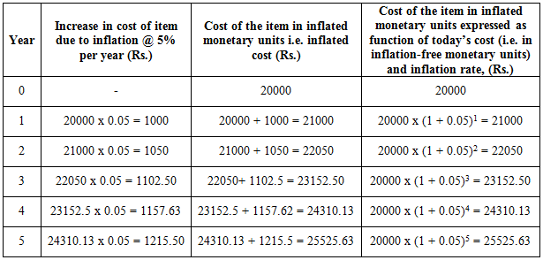

From above table, the relationship between cost in actual monetary units (inflated) in time period ‘n' and cost in constant value monetary units (inflation-free) can be represented as follows;

|  |  |
| --- | --- |
| https://nptel.ac.in/courses/105103023/module3/lec4/images/2.png | (3.49) |

From equation (3.49), the expression for cost in constant value monetary units (inflation-free) is written as follows

|  |  |
| --- | --- |
| https://nptel.ac.in/courses/105103023/module3/lec4/images/3.png | (3.50) |

In the above expressions, ‘*f'* is the inflation rate per year i.e. 5% and the base or reference period is considered as ‘0'. However the above relationship between constant value monetary units and actual monetary units can also be written for any base period *‘b'* .

|  |  |
| --- | --- |
| https://nptel.ac.in/courses/105103023/module3/lec4/images/4.png | (3.51) |

In the above relationship, the base period *‘b'* defines the purchasing power of constant value monetary units*.* As shown in Table 3.7, the actual cost (inflated) of the item in years 1, 2, 3, 4 and 5 are Rs.21000, Rs.22050, Rs.23152.50, 24310.13 and Rs.25525.63 respectively. However the cost of the item in inflation-free or constant value rupees in all the years is always Rs.20000 [i.e. 21000/(1+0.05) 1, 22050/(1+0.05) 2, etc.] i.e. equal to the cost at the beginning. In this example, effect of interest rate i.e. effect of time value of money is not considered.

**Income redistribution**: One risk of higher inflation is that it has a **regressive effect** on lower-income families and older people in society. This happen when prices for food and domestic utilities such as water and heating rises at a rapid rate.

**Falling real incomes**: With millions of people facing a cut in their wages or at best a pay freeze, rising inflation leads to a fall in real incomes.

**Negative real interest rates**: If interest rates on savings accounts are lower than the rate of inflation, then people who rely on interest from their savings will be poorer. Real interest rates for millions of savers in the UK and many other countries have been negative for at least four years

**Cost of borrowing**: High inflation may also lead to higher borrowing costs for businesses and people needing loans and mortgages as financial markets protect themselves against rising prices and increase the cost of borrowing on short and longer-term debt. There is also pressure on the government to increase the value of the state pension and unemployment benefits and other welfare payments as the cost of living climbs higher.

**Risks of wage inflation**: High inflation can lead to an increase in pay claims as people look to protect their real incomes. This can lead to a rise in unit labour costs and lower profits for businesses

**Business competitiveness**: If one country has a much higher rate of inflation than others for a considerable period of time, this will make its exports less price competitive in world markets. Eventually this may show through in reduced export orders, lower profits and fewer jobs, and also in a worsening of a country’s trade balance. A fall in exports can trigger negative multiplier and accelerator effects on national income and employment.

**Business uncertainty**: High and volatile inflation is not good for business confidence partly because they cannot be sure of what their costs and prices are likely to be. This uncertainty might lead to a lower level of capital investment spending. 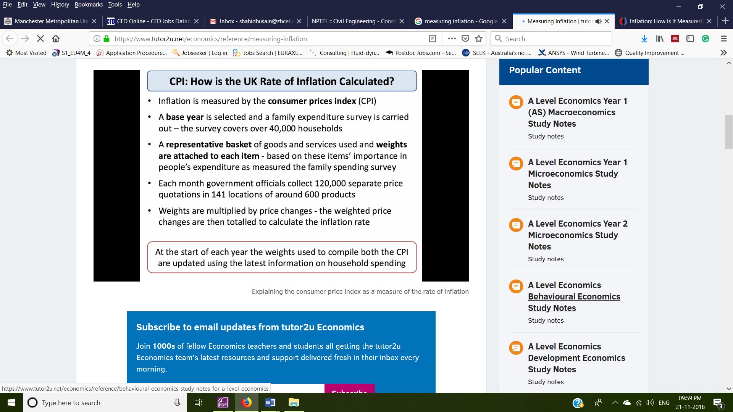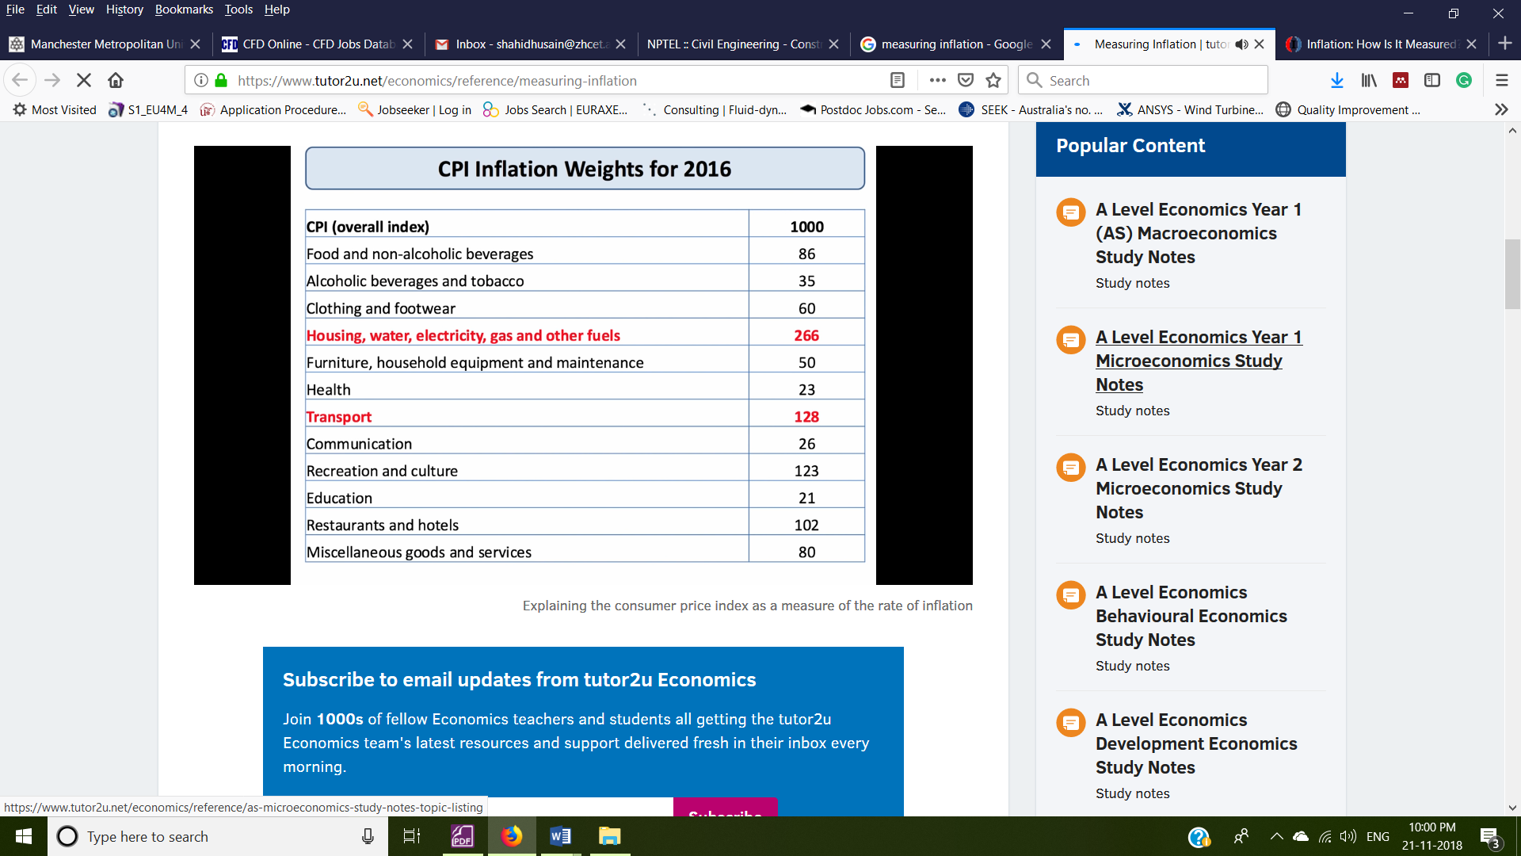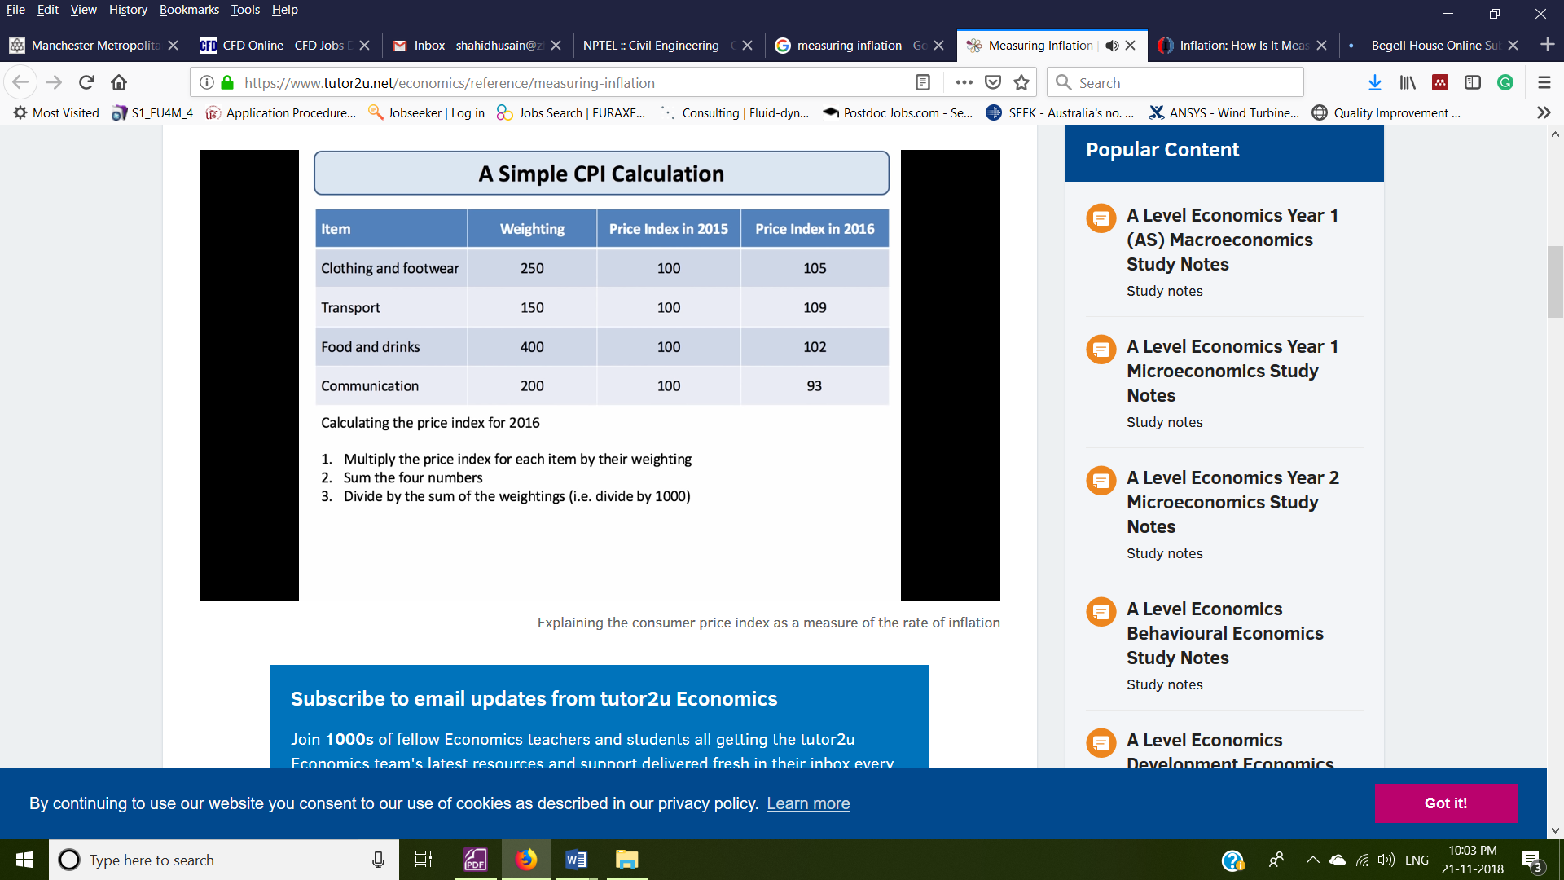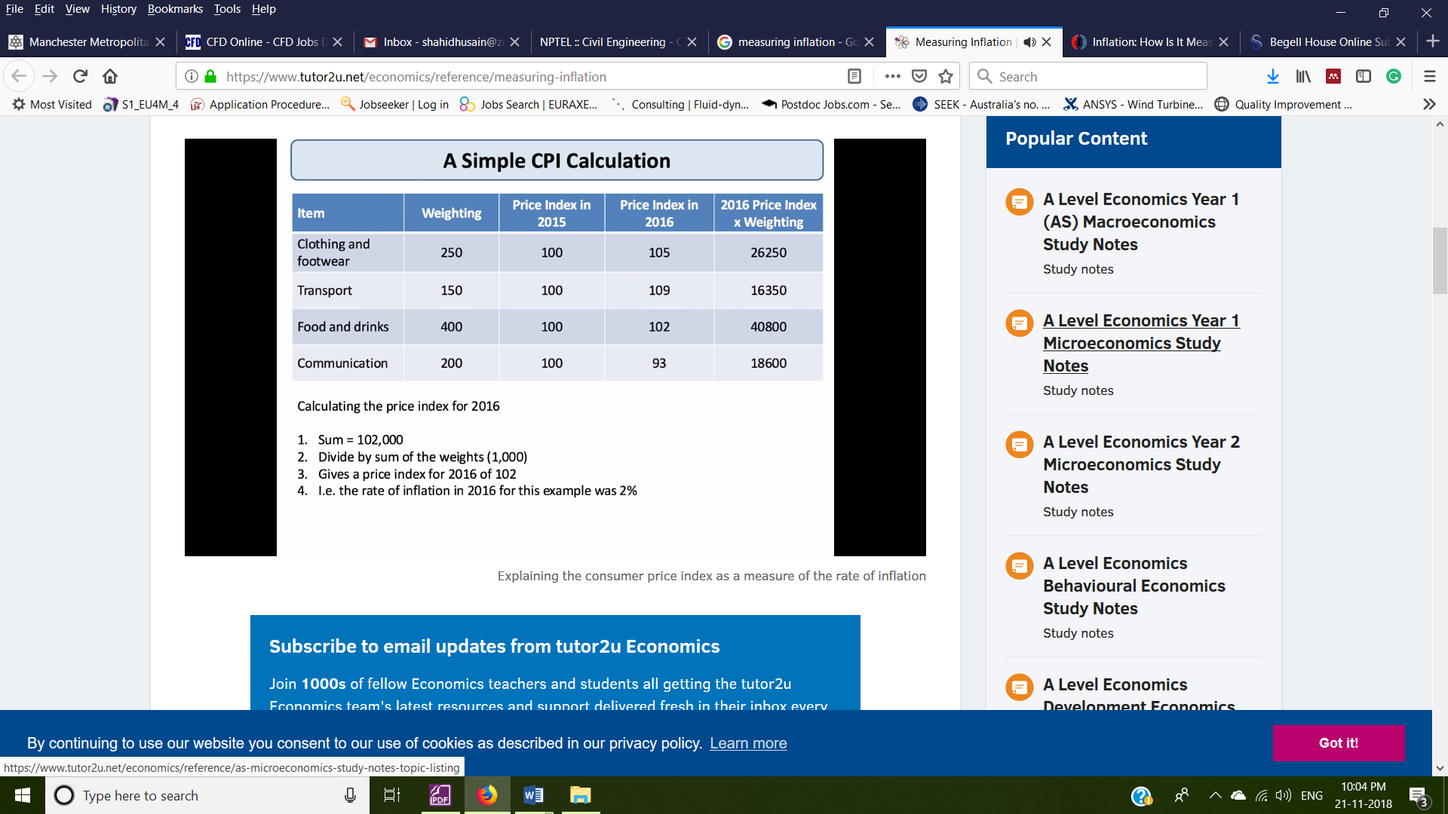

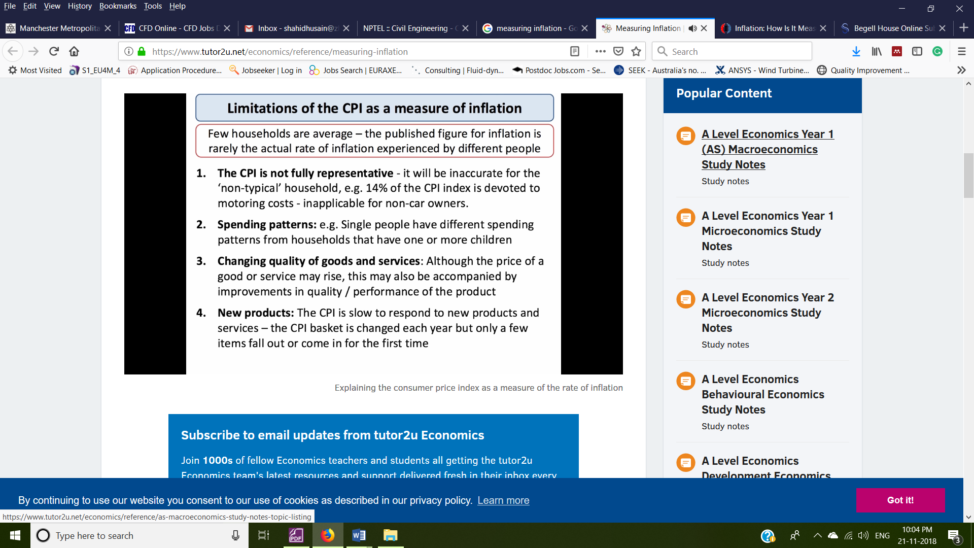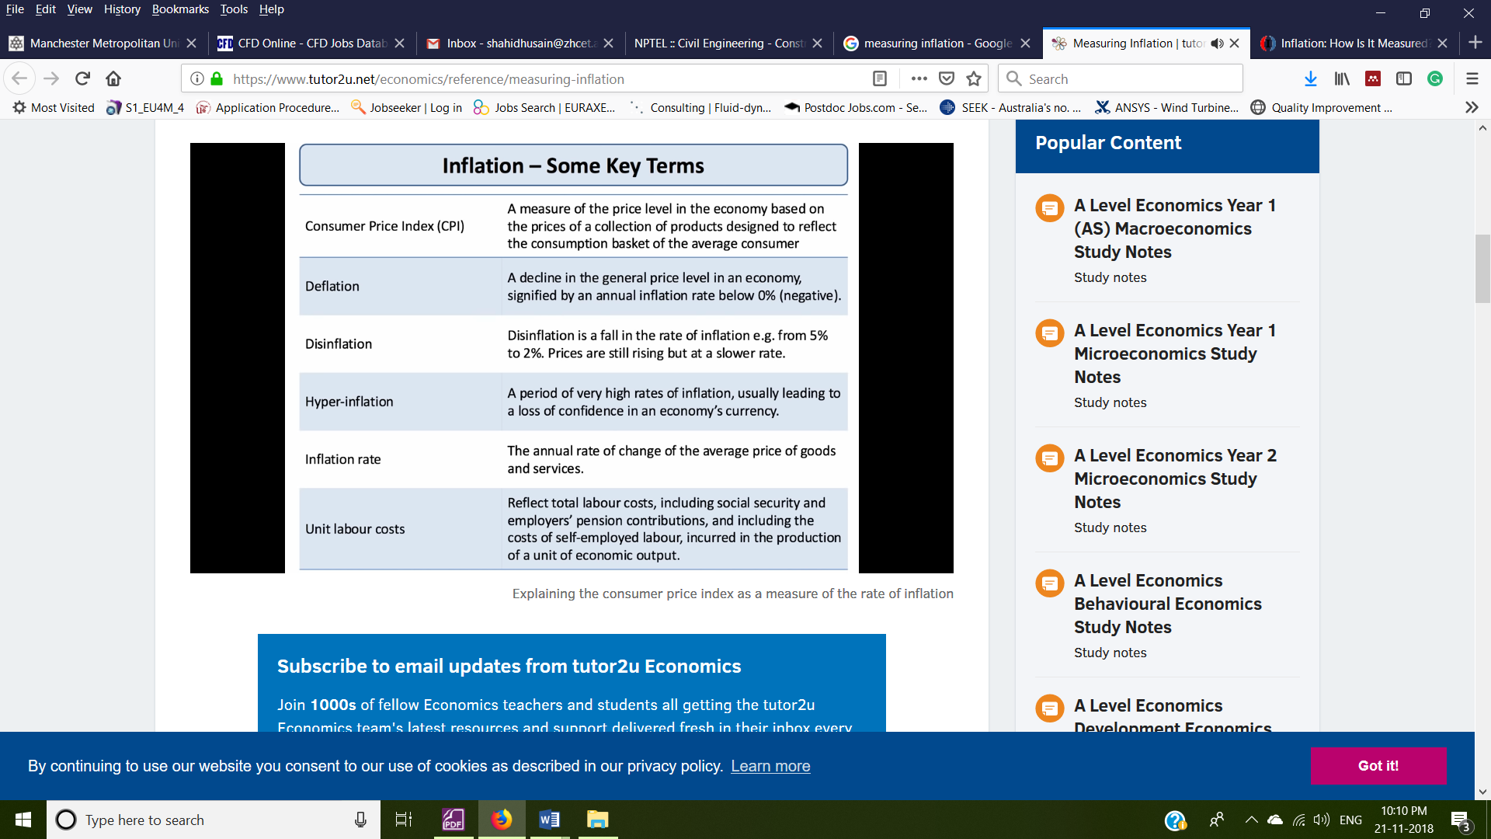

***Consequences of Inflation***

GDP

Economic growth is measured in gross domestic product (GDP), or the total value of all goods and services produced. The percentage of growth or decline, compared to the previous year, is adjusted for inflation. Therefore, if growth was 5% and inflation was 2%, GDP would be reported at 3%.

As prices rise, the value of the money declines, as its purchasing power erodes with each increase in the price of basic goods and services.

The Cost of Borrowing

Low or no inflation, theoretically, may help an economy recover from a recession or a depression. With both inflation and interest rates low, the cost of borrowing money for investments or borrowing for the purchase of big-ticket items, such as automobiles or securing a mortgage on a house or condo, is also low. These low rates are expected to encourage consumption, say some economists.

Banks and other lending institutions, however, may be reluctant to lend money to consumers when rates of return on loans are low, which decreases profit margins. Businesses can plan their borrowing, hiring, marketing, and improvement and expansion strategies accordingly. Investors, likewise, know roughly what government and corporate bonds and other debt will return since most of these instruments are pegged to Treasury yields.