

**ALIRO**

**Access Tracker for TechParks**

**By**

**GAURAV JAIN (2241129)**

**HIMANSHI AGARWAL (2241132)**

**SUMIT ROBERTS EMMANUEL (2241160)**

**Bachelor of Computer Application Under the supervision of**

**GUIDE NAME**

**Dr. Logeshwaran J.**

**Department of Computer Science**

**CHRIST(Deemed to be University) Bangalore, India**

**Schema Diagram**

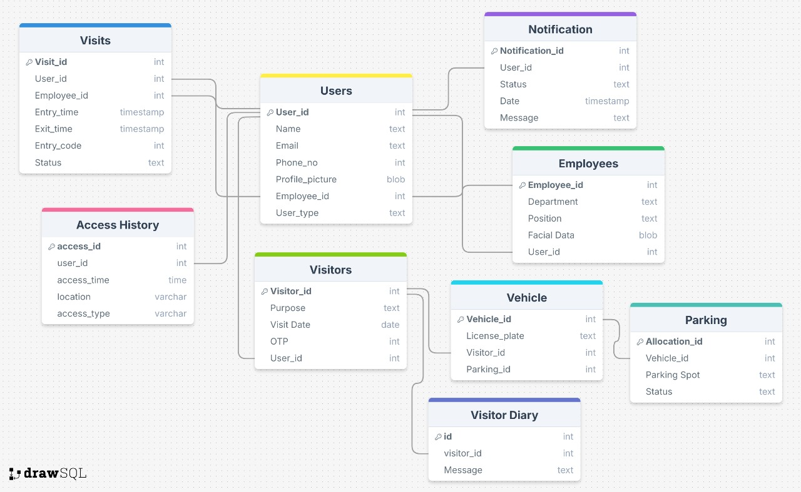

**ER Diagram**

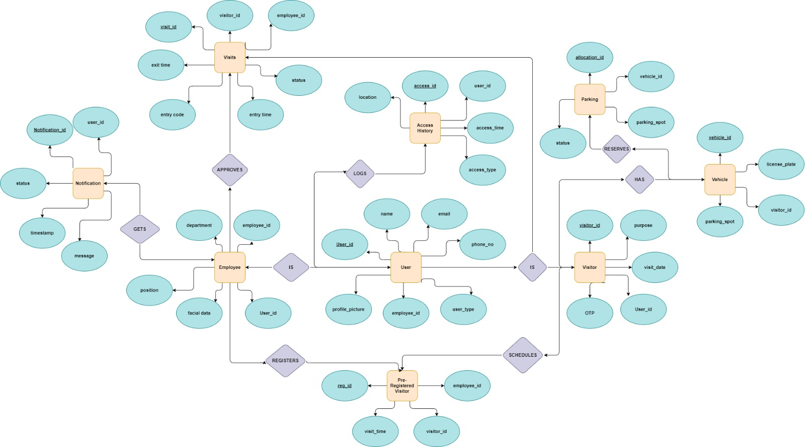

**Tables**

**Users**

|  |  |
| --- | --- |
| **Attributes** | **Data** **Type** |
| User_id | Int (Primary Key) |
| Name | Text |
| Email | Text |
| Phone_no | Int |
| Profile_picture | BLOB |
| Employee_id | Int |
| User_type | Text |

**Employees**

|  |  |
| --- | --- |
| **Attributes** | **Data Type** |
| Employee_id | Int |
| Position | Text |
| Department | Text |
| Facial data | BLOB |
| User_id | Int |

**Visitors**

|  |  |
| --- | --- |
| **Attributes** | **Data Type** |
| visitor_id | Int |
| Purpose | Text |
| Visit Date | Date |
| OTP | Int |
| User_id | Int |

**Access History**

|  |  |
| --- | --- |
| **Attributes** | **Data Type** |
| access_id | Int |
| User_id | Int |
| Location | Text |
| Access_time | Date |
| Access_type | Text |

**Vehicle**

|  |  |
| --- | --- |
| **Attributes** | **Data Type** |
| Vehicle_id | Int |
| License_plate | Text |
| Visitor_id | Int |
| Parking_id | Int |

**Parking**

|  |  |
| --- | --- |
| **Attributes** | **Data Type** |
| allocation_id | Int |
| vehicle_id | Int |
| Parking spot | Text |
| Status | Text |

**Visits**

|  |  |
| --- | --- |
| **Attributes** | **Data Type** |
| visit_id | Int |
| User_id | Int |
| Employee_id | Int |
| Entry_time | TimeStamp |
| Exit_time | TimeStamp |
| Entry code | Int |
| Status | Text |

**Notification**

|  |  |
| --- | --- |
| **Attributes** | **Data Type** |
| notificattion_id | Int |
| User_id | Int |
| Status | Text |
| Date | TimeStamp |
| Message | Text |

**Visitor dairy**

|  |  |
| --- | --- |
| **Attributes** | **Data Type** |
| id | Int |
| visitor_id | Int |
| Message | Text |