A

Project Report

On

# Eve-Intelligent Voice Assistant

Submitted during 3rd semester in partial fulfilment of the requirements for the award of degree of

# Master of Computer Applications

by

# Aastha(23001602003)

**Himanshi Giri (23001602028)**

Under supervision of

# Dr. Maanvi



## Department of Computer Applications

**J.C. Bose University of Science & Technology, YMCA Faridabad – 121006**

**May 2024**

# CANDIDATE’S DECLARATION

We hereby certify that the work which is being presented in this Project titled “**Eve-Intelligent Voice Assistant**” in fulfilment of the requirements for the degree of Master of Computer Application and submitted to “J.C. Bose University of Science and Technology, YMCA, Faridabad”, is an authentic record of our own work carried out under the supervision of **Dr. Maanvi .**

The work contained in this project has not been submitted to any other University or Institute for the award of any degree or diploma by us.

## Student’s Signature

**Aastha**

**Student’s Signature**

**Himanshi Giri**

# CERTIFICATE

It is hereby certified that the project titled “Eve -Intelligent Voice Assistant” by Aastha (23001602003) and Himanshi Giri (23001602028) of 2nd year (3rd Semester) to “**J. C. Bose University of Science and Technology, YMCA, Faridabad**” for the award of the degree of Master of Computer Application is a record of a bonafide work carried out by him/her in the Project Lab – J.C. Bose University of Science and Technology, YMCA, Faridabad under my supervision as mentor for May 2024 examination.

In my opinion, the project has reached the standards of fulfilling the requirements of the regulations to the degree.

## Dr. Maanvi

Department of Computer Applications

# ACKNOWLEDGEMENT

We have taken efforts in this project. However, it would not have been possible without the kind support and help of many individuals.

We would like to extend our sincere thanks to all of them. We are highly indebted to our mentor Dr. Maanvi for their guidance and constant supervision as well as for providing necessary information regarding the project & also for their support in completing the project.

We would like to express our gratitude towards our parents & members of J.C. Bose University of Science and Technology for their kind cooperation and encouragement which helped in the completion of this project.

## Student’s Signature

**Aastha**

**Student’s Signature**

**Himanshi Giri**

# TABLE OF CONTENTS

## Candidate’s Declaration Certificate

**Acknowledgement Chapter 1: Introduction**

* 1. Brief of the Project
  2. Technologies Used

## Chapter 2: LITERATURE SURVEY (optional)

* 1. Existing Systems and Their Limitations
  2. Need for an Improved System
  3. Related Work and Research
  4. Summary of Findings

## Chapter 3: Implementation and Result Analysis

* 1. Problem Formulation
  2. Objectives

3.3. Methodology

* 1. Overview and Implementation

## Chapter 4: Applications and scope

* 1. Applications
  2. Future Scope References

# Chapter 1: Introduction

## Brief of the Project

The project **"Eve-Intelligent Voice Assistant"** is a voice assistant capable of performing tasks such as real-time transcription, generating intelligent responses, and producing audio outputs. The assistant integrates technologies like **AssemblyAI**, **Google Gemini**, and **ElevenLabs** for its functionality. It aims to streamline tasks, enhance user interaction, and provide a seamless voice-driven experience.

It can help you with tasks, answer your questions, and provide a conversational experience.

## Technologies Used

* **Programming Language :** Python
* **Real-time Transcription:** AssemblyAI
* **Generative AI for Responses:** Google Gemini
* **Audio Generation:** ElevenLabs
* **GUI Development:** Tkinter or PyQt (Planned)
* **Development Tools:** VS Code .

# Chapter 2: Literature Survey

### **2.1 Existing Systems and Their Limitations**

Voice assistants have evolved significantly over the years, with major players like **Siri (Apple)**, **Google Assistant**, **Alexa (Amazon)**, and **Cortana (Microsoft)** leading the industry. These systems are advanced but come with specific limitations:

1. **Limited Customization**
   * Mainstream voice assistants cater to general use cases, offering predefined functionalities. They lack the flexibility to be customized for unique or domain-specific tasks, making them less useful for developers and enthusiasts building niche applications.
2. **Data Privacy Concerns**
   * Many voice assistants store user data on centralized servers, raising privacy and security concerns. Sensitive information may be at risk, especially in applications requiring confidentiality.
3. **High Cost for Advanced Features**
   * While these systems provide free access for basic use, advanced functionalities often come at a premium cost. APIs and extended features may not be affordable for students, researchers, or hobbyists.
4. **Dependency on Ecosystem**
   * Assistants like Siri or Alexa are deeply integrated into their ecosystems (Apple and Amazon, respectively). This dependency limits cross-platform compatibility and integration with non-native systems.

### **2.2 Need for an Improved System**

To address the gaps in existing systems, there is a growing demand for a voice assistant that offers:

* **Affordability:** A cost-effective solution, particularly for personal projects or small-scale use cases.
* **Customizability:** Open architecture allowing developers to tailor the assistant to specific needs.
* **Enhanced Privacy:** Local processing and minimized dependency on external servers for sensitive tasks.
* **Advanced Features for Developers:** Tools for integrating cutting-edge technologies, such as AI-driven transcription and dynamic response generation, without being locked into a proprietary ecosystem.

**"Eve-Intelligent Voice Assistant"** aims to fill this gap by providing an innovative, developer-friendly, and privacy-conscious voice assistant.

### **2.3 Related Work and Research**

Research and advancements in voice technology provide the foundation for this project. Below are key developments that informed the design and implementation of **Eve**:

1. **Speech-to-Text Technology**
   * Research in automatic speech recognition (ASR) systems has greatly improved accuracy. APIs like **AssemblyAI** leverage neural networks to achieve high precision in transcription, making them ideal for real-time applications.
2. **Generative AI for Contextual Responses**
   * Advances in natural language processing (NLP) models, such as **ChatGPT** and **Google Gemini**, enable machines to generate human-like responses. These models understand context, user intent, and subtleties in language, improving conversational quality.
3. **Human-Computer Interaction (HCI)**
   * Studies highlight the importance of personalization and adaptability in improving user experience with voice interfaces. Features like voice pitch adjustment and tone customization enhance user satisfaction.
4. **Integration of Speech Synthesis**
   * Speech synthesis technologies, such as **ElevenLabs**, have introduced lifelike audio output. These systems make voice assistants more relatable and engaging, bridging the gap between humans and machines.

### **2.4 Summary of Findings**

The literature review revealed key insights that shaped the development of **Eve**:

* There is significant room for innovation in voice assistant technologies, especially for developer-friendly, privacy-centric, and affordable solutions.
* Leveraging cutting-edge technologies such as ASR, NLP, and speech synthesis can significantly enhance the capabilities and usability of a voice assistant.
* The need for personalized and adaptable systems is growing, indicating a shift in user expectations towards solutions that cater to individual needs.

**"Eve-Intelligent Voice Assistant"** aligns with these findings, offering an advanced, modular, and user-centric voice assistant solution that addresses the limitations of existing systems.

# Chapter 3: Implementation and Result Analysis

## Problem Formulation

This project is made with the perspective of commutating ease in today's hectic schedule with which each person suffers. Along With this, it would be helpful for blind people especially, as just by giving commands they will be getting the results for the same and it will definitely save their time and they can do work with more ease and comfortably sitting next to their systems. Using this assistance, the chances of error caused by typing also reduces and it provides personalized assistance to users in a seamless and intuitive manner. Moreover, it is more accurate than manual data entry, it is faster than typing. Quickly respond to voice commands or text-based questions, eliminating the need for manual input or navigation. This streamlined approach can be especially useful when performing repetitive or time-consuming tasks, allowing the user to focus on other important responsibilities

## Objectives

• Develop a robust transcription system.

• Provide meaningful, context-aware responses.

• Generate clear, natural-sounding audio outputs.

• Integrate a GUI for enhanced user interaction.

## Methodology

• Data **Flow:** User input → Transcription → Response generation → Audio output.

• **Implementation:** Modular approach with each file handling a specific functionality.

1. **eve_main.py**: Central script coordinating all modules.
2. **Dict.py**: The code defines a simple assistant program that can open and close applications or websites based on user commands.

**Libraries imported** :-

• **os**: Provides functions to interact with the operating system.

• **pyautogui**: Automates keyboard and mouse actions.

• **webbrowser**: Opens websites in the default web browser.

• **pyttsx3**: Text-to-speech conversion.

• **sleep (from time)**: Pauses the execution for a specified duration.

1. **Calculatenumber.py**: This code defines a Python script (calculatenumbers.py) to perform mathematical calculations or answer computational queries using the WolframAlpha API. It also provides text-to-speech feedback.

Libraries Imported :-

• **wolframalpha**: Used to interact with the WolframAlpha API for computational intelligence.

• **pyttsx3**: Converts text-to-speech for auditory feedback.

• **speech_recognition**: (Imported but not used in the given code) Commonly used for voice input processing.

4.**Greet.py**: This script is a **Python program** that greets the user based on the current time and asks how it can assist.

Libraries imported:

* **pyttsx3**:
  + For text-to-speech functionality, allowing the program to "speak" its responses.
* **speech_recognition**:
  + (Not used in the given code but typically used for voice input).
* **datetime**:
  + To retrieve the current time for greeting the user appropriately.

5.Info.py:- This code combines **Tkinter** (for GUI), **Pillow** (for image manipulation), and **Pygame** (for audio playback) to create an application that plays a **GIF animation** along with two audio files in sequence.

Libraries imported :-

* **Tkinter**: Provides a graphical interface for the application.
* **Pillow**: Used for handling the GIF animation frame by frame.
* **Pygame**: Plays audio files.

6) NewsRead.py :- This Python script fetches the latest news articles from various categories using the **NewsAPI** and provides a **text-to-speech** summary of the news. It allows the user to choose a news category, retrieves news headlines, and optionally shares URLs for more details.

7)SearchNow.py :- This code defines a voice-controlled assistant that can listen to voice commands, process queries for Google searches, YouTube videos, and Wikipedia summaries, and provide responses via text-to-speech.

.

## Overview And implementation:

* 1. To run the project :-

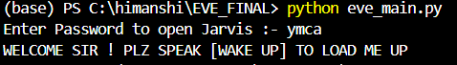

* 1. Now after entering the password , that is [ymca] , eve appers as follow

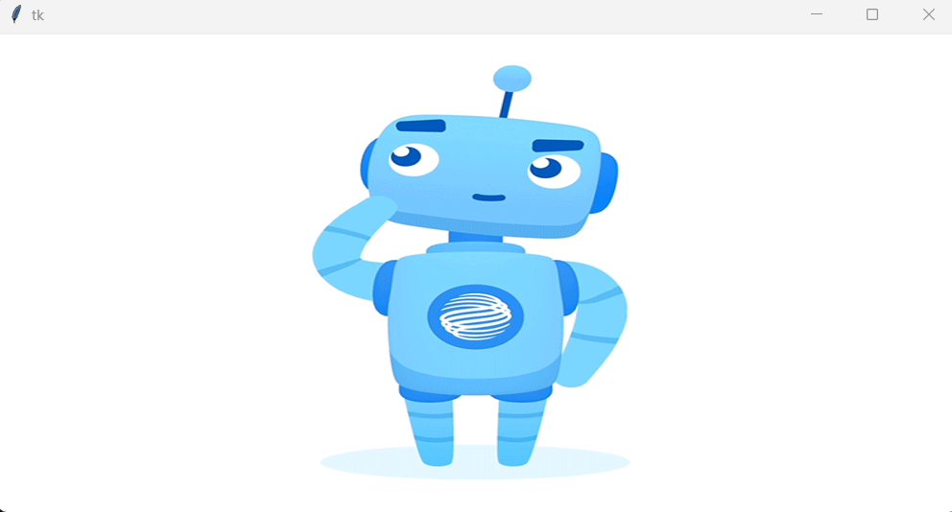

* 1. **Firstly , we need to give the wake up command :-**

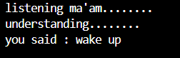

* 1. **Then when we gave the following command :-**

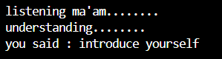

**It speaks about itself as :-** My creators named me Eve, your personal AI assistant... Hello! I am Eve, your virtual assistant. I can help you with tasks, answer your questions, and provide a conversational experience.Let’s make your day more productive and enjoyable together!How can I assist you today?

* 1. When the command says :-Amitabh Bachhan on Wikipedia



# When asked to calculate 3+4 : It gives ans 7

# 

# 

# When asked about the news : it asks the category and then speaks the news

# 

# 

# It also does some basic functionalities like , opening chrome and closing it as well.

# We can also play anything on youtube .

# 10) It also tells the current temperature .

# Chapter 4: Applications and Scope

### **4.1 Applications**

* **Personal Assistant**: Schedule management, reminders, and information retrieval.
* **Education**: Assisting students with learning tasks and queries.
* **Accessibility**: Helping individuals with disabilities through voice interaction.

### **4.2 Future Scope**

* **Multilingual Support**: Adding capabilities for non-English languages.
* **Offline Mode**: Enhancing privacy by processing data locally.
* **Integration with IoT**: Controlling smart devices using voice commands.
* **Enhanced GUI**: Incorporating advanced features like voice visualization and themes.

# ****References****

1. AssemblyAI Documentation: <https://www.assemblyai.com/>
2. Google Gemini API Guide: [Google AI](https://www.google.com/)
3. ElevenLabs API Documentation: <https://www.elevenlabs.io/>
4. Python Official Documentation: <https://www.python.org/doc/>