REVERSE-PROXY CONFIGURATION

We first need to update the configuration file **, ie haproxy.cfg with Jinja**.

Here I used **‘for loop’** in Jinja language for printing Groups **(webserver)** Value**(Ip’s present in that group)**

I created the architecture in the type like in future it would automatically update it’s configuration file on each time new Managed node join the inventory.

**Before copying the haproxy.cfg file to the managed node**

Image for post

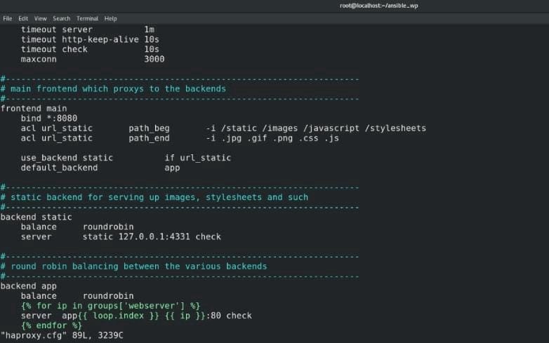

haproxy.cfg file in controller node

**After copying the haproxy.cfg file to the managed node**

Image for post

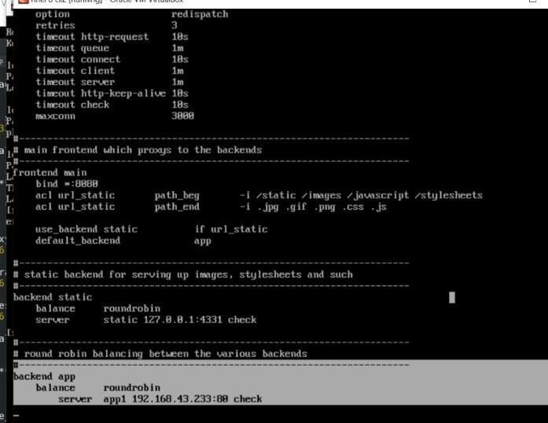

haproxy.cfg file in managed node

**Inventory File**

Image for post

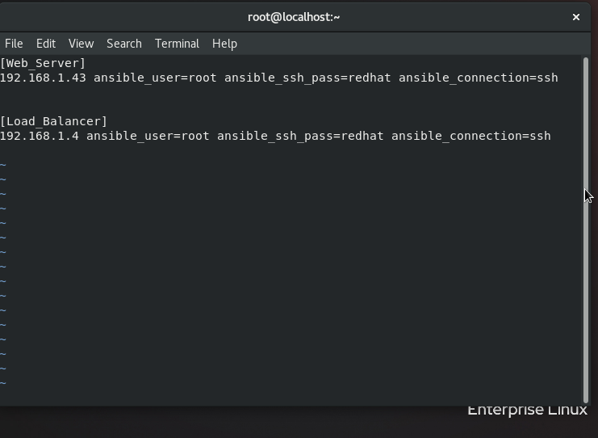

Inventory file

After Working on the configuration file in the side of controller node ,I created a playbook which would **automatically launch a webserver with a Load Balancer or Reverse proxy configured and also start the services .**

In haproxy.yml playbook

Image for post

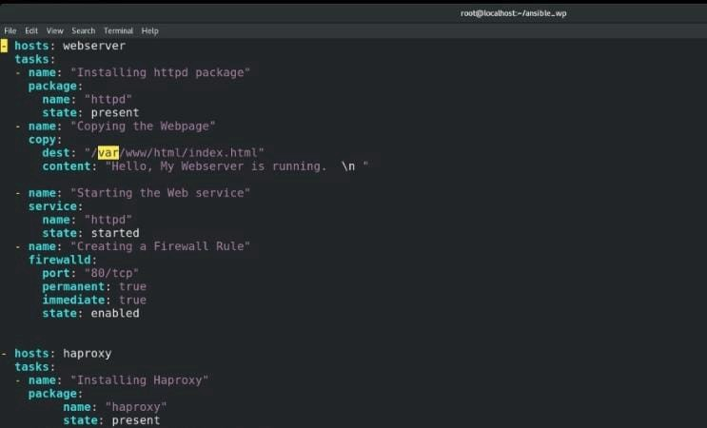

Image for post

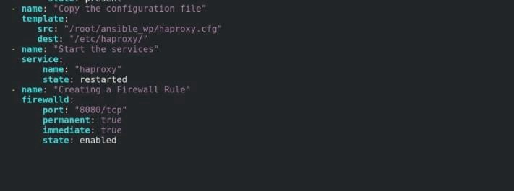

haproxy.yml playbook

First Creating a play for webserver groups

Image for post

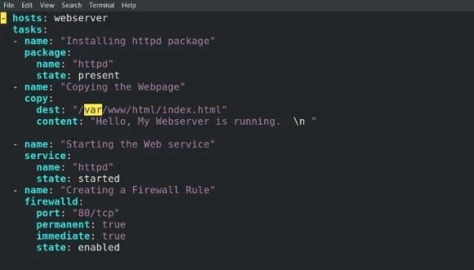

Play for webserver

**STEP 1**

**Creating a host** ,ie webserver groups.

Image for post

Image for post

Host

**STEP 2**

**Installing Httpd package** with the help of **package module**.

Image for post

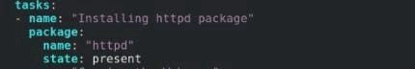

Installing httpd package

**STEP 3**

**Creating a simple html file** in document root of managed node using the **module copy**.

Image for post

Image for post

Copying the webpage

**STEP 4**

**Starting the Httpd Web Services** using the **module service.**

Image for post

Image for post

Starting httpd services

**STEP 5**

**Creating a Firewall rule** for port no 80 with the protocol tcp using the **module firewall.**

Image for post

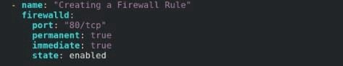

Creating a Firewall Rule

Secondly creating a play for haproxy groups.

Image for post

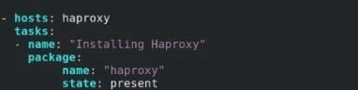

Image for post

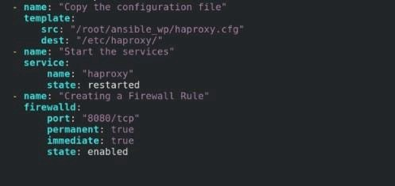

Play for haproxy

**STEP 1**

**Creating a host** ,ie haproxy groups.

Image for post

Image for post

Host

**STEP 2**

**Installing haproxy package** with the help of **package module .**

Image for post

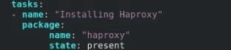

Installing haproxy

**STEP 3**

**Copying the configuration file**that we updated onto the controller node using the **module template .**

Image for post

Image for post

Copying the file

**STEP 4**

**Starting the Haproxy service** using the **module service.**

Image for post

Image for post

Starting haproxy service

**STEP 5**

**Creating a Firewall rule** for port no 8080 with the protocol tcp using the **module firewall.**

Image for post

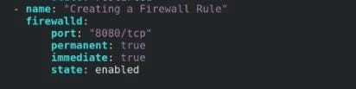

Creating a Firewall Rule

**Now running haproxy.yml playbook**

ansible-playbook haproxy.yml

Image for post

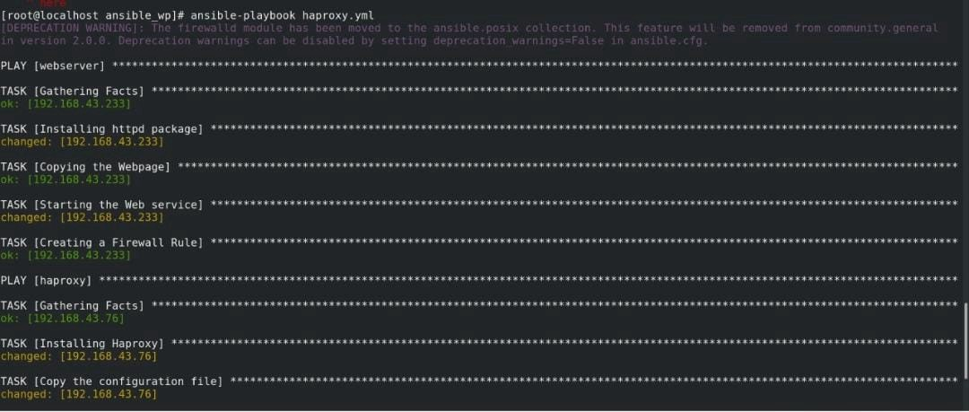

Image for post

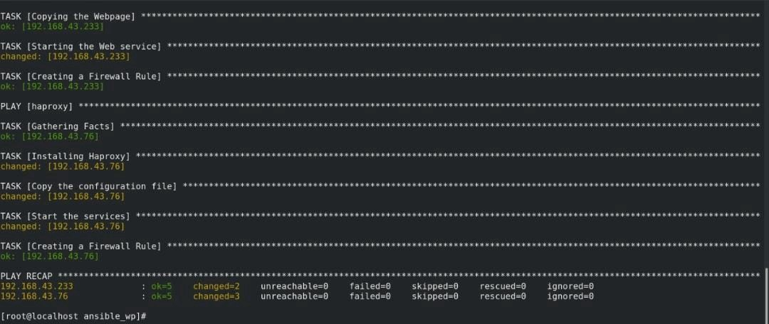

Running Playbook

Here my website is running with the Reverse proxy configured .

ThankYou .