Q1.

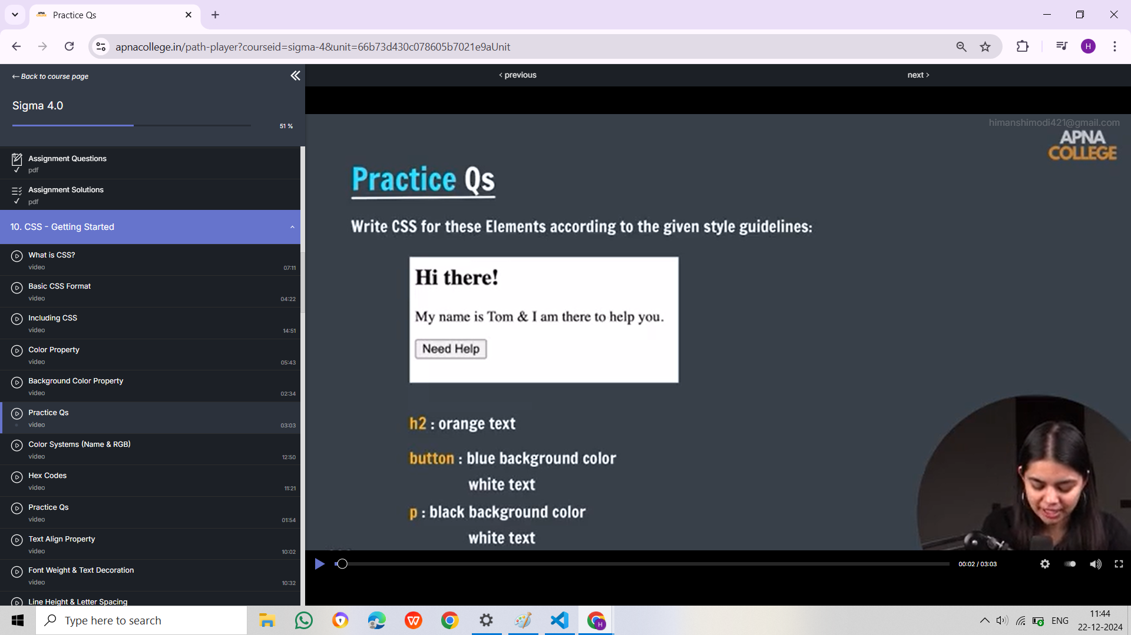

Q2.

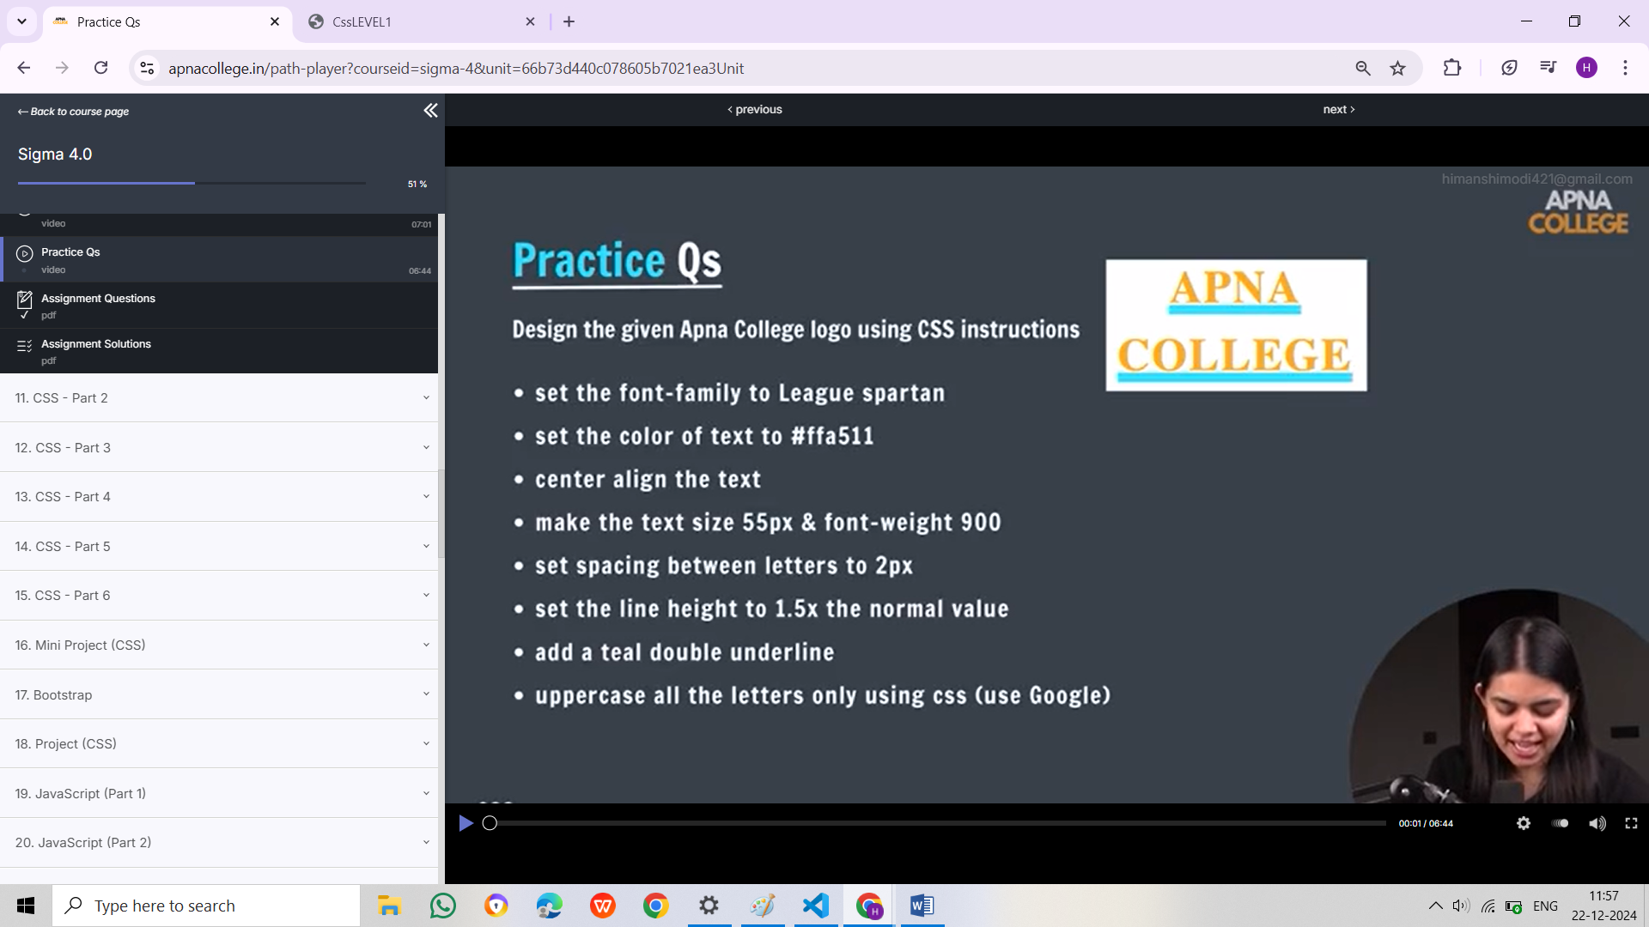

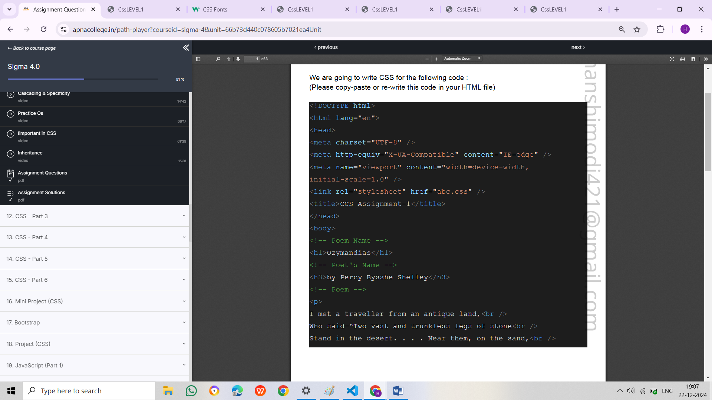

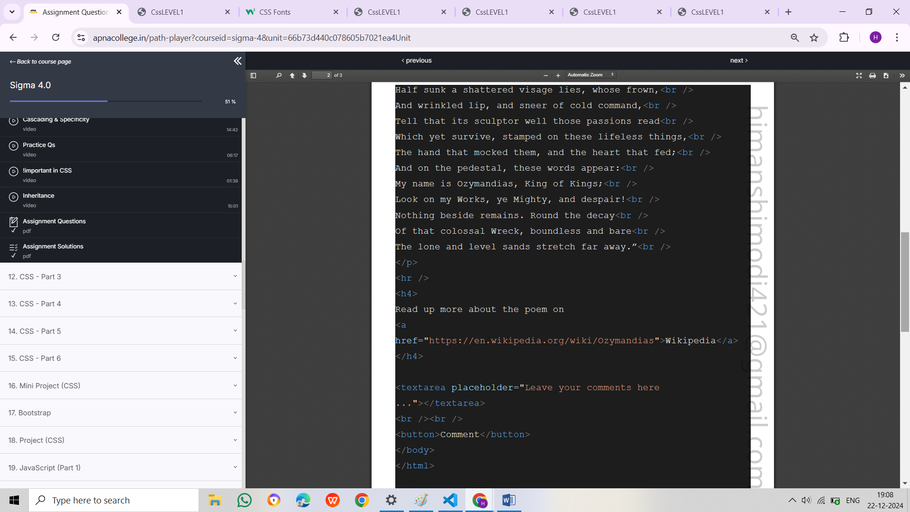

<h1>Ozymandias</h1>

<h3>by Percy Bysshe Shelley</h3>

<p>I met a traveller from an antiquel and,<br/>

Who said—“Two vast and trunkless legs of stone<br/>

St and in the desert....Near them,on the sand,<br/>

Half sunk a shattered visage lies,whose frown,<br/>

And wrinkled lip,and sneer of cold command,<br/>

Tell that its sculptor well those passions read<br/>

Which yet survive,stamped on these lifeless things,<br/>

The hand that mocked them,and the heart that fed;<br/>

And on the pedestal,these words appear:<br/>

My name is Ozymandias,King of Kings;<br/>

Look on my Works,ye Mighty,and despair!<br/>

Nothing beside remains.Round the decay<br/>

Of that colossal Wreck,boundless and bare<br/>

The lone and level sands stretch far away.”<br/>

</p><hr/>

<h4>Read up more about the poem on<a href="https://en.wikipedia.org/wiki/Ozymandias">Wikipedia</a></h4>

<textarea placeholder="Leave your comments here..."></textarea>

<br/><br/>

<button>Comment</button>

