Java Web Development

**Web development** refers to the building, creating, and maintaining of websites. It includes aspects such as web design, web publishing, web programming, and database management. It is the creation of an application that works over the internet i.e. websites.

The word Web Development is made up of two words, that is:

* **Web:** It refers to websites, web pages or anything that works over the internet.
* **Development:** Building the application from scratch.

**Web Development can be classified into two ways:**

* [Frontend Development](https://www.geeksforgeeks.org/how-to-become-a-front-end-developer/)
* [Backend Development](https://www.geeksforgeeks.org/what-is-the-difference-between-front-end-and-back-end-web-development/)

**Frontend Development:**The part of a website that the user interacts directly is termed as front end. It is also referred to as the ‘client side’ of the application.

* **Frontend Roadmap:**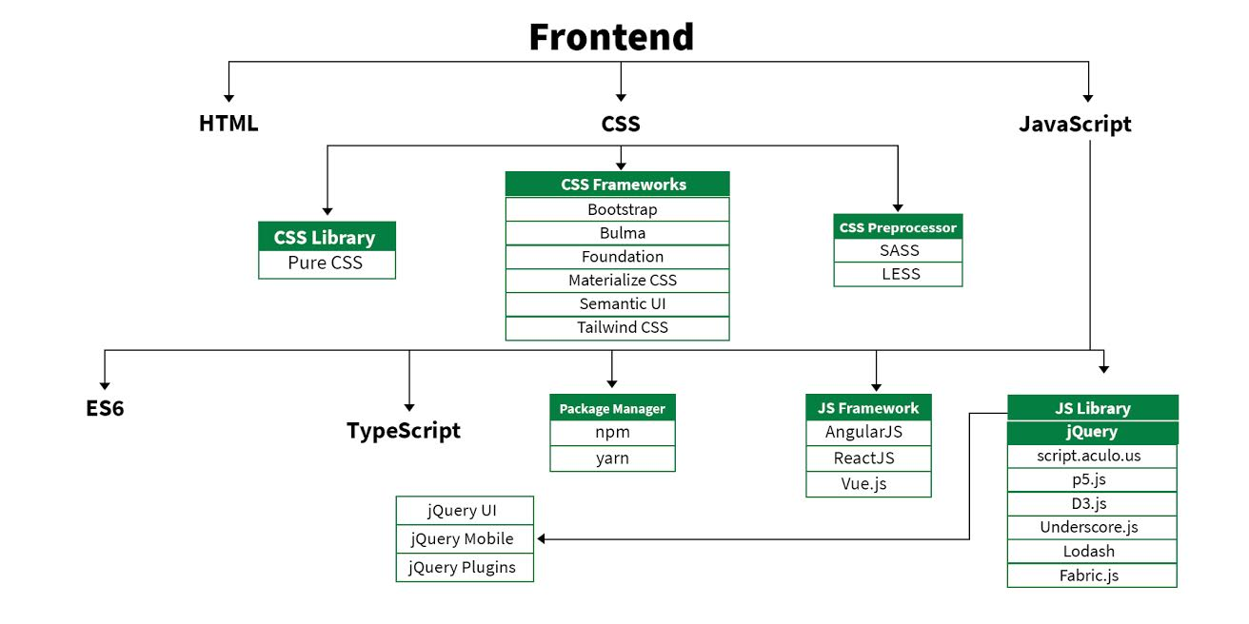
* [**HTML**](https://www.geeksforgeeks.org/html-tutorials/): HTML stands for HyperText Markup Language. It is used to design the front end portion of web pages using markup language. It acts as a skeleton for a website since it is used to make the structure of a website.
* [**CSS**](https://www.geeksforgeeks.org/css-tutorials/)**:**Cascading Style Sheets fondly referred to as CSS is a simply designed language intended to simplify the process of making web pages presentable. It is used to style our website.
* [**JavaScript**](https://www.geeksforgeeks.org/javascript-tutorial/)**:**JavaScript is a scripting language used to provide a dynamic behavior to our website.
* [**Bootstrap:**](https://www.geeksforgeeks.org/bootstrap-tutorials/)Bootstrap is a free and open-source tool collection for creating responsive websites and web applications. It is the most popular CSS framework for developing responsive, mobile-first websites. Nowadays, the websites are perfect for all the browsers (IE, Firefox, and Chrome) and for all sizes of screens (Desktop, Tablets, Phablets, and Phones).
  + [Bootstrap 4](https://www.geeksforgeeks.org/bootstrap-4-introduction/)
  + [Bootstrap 5](https://www.geeksforgeeks.org/bootstrap-5-introduction/)

**Frontend Frameworks and Libraries:**

* [AngularJS](https://www.geeksforgeeks.org/angularjs-tutorials/)
* [React.js](https://www.geeksforgeeks.org/reactjs-tutorials/)
* [VueJS](https://www.geeksforgeeks.org/vue-js-introduction-installation/)
* [jQuery](https://www.geeksforgeeks.org/jquery-tutorials/)
* [Bootstrap](https://www.geeksforgeeks.org/bootstrap-tutorials/)
* [Material UI](https://www.geeksforgeeks.org/material-ui-introduction-and-installation-for-react/)
* [Tailwind CSS](https://www.geeksforgeeks.org/css-tailwind-introduction/)
* [jQuery UI](https://www.geeksforgeeks.org/tag/jquery-ui/)
* Some other libraries and frameworks are: [Handlebar.js](https://www.geeksforgeeks.org/handlebars-templating-in-expressjs/) [Backbone.js](https://www.geeksforgeeks.org/difference-between-backbone-js-and-angular-js/), [Ember.js](https://www.geeksforgeeks.org/emberjs-vs-reactjs/) etc.

[**Backend Development**](https://www.geeksforgeeks.org/which-one-is-most-demanding-back-end-web-framework-between-laravel-nodejs-and-django/)**:**Backend is the server side of a website. It is the part of the website that users cannot see and interact. It is the portion of software that does not come in direct contact with the users. It is used to store and arrange data.

* **Backend Roadmap:**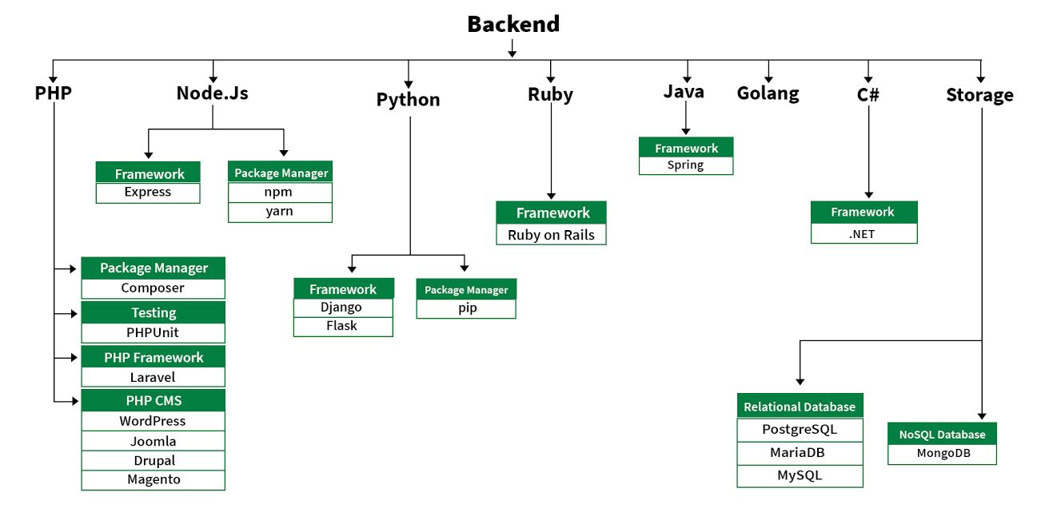
* [**PHP**](https://www.geeksforgeeks.org/php-tutorials/)**:** PHP is a server-side scripting language designed specifically for web development.
* [**Java**](https://www.geeksforgeeks.org/java-tutorial/)**:** Java is one of the most popular and widely used programming language. It is highly scalable.
* [**Python**](https://www.geeksforgeeks.org/python-programming-language/)**:**Python is a programming language that lets you work quickly and integrate systems more efficiently.
* [**Node.js**](https://www.geeksforgeeks.org/nodejs-tutorials/)**:** Node.js is an open source and cross-platform runtime environment for executing JavaScript code outside a browser.
* **Back End Frameworks:** The list of back end frameworks are: [Express](https://www.geeksforgeeks.org/introduction-to-express/), [Django](https://www.geeksforgeeks.org/django-tutorial/), [Rails](https://www.geeksforgeeks.org/how-to-install-ruby-on-rails-on-windows-and-linux/), [Laravel](https://www.geeksforgeeks.org/tag/laravel/), [Spring](https://www.geeksforgeeks.org/introduction-to-spring-framework/), etc.

## **What are the Java Technologies Involved in Web Application Development?**

### **1. Java Servlet API**

The Java Servlet runs on the server side without an application of its own as an HTML user interface (UI) or an application GUI. They are used to extend the applications hosted by the web servers. Several web applications are developed with Java Servlet extensions.

### **2. JavaServer Pages Technology**

It gives a simple and fast way to create dynamic content. It facilitates the addition of snippets of servlet code into the text-based document. JSP contains static data expressed in text-based format namely HTML, Wireless Markup Language (WML) or XML; JSP technology elements which determine the dynamic content construction by the page.

### **3. JavaServer Pages Standard Tag Library**

It has the iterator and conditional tags to handle flow control, tags for accessing databases with SQL, manipulating XML documents, internalization, and commonly used functions.

### **4. JavaServer Faces Technology**

It forms the UI framework to build web applications.

### **5. Java Message Service API**

With the combination of Java technology with enterprise messaging, the JMS API forms a powerful tool to solve enterprise computing problems.

### **6. JavaMail API and the JavaBeans Activation Framework**

It is used to send e-mail notifications. In conjunction, one may use the JavaBeans Activation Framework (JAF) API, which determines the type of data, encapsulate the access, and discover the operations available.

### **7. Java API for XML Processing**

It is flexible and JAXP facilitates the use of any XML-compliant parser or the XSL processor within the application and supports the W3C schema.

### **8. Java Naming and Directory Interface**

It provides the functionality of naming and directory, enables the applications to access several naming and directory services.

### **Wrapping Up**

Depending on the complexity of the web application, the other technologies involved are J2EE Connector Architecture; Java Authentication and Authorization Service (JAAS); Java Architecture for XML Binding (JAXB); SOAP with Attachments API (SAAJ); Java API for XML Registries (JAXR); Java Transaction API (JTA), and, etc.

To know more about the Java technologies used in web applications, you may get in touch with the [**expert Java application developers**](https://www.orangemantra.com/services/hire-java-developer/) at OrangeMantra. Share your web application requirements here at the leading Java web development company and get the perfect solution within the desired time frame. Timely reporting of the project will take the development work in the right direction.