PROJECT REPORT
PROJECT TITLE: Forecasting Air Quality Using Machine Learning Regression Models
Himanshi Tanwar

Abstract
Air pollution has grown into a critical environmental and public health threat in major Indian cities. Accurate forecasting of the Air Quality Index (AQI) helps authorities issue early warnings, implement mitigation policies, and reduce health complications for vulnerable populations. This project applies machine learning regression models to predict AQI using historical pollutant data from the “Air Quality in Major Indian Cities” dataset (city_day.csv) available on Kaggle. The experiment compares a baseline Linear Regression model with a Random Forest Regressor. Performance evaluation uses RMSE, MAE, and R² metrics. Results show that Random Forest significantly outperforms Linear Regression, achieving lower prediction errors (RMSE = 40.19, MAE = 20.38) and a higher R² score (0.912), demonstrating its suitability for capturing nonlinear pollutant interactions. Feature importance analysis shows PM2.5 and CO as the strongest predictors of deteriorating air quality. The study highlights the effectiveness of ensemble machine learning in supporting data-driven environmental management.

1. Introduction
Air quality deterioration has become a severe environmental concern driven by rapid industrial expansion, increasing vehicular emissions, and dense urban development. Long-term exposure to polluted air is linked with respiratory infections, asthma, cardiovascular disorders, and reduced life expectancy. Therefore, forecasting AQI is essential for issuing public health alerts and supporting evidence-based policy planning.
Traditional AQI forecasting methods rely on statistical approaches that assume linear pollutant behavior, which limits accuracy when pollutants interact in complex, nonlinear patterns. Machine learning addresses this limitation by learning from historical pollution levels and identifying relationships among pollutants.
1.1 Challenges
Key challenges identified in AQI forecasting include:
- Missing or incomplete pollutant readings from monitoring stations.
- Nonlinear pollutant behavior influenced by weather and seasonal changes.
- Variability among cities with different emission patterns.
- Selection of suitable regression models for accurate prediction.
1.2 Contribution
This project contributes:
- A complete AQI forecasting pipeline using pollutant concentration data.
- A comparative evaluation of Linear Regression and Random Forest models.
- Feature importance analysis identifying key pollutant drivers of AQI.
- Results visualized using feature importance and prediction scatter plots.

2. Literature Review
The reviewed research focuses on forecasting PM2.5 and AQI through machine learning and hybrid ensemble models. Authors highlight limitations of traditional statistical forecasting, particularly when modeling nonlinear pollutant dynamics. Studies experimented with Gradient Boosting Regression, ARIMA, Prophet, LSTM, and ensemble Gaussian Process Regression across datasets from Taiwan, China, and India. Key challenges included temporal fluctuations, incomplete pollution data, and model selection difficulty. Evaluation metrics such as RMSE, MAE, MSE, and R² demonstrated that Gradient Boosting and ensemble methods delivered stronger predictive accuracy than classical models.
The studies compared different machine learning algorithms—Linear Regression, Decision Trees, Random Forest, Gradient Boosting, and SVR—to determine effective AQI predictors. Data sources included CPCB India and Taiwan meteorological monitoring systems. Core challenges included real-time prediction delays, missing pollutant readings, and seasonal pollution shifts. Performance assessment used RMSE, MAE, and R², with Random Forest consistently showing best accuracy due to its robustness against noise and nonlinear relationships.
This literature explored both machine learning and deep learning methods for AQI and pollutant prediction. Algorithms evaluated included Regularized Regression, SVR, Decision Trees, ensemble models, and deep learning architectures such as RNN and LSTM for time-series forecasting. Studies emphasized capturing pollutant seasonality and incomplete monitoring data. Datasets included Beijing and Italian urban monitoring networks. Metrics included RMSE, MAE, accuracy, and correlation coefficients. Findings suggested that ensemble and optimized deep learning frameworks provided improved stability for AQI and pollutant grade prediction.
This set of studies concentrated on city-specific and multi-source AQI forecasting, using advanced ensemble and optimization methods. Machine learning models included SVM (RBF kernel), Random Forest, stacking ensembles (MLP, SVR, RF), XGBoost, CatBoost, and LightGBM. Some studies integrated Grey Wolf Optimization for model improvement. Datasets came from Ahmedabad, Beijing, Istanbul, Sri Lanka, and EPA/IoT sensor networks. Metrics included Accuracy, RMSE, MAE, and R², with ensemble and optimized models providing superior prediction reliability, especially for extreme AQI events.

3. Dataset Description
The dataset used is city_day.csv from Kaggle, containing daily pollutant concentration data for major Indian cities. Features include:
Pollutants / Attributes
PM2.5, PM10, NO, NO₂, NOx, NH₃, CO, SO₂, O₃, Benzene, Toluene, Xylene
City (categorical), Date (converted to year, month, day, weekday)
Target Variable: AQI
Missing AQI records were removed. The dataset was suitable for supervised regression modeling.

4. Methods and Models
4.1 Data Preprocessing
- Handled missing values using median imputation.
- Encoded City using One-Hot Encoding.
- Extracted time-based features: year, month, day, weekday.
- Scaled numeric variables using StandardScaler.
- Train-test split: 80% training, 20% testing.
4.2 Machine Learning Models
Model | Description
Linear Regression | Baseline parametric model; assumes linear pollutant-AQI relation.
Random Forest Regressor | Ensemble bagging model; handles nonlinear relationships and reduces variance.
4.3 Evaluation Metrics
$$RMSE=\sqrt{\frac{1}{n}∑(y_{i}-\hat{y_{i}})^{2}} \\ MAE=\frac{1}{n}∑∣y_{i}-{\hat{y}}_{i}∣ \\ R^{2}=1-\frac{∑(y_{i}-\hat{y_{i}})^{2}}{∑(y_{i}-\overset{ˉ}{y})^{2}}$$

5. Results and Analysis
Model | RMSE | MAE | R²
Linear Regression | 56.797 | 30.060 | 0.824
Random Forest | 40.191 | 20.388 | 0.912
Feature Importance (Top Predictors):
- PM2.5 (0.489)
- CO (0.367)
- NO, PM10, O₃, NOx contributing smaller proportions.
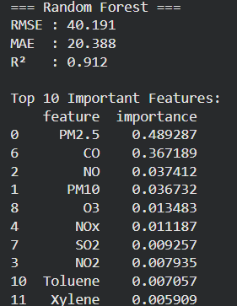
The scatter plot showed strong clustering of predicted AQI around the actual values line, confirming prediction reliability.

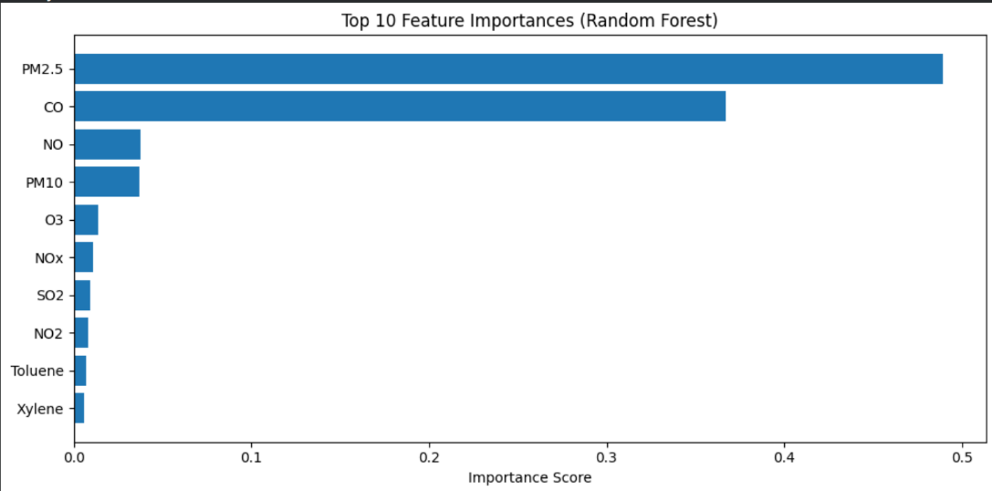
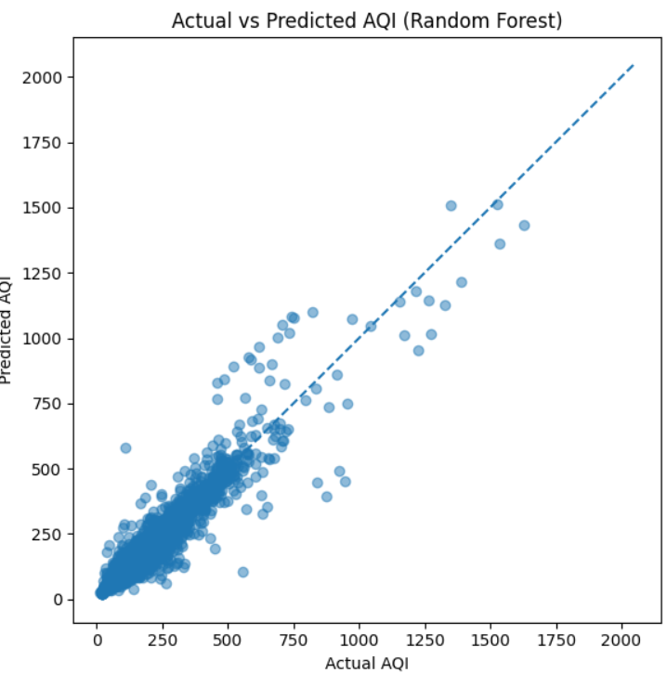

6. Conclusion and Future Work
This study developed an AQI forecasting model using pollutant concentration data and demonstrated that Random Forest outperforms Linear Regression. PM2.5 and CO emerged as critical pollutant indicators. Results validate the application of ensemble machine learning for AQI prediction in Indian cities.
Future Enhancements
- Integration of meteorological variables (temperature, wind speed, humidity).
- Hourly forecasting using city_hour.csv.
- Real-time dashboard deployment for public alerts.
- Testing advanced ensemble models (XGBoost, LightGBM) and LSTM time-series models.

References
(Keep these as-is in Word)
Gupta, N. S., et al. (2023). Prediction of Air Quality Index using Machine Learning Techniques.
Lee, M., et al. (2020). Forecasting Air Quality in Taiwan by Using Machine Learning.
Rahman, M. M., et al. (2024). AirNet: Predictive Machine Learning Model for Air Quality.
Kothandaraman, D., et al. (2022). Intelligent Forecasting of Air Quality.
Castelli, M., et al. (2020). A Machine Learning Approach to Predict Air Quality in California.
Doreswamy, H. K. S., et al. (2020). Forecasting Air Pollution Particulate Matter (PM2.5).
Hardini, M., et al. (2023). Predicting Air Quality Index using Ensemble Machine Learning.
Srivastava, C., et al. (2018). Estimation of Air Pollution in Delhi Using ML Techniques.
Ke, H., et al. (2021). Automated Air Quality Forecasting System.
Liu, H., et al. (2019). Air quality index and pollutant concentration prediction.
Zhu, D., et al. (2018). Model Regularization and Optimization for AQI Prediction.
Madan, T., et al. (2020). AQI Prediction Using Machine Learning — A Review.
Aram, S. A., et al. (2024). AQI Index & Grade Prediction Comparative Analysis.
Freeman, B. S., et al. (2018). Forecasting Air Quality Time Series Using Deep Learning.
Maltare, N. N., & Vahora, S. (2023). AQI prediction for Ahmedabad.
Kang, G. K., et al. (2018). Big Data and ML Approaches for AQI Prediction.
Emeç, M., & Yurtsever, M. (2024). Ensemble Machine Learning for Accurate AQI Prediction.

