CUSTOMER CHURN PREDICTION AND RETENTION SYSTEM
Himanshi Tanwar

Abstract

Losing customers now stands among the toughest problems for today’s service businesses, especially telecoms and online video services. With markets getting tighter, keeping clients already on board matters far more than chasing fresh faces - so guessing who might leave turns into a strategic priority [1]. Old methods usually judge success by how well they sort users into groups, relying on data from just one area at a time, while skipping over skewed distributions, poor adaptability across contexts, and thin guidance for actual moves [2], [9]. That flaw leaves plenty of tools stuck between number-crunching models and practical choices companies must make.
This work introduces a complete method for predicting churn and supporting retention, merging machine learning with time-based forecasts and personalized suggestions within one cohesive setup [2], [3]. Rather than depending on isolated information sources, the design pulls user records from both telecommunications and video services, allowing insights across sectors to boost performance. Starting with raw inputs, the process reshapes details like how long someone has stayed active, their payment history, consumption trends, and periods without engagement into uniform features. Through statistical checks, only those elements showing strong links to outcomes move forward - others get set aside before scaling adjusts values uniformly. Afterward, the cleaned collection splits into parts meant for teaching algorithms and testing their accuracy later.
Dealing with uneven class distribution in churn data, SMOTE boosts the number of rare churn instances through synthetic generation [4]. Rather than relying on one algorithm, several are tested - Logistic Regression, Decision Trees, Random Forests, MLP, and XGBoost - with evaluation based on accuracy, precision, recall, F1-score, and ROC-AUC [2], [3], [5]. What stands out is how ensemble methods outperform others by better handling intricate data structures [3]. Beyond classification, patterns across time emerge when applying ARIMA and SARIMA models to predict evolving churn tendencies [7] predictive analytics has emerged [1]. These approaches together allow a deeper look into how customers might behave down the line.
What stands out here is how the method combines forecasts of customer departure with practical steps businesses can take. Because it uses patterns in user activity and likelihood scores, tailored actions follow - discounts for loyalty, offers to upgrade plans, or messages meant to win people back. Instead of sitting idle, predictions become guidance that shapes choices and leads to measurable outcomes. Insights drawn from which variables matter most also open the black box, giving teams clear reasons behind why customers leave [8].
Even under changing circumstances, predictions hold steady - Random Forest paired with XGBoost leads due to high ROC-AUC scores and balanced accuracy [2], [3]. Drawing data from multiple areas helps; so does handling uneven spreads [4], [9], followed by suggesting practical follow-ups, setting it apart from older approaches when applied outside labs. Over time, one thing becomes visible: a system shaped for expansion, able to project customer loss while guiding strategy, quietly reshaping how companies retain users and remain active long-term.

1.Introduction

Background
Noticing when users stop using a service matters deeply - especially in fields like telecom or online video platforms [1]. Though keeping current clients costs less than finding new ones, companies still lose money because warning signs go unseen [1]. Many wait until someone exits before doing anything, making recovery harder and hurting future earnings. Predicting who might leave ahead of time changes that pattern [1]. Instead of reacting too late, firms now use data tools to spot early signals, shifting how they protect income.

Later years saw more ways to guess who might stop using a service, thanks to machines learning patterns [2], [3]. Not just grouping outcomes anymore, tools such as Logistic Regression or Decision Trees pull out visible paths across messy data streams [2]. Alongside them works Random Forest, frequently revealing subtle hints that slip past simpler systems [2]. Progress marches forward with Gradient Boosting refining forecasts even more [3]. Though numbers improve, clarity about long-term loyalty stays missing. Organized customer facts form the base these techniques depend upon. Most studies fixate on precision improvements instead of practical follow-up actions companies might adopt. In real-world settings, mere identification falls short - knowing someone is leaving matters less than interventions that alter their path.
One key issue with today’s churn forecasting tools lies in their reliance on data from just one sector - like telecommunications or a single digital platform [1]. Because behavior differs widely across fields, models trained this way struggle to adapt elsewhere. Often, these datasets contain far more records of users who stay than those who leave. Such uneven distribution skews results, pushing algorithms to favor the larger group. When imbalance goes unaddressed, the system overlooks true dropouts more frequently [4],[9]. Poor detection follows naturally from that tilt.

Instead of relying on narrow datasets, this research introduces a blended approach to predicting and managing customer turnover by merging information from telecommunications and digital media services into one cohesive design. Because it pulls together varied usage indicators - like account age, payment history, and interaction frequency - the method detects broader tendencies that apply across sectors. What makes it distinct is its use of chronological tracking, revealing shifts in leaving behaviors as time progresses [7]. This temporal lens improves anticipation of upcoming changes without depending solely on static snapshots.

What sets this method apart is how it moves beyond mere forecasting. Instead of ending at predictions, the model adds a step: suggesting ways to keep customers. Depending on risk levels, actions might include special pricing offers - longer subscriptions encouraged through incentives - or outreach efforts aimed at those who have stopped engaging. Connecting forecasts directly to next steps makes the output more useful in actual operations. Practical impact matters just as much as accuracy here, allowing application across varied, fast-moving settings.

2. Problem Identification and Novelty

One reason progress stalls lies in how studies treat churn data - too focused on isolated sectors like telecom or online shopping [1]. When systems learn only from one type of business, they miss shifts seen elsewhere. Patterns driving departures differ widely between fields, making universal rules hard to build. Without exposure to varied environments, algorithms struggle once moved outside familiar ground. Performance drops appear quickly under new conditions, exposing weak flexibility. So far, few solutions manage stability across diverse settings.

A major hurdle emerges when dealing with uneven class distribution, common across many customer turnover records. Often, those who stay outnumber those who leave by a large margin, skewing how algorithms learn patterns. Instead of tackling this gap, numerous past efforts overlook it entirely - some attempt fixes but fall short. As a result, predictions may show strong general correctness while missing true dropouts consistently. Since spotting at-risk users matters far more than broad precision, these flaws weaken real-world usefulness drastically [4], [9].

What often gets overlooked in today’s studies is how little attention goes to practical follow-up steps after predicting churn. While most algorithms sort users into likely or unlikely leavers, few suggest concrete moves for those flagged at risk. Because of this gap, data outputs rarely align well with actual company choices. Useful forecasts exist - yet firms frequently lack direction on reducing attrition. Without guidance tied to decisions, even accurate models lose value quickly.

Despite these hurdles, sophisticated approaches like deep learning and ensemble techniques bring along concerns about intricacy and clarity [1], [2], [3]. Though powerful in detecting intricate trends and delivering strong results, such systems frequently operate without clear insight into their decision logic. Because explanations for outcomes remain hidden, confidence tends to weaken, especially in corporate settings that depend on understanding how conclusions are reached [8]. Without visibility into processes, acceptance often slows down when justifications matter.

Time dynamics often missing in current research stand out when predicting customer departures. Treating turnover as fixed, many models fail to track shifts in user actions across periods. When timing plays no role, spotting upcoming drop-offs grows harder. Planning early interventions also turns uncertain without such context [7].

Facing these gaps, a new combined approach brings several upgrades together within one system. Notably, it uses both telecom and streaming information joined into a shared format. Because of this blend, behavior trends become clearer across varied sectors. Next comes balanced learning through SMOTE methods - this gives rare churn instances proper weight when teaching the model [4].

It’s noticeable that multiple machine learning approaches work side by side, allowing comparisons so the strongest model can be chosen rather than relying on a single option [2], [3]. Thanks to this setup, performance remains steady despite shifting environments. Meanwhile, tracking changes over time through forecasting reveals trends in customer loss, bringing a sense of timing into the prediction process [7]. This study stands out because it includes guidance on keeping users, changing predicted churn into specific actions. Rather than stopping at predictions, as past models often did, it links understanding to doing - using behavior-based reactions shaped by individual usage. For the first time, the system moves beyond prediction, supporting actual decisions. What changes everything? The step from warning to helping.

One thing clear here: progress happens when different pieces fit - like cross-domain learning, handling uneven groups, model comparisons, forecasting shifts, along with actionable outputs - all woven into a single design. Rather than zeroing in on fragments, this approach fills holes older methods missed. Because of that, the structure covers more ground, scales smoother with big data, functions sharper in real company environments. Power isn’t only in mixing parts - it lies in arranging them so every piece feeds forward. With this linked setup, studying why customers leave becomes richer, yet easier to apply.

3. Literature Review

3.1 Customer Churn Prediction in Telecom Using Machine Learning Techniques
Looking at telecom data, this work uses several machine learning methods to forecast when customers might stop using a service [2]. Billing records, patterns in usage, alongside contract details form the core inputs shaping these predictions. Instead of guessing, models learn from past behavior - spotting those at risk before they exit.
Classification approaches turn raw numbers into practical insights, helping companies respond earlier. Better decisions follow when firms know which factors drive people away. Loss rates shift - not because of luck - but due to clearer visibility into customer habits. Predictive tools, once tuned, reveal quiet signals hidden across large datasets. Earlier warnings mean interventions happen while there is still time. Patterns repeat, yet each case differs slightly - the model adapts without rigid rules. Businesses gain not by reacting faster, but by seeing ahead.
Though basic at first glance, the telecom data becomes more revealing when processed through Logistic Regression, Decision Trees, and Random Forest models [2]. Evaluation unfolds via accuracy, precision, recall, along with the F1-score - each offering distinct clues about model strength [5]. It turns out that methods combining multiple trees, particularly Random Forest, tend to lead, mainly because they manage tangled relationships between variables quite well. Instead of stopping at predictions, the work digs into which features matter most, exposing what truly drives customers to leave.
What stands out most is how the research tests several algorithms using actual data. Still, applicability beyond one field remains unproven because the framework applies solely within a narrow context. One issue overlooked involves uneven class distribution, which skews results without correction methods [4], [9]. Another gap appears in the absence of follow-up mechanisms - predictions emerge, yet next steps receive little attention.

3.2 Customer Churn Prediction Using XGBoost Algorithm
This study explores XGBoost for forecasting customer churn, emphasizing fast processing and high precision [3]. When patterns grow intricate, gradient boosting proves effective - uncovering subtle shifts in user activity across time. Behavioral data at scale fits better with these techniques, unlike conventional approaches that struggle under complexity. Where features mix unpredictably, performance lifts noticeably through layered variable relationships.

After beginning with unprocessed customer data, cleaning happens first - removing errors clears the way for handling missing pieces. Once tidy, a custom-built XGBoost model detects trends using finely tuned configurations. Performance stands out clearly - the ROC-AUC score beats previous methods [3]. Rather than relying on assumptions, understanding grows from sorting variables by impact strength. From this ordering, what pushes customers to leave shows up plainly.

Though the model works effectively, certain limitations exist. Parameter adjustment requires significant effort; meanwhile, handling large datasets needs strong computational resources. Explanation techniques are missing in the study - on top of that, strategies for retaining knowledge across time have not been developed. Owing to such shortcomings, application beyond prediction tasks proves challenging.
3.3 A Hybrid Approach for Customer Churn Prediction Using SMOTE and Machine Learning
A different route emerges when machine learning meets SMOTE, shaping a method to tackle uneven classes in customer loss data [4]. Because skewed distributions often weaken predictions, spotting departures becomes harder - this work shows why. While models struggle with rare outcomes, balancing the data first helps tip accuracy upward. Instead of accepting poor recall, adjusting sample proportions changes what the algorithm learns. Though imbalanced sets are common, they do not need to define model limits.

Preprocessing the data comes first, followed by using SMOTE to even out class distribution before moving on to model training with tools like Decision Trees and Random Forest [4]. Better recall along with higher F1-scores appears in the outcomes, especially when spotting the less frequent class. What stands out is how much these balancing methods boost detection of customers likely to leave.

Though the method manages uneven class distribution well, its reach is narrow due to reliance on just one data source. Still, the goal stays fixed on boosting prediction accuracy rather than blending practical outcomes like customer retention or broader domain application.

3.4 Customer Churn Analysis Using Deep Learning Techniques
What stands out is the use of deep learning approaches designed to predict customer disengagement - neural networks play a key role [1]. Moving beyond conventional analysis, this study explores multi-layered systems that detect faint signals within patterns of user activity. As layers stack, previously invisible links begin to surface, something basic models rarely achieve. With depth comes clarity; intricate structures turn what seems messy into meaningful insight. Subtle changes appear sharper, uncovered by designs built to handle nuance rather than avoid it.
Starting elsewhere, some methods train a neural net on customer data before checking results against standard tests. Not only do modern setups reach similar accuracy, they also push identifying capabilities beyond simpler techniques. Remarkably, these models develop depth in recognizing structures without being told. Despite their intricacy, the way they process signals reveals more about underlying features compared to older approaches.
Even with better speed, longer training times demand more processing power. Since reasons behind results stay murky, confidence in choices drops off. When systems lack memory support, using them widely in business runs into roadblocks.

3.5 Time Series Forecasting for Customer Churn Using ARIMA Models
Looking ahead begins with old numbers, not categories. Past exits form a base for what follows. Instead of grouping people, trends emerge from time-based changes. What happened before guides expectations now. Shifts spread out matter more than sudden drops. Forecasting leans on order, revealing slow moves beneath. Methods such as ARIMA track flow across months. Sequences show direction, ignoring isolated moments [7].
Beginning with the structure of customer records, forecasting turnover involves dividing information into time segments before applying ARIMA models[7]. Rather than focusing solely on highs and lows, useful clues come from recurring movements over monthly periods. Past cancellations help expose probable declines ahead, revealing gradual trends. Noticeable is the timing of losses - certain seasons show increased endings, while others slow down. Timing shapes planning, making it sharper when matched with what comes next. When past steps inform future ones, foresight strengthens without force. What happens before sets the pace for what follows after.
Even when good at finding patterns, this method fails to identify exactly who will stop using the service. Because
attention stays fixed on overall groups, individual signals often go unnoticed. When engagement tools or adaptive models aren’t included, results in practice tend to fall flat. Built-in boundaries block its use just as more targeted steps become necessary.
3.6 Explainable AI for Customer Churn Prediction Using SHAP
Oddly enough, knowing how algorithms reach conclusions becomes crucial when forecasting customer departures. Viewed through explainable AI, hidden processes start making sense. This approach brings in SHAP, a technique that reveals how each variable influences outcomes while increasing openness in predictions [8].
Although SHAP values are used here, their role is to clarify feature impact within ML models predicting customer departures. Visuals emerge not just as illustrations but as tools that reveal decision logic to non-experts. Because interpretations become clearer, confidence in outputs grows alongside actionable understanding.
Though interpretation gets a boost here, prediction accuracy sees no attention - nor does the issue of uneven class distribution [4], [9]. What's more, without links to real-world decision frameworks, the work leans heavily toward analysis instead of practical use.

3.7 A Multi-Model Framework for Customer Churn Prediction
This study introduces a method merging several machine learning approaches to boost accuracy in predicting customer turnover [2], [3]. By leveraging diverse algorithms, each picks up unique patterns within the dataset - improving overall detection when integrated. Outcomes show synergy among models enhances predictive strength beyond individual efforts.

Starting with multiple algorithms - Logistic Regression, Random Forest, alongside Gradient Boosting - the process trains each one separately. Performance decides the winner, guided purely by measurable results. Instead of relying on just one model, this method achieves higher precision, also proving more stable under variation [2], [3].

Facing limitations, the model draws solely from one data source without tapping into broader domains. Without a way to retain past patterns, it narrows its aim strictly at forecasting instead of guiding decisions.

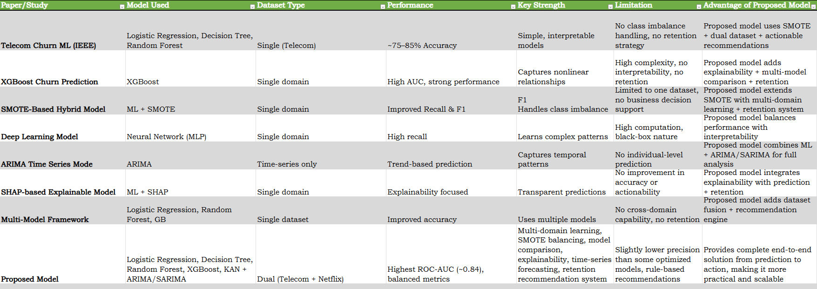

Fig 3.1 Comparison Table

4. Comparison with Existing Solutions

A One look at current work on predicting customer churn shows a strong emphasis on boosting model precision through machine learning methods - yet full, ready-to-use systems remain rare [2], [3]. While older efforts leaned on classic tools like Logistic Regression, Decision Trees, and Random Forests, delivering fair results in sorting churning users [2]. Telecom data, neatly organized, feeds these models well enough to hit accuracy marks around 75% to 85%. Still, relying only on one field's data weakens how far those findings can stretch into others [1]. Worse yet, many skip tackling uneven class distributions entirely, pushing forecasts off balance and favoring non-leavers too heavily - a flaw that hampers practical application [4], [9]. Even with solid scores in forecasting what customers do, powerful tools such as XGBoost face issues revealing how decisions unfold [3]. Since these models spot complex links, measures like ROC-AUC rise sharply. Still, understanding fades once systems grow too tangled to trace. Gains in precision tend to come paired with greater computing needs. Without clear inner workings, firms hesitate to rely completely on outputs [8]. Though they sort data effectively, turning results into actions is still hard. Because routes to planning are vague, what they do often ends up being measurement without direction.

One way researchers tackle uneven class distribution is through methods like SMOTE - this boosts recall and F1-score by creating artificial examples for smaller groups [4]. Though better at spotting churn patterns, such strategies rely solely on data from one source, limiting their reach beyond that context. Because of this constraint, findings tend to apply narrowly, losing strength when shifted to new sectors or sets of information [1]. What also stands out is how these systems prioritize predictive precision alone, lacking tools to turn forecasts into actionable business steps.

Though deep learning methods like neural nets and combined designs show up in churn forecasts, they handle tangled data links well while spotting at-risk users effectively [11]. Because these systems demand heavy computing power, though, running them takes more time and resources than simpler tools. Their inner logic stays hidden during predictions - this opacity makes it hard to see how choices emerge. When companies need clear reasoning behind alerts, that invisibility becomes a barrier, slowing down practical use despite strong performance numbers [8].

Looking into past patterns, ARIMA-style methods track how churn changes across months or quarters instead of guessing who might leave next [7]. While these approaches reveal shifts in overall departure rates over periods, their reach stops short when it comes to spotting particular users likely to exit. Because they only map broad movements, fine-tuned interventions based on personal habits stay out of grasp. Without tying results to single accounts, actions built solely on such forecasts often miss the mark in real-world handling of customer loss.

Feature contributions get highlighted through methods like SHAP, making predictions easier to follow [8]. Though insight grows, accuracy sees little boost from such techniques. Class skew stays problematic, just as before [4], [9]. Real-world speed requirements often go unmet. These tools analyze - yet fall short of guiding full choices. Not a solution, but part of one.

Though combining various algorithms, multi-model setups aim for higher performance through diversity in approach [2], [3]. By using several models at once, accuracy gains appear alongside stronger resistance to errors. Yet reliance remains fixed on data from just one domain, leaving retention methods untouched [1]. What complicates things further is the added structural weight these frameworks bring - without solving how predictions become real-world actions.

Instead of following earlier methods, this new approach builds a complete system merging several sophisticated parts into one structure. Through linking telecom data with streaming records, cross-area insights emerge - boosting how well patterns apply beyond original contexts. Balancing rare examples via SMOTE sharpens detection of uncommon customer exits [4]. Rather than sticking to just one method, various models undergo testing; the top performer gets chosen using broad evaluation criteria, strengthening consistency across results [2], [3], [5].

What sets this approach apart is its use of time-series methods like ARIMA and SARIMA, capturing patterns in personal usage alongside broader shifts over time - something missing in prior work [7]. Instead of just predicting outcomes, it examines which factors drive decisions through feature importance scoring, making results easier to grasp [8]. A key addition sits at the core: a module that turns likelihoods of leaving into concrete steps firms can take. Rather than staying confined to forecasts, the framework supports real-world choices by guiding response efforts.

Though much of today’s work targets just one area - say, precision or skewed data - the method introduced here weaves together multiple strengths without sacrificing speed or adaptability. By uniting clarity, balance, and strong results in one structure, it performs better where it counts: actual deployment. Effectiveness isn’t just measured in numbers; context matters, and that shifts how success is judged.

5. Project Methodology

A new approach aims to create a reliable system that predicts when customers leave, combining information from multiple areas along with smart algorithms, trend analysis over time, and ways to suggest actions for keeping users [2], [3], [7]. Starting off, data comes from two separate sources - telecom providers and online video services - each recording how people use their subscriptions. Information includes how long someone has been a user, payment records, frequency of access, and interaction habits. Because formats and types of details differ greatly between these origins, early steps involve fixing gaps in data, correcting errors, then reshaping everything into one consistent layout. After adjustments, the sets link together smoothly, forming one combined resource so patterns can emerge across fields instead of just within isolated cases [1].
After cleaning, the data undergoes feature creation to boost its clarity and usefulness. From current variables, new ones form - like charges relative to time active, periods without engagement, and how intensely services get used. Such constructed inputs reveal subtle trends missed when looking at original records alone. Next, traits closely tied to customer departure stay; others drop through analysis of statistical links. Cutting less useful elements trims complexity, speeds up learning, while lowering interference during modeling.
After locking in the features, data splits into training and test portions while scaling adjusts values so each one holds similar weight. Because customer loss records often contain far fewer examples of departures than stays, artificial instances get created through SMOTE to even things out [4].
With more balanced groups present, detection of true exits becomes easier, reducing automatic preference for the larger group. The approach shifts emphasis where it belongs - on catching real signals instead of defaulting to common patterns [9].
Starting off, Logistic Regression kicks things into motion, followed by Decision Trees shaping decisions based on splits [2]. Instead of using untouched information, every technique draws insights from a rebalanced form of the data. Moving ahead, success shows up through numbers like accuracy and precision, yet also includes recall plus F1-score and ROC-AUC [5]. For stability testing under shifting conditions, cross-validation comes into play during analysis. Out of all contenders, one method proves more reliable, stepping beyond others toward further scrutiny and real-world application. Most times, methods such as Random Forest together with XGBoost stand out due to strong performance [2], [3]. Because they manage complex, curved patterns tucked inside data, their power shows clearly.
Beyond sorting outcomes, the approach uses sequential pattern analysis to track how customer departures evolve across months. With data reshaped into chronological order, techniques like ARIMA along with its seasonal variant model upcoming turnover levels [7]. Such modeling supports foresight spanning weeks or years, offering firms a clearer view of likely shifts in user retention. Insights emerge not just from categories but from timing, guiding steps before losses accumulate.
Looking at what drives decisions, model-derived insights spotlight key factors linked to customer departure. By revealing these elements clearly, teams gain clearer insight into why outcomes occur [8]. Near the end, guidance tools join the workflow, drawing on forecasted risk levels and individual traits to shape responses. High-impact offers go to valuable clients showing exit signs. Short-term subscribers see incentives nudging them toward extended commitments. Those who have disengaged receive tailored efforts aimed at revival.
Putting it together, this approach links data merging with smart models, time-based review, and tools for guiding choices - all woven into one working structure. Instead of relying on just one type of data, struggling with uneven samples, or failing to suggest clear next steps, the design tackles these gaps head-on [1], [4], [7]. Through that shift, outcomes become more usable in actual business settings where keeping customers matters most.

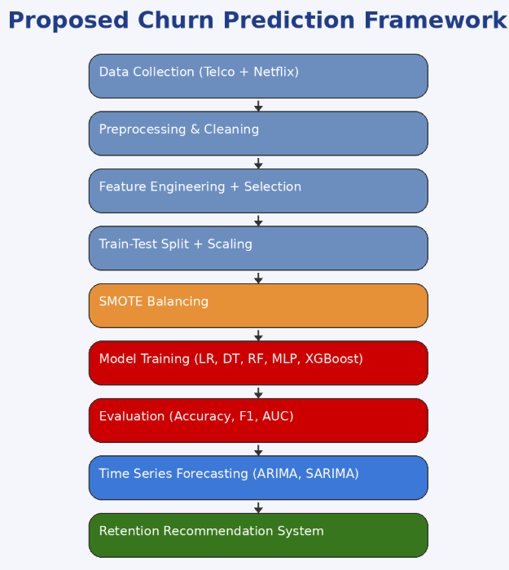
Fig 5.1 Model Architecture

6. Result and Analysis

Not every model handled customer turnover forecasts the same way. When fed combined telecom and streaming datasets, their real-world actions diverged sharply. Evaluation leaned on standard metrics - accuracy sat alongside precision, recall tagged along, F1-score joined in, ROC-AUC completed the picture [5]. Rather than chasing single outcomes, attention spread across balanced results. Catching actual churn events became a strength for several; meanwhile, restraint around incorrect warnings defined others. One step ahead in spotting true churns, Logistic Regression hit 74.86% accuracy, reaching a recall of 75.83%. Precision trailed at 62.85%, mainly because false alarms piled up during predictions. As a result, the F1-score settled around 69%. Although it captured many real dropouts successfully, misclassifying inactive users kept performance restrained. Close in rank, Decision Tree achieved 74.45% accuracy - slightly less sharp in precision than Logistic Regression. Its F1-result also edged downward, barely falling short. While human readers find its logic easier to follow, signs point to overfitting tendencies during learning [2]. Because of that habit, subtle data signals were missed when facing new samples. Generalization limits held back deeper insight extraction.
Top spot went to Random Forest, hitting 76.28% in accuracy, with precision landing at 65.27%. Recall climbed to 74.57%, leading to an F1-score recorded at 69.61%. On ROC-AUC, it scored roughly 0.8395 - this edge made its strength clear through steady predictions. By forming many decision trees, subtle trends emerge without veering into overfitting too easily [2]. Close behind came XGBoost, posting accuracy near 75.45%, ROC-AUC just under 0.8359. Though a bit lower, every measure stayed even, handling intricate links effectively [3].
Accuracy sat at 74.16%, showing how well the Multi-Layer Perceptron performed overall. At its peak, recall hit 80.16%, meaning it caught many true churn cases. Still, precision fell to 61.08%, pointing to errors - active users were wrongly tagged as churning. This tilt meant catching real exits mattered more than avoiding false alarms. The model favored detection over sharp class separation. True departures matter most when missing one brings greater cost than extra false alarms. While flawed, the approach leans toward spotting real leave-takers - errors grow too, yet detection stays sharp. What counts is fewer overlooked goodbyes [11].
Still, the data revealed that Random Forest along with XGBoost held steadier accuracy in spotting true positives and negatives when set beside simpler models [2], [3]. This pattern became clearer through ROC analysis - curves sitting higher and stretching wider under the threshold range signaled better detection power across shifting decision points for these advanced techniques [5].
Every time, the strongest signals showed up in how long people stayed, their monthly payment size, expenses compared to duration, yet also hints they were pulling away. Though many methods tried, only a few factors kept appearing - over and over, without fail. Hidden rhythms within basic numbers became visible when tailor-made measures joined the analysis.
Slowly, patterns in customer turnover began appearing through ARIMA and SARIMA outputs, not merely categorizing results. As stays of varying lengths progressed, prediction methods shifted in response. What came into view was a clearer sense of what followed. Well ahead of issues spreading, forecasts started informing decisions. With each update, understanding deepened - timing gradually matching real actions [7].
Among outcomes, identifying at-risk customers through churn metrics stands out. Nearly one-quarter showed elevated risk following model assessment. Rather than blanket strategies, targeted responses appeared - discounts reached heavy users, extended agreements appealed to recent sign-ups, re-engagement efforts contacted inactive profiles. Not merely predicting departures, the process converts insights into concrete steps. What emerges is less about warnings, more about directed change.
One model might work well on its own, yet stacking several improves accuracy and consistency under changing circumstances [2], [3]. As information streams come together - paired with even class distribution and cleaned inputs - the method adjusts more smoothly to how things unfold outside labs [4], [9]. Over time, integrating forward views builds richness, so estimates shift along with emerging movements. With a nudge built in, findings transform into practical steps, moving beyond raw results toward useful decisions. Instead of narrow alert systems, this path spans wider terrain, managing spotting issues and reacting all inside a single design.
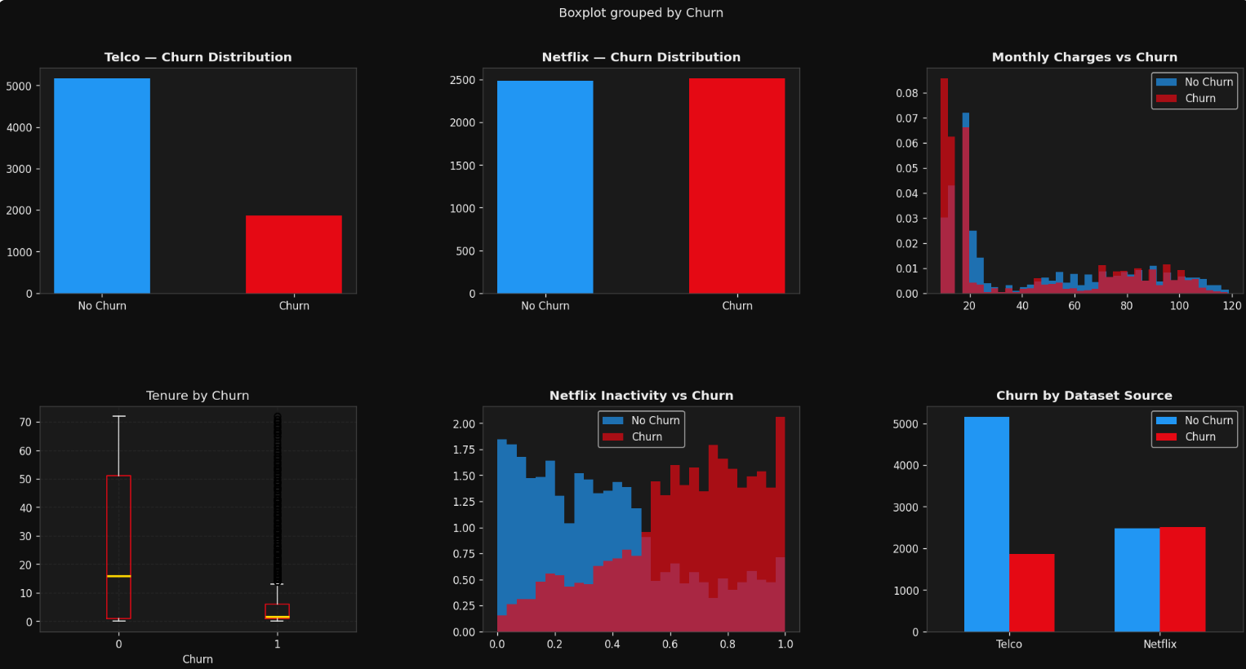
Fig 6.1 EDA

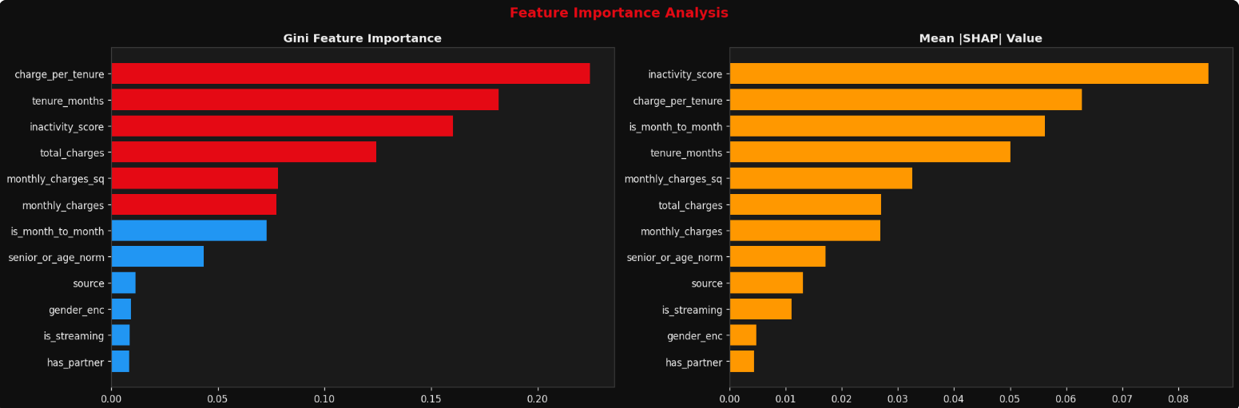
Fig 6.2 Feature Importance

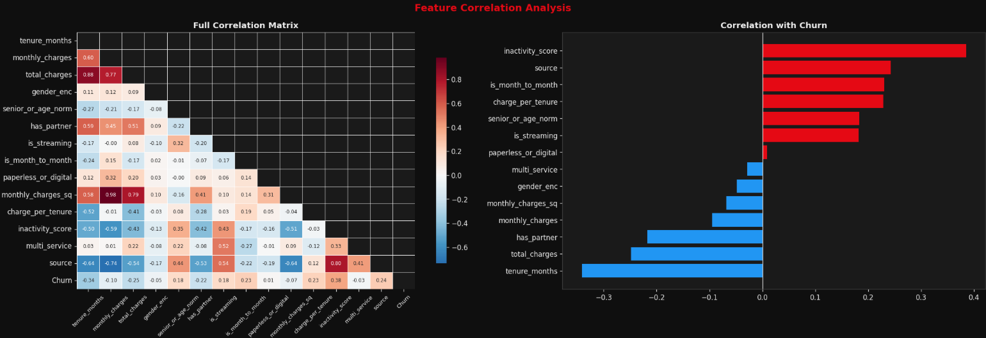
Fig 6.3 Feature Correlation

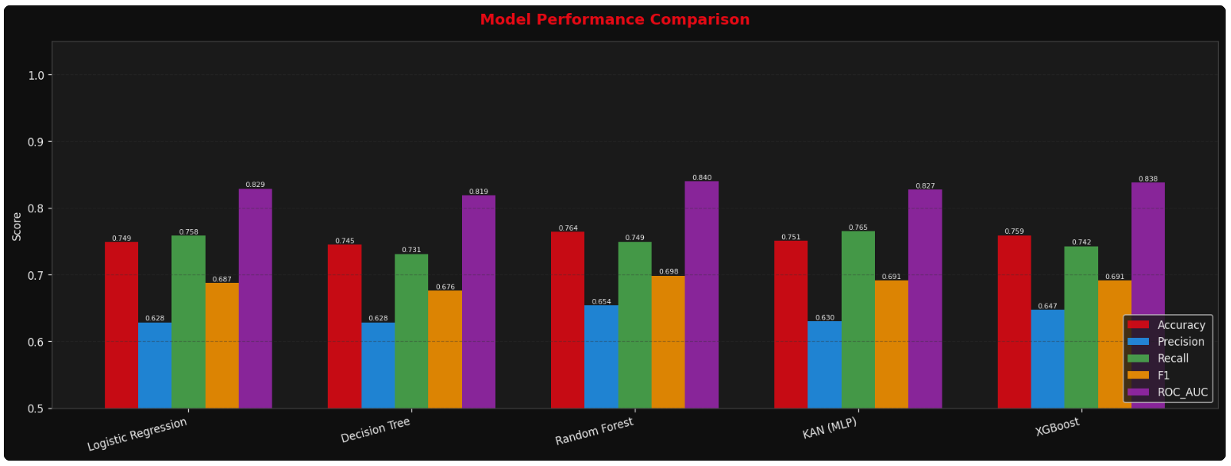
Fig 6.4 Model Comparison
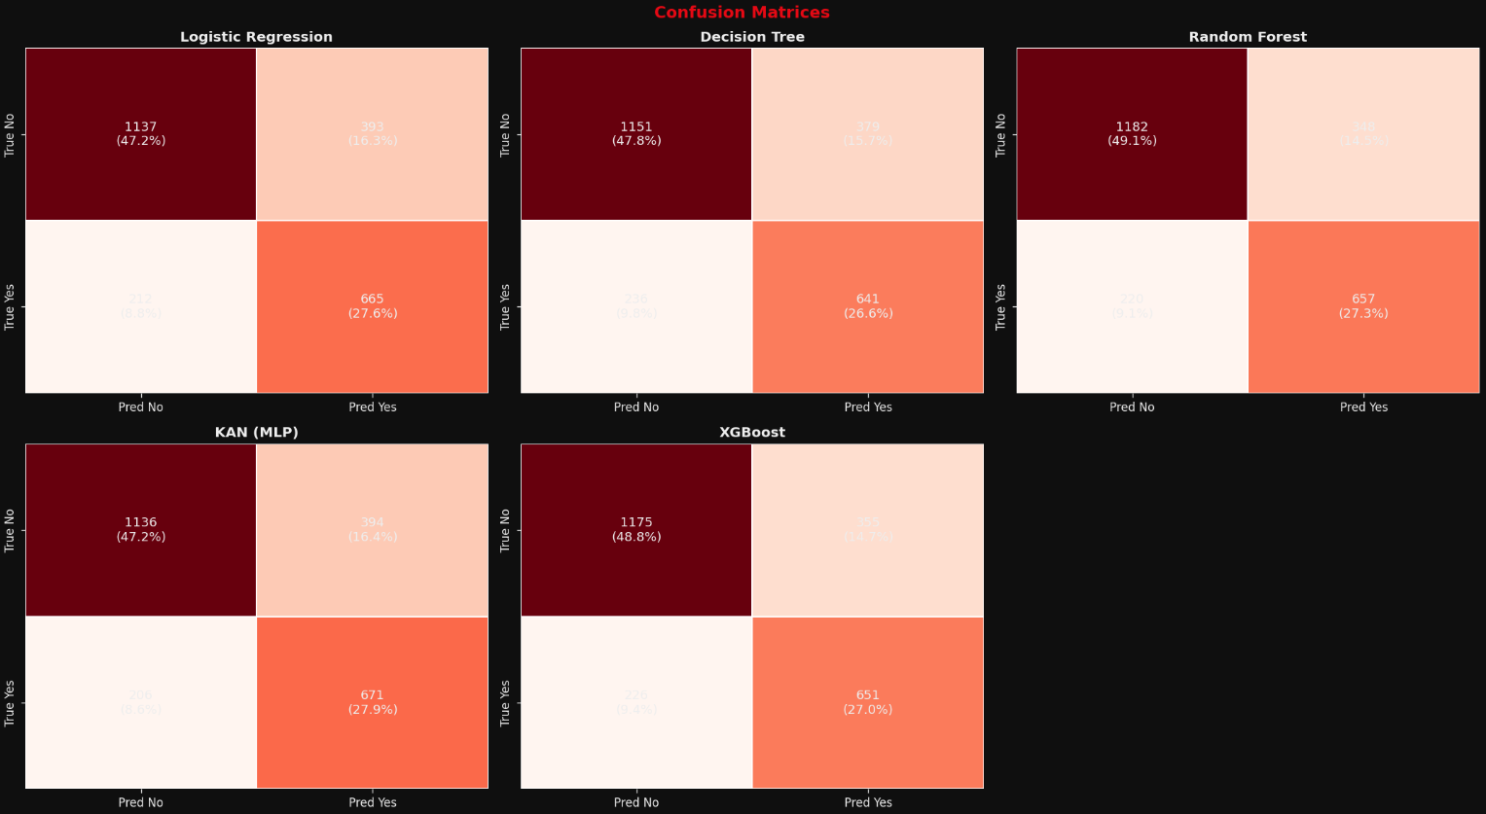
Fig 6.5 Confusion Matrices

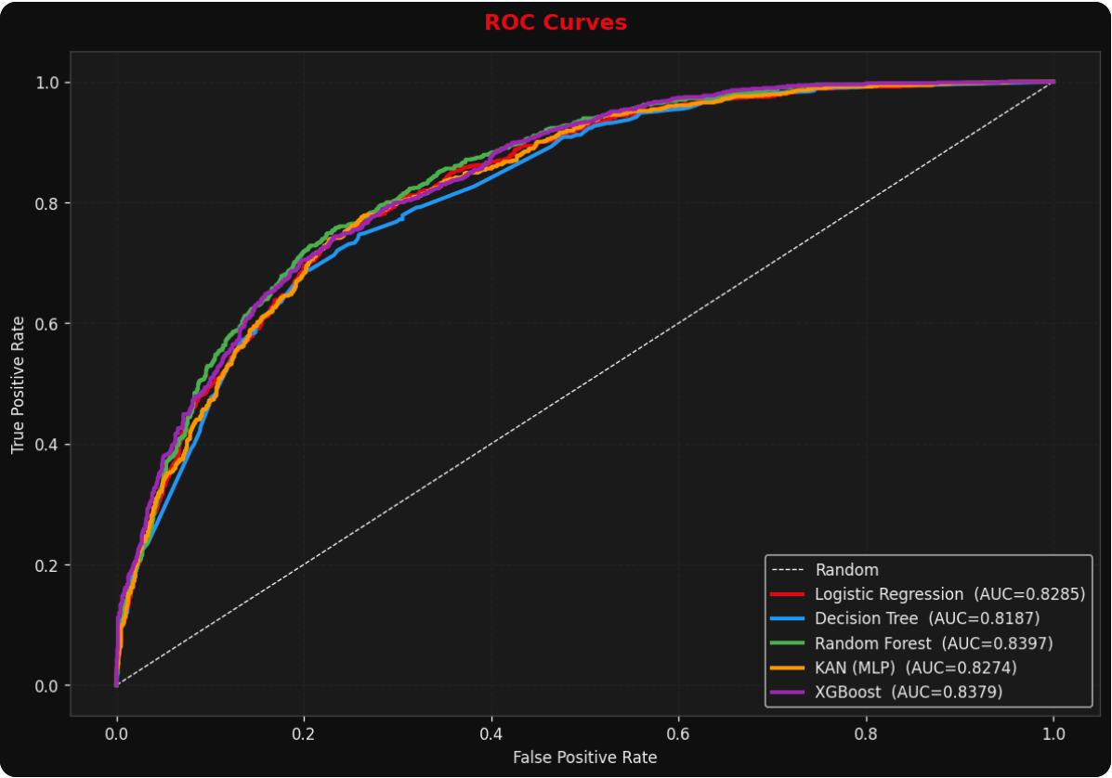
Fig 6.6 ROC Curves

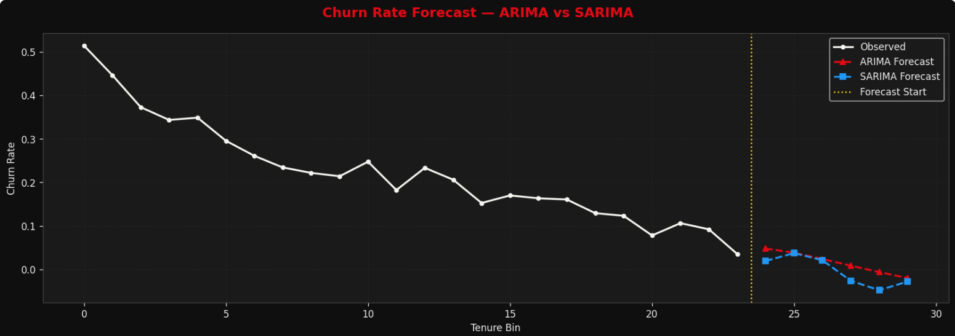Fig 6.7 Time Series

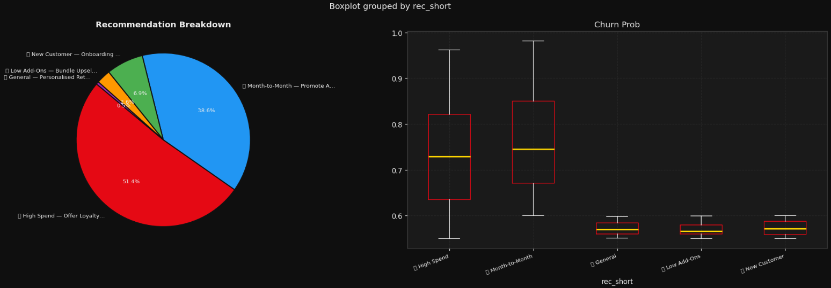
Fig 6.8 Recommendations
7
. Conclusion and Future work

Examining customer departures from platforms, this study develops a straightforward approach to forecast and lower turnover by addressing frequent flaws in existing setups [1]. Rather than relying solely on one data type, it combines inputs from telecom networks along with streaming usage patterns - broadening understanding of behavior trends [1]. With enhanced attributes selected early and less useful predictors removed via correlation checks, the learning set becomes more focused. When class imbalances arise, artificial examples generated by SMOTE improve visibility into smaller groups during modelling [4], [9]. Among various approaches examined, Random Forest along with XGBoost performs better, delivering higher precision, reliability, and improved AUC scores [2], [3]. When predictions rely on combining techniques before selecting the best result, outcomes grow more dependable compared to sticking strictly to one method from the start [2], [3].
Beyond sorting outcomes, weaving in time-sequence forecasts helps trace how churn shifts across months, revealing patterns that fixed snapshots miss [7]. Because it highlights which variables weigh heaviest, feature scrutiny makes model logic clearer [8]. What sets this study apart sits in its added tool for suggesting retention moves based on forecasted exit risks. Tied closely to choices managers face, the approach steps past common prediction setups by grounding results in operational next steps. Though strong in many areas, the system faces constraints that suggest room for growth. Rule reliance defines today’s recommendation logic - this might reduce flexibility when conditions shift fast. Shifting toward methods like reinforcement learning could help shape smarter, responsive suggestions down the line. Instead of fixed rules, adaptive patterns drawn from user behavior may offer richer results. Forecasting now uses traditional statistics; however, deeper temporal structures might emerge through neural networks [11]. Models such as LSTM or GRU hold potential where past trends influence future outcomes in subtle ways. Progress here could refine predictions without depending solely on historical averages.
One step forward might be running the system live with constant data flow, so shifts in how customers act trigger instant reactions. Instead of waiting, updates happen as things change. When fresh inputs arrive, responses follow without delay. Broader industry data woven into the model may strengthen its ability to adapt across varied settings [1]. Different sources bring new patterns, testing resilience beyond current limits. A deeper blend of interpretable methods - shown interactively - could clarify why decisions occur [8]. Seeing reasoning unfold builds confidence during actual use. Trust grows not from speed but clarity. With each explanation, users gain insight into outcomes.
Putting it together, the framework links forecasting methods, time-based patterns, and practical guidance within one structure. Because earlier studies miss key elements, this approach fills those spaces with a method that grows easily and works well for spotting when customers leave [1], [4], [7]. Given ongoing upgrades, such a setup might eventually operate on its own, helping companies make smarter choices over time.

8. References

[1] S. Verbeke, D. Martens, C. Mues, and B. Baesens, “Building Comprehensible Customer Churn Prediction Models with Advanced Rule Induction Techniques,” Expert Systems with Applications, vol. 38, no. 3, pp. 2354–2364, 2012.
https://www.sciencedirect.com/science/article/pii/S095741741000941X
[2] A. Idris, A. Khan, and Y. S. Lee, “Intelligent Churn Prediction in Telecom: Employing mRMR Feature Selection and Rotated Random Forest,” Applied Intelligence, vol. 39, pp. 659–672, 2013.
https://link.springer.com/article/10.1007/s10489-013-0446-4
[3] T. Chen and C. Guestrin, “XGBoost: A Scalable Tree Boosting System,” in KDD Conference, 2016.
https://arxiv.org/abs/1603.02754
[4] N. V. Chawla et al., “SMOTE: Synthetic Minority Over-sampling Technique,” Journal of Artificial Intelligence Research, vol. 16, pp. 321–357, 2002.
https://www.jair.org/index.php/jair/article/view/10302
[5] F. Provost and T. Fawcett, “Analysis and Visualization of Classifier Performance,” KDD Conference, 1997.
https://dl.acm.org/doi/10.1145/3097983.3098108
[6] J. Brownlee, “Machine Learning for Customer Churn Prediction,” 2018.
https://machinelearningmastery.com/predicting-customer-churn-with-machine-learning/
[7] G. Box, G. Jenkins, and G. Reinsel, Time Series Analysis: Forecasting and Control, Wiley, 2015.
https://onlinelibrary.wiley.com/doi/book/10.1002/9781118675021
[8] S. M. Lundberg and S. I. Lee, “A Unified Approach to Interpreting Model Predictions,” NeurIPS, 2017.
https://arxiv.org/abs/1705.07874
[9] H. He and E. Garcia, “Learning from Imbalanced Data,” IEEE TKDE, 2009.
https://ieeexplore.ieee.org/document/4633969
[10] A. Jain, M. Murty, and P. Flynn, “Data Clustering: A Review,” ACM Computing Surveys, 1999.
https://dl.acm.org/doi/10.1145/331499.331504
[11] Y. LeCun, Y. Bengio, and G. Hinton, “Deep Learning,” Nature, 2015.
https://www.nature.com/articles/nature14539
[12] S. Amin et al., “Comparing Oversampling Techniques for Churn Prediction,” IEEE Access, 2016.
https://ieeexplore.ieee.org/document/7752782

