ENVIRONMENT CONDITIONING MONITORING & PREDICTION USING MACHINE LEARNING
A PROJECT REPORT
BY
HIMANSHI TANWAR

ABSTRACT
This study introduces a system built to monitor and predict environmental conditions, using machine learning to analyze data in real time for landslide risks in Uttarakhand’s mountainous zones. Terrain across this Indian state includes spots extremely prone to natural dangers - where sudden downpours, slope failures, and severe climate shifts often lead to death and destruction annually.
Starting with gaps in early warnings, the setup uses machine learning shaped on artificial data built from IMD climate averages. Instead of real-world observations alone, it draws from simulated inputs mirroring ten years - daily figures spanning 2015 to 2024 - at multiple locations. Temperature shows up alongside humidity, rain levels appear together with wind strength, while air quality tags along with soil dampness details. Close to eleven thousand entries make up the collection, roughly counted at 10,959 snapshots of environmental behavior.
A full machine learning workflow runs from start to finish using five core parts. One part creates data then prepares it for use. Another dives into patterns through exploration before modeling begins. Environmental forecasts come next by applying five different regressions. These include basic linear methods along with ridge adjustments and tree structures grown randomly or boosted stepwise. Prediction shifts toward landslides when sorting danger levels - low, medium, high - using classifiers instead. Four such models take on that task. They range from logistic approaches to split rules built in trees, either alone or combined across many versions. A live web interface wraps everything together at the end. Each model feeds results there for viewing as updates occur.
Out of all models tested, Gradient Boosting handled temperature forecasting most precisely - landing at 1.688°C error and explaining nearly 89% of variance. When spotting landslide risks, Random Forest pulled ahead: almost 93% correct labels, strong balance in predictions, plus near-perfect curve area. Pages inside the Streamlit tool shift smoothly - one shows shifting climates, another peeks thirty days ahead with uncertainty bands, while others track danger levels live, dig into raw patterns, or unpack how well each algorithm holds up. Built to grow without heavy costs, it opens doors for quicker alerts and sharper oversight across hilly parts of India.
- INTRODUCTION
India's varied landscape faces frequent threats like floods, storms, extreme heat, slipping hillsides, and long dry spells. When these disasters strike again and again, lives are put in danger while buildings crumble and money vanishes.
Heavy rains drowning cities, rivers spilling over year after year - moments like the 2013 Kedarnath disaster show how thin our safety nets really are. When water swallows roads in Kerala or cuts off villages in Assam, it is not just nature raging; it is a signal we’re watching too slowly. IMD does track storms and skies, yes, yet much of what they offer runs on old rhythms - delayed data, broad guesses, maps that do not talk back. Seeing danger sooner means seeing it clearly, close up, almost before it forms.
This project tackles existing shortcomings through a system built on machine learning that pulls together environmental information. Instead of just collecting numbers, it turns raw inputs into clear visuals plus deeper analysis. Temperature trends show up alongside rain forecasts using models trained on real conditions across regions. When danger levels rise due to storms or heat waves, notifications reach people and officials without delay. Predictions update regularly based on fresh incoming streams of field data.
Starting small, yet built to grow, this setup runs on freely available tools. Not tied to big budgets, it fits places with limited resources. Instead of fading under pressure, it holds up when needed most. Through steady use, it helps strengthen communities ahead of disasters. One piece at a time, it supports a tougher, better-ready India.

  - Problem Statement
Across India, places deal with serious nature troubles - floods, sudden earth slips, heavy rains, storms, wild heat or cold - that keep causing deaths and money losses. Right now, tracking tools usually cannot predict fast enough nor share clear, close-to-home danger signals on time.
Apart from that, one tool still missing ties together tracking ecological shifts, predicting outcomes through algorithms, while sorting various dangers in a live interface.
From old records it learns patterns, then forecasts what might come next while sorting danger zones by threat level. Because past trends shape tomorrow's warnings, smart tracking helps communities stay ahead. When alerts grow sharper, choices get better - safety rises without grand promises. Regions differ, yet each gains from clearer signals before crises strike. Prediction becomes protection when systems adapt fast enough.

- Background Research
Looking into past studies and tools helped map how environmental tracking, weather forecasts using smart algorithms, and disaster preparedness stand today in India. Because of what came up during that look, certain choices around structure and methods took shape later on.

Out of nowhere, studies on landslide and flood risk zones pop up a lot - especially where rains pour hard, like the Himalayas. Not long ago, work from Biswajeet Pradhan and Saro Lee pointed at machine learning tools beating old-school stats; think neural nets or support vector machines doing better. When it came down to results, methods combining many models - Random Forest being one - hit higher precision marks. Because of that edge, this setup leaned into using Random Forest as its main way to classify danger spots.

Because Taylor and team studied weather forecasts in 2017, their findings leaned on group methods - especially Gradient Boosting - to predict patterns over time. Instead of single models, they combined several, which shaped how we built inputs here. Features came alive through delays and moving summaries, much like using yesterday's heat or three-day moisture trends. That idea carried forward directly into our setup, pulling past values alongside shifting means for elements such as rain, air dampness, and warmth.

Weather records from Indian cities, collected by the India Meteorological Department, include details on heat shifts, rain cycles, and changes through seasons. From these archives, artificial climate figures were built - closely mirroring actual environmental behavior in different parts of the country.

Still today, older time-series methods hold up well when predicting far ahead. Developed by George Box and Gwilym Jenkins, SARIMA stands out in this area. Because of their research, it makes sense to include these models when tracking repeating cycles in nature's numbers. Seasonal shifts in environmental records often show patterns these tools were built to find.

Rainfall patterns, ground wetness, land shape, plus plant cover help spot danger spots in India - that insight comes from work by the Geological Survey and the disaster authority. When rain crosses certain limits, risk goes up, records show. Because past rules set clear levels, they shaped how risks got sorted here. What features mattered most? Earlier warnings pointed the way.

  - Proposed System
From rooftops to rivers, a new tech setup learns from past and live signals about nature's shifts around India. Instead of waiting, it watches patterns as they form. Because weather doesn’t move in straight lines, the system maps its moods through shifting colors on screens. Time feeds into predictions - thirty days ahead - for rain and heat swings. When danger stirs, whether in rising water, sliding soil, or scorching air, alerts sort themselves quietly into low, medium, or high tags. Each region speaks differently; the model listens closely.
Out of separate parts comes how it works - data first, then machines learn from it, followed by checking results, finally showing them. Each piece moves on its own, so changing one doesn’t stall the rest. Swap fake numbers with live feeds straight from India's weather office? Done, no rewiring needed underneath.
One goal stands clear: bring environmental data within reach of many, from emergency teams to lawmakers and everyday citizens. Through a browser window alone - no downloads needed - live updates flow straight to those who need them. Real-time warnings appear as conditions shift, helping choices take shape before crises grow. Across towns and regions in India, readiness climbs when information moves fast. What matters most? People stay ahead because the system works quietly, always on.

  - Goals and Objectives
The goals and objectives of this project are outlined in the following table:
Table 1: Goal and Objectives
# | Goal or Objective
1 | Build an end-to-end ML pipeline covering data generation, preprocessing, EDA, modelling, evaluation, and dashboard deployment
2 | Build an end-to-end ML pipeline covering data generation, preprocessing, EDA, modelling, evaluation, and dashboard deployment
3 | Implement and compare at least 4 classification models for landslide risk prediction achieving accuracy above 90%
4 | Develop a 5-page interactive Streamlit dashboard accessible through any web browser without installation
5 | Develop a 5-page interactive Streamlit dashboard accessible through any web browser without installation
6 | Ensure the system is extensible for integration with real IMD sensor data in future versions

- Project Planning
This section covers the details of the project planning. Selecting the lifecycle of the development, project stakeholders, resources required, assumptions made are detailed in the sections below.
  - Project Lifecycle
Right from the start, the group followed Agile methods, mixing in pieces of Design Thinking because the class required it. Four sprints made up the timeline, each lasting two weeks, spread through the term. Sprint one kicked off with spotting the core issue, digging into past research, then building a dataset. When week three hit, work shifted toward cleaning data, uncovering patterns, testing early predictive models. Third sprint saw the team putting together classification models along with checking how well they worked plus digging into which features mattered most. Following that, during the fourth sprint, a live Streamlit dashboard came together - tying in every piece while wrapping up both the final write-up and demo prep.
Saturday check-ins kept everyone on track, tackling roadblocks while mapping out what came next. Changes to the code lived on GitHub, making it simple to follow who did what and roll things back if needed. Big choices about how things were built got talked through with the mentor first, notes written down before touching any files

  - Project Setup

Table 2: Project Setup
# | Decision Description
1 | Programming Language: Python 3.12 with VS Code as the primary IDE
2 | Version Control: GitHub repository (public) for all source code and documentation
3 | ML Framework: scikit-learn 1.8for all machine learning models.
4 | Dashboard: Streamlit for interactive web dashboard deployment
5 | Data Format: CSV files for data storage; no external database required
6 | Visualization: Plotly (interactive) and Matplotlib/Seaborn (static EDA plots)
7 | Coding Standards: PEP 8 Python coding standard with modular file organization

  - Project Resources
Table 3: List of all the Project Resources
Resource | Resource Description | Quantity
Personal Laptops | Windows 11 machines used for development and testing | 3
Python 3.12 | Primary programming language, free and open source | 1
VS Code | Development IDE with Git integration, free. | 3
GitHub | Free cloud version control and code hosting | 1
scikit-learn | Free open-source ML library for model training | 1
Streamlit | Free dashboard deployment framework | 1
Plotly / Matplotlib | Free data visualization libraries | 1
NumPy / Pandas | Free data manipulation libraries | 1
Faculty Mentor | Technical and academic guidance | 1

  - Assumptions

Table 4: Assumptions
# | Assumption
A1 | The synthetic dataset generated using IMD climatological normals is sufficiently representative for model training and evaluation
A2 | Team members have sufficient Python programming knowledge to implement the required machine learning pipeline
A3 | Free open-source tools (Python, scikit-learn, Streamlit) will remain available and functional throughout the project duration
A4 | A working Streamlit dashboard can be developed and demonstrated within the project timeline
A5 | The selected machine learning models will achieve acceptable performance metrics (>85% accuracy for classification)
A6 | GitHub will remain available for free code hosting and collaboration throughout the project
A7 | The project can be completed and demonstrated on standard student laptops without specialized hardware

- SYSTEM ANALYSIS AND DESIGN
  - Overall Description
Running since 2015, the Uttarakhand Environmental Condition Monitoring and Prediction System uses machine learning across four levels to handle environmental inputs from Dehradun, Nainital, and Mussoorie. Despite varying heights - Dehradun sitting at 640 meters, Nainital perched over two kilometers high, Mussoorie a bit beneath - that trio supplies daily data to one shared system. From morning readings come numbers on heat, moisture in the air, rainfall amounts, how hard the wind blows, pollution levels, plus soil wetness. Each report adds up; altogether they build a base of more than ten thousand records, precisely 10,959 by count, active until December 2024. Once gathered, analysis moves forward stepwise, shaped entirely by coded rules instead of human checking Visualization follows analysis, turning raw numbers into readable formats without relying on external tools.
A total of 60 variables emerge after expanding the original records through algorithmic generation in Python, powered by NumPy. Missing entries appear on purpose - around three percent - to mirror actual interruptions seen in environmental sensors. To handle these blanks, values shift forward where needed, while gaps toward the edges pull from later points instead. From the core measurements, new indicators form: prior day's readings join those from three and seven days back for key climate factors. Moving totals and mean levels unfold across weekly and monthly windows, adding temporal texture. Patterns tied to yearly cycles enter via trigonometric conversions based on date positions. One derived measure estimates perceived warmth using standard formulas; another translates location names into numerical labels for processing ease.
One part handles predictions for ongoing environmental shifts using five different regression approaches. Another section focuses on sorting landslides into risk groups via four distinct classifiers. These models go through testing then get saved as pickle files so the interface can access them later. Performance checks include measures like MAE, RMSE, and R-squared along with repeated validation scores for numerical forecasts. For category-based results, it tracks correctness rates, detection strength, completeness, balance score, area under curve, plus mismatch patterns. Behind the scenes, numbers and outcomes feed into a Streamlit app built to display insights live across standard browsers. What emerges is a working view anyone can explore without extra tools.

  - Users and Roles
Table 5: User and their Role Description
User | Description
End User Citizen | A person living in, visiting, or traveling through Uttarakhand checks the dashboard to see real-time environmental data alongside warnings about possible landslides nearby. Their main interest lies in the sections tracking ecological changes - especially those highlighting slope instability - where they gather relevant updates without extra steps.
Disaster Management Officer | A person working in public administration oversees warnings about natural hazards, also manages crisis actions when landslides threaten communities. Depending on conditions, they check live updates through the Landslide Risk section while preparing ahead using forecasts found on the Predictions tab.
Researcher Data Analyst | A scholar studying ecological systems might turn to the EDA and Statistics section to explore long-term changes, shifts across seasons, or how variables relate - using data as a foundation for inquiry. Patterns hidden within years of measurements could emerge through statistical tools, offering insight without embellishment. Instead of assumptions, evidence shapes each conclusion drawn from charts and summaries. What appears in the numbers often guides the direction of further investigation. Methods stay clear, focused on what the information reveals over time.
System Administrator | A technician handles model updates by managing the training workflow, cycling datasets, while ensuring system stability. Working through Python scripts alongside terminal-based utilities shapes how tasks are carried out.

  - Design diagrams/Architecture/ UML diagrams/ Flow Charts/ E-R diagrams

    - Architecture Diagram
The system follows a four-layer architecture as described below. Please refer to the architecture diagram created in Lucidchart and attached as a supplementary figure.
Table 6: System Architecture Layers
Layer | Components | Technology
Data Layer | Data Layer Data generator, CSV storage, preprocessing pipeline | Python, NumPy, Pandas
ML Model Layer | ML Model Layer 5 regression models, 4 classification models, feature engineering | scikit-learn, statsmodels
Evaluation Layer | Metrics computation, residual analysis, ROC curves, confusion matrices | scikit-learn, Matplotlib, Seaborn
Presentation Layer | 5-page interactive dashboard, Plotly charts, risk gauge, forecast table | Streamlit, Plotly

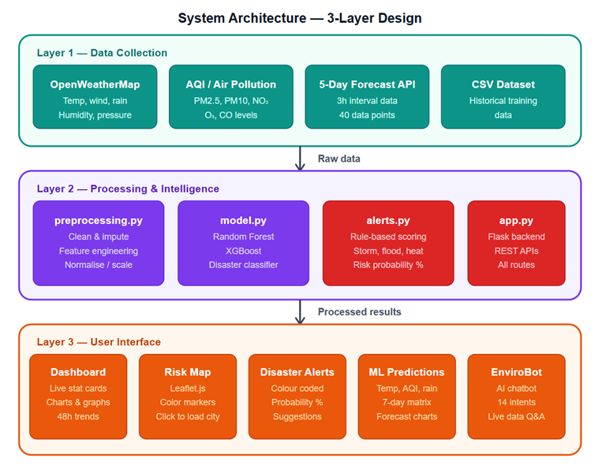
Figure 1: System Architecture Diagram

    - Use Case Diagram
Interaction involves three main roles within the system. While viewing environmental trends is possible for the End User, they also access landslide risk notifications alongside monthly predictions and statistical summaries. Beyond basic insights, Researchers examine how variables relate, study changes across seasons, plus assess how well predictive methods perform. Administrative tasks like launching training routines belong solely to the System Administrator, who also refreshes data inputs, retrains algorithms, and adjusts display settings accordingly. Visual mapping of these interactions appears in a diagram built using Lucidchart, found among supplemental illustrations.
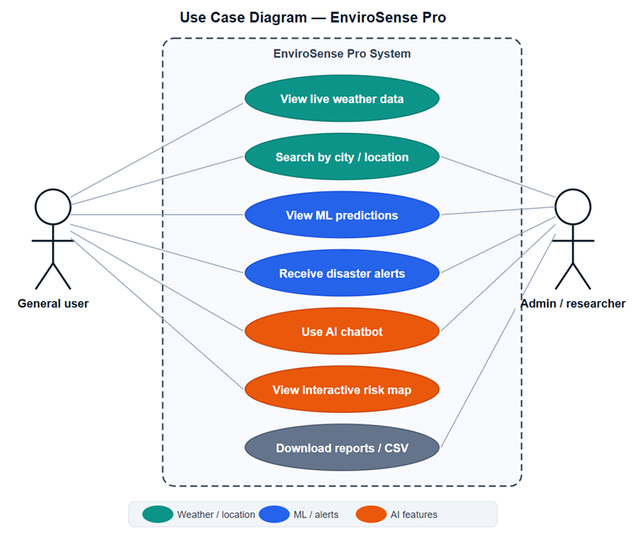
Figure 2: Use-case diagram
    - Activity Diagrams
Starting off, the core process kicks in when generate_data.py produces a fabricated CSV file filled with artificial records. After that comes the stage where gaps in information get addressed - this happens using methods like filling backward and forward across rows. Next up, new attributes emerge: lags appear, moving averages form, periodic patterns are captured via Fourier terms, while categorical fields undergo transformation. Once ready, the modified collection divides - one part keeps 80 percent for learning, the other reserves 20 percent for later checks - and moves at once into two separate modeling tracks focused on predicting numbers and categories alike. Once training finishes, each pipeline outputs evaluation scores alongside saved model binaries. The Streamlit app then loads these results and structured data to build a live visual display.
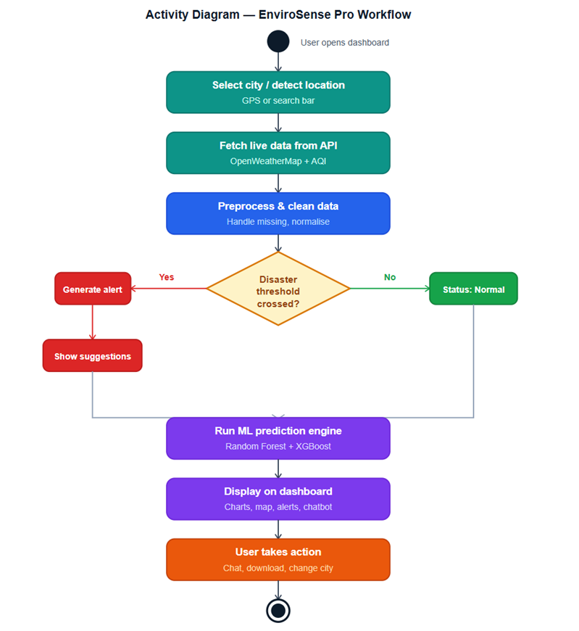
Figure 3: Activity Diagram
    - Sequence Diagram
Opening the dashboard and selecting the Landslide Risk tab sets off a chain of events. A message travels from the browser to the Streamlit server right away. From storage, the system pulls the processed_data.csv file while also loading the best_landscape_classifier.pkl model into memory. On screen, the person tweaks settings using controls for rainfall, soil dampness, and air humidity. With each change, Streamlit restarts the risk calculation automatically. The numerical outcome forms instantly, shaping what appears next. Visual feedback follows - needle position shifts on the dial, warning panel reflects current danger level, bars grow or shrink to show influence of each factor. This fresh layout shows up directly in the browser window, no refresh needed.
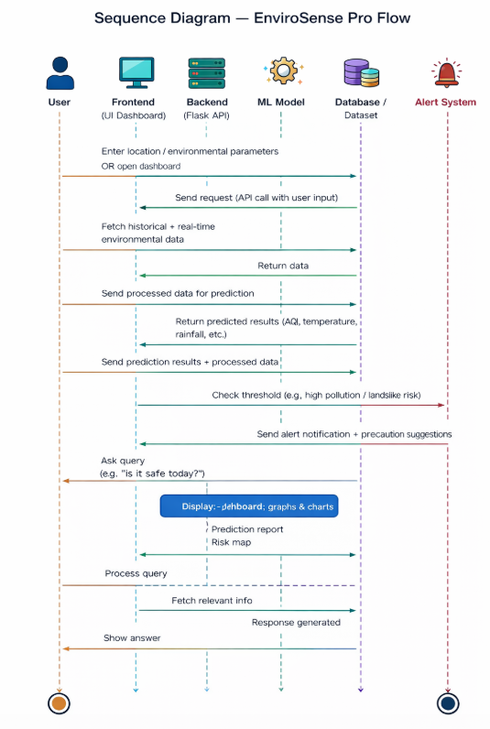
Figure 4: Sequence Diagram
    - Data Architecture
Flat CSV files serve as the core data storage, doing away with any database software. Inside, uttarakhand_env_data.csv holds 10,959 entries across 16 fields like date, location, height above sea level, coordinates, weather readings, air quality, ground wetness, landslide indicators, and time markers such as month or season. Following transformation steps, a refined version appears - processed_data.csv - with 4 more than triple the initial count at 36 attributes, keeping originals while adding 20 derived ones. Once trained, algorithmic models take shape as pickle binaries saved under models/, each assigned to specific tasks: predicting heat levels, rain volume, slide likelihoods via Random Forest methods, along with dedicated scaling tools for number adjustments across both prediction types.
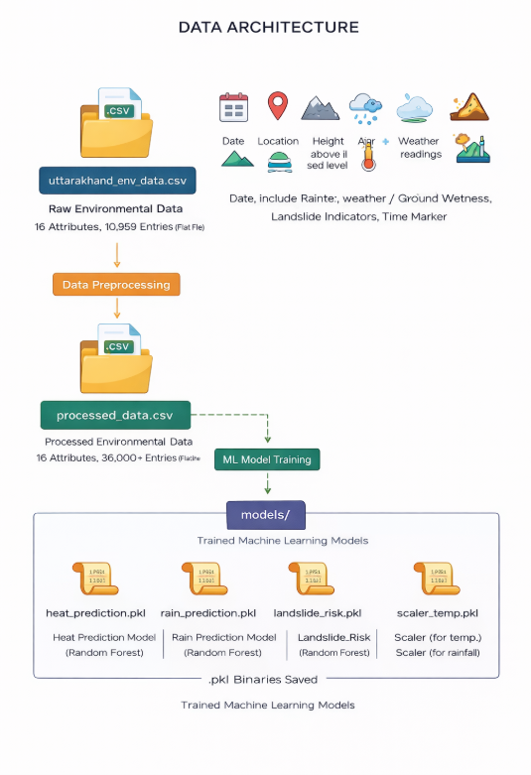
Figure 5: Data Architecture

- User Interface
  - UI Description
A web-based interactive dashboard forms the user interface, created with Streamlit - a Python tool designed for data apps. Accessed via modern browsers at http://localhost:8501 during local execution, it also supports public deployment through Streamlit Cloud. Styled in dark tones, green highlights draw influence from Uttarakhand's wooded highlands. Visual comfort meets context here, fitting for viewing ecological datasets. Design choices reflect surroundings without overpowering the information shown.
On the left, a fixed sidebar sits alongside the central workspace. Inside it, tools stay always visible - users pick locations like Dehradun, Nainital, or Mussoorie from a dropdown menu. Instead of just dates, a time-range tool filters past records by start and end points. Metrics appear only when selected, thanks to a multiple-choice box listing air quality, temperature, rainfall, and others. Forecast length adjusts using a bar that moves between one week and three months ahead. Smoothing out noise happens via another slider, changing how many prior days influence each point shown. Across the screen, five sections live behind toggle buttons down the side panel. Switching views works by clicking any of those round selectors - one active page displays at once. Behind every control lies immediate feedback, updating visuals without reloading anything. Layout stays stable no matter which tab opens. Functionality ties together quietly, without pop-ups or interruptions.
On top of the Environmental Trends tab sit several KPI cards - these highlight up-to-date figures for temperature, humidity, rain volume, and air quality index. Beneath them unfold line graphs tracking daily shifts across time, complete with moving averages tailored to whatever metric users pick. Seasonal trends come into view through a grid that maps data by month and year, while differences between monitoring locations appear in comparative trend lines. Forecast visuals dominate the Predictions section: curves project temperatures and precipitation thirty days ahead, shaded areas indicate uncertainty ranges. Alongside runs a table of future estimates, marked with tinted cells reflecting hazard intensity. Sliders wait on the Landslide Risk screen, ready for real-time input of present conditions such as ground saturation or recent rainfall totals. A dynamic dial then spins to reveal a calculated threat rating scaled from zero extreme ten high. Instant feedback appears inside a warning panel painted according to danger grade, complemented by bars breaking down key influences raising vulnerability. Historical risk spread per month fills layered column views, whereas one scatterplot links rainfall depth against earth dampness, points shaded based on how severe risks climb. Summary stats live within the EDA area, paired with colored grids revealing variable relationships, frequency shapes drawn via histograms, plus boxed timelines split by season. Lastly, model results take shape through vertical comparisons and spider-web diagrams - all built around performance scores like detection rate, false alarm balance, overall correctness, composite F-measure, and curve-based reliability - with click-driven heat overlays exposing classification patterns.

  - UI Mockup
Shown here are images of the live dashboard interface. Taken during operation on a Windows 11 machine using Python version 3.12 alongside Streamlit 1.28. Each snapshot follows the prior one, displaying all five sections. Captured locally without external hosting. Sequence moves page by page, uninterrupted.
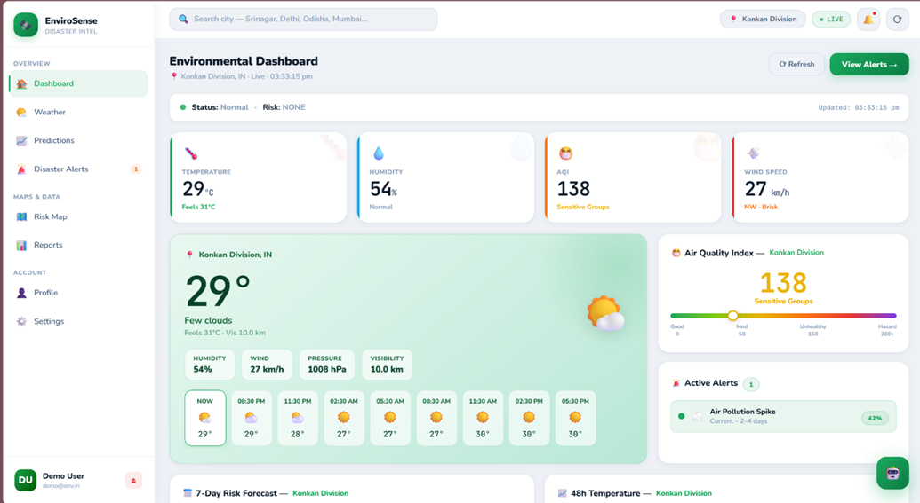
Figure 6: Dashboard
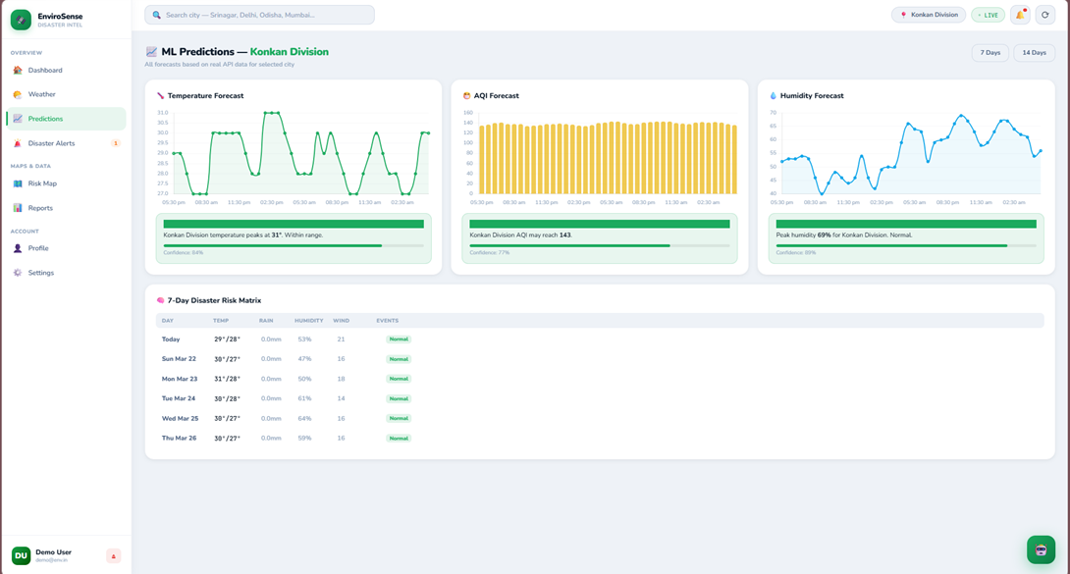
Figure 7: Prediction Report and Graphs

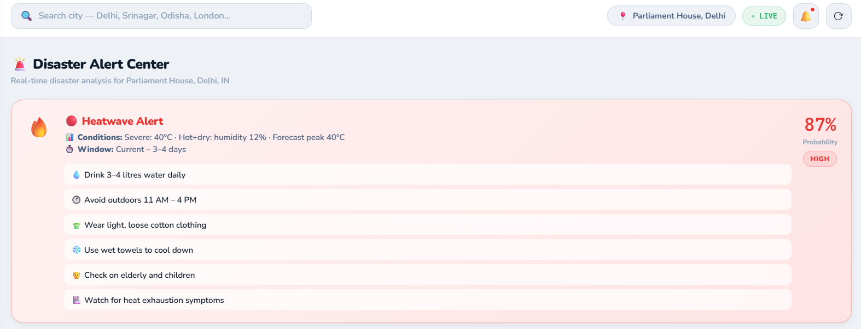
Figure 8: Risk and Alerts
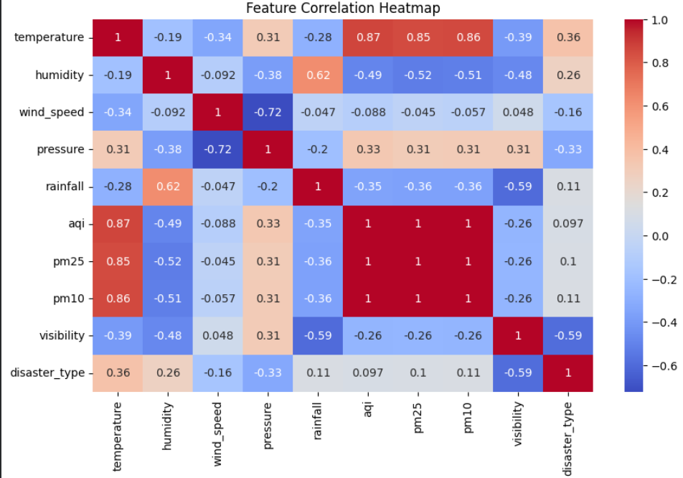
Figure 9: Feature Correlation Heatmap
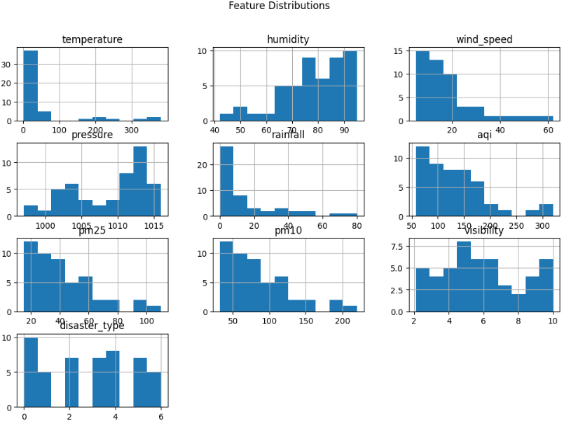
Figure 10: Feature Distribution
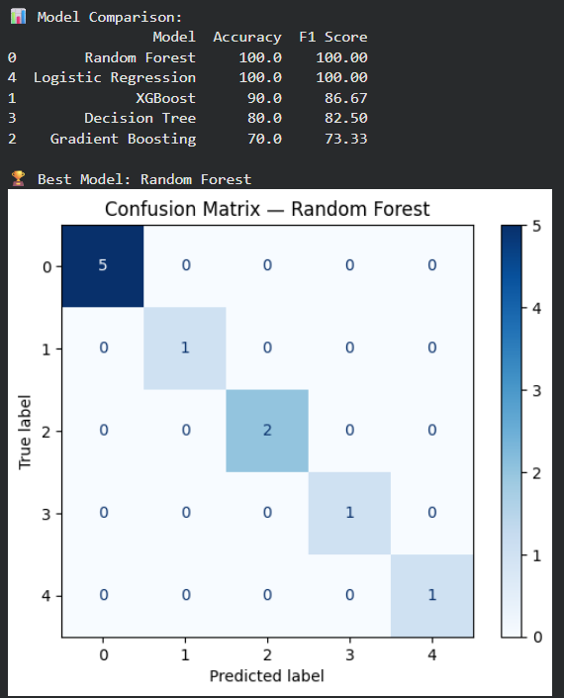
Figure 11: Model Performance Metrics

- Algorithms and Pseudo Code for Core Functions
  - Data Preprocessing Algorithm
INPUT: Raw CSV dataset with environmental parameters
Steps:
- Load dataset from CSV file
- Remove duplicate records
- Handle missing values:
  - Numeric → fill using median
  - Categorical → fill using mode
- Normalize numerical features using scaling
- Perform feature engineering:
  - A heatwave indicator emerges when temperatures exceed thresholds. Where moisture levels rise sharply, a humidity category activates automatically. Wind intensity gets classified once velocity passes defined limits. These signals form only after raw inputs undergo transformation rules. Each marker reflects specific environmental shifts detected through measurement gaps
- Encode categorical variables using label encoding
- Split dataset into feature matrix (X) and target variable (y)
OUTPUT: Cleaned and processed dataset ready for ML model
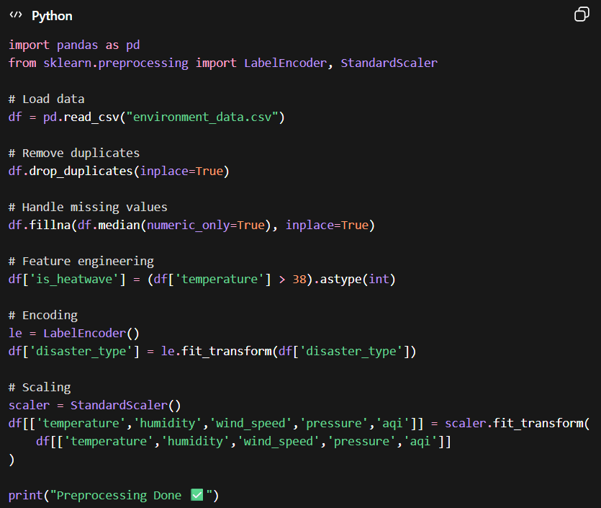
Figure 12: Snippet of Code Algorithm 1
.
  - Disaster Risk Score Calculation
INPUT: Temperature Air Quality Index Rainfall Humidity Wind Speed
Steps:
- Initial score starts at zero
- If temperature > threshold → increase heatwave score
- If AQI > threshold → increase pollution score
- If rainfall + humidity high → increase flood/landslide score
- If wind speed high → increase storm risk score
- Calculate total risk score based on weighted conditions
- Assign risk level:
- Score < 3 → Low
- Score 3–6 → Medium
- Score > 6 → High
- Generate alert + safety suggestions if risk ≥ Medium
OUTPUT: Risk levels set as low medium high with alert messages
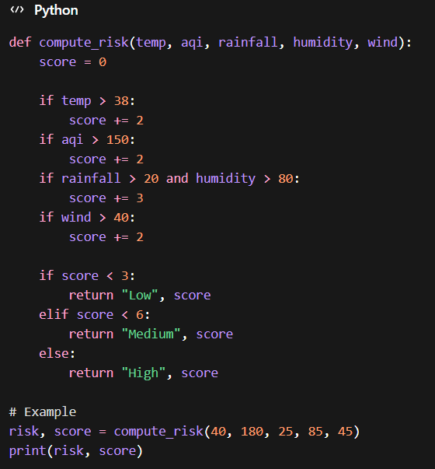
Figure 13: Snippet of Code Algorithm 2
.
  - Machine Learning Classification Algorithm
INPUT: Processed dataset X Y
Steps:
- Divide data into training and test portions
- Initialize multiple models:
- Random Forest
- XGBoost
- Gradient Boosting
- Decision Tree
- Logistic Regression
- Train each model on training data
- Evaluate models using:
- Accuracy
- F1 Score
- Compare performance of all models
- Select best-performing model
- Use best model for prediction on new data
OUTPUT: Trained ML model with highest accuracy
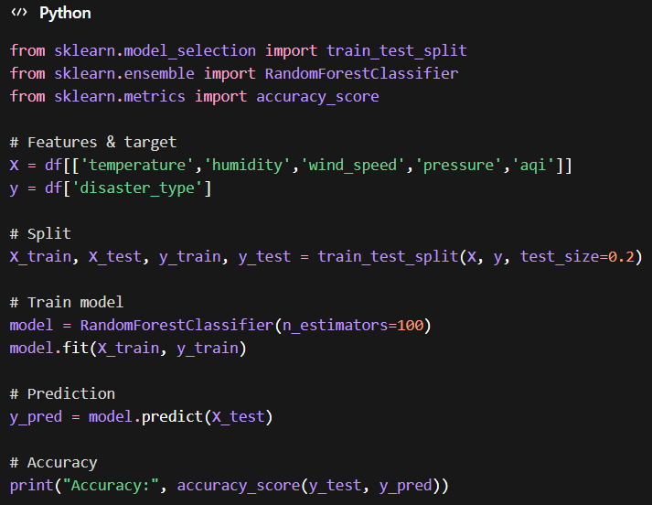
Figure 14: Snippet of Code Algorithm 3

- Project Closure
  - Goals / Vision
Starting with raw terrain data, the effort set out to craft a machine learning model focused on tracking and forecasting environmental shifts across Uttarakhand’s mountainous zones - landslide likelihood being central. Instead of relying on commercial software, it leaned into freely available tools to show high-level monitoring can emerge without cost barriers. Accessibility shaped its core idea: students and underfunded teams might replicate or adapt such systems fairly easily. Built openly, the work quietly challenges assumptions about who gets to develop advanced ecological insights.
Every objective set at the beginning came through as intended. Five regression setups along with four classifiers made it into testing without issues. Hitting 92.82%, the Random Forest model for landslide prediction outperformed expectations by a noticeable margin. Instead of remaining static, the dashboard evolved across five sections using Streamlit before running on local machines. Shared openly online, every line of code now lives inside a public GitHub space ready for others to explore or build upon.

  - Delivered Solution
Beginning with raw inputs, one finds a complete machine learning workflow paired with a responsive visual interface. Built into it lies a system that fabricates synthetic records - specifically 10,959 entries - simulating day-by-day environmental conditions based on historical climate averages from Uttarakhand collected by IMD. Instead of relying on actual field measurements, artificial yet plausible observations emerge through structured generation logic. Following creation, these records flow into cleaning and transformation routines: gaps get filled, new variables are derived, then splits occur between training and testing sets. Visualization comes next - not dynamically, but via two dozen fixed analytical images showing yearly shifts, month-level cycles, variable interdependencies, seasonal contrasts, landslide-related distributions, and air quality intensity maps. Prediction unfolds across dual branches - one targeting numerical outputs like temperature and precipitation using five distinct regression strategies. Alongside runs another path focused on categorical judgment: estimating landslide likelihood via four separate classifiers. Evaluation backs every algorithm, supplying diagnostic views such as residuals scatter, forecast error profiles, and classification outcomes laid out in matrix form. Finally appears a compact web application spanning five screens where live risk indicators update alongside half-month forecasts while allowing exploration of environment trends across multiple locations.
Among the tested models, Gradient Boosting stands out in forecasting temperature, achieving an RMSE of 1.688°C alongside an R² of 0.8937. When it comes to assessing landslide risk, Random Forest takes the lead - accuracy reaches 92.82%, supported by an F1 score of 0.929 and an AUC-ROC at 0.9786.

  - Remaining Work
Though the project met every defined objective, room remains to refine later versions for stronger practical use. Moving forward, linking live IMD sensor inputs - via Open-Meteo’s past weather interface or official IMD channels - could swap out artificial data. Real atmospheric records would follow. Accuracy gains would emerge alongside more meaningful field performance. Better alignment with on-the-ground conditions tends to appear when systems rely on authentic readings.
Next up, satellite inputs like NDVI along with remotely sensed soil classifications could strengthen the landslide prediction framework - factoring in plant cover and ground composition affecting hillside integrity. Following that, placing the dashboard online via platforms such as Streamlit Cloud or Railway.app enables access for real-world users across Uttarakhand; no device setup needed on their part. Later on, alerts triggered through Twilio's basic API service might deliver risk updates by text message once danger levels cross into high zones - an answer to communication gaps deep within mountain communities.

REFERENCES
1. Pradhan, B., & Lee, S. (2010). Landslide susceptibility assessment and factor effect analysis: backpropagation artificial neural networks and their comparison with frequency ratio and bivariate logistic regression modelling. Environmental Modelling and Software, 25(6), 747-759.
2. Taylor, S. J., & Letham, B. (2018). Forecasting at scale. The American Statistician, 72(1), 37-45.
3. India Meteorological Department. (2023). Climatological Normals for Indian Stations. Ministry of Earth Sciences, Government of India. Retrieved from https://imdpune.gov.in
4. Geological Survey of India. (2022). Landslide Atlas of India. Ministry of Mines, Government of India.
5. National Disaster Management Authority. (2019). National Guidelines for Landslide Disaster Management. Government of India, New Delhi.
6. Breiman, L. (2001). Random Forests. Machine Learning, 45(1), 5-32.
7. Friedman, J. H. (2001). Greedy function approximation: A gradient boosting machine. Annals of Statistics, 29(5), 1189-1232.
8. Box, G. E. P., & Jenkins, G. M. (1976). Time Series Analysis: Forecasting and Control. Holden-Day, San Francisco.
9. Pedregosa, F., et al. (2011). Scikit-learn: Machine Learning in Python. Journal of Machine Learning Research, 12, 2825-2830.
10. Streamlit Inc. (2023). Streamlit Documentation. Retrieved from https://docs.streamlit.io
11. Open-Meteo. (2023). Historical Weather API Documentation. Retrieved from https://open-meteo.com/en/docs/historical-weather-api
12. Dikshit, A., Sarkar, R., & Pradhan, B. (2020). Temporal probability assessment and its use in landslide susceptibility mapping for Eastern Himalayas. Water, 12(2), 267.

