WeatherBot

**Himanshi Aggarwal**

**(hxa152730@utdallas.edu)**

**Abstract**

Tech world is increasingly taking notice of Chatbots. Chatbots, also known as automated computer programs, simulate online conversations with people to answer queries or perform tasks. While chatbots have taken various elementary forms for years — think of Poncho, Facebook’s weather chatbot — they have been taking off lately as advances in Natural Language Processing and Artificial Intelligence make them more versatile than ever. Inspired with Poncho, I thought of making my own Natural Language and Artificial Intelligence based Weather ChatBot- “WeatherBot”.

**Keywords:** Chatbot, NER, WeatherBot, Natural Language Processing, Artificial Intelligence, OpenWeatherMap Api.

1. **Introduction**

A bot is a software application that automates a task. A chatbot is a [computer program](https://en.wikipedia.org/wiki/Computer_program) which conducts a [conversation](https://en.wikipedia.org/wiki/Conversation) via auditory or textual methods. Such programs are often designed to convincingly simulate how a human would behave as a conversational partner, thereby passing the [Turing test](https://en.wikipedia.org/wiki/Turing_test). Turing test is a test for intelligence in a computer, requiring that a human being should be unable to distinguish the machine from another human being by using the replies to questions put to both. Chatterbots are typically used in [dialog systems](https://en.wikipedia.org/wiki/Dialog_system) for various practical purposes including customer service or information acquisition. Some chatbots use sophisticated [natural language processing](https://en.wikipedia.org/wiki/Natural_language_processing) systems. Today, chatbots are part of [virtual assistants](https://en.wikipedia.org/wiki/Virtual_assistant_(artificial_intelligence)), and are accessed via many organizations' apps, websites, and on [instant messaging](https://en.wikipedia.org/wiki/Instant_messaging) platforms such as [Facebook Messenger](https://en.wikipedia.org/wiki/Facebook_Messenger).

Weather bot is simple java chatbot application that will tell us 5 day – 3-hour weather forecast for a city. It is inspired from Hi Poncho-Facebook weather chatbot and IBM Watson’s Weather Channel Bot. It uses Stanford Named Entity Recognizer[1] NLP library to classify text and Open Weather map Api [2] to get the weather results. They will be further discussed in detail.

1. **Related Works**
   1. **Hi Poncho[3]**: Hi Poncho, mixed with Natural Language Processing and Artificial Intelligence, is a simple weather bot that gives us the current weather conditions and forecast for a city. While giving us the weather, Hi Poncho, also uses some of humor and personality.
   2. **Weather Channel Bot[4**]: The Weather Channel bot gives users a new way to access and share personalized weather content including current conditions, severe weather alerts and five-day forecasts. The bot uses IBM Watson's natural language and machine learning tools to get to know a user's preferences for weather information, according to an IBM press release.
2. **Approach**

**3.1 Keyword Extraction:** Main step towards making a Chatbot is that what interests user. To accomplish this task, we will have to remove stop words and extract the keywords.

* 1. **Text Classification:** After keywords are extracted, we do need to know what does these keywords mean. So, text classification is done to give meaning to the keywords extracted.
  2. **Fetching Results:** Once the classification is done, WeatherBot will give us the required result. To do that I am using Open Weather Map Api that gives us result in json format.
  3. **Response:** Once the Json format result is fetched, I convert it to display in presentable form.

1. **Implementation**
   1. **Data:** Open Weather Map Api[2] is used to display weather result. OpenWeatherMap weather service is based on the [VANE Geospatial Data Science platform](http://owm.io/)[6] for collecting, processing, and distributing information about our planet through easy to use tools and APIs. Its 5 day-3 hour weather api gives 5 day forecast at any location or city. It also includes weather data every 3 hours. Provides forecast in JSON and XML formats. Its Current weather data api access current weather data for any location including over 200,000 cities. Current weather is frequently updated based on global models and data from more than 40,000 weather stations. Its data is available in JSON, XML, or HTML format.
   2. **Software Architecture:** 
      1. **Receive User Message:** User can ask bot questions like: What will be the weather today? Will it rain today?, What will be the weather in Dallas,Tx on 26th April 2017 at 9:00pm ?. Proper format is necessary to get proper results.
      2. **Keyword Extraction:** It is important to know what the user is asking. I removed the stop words from the text and returned the text with important words.
      3. **Entity Recognizer:** Keywords are required to be given some meaning. So, I used Stanford Named Entity Recognizer (NER)[4] Nlp library to classify text like finding date, location and time from the text. Named Entity Recognition (NER) labels sequences of words in a text which are the names of things, such as person and company names, date, time and location. It comes with well-engineered feature extractors for Named Entity Recognition, and many options for defining feature extractors. Stanford NER is also known as CRFClassifier. The software provides a general implementation of linear chain Conditional Random Field (CRF) sequence models. For keywords like today, tomorrow, Cloudy, Rainy etc, are separately classified using regex.
      4. **Response Generator:** Once the text is classified and we are known the date, time and location in the text, using the location (by default taken as Richardson, Tx) Open weather Map 5Day-3hour api or current weather api is called according to the requirements which returns us results in the format of JSON. After Reading JSON, a proper formatted the results according to date and time are displayed.
2. **Result**

**5.1 Current weather.**

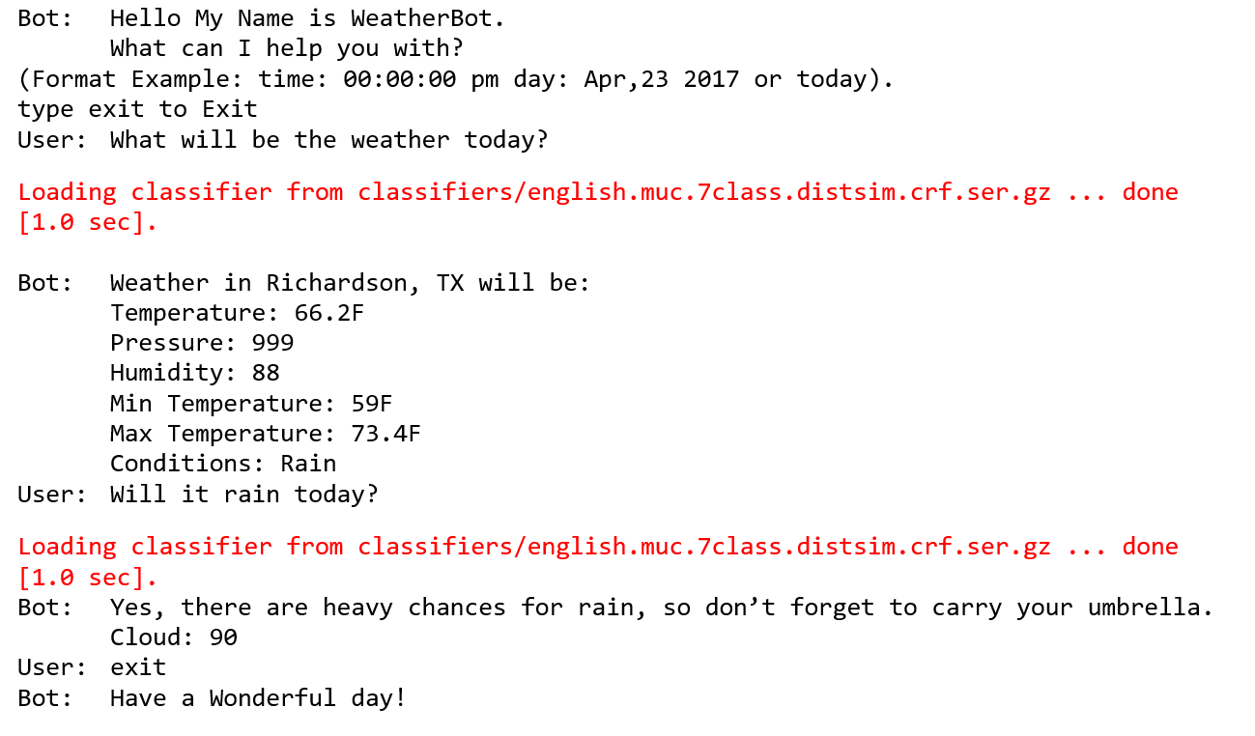

**5.2 Weather in a city on a day and time**

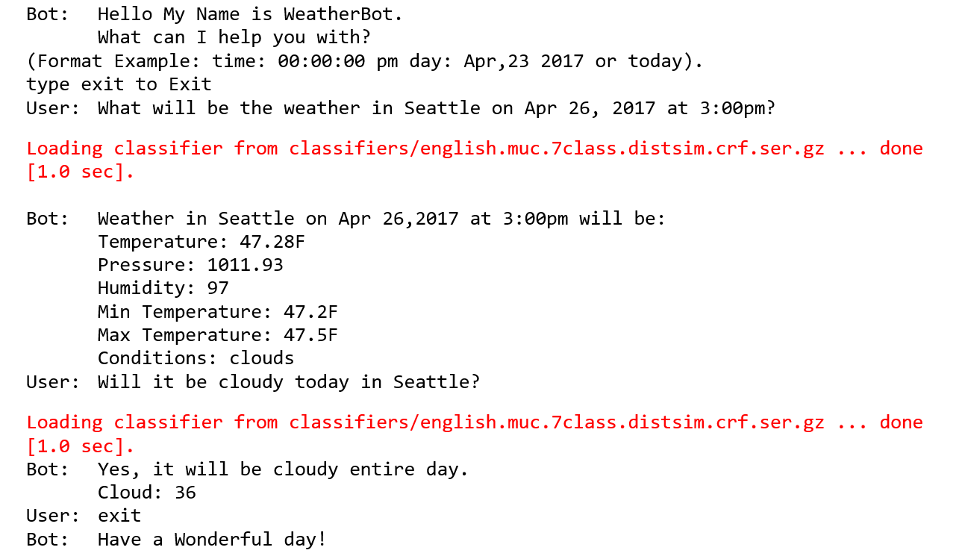

**5.3 Weather next day in a city.**

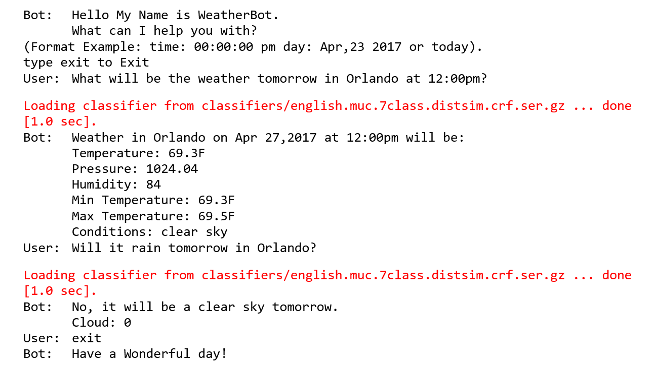

**5.4 Fails in case proper format for date and time is not provided. It will take current time and date.**

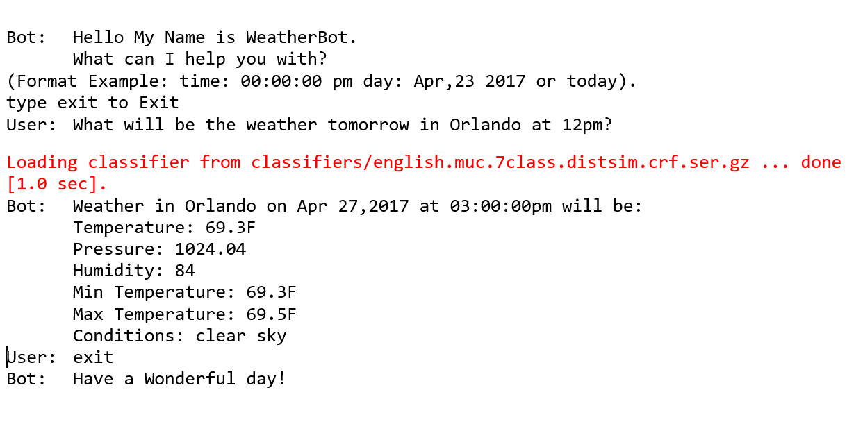

1. **Conclusions and Future Enhancements**

Chatbots are the new Applications. Chatbots enriches usability of a messaging application. They can give a human like touch to some aspects and make it an enjoying conversation. And they are focused entirely on providing information and completing tasks for the humans they interact with. They are evolving with capabilities including Natural Language processing and the ability to integrate with enterprise systems. My weather bot application help in situations when we want to check weather of any city and don’t have any weather app install. It can be improved while adding some humor and giving data based on the days of the week.

1. **References**
   1. <https://nlp.stanford.edu/software/CRF-NER.shtml>
   2. <http://openweathermap.org/api>
   3. <http://www.businessinsider.com/poncho-weather-bot-in-facebook-messenger-2016-4>
   4. <http://mashable.com/2016/10/25/ibm-watson-facebook-weather-chatbot/#rLS2q1n4Bmq9>
   5. <http://owm.io/>
   6. <https://en.wikipedia.org/wiki/Chatbot>