**Tool: CNTK** 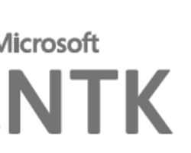

OfficialWebsite: <https://github.com/microsoft/CNTK>

Purpose:

* An open-source deep learning framework from Microsoft. CNTK is designed for building and training deep learning models, especially for speech and language tasks.