**Tool: Keras** 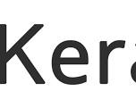

OfficialWebsite: <https://keras.io/>

Purpose:

* A high-level neural network API built on top of TensorFlow or other deep learning frameworks. Keras provides a simpler interface for building and training neural networks