**Tool: Matplotlib** 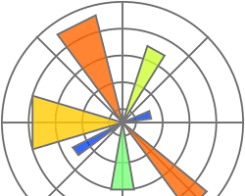

OfficialWebsite: <https://matplotlib.org/>

Purpose:

* A Python library for creating static, animated, and interactive visualizations. Matplotlib is a versatile tool for creating various plots and charts.