**Tool: Plotly** 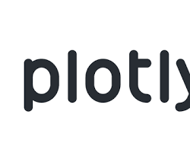

Official Website: <https://plotly.com/>

Purpose:

* An open-source library for creating interactive visualizations in Python, JavaScript, R, and other languages. Plotly allows for the creation of various chart types, including scientific charts, financial charts, geographical charts, and more