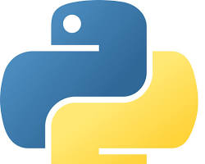**Tool: Python**

Official Website: <https://www.python.org/>

Purpose:

* A powerful general-purpose programming language that is popular in data science due to its readability, extensive libraries, and large community.