**Tool: RapidMiner**  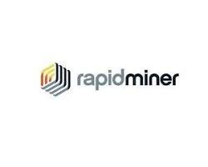

Official Website: <https://altair.com/altair-rapidminer>

Purpose:

* An open-source end-to-end data science platform that provides a visual interface for data preparation, modeling, and deployment. RapidMiner is a good option