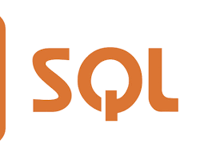

**Tool: SQL**

OfficialWebsite: <https://www.mysql.com/>

Purpose:

* Structured Query Language used to communicate with relational databases.
* Enables querying, updating, and manipulating data stored in relational databases.
* Essential for data retrieval and analysis in various data science tasks.