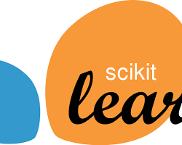

**Tool: Scikit-learn**

Official Website: <https://scikit-learn.org/>

Purpose:

* Free and open-source machine learning library for Python.
* Offers a wide range of machine learning algorithms for classification, regression, clustering, dimensionality reduction, and model selection.
* Easy to learn and use, making it a great option for beginners in machine learning