**SOFTWARE REQUIREMENT SPECIFICATION**

**1. INTRODUCTION**

This section gives a scope description and overview of everything included in this

SRS document. Also, the purpose for this document is described and a list of

abbreviations and definitions is provided.

The D.C. Management Information System of IIPS is a web application  to speed up the process of managing development centre in this educational institute .

**1.1 PURPOSE**

The purpose of this document is to give a detailed description of the requirements for the “Management information system”  software.

The main objective of this project is to provide the solution for a non-profitable organization which provides a base to carry out academic experiments, to introduce new trends and technologies and involves a good practice to groom their students as an IT professionals in all aspects .

It will also explain system constraints, interface and interactions with other external applications. This document is primarily intended to be proposed to the DC incharge for its approval and a reference for developing the first version of the system for the development team.

The existing systems are time consuming and there are many difficulties faced by administrator to get information about any activity or work done in D.C. Presently, most of the tasks are carried out manually such as entrance forms for new comers, updating for any activity etc.

This software provides a solution to these problems. It provides interactive user interface and helps users in an organization to get information immediately at that instant of time.

**1.2 SCOPE**

The “Management information system” is a web application which helps DC members,visitors and administrator(DC incharge) to manage all the things online. The web application is OS independent and can be accessed from any modern browsers. The whole system consists of following categories of stakeholders:

Visitors: The visitors to this application can only see the basic information provided about DC.

DC members: The DC members can login and manage their profile(containing daily work log ). He/She can make changes in some areas like projects, Worklog, ongoing activities and can’t alter the contents of books available and information related to infrastructure.

Administrator:The administrator(DC incharge) can monitor performance and  add/remove DC members accordingly.

The scope of MIS-DC is not only about product-development but also up to the implementation and deployment,This includes the training of the various end-users and maintenance of the products.

Objectives-

* Helps the administrator  and dc members  to keep track of the detailed  information of the dc.

* Assists in the smooth interaction between coordinators of different departments.

* Proper  maintenance  of  available resources.

* Helps Technical staff/instructor  to introduce latest technologies in a more handy way.
* Automate the task of assigning new students to specific technical staff based on the area of  interest .

**1.3** **DEFINITIONS,ACRONYMS AND ABBREVIATIONS:**

DC : Development Centre - It is driven by the enthusiastic, committed, strongly motivated IIPS students and expertise of its industrious team and Mentor.

MIS : Management Information System

User :   Someone who interacts with the web application

Admin/Administrator:   System administrator who is given specific permission for managing and controlling the system

Stakeholder :  Any person who has interaction with the system who is not a developer.

HTML : Hyper Text Markup Language

HTTP : Hyper Text Transfer Protocol

**1.4 REFERENCES:**

* IEEE Software Engineering Standards Committee, “IEEE Std 830-1998, IEEE Recommended Practice for Software Requirements Specifications” October 20, 1998.
* Davis M A, “Just Enough Requirements Management: Where Software Development Meets Marketing”, New York, Dorset House Publishing, 2005.

**1.5 OVERVIEW:**

The remainder of this document includes four chapters and appendices. The second one provides an overview of the general description and system interaction with other systems. This chapter also introduces different types of stakeholders and their interaction with the system. Further, the chapter also mentions the system constraints and assumptions about the product. The third chapter provides the requirements specification in detailed terms and a description of the different system interfaces. Different specification techniques are used in order to specify the requirements more precisely for different audiences. The fourth chapter deals with the analyzation of different modules of the system .

**2. GENERAL DESCRIPTION:**

**2.1 PRODUCT PERSPECTIVE**

DC MIS is aimed towards an organization which has some self motivated, enthusiastic, committed members and expertise of its industrious team and mentor.It will also explain system constraints, interface and interactions with other external applications.

It is intended to be a stand alone product and should not depend on the availability of other software. It should run on any platform.

**2.2 PRODUCT FUNCTIONALITIES:**

Management Information System  is used to maintain and manage the information of the Development Center .This web application helps the user to easily access the information .This software is also helpful for the administrator because he can easily bring changes to the records of the student.The site is developed in such a way that every DC member will maintain his/her daily diary and also manages his/her information regarding his/her current project and past projects.

There will unique id and password provided for the authorized users so they can modify the content as per their interests.

The visitors will be provided with limited access to the application(i.e. they can only view the specific contents.)

The newly created site have an extra feature of 'Knowledge Center' which is visible to all DC- members which familiarizes them about the advanced technologies like OPEN SOURCE( open source refers to a computer program in which the source code is available to the general public for use and/or modification from its original design) and helps them to know about latest trends in the present IT scenario.

**2.3 USER CHARACTERISTICS:**

The users of the system are visitors, DC members and the administrators who maintain the system. The visitors are expected to be Internet literate, once he/she can login the system and navigate between web pages, he/she can use the basic functionality of the system.The administrators of the system to have more knowledge of the internals of the system and is able to rectify the small problems that may arise due to disk crashes, power failures and other catastrophes to maintain the system.Also,the user must be aware of basic English to interact with the system.

**2.4 GENERAL CONSTRAINTS:**

* Since the system consists of three categories of stakeholders(viz Visitor,DC-member and admin) , each of them interact with the system differently.
* The system shall use  database phpmyadmin for all data management tasks.
* The Internet connection is also a constraint for this web application. Since the application fetches data from the database over the Internet,it is crucial that there is an Internet connection for the application to function.
* Since the system is using bootstrap and other technologies,the user needs to use the advanced browsers(Mozilla Firebox 1.5, Internet Explorer 6,Google Chrome) to access the web application.
* The web application will also be constrained by capacity of database. Since the database is shared between different categories of users, it may be forced to queue incoming requests and therefore increase the time it takes to fetch data.
* The users must have their correct usernames and passwords to enter into the Online Management Information System.

**2.5 ASSUMPTIONS AND DEPENDENCIES:**

* One assumption about the web application is that it will always be run on the system that have enough performance. Also to run the web application it is the most important to have an internet connection and Internet Server Capabilities..
* The user should provide valid information as the input that can be readily available to him/her. Also user might be having enough knowledge of the operating system and advanced browser to be used.

**3. SPECIFIC REQUIREMENTS:**

This section contains all of the functional and quality requirements of the system. It gives a detailed description of the system and all its features. In other words, information content flow and structure is documented here.

**3.1 EXTERNAL INTERFACE REQUIREMENTS:**

This section provides a detailed description of all inputs into and outputs from the system. It also gives a description of the hardware, software and communication interfaces and provides basic prototypes of the user interface.

**3.1.1 USER INTERFACE:**

The proper user interface, users manual, online help and the guide to install and maintain the system must be sufficient to educate the users on how to use the system without any problems. Each level of user will have its own interface and privilege to manage and modify the project information such as administrator able to monitor/manage his student progress and make comment on it, members can change his/her details, view the performance, submit project idea. All pages of the system are following a consistent theme and clear structure. HTML Tables to display information to give a clear structure that easy to understand by user.

**3.1.2 HARDWARE INTERFACE:**

The system is a web based application; clients are requiring using a modern web browser such as Mozilla Firefox 1.5, Internet Explorer 6 and Enable Cookies. The computer must have an Internet connection in order to be able to access the system.

Since the web application doesn’t have any designated hardware, it does not have any direct hardware interfaces and therefore the hardware connection to the database server is managed by the underlying operating system on the web server.

**3.1.3 SOFTWARE INTERFACE:**

This system is designed using bootstrap and can therefore be run on all modern browsers(Safari, latest Google chrome, Firefox 4+, Internet explorer 7+).

**3.1.4  COMMUNICATION INTERFACE:**

The HTTP protocol will be used to facilitate communications between the client and server.

**3.2 FUNCTIONAL REQUIREMENTS:**

The Functional requirements depends upon different stakeholders of the system:

**3.2.1 VISITORS**

3.2.1.1 INTRODUCTION

The visitors have limited access to the web application and they can’t alter any content.The visitors can only visit and are not provided with login facilities.They have access to following categories:

1. About Us: He can know about the aim, mission, and core areas of development center. In short, he can know what is DC all about, how it works and what are its objectives.
2. Open Source: Development center believes in open source technology, which refers to a computer program in which the source code is available to the general public for use and/or modification from its original design.Some of them are- Linux, Fedora, Python etc.
3. DC Members: He can see the profile of current and past DC members along with their achievements and project experiences.
4. Projects: Information about all the current and past projects are made available to the visitors.

3.2.1.2 INPUT

The visitors are not laced with any input facility. They can only visit the website.

3.2.1.3 PROCESSING

Depending upon the user choice or the response to any link the data gets automatically fetched from the database and associated information will be displayed.

3.2.1.4 OUTPUT

On user’s click the information requested will be retrieved from the database and displayed.Output will be generated in case of no errors.

3.2.1.5 ERROR HANDLING

There are rare possibilities of occurrences of errors except in case if there is not a proper web server capabilities or internet connection.. And this error can be rectified by the user itself by checking the Internet connection or other criteria related to network problem.

**3.2.2  DC MEMBERS**

3.2.2.1 INTRODUCTION

DC members are required to sign in to the system for security purposes.They have access to following categories:

1.  Worklog*:*  This page keeps track on the daily activities and the work done by DC members through various groups, forums and github link.

2.   Project list: It contains personal projects, paid projects, and social welfare projects which are undertaken in past or present along with their objective, abstract, SPMP(Software Project Management Plan), SRS, SDD(Software Design Description), members involved, github link.

3. Profile/Dashboard: It includes all basic information along with their certifications and specifications which are taken from their linkedin profile automatically. It includes a checkbox in which number of days according to dates is given and a block for the reason is given which sends a notification to admin for approval of leave.

*4.Activities:-* This page contains activities like workshops, presentations, seminars conducted by DC members( inhouse or outhouse)

5. *Correspondence:-* Correspondence consists of memos, letters, and electronic mail. Correspondence is an effective way to make requests, submit changes to a job, and deliver specific information.Correspondence presents the audience with a legal contract.

*6. Hardware and Networking support:*- It deals with assembling any new system, modifying hardware for any system,Installing new h/w like printer, scanner, etc , Troubleshooting networking issues, Installing devices over the network, To provide training regarding h/w and networking devices, installations, upgradation and assembling systems.

*7. Human Resource:*-  It contains the basic information of the member like goals, objectives, achievements, profile picture(professional), projects information, contact information, online courses details with certificates, to do list, URL’s of linkedin, git, Google+ and your work.

*8. Infrastructure:*- Infrastructure department of Development center is responsible to keep  track of related  resources such as allocation of PC , Mouse , Keyboard , LAN , Books etc.

*9. Training:*- To train and provide resources and making aware of various new trends and technologies in open-source .Consultation regarding the use of technologies(API's , tools, softwares) and project methodologies.

*10. Software Technical Support:*- It is related to Technology-stack decision, regarding major errors in coding and Maintaining Online Repositories for frequent errors and their alternative solution,O.S.,Antiviruses,Library of Tools and related issues for DC computers, IIPS-Youtube .

Special privileges provided to DC members:

1. Books: This section contains study materials like e-books , links of different tutorials that can help DC members for better learning.
2. Knowledge Centre: It is a pool of knowledge containing information about advanced technologies ,also an open source submission by DC members that contains presentation,files ,videos ,pdf and links of various topics.

3.2.2.2 INPUT

The input for DC members are their login id and password along with the contents for their profile.

3.2.2.3 PROCESSING

After login by the DC members, his/her username and passwords are checked for its validity on the server.If the validity is confirmed associated dashboard is displayed to the DC members and in case of incorrect input , an error message is shown.

3.2.2.4 OUTPUT

After login information is verified,the dashboard(profile) of DC members is displayed as the output.

3.2.2.5 ERROR HANDLING

The possibility of errors are very less only in the case if the information provided by DC members are incomplete and it is the responsibility of DC members to correct such errors by updating their profile.

**3.2.3 ADMINISTRATOR (ADMIN)**

3.2.3.1 INTRODUCTION

ADMIN is considered as the head incharge of DC, who have all rights to directly access the accounts of each DC member.He has access to following categories:-

1. Profile: He can have a look at the profiles of each members and according to it , he can analyze his/her performance.
2. Add/Remove members: He can add a new person after approving his/her entrance form and has also given right to remove any existing DC member on the basis of their work done.
3. Monitoring : Admin monitor the daily, weekly or monthly status of  any DC according to his project or individual task, by github graph and commits.
4. Add Project: If a DC member wants to work on a project under the guidance of DC, the permission would be given by the admin to add the project.
5. Approval for leave: Admin can approve for the leave requested by a DC member.
6. Assigning mentors to newcomers: It is the responsibility of admin to assign an expert to newcomers according to their area of interests.

 3.2.3.2 INPUT

Admin would be having his unique id and password in order to make changes and he has to provide name of the specific member whose profile he wants to visit.

3.2.3.3 PROCESSING

When administrator feeds the name of any DC member the name is first checked for its validity in the database and after that the corresponding data is displayed.

3.2.3.4 OUTPUT

The output will contain specific information which was requested by the administrator about any member.

3.2.3.5 ERROR HANDLING

The only error that can occur is when the information provided by members are incomplete and this error can be resolved by admin itself by performing strict actions on the specific member.

**3.3  USE CASES:**

**3.3.1 For Visitors**

|  |
| --- |
| **https://lh4.googleusercontent.com/by_i4JW268SAbXM-nJ6Hvx2p0JEdPgwHWK3wR9Uas336SpcDlreVVgkjr_Z0ip2svAaOI83Kyjj5WkZP0oL2nZoP8EXLOaWTR9pEjJJVsMfVGE54Wpl7rTzx6Z686VK55kagU1U** |

**3.3.2 For DC Member**

|  |
| --- |
| dcmemberusecase.png |

**3.3.3 For Admin**

|  |
| --- |
| adminusecase.png |

**3.4 NON FUNCTIONAL REQUIREMENTS:**

**3.4.1 Performance**

* Response Time:

The web page or Information page should be able to be downloaded within a minute . The information is refreshed every two minutes. The access time for a mobile device should be less than a minute. The system shall respond to the member in not less than two seconds from the time of the request submittal except in case of no errors. It has short data transmission time.

* Capacity:The system is capable of handling multiple users at a time.

**3.4.2 Reliability**

The system has to be very reliable due to the importance of data and the damages incorrect or incomplete data can do.The IIPS DC MIS is reliable because there are no chances of system failure as there are only limited users who can access it and the site have enough capability to maintain its performance over time.

**3.4.3 Availability**

The system is available 100% for the user and the system shall be operational 24*7. The website is available on the user’s click. Also the availability depends on the Internet speed of the user's system.

**3.4.4 Security**

The MIS is a secure system as there is a login ID and password required for a particular user to access the database of the system. Only the administrator has permission to modify the contents of the database except the personal profile of the DC member which is accessible by the corresponding DC member only.

**3.4.6 Portability**

Due to its portability feature a client does not need to access it from a specific machine and can be accessed from any device which has a web browser.

**4. ANALYSIS MODEL**

**4.1 SEQUENCE DIAGRAMS**

**4.1.1 ADMIN**

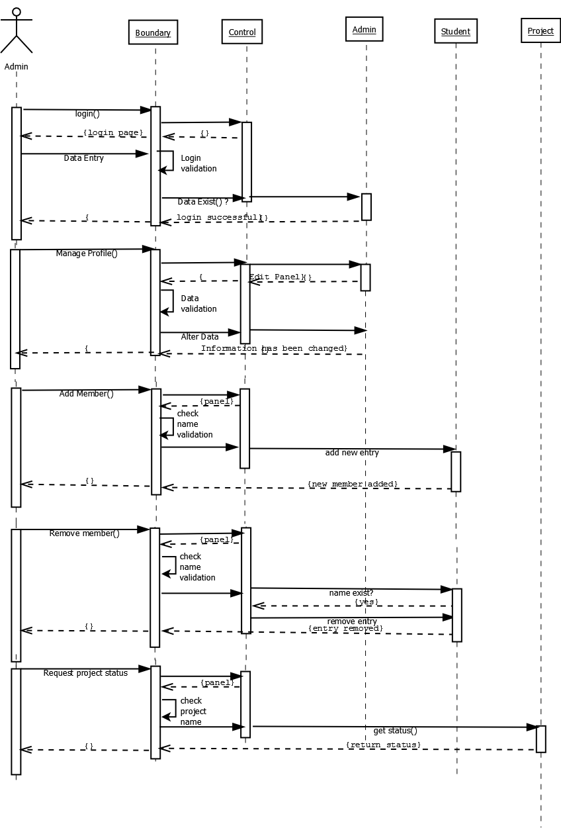

**4.1.2 DC MEMBER**

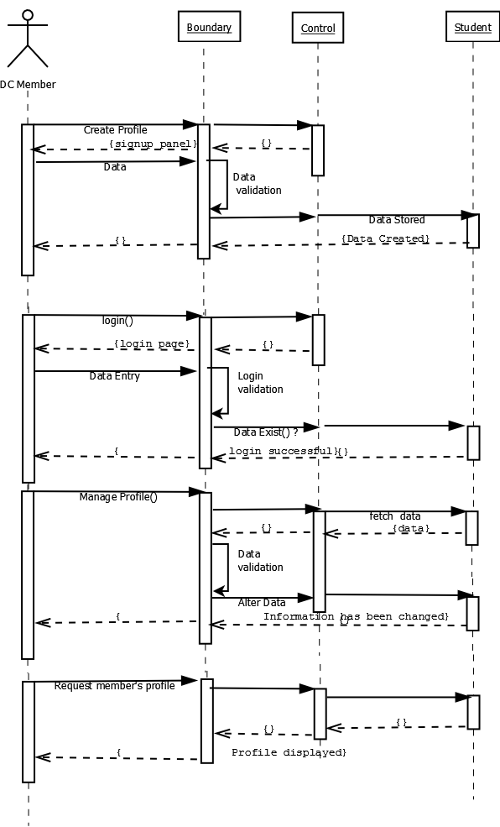

**4.1.3 VISITOR**

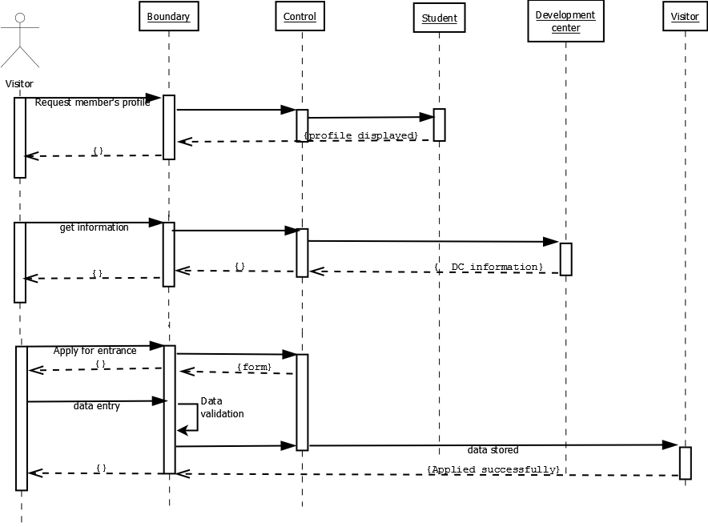

**4.2 DATA FLOW DIAGRAMS**

**4.2.1 Level 0 Diagram**

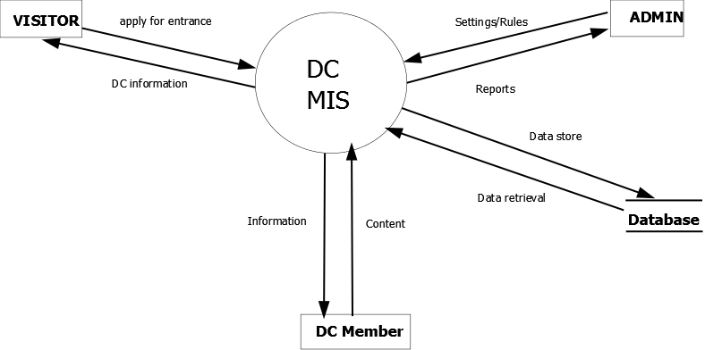

**4.2.2 Level 1 Diagram (Part 1)**

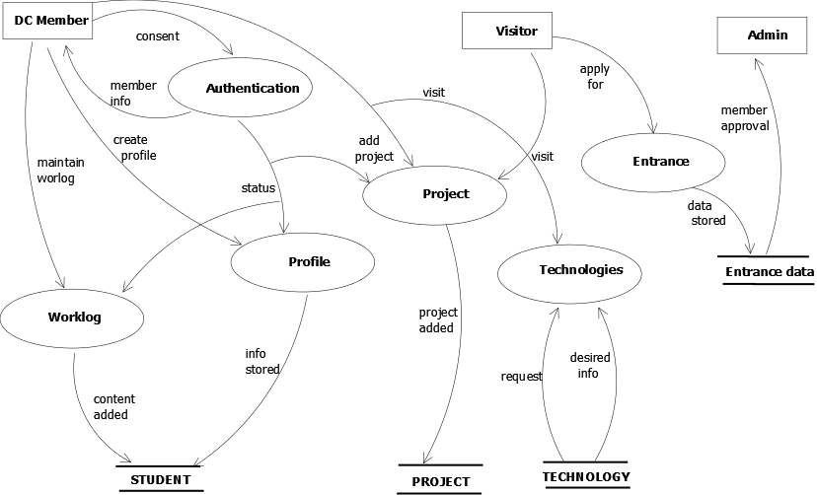

**4.2.3 Level 1 Diagram (Part 2)**

