**ADMIN Sequence Diagram**

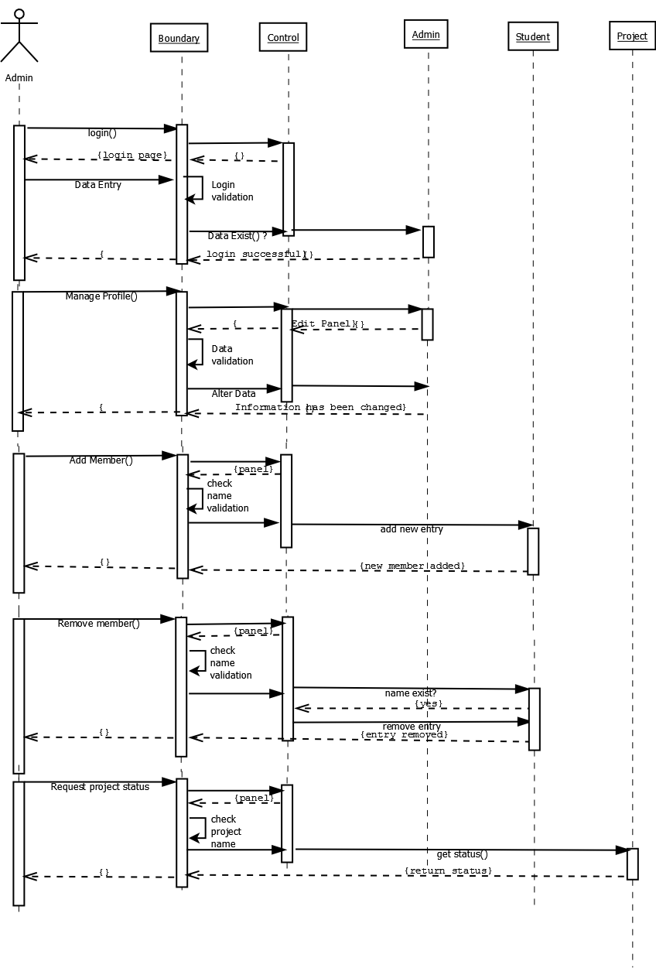

**DC Member Sequence Diagram**

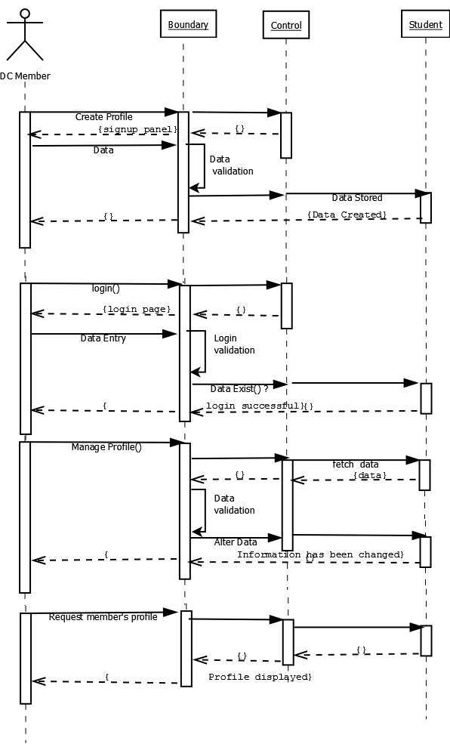

**VISITOR Sequence Diagram**

