**DOCUMENT DEVELOPMENT LIFE CYCLE (DDLC)**

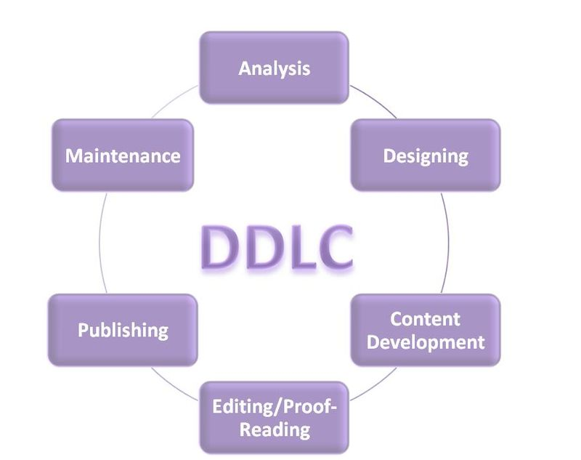

**REQUIREMENTS ANALYSIS :**

Requirement Analysis is an important phase of the Document Development Life Cycle. In this phase the technical writer gathers the useful material for the project and understands and analyzes all the information of the project.

It is the first stage of DDLC in which a technical writer analyzes the document requirement, targeted audience and documentation tools for throughout use. Intended towards the audience level Technical writer will decide the complexity and depth of the document. Use of language level will be decided at this stage.

The process involves a lot of effort. Information is collected from various sources connected with the project. To learn the features of the new product, technical writers resolve all the queries and problems regarding the project with the help of software developers. The earlier versions of the document, if exists, can also be reviewed for better understanding of the project. Technical writers also search related information on online libraries and from the company resources and gather updated information.

Technical writers must understand the software from the technical point of view. Technical writers must use and test the software product in various ways to get a detailed idea about it.They are expected to do their homework and prepare questionnaires related to the project, before meeting and interviewing important people in the project. They may have to meet the people involved a number of times to arrive at a comprehensive understanding of the project. At the end of this phase a technical writer must have resolved all the problems and queries in terms of documenting this understanding for a specific audience.

**DESIGNING :**

At this stage some estimates are decided like approximate pages, format of the document, several representation styles, etc. Subject knowledge, good writing skills, sufficient information about the project will help the technical writer to make a quality document.

**CONTENT DEVELOPMENT :**

At this stage content is developed as per the design prospective and in accordance with planning of the documents at previous stages. A smart technical writer will use graphical illustrations for a better understanding by the end reader.

**EDITING/PROOF READING :**

At this stage, the document is thoroughly read by the writer, and also verified by a third party. It checks for all sorts of grammatical errors. This verification ensures that the document is ready for publishing.

**PUBLISHING :**

Document is published by parent authority of the document. Generally technical documents are published either in digital format on internet or in hard-copies and distributed along with module (e.g. Software, Gadget etc.). Several Publication options can be used as per the distribution requirement of document.

**MAINTENANCE :**

At this stage collection of further updates, modification is done. Also time to time updated backup is taken.