MindNest
A Safe Place for Your Mind

Project Report Submitted in Partial Fulfilment of Academic Requirements
By
Himanshi Prakash Rewatkar

Enrollment No: AF05203483
Guided By: Rajshri ma’am

Index
Sr. No. | Topic | Page No.
1 | Title of Project | 1
2 | Acknowledgement | 3
3 | Abstract | 4
4 | Introduction | 5
5 | Objective | 6
6 | System Analysis | 7
7 | System Design | 16
8 | Screenshots | 20
9 | Coding | 24
10 | Testing | 28
11 | Report | 29
12 | Future Scope | 30
13 | Conclusion | 30
14 | Bibliography | 31
15 | References | 31

Acknowledgement
The project “MindNest – A Safe Place for Your Mind” is the project work carried out by:
Name | Enrollment No.
Himanshi Prakash Rewatkar | ____________________

Under the guidance of my project guide, I am thankful for the direction and valuable feedback provided throughout the development of this project. Their suggestions greatly helped shape both the application and this report.
I am also thankful to my family and friends who provided constant support and encouragement while working on this project.

Abstract
MindNest is a desktop wellness application built using Python and MySQL, designed to help users build healthy mindfulness habits and manage their day-to-day emotional wellbeing. It replaces scattered, manual approaches to self-care — sticky notes, memory-based mood tracking, disconnected meditation apps — with a single, structured, and private desktop platform.
The application allows users to register and securely log in, check in with their mood once a day, and immediately receive personalized self-care tips based on how they are feeling. Users can track their mood history over time, use a guided meditation timer with a spoken-style script, listen to peaceful nature sounds, read a rotating daily quote and affirmation, and maintain a private journal for their thoughts and reflections.
A Progress Dashboard consolidates the user's mood check-in count, total meditation minutes, and journal entry count into one view, helping users see their wellness habits taking shape over time. The system also includes full profile management, allowing users to update their details and change their password securely.
MindNest is simple, calming by design, and works entirely offline once installed, making it accessible without needing an internet connection or cloud account. It focuses on privacy, consistency, and gentle daily engagement — helping users build sustainable mindfulness habits rather than one-off wellness activities.

1. Introduction
In an age where daily life is increasingly fast-paced and digitally saturated, mental wellbeing is often the first thing pushed aside. Mindfulness — the practice of being present and aware of one's emotional state — has been shown to reduce stress, improve focus, and support long-term emotional resilience. However, most people lack a single, private, and consistent tool to help them practice it daily.
Existing solutions are often fragmented: mood trackers, meditation timers, journaling apps, and ambient sound players usually exist as separate applications, frequently tied to subscriptions, internet connectivity, or third-party cloud storage of sensitive personal data.
MindNest was developed to solve this problem by combining the core building blocks of a daily mindfulness practice — mood check-ins, guided meditation, journaling, self-care tips, and calming audio — into a single, self-contained desktop application backed by a local MySQL database. Because MindNest runs locally and stores data in a database the user controls, there is no reliance on external servers or subscriptions.
The result is a calm, supportive digital space where a user can build small, repeatable wellness habits — checking in once a day, meditating for a few minutes, or writing a short journal entry — and see their own progress reflected back to them over time.

2. Objective
The objectives of this project are as follows:
- To develop a desktop wellness application that helps users build consistent daily mindfulness habits.
- To allow users to check in with their mood once per day and track their mood history over time.
- To provide personalized self-care tips based on the user's currently selected mood.
- To provide a guided meditation timer with adjustable durations and a spoken-style guidance script.
- To provide a library of peaceful nature sounds for relaxation and focus.
- To display a rotating daily motivational quote and positive affirmation.
- To give users a private, secure space to journal their thoughts and reflections.
- To consolidate a user's wellness activity into a single Progress Dashboard.
- To secure user accounts through registration, login, and password management.
- To keep the application simple, calm in visual design, and usable entirely offline.

3. System Analysis

3.1 Problem Definition
Many people want to build healthy mental wellness habits but lack a single, consistent tool to support them. Mood tracking is often done informally (or not at all), meditation apps are usually separate from journaling tools, and self-care advice is generic rather than tailored to how a person is actually feeling in the moment.
This project solves these problems by combining mood check-ins, self-care tips, guided meditation, journaling, and ambient sound into a single application, backed by a structured MySQL database that preserves a full history of the user's wellness activity for later reflection.

3.2 Preliminary Investigation

Purpose
MindNest is designed to give users a calm, private space to check in with their emotions, build small daily wellness habits, and track their progress over time — without needing an internet connection or a third-party account.

Benefits
- Daily Emotional Awareness: Users check in with a mood once a day and immediately see relevant self-care guidance.
- Consolidated Wellness Tools: Meditation, journaling, ambient sound, and quotes are all available from one dashboard.
- Private by Design: All data is stored locally in MySQL under the user's own control, not on a third-party server.
- Progress Visibility: A dashboard view shows check-in counts, meditation minutes, and journal entries at a glance.

Proposed System
- Users can register, log in, and check in with their mood once per day, with the option to update that check-in later in the day.
- The system automatically shows self-care tips relevant to the mood the user selected.
- A guided meditation timer logs completed sessions, contributing to the user's total meditation minutes.
- A private journal lets users record and revisit their thoughts and reflections.
- A Progress Dashboard aggregates mood history, meditation totals, and journal entry counts.

3.3 Feasibility Study

Technical Feasibility
- The application is built using Python with Tkinter for the graphical interface, requiring no separate installation of a web browser or server.
- MySQL is used for structured, relational data storage of users, mood entries, meditation sessions, journal entries, and reference data (tips, quotes, sounds).
- Nature sound playback is handled using the pygame audio library.
- The system runs entirely on the user's local machine, requiring no external hosting.

Economic Feasibility
- All technologies used (Python, MySQL, Tkinter, pygame) are free and open-source, minimizing development cost.
- No ongoing hosting or subscription costs are required since the application runs locally.

Operational Feasibility
- The interface uses a simple sidebar layout, making navigation between features intuitive.
- Mood check-in uses large, clearly labeled buttons rather than free-text input, reducing friction in daily use.
- Self-care tips and quotes require no configuration — they are generated automatically.

Schedule Feasibility
- The project was developed in modular stages — authentication, mood tracking, meditation, sounds, journal, dashboard, and profile — allowing incremental development and testing.
- Each module could be built and verified independently before integration into the main application.

Social Feasibility
- The application encourages private self-reflection without the social pressure of sharing on public platforms.
- Self-care tips are supportive and non-judgmental in tone, suitable for users at any stage of their wellness journey.

3.4 Project Planning
Development followed a structured Waterfall model, adapted with iterative refinements between the coding and testing phases as new requirements were clarified.
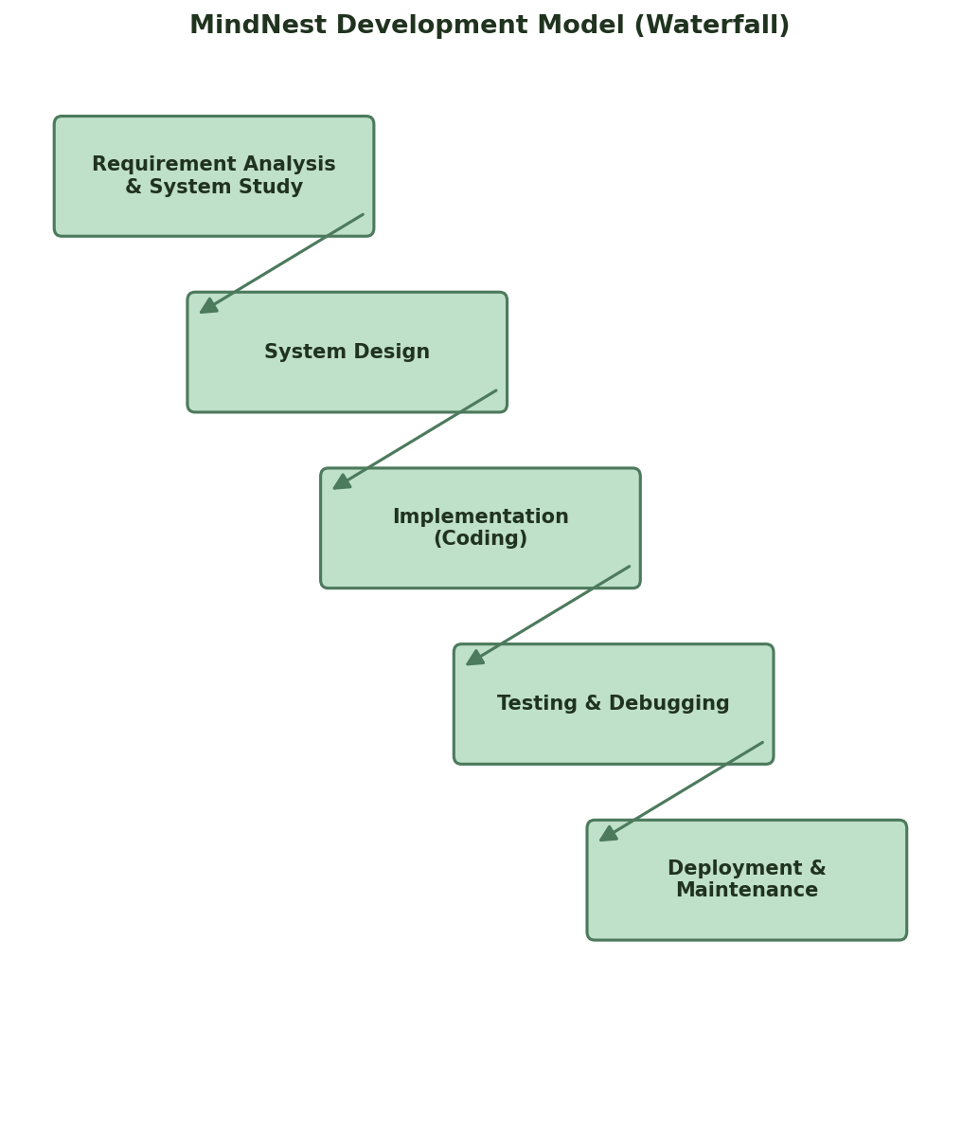
Fig. 3.1: MindNest Development Model

3.5 Software Requirement Specification (SRS)

System Overview
MindNest is structured into distinct functional modules, each backed by its own set of backend functions and MySQL tables:
- Authentication Module – handles registration, login, and password hashing.
- Mood Module – handles daily check-in, mood history, and self-care tips.
- Meditation Module – handles the guided timer and session logging.
- Sounds Module – handles nature sound playback.
- Quotes Module – handles the daily quote and affirmation.
- Journal Module – handles creating and viewing journal entries.
- Profile Module – handles viewing/updating profile details and password changes.

Software & Hardware Requirements
Category | Requirement
Frontend (GUI) | Python 3 with Tkinter
Backend Logic | Python 3 (modular functions per feature)
Database | MySQL 8.0
Audio Playback | pygame (or pygame-ce for newer Python versions)
Processor | Intel i3 or higher
RAM | Minimum 4 GB
Storage | At least 200 MB for application and database
Connectivity | None required — fully offline application

3.6 Functional Requirements
Authentication:
- Users can register with a username, email, password, and full name.
- Users can log in with valid credentials; invalid credentials show an error message.
Mood Check-in:
- Users select one mood per day from six options (Happy, Calm, Tired, Anxious, Sad, Angry).
- Users may add optional notes to their check-in.
- Submitting a check-in on a day that already has one updates the existing entry rather than duplicating it.
Meditation:
- Users select a session duration (1, 3, 5, 10, or 15 minutes).
- A countdown timer displays remaining time along with rotating guidance text.
- Completed sessions are logged to the database and contribute to total meditation minutes.
Journal:
- Users can add a titled or untitled journal entry with free-text content.
- Past entries are listed in reverse chronological order.
Profile:
- Users can update their full name and email.
- Users can change their password after verifying their current password.

3.7 Software Engineering Paradigm
MindNest follows an adapted Waterfall model, where each phase (requirement analysis, design, implementation, testing, deployment) is completed in sequence, with feedback loops permitted between the implementation and testing phases to refine earlier design decisions based on issues found during testing.

3.8 Data Flow Diagrams
A Data Flow Diagram (DFD) shows how data moves through the system, what transforms it, and where it is stored, without implying any strict order of events.
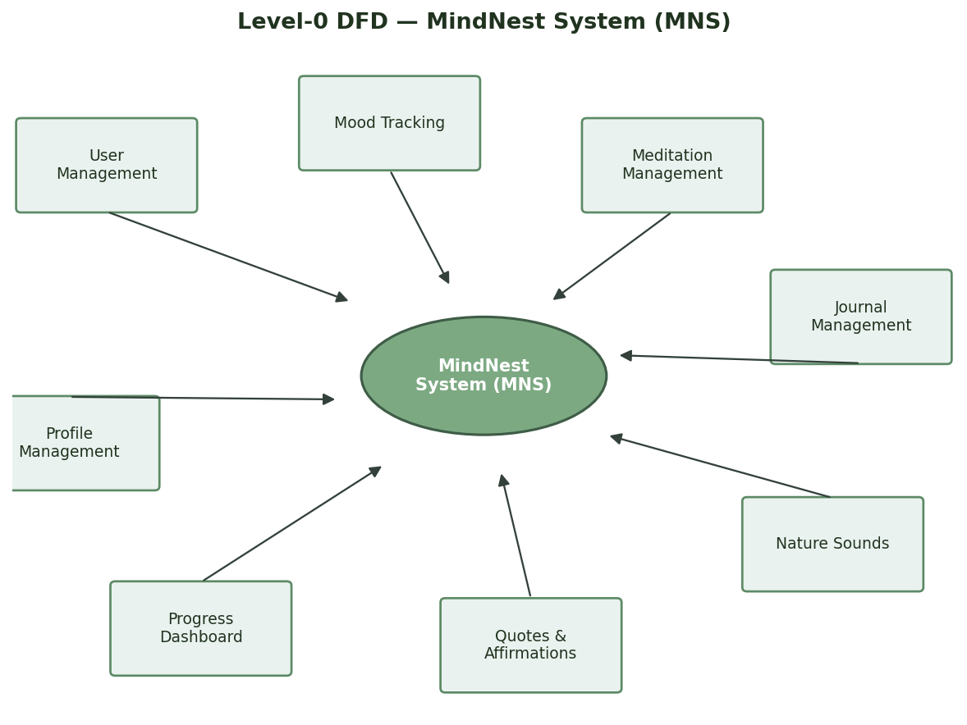
Fig. 3.2: Level-0 DFD — MindNest System (MNS)
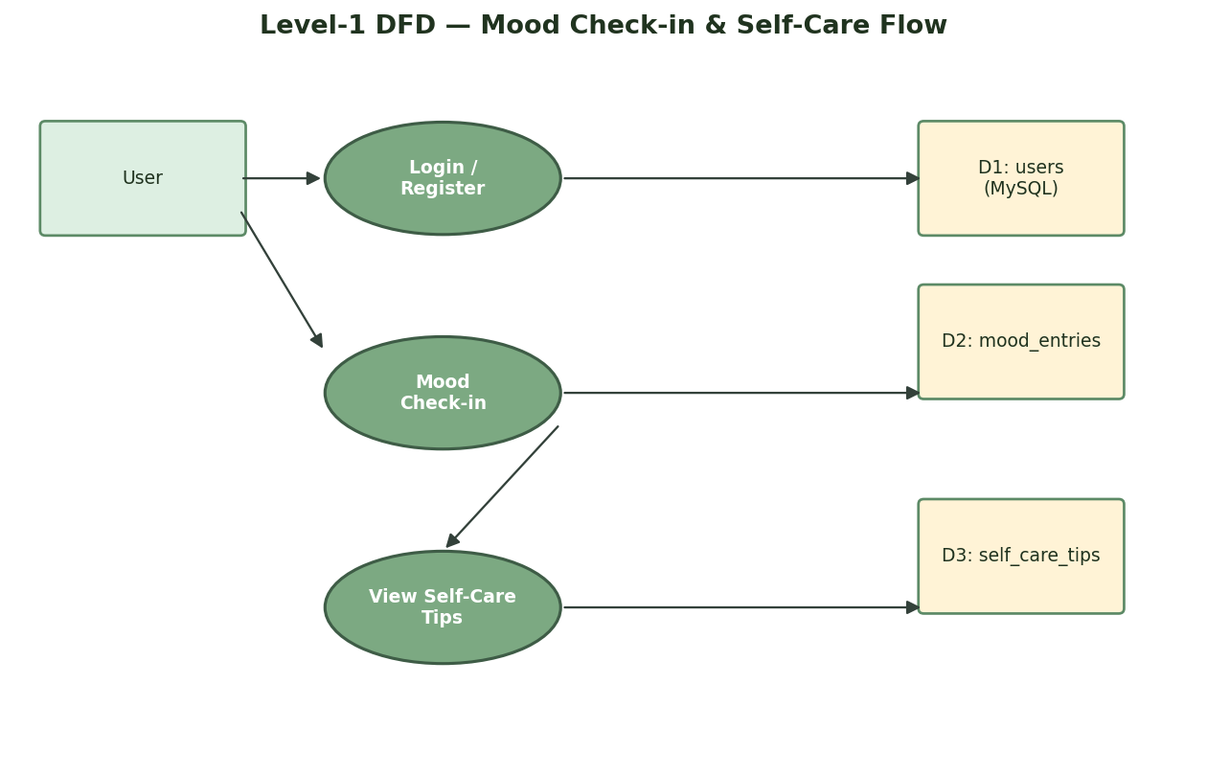
Fig. 3.3: Level-1 DFD — Mood Check-in & Self-Care Flow

3.9 ER Diagram
The Entity-Relationship Diagram below shows the key tables in the MindNest database and how they relate to one another through the central users table.
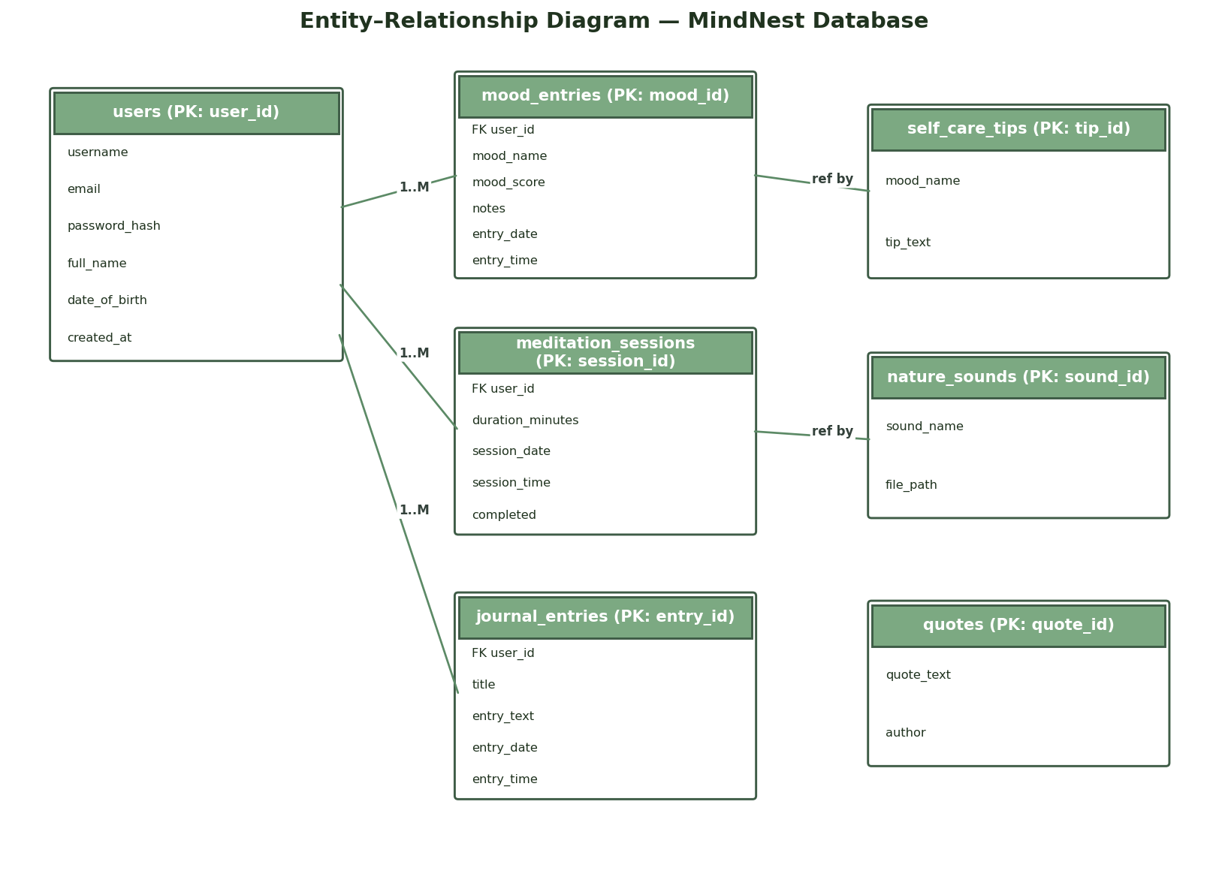
Fig. 3.4: ER Diagram — MindNest Database

4. System Design

4.1 Modules
The system is structured into the following modules, mirrored directly in the codebase as separate backend files:
Module | Responsibility
auth.py | User registration, login, password hashing, email validation
mood.py | Daily mood check-in, mood history, self-care tips
meditation.py | Meditation timer logic, guided script, session logging
sounds.py | Nature sound playback via pygame
quotes.py | Daily quote and affirmation rotation
journal.py | Journal entry creation and retrieval
profile_manager.py | Profile viewing/updating, password changes
db_connection.py | Central MySQL connection handling for all modules

4.2 Data Structure of All Modules
MindNest uses one MySQL database, mindnest_db, containing 7 tables. Each table's structure is described below.

users
Stores user account and login details.
Field | Type | Key
user_id | INT | PRIMARY KEY
username | VARCHAR(50) | UNIQUE
email | VARCHAR(100) | UNIQUE
password_hash | VARCHAR(255) | -
full_name | VARCHAR(100) | -
date_of_birth | DATE | -
created_at | DATETIME | -

mood_entries
Stores each user's daily mood check-ins.
Field | Type | Key
mood_id | INT | PRIMARY KEY
user_id | INT | FOREIGN KEY
mood_name | VARCHAR(30) | -
mood_score | INT | -
notes | TEXT | -
entry_date | DATE | -
entry_time | TIME | -

self_care_tips
Reference table of self-care tips mapped to each mood.
Field | Type | Key
tip_id | INT | PRIMARY KEY
mood_name | VARCHAR(30) | -
tip_text | VARCHAR(255) | -

meditation_sessions
Logs each completed meditation session per user.
Field | Type | Key
session_id | INT | PRIMARY KEY
user_id | INT | FOREIGN KEY
duration_minutes | INT | -
session_date | DATE | -
session_time | TIME | -
completed | BOOLEAN | -

nature_sounds
Reference table listing the available ambient sound tracks.
Field | Type | Key
sound_id | INT | PRIMARY KEY
sound_name | VARCHAR(50) | -
file_path | VARCHAR(255) | -

quotes
Reference table of motivational quotes shown to users.
Field | Type | Key
quote_id | INT | PRIMARY KEY
quote_text | VARCHAR(255) | -
author | VARCHAR(100) | -

journal_entries
Stores each user's personal journal entries.
Field | Type | Key
entry_id | INT | PRIMARY KEY
user_id | INT | FOREIGN KEY
title | VARCHAR(150) | -
entry_text | TEXT | -
entry_date | DATE | -
entry_time | TIME | -

4.3 Procedural Design
The flowcharts below describe the process logic of two of MindNest's core modules.

4.3.1 Login / Registration Flow
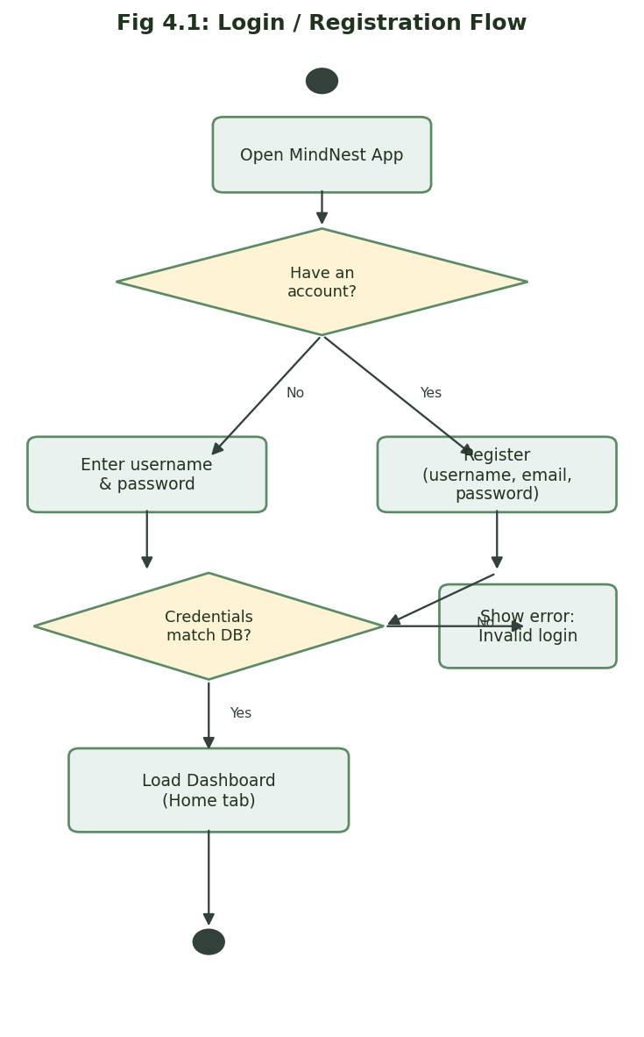
Fig. 4.1: Login / Registration Flowchart

4.3.2 Mood Check-in Flow
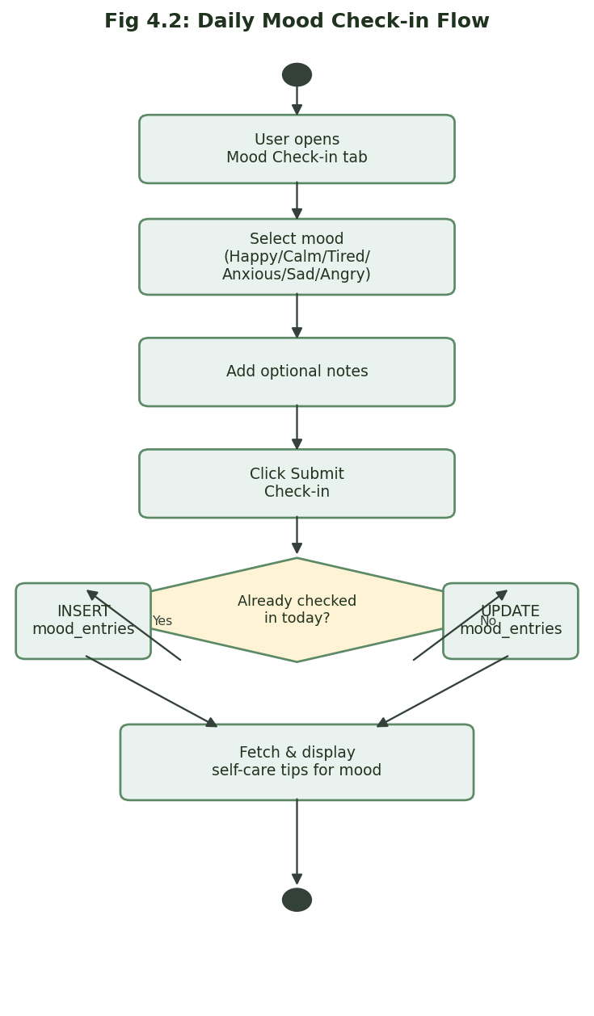
Fig. 4.2: Daily Mood Check-in Flowchart

5. Screenshots
The following mockups illustrate MindNest's interface, based directly on the application's actual layout, color scheme, and navigation structure.

Login Page
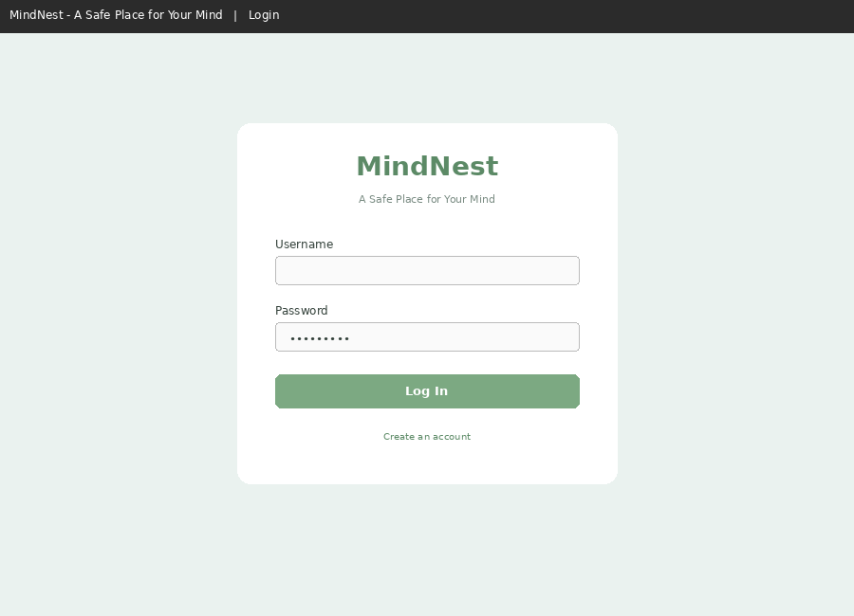

Registration Page
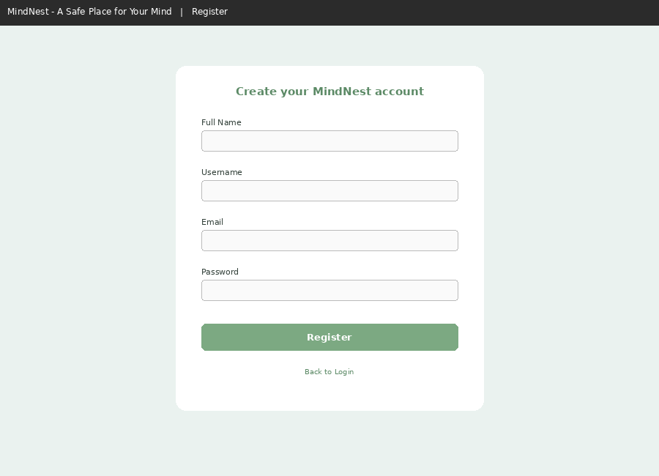

Home Tab — Quote of the Day, Affirmation, Status
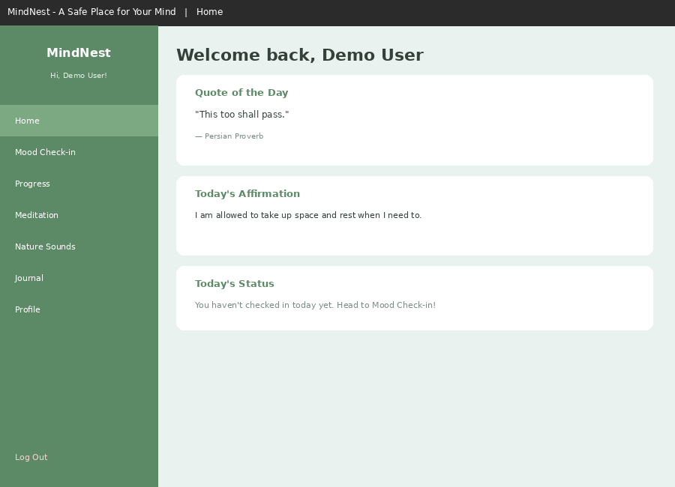

Mood Check-in Tab with Self-Care Tips
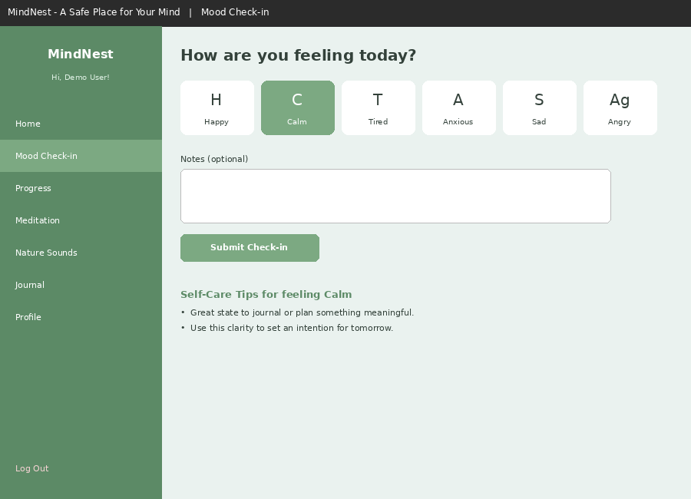

Progress Dashboard — Stats & Mood History
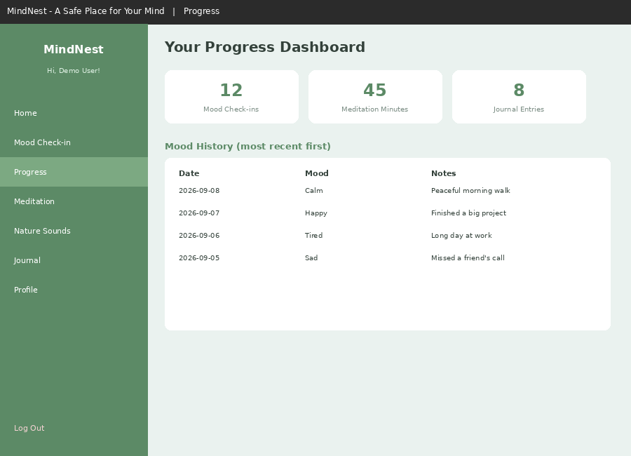

Guided Meditation Timer
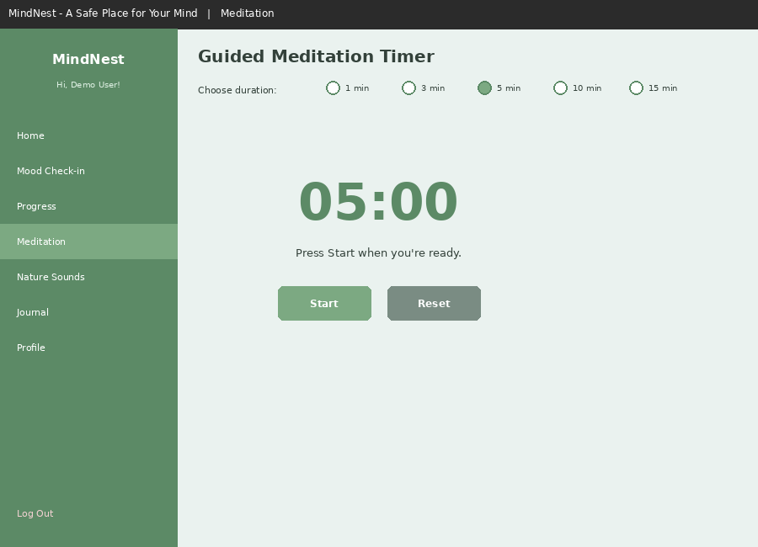

Nature Sounds Player
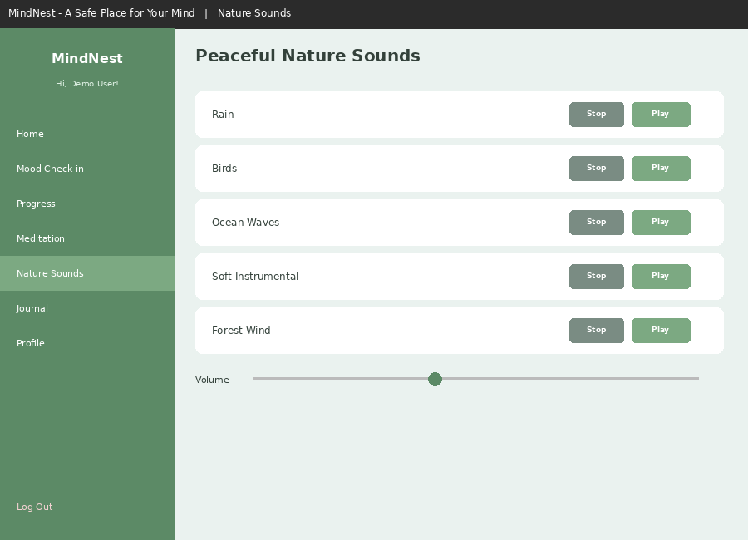

Personal Journal
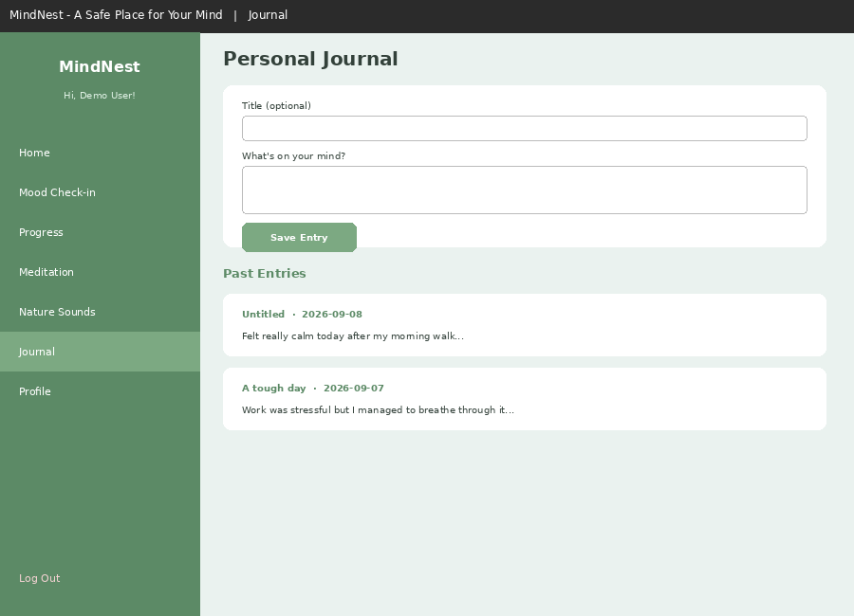

Profile Management
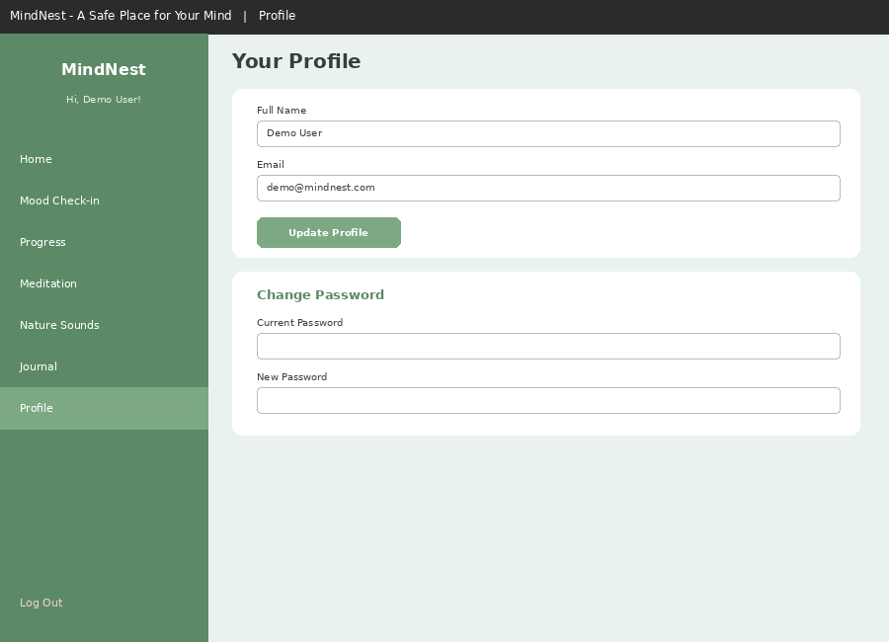

6. Coding
Selected code excerpts from the MindNest application are shown below.

auth.py — Password Hashing & Login
def hash_password(password: str) -> str: return hashlib.sha256(password.encode()).hexdigest() def login_user(username, password): if not username or not password: return False, "Please enter both username and password." password_hash = hash_password(password) user = run_query( "SELECT user_id, username, full_name, email FROM users " "WHERE username = %s AND password_hash = %s", (username, password_hash), fetchone=True ) if user: return True, user return False, "Invalid username or password."

mood.py — Daily Mood Check-in
def submit_mood_checkin(user_id, mood_name, notes=""): if mood_name not in MOODS: return False, "Invalid mood selected." today = datetime.now().strftime("%Y-%m-%d") score = MOODS[mood_name]["score"] existing = run_query( "SELECT mood_id FROM mood_entries WHERE user_id = %s AND entry_date = %s", (user_id, today), fetchone=True ) if existing: run_query("UPDATE mood_entries SET mood_name=%s, mood_score=%s, " "notes=%s WHERE mood_id=%s", (mood_name, score, notes, existing["mood_id"])) return True, "Today's mood check-in updated." else: run_query("INSERT INTO mood_entries (user_id, mood_name, mood_score, " "notes, entry_date) VALUES (%s, %s, %s, %s, %s)", (user_id, mood_name, score, notes, today)) return True, "Mood check-in recorded for today."

meditation.py — Session Logging
def log_meditation_session(user_id, duration_minutes): today = datetime.now().strftime("%Y-%m-%d") now_time = datetime.now().strftime("%H:%M:%S") run_query( "INSERT INTO meditation_sessions " "(user_id, duration_minutes, session_date, session_time, completed) " "VALUES (%s, %s, %s, %s, TRUE)", (user_id, duration_minutes, today, now_time) )

7. Testing

Unit Testing
Individual functions in each module (e.g. hash_password, submit_mood_checkin, log_meditation_session) were tested independently to confirm correct behavior for both valid and invalid inputs.

Module Testing
Each feature module (Authentication, Mood, Meditation, Sounds, Journal, Profile) was tested as a complete unit, verifying that its functions worked correctly together with the database.

Integration Testing
Modules were tested together through the Tkinter interface — for example, confirming that a mood check-in correctly triggers the display of matching self-care tips, and that a completed meditation session updates the Progress Dashboard's totals.

System Testing
The complete application was tested end-to-end: registering a new account, logging in, checking in a mood, completing a meditation session, playing a nature sound, writing a journal entry, and updating the profile — confirming all data persisted correctly in MySQL.

Test Cases
Test Case | Input | Expected Result | Status
Register with existing username | Duplicate username | Error: username already exists | Pass
Login with wrong password | Valid username, wrong password | Error: invalid username or password | Pass
Submit mood check-in twice in one day | Same user, same day | Second submission updates the first | Pass
Meditation timer reaches zero | 5-minute session run to completion | Session logged in meditation_sessions | Pass
Play nature sound with missing file | sounds.play_sound() on missing file | Graceful error message, no crash | Pass

8. Report
Through the Progress Dashboard, MindNest gives users a simple report of their own wellness activity: total mood check-ins recorded, total minutes spent meditating, and total journal entries written, alongside a scrollable table of their full mood history. This turns scattered daily actions into a visible pattern the user can reflect on over time.

9. Future Scope
- Daily Reminders – scheduled notifications to prompt mood check-ins or meditation sessions.
- Dark Mode – a toggleable dark color theme stored as a per-user preference.
- Goal & Habit Tracking – letting users set and track recurring wellness goals.
- Favorite Quotes & Sounds – allowing users to bookmark content they find most helpful.
- Weekly/Monthly Wellness Reports – aggregated summaries, optionally exportable as PDF.
- Emergency Calm Mode – a full-screen guided breathing exercise for moments of acute stress.
- Mobile Companion App – extending MindNest's core features to a mobile platform.

10. Conclusion
MindNest offers a comprehensive, private, and easy-to-use solution for daily mindfulness and emotional wellbeing. By combining mood tracking, guided meditation, journaling, ambient sound, and daily affirmations into a single offline desktop application, it removes the friction of switching between multiple disconnected tools.
The system's modular design — separating authentication, mood tracking, meditation, sounds, journaling, and profile management into distinct backend modules — makes it straightforward to maintain, test, and extend with the future enhancements outlined above. With its calm visual design and focus on daily, low-friction engagement, MindNest is well positioned to help users build sustainable, long-term wellness habits.

11. Bibliography
- Python Crash Course by Eric Matthes
- MySQL Cookbook by Paul DuBois
- Tkinter GUI Application Development by Alan D. Moore

12. References
- Python Documentation – https://docs.python.org/3/
- Python Tkinter Documentation – https://docs.python.org/3/library/tkinter.html
- MySQL Official Site – https://www.mysql.com/
- MySQL Connector/Python Documentation – https://dev.mysql.com/doc/connector-python/en/
- pygame Documentation – https://www.pygame.org/docs/

