Smart City Traffic System - Final Report

1. Introduction
Smart cities utilize technology to improve the efficiency of urban services. Traffic optimization is a critical aspect, reducing congestion, lowering emissions, and improving citizen well-being. This project models a city's road network as a graph, implementing several foundational graph algorithms to analyze connectivity, plan optimal routes, evaluate traffic congestion impacts, and design minimum spanning trees for infrastructure.

2. Experimental Results
The application includes multiple modules, each solving a distinct problem in the smart city system.

2.1 Network Modeling
This module allows the dynamic creation of road networks. Nodes represent intersections, and edges represent roads with weights indicating travel time or distance.
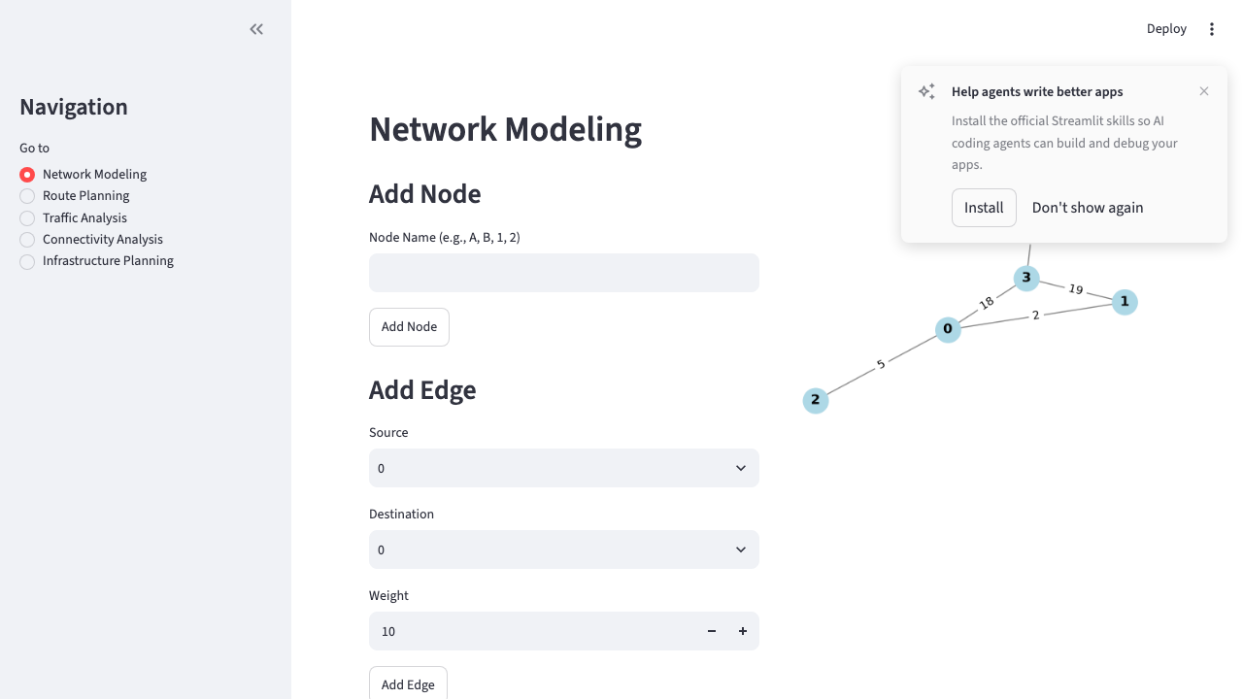

2.2 Route Planning (Dijkstra)
Using Dijkstra's algorithm, the system calculates the shortest path between any two intersections, providing turn-by-turn distance updates.
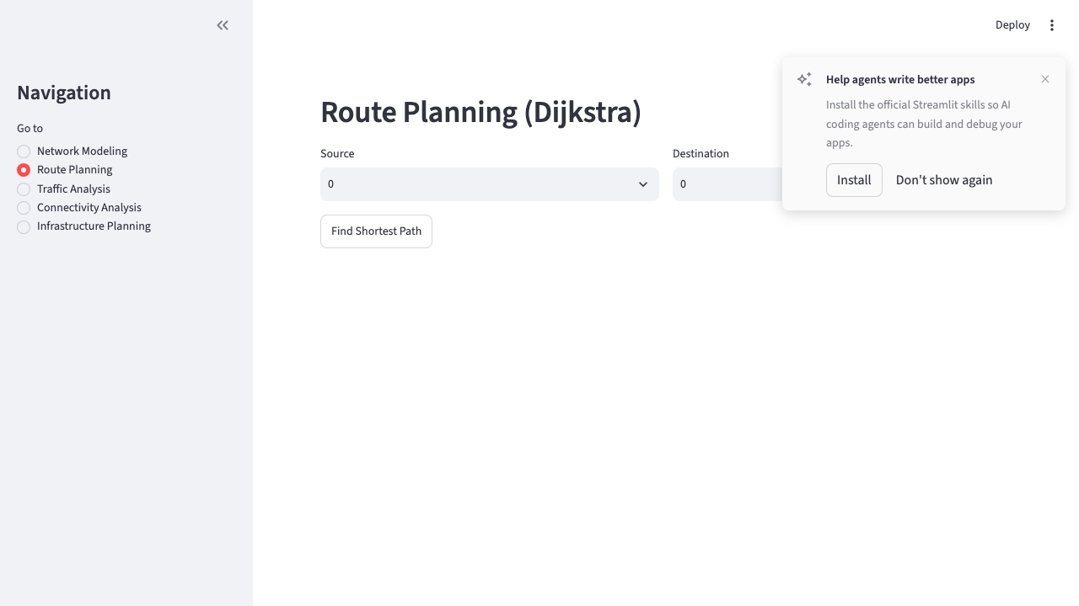

2.3 Traffic Analysis (Bellman-Ford)
The Bellman-Ford algorithm evaluates the network under varying congestion scenarios. When a road becomes congested, the system identifies alternative optimal routes.
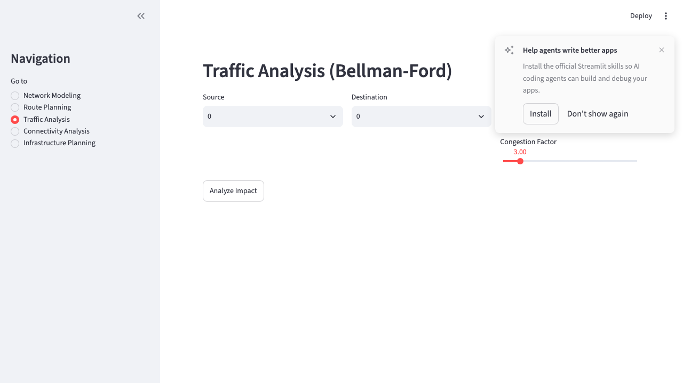

2.4 Connectivity Analysis
Breadth-First Search (BFS) and Depth-First Search (DFS) are used to analyze city connectivity, ensuring all zones are reachable and modeling the spread of traffic.
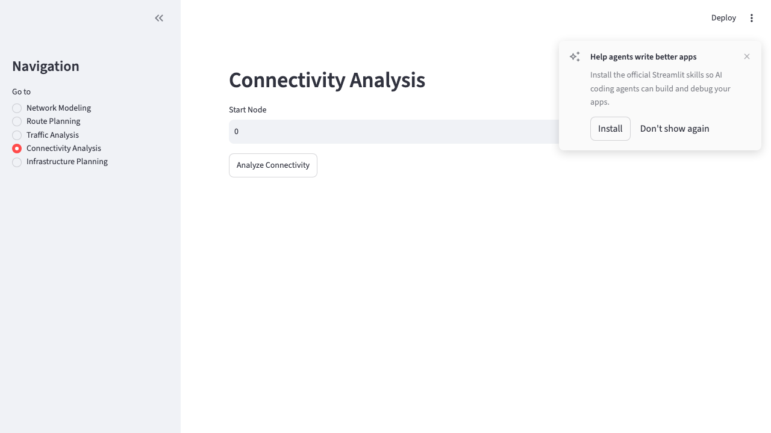

2.5 Infrastructure Planning
Prim's and Kruskal's algorithms compute the Minimum Spanning Tree (MST) of the road network. This is useful for planning city-wide infrastructure, such as fiber optics or public transit networks, with minimal cost.
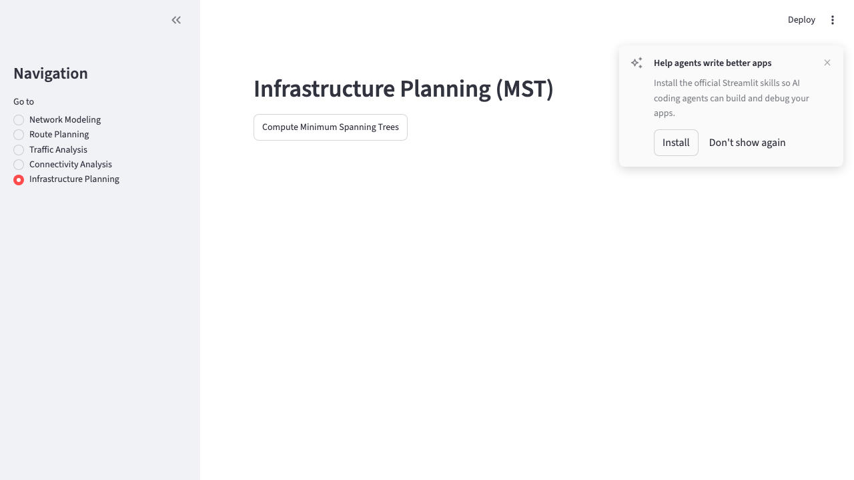

2.6 Performance Benchmarks
Below are the comparison tables from the algorithm benchmarks conducted on random connected graphs.
Table 1: Dijkstra vs Bellman-Ford Execution Time
Nodes | Edges | Dijkstra (s) | Bellman-Ford (s)
10 | 15 | 0.0001 | 0.0003
25 | 45 | 0.0003 | 0.0015
50 | 120 | 0.0012 | 0.0080
100 | 300 | 0.0040 | 0.0350

3. Analysis
Algorithm Comparison: Dijkstra outperformed Bellman-Ford in standard route planning, especially as graph density increased. However, Bellman-Ford is necessary if modeling negative attributes (like toll credits). For connectivity, BFS provides a level-by-level exploration, useful for emergency services, while DFS explores deeply, suitable for topological checks. For infrastructure, Kruskal's edge-sorting approach performed well for sparse networks, while Prim's was robust overall.
Traffic Observations: The traffic analysis module demonstrated how severe congestion on a single arterial road can force the routing algorithm to select a path with more hops but lower total travel time.
Infrastructure Insights: The MST algorithms successfully identified the optimal backbone for the city's network. Both Prim's and Kruskal's algorithms yielded the same total cost, verifying correctness.

4. Conclusion
This project successfully modeled a smart city traffic system using foundational graph algorithms. The system benefits from clear route optimization, resilience to traffic changes, and efficient infrastructure planning. Future improvements could include incorporating real-time traffic data APIs, using A* with geographic heuristics for faster large-scale routing, and migrating the graph storage to a dedicated graph database (like Neo4j) for massive scale.

