ASSIGNMENT
Database & Collection
use companyDB
db.employees.insertMany([
{
emp_id: 101,
name: "Amit",
department: "IT",
skills: ["Python", "MongoDB", "Docker"],
projects: [
{ name: "HRMS", duration: 6, technologies: ["Python", "MongoDB"] },
{ name: "Ecommerce", duration: 8, technologies: ["NodeJS", "MongoDB"] }
],
salaries: [45000, 48000, 52000],
certifications: ["AWS", "Azure"]
},
{
emp_id: 102,
name: "Neha",
department: "HR",
skills: ["Communication", "Recruitment"],
projects: [
{ name: "HiringPortal", duration: 4, technologies: ["PHP", "MySQL"] }
],
salaries: [35000, 38000],
certifications: ["SHRM"]
},
{
emp_id: 103,
name: "Ravi",
department: "Finance",
skills: ["Excel", "Tally", "SQL"],
projects: [
{ name: "Accounting", duration: 10, technologies: ["SQL", "PowerBI"] }
],
salaries: [40000, 42000, 46000],
certifications: ["CPA", "CFA"]
},
{
emp_id: 104,
name: "Pooja",
department: "IT",
skills: ["Java", "Spring", "MongoDB"],
projects: [
{ name: "BankingApp", duration: 12, technologies: ["Java", "MongoDB"] },
{ name: "CRM", duration: 7, technologies: ["Spring", "MySQL"] }
],
salaries: [50000, 54000, 60000],
certifications: ["Oracle", "AWS"]
}
])

- Display all employees who have MongoDB skill
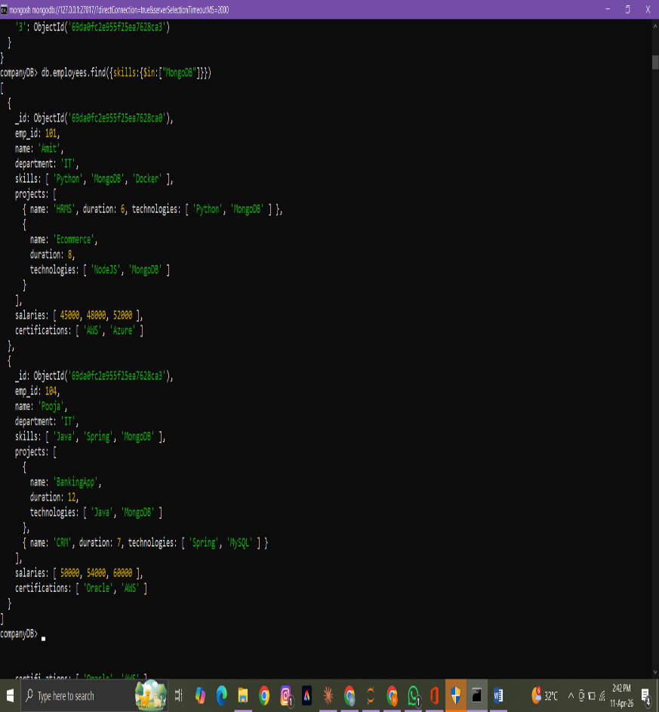

- Find employees having both Python and MongoDB skills
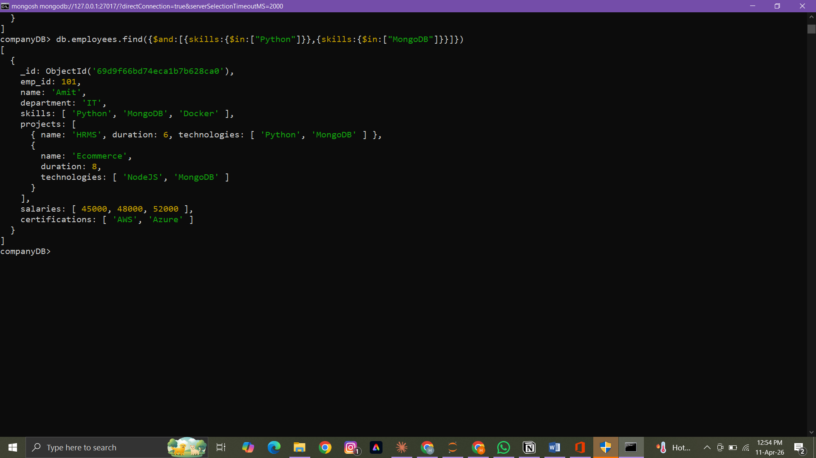

- Display employees with more than 2 skills


- Add a new skill "Kubernetes" to Amit
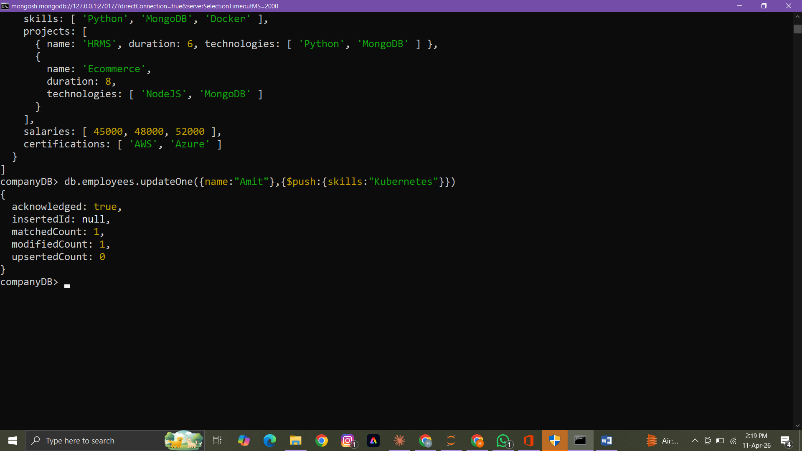

- Add multiple skills to Pooja
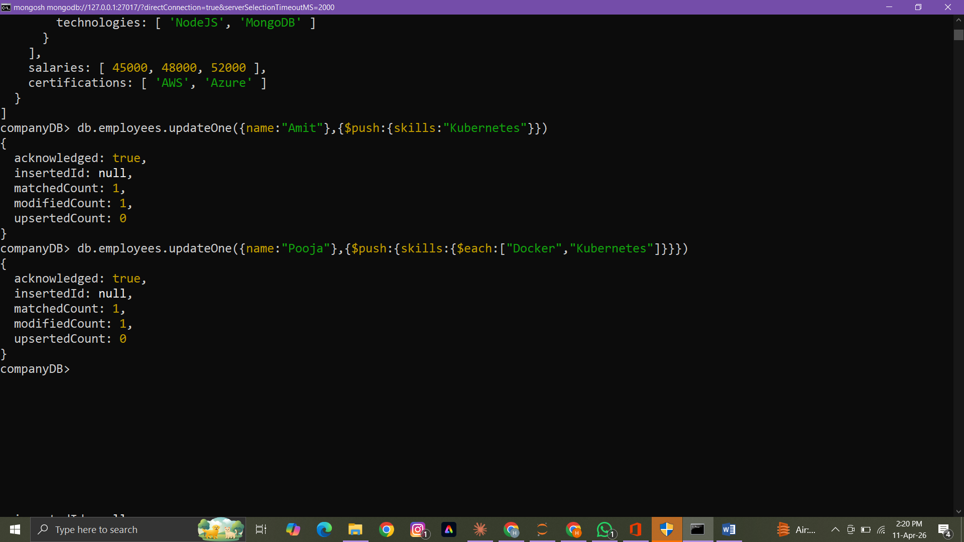

- Add a certification only if not already present
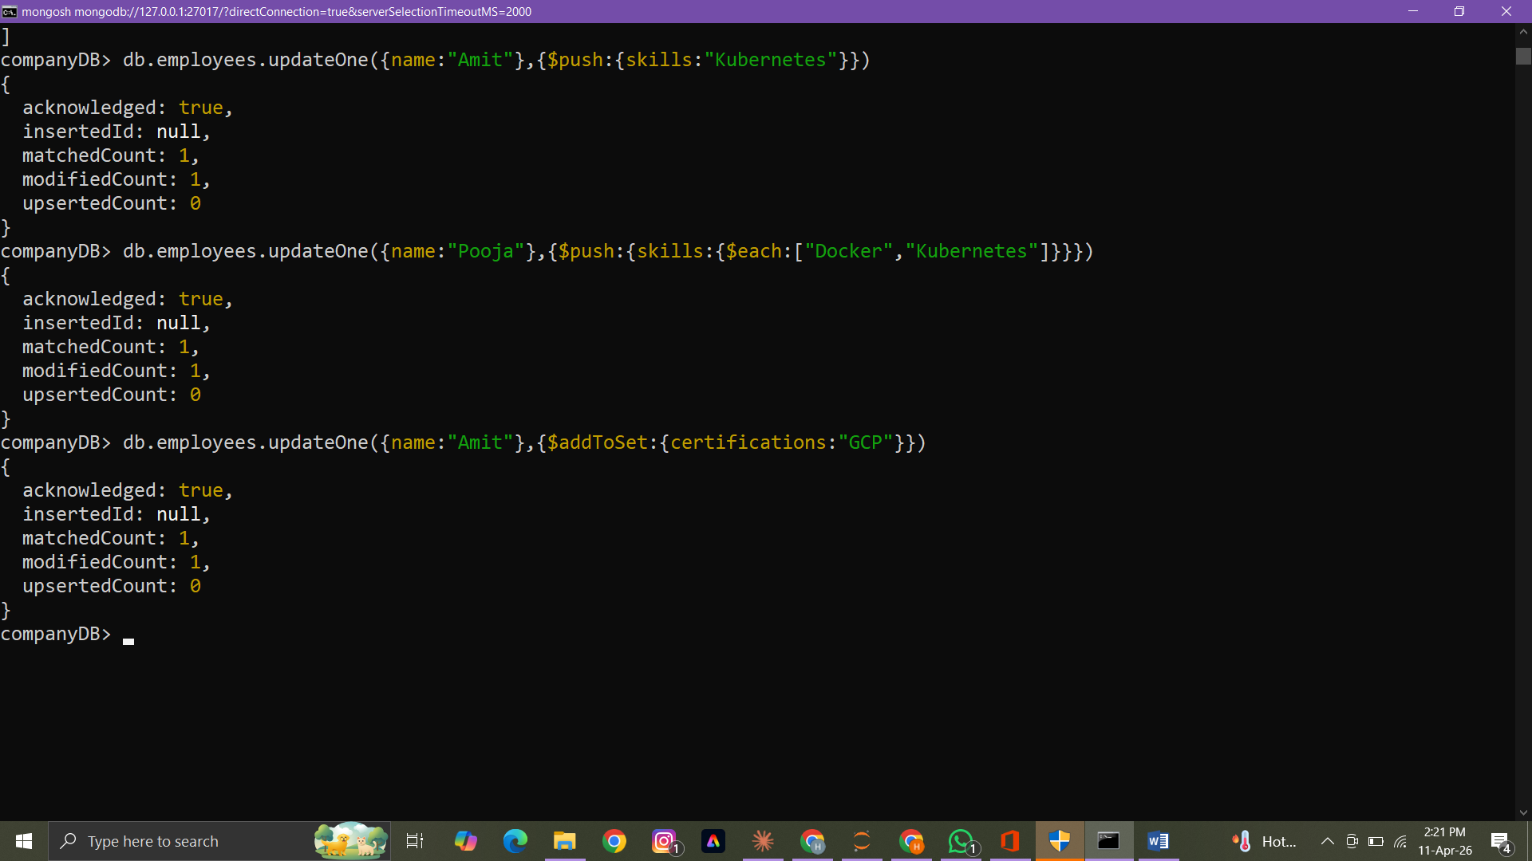

- Remove "Docker" skill from Amit
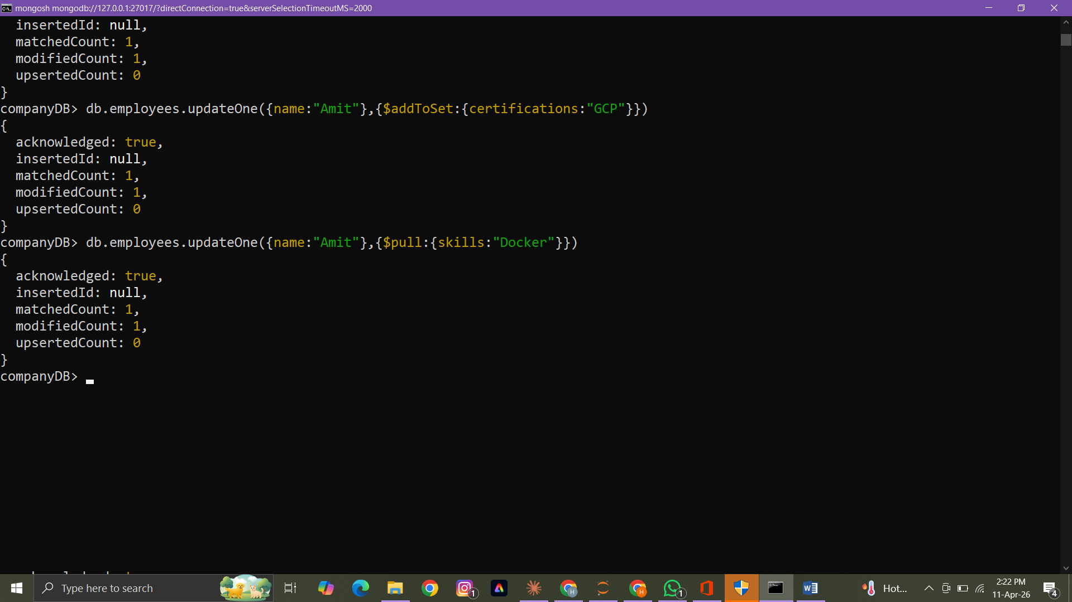
- Remove multiple salaries less than 45000
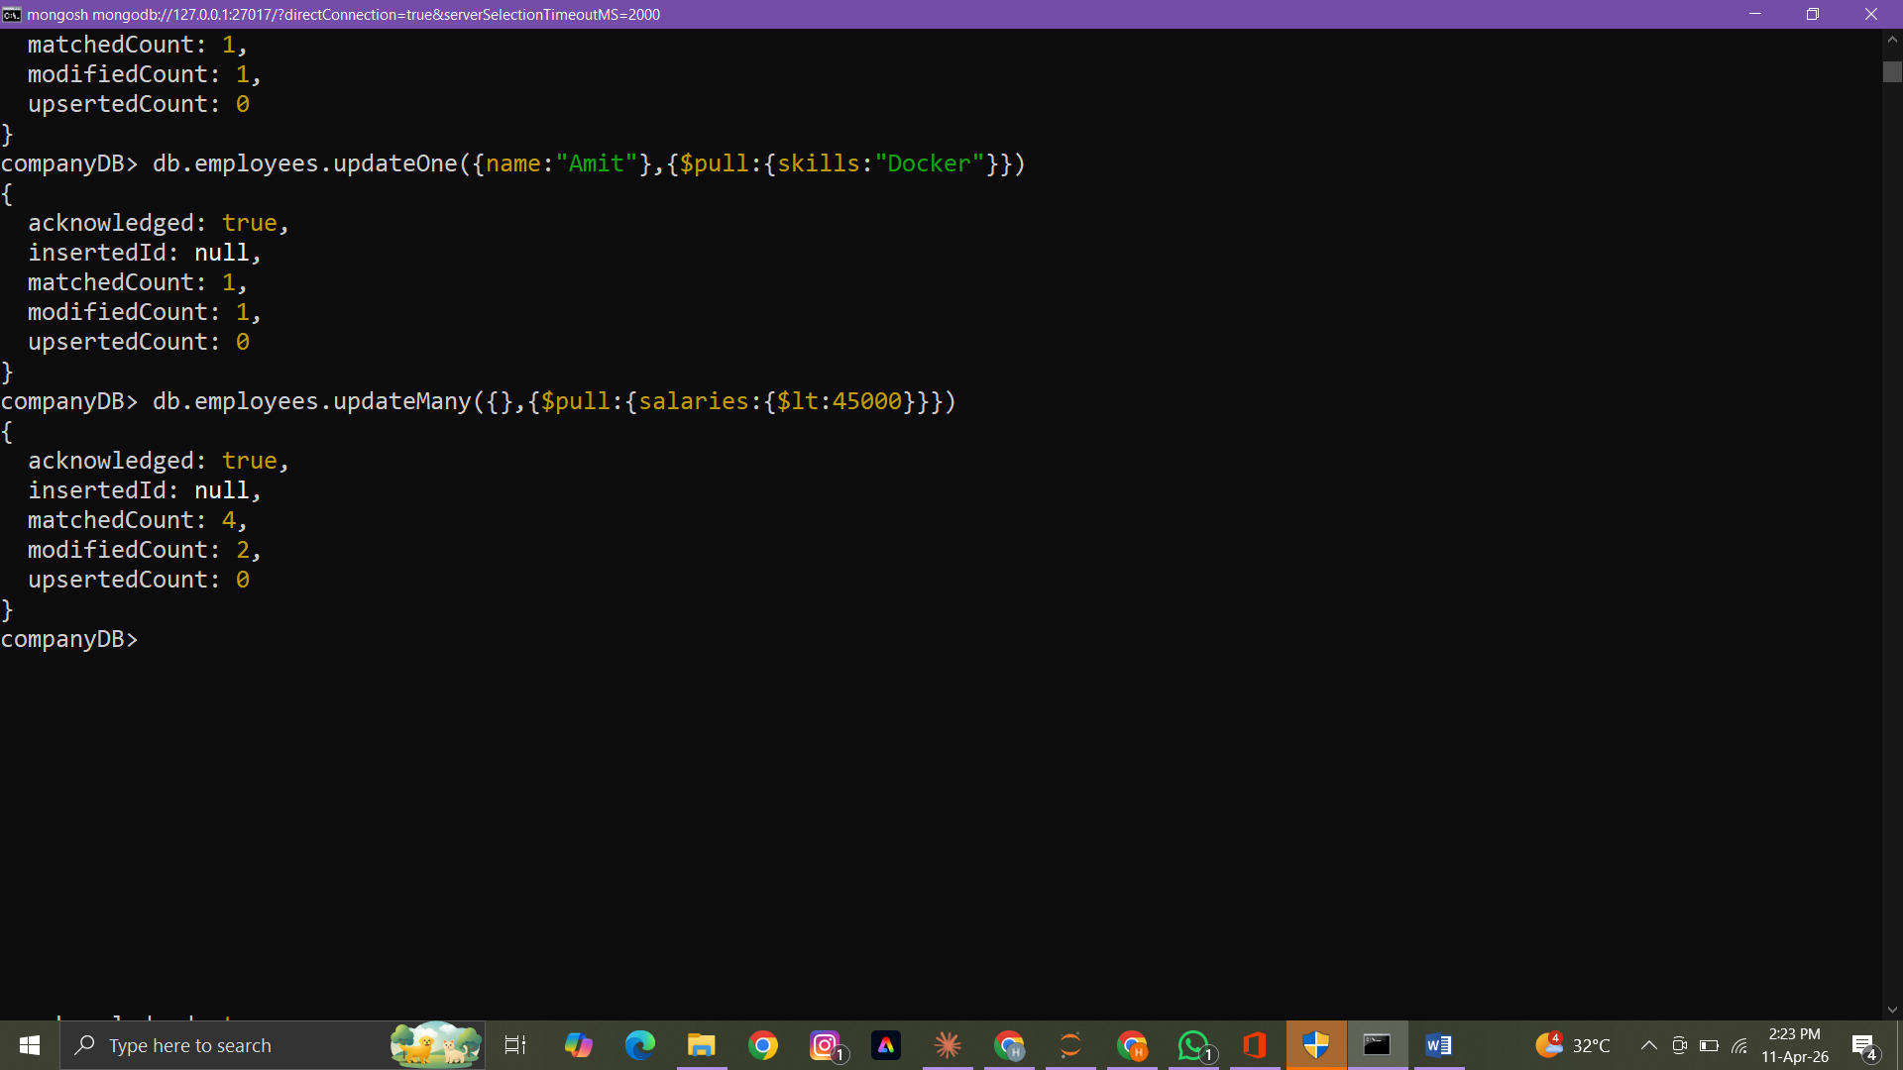

- Find employees who worked on MongoDB projects
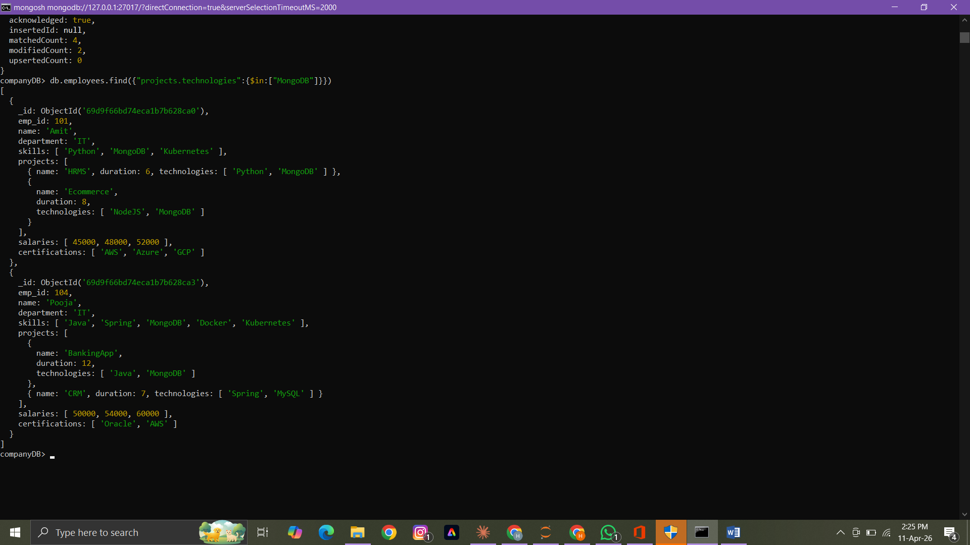

- Use $elemMatch to find project duration > 6 using MongoDB

Not covered

- Count number of projects for each employee
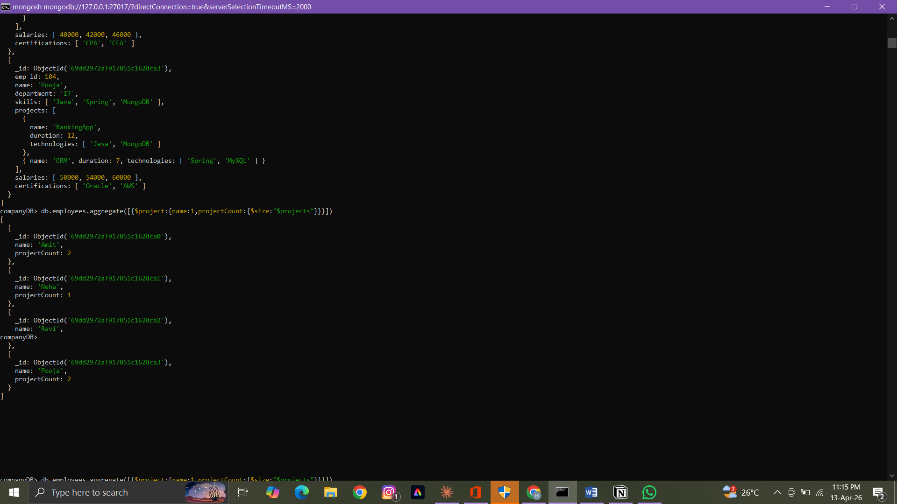

- Unwind skills array
Not covered

- List unique skills across company
Not covered

- Find employees with salary greater than 50000
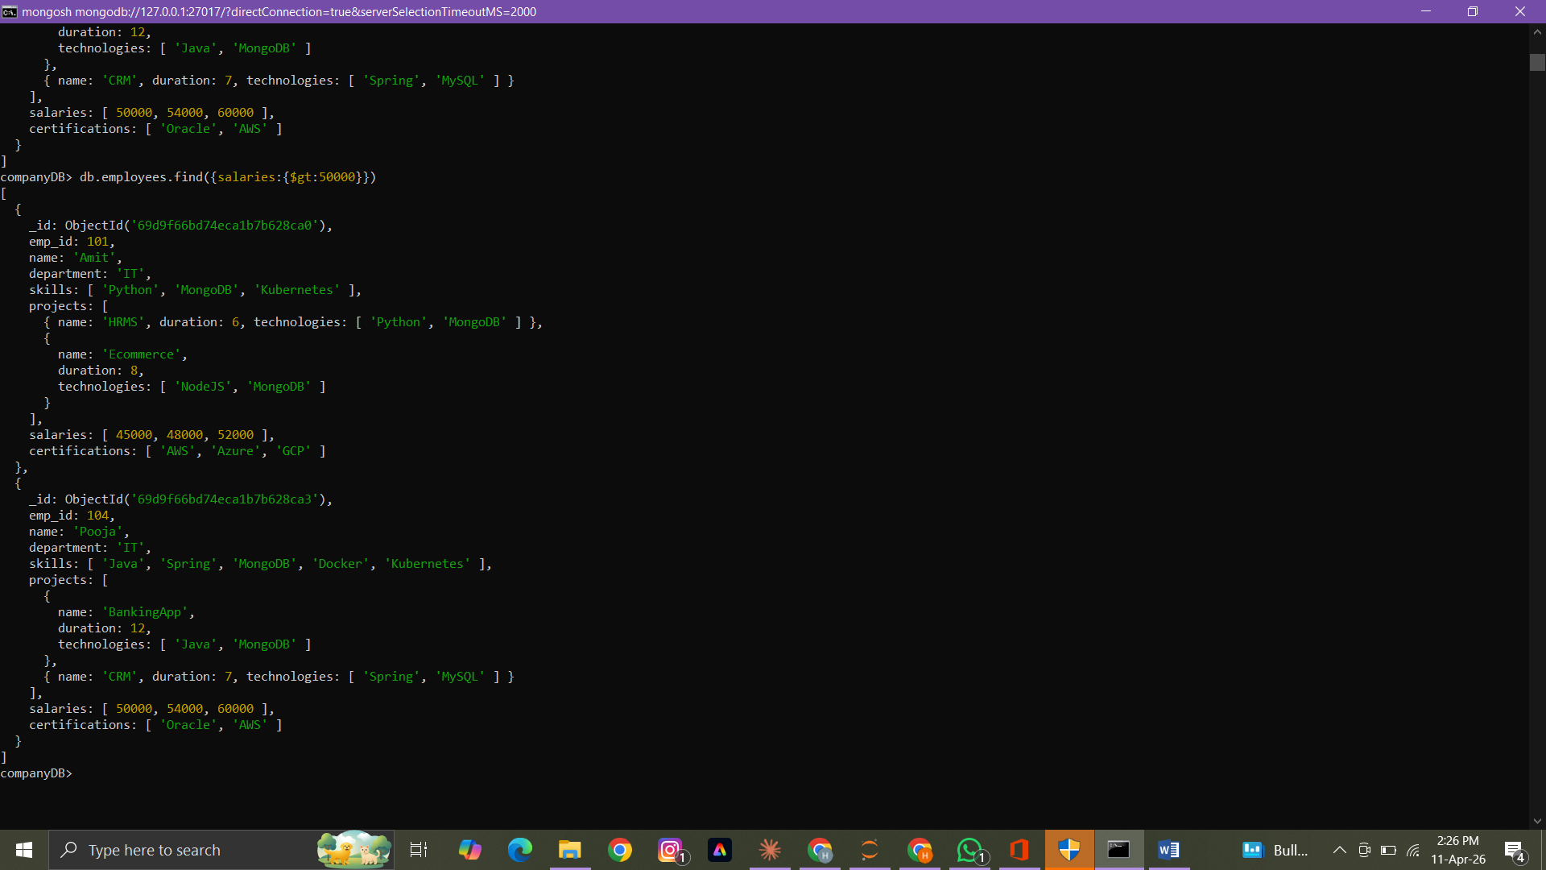

- Find employees with exactly 2 certifications

Not covered

- Add new project to Ravi
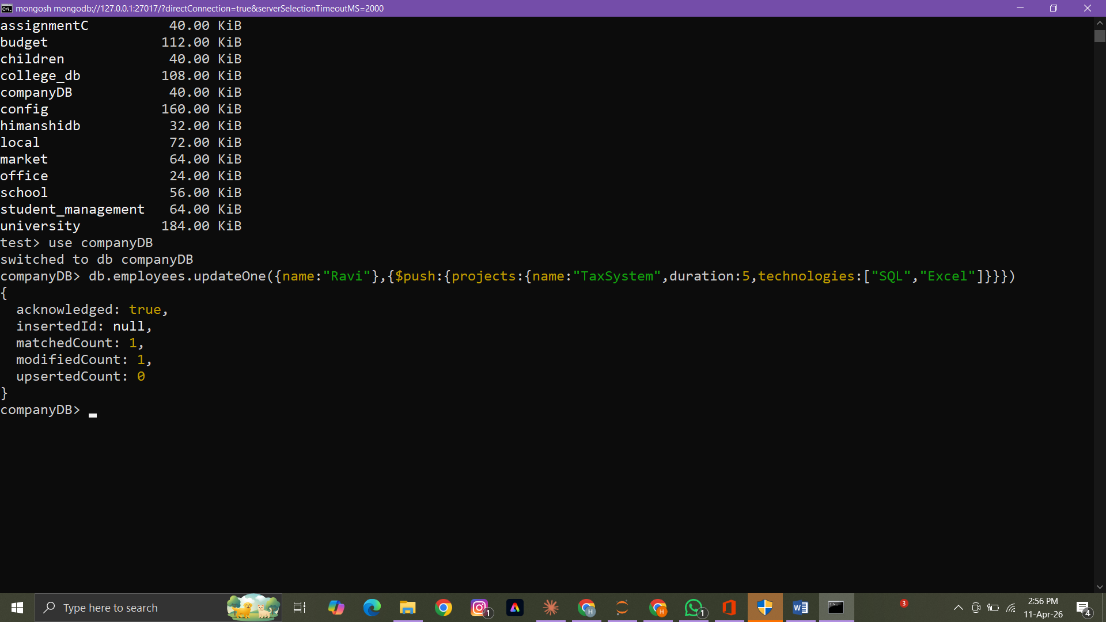

- Increase all salaries by 10% (array update)

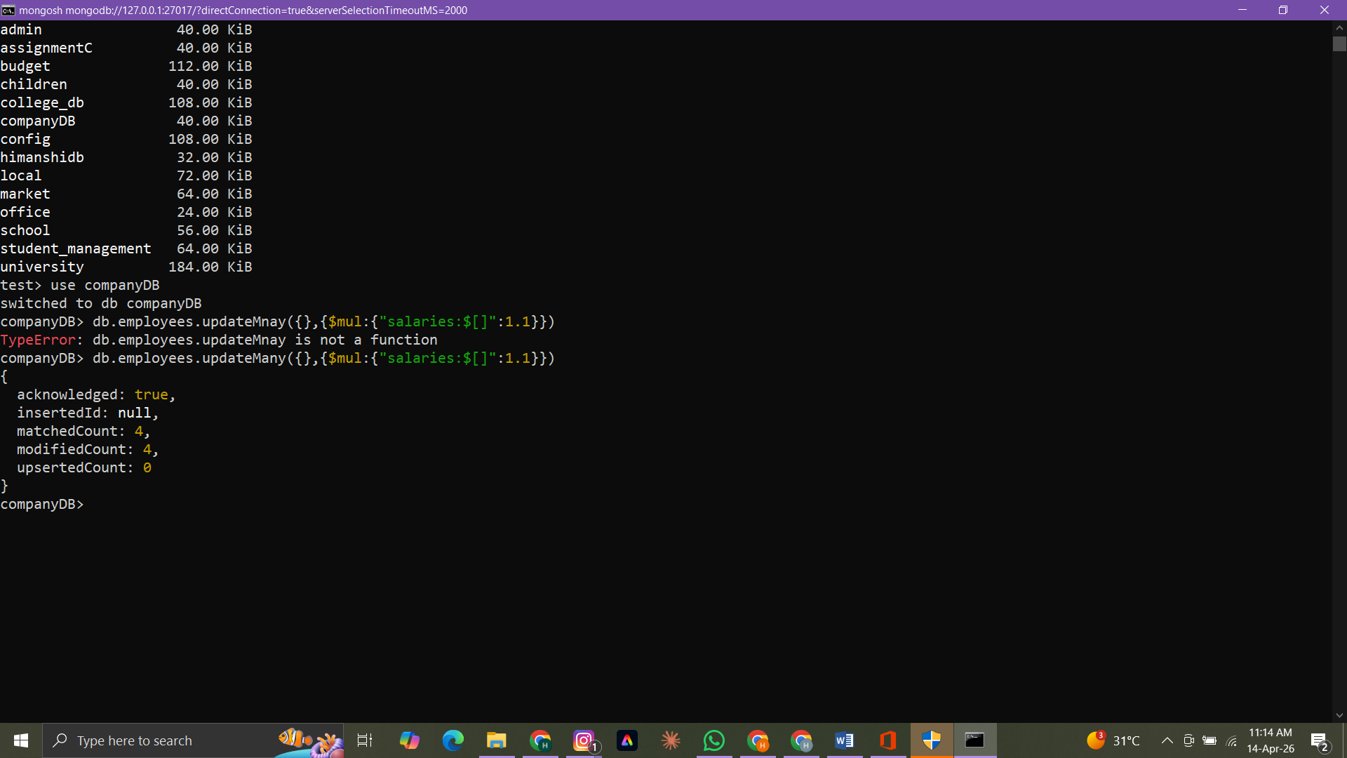

- Find highest salary of each employee
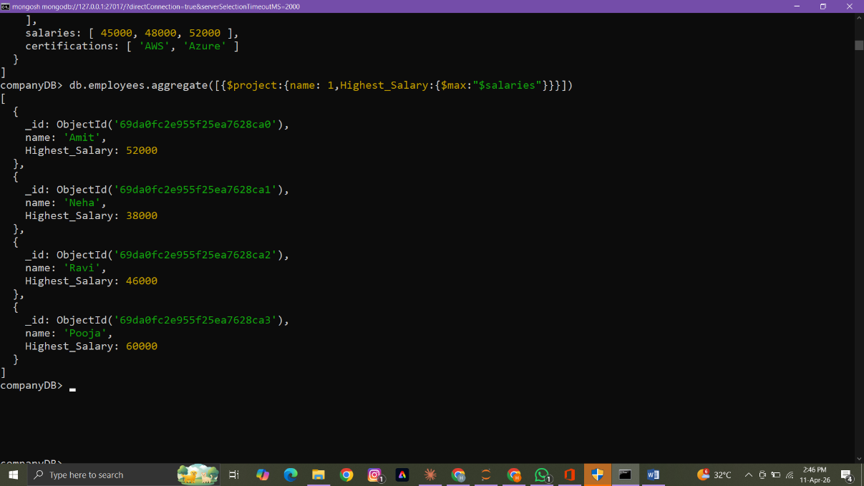
- Find average salary of employees
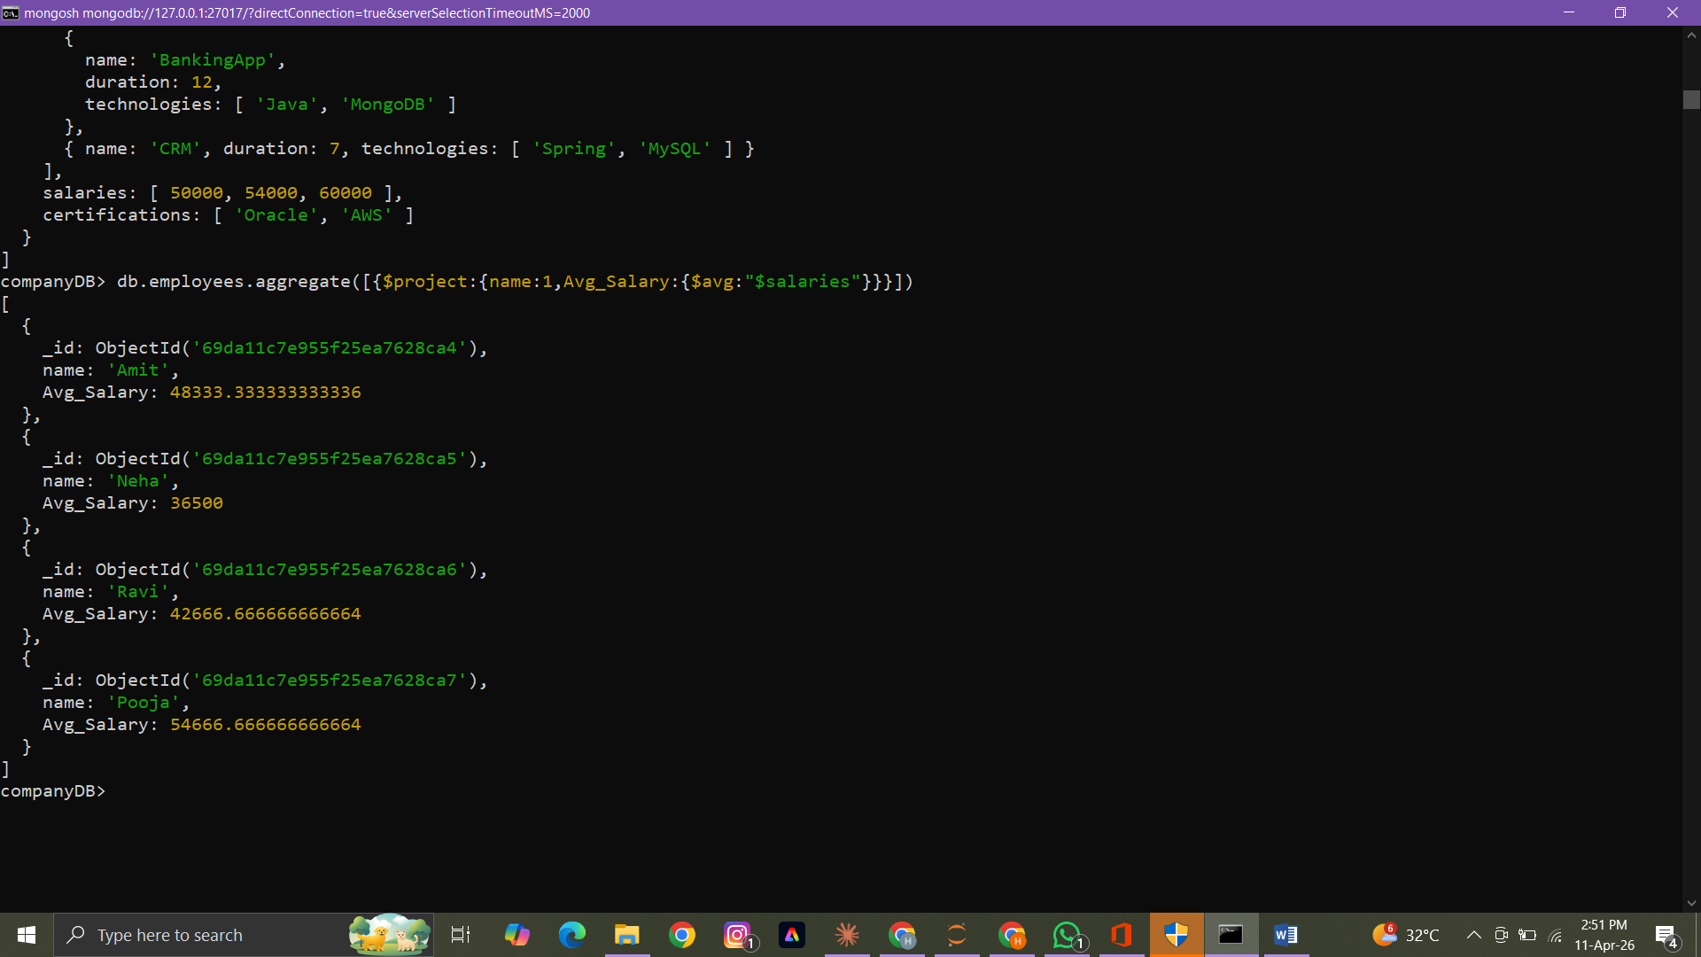
- Filter projects longer than 6 months
Not covered
- Find employees who have any of these skills: Java or Python
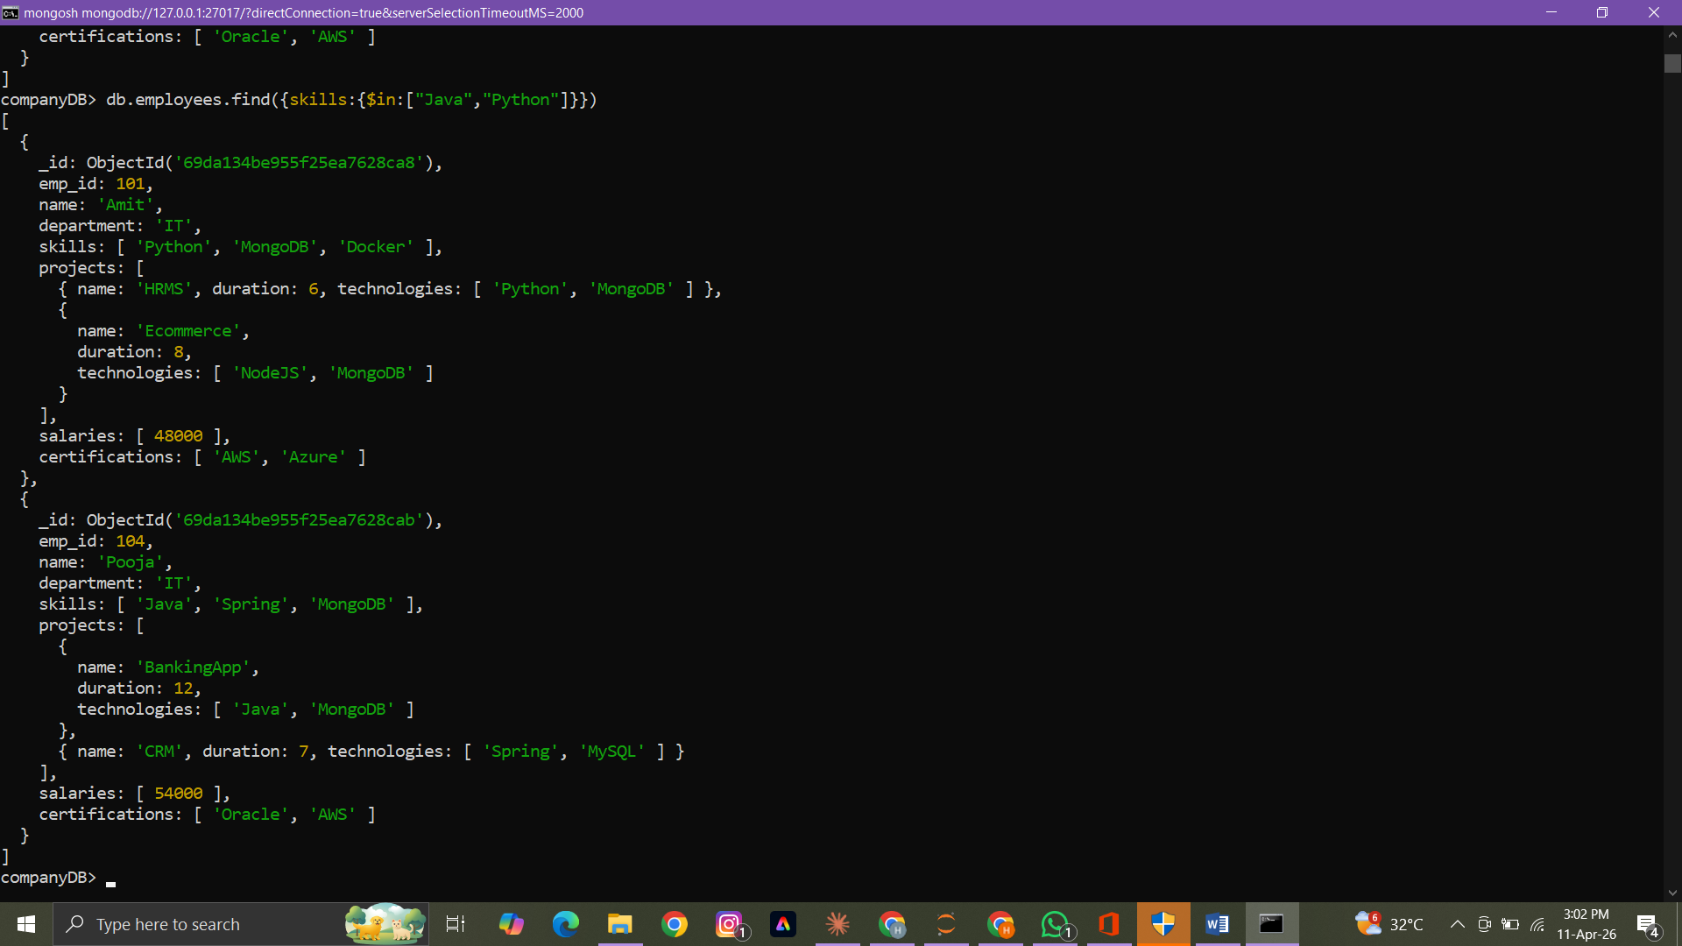

- Remove last salary entry

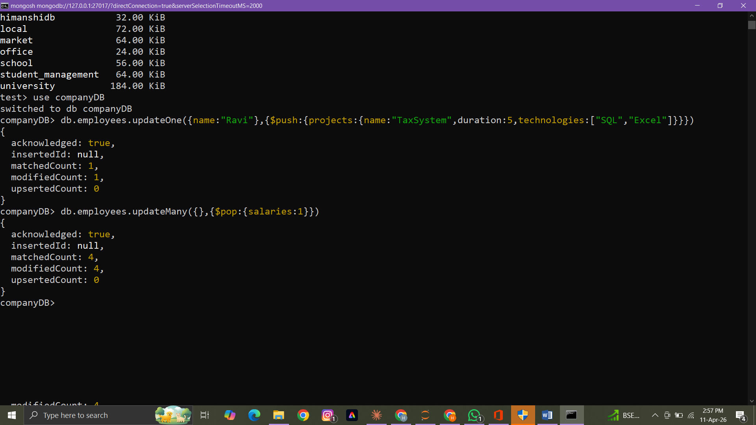

- Remove first salary entry
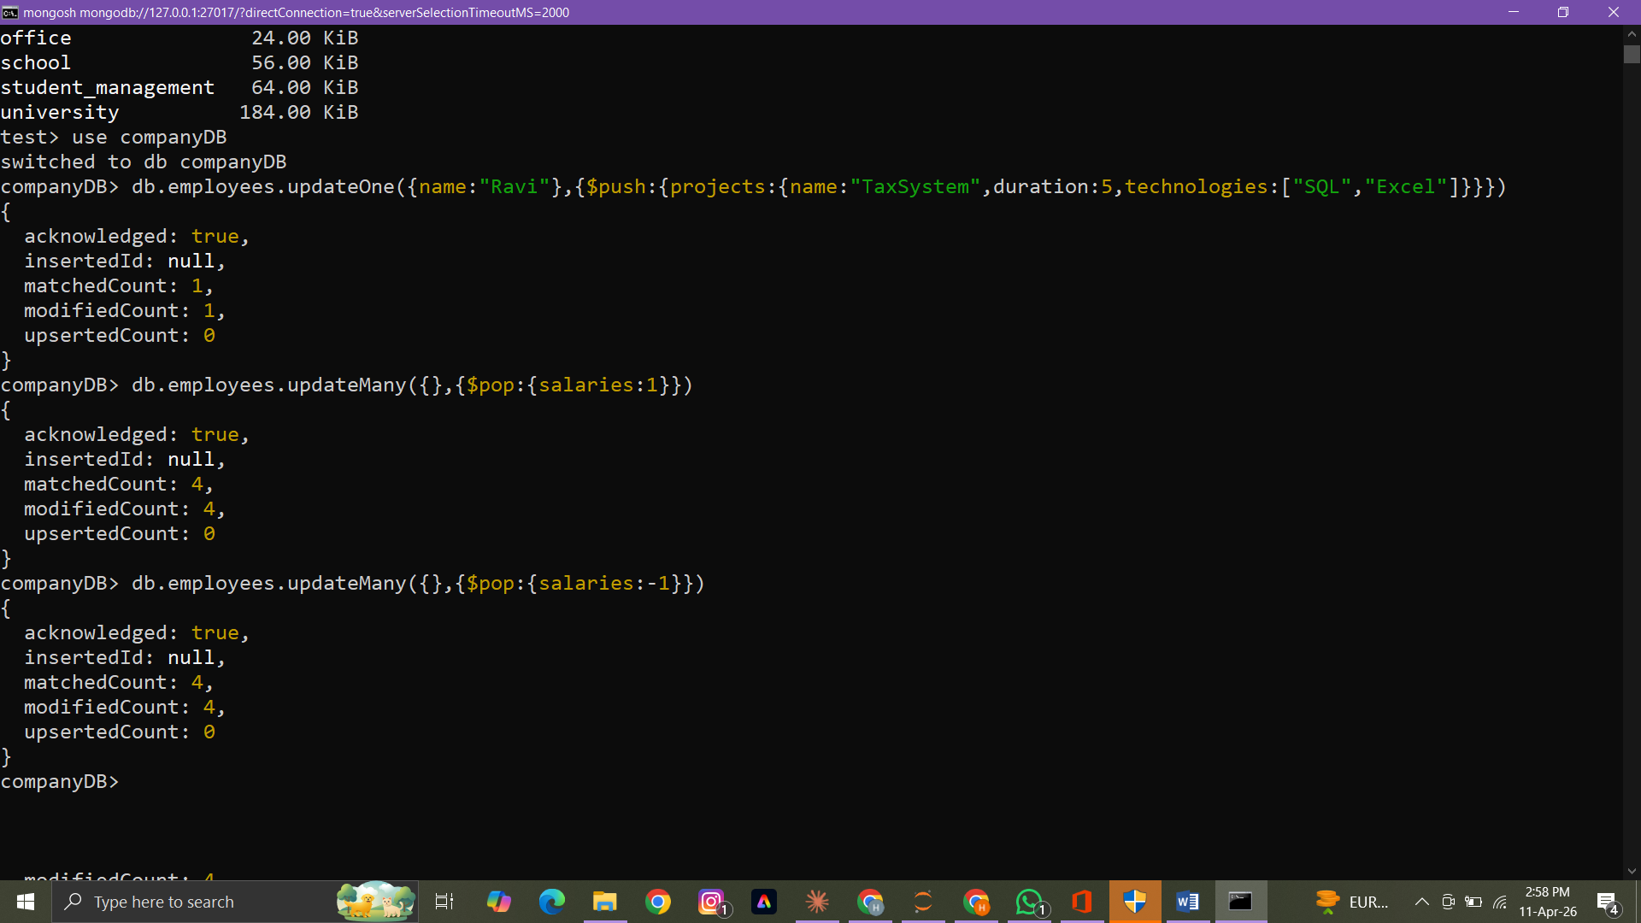

- Sort salaries array
Not covered

- Limit salaries array to last 2 entries
Not covered

- Find total salary paid to each employee

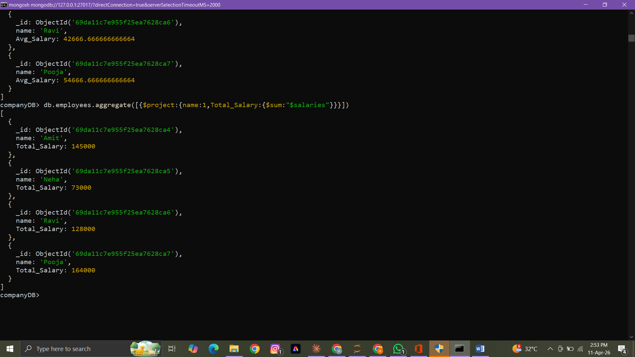
- Convert skills to uppercase
Not covered

- Find employees with more than one project
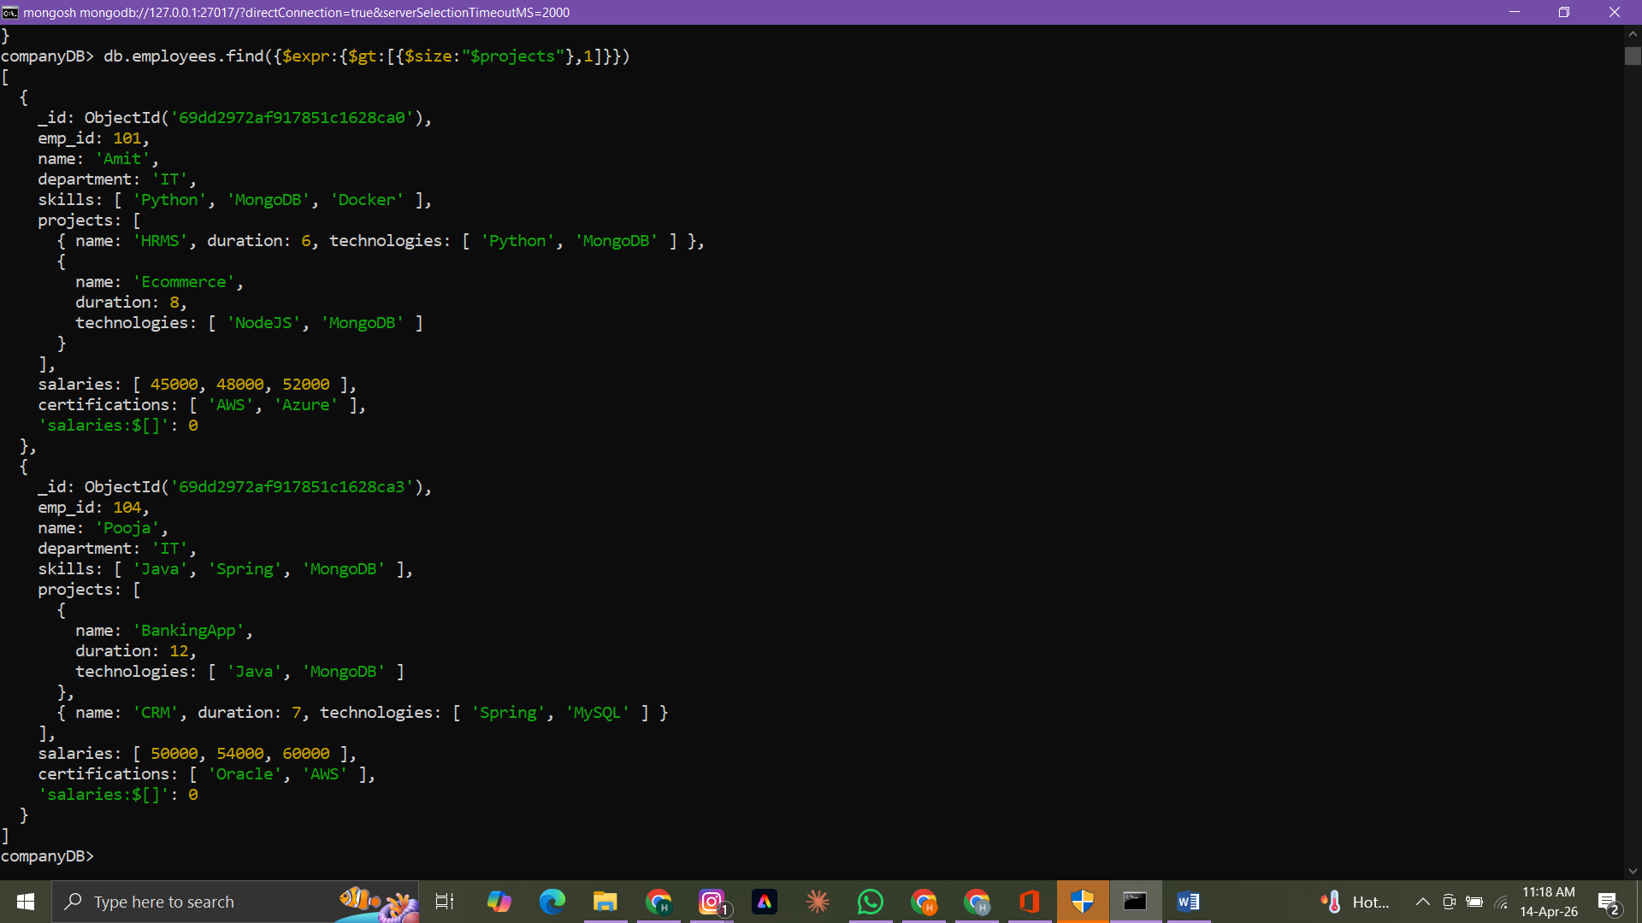

- Count employees per skill

Not covered

- Find employees whose all projects use MongoDB
Not covered

