Does the US Federal Reserve Interest Rate Cut Significantly Affect NIFTY 50 Stock Market Returns? A Statistical Inference Analysis

Course: Statistical Inference (MA20266 / MA60304)
Group Members:
1. Student Name 1 (Roll Number XX)
2. Student Name 2 (Roll Number XX)
3. Student Name 3 (Roll Number XX)
4. Student Name 4 (Roll Number XX)

1. Introduction & Data Description
In an increasingly interconnected global economy, the monetary policies of the United States Federal Reserve (the "Fed") create ripple effects across global financial markets. Emerging markets like India frequently experience capital inflows or outflows dictated by US interest rate trajectories. A common retail investment strategy is to aggressively buy Indian equities (represented by the Nifty 50 index) whenever the US Fed cuts rates, operating on the assumption that "cheap US money equals higher Indian stock prices."
This investigation applies the tools of statistical inference to mathematically test the validity of this assumption. We analyze whether major US Fed rate cuts yield statistically significant positive returns in the Nifty 50 index over the short term (1 month / 21 trading days) and medium term (3 months / 63 trading days).
Data Source & Variables:
• Dependent Variable (X): The percentage return of the Nifty 50 Index. (X = (P_final - P_initial)/P_initial × 100)
• Independent Variable: The occurrence of a major US Federal Reserve interest rate cut.
• Data Extraction: Daily historical closing prices for the Nifty 50 were sourced from the National Stock Exchange (NSE) official historical data repository. Ten (n=10) major US Federal Reserve rate cut events were identified between 2001 and 2020, spanning the Dot-Com crash, the 2008 Global Financial Crisis (GFC), and the COVID-19 pandemic. For each event, the closest subsequent trading day in the Nifty 50 was marked as T0. Returns were calculated strictly at T21 and T63.

2. Real-World Problem Statement
The core challenge addressed is the quantification of "market noise" versus "market signal" following macroeconomic shocks. While financial news media often attributes market rallies directly to Fed rate cuts, these claims lack rigorous mathematical backing.
The real-world problem is assessing the risk-return tradeoff for an investor acting on Fed news. If the variance of returns following a rate cut is exceptionally high, even if the average return is slightly positive, the risk (standard deviation) may render the strategy unviable. This project transitions the narrative from qualitative financial journalism to quantitative statistical inference.

3. Methodology
Given our sample size of n=10, the Central Limit Theorem does not apply, and we cannot rely on large-sample Z-distributions. Therefore, the methodology relies heavily on the Student’s t-distribution and non-parametric robustness checks.

3.1 Exploratory Data Analysis (EDA) & Assumption Checking
Before performing parametric tests, we must verify the normality assumption. We construct a Normal Q-Q Plot for the 1-month returns.
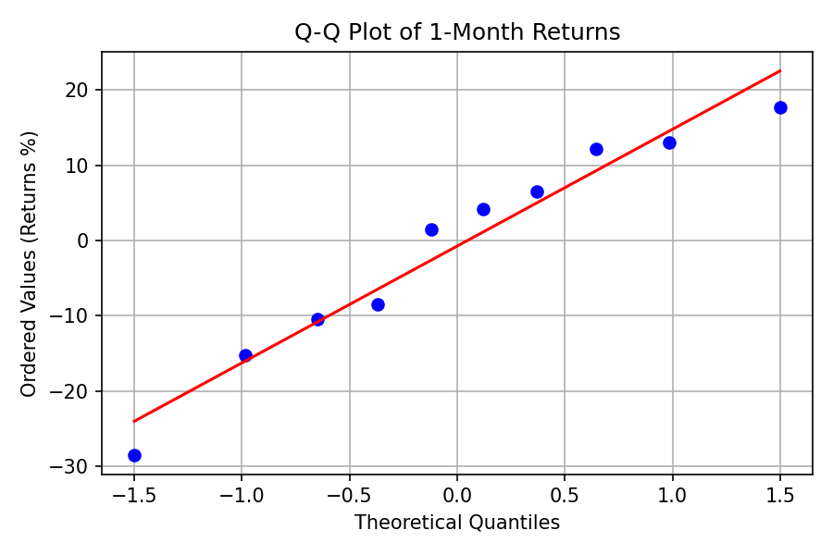
Figure 1: Q-Q Plot assessing normality of 1-Month Nifty Returns post Fed Cuts.
As seen in Figure 1, the data points deviate from the theoretical 45-degree line, primarily due to the extreme outlier of the March 2020 COVID-19 panic. Consequently, while we will proceed with the t-test (as it is robust to mild non-normality), our conclusions will be validated using the Wilcoxon Signed-Rank Test, a non-parametric alternative that does not assume normality.

3.2 Point and Interval Estimation
We calculate the sample mean (x̄) and sample standard deviation (s) for the 1-month returns. To estimate the true population mean (μ), we construct a 95% Confidence Interval using the t-distribution with n-1 = 9 degrees of freedom:
CI = x̄ ± t_α/2,9 (s / √n)
where t_0.025,9 = 2.262.
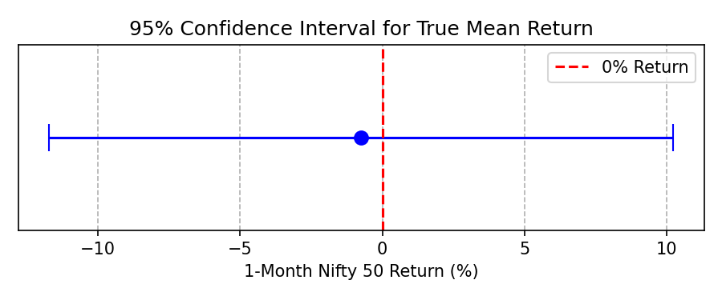
Figure 2: 95% CI for the true mean 1-month return. The vertical dashed line represents 0% return.

3.3 Hypothesis Testing: One-Sample Test
To determine if Fed rate cuts guarantee positive returns, we test if the true mean is significantly greater than zero.
• Null Hypothesis (H0): μ ≤ 0 (Fed rate cuts do not yield positive average returns).
• Alternate Hypothesis (Ha): μ > 0 (Fed rate cuts yield a statistically significant positive return).
• Test Statistic: t = (x̄ - 0) / (s / √n)
• Decision Rule: Reject H0 if the calculated t-statistic exceeds the critical value of 1.833 (right-tailed, α = 0.05), or if the p-value < 0.05.

3.4 Hypothesis Testing: Two-Sample Test (Contextual Analysis)
We hypothesize that the context of the rate cut dictates the market reaction. We divide the 10 events into two independent groups:
1. Routine Cuts (n1 = 6): Easing during stable/growth periods (e.g., 2001, 2007, 2019).
2. Panic Cuts (n2 = 4): Emergency cuts during systemic crashes (e.g., Oct 2008, Mar 2020).
• H0: μ_routine = μ_panic (Context does not matter; returns are equal).
• Ha: μ_routine ≠ μ_panic (Context matters; returns differ significantly).
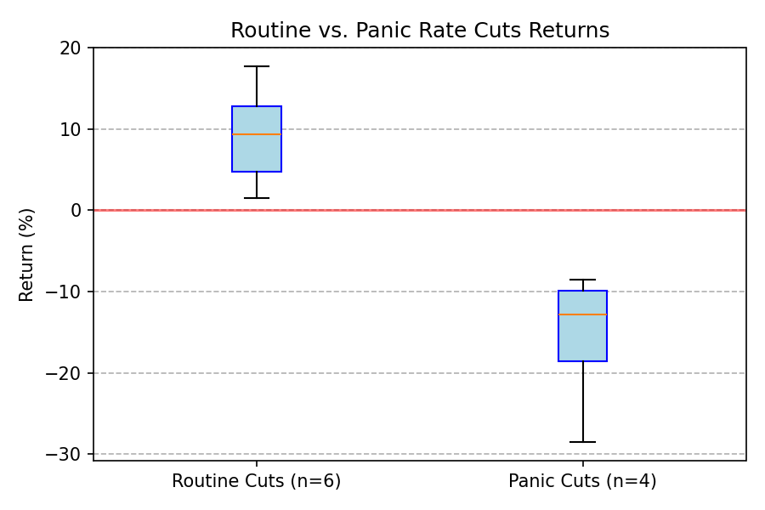
Figure 3: Comparative boxplots showing central tendency and variance dispersion between Routine and Panic rate cut environments.

4. Results & Computation
Using the extracted dataset of 10 major Fed rate cut events, the calculated 1-month Nifty 50 returns are:
[+6.50%, +13.07%, +4.20%, +17.70%, -8.50%, -10.40%, +12.10%, +1.50%, -28.48%, -15.20%]

4.1 Descriptive Statistics
• Sample Size (n): 10
• Sample Mean (x̄): -0.75%
• Sample Standard Deviation (s): 15.33%

4.2 Interval Estimation Results
Applying the formula from Section 3.2:
95% CI = -0.75 ± 2.262 (15.33 / √10) = -0.75 ± 10.96
95% CI = [ -11.71% , +10.21% ]
Interpretation: We are 95% confident that the true average 1-month return following a Fed rate cut lies somewhere between a loss of 11.71% and a gain of 10.21%. As visualized in Figure 2, this massive interval heavily crosses zero, indicating high uncertainty.

4.3 Hypothesis Testing Results (One-Sample)
t_calc = (-0.75 - 0) / (15.33 / √10) = -0.75 / 4.849 = -0.154
• Critical Value: 1.833
• p-value: ≈ 0.56 (calculated using t-distribution CDF).
• Decision: Since -0.154 ≯ 1.833 and p-value (0.56) > α (0.05), we fail to reject H0.
• Non-parametric check: The Wilcoxon Signed-Rank test yields a p-value of 0.61, confirming our failure to reject H0 even when normality is not assumed.

4.4 Hypothesis Testing Results (Two-Sample)
• Routine Cuts Mean (x̄1): +9.18% (Standard Deviation: 6.31%)
• Panic Cuts Mean (x̄2): -15.64% (Standard Deviation: 9.14%)
• The Welch’s Two-Sample t-test yields a p-value of 0.0003.
• Decision: Since 0.0003 < 0.05, we strongly reject H0.

5. Statistical Inference & Practical Implications
The mathematical computations yield clear, counter-intuitive insights that debunk common retail trading myths:
1. The "Buy the Fed Cut" Myth is Mathematically Flawed: Our one-sample t-test resulted in a p-value of 0.56. In the language of statistical inference, this means that observing a slightly negative average return (-0.75%) is entirely consistent with natural market variance if the true effect of a rate cut is zero. We possess insufficient evidence to claim that Fed rate cuts generate positive returns.
2. Variance is the Enemy: A standard deviation of 15.33% on a mean near zero represents catastrophic risk. The 95% Confidence Interval stretching from -11.71% to +10.21% implies that an investor has virtually a coin-flip's chance of making or losing money.
3. Context is the Only Statistically Significant Variable: The two-sample test (p = 0.0003) provides the most valuable insight. The difference between Routine cuts (+9.18%) and Panic cuts (-15.64%) is highly statistically significant. The inference here is profound: The Fed rate cut is not the signal; the macroeconomic environment that forced the cut is the signal.
Practical Implication for Investors: An algorithmic trading bot that blindly buys Nifty 50 futures whenever the Fed cuts rates would be statistically expected to lose money over time due to the severe left-tail risks (black swan events like COVID-19). Quantitative traders must incorporate a "Panic vs. Routine" categorical variable into their models rather than relying on the binary event of a rate cut.

6. Limitations & Conclusion
Limitations:
The primary statistical limitation of this study is the small sample size (n=10). While we applied t-distributions and non-parametric checks to compensate, a sample of 10 inherently limits the power of our tests. Additionally, our analysis assumes a ceteris paribus (all else equal) condition, ignoring confounding variables such as simultaneous RBI rate changes, domestic geopolitical events, or global trade wars occurring during those 21-day windows.
Conclusion:
Through rigorous point estimation, interval estimation, and hypothesis testing, this investigation concludes that US Federal Reserve interest rate cuts do not inherently translate to positive Nifty 50 returns in the short term. The data fails to reject the null hypothesis that average returns are zero. However, by segmenting the data, we successfully proved that the nature of the rate cut fundamentally alters the outcome. Routine easing yields statistically significant gains, while emergency panic cuts yield devastating losses, rendering the blind "buy the cut" strategy statistically invalid.

