**Experiment 08: Mouse Interfacing**

**Learning Objective**: Student should be able to Develop program to interface mouse driver.

**Tools:** TASM/MASM

**Theory:**

**Interface mouse using Int 33H**

**Int 33h MS Mouse Interrupt**

**Function 0 Reset**

Input

AX = 0

Output

AX = mouse status -1 = installed

0 = not installed

BX = number of buttons

**Function 1 Show Mouse Cursor**

Input

AX = 1

Output

NONE

**Function 2 Hide Mouse Cursor**

Input

AX = 2

Output

NONE

**Function 3 Get Mouse Position & Button Status**

Input

AX = 3

Output

BX = Button Status

xxxx xxxx xxxx xMRL

M=middle (if present) R=right L=left

0= not pressed 1 = pressed

CX = Horizontal Mouse Cursor Position

DX = Vertical Mouse Cursor Position

(div positions by 2 for med res

graphics; div by 8 for text mode)

**Function 4 Set Mouse Cursor Position**

Input

AX = 4

CX = new horizontal cursor position

DX = new vertical cursor position

Output

NONE

**Function 5 Get Button Press Information**

Input

AX = 5

BX = button of interest (0=L; 1=R; 2=M)

Output

AX = button status (current status of ALL buttons)

BX = number of buutton presses on specified button

CX = horizontal position at last press

DX = vertical position at last press

**Function 6 Get Button Release Information**

Input

AX = 6

BX = button of interest (0=L; 1=R; 2=M)

Output

AX = button status (current status of ALL buttons)

BX = number of buutton presses on specified button

CX = horizontal position at last release

DX = vertical position at last release

**Function 7 Set Minimum and Maximum X Position**

Input

AX = 7

CX = new minimum horizontal cursor position

DX = new maximum horizontal cursor position

Output

NONE

**Function 8 Set Minimum and Maximum Y Position**

Input

AX = 8

CX = new minimum vertical cursor position

DX = new maximum vertical cursor position

Output

NONE

**Function 9 Define Graphics Cursor**

Input

AX = 9

BX = horizontal cursor hot spot (0,0) upper left

CX = vertical cursor hot spot

ES:DX = address of screen and cursor mask

Output

NONE

**Application:** Use of Int 33 H to interface mouse with system.

**Design:**

**Result and Discussion:**

**Code:**

.MODEL SMALL

.STACK

.DATA

M1 DB 10,13,"MOUSE DRIVER PRESENT$"

.CODE

DISP MACRO XX

MOV AH,09

LEA DX,XX

INT 21H

ENDM

.STARTUP

MOV AX,0000 ;MOUSE DRIVER PRESENT OR NOT

INT 33H

; IF AX CONTAINS NON ZERO VALUE THEN MOUSE DRIVER PRESENT

CMP AX,00

JE LAST

DISP M1

MOV AX,0004H ;MOUSE CURSOR POSITION

MOV CX,5 ;HORIZONTAL POSITION

MOV DX,5 ;VERTICAL POSITION

INT 33H

MOV AX,0007H ;SET HORIZONTAL LIMIT

MOV CX,0005H ;MIN X COORINATE

MOV DX,0010H ; MAX X COORINATE

INT 33H

MOV AX,0008H ;SET VERTICAL LIMIT

MOV CX,0005H ;MIN Y COORINATE

MOV DX,0010H ; MAX Y COORINATE

INT 33H

PIXEL:

MOV AX,0001 ;

INT 33H

MOV AX,0003; GET STATUS OF MOUSE BUTTON

INT 33H

; RESULT OF MOUSE STATUS IS RETURNED IN BX

CMP BX,01; LEFT BUTTON IS PRESSED

JE LEFT

JMP RIGHT ; RIGHT BUTTON CLICKED

LEFT:

MOV AX,0011H ; SETTING GRAPHICS MODE TO SHOW PIXEL ON LEFT CLICK

INT 10H

;MOV AX,0003

;INT 33H

MOV AH,0CH ;

INT 10H

RIGHT:

;MOV AX,0001

;INT 33H

CMP BX,02

JE LAST

JMP PIXEL

LAST:

MOV AX,00

INT 10H

.EXIT

END

**Output:**

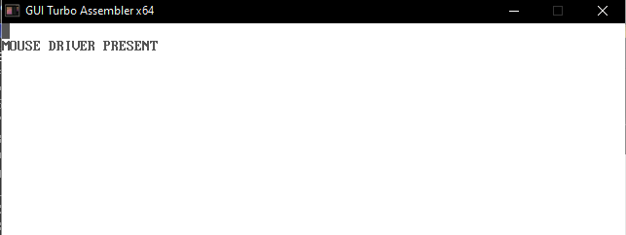

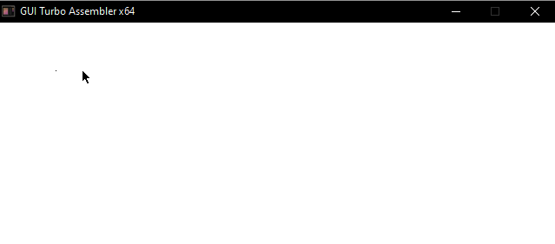

**Learning Outcomes:** The student should have the ability to

|  |
| --- |
| LO 9.1: Compare DOS and BIOS interrupts. |
| LO 9.2: Develop an application for Mouse interfacing using INT 33H. |
| LO 9.3: Develop an application for keyboard and Printer interfacing  using INT 09H and INT 05H respectively. |

**Course Outcomes**: Upon completion of the course students will be able to make use of instructions of 8086 to build assembly and Mixed language programs.

**Conclusion:** A system to Interface mouse using Int 33h is designed successfully.

**Viva Questions:**

1. Which interrupt used for mouse interfacing?

For Faculty Use

|  |  |  |  |  |
| --- | --- | --- | --- | --- |
| **Correction Parameters** | **Formative Assessment [40%]** | **Timely completion of Practical [ 40%]** | **Attendance / Learning Attitude [20%]** |  |
| **Marks Obtained** |  |  |  |