**Dataset used: Shrew**

**Name: Himanshu Gupta**

**Student Number: 18203712**

**Name: NA**

**Student Number: NA**

**Date of Submission: 21st June, 2019**

**Procedures for Submission and Late Submission**

Submit this assignment using the safeAssign link in the Assessments folder on Blackboard. You should also submit the R scripts that you have developed for the analysis via the separate link in the Assessments folder on Blackboard

**This report and the associated R scripts can be written and submitted with your study partner. If you wish you can submit an individual assignment.**

**Note**: There are penalties for the late submission of assessments. For further information please see the University’s *Policy on Late Submission of Coursework,* (<http://www.ucd.ie/registry/academicsecretariat/late_sub.pdf>)

[**Plagiarism**](http://www.ucd.ie/library/supporting_you/support_learning/plagiarism/) is a form of academic dishonesty. In any assignment, plagiarism means that you have presented information or ideas belonging to someone else falsely as being your own original thoughts on a subject. The penalties associated with plagiarism reflect the seriousness of the University’s commitment to academic integrity.

Ensure that you have read the University’s [Briefing for Students on Academic Integrity and Plagiarism](http://www.ucd.ie/registry/academicsecretariat/plag_brief.pdf) and the University’s [Plagiarism Statement, Plagiarism Policy and Procedures](http://www.ucd.ie/registry/academicsecretariat/plag_pol_proc.pdf), (more information at <http://www.ucd.ie/registry/academicsecretariat/info_stud.htm>)

**Declaration of Authorship**

I declare that all material in this thesis is my own work except where there is clear acknowledgement and appropriate reference to the work of others.

Name: Himanshu Gupta Name: NA

Date: 21st june, 2019

Sexual Dimorphism in Greater White Toothed Shrews

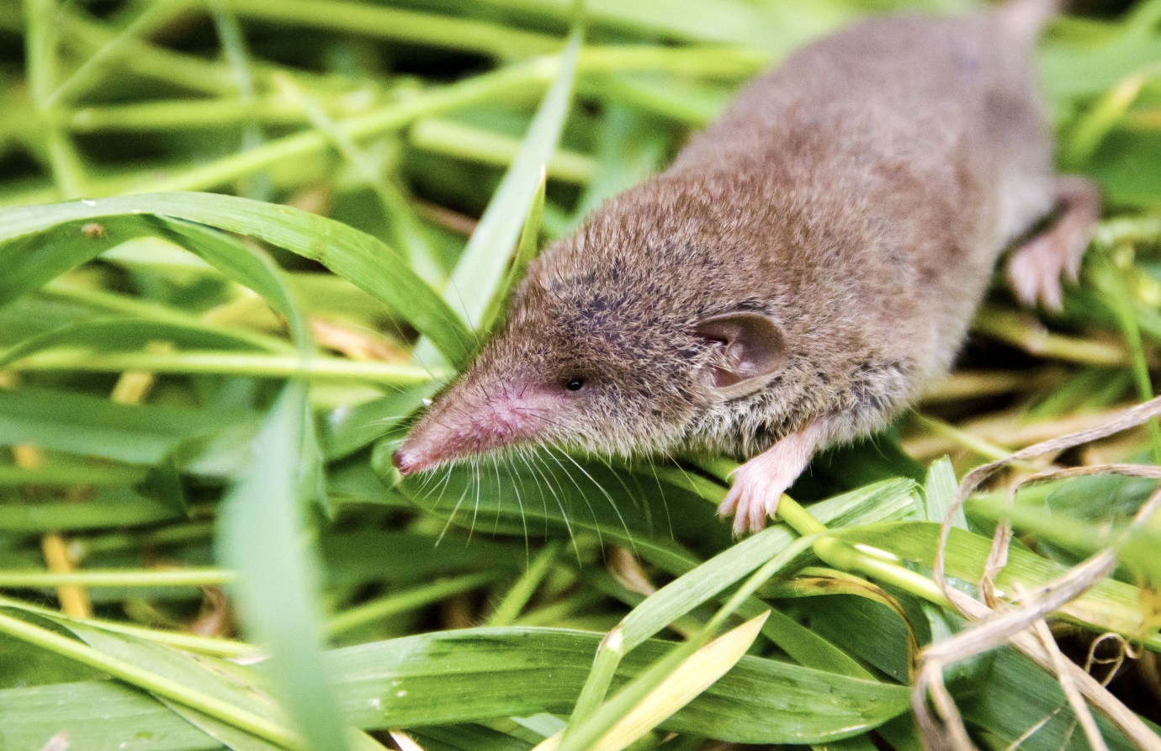**Part 1**

**Methods**

The file containing data regarding the maturity, sex and weight of greater white toothed shrews caught in and around a village in the Swiss Alps was pre-processed in excel to remove invalid values and homogenize the data. The statistical analysis on this data was carried out in analysed RStudio 1.1.463.

General linear modelling approach was used to test the hypothesis H1: the average weight of male shrews is different from average weight of female shrews, H2: the average weight of adult male shrews is different from adult female shrews and H3: the average weight of juvenile male shrews is different from juvenile female.

The validation of the models to test homogeneity of variance and normality was carried out using residual vs fitted values plots. Boxcox transformation with appropriate values of lambda was used to satisfy homogeneity of variance and normality where required.

**Results**

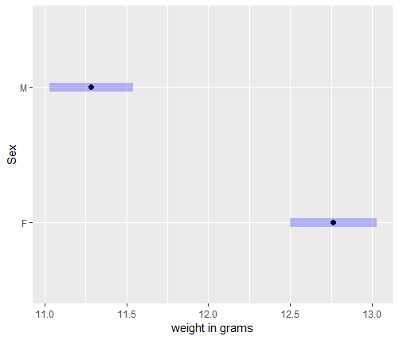

Fig 1. Mean weight in grams for male and female shrews. Error bars show 95% confidence level.

On average, the power transformed weight of female shrews was found to be higher than that of male shrews (F1,787  = 62.52, p = 8.89e-15). The average weight of female shrews was found to be 12.80 ± 0.13 grams while that of males was found to be 11.30 + 0.13 grams as shown in figure 1. This leads to the conclusion that the greater white toothed shrews show sexual dimorphism in body weight.

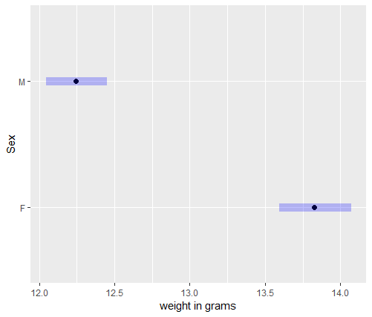

Fig 2. Mean weights of adult male and female shrews. Error bars show 95% confidence level.

The reciprocal transformed average weights of females were found to be higher than that of males (F1,530 = 99.07, p = 2.2e-16). The average weight of females was found to be 13.80 ± 0.12 grams and that of males was found to be 12.20 ± 0.10 grams as shown in figure 2.

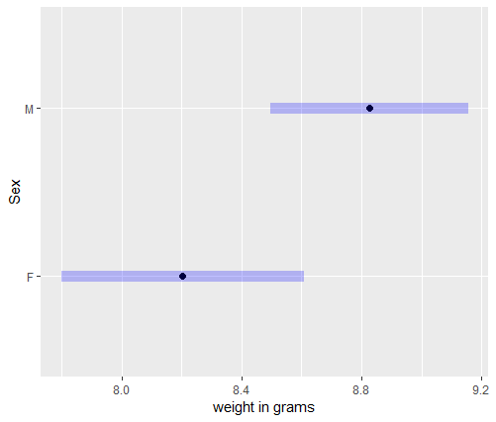

Figure 3. Mean weight of juvenile male and female shrews. Error bars show 95% confidence level.

The average weight of juvenile male shrews was higher than the average weight of juvenile female shrews (F1,131 = 5.60, p = 0.02). The average weight of juvenile male shrews was found to be 8.83 ± 0.16 grams and that of female shrews was found to be 8.20 ± 0.20 grams as shown in fig 3.

According to the results, the average weight of males is higher than females in juveniles, whereas in adults the average weight of females if higher than males. This means that the pattern of sexual dimorphism differs between adult and juvenile greater white toothed shrews.

**Part 2**

**Validity**

The validation of homogeneity of variance and normality was performed using the residual vs fitted plots and quantile-quantile plots respectively. The residual vs fitted plot show that the spread of the residuals is roughly the same for both males and females, for the power transformed datasets of all shrews (Fig 4) and only adult shrews (Fig 5), which validates the homogeneity of variance assumption of the respective general linear models m1 and m1_ad fitted to these datasets. The quantile-quantile plots for the m1 and m1_ad do not show much curvature and most points lie on a straight line which validates the normality assumption of general linear modeling.

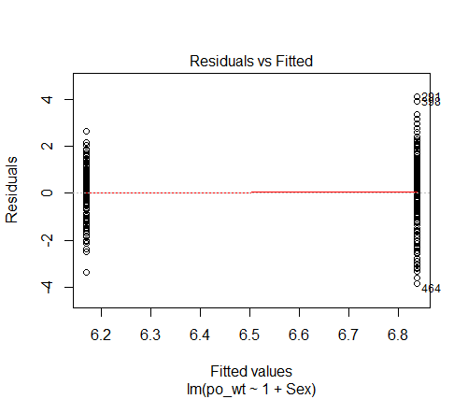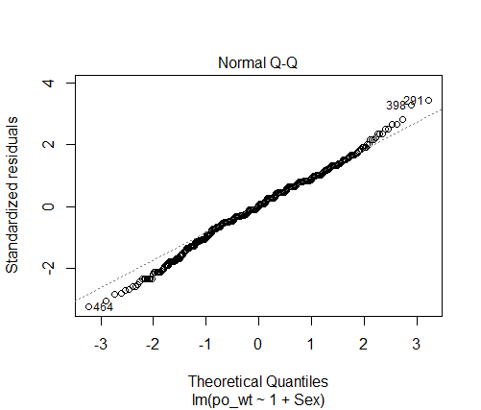

Fig 4. Resduals vs Fitted plot and quantile-quantile plot of the linear model m1: po_wt = µsex + Normal (0,σ) for all shrews where po_wt is boxcox transformed weight with λ = 0.68.

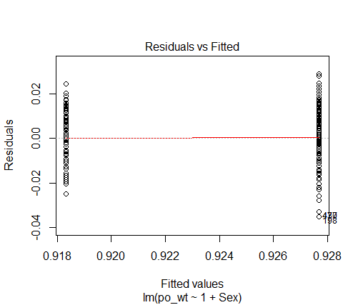 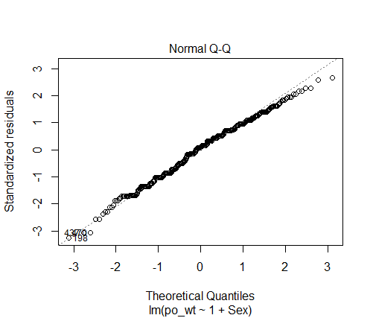

Fig 5. Resduals vs Fitted plot and quantile-quantile plot of the linear model m1_ad : po_wt = µsex + Normal (0,σ) for adult shrews where po_wt is boxcox transformed weight with λ = -1.

For the general linear model m_juv fitted to the juvenile shrew data, the residual vs fitted plot showed roughly equal spread and most points of the quantile-quantile plot lie on the straight line. Hence, a boxcox transformation was not required.

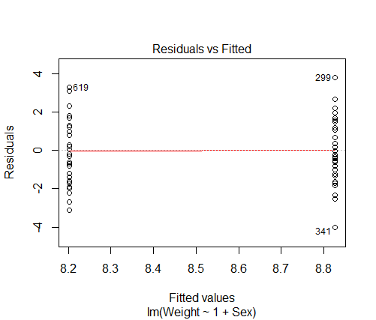 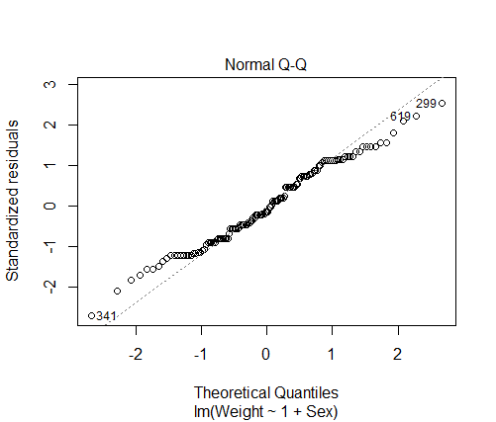

Fig 6. Residuals vs Fitted plot and quantile-quantile plot of the linear model m_juv : Weight = µsex + Normal (0,σ) for juvenile shrews.

The p values obtained for the general linear models m1, m_ad and m_juv were 8.89e-15, 2.2e-16 and 0.02 respectively. These p values are well below the critical significance level of 0.05. Hence, the analyses provide strong evidence to prove that greater white toothed shrews show sexual dimorphism in weight and the pattern of sexual dimorphism differs between adults and juveniles.

**Part 3**

**Follow Up Study**

A follow up study with the objective of finding out if the greater white toothed shrews show sexual dimorphism in weight in winter. The collection of data will take place during two sessions – one in October-November and one in December-January - in the same location and area where the previous collection was carried out. The factor class is nested within the class session and the factor sex is nested within the factor class. Sex and class are fixed factor while session is a random factor.

In the previous experiment, the number of replicates for adults (549) and juveniles (135) had a big difference of 414. To ensure a balanced design, the number of replicates for each class (adult, juvenile) for this experiment will be approximately equal and shrews for which it cannot be decided whether they are adults or juveniles (ad/j) will be excluded from the dataset.

It is possible that the adults may have an effect on the weight of juveniles in an area or vice versa. Hence, to ensure independence it is important to carry out an analysis of correlation between weights of adult shrews and juvenile shrews. Since both the weight of adults and juveniles are quantitative variables pearson correlation coefficient will be used.

A similar methodology will be used as in the first experiment. General linear model will be fitted to the shrew data collected with weight of the shrews as response variable and sex as the explanatory variable and validity of the models will be tested using quantile-quantile plot and residual vs fitted plot.