|  |
| --- |
| Himanshu Banodha  June 26, 2024 |

|  |  |
| --- | --- |
| iNeuron.ai | |
| Insurance Premium Prediction |
| **Wireframe Documentation** | |

1. The first page displays the form where the user has to provide the specific details such as Age, Gender, BMI, Number of Children etc.

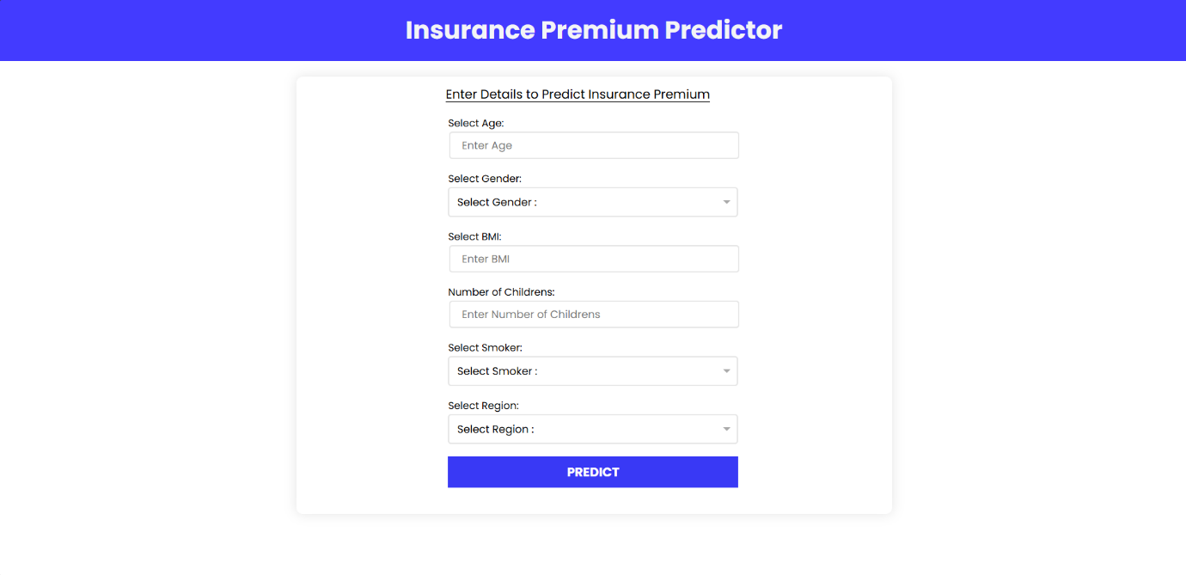

1. After entering all the required data, when the user clicks on predict button, we will show the premium on the same page.

