Job Hunter
Local Job-Hunting Dashboard — Architecture & API Reference
React (Vite) front end · Node.js + Express back end · June 2026
Contents

1. Overview
Job Hunter is a fast, fully local job-hunting dashboard. It aggregates live software-engineering openings from public company job boards and LinkedIn, filters them to core software-engineer roles in a chosen location and experience window, scores roles against the user’s résumé, and links straight to each company’s apply portal. Everything runs on the user’s machine with no API keys, database, or sign-up.
The application is split into two processes: a React + Vite front end (UI, port 5173) and a Node.js + Express back end (REST API, port 5179). In development the Vite dev server proxies /api requests to the back end.

Key capabilities
- Resolve a company name to its live job board (Greenhouse, Lever, Ashby, SmartRecruiters, Workday, Avature) or detect it from the company’s own career site.
- Filter to core software-engineering IC roles (SWE / SDE / MTS / Computer Scientist), excluding test, management, and hardware roles.
- Read the real years-of-experience from each job description (fetched on demand) instead of guessing from the title.
- India-first location matching with a one-click “Bangalore only” toggle (matches both Bangalore and Bengaluru).
- Exclude IT-services / consulting / staffing firms via a blocklist across every tab.
- Score each role against the user’s résumé (skill overlap + breadth + title + experience fit).
- A weekly digest of fresh (last-7-day) roles across all companies plus LinkedIn.

2. Technology Stack
Layer | Technology
Front end | React 18, Vite 5 (dev server + build), plain CSS (dark theme)
Back end | Node.js 22, Express 4
HTTP / parsing | axios (REST + Workday/Avature detail), cheerio (LinkedIn & Avature HTML)
Caching | In-process Map caches (no external store)
Data sources | Greenhouse, Lever, Ashby, SmartRecruiters, Workday, Avature, LinkedIn guest search
Dev workflow | npm workspaces; concurrently runs UI + API together

3. High-Level Architecture
At a high level the system is a four-tier pipeline. The browser loads the React single-page app, which is organised into five tabs. Every data request goes through the Vite proxy to the Express API, which applies caching, filtering and scoring before calling the relevant external job board and returning normalised JSON.
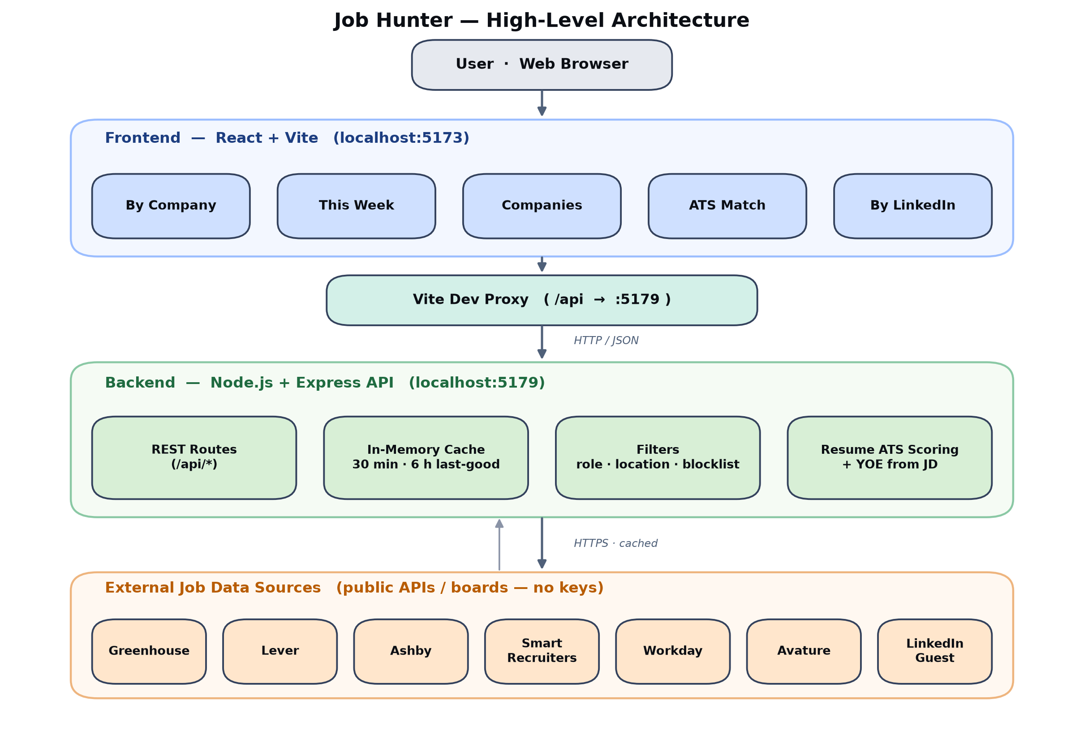
Figure 1 — High-level architecture: browser → React UI → Vite proxy → Express API → external job boards.

Layers
- Frontend (React + Vite, :5173) — five tabs: By Company, This Week, Companies, ATS Match, By LinkedIn Title.
- Vite dev proxy — forwards /api/* to the back end so the UI and API share an origin in development.
- Backend (Node + Express, :5179) — REST routes, an in-memory cache (30-minute results, 6-hour last-good fallback), role/location/blocklist filters and résumé scoring.
- External data sources — public, key-less ATS APIs and boards, fetched server-side and cached.

4. Low-Level Architecture
Internally the back end is a thin routing layer over a set of focused service modules. The route handlers in index.js orchestrate the service modules; the heavy lifting of resolving a company to a job board lives in ats.js, which contains one adapter per provider plus career-site discovery and on-demand description enrichment.
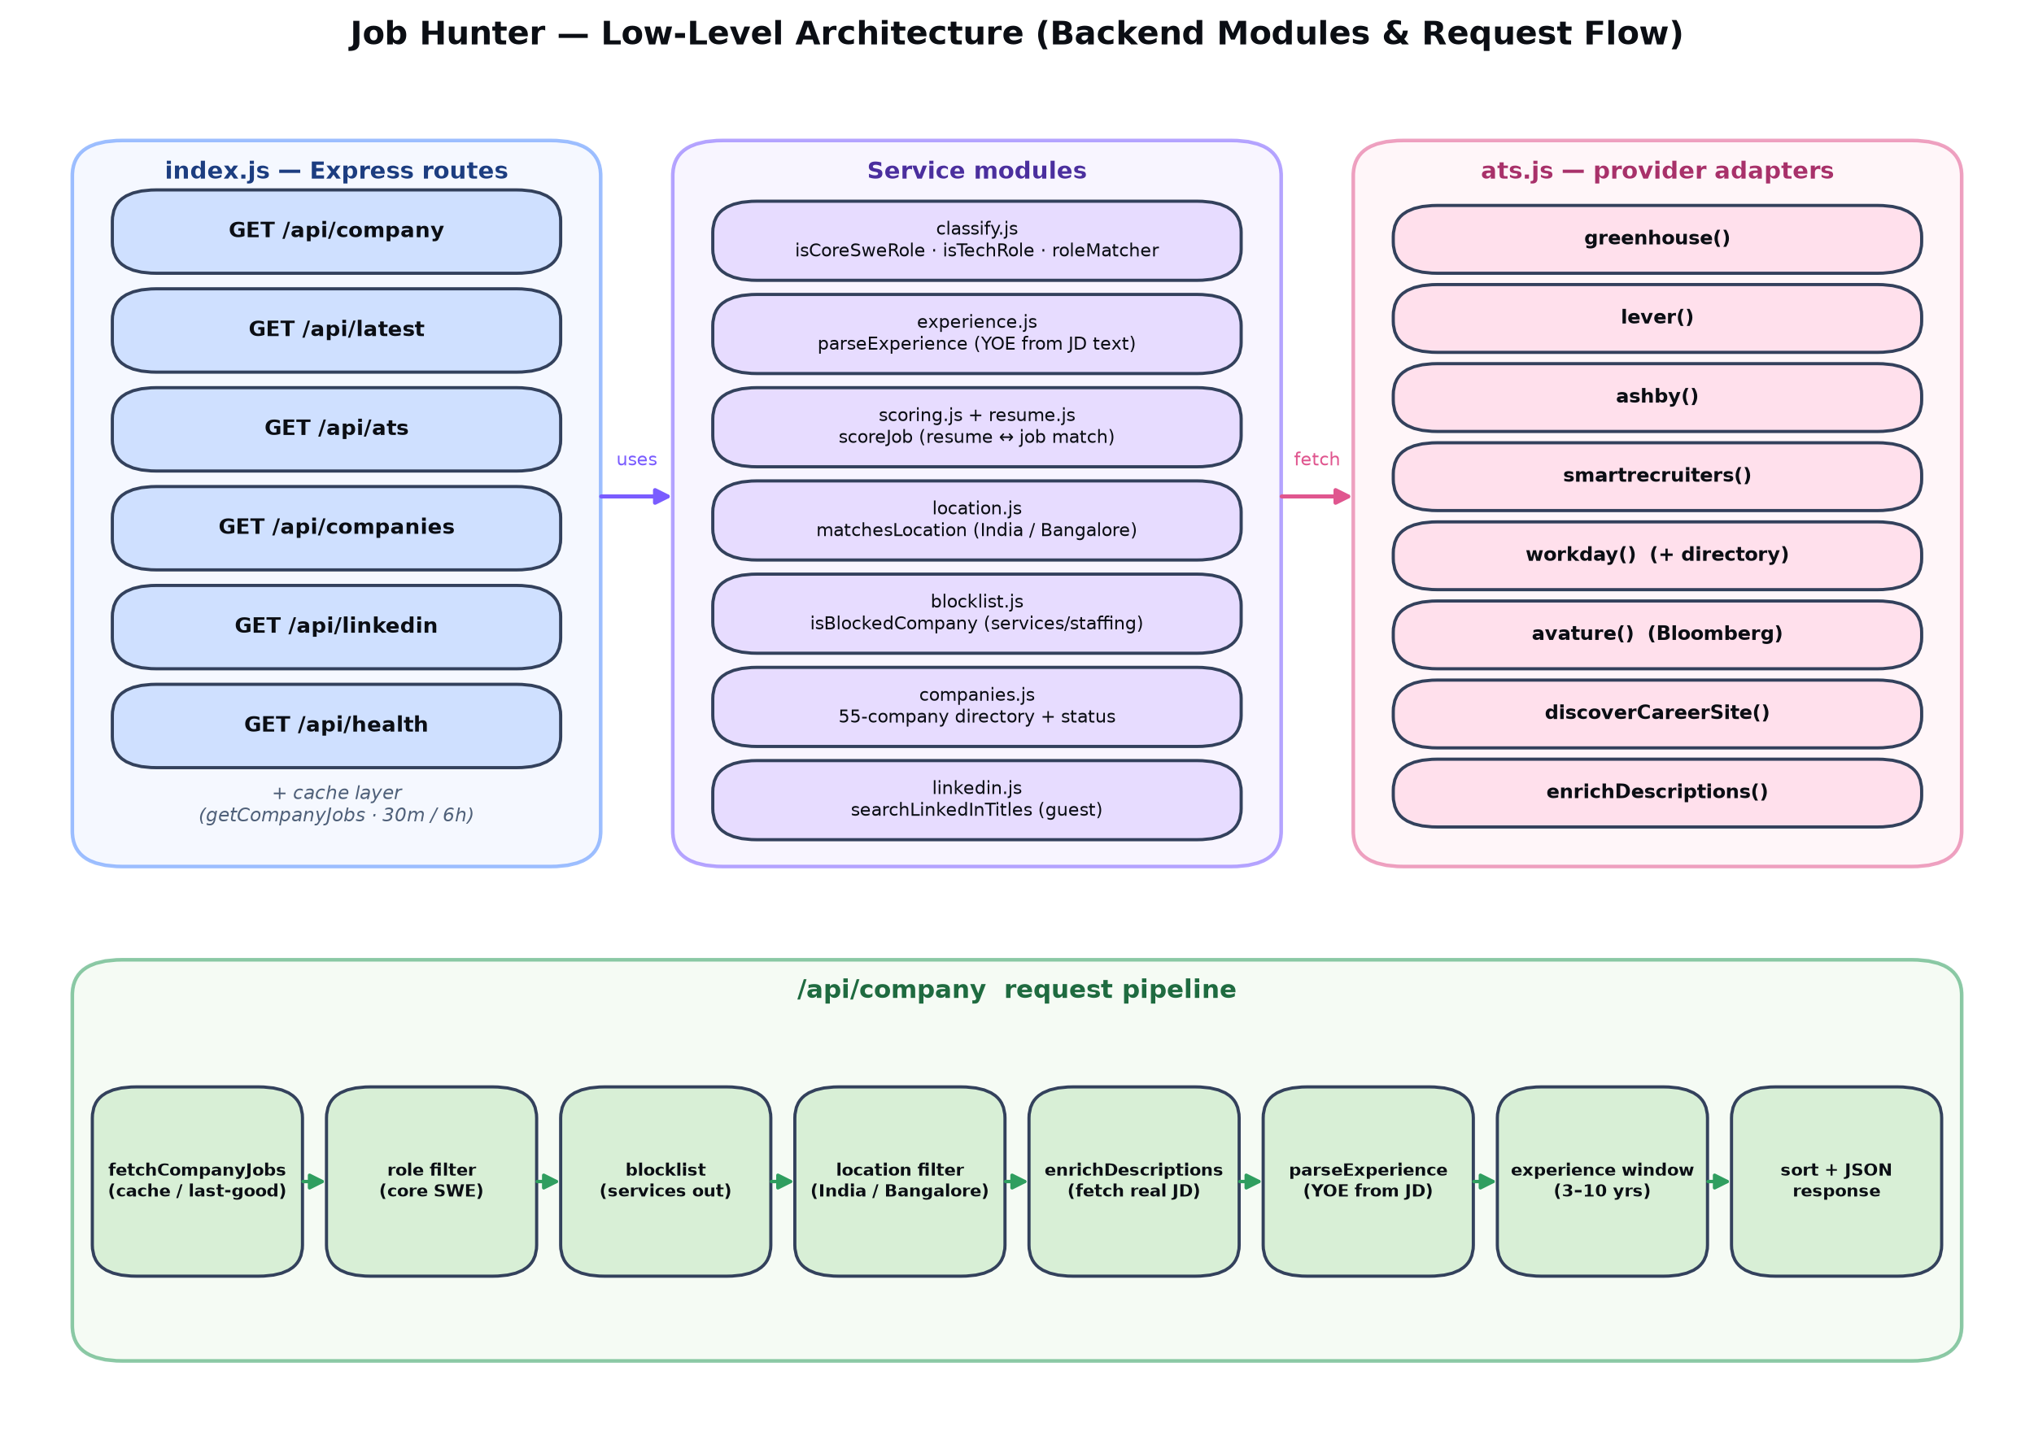
Figure 2 — Low-level architecture: Express routes, service modules, provider adapters, and the /api/company pipeline.

The /api/company request pipeline
A company search flows through the bottom band of Figure 2:
- fetchCompanyJobs — resolve the company to a board and return its jobs (served from the 30-min cache, or the 6-h last-good copy if the upstream is briefly rate-limited).
- Role filter — keep only core software-engineering IC roles (isCoreSweRole).
- Blocklist — drop IT-services / consulting / staffing firms.
- Location filter — India by default, or Bangalore/Bengaluru when the toggle is on.
- enrichDescriptions — fetch the real job description for Workday/Avature/SmartRecruiters postings (Greenhouse/Lever/Ashby already include it).
- parseExperience — read the years-of-experience from the description text; fall back to a clearly-labelled title estimate only when the JD states no number.
- Experience window — keep roles overlapping the 3–10-year range (configurable).
- Sort + JSON — matched-with-experience first, newest next; respond.

5. Backend Modules
Module (server/src) | Responsibility
index.js | Express app: all REST routes, the in-memory cache layer (getCompanyJobs with 30-min + 6-h last-good), and the weekly-digest aggregator.
ats.js | Company → jobs resolution: provider adapters (greenhouse, lever, ashby, smartrecruiters, workday, avature), Workday/Avature directories, career-site discovery, and enrichDescriptions().
classify.js | Role classification: isCoreSweRole, isTechRole, roleMatcher (swe | tech | all).
experience.js | parseExperience — extract years-of-experience from JD text; title-only seniority fallback.
scoring.js | scoreJob — résumé↔job ATS score (skill overlap + breadth + title + experience fit).
resume.js | Parsed résumé profile (skills, years, target titles) used by the scorer.
location.js | matchesLocation — India/Bangalore-aware city matching.
blocklist.js | isBlockedCompany — excludes IT-services / consulting / staffing employers.
companies.js | Seeded 55-company career-site directory with resolved provider + live status.
linkedin.js | searchLinkedInTitles — LinkedIn public guest search + HTML parsing (cheerio).

6. API Endpoints
All endpoints are GET and return JSON. Base URL in development: http://localhost:5179 (proxied from the UI as /api).
Endpoint | Purpose | Key query parameters
GET /api/company | Resolve a company and return its software-engineering roles, with YOE read from the job description. | name · roleFilter · location · min · max · q · includeUnknown
GET /api/latest | Weekly digest: core-SWE roles posted in the last N days across all live companies + LinkedIn. | days · location · includeLinkedIn · pages · refresh
GET /api/ats | Score every role at a company against the stored résumé; returns a ranked match table. | name · location · roleFilter · min · max
GET /api/companies | The seeded 55-company directory with resolved provider, status and career-site URL. | —
GET /api/linkedin | LinkedIn public guest job search across one or more job titles. | titles · location · pages · roleFilter
GET /api/health | Liveness probe. | —

Common parameters
Parameter | Meaning
roleFilter | swe (core software-engineer, default) | tech (all tech) | all (no role filter).
location | Free text; “india” / “bangalore” expand to their cities; empty = anywhere.
min / max | Desired years-of-experience window (default 3–10); a role is kept when its requirement overlaps it.
q | Title keyword filter; for Workday it also drives the board’s own search.
includeUnknown | Whether to keep roles whose description states no experience (default true).

7. External Data Sources
Provider | Access | Notes
Greenhouse | Public JSON board API | Job descriptions included inline; e.g. Stripe, Databricks, Figma, OpenAI.
Lever | Public JSON postings API | Descriptions inline; e.g. Palantir, Mistral AI (via career site).
Ashby | Public posting board API | Descriptions inline; e.g. Snowflake, Cohere, Notion.
SmartRecruiters | Public postings API | Descriptions fetched per posting; e.g. Uber, ServiceNow, Canva.
Workday | CXS jobs API (verified tenant directory) | Title-only list; description fetched per job. Gentle batching + retry to respect rate limits.
Avature | Career board HTML (cheerio) | Bloomberg (bloomberg.avature.net); description fetched per job.
LinkedIn | Public guest job search (HTML) | Title-driven; past-week filter for the weekly digest. Light personal use only.

8. Cross-Cutting Concerns

Caching & resilience
- Company results are cached for 30 minutes; the last successful (non-empty) result is kept for 6 hours and served if a fresh fetch is briefly rate-limited — so a flaky upstream never makes a company look broken.
- The weekly digest is cached for 30 minutes (a full scan takes ~1 minute on a cold cache).
- Workday requests use small batches, inter-batch delays and retry-with-backoff, and detect the “currently unavailable” rate-limit page.
- Job descriptions are cached for 6 hours so the first search per company is the only slow one.

Filtering & scoring
- Role filter excludes test (SDET / “in test”), management, and hardware/silicon roles; recognises vendor titles such as Adobe “Computer Scientist” and “Member of Technical Staff”.
- Years-of-experience is read from the actual JD; estimates from the title are clearly labelled, and roles with no stated number show “YOE not specified”.
- ATS scores blend skill-keyword overlap, skill breadth, title alignment and experience fit, with a confidence flag (high for description-based, low for title-only sources).

9. Running Locally
npm install
npm run dev
This starts the API on :5179 and the UI on :5173. Open http://localhost:5173.

