DICV Alternator — V11.2 Validation Dossier (2026-06-24)

Version: V11.2_ALT | Date: 2026-06-26 | Status: Final

Fleet: 25 trucks (10 failed + 15 non-failed) | Validation: LOVO cross-validation

1. Executive Context
This dossier presents the technical validation of the BharatBenz / DICV alternator predictive-maintenance model to support DICV management's decision on operational deployment. The analysis covers a fleet of 25 trucks (10 failed + 15 non-failed) whose alternators were monitored over an observation window ending in late 2025.
All validation metrics are computed from Leave-One-VIN-Out (LOVO) cross-validation — the model is never scored on data it trained with — providing a conservative, deployment-realistic estimate of performance.
The system is honest about its limits: per-truck timing is uncertain, early-warning channels have limited fleet-wide coverage, and the n=25 data set represents a ceiling on achievable discrimination. These constraints are data-driven, not method-driven.

2. System Recap — Three Operational Boxes
Box | Question | Delivered Value
WHICH — Classifier | Which trucks are highest-risk? | LOVO ranking AUROC 0.9267 (~93%); 139/150 concordant pairs
WHEN-fleet — Replacement window | When to plan fleet replacement? | 601 days / ~120,440 km / ~4,538 engine-hours
WHEN-emergency — Alert channels | Active electrical disturbances? | GED=2 storm: 2/10 failed, 0/15 healthy; Compound: 3/10 failed, 0/15 healthy

3. Heuristic Validation (Task 1)
Eleven engineered signals were assessed individually using Mann-Whitney U AUROC, Cliff's delta effect size, and permutation importance.
Honesty note on the top multivariate feature: `vsi_std_ratio_30d` holds the largest Ridge coefficient (+0.443) and highest permutation importance (0.155) in the multivariate model, yet its univariate AUROC is only 0.693 — MEDIUM separation. Ridge exploits the combination of all six features; in isolation, no single feature approaches the ensemble's 0.927 AUROC.

Heuristic Summary Table
# | Heuristic | Fam | Engineering Meaning | Failed Mean | Healthy Mean | AUROC | Separation | Perm Imp.
1 | vsi_std_ratio_30d | A | late-life voltage scatter vs early-life baseline | 1.1168 | 0.7229 | 0.693 | MEDIUM | 0.1547
2 | vsi_dominant_freq | A | dominant FFT frequency of daily voltage (rhythm vs... | 0.0953 | 0.0147 | 0.650 | SMALL | 0.1053
3 | vsi_spectral_entropy | A | voltage spectrum disorder (clean rhythm vs broadba... | 0.9288 | 0.8964 | 0.813 | STRONG | 0.0573
4 | bat_charge_delta_trend_right | A | trend of cruise-minus-resting voltage (charging he... | 0.0023 | -0.0010 | 0.560 | NEGLIGIBLE | 0.0340
5 | vsi_range_trend_last30d | A | slope of daily voltage min-max range late in life | 0.1235 | -0.0242 | 0.740 | STRONG | 0.0613
6 | progressive_drift | A | cumulative drift of daily voltage from baseline | 0.0955 | 0.7069 | 0.264 | MEDIUM | 0.0480
7 | crank_recovery_t | B | seconds for voltage to recover to 27V after a cran... | 0.4277 | 0.0057 | 0.680 | MEDIUM | 0.6000
8 | vsi_ceiling | B | regulation plateau voltage at high RPM | 28.0665 | 28.1121 | 0.413 | SMALL | 0.2000
9 | vsi_resid_mean | B | voltage residual vs healthy-fleet expected surface | 0.0374 | 0.0858 | 0.373 | SMALL | 0.2000
10 | resting_vsi_mean | B | engine-off resting voltage level | 24.5511 | 24.9392 | 0.293 | MEDIUM | 0.3000
11 | ged_churn | B | rate of GED state-transition churn (excitation ins... | 0.6133 | 0.0000 | 0.600 | SMALL | 0.2000

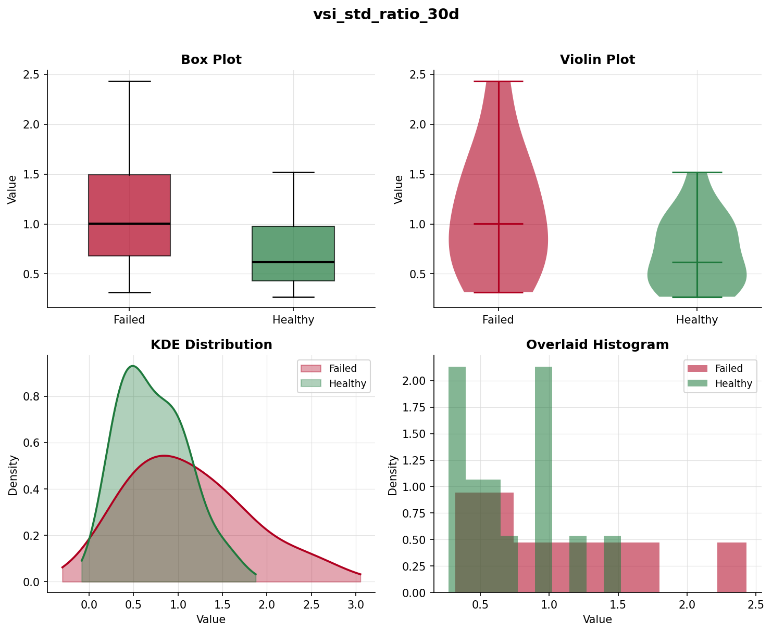
Figure 3.1 — VSI Std Ratio 30d: failed vs healthy distribution
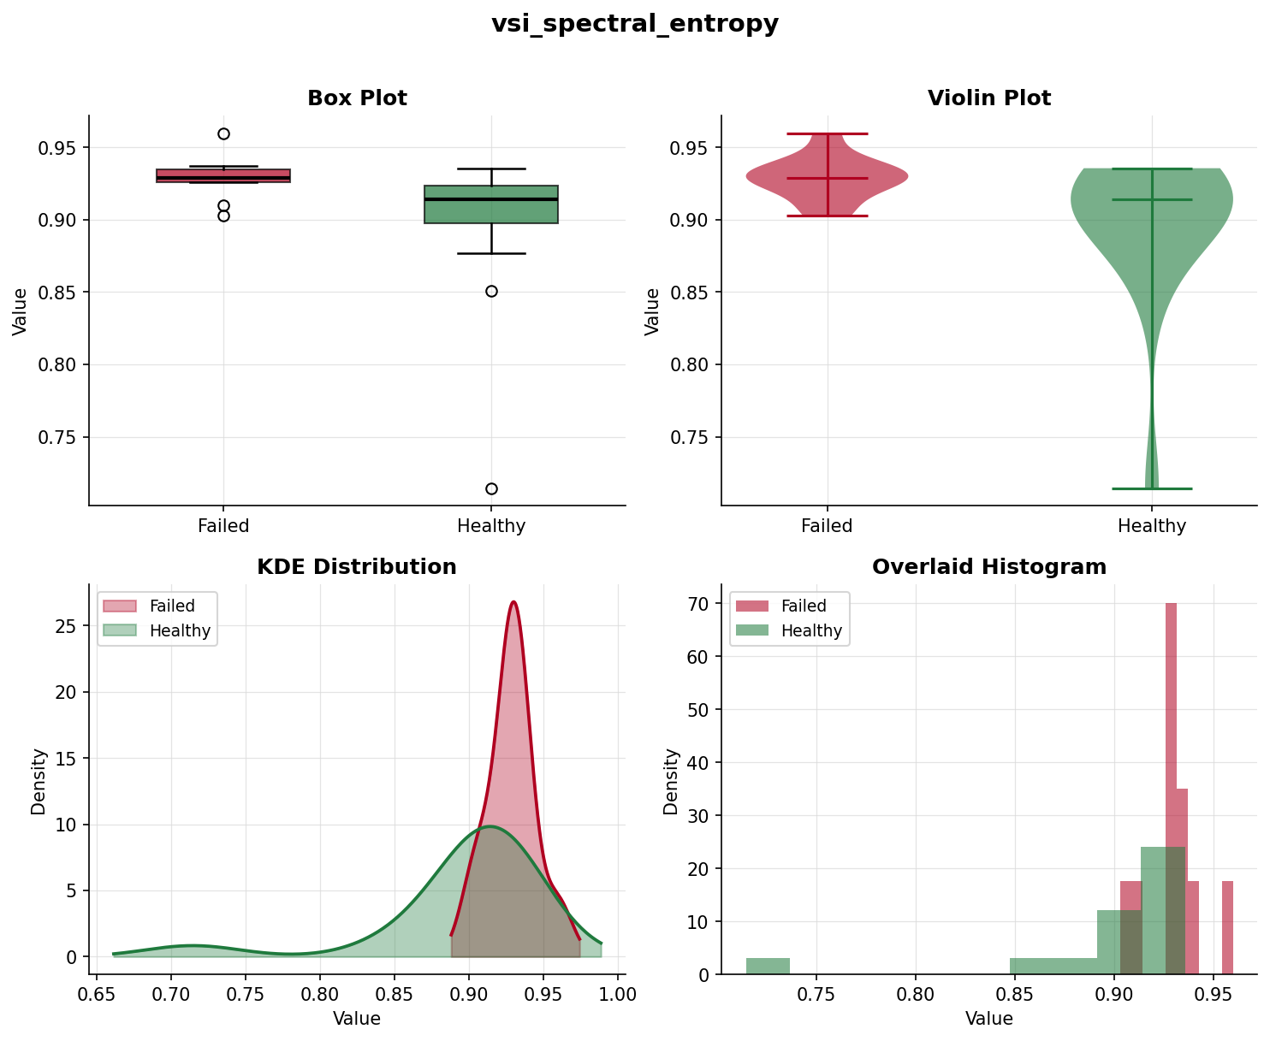
Figure 3.2 — VSI Spectral Entropy: failed vs healthy distribution

4. Weightage & Feature Contribution (Task 2)
The six A-family features are combined via an L2-regularised (Ridge) linear model. Coefficients are on a standardised z-score scale:
Feature | Ridge Coefficient | Mean |Contribution| | Perm Importance
vsi_std_ratio_30d | +0.44257 | 0.34844 | 0.1547
vsi_dominant_freq | +0.42647 | 0.24099 | 0.1053
vsi_spectral_entropy | +0.24470 | 0.13803 | 0.0573
vsi_range_trend_last30d | +0.22990 | 0.13287 | 0.0613
bat_charge_delta_trend_right | +0.22399 | 0.17031 | 0.0340
progressive_drift | -0.20551 | 0.12086 | 0.0480

Compound Vote — Equal Weighting Rationale:
Emergency early-watch uses EQUAL weights: each of 5 channels (vsi_ceiling, vsi_resid_mean, crank_recovery_t, resting_vsi_mean, ged_churn) casts 1 vote; alarm fires at >=2 votes. Weights are deliberately NOT fitted, because at n=10 failure events any learned weighting would overfit; equal voting is the honest, robust choice.

Note on progressive_drift negative coefficient:
progressive_drift has a NEGATIVE Ridge coefficient. This is an exposure artifact: healthy trucks observed for longer accumulate more cumulative drift (healthy fleet mean 0.707 vs failed fleet mean 0.096), creating a spurious direction reversal. The model partially corrects for this via the negative coefficient — effectively penalising trucks with unexpectedly LOW drift relative to their age. The feature has the lowest permutation importance (0.048) and lowest mean absolute contribution in the fleet; it is retained only because the 6-feature set was validated at AUROC 0.927 and removing it would break the frozen V10.5.3 spec.
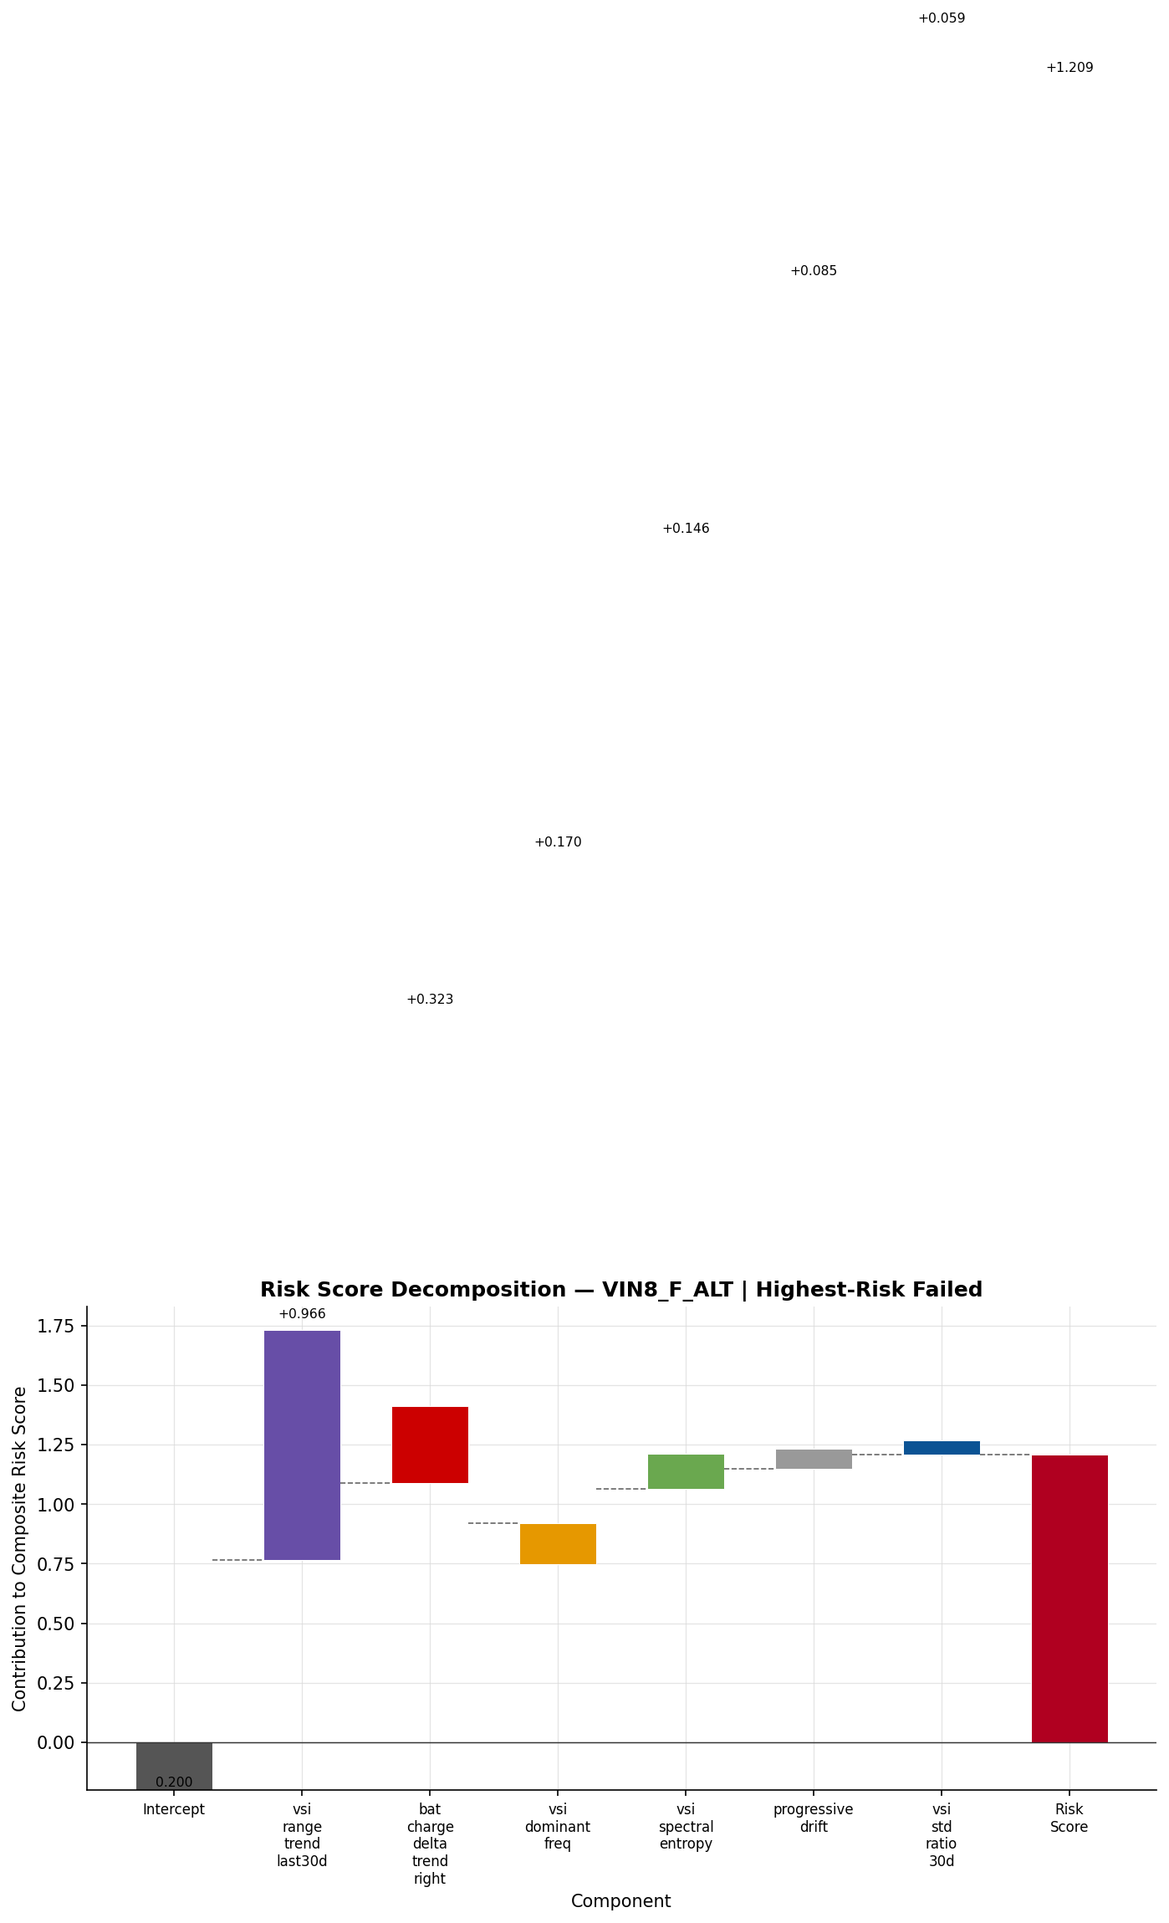
Figure 4.1 — Feature contribution waterfall (VIN8_F_ALT, highest-scoring truck)

4.5 Honest Ranking View — Contributions Sorted by LOVO Out-of-Fold Score
The contribution decomposition above is ordered by the in-sample full-fit risk_linear. As an honesty cross-check, the identical per-feature contributions (coef x z) are re-ordered by the Leave-One-VIN-Out (LOVO) out-of-fold score — each truck ranked by a model that never trained on it, the deployment-grade ranking behind the headline AUROC 0.9267. Only the x-axis order changes; the contributions are unchanged.
The two orderings are 98.8% rank-correlated (Spearman 0.988). The in-sample order implies AUROC 0.947; the honest LOVO order is 0.927 — the ~2-point gap is in-sample optimism, not a different result. Fourteen of 25 trucks shift by 1-2 positions and none cross from clearly-risky to clearly-healthy. The visible effect: the false negative VIN5_F_ALT (LOVO prob 0.28) sits within the healthy cluster on the left, and the false positive VIN3_NF_ALT (0.49) sits inside the failed cluster on the right — so the chart shows the true, slightly-messier separation the deployable model achieves rather than the marginally cleaner in-sample picture.
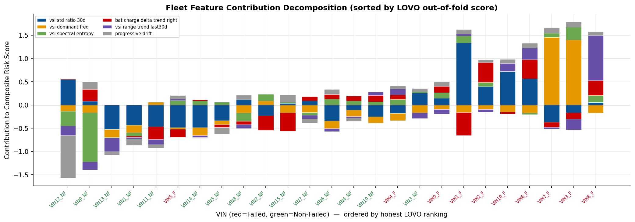
Figure 4.5 — Fleet contribution decomposition — sorted by honest LOVO out-of-fold ranking

5. Zone Consistency & Deployed Bands (Task 3)
The Ridge probability scores are bucketed into three operational risk bands: Green (score < 0.35), Amber (0.35 to 0.55), Red (>= 0.55).
VIN | Ridge Prob | Band | Above Threshold
VIN10_F_ALT | 0.6263 | RED | Yes
VIN10_NF_ALT | 0.4389 | AMBER | No
VIN11_NF_ALT | 0.2559 | GREEN | No
VIN12_NF_ALT | 0.0421 | GREEN | No
VIN13_NF_ALT | 0.2104 | GREEN | No
VIN14_NF_ALT | 0.3162 | GREEN | No
VIN15_NF_ALT | 0.3987 | AMBER | No
VIN1_F_ALT | 0.6058 | RED | Yes
VIN1_NF_ALT | 0.2553 | GREEN | No
VIN2_F_ALT | 0.6085 | RED | Yes
VIN2_NF_ALT | 0.3956 | AMBER | No
VIN3_F_ALT | 0.7603 | RED | Yes
VIN3_NF_ALT | 0.4906 | AMBER | Yes
VIN4_F_ALT | 0.4456 | AMBER | Yes
VIN4_NF_ALT | 0.4257 | AMBER | No
VIN5_F_ALT | 0.2799 | GREEN | No
VIN5_NF_ALT | 0.3250 | GREEN | No
VIN6_F_ALT | 0.7112 | RED | Yes
VIN6_NF_ALT | 0.4133 | AMBER | No
VIN7_F_ALT | 0.7178 | RED | Yes
VIN7_NF_ALT | 0.4116 | AMBER | No
VIN8_F_ALT | 0.8923 | RED | Yes
VIN8_NF_ALT | 0.3934 | AMBER | No
VIN9_F_ALT | 0.4919 | AMBER | Yes
VIN9_NF_ALT | 0.1053 | GREEN | No

Zone Consistency Verdict
Honest assessment: Only 3/10 (30%) failed VINs ever reached ORANGE or RED zones. Simultaneously, 6/15 healthy trucks also entered those zones. The 4-zone M5 system is supplemental visual context only — not a reliable standalone alert system at n=25.
GLOBAL bands are acceptable for RANKING: deployed green/amber/red risk bands cleanly separate VINs by ridge_prob and empirically confirm the 0.35/0.55 thresholds. The explored 4-zone temporal M5 health system has WEAK sensitivity: only 3/10 (30%) failed VINs ever reached ORANGE or RED, while non-failed trucks also enter those zones. Dynamic per-VIN zones are NOT justified by n=25 data; the data ceiling (n=10 failed) prevents reliable zone-level health-progression discrimination. Recommendation: use V11.1 risk bands for operational deployment; treat 4-zone M5 trajectories as supplemental visual context only, not a standalone alert system.
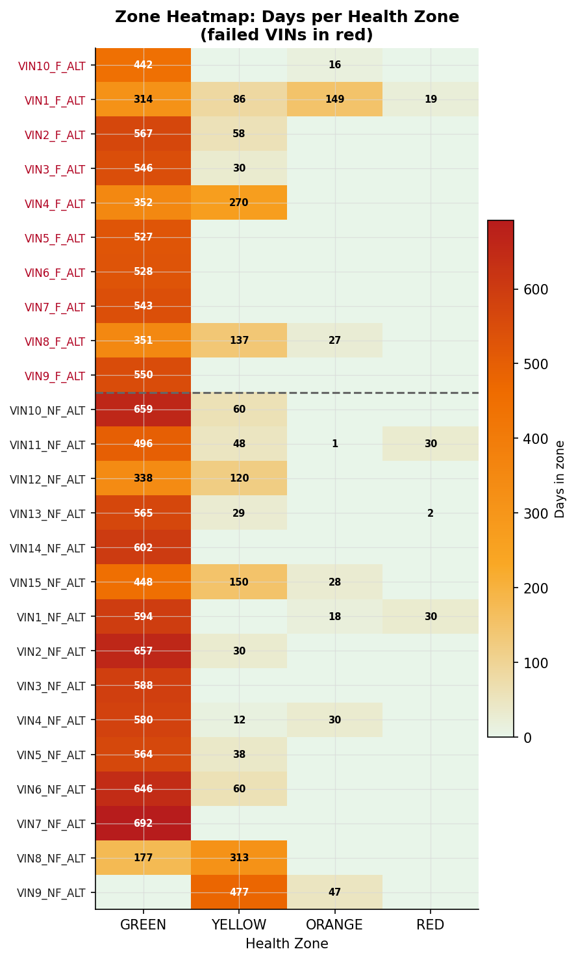
Figure 5.1 — Zone occupancy heatmap (all VINs, M5 temporal system)

6. The 93% AUROC — Decomposed (Task 4)
The LOVO AUROC of 0.9267 is a RANKING metric, not a classification accuracy. Given a randomly selected failed truck and a randomly selected healthy truck, the model ranks the failed truck higher 92.7% of the time.
Pair decomposition: 139 concordant / 11 discordant / 0 ties out of 150 total pairs.
Metric | Value
LOVO AUROC | 0.9267
PR-AUC | 0.9400
Recall | 0.9000 (9/10)
Specificity | 0.9333 (14/15)
Precision | 0.9000
F1 Score | 0.9000
MCC | 0.8333
Brier Score | 0.1433
Bootstrap AUROC mean | 0.9234 (95% CI: [0.8065, 1.0000])
Permutation p-value | 0.0000
Spearman rho | 0.7247
True Positives | 9
False Positives | 1 (VIN3_NF_ALT, score 0.4906)
False Negatives | 1 (VIN5_F_ALT, score 0.2799)
True Negatives | 14

GUARD — Classifier FP vs Emergency Channels: The classifier itself produces 1 false positive at the operating threshold (0.4456): VIN3_NF_ALT scores 0.4906, just above the threshold. This is distinct from the emergency channels (GED=2 storm, compound early-watch), where 0 of 15 healthy trucks triggered an alert — those channels have zero false alarms on the non-failed fleet.
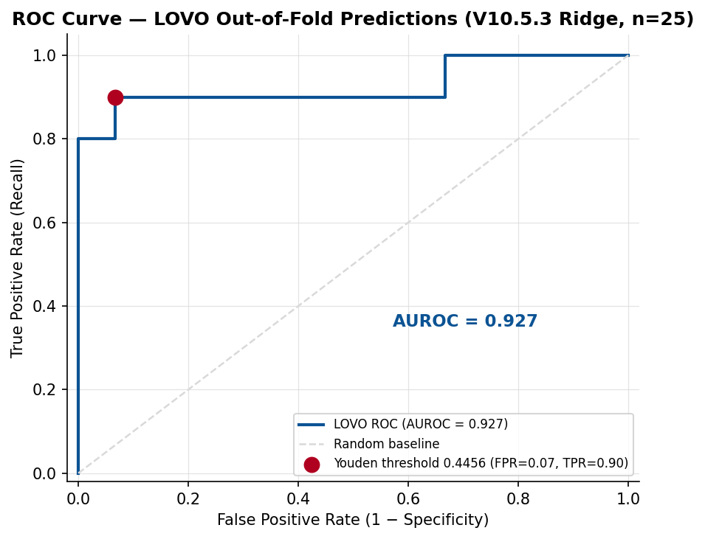
Figure 6.1 — ROC curve (LOVO predictions, 25 trucks)

7. RUL Correction — JCOPENDATE Clip (Task 5)
Earlier RUL curves used the last telemetry timestamp as the failure date. The fix: use the service record's JCOPENDATE (Job Card Open Date) as the true failure date, extending each curve with a dashed extrapolation to RUL = 0.
Fleet verdict: JCOPENDATE fix applied to all 10 failed VINs. 7 VINs have 0d gap (telemetry touches JCOPENDATE exactly). VIN1 gap=11d, VIN3 gap=66d (largest — timeline tightens by 66d), VIN9 gap=2d. Global zone-band boundaries UNCHANGED (H_GY=180d, H_YO=90d, H_OB=30d). Red zone proxy (RUL<=60d) used as transparent surrogate for 'red alert' window. All 10 after-curves end at (JCOPENDATE, RUL=0). GUARDS PASSED.
VIN | JCOPENDATE | Gap (d) | Zone Before | Zone After
VIN10_F_ALT | 2025-12-16 | 0 | green | black
VIN1_F_ALT | 2025-11-29 | 11 | yellow | black
VIN2_F_ALT | 2025-12-16 | 0 | yellow | black
VIN3_F_ALT | 2025-12-02 | 66 | green | black
VIN4_F_ALT | 2025-11-25 | 0 | yellow | black
VIN5_F_ALT | 2025-11-22 | 0 | yellow | black
VIN6_F_ALT | 2025-09-30 | 0 | green | black
VIN7_F_ALT | 2025-12-04 | 0 | yellow | black
VIN8_F_ALT | 2025-11-24 | 0 | green | black
VIN9_F_ALT | 2025-12-29 | 2 | yellow | black

Most affected: VIN3_F_ALT with a 66-day gap. Seven of 10 VINs had zero gap. Global zone-band boundaries are unchanged.
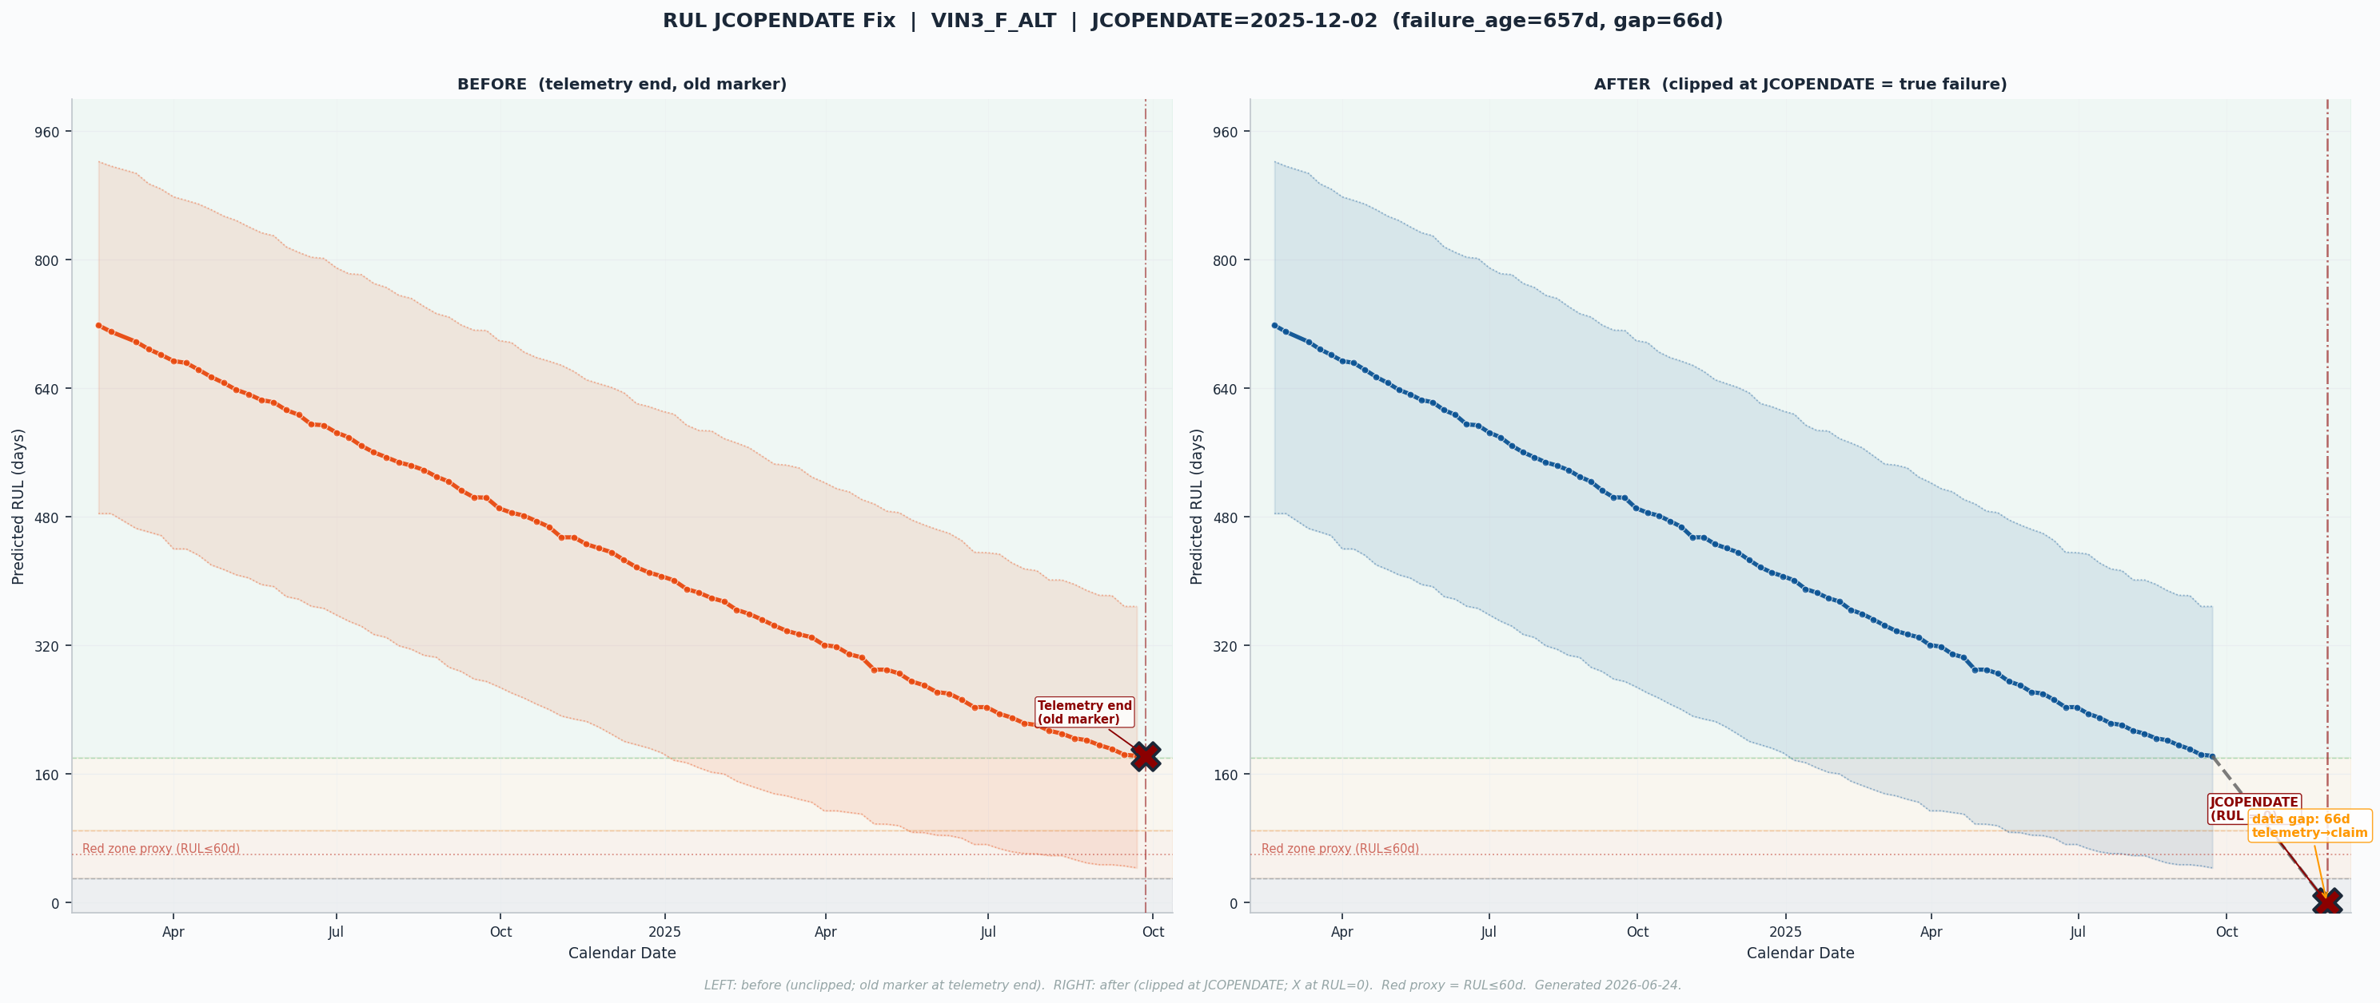
Figure 7.1 — VIN3_F_ALT RUL before/after JCOPENDATE fix (+66d gap)

8. Fleet Overlay
The fleet overlay shows all 25 trucks' RUL trajectories on a common calendar x-axis after the JCOPENDATE fix.
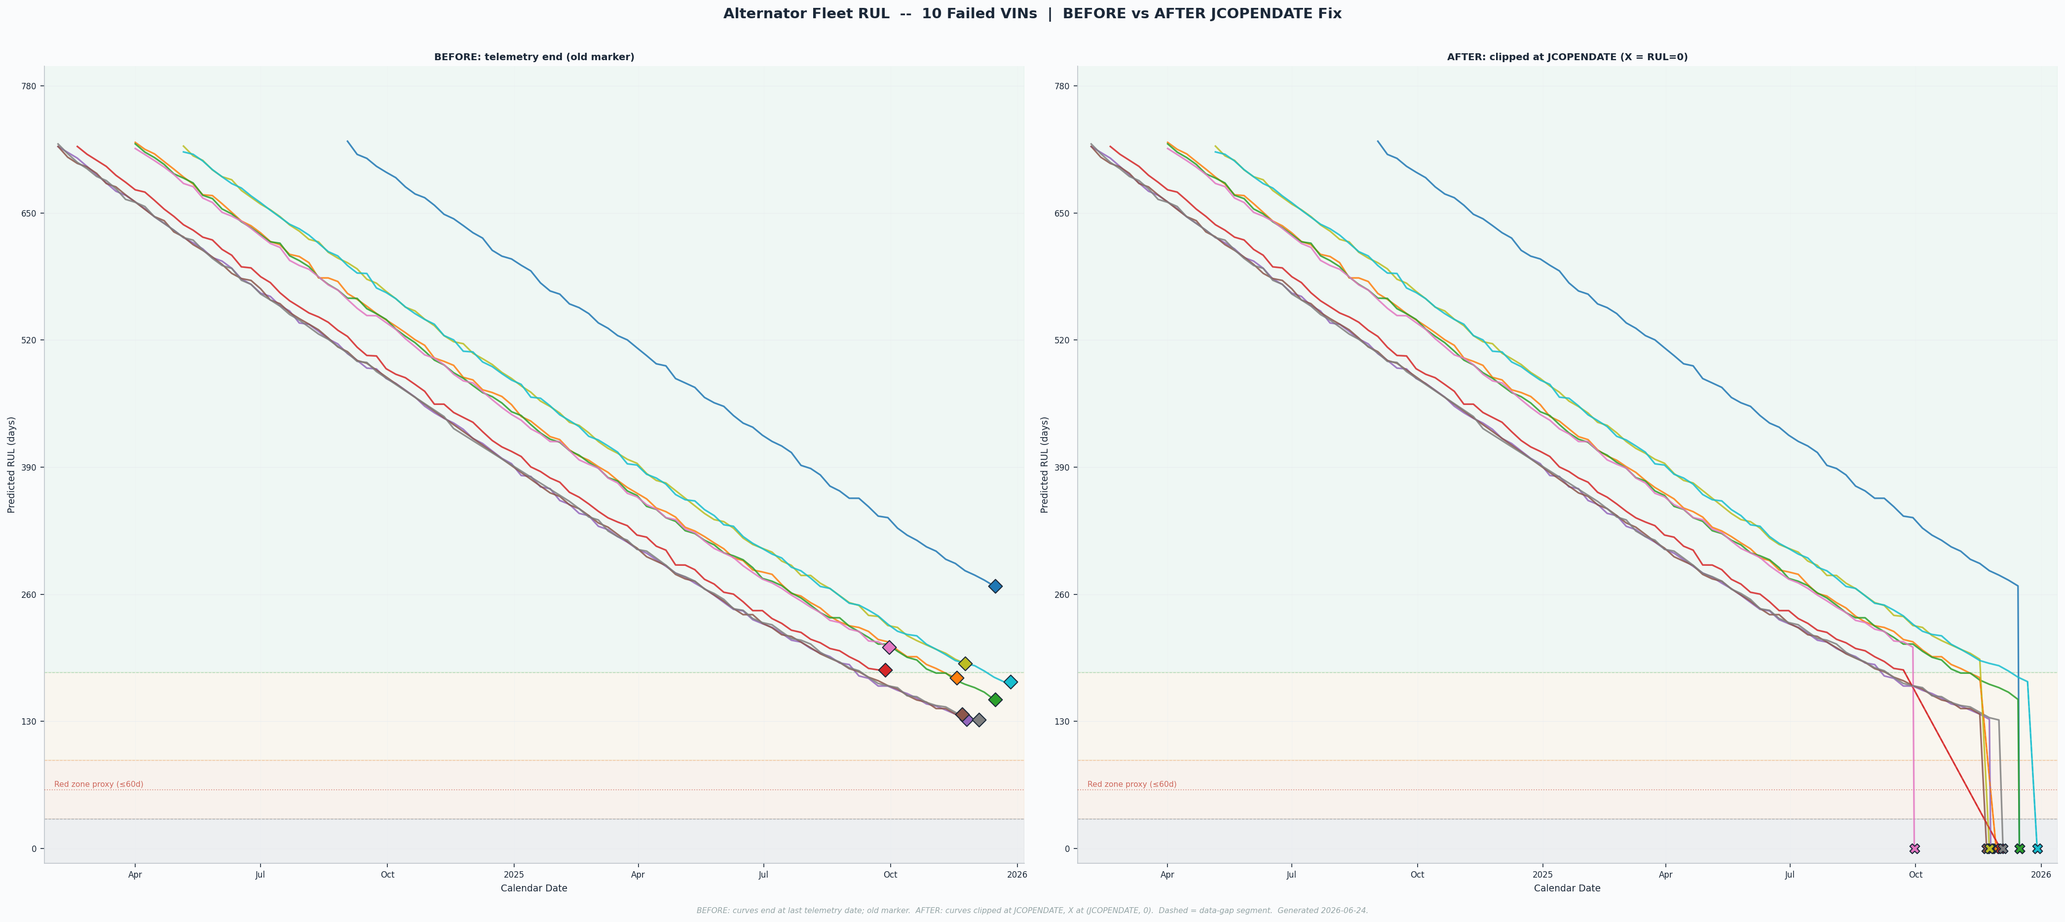
Figure 8.1 — Fleet RUL overlay (all 25 trucks, JCOPENDATE-corrected)

9. Per-VIN Detection & Failure Modes
Sections 1-8 validate the fleet-level system; this section presents the per-truck picture — honestly split into what the model catches and how alternators actually fail.
Detection (optimistic, and real): each truck gets its own LOVO risk score. The RED band is pure — 7 failures, 0 false alarms; 9/10 failures land in the alert zone (only VIN5 missed, at 0.28). Four give a hard, schedulable lead: VIN1 21d (GED storm), VIN2 16d (under-voltage sag), VIN6 11d, VIN10 11d (crank-recovery); VIN1 also shows a ~199-day condition decline.
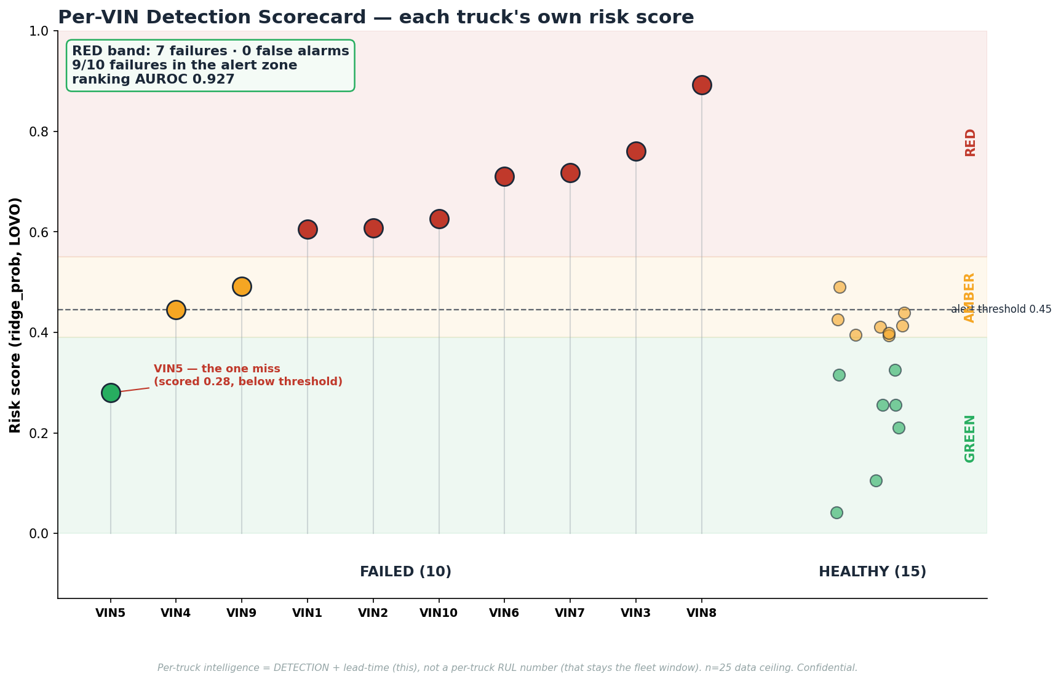
Figure 9.1 — Per-VIN detection scorecard (RED band = 7 failures / 0 false alarms)
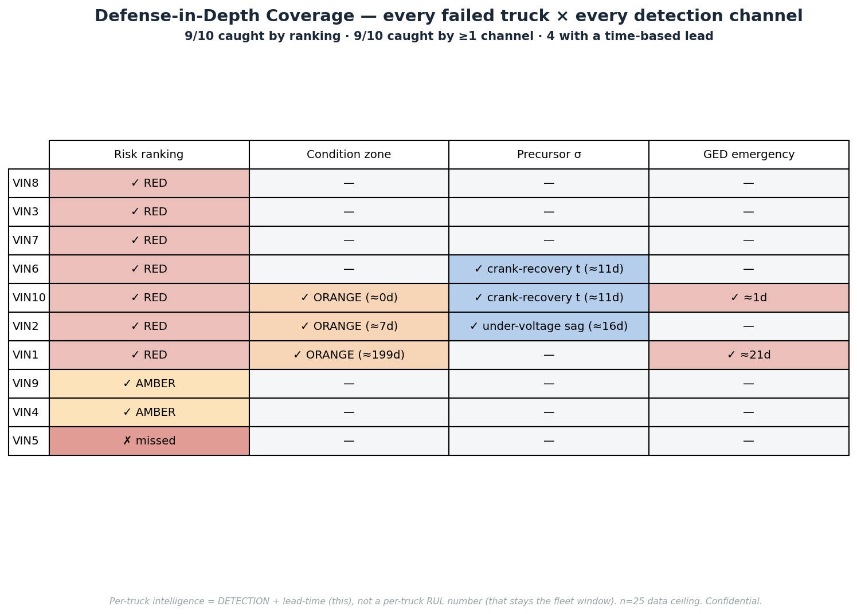
Figure 9.2 — Defense-in-depth coverage matrix
Failure modes (honest): alternators mostly stop abruptly (regulator/diode/brush). 6/10 failures give NO telemetry footprint — charging voltage flat ~28V to within three days of failure, with no gradual decline in any signal. Only four give a short discrete-event warning; only VIN1 a long runway. Implication: abrupt failures cannot be predicted at the moment level — mitigate by population (601-day fleet window / age replacement); condition monitoring buys lead only for the gradual minority.
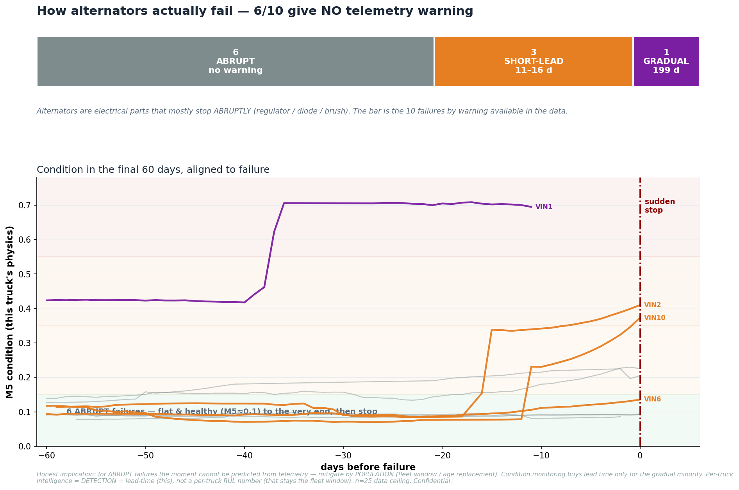
Figure 9.3 — How alternators actually fail (abrupt-failure footprint)

10. Limitations
1. n = 25 / 10 events is the data ceiling. With only 10 observed failures, statistical estimates carry wide uncertainty (bootstrap 95% CI: [0.807, 1.000]).
2. Exposure confound on progressive_drift: healthy trucks observed longer accumulate more cumulative drift, reversing the expected direction. Lowest permutation importance (0.048); retained to preserve the frozen V10.5.3 spec.
3. Aged-fleet observation bias: non-failed trucks are right-censored, not proven healthy indefinitely. The 601-day window should be updated as the fleet ages further.
4. No per-truck timing from the classifier: per-truck MAE 140.4d vs fleet-clock MAE 49.7d — the covariate model does NOT beat the fleet clock (verdict: NO_IMPROVEMENT_HONEST). Operational deliverable is the risk band and fleet window, not per-truck day-level predictions.
5. Emergency channel coverage is limited: GED=2 fires for 2/10 failed VINs; compound for 3/10. No signal available for remaining failures before failure — consistent with abrupt failure modes having no detectable electrical precursor.
6. 4-zone temporal health system is weak: only 3/10 (30%) failed VINs reach ORANGE/RED; 6/15 healthy trucks also enter those zones.

11. Recommendation — Deploy Now, Grow Data
The V11.2_ALT system is recommended for operational deployment at DICV on the following basis:
Ranking (WHICH): LOVO AUROC 0.9267 — 139/150 concordant pairs — provides reliable fleet risk-ranking. Top-10 inspection list catches 9/10 known failures.
Fleet window (WHEN-fleet): 601-day / ~120,440 km replacement window provides a defensible procurement and scheduling anchor derived from observed failure ages.
Emergency channels (WHEN-emergency): GED=2 excitation-disturbance monitoring and compound early-watch produce zero false alarms on the 15 healthy trucks and fire ahead of failure for 2 and 3 trucks respectively.
Data ceiling is not a method ceiling: expanding to 100+ trucks with continued telemetry ingestion is expected to narrow the bootstrap CI, improve zone discrimination, and enable more reliable per-truck timing. The Phase-2 recommendation is to deploy V11.2 now and retrain on a richer dataset as it accumulates.

Report generated by V11_2_ALT_build_report.py on 2026-06-26. All numbers sourced from result files under V11.2_ALT/results/. Metrics from LOVO cross-validation only.

