**HYBRID BEAMFORMING FOR MILLIMETER WAVE MASSIVE MIMO**

**ABSTRACT**

Fifth generation and beyond fifth generation (5G and B5G) wireless network which aims to serve the users with the higher data rates and provide the lower latency. As there is a rapid growth in the communication system which leads to increase in the data traffic which has motivated the study of Multiple Input Multiple Output (MIMO) systems. The MIMO systems utilizes multiple antennas on the both transmitter side as well as at the receiver sides. That’s the reason it’s becomes a necessity to improve the on-going technology to achieve fast and reliable communication.

The primary goal of this review paper is to analyze and discuss the advancement in research related to the beamforming techniques. Our aim is to identify and evaluate the most efficient or optimal types of beamforming technique that can be deployed in massive MIMO systems and to clarify the importance of beamforming techniques in massive MIMO that can eliminate and resolve many technical problem faced in the implementation of massive MIMO systems.

Simulation result indicates that the proposed rectangular array antenna-based hybrid beamforming in massive MIMO reduces computational complexity by up to 99% compared to conventional fully digital beamforming.

INTRODUCTION:

**SYSTEM & CHANNEL MODEL:**

The system model considered in this study is shown in Fig. 1. A mass MIMO system was considered. It is a multi-user system with multiple streams, whose downlink is equipped with 3-D $N_{t}$ antenna arrays with $N_{t}^{RF}$ RF chains, and the uplink is equipped with 3-dimensional $N_{r}$ antenna arrays and $N_{r}^{RF}$ RF chains. Let $N_{r}$ denote the number of streams received by each receiver. The proposed hybrid MIMO system model was configured such that ${ N}_{t}^{RF}<N_{t}$ and $N_{r}^{RF}<N_{r}$

A transmitter is likely to be sectored to reduce interference and increase beamforming gain. The foremost thought of beamforming or large antenna arrays is the excellent flexibility in which the beam can be steered when there is a multiple user environment. Most beam steering flexibility comes from the fully digital MIMO beamforming technique, but the cost is high for this technique. The best outcome can be brought by combining the beamforming techniques of digital, analog system, and the RF domain, which has lower flexibility than a fully digital MIMO system at low cost. In conventional (fully digital) MIMO systems, both the number of RF chains and antennas are equal on the transmitter side for pre-coding and the number of antennas on the receiver side for combining. The performance analysis of a conventional fully digital MIMO system is compared with the Hybrid MIMO system using hybrid pre-coding and combining. It depicts that there is a negligible loss in Hybrid MIMO when compared with fully digital conditions. Conventional fully digital beamforming technique demands a dedicated RF chain corresponding to a particular antenna. Hence it will be extremely costly and complex. Whereas, with a fewer number of RF chains, as shown in Fig. 1, the Hybrid beamforming techniques promise to reduce the complexity of the hardware and also cost. Their performance is analyzed and discussed in Sect. 4.

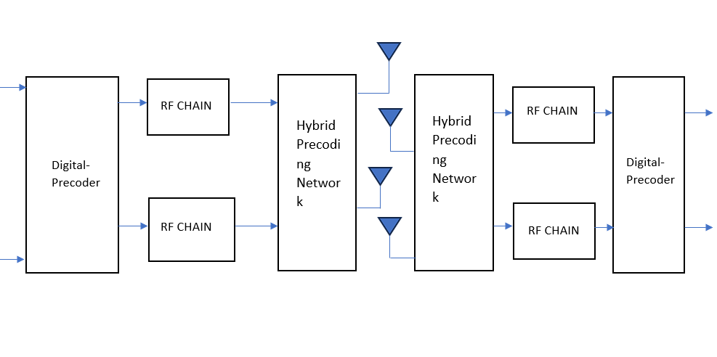

To reduce the complexity in hardware, a hybrid MIMO system with digital and analog pre- coding architecture has been considered (Fig. 1). The transmitted signal at the base station side is given by.

$$x=T_{RF}\sum_{k=1}^{K}{T_{BB_{k}}S_{k}}$$

where $T_{BB_{k}}∈C^{N_{t}×N_{t}^{RF}}$ is denoted as the analog beamforming matrix and $T_{RF}∈C^{N_{t}^{RF}×N_{s}}$ is denoted as the digital beamforming matrix. After the BS analog pre-coder where the signals go through analog phase shifters, the signals are processed digitally and then against up-converted to the carried frequency through RF chains and $S_{k}∈C^{N_{s}×T}$ denotes the data stream of the $k^{th}$ user.

The signal received for the kth user is given by

$$y_{k}=\sqrt{ρ}H_{k}+n_{k}$$

and combined. This indicates that there is negligible loss in Hybrid MIMO when compared with fully digital conditions. Conventional fully digital beamforming techniques require a dedicated radio frequency (RF) chain corresponding to a particular antenna. Hence, it is extremely expensive and complex. However, with fewer RF chains, as shown in Fig. 1, the hybrid beamforming techniques promise to reduce the complexity of the hardware and cost. Their performance was analyzed and discussed in Sect. 4. To reduce the complexity of hardware, a hybrid MIMO system with digital and analogcoding architectures was considered (Fig. 1). The transmitted signal at the base-station side is given by where $h_{k}$ is the $N_{t} ×N_{r}$ channel matrix between the BS and kth user which can be rep resented as:

$$H_{k}=\left[\begin{matrix}H_{11} & \begin{matrix}H_{21} & ⋯\end{matrix} & H_{1N_{t}} \\ H_{21} & \begin{matrix}H_{22} & …\end{matrix} & H_{2N_{t}} \\ \begin{matrix}⋮ \\ H_{N_{r}1}\end{matrix} & \begin{matrix}\begin{matrix}⋮ & ⋱\end{matrix} \\ \begin{matrix}H_{N_{r}2} & …\end{matrix}\end{matrix} & \begin{matrix}⋮ \\ H_{N_{r}N_{t}}\end{matrix}\end{matrix}\right]$$

For user k, where $ρ$ is the average received power, and nk is the additive white Gaussian noise (AWGN) with zero mean and $σ^{2}$ covariance. The finally processed discrete signal at the receiver side is given by

$${\tilde{S}}_{k}=R_{BB_{k}}^{*}R_{RF_{k}}^{*}y_{k}$$

where $R_{RF_{k}}∈C^{N_{r}×N_{r}^{RF}}$ is denoted as the analog combiner matrix and $R_{BB_{k}}∈C^{N_{S}×N_{r}^{RF}}$ is denoted as digital combiner matrix. The received signal is processed in the first analog domain, which is then processed in the digital domain, and then down-converts the signalthrough the RF chains. Equation (7) may be rewritten as

$${\tilde{S}}_{k}=\sqrt{ρ}R_{BB_{k}}^{*}R_{RF_{k}}^{*}H_{k}T_{RF}T_{BB_{k}}S_{k}+R_{BB_{k}}^{*}R_{RF_{k}}^{*}n_{k}$$

The spectral efficiency achieved by this proposed hybrid beam-forming massive MIMO is given by

$$SE= \log_{2}{[\det{(I_{N_{s}}+\frac{ρ}{N_{s}}S_{n}^{-1}R_{BB_{k}}^{*}R_{RF_{k}}^{*}H_{k}T_{RF}T_{BB_{k}}T_{BB_{k}}^{*}T_{RF_{k}}^{*}H_{k}^{*}R_{RF_{k}}R_{BB_{k}})]}}$$

Where $S_{n}= σ^{2}R_{BB_{k}}^{*}R_{RF_{k}}^{*}R_{RF_{k}}R_{BB_{k}}$ is the noise covariance matrix of analog–digital combiner.

**Rectangular antenna array model**

The rectangular antenna array model is shown in Fig. 2. Let the source be in the far-field

of the receive antenna array.

Assume that every element of the rectangular antenna array is having either isotropic

or omnidirectional radiation pattern. The received signals due to the far-field source of

the four array elements can be obtained using the expressions given below.

R1 = 1

It is observed that as per the vector geometry, the resultant signal is depending upon the

relative phase of the above four vector components. Therefore the resultant field received at

the rectangular antenna array due to the far-filed source is given by

*R* = *R*1 + *R*2 + *R*3 + *R*4

However in the proposed Hybrid Beamforming for Massive MIMO using Rectangular

Antenna Array Model, *Nt × Nr* rectangular array antenna is considered. The resultant signal

can be written as

$$R_{T}=\sum_{n=0}^{N_{t}-1}{\sum_{m=0}^{N_{r}-1}{e^{-j2π(md_{y}sinθ+nd_{x}cosθ)/λ}}}$$

The range of *n* and *m* is 0 to $N_{t}$ *− 1* and 0 to $N_{r}$*− 1* respectively.

**Bit Error Rate, Spectral Efficiency and Channel Capacity**

The proposed system model has been analyzed by computing spectral efficiency, channel

capacity and BER over SNR for a different combination of transmitter and receiver antennas

is very important for MIMO systems.

SNR is a ratio of the strength of the received signal to the strength of noise in the operating

frequency range. Noise commonly includes unwanted signals, environmental noises,

which end up as interference. SNR is generally used as an indicator to assess the quality of

the communication channel. The relationship between BER and SNR is inversely related,

i.e., high SNR causes low BER and SNR is measured in decibels(dB) The SNR and BER

formulae are given by:

$$SNR=10×\log_{10}\frac{Signal Power}{Noise Power}dB$$

$$BER=\frac{Bits in Error}{Total bits received}$$

The channel matrix *hji* of the massive MIMO channel matrix can be represented as

(6), where it is a complex Gaussian random variable that models fading gain between the

*i*th transmitter and *jth* receiver antenna. And in terms of spectral efficiency, the spectral

efficiency and the channel capacity of the various system can be calculated using Eqs.

(19)–(24). The spectral efficiency and the channel capacity of the conventional system is

given by

${SE}_{SISO}=\log_{2}\left(1+\frac{S}{N}\right)$ bits/s/Hz/cell

$C_{SISO}=B * \log_{2}\left(1+\frac{S}{N}\right)$ bits/s

The spectral efficiency and the channel capacity of the SIMO as well as MISO system

is given by

${SE}_{SIMO}={SE}_{MISO}=\log_{2}\left(1+n\frac{S}{N}\right)$ bits/s/Hz/cell

$C_{SIMO}=C_{MISO}=B * \log_{2}\left(1+n\frac{S}{N}\right)$ bits/s

where n = Nris the number of antennas on the receiver side for SIMO and n = Ntis thenumber of antennas on the transmitter side for MISO.

The Spectral efficiency and the channel capacity for the MIMO is given by

${SE}_{MIMO}=\log_{2}\left(1+N_{t}*N_{r}*\frac{S}{N}\right)$ bits/s/Hz/cell

$C_{MIMO}=B *\log_{2}\left(1+N_{t}*N_{r}*\frac{S}{N}\right)$ bits/s

It has been proven theoretically and practically that massive MIMO shows the highest

spectral efficiency and channel capacity.Thus the average area throughput increases with

the increased number of transmitting and receiving antennas.

**Experimental Results and Discussions**

This section deals with the result obtained for proposed rectangular antenna array based hybrid beam-forming for massive MIMO system.

**Rectangular Antenna Array Structure**

Figure x illustrates a rectangular antenna array featuring a $8×8$ configuration, utilizing polyhedral materials.

The array comprises $24$ planar arrays, each transmitting an equivalent amount of power individually, and each is connected to a single receiving antenna within a device. The proposed array antenna is capable of forming radiation beams omnidirectionally in a three-dimensional manner. This design aims to optimize efficiency and provide User Equipment (UE) with enhanced data rates and reduced latency. The average size of the receiving antenna device is considered to range from $0.9$ to $1.5$ meters.

The developed Rectangular Antenna Array-based Hybrid Beamforming model for massive MIMO has been simulated and validated using MATLAB $R2024b$. The parameters assumed for the simulation are detailed in Table x. Initially, the radiation and azimuth patterns, both with and without Chebyshev Tapering, for various rectangular array sizes of the developed model were simulated using the parameters listed in Table x. Subsequently, the spectral efficiency improvement achieved through the developed Rectangular Antenna Array-based Hybrid Beamforming in massive MIMO for 5G was simulated for various data streams and compared with the conventional fully digital beamforming technique. Finally, the Bit Error Rate (BER) performance relative to Signal-to-Noise Ratio (SNR) was analyzed.

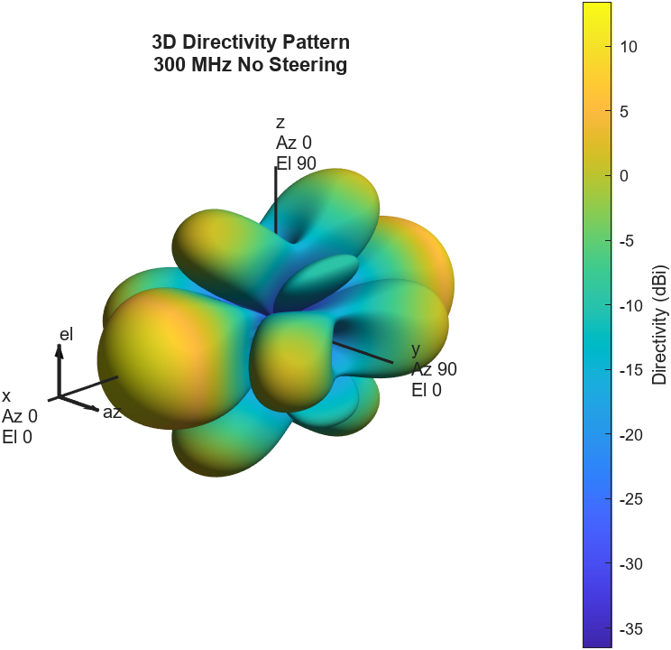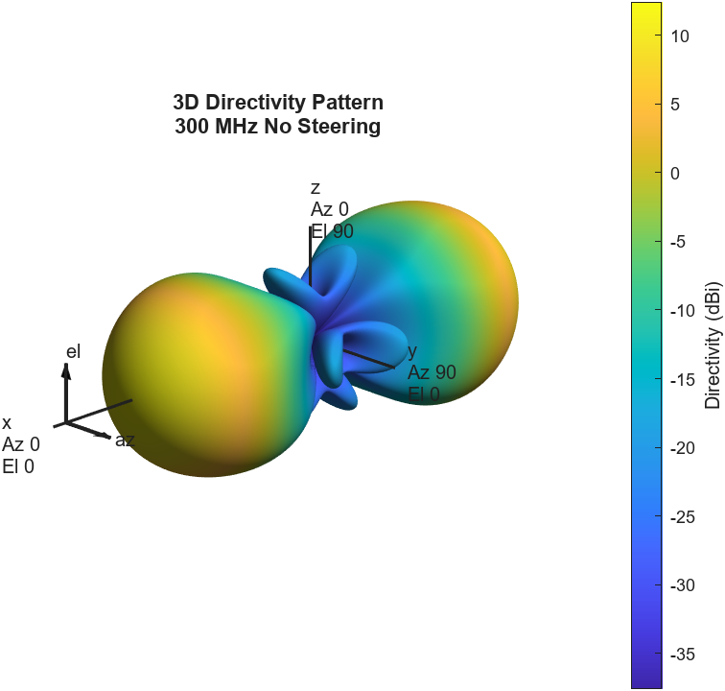

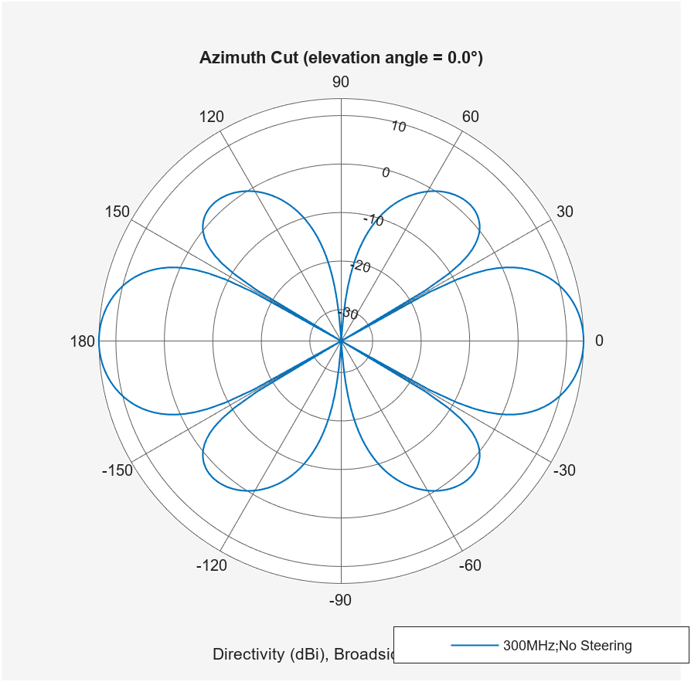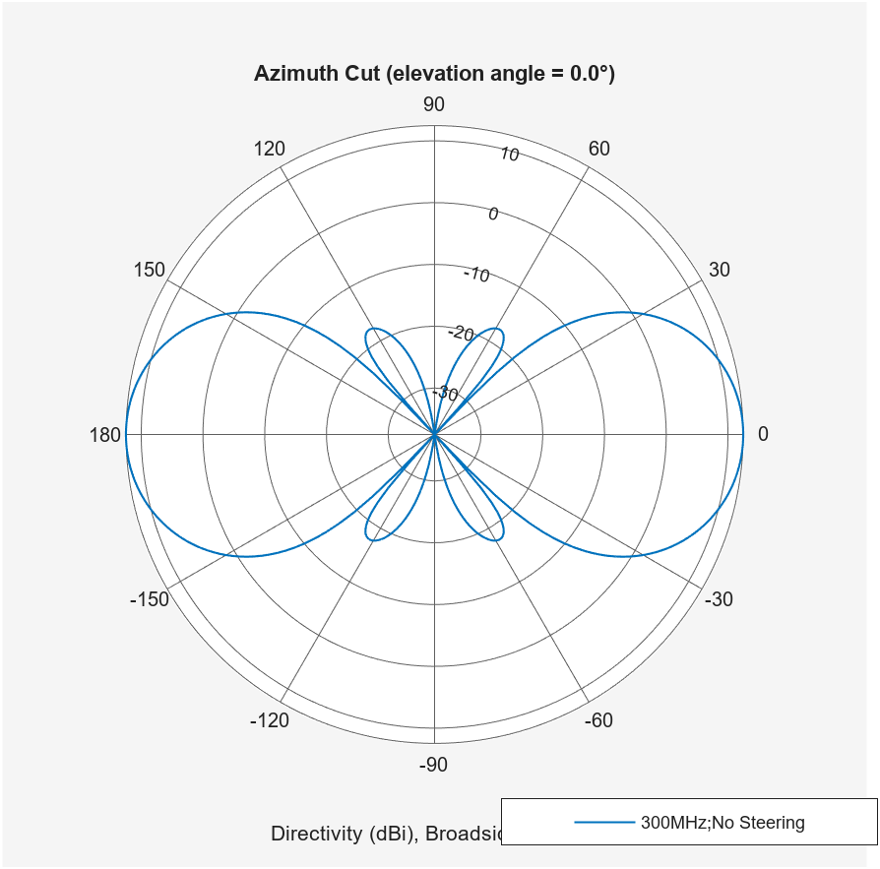

**3D Radiation and Azimuth Patterns**

In this subsection, the simulation and analysis of the radiation and azimuth patterns for various rectangular antenna arrays are presented. Different types of patterns with varying array sizes were considered, and their spectral efficiency and BER versus SNR performance were analyzed.

The simulated beam and azimuth patterns, with and without Chebyshev tapering, for rectangular array sizes of $8 × 8$, $12 × 12$, and $16 × 16$ are illustrated in Figs. x, y, and z respectively. The simulation results indicate a clear distinction in radiation and azimuth patterns with and without Chebyshev tapering.

For the basic design parameters, the number of antennas used in Fig. x is $N_{row}=8$, $N_{col}=8$ $(8 × 8)$, with an element spacing of $λ= \left[0.5 0.5\right]$. The lattice structure is rectangular, and an amplitude taper is applied to the antenna structure. The element used is an isotropic antenna with a propagation speed of $3 × {10}^{8}$ m/s and a signal frequency of $300$ MHz, without any steering. A 2D-Azimuth pattern is employed, considering a polar coordinate system.

A primary issue identified is the formation of side lobes in the radiation pattern, which are undesirable as they lead to the reception or transmission of energy in unintended directions. Amplitude tapering or amplitude weighting can be employed to reduce the directivity of side lobes in different array sizes. Amplitude tapering is applied from the center to the end of the array to control minor lobe levels. These arrays are non-uniformly excited. Improved main beams can be achieved in the desired direction by controlling the side lobes on the linear array using amplitude tapering, effectively creating a steerable antenna array.

In Fig. x, where a $8 × 8$ antenna array is considered, numerous side lobes and one main lobe are present. However, due to the small number of antennas, i.e., only $64$, compared to other configurations with a higher number of antennas, it is observed that many side lobes can act as the main lobe. This indicates that the signal power of the antenna is very small, yet it covers a larger area, which is not a desired feature. By increasing the antenna size to $144$, as in an $12 × 12$ antenna array shown in Fig. x, it is observed that the number of side lobes has increased, but they are not as functional as the main lobe. The directional power of the $12 × 12$ antenna array increases with the number of antennas, and the signal power is enhanced in a specific direction.

The process of beamforming and beam steering is enhanced with an increase in the number of antennas. The radiation and azimuth patterns of the $16×16$ antenna array configuration have been computed and are illustrated in Fig. x. It is observed that, compared to the $8×8$ and $12×12$ array antennas, although the number of side lobes is higher, the directivity of these side lobes is reduced. The incorporation of Chebyshev Tapering further decreases the directivity of the side lobes, thereby enhancing the directivity of the main lobe. The antenna array configuration of $16 × 16$ has been simulated and is depicted in Fig. x. The primary distinction between standard 3D patterns and those with Chebyshev tapering is that the latter results in a significantly reduced number of side lobes. In the 3D patterning with Chebyshev tapering, it is noted that the patterns exhibit a small number of side lobes even in a $8×8$ antenna array size, compared to a 3D pattern formed without tapering. The reduction in sidelobe signal gain is attributed to the alteration in excitation amplitude effected by Chebyshev amplitude tapering. In previous generations of wireless communication systems, the dissipated signal was bidirectional, resulting in a low power reception by each user. Upon examining the azimuth pattern in Fig. x, it is evident that the side lobes are formed with reduced intensity/directivity, while the directivity of the main lobe is significantly high. From these observations, it is evident that configuring the antenna with rectangular array geometry and Chebyshev amplitude tapering results in higher signal strength with lower side lobes, allowing the signal to be focused in a desired single direction.

**Spectral Efficiency for Different Rectangular array antennas**

In this subsection, the performance of the proposed Rectangular Antenna Array-based Hybrid Beamforming model for massive MIMO is analyzed by computing the spectral efficiency. The spectral efficiency has been calculated for the proposed hybrid beamforming and fully conventional digital beamforming, generated with varying numbers of antennas and RF chains. The spectral efficiency has been simulated for different numbers of data streams with various SNRs ranging from $-40s$ to $20 dB$. The simulated spectral efficiency for the various numbers of the rectangular antenna array is shown in Figs. a, b, c, d, and e.

Initially, a $36 × 4$ massive MIMO system is considered with rectangular planar arrays at both the transmitter and receiver, with the number of RF chains at each end being $N_{rf} = 4$. The spectral efficiency of the proposed rectangular array antenna-based Hybrid beamforming of $36 × 4$ massive MIMO systems for various numbers of data streams $N_{s}$ has been simulated and is shown in Fig. x. It has been observed that, instead of fully digital beamforming, the number of base stations required is $4$ or $36$, whereas the same spectral efficiency has been achieved by the proposed hybrid beamforming approach, utilizing $16$ RF chains with various data streams, has demonstrated enhanced spectral efficiency. Figure x illustrates the spectral efficiency achieved in a $64 × 16$ massive MIMO hybrid beamforming model with $N_{rf} = 4$ at both ends for different transmitting data streams, specifically $N_{s} = 1, 2, and 3$. It has been observed that, instead of employing $1024$ RF chains as in conventional fully digital beamforming, the proposed rectangular array antenna-based hybrid beamforming with $256$ RF chains can achieve nearly equivalent spectral efficiency.

The spectral efficiency for a $64 × 16$ massive MIMO hybrid beamforming system with $N_{rf} = 8$ for different data streams is depicted in Figure x. It has been found that, instead of $1024$ RF chains in conventional fully digital beamforming, hybrid beamforming with $512$ RF chains can achieve the same spectral efficiency. Figures x and x indicate that increasing the number of RF chains, while maintaining the same number of antennas, enhances spectral efficiency to match that of conventional fully digital beamforming. More data streams can be transmitted simultaneously at high SNRs by activating additional RF chains, thereby improving spectral efficiency. Consequently, an increase in RF chains enhances spectral efficiency.

The difference in spectral efficiency between systems using 4RF and 8RF chains is minimal, suggesting that hybrid MIMO systems with fewer RF chains can be preferred for efficient signal transmission with lower complexity. To explore the performance of larger antenna arrays, Figure x presents the spectral efficiency achieved for a $256 × 64$ rectangular array antenna-based hybrid beamforming MIMO system with $N_{rf} = 8$ at both ends, where spectral efficiency is nearly identical with minimal deviation between fully digital and hybrid systems. The spectral efficiency for the $256 × 64$ massive MIMO hybrid beamforming system with $N_{rf} = 8$ and $N_{rf} = 16$ for different data streams is illustrated in Figures x and x, respectively. It can be observed that the spectral efficiency of hybrid beamforming in a massive MIMO system aligns closely with that of a fully digital MIMO system when the RF chains are increased from $N_{rf}=8$ to $N_{rf}=16$ in the hybrid MIMO system. This analysis demonstrates that a larger rectangular antenna array with hybrid beamforming techniques achieves spectral efficiency nearly equivalent to fully digital beamforming techniques with fewer antennas and RF chains. This results in reduced computational complexity and enhanced system performance, thereby offering an advantage over conventional fully digital MIMO systems.

The computed spectral efficiencies for both fully digital conventional beamforming and the proposed rectangular antenna array-based hybrid beamforming in a massive MIMO system with varying numbers of RF chains are presented $SNR = 20dB$ are compared and tabulated in Table x. It is observed that for $64 × 16$ massive MIMO system, almost the same spectral efficiency of that fully digital beamforming has been achieved if the number of RF chain has been varied from $64$ to $16$. This will decrease the $\%$ of reduction of RF chains from ____ to ____ Similarly, for the $256 × 64$ massive MIMO system, the same spectral efficiency of that fully digital beamforming has been achieved if the num ber of RF chains has been varied from $256$ to $64$. This will decrease the % of reduction of RF chains from ____ to ____ From Table x, it has been observed that rectangular array antenna-based Hybrid beamforming in a massive MIMO system reduces the computational complexity up to ____ as compared with conventional fully digital beam forming to achieve the almost same spectral efficiencies.

Fig 4 -> 8 x 8

Fig 5 -> 12 x 12

Fig 6 -> 16 x 16