MongoDB Assignment-D
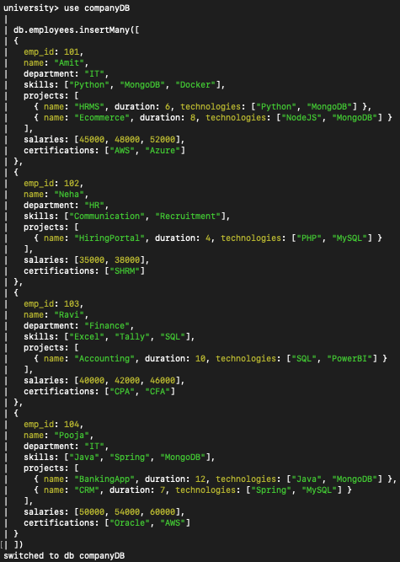
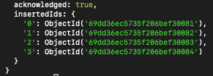
- Display all employees who have MongoDB skill
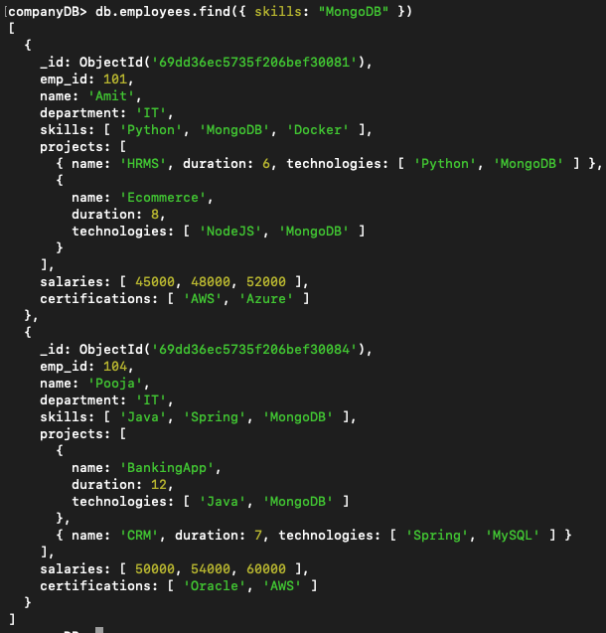
- Find employees having both Python and MongoDB skills
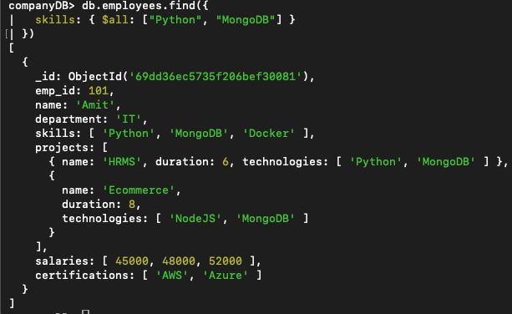
- Display employees with more than 2 skills
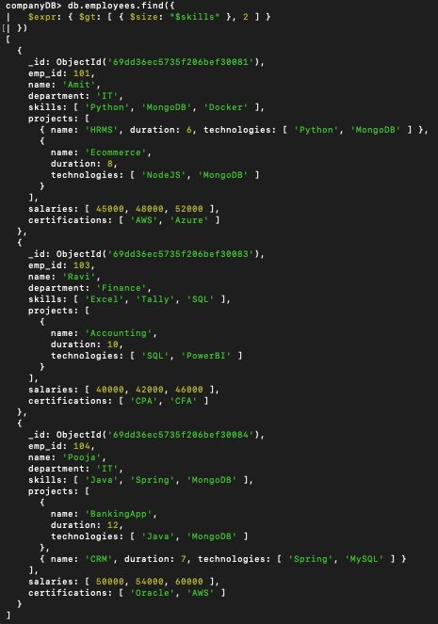
- Add a new skill "Kubernetes" to Amit
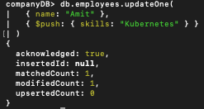
- Add multiple skills to Pooja
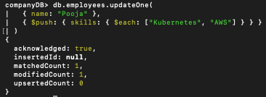
- Add a certification only if not already present.
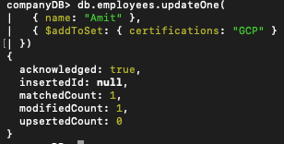
- Remove "Docker" skill from Amit
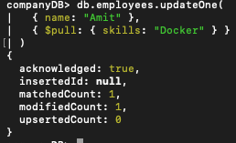
- Remove multiple salaries less than 45000
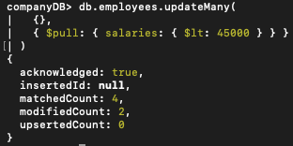
- Find employees who worked on MongoDB projects
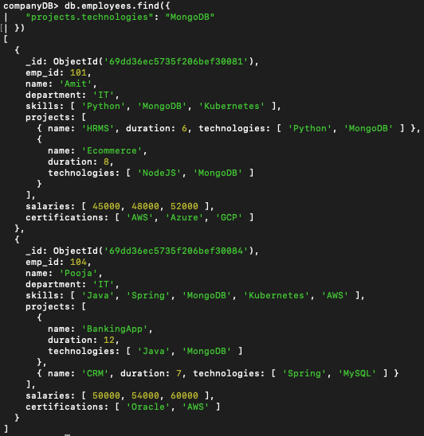
- Use $elemMatch to find project duration > 6 using MongoDB
This Topic is Not covered.
- Count number of projects for each employee
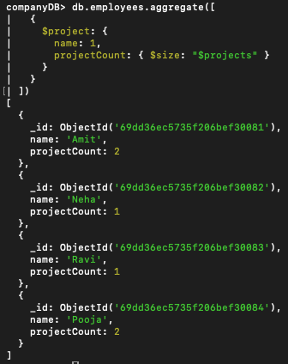
- Unwind skills array
This Topic is Not covered.
- List unique skills across company
This Topic is Not covered
- Find employees with salary greater than 50000
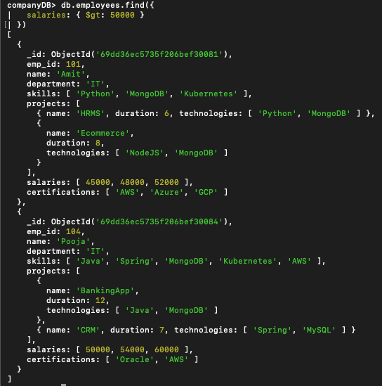
- Find employees with exactly 2 certifications
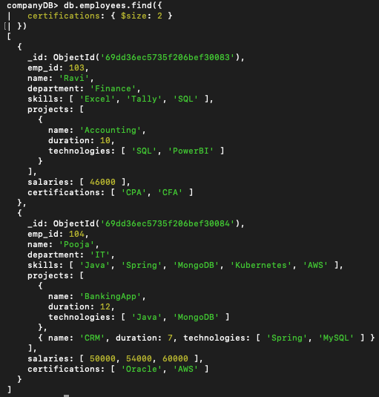
- Add new project to Ravi
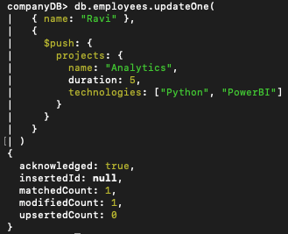
- Increase all salaries by 10% (array update)
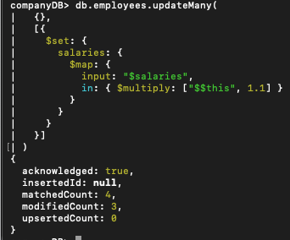
- Find highest salary of each employee
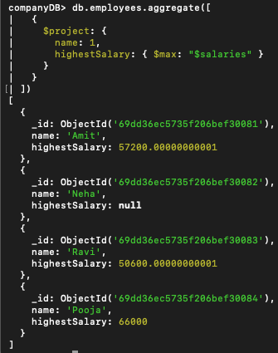
- Find average salary of employees
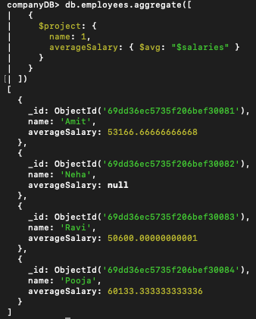
- Filter projects longer than 6 months
This Topic is not Covered
- Find employees who have any of these skills: Java or Python
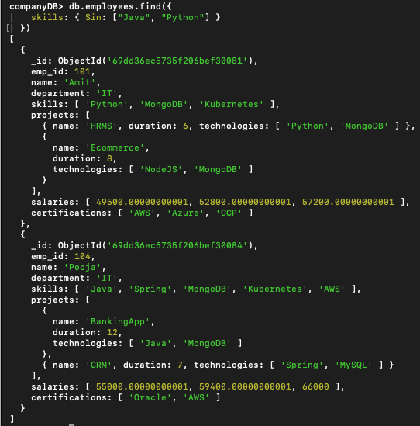
- Remove last salary entry
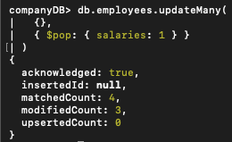
- Remove first salary entry
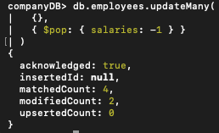
- Sort salaries array
This Topic is not Covered
- Limit salaries array to last 2 entries
This Topic is not Covered
- Find total salary paid to each employee
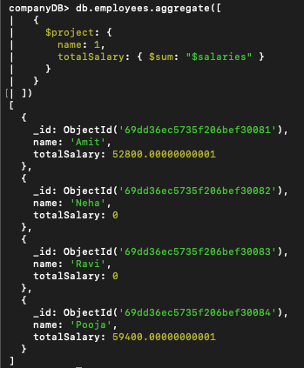
- Convert skills to uppercase
This Topic is not Covered
- Find employees with more than one project
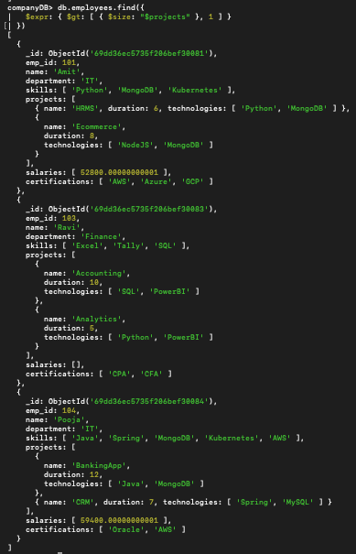
- Count employees per skill
This Topic is not Covered
- Find employees whose all projects use MongoDB
This Topic is not Covered

