MongoDB Assignment B
- Create a database named university and a collection named students. Insert multiple student documents with fields: name, age, department, and grades.
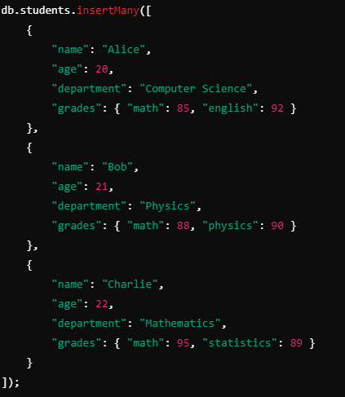
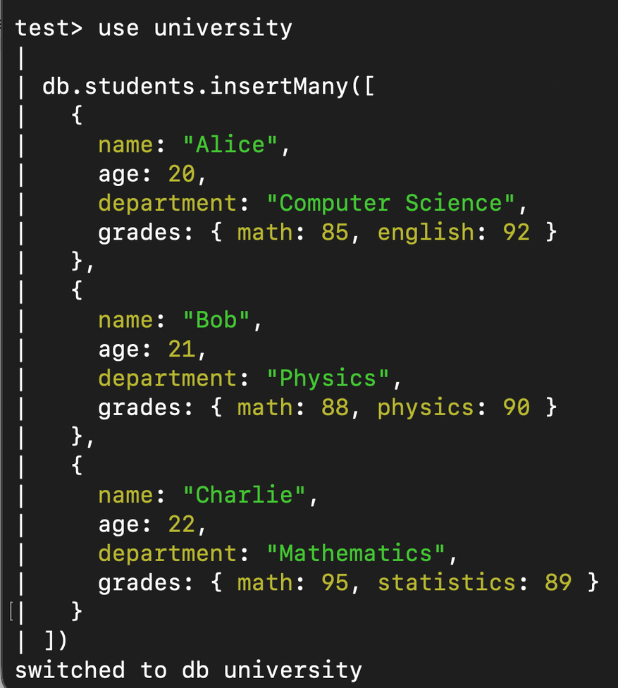
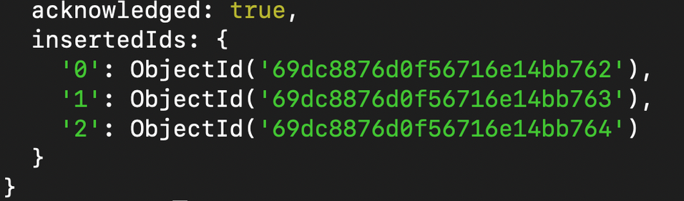
- Write a query to display all students who are in the Computer Science department.
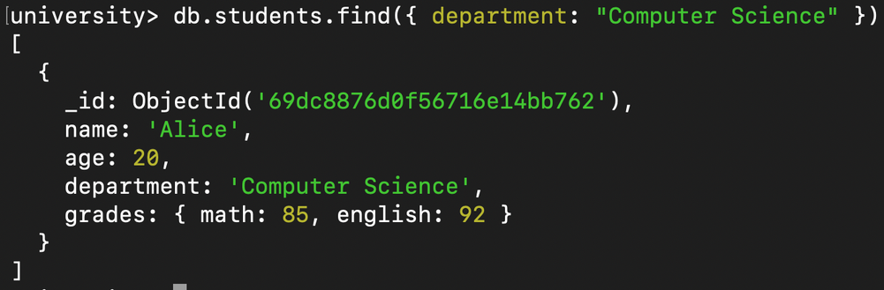
- Write a query to update the grades of a student named Alice by adding a new subject programming with a grade of 93.
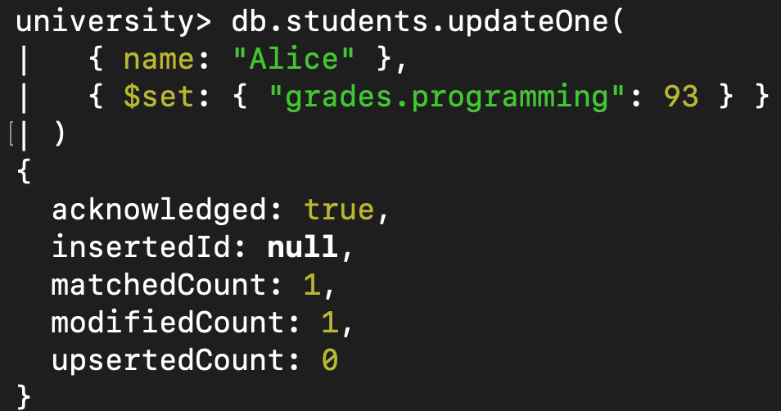
- Write a query to increment the age of all students by 1.
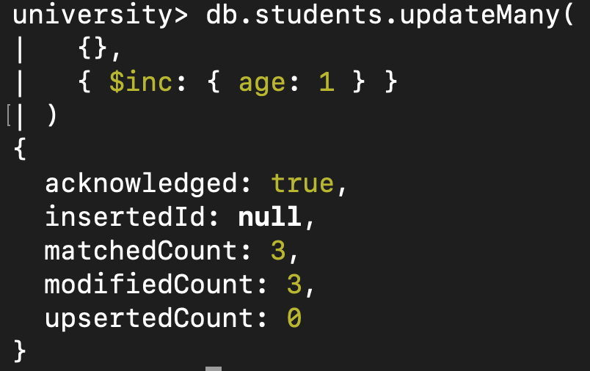
- Write a query to delete all students who are 23 years old.
- Write a query to create an index on the name field of the students collection.
__This Topic Not Covered__
- Write an aggregation query to group students by their department and calculate the average age in each department.
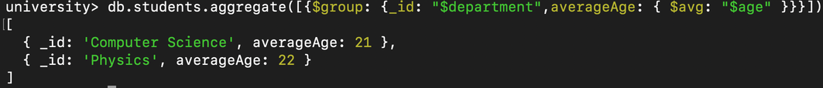
- Write a query to find all students who have scored more than 90 in any subject.
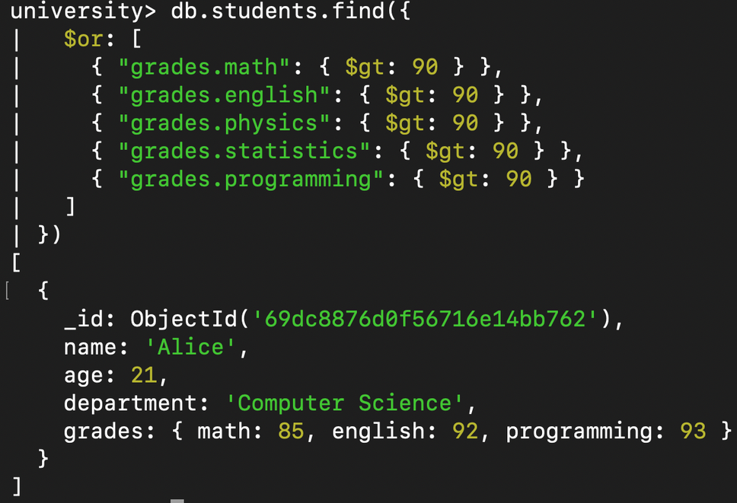
- Write a query to add a new field graduated set to false for all students who are in the Mathematics department.
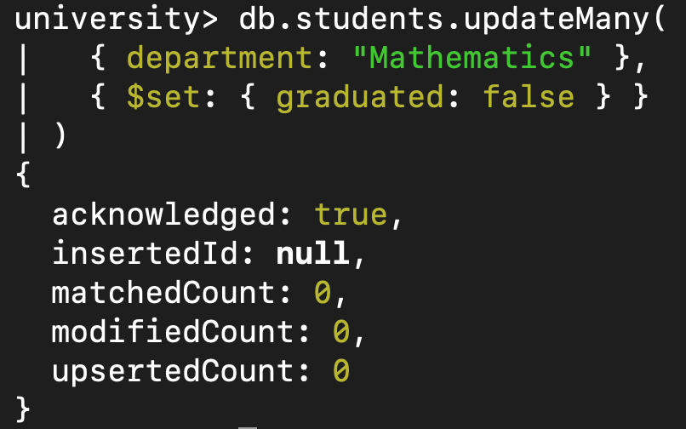
- How can you retrieve only the name and department fields for all students, excluding the _id field?
