**WeConnect Application**

This is a chatting application which enables two friends to connect and share thoughts. The application connects with a remote chat server to exchange messages between two connected friends.

**Implementation:**

* The TCP/IP protocol is used
* To sync the message area with the incomming messages, a message consumer is used which is triggered everytime a new message is arrived
* To start WeConnect application, run Main.java

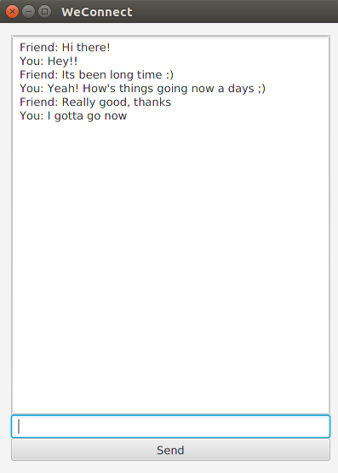

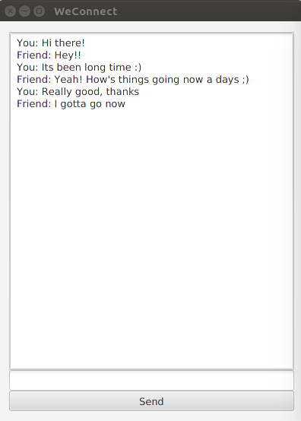

**Note: Make sure the chat server is already running before starting the WeConnect application**

**Chat Server**

The server acts as a mediator to exchange messages between two conneted friends.

**Implementation:**

* It opens the channel when two friends come online. At a moment, it can serve only two connections. When any or both friends go offline, it again goes to the waiting state.
* Every message consumed by the server is logged onto the console.
* To start chat server, run ChatServer.java

**Server logs:**

