

Course : Operating System ( CSE316 )

- Student Name : Himanshu Sagar
- Student ID : 11804469

Email Address : sagarhimanshu355@gmail.com
- GitHub Link : https://github.com/sagar-ML-Developer/os_project_sjf_ljf
- Problem Code : 17

Problem Statement Q17 :

Design a scheduler following non-preemptive scheduling approach to schedule the processes that arrives at different units and having burst time double the arrival time. Scheduler selects the process with largest burst time from the queue for the execution. Process is not being preempted until it finishes its service time. Compute the average waiting time and average turnaround time. What should be the average waiting time if processes are executed according to Shortest Job First scheduling approach with the same attribute values.

Description:

A/c to the given problem statement ,it is given that we have create CPU process schedular.

The schedular is created for scheduling process according to the Longest job first Scheduling

Which is similar to the shortest first job Scheduling.Here the user will select the no. of processes he want to schedule.Then accordingly user will input the arrival time for the processes. It is given in the problem that the Burst time for each process is double the arrival time.Then the process which is having largest burst time will be executed first if it is arrived in the ready queue.The process which is executing will not exit until it is executed completely because it is non-preemptive approach.The program should be able to schedule the process according to the given constraint.Finally we have to calculate the average waiting time and average turn around time for the longest job first.Also we have to calculate the waiting time for Shortest job first with the same input.

Algorithm :
Longest Job First(Non-Preemptive)
- Sort all the process according to the arrival time according to selection sort algorithm.
- Then select that process which has minimum arrival time and maximum Burst time.
- After completion of process make a pool of process which after till the completion of previous process and select that process among the pool which is having maximum Burst time
- Calculate sum of burst time and waiting time.
- Find average of the burst time and waiting time.
Shortest Job First(Non-Preemptive)
- Sort all the process according to the arrival time using selection sort algorithm.
- Then select that process which has minimum arrival time and minimum Burst time.
- After completion of process make a pool of process which after till the completion of previous process and select that process among the pool which is having minimum Burst time
- Calculate sum of burst time and waiting time.
- Find average of the burst time and waiting time.

Formula used:
- Turn Around Time: Time Difference between completion time and arrival time.
Turn Around Time = Completion Time – Arrival Time
- Waiting Time(W.T): Time Difference between turn around time and burst time.
Waiting Time = Turn Around Time – Burst Time

Description:
Purpose of Use:
- Sorting →Selection sort
It is used to sort all processes according to its arrival time.
So we will arange the process id and Burst time according to arrival time.
Complexity: O(n^2)

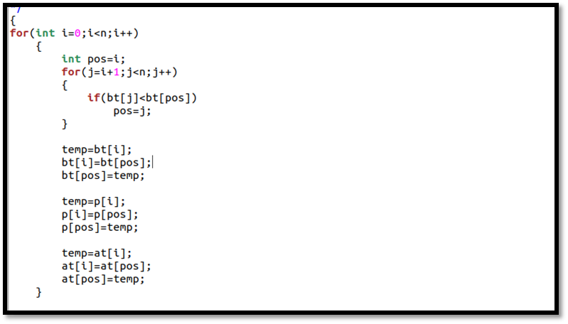

- Waiting time calculation in LJF.
Complexity: O(n)
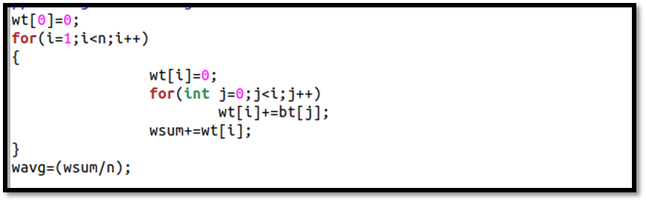
- Turn around time calculation in LJF.
Complexity: O(n) 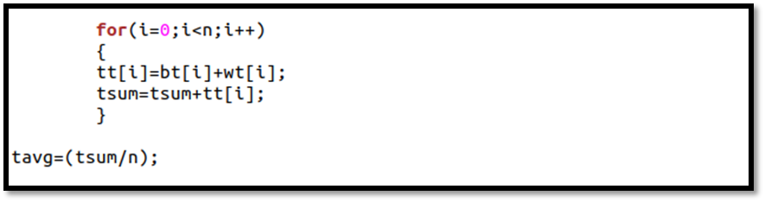

- Input from the user:
Arrival time should not be zero because it will result in zero burst time.
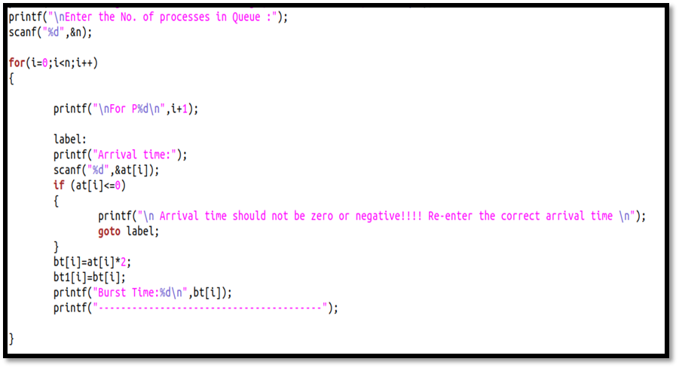
- Swapping:
Used for swapping in section sort.

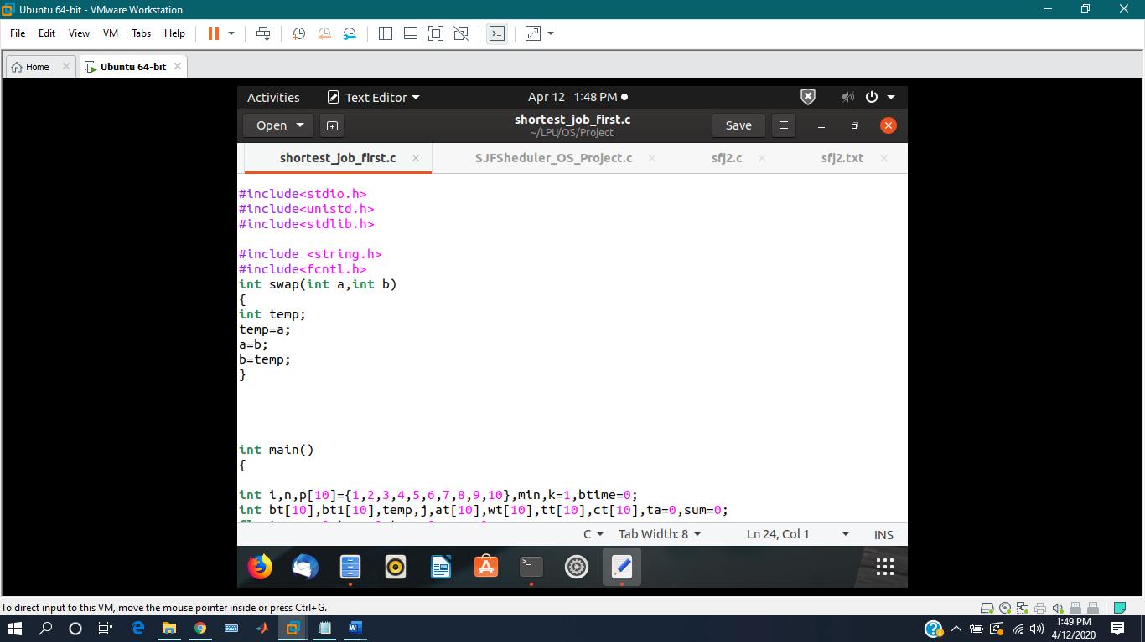

Boundary conditions:

I have taken maximum 10 processes in my program but we can increase it as our wish.

The arrival time can not be zero or negative in this program.If it will be zero the burst time ,which is double of arrival time will also be zero.

Test cases :

