Customer Shopping Behavior Analysis
Python (Pandas & NumPy) • SQL • Power BI

Project Overview
This project analyzes 3,900 customer transactions from a retail shopping dataset to understand revenue drivers, discount behavior, product performance, and customer loyalty. The workflow moved from data cleaning and exploration in Python, through ten targeted SQL queries answering specific business questions, to an interactive Power BI dashboard for ongoing monitoring.

Dataset Summary
The source file contains 3,900 records across 18 fields covering customer demographics, the item purchased, transaction value, and shopping behavior flags such as discounts, subscriptions, shipping type, and review ratings.
Metric | Value
Total Records | 3,900
Total Fields | 18
Product Categories | 4 — Clothing, Accessories, Footwear, Outerwear
Missing Values | 37 (Review Rating only, 0.9%)
Purchase Amount Range | $20 – $100 (mean $59.76)

Exploratory Data Analysis (Python)
Key points from data cleaning and exploration in Pandas and NumPy, ahead of the SQL analysis:
- Structure check — loaded with pandas (.info(), .describe()); 3,900 rows × 18 columns, no duplicate customer IDs.
- Missing data — only Review Rating has nulls (37 records, 0.9%); left as-is since SQL's AVG() ignores nulls automatically.
- Purchase Amount — ranges $20–$100, mean $59.76, no extreme outliers.
- Demographics — 68% Male / 32% Female; Clothing (44.5%) and Accessories (31.8%) lead the category mix.
- Behavior flags — ~43% of orders used a discount; 27% of customers hold an active subscription.
- Feature engineering — built an Age Group column (Young Adult, Adult, Middle-aged, Senior) with NumPy, used later in the SQL age-based revenue breakdown.

Data Analysis (SQL)
Each business question below was answered with a SQL query run against the cleaned dataset; the result set and a one-line takeaway follow each query.

Q1. Total revenue generated by male vs. female customers

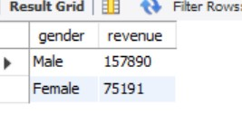
Insight: Revenue share mirrors customer share (68% / 32%) — gender has little effect on individual spend.
Q2. Discount-using customers who still spent above the average purchase amount

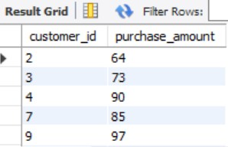
Showing the first 5 of 839 qualifying customers; average spend in this group is $79.79 (range $60–$100).
Insight: Half of all discount users (839 of 1,677) still spent above average — discounts aren't suppressing spend.

Q3. Top 5 products by average review rating

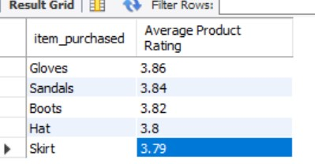

Insight: Top ratings cluster tightly between 3.79 and 3.86 — no single standout product.

Q4. Average purchase amount: Standard vs. Express shipping

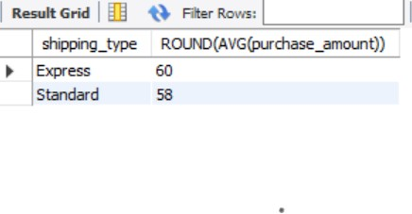
Insight: Express orders run about $2 higher on average than Standard — a small but consistent premium.

Q5. Subscribers vs. non-subscribers: spend and revenue

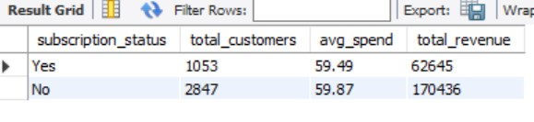
Insight: Subscribers spend about the same per order as non-subscribers — the program drives volume, not basket size.
Q6. Top 5 products by discount usage rate

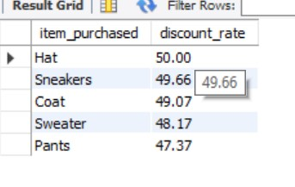
Insight: Hats, Sneakers, and Coats are discounted on nearly half of all orders — worth a margin check.

Q7. Customer segmentation: New, Returning, and Loyal

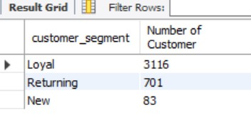
Insight: 80% of customers are already Loyal and only 2% are New — retention is strong, acquisition is thin.

Q8. Top 3 best-selling products by category

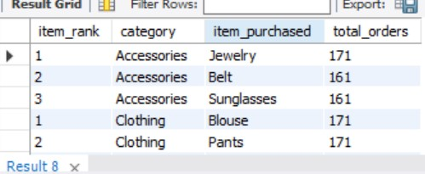

Insight: Demand is broad and even — top products within each category are separated by only a handful of orders.

Q9. Are frequent repeat buyers (>5 previous purchases) more likely to subscribe?
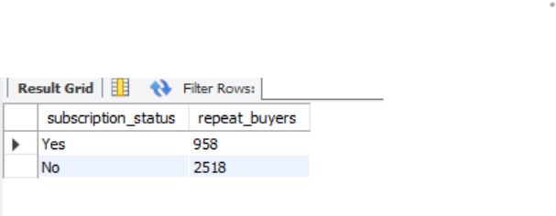
Insight: 91% of subscribers vs. 88% of non-subscribers are frequent repeat buyers — a real but small gap.

Q10. Revenue contribution by age group

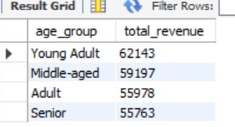
Insight: Revenue tracks group size, not age — spend per customer stays close across all four age bands.

Power BI Dashboard
The query results above were consolidated into a single-page interactive dashboard, “Customer Behavior Dashboard,” built on the cleaned dataset:
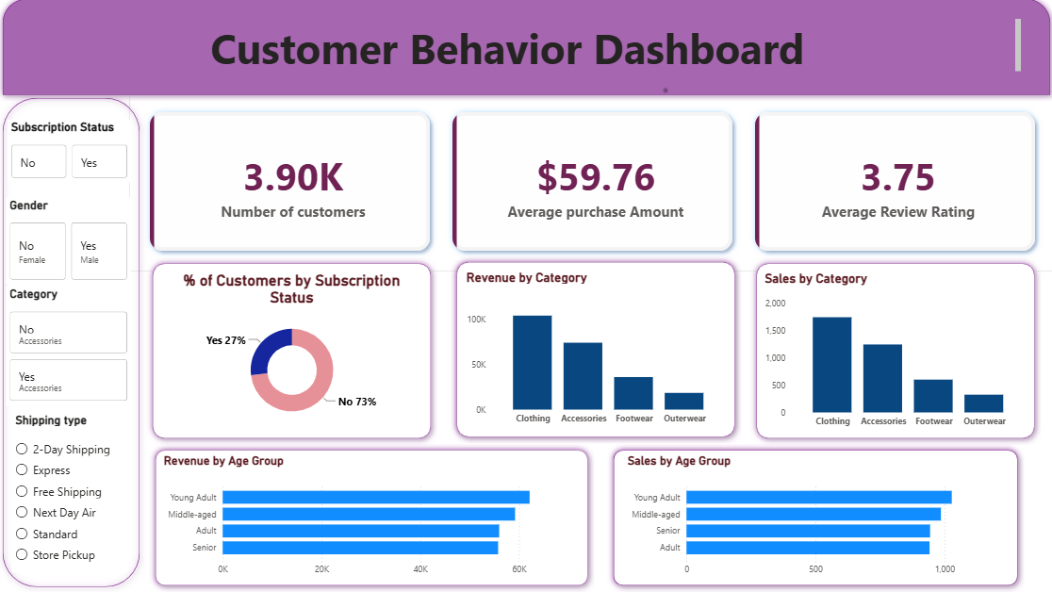
- KPI cards — Number of Customers, Average Purchase Amount, Average Review Rating.
- Charts — Revenue by Category, Sales by Category, Revenue by Age Group, Sales by Age Group, and a donut chart of % of Customers by Subscription Status.
- Slicers — Subscription Status, Gender, Category, and Shipping Type, for live interactive filtering.

Business Recommendations
- Grow acquisition — only 2% of customers are new; the loyalty engine already works well once they arrive.
- Re-think subscription perks — subscribers don't spend more per order, so add spend-based incentives, not just access.
- Target discounts more precisely — half of discount users were already big spenders; reserve discounts for new or lapsing customers instead.
- Watch margins on Hats, Sneakers, and Coats — each is discounted on nearly half of all orders.
- Keep Clothing and Accessories central — they lead both order volume and revenue.
- Review the Power BI dashboard on a set cadence — track revenue, discount rate, and segment mix as new data arrives.

