**Software Engineering Project Report**

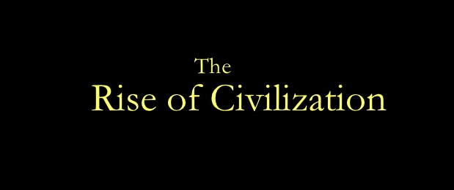

**Project Development Report for**

**The Rise of Civilization**

**Group 13:**

**Akhil Kateja**

**Adil Qaisar**

**Andriy Serafyn**

**Himanshu Anand**

**CS 440**

**University of Illinois at Chicago**

**09/24/2015**

**Table of Contents**

List of Figures 3

I Project Description 4

1 Project Overview 4

2 The Purpose of the Project 5

2a The User Business or Background of the Project Effort 5

2b Goals of the Project 5

2c Measurement 5

3 The Scope of the Work 6

3a The Current Situation 6

4 The Scope of the Product 6

4a Scenario Diagram(s) 6

4b Product Scenario List 12

4c Individual Product Scenarios 12

5 Stakeholders 13

5a The Client 13

5b The Customer 13

5c Hands-On Users of the Product 13

5d Priorities Assigned to Users 14

5e User Participation 15

5f Maintenance Users and Service Technicians 15

5g Other Stakeholders 15

6 Mandated Constraints 15

6a Solution Constraints 15

6b Implementation Environment of the Current System 16

6c Anticipated Workplace Environment 17

6d Scheduled Constraints 17

6e Budget Constraints 17

7 Naming Conventions and Definitions 18

7a Definitions of Key Terms 18

7b Data Dictionary for Any Included Models 19

8 Relevant Facts and Assumptions 22

8a Facts 22

8b Assumptions 22

### ****List of Figures****

Figure 1.0 – User Starts Game and initiates virtual marketplace trade 10

Figure 2.0 – New User and Returning User Gameplays 12

Figure 3.0 – User engages in conquest with opponent 13

Figure 4.0 – Game summary from start to end of gameplay 14

Figure 5.0 – Scenario where multiple users join hands to play collectively 15

# Project Description

## Project Overview

Rise of Civilization is a turn based strategy game. It is an intuitive and easy to play game that is suitable for everyone. As a strategy game, it requires the player to think logically in order to beat his opponents. Once you start the game, you get the opportunity to choose to play either versus an AI opponent or versus players on your local area network.

The objective of this game is to develop and expand the user’s empire that can last for ages and resist conquests from other empires. Each player assumes the role of a ruler of an empire and will initially have some resources in the form of manpower, goods, army units and virtual currency to build his/her empire and compete with other empires/civilizations. The player should possess a knack of taking critical decisions regarding exploration, warfare and diplomacy.

The game basically requires players to build a base where they build their buildings and units and eventually defeat all of the other players that are not in their team. That is a really good and fun way for people to develop their logical thinking, because the game requires from you to start thinking a few moves ahead (like a chess game).

As it is a turn based game, each player has a number of things he can do during his turn, which include: create new buildings, spawn units, move units and more. It is important to be noted that in our game, when you create a new soldier for example, that is not only one soldier, but it represents a brigade of soldiers. Movement of units is limited to their range and different types of units have different ranges. Player will be able to find new cities, build buildings and create new units. He/she also can conquer all of the above from his/her opponents (real or AI) through conquests. The player can choose to engage some or all of his/her units for the conquest. The player with greater unit strength will have a greater chance of winning the Conquest. Two emperors can choose to join hands with each to fight jointly with other Civilizations.

There exists virtual market place where player could buy or exchange goods with other players. It uses virtual currency that is earned from each turn that player makes. Enemy’s skills depend on the level of adventure i.e. higher the level, higher the skills of an enemy.

There are also different cell terrains, each of which has buffs for units that are onto it. It is very easy to go around the map and there is also a mini map that is a real time representation of the map, which helps you to have a better view of the whole map at any time, but scaled to be fit in the bottom context bar. At the end of your turn, you receive a fixed amount of money and a new “game day” begins. The game is really easy and fun to be played and if a player has difficulty in understanding the game rules, there is an instructions menu that will bring you the instructions screen, where everything that you are required to do as a player is described.

## The Purpose of the Project

### The User Business or Background of the Project Effort

### Our project, The Rise of Civilization, is a turn based strategy game, wherein the player has an option to play either against an AI or against other players on your local area network. The game basically requires players to build a base where they build their buildings and units and eventually defeat all of the other players that are not in their team. The situation that triggered the development effort of the project is that in today’s world, where we are surrounded by technology, students have lost the ability to think abstractly or logically and destroying social interactions. This, in-turn, is impacting their ability of problem solving and abstract thinking. Rise of Civilizations will provide the children with a platform to apply strategies in guiding troops, conquering territories, performing trade and managing resources, which will, in process, enhance their cognitive power. As it is a turn based game, each player has a number of things he/she can do during his/her turn, which includes: creating new buildings, spawning units, moving units and more. The user is presented with a map which gives a good view of different terrains and assists the user in building the units. The user can pan the map with the movement of the mouse. The user can pan the map left, right, up, down by moving the mouse to the left-most, right-most, up-most, down-most part of the map as well as using the mouse to pan the map, the user can use the keyboard to pan the map by using the left, right, up, down arrow keys to pan the map left, right, up, down. The keyboard can also be used for zooming in and zooming out of the map to get a wider view of the map. This is done by the + or - keys, which will increment the zoom accordingly. The buildings and units have stats that determine their effect on the game. For buildings they have stats for Health, Cost and Reward. For units they have stats for Health, Cost, Number of Units and Range. The health stat track how much damage a building/unit can take before it is removed from the game. The cost tracks how much money the player needs to create that building/unit. The reward stat tracks how much money the enemy player gets from destroying the building/unit. The damage stat for units track how much health is removed from other units or buildings. Game ends when there are no opponents left in the game, or when last of players “settlements” is captured.

### Goals of the Project

The main goal of our project is to provide an opportunity to the people to apply strategies and conceptualize things. It will involve substantial and well defined planning, together with right actions which will lead to the strategy’s success. The players will engage in battles, conquer territories, perform trades and forge relationships. The Rise of Civilizations will compel and urge the users to think. It will also increase the social engagement among the players as the game is highly interactive. Hence, the players will be completely engaged and engrossed.

### Measurement

The goals of our project The Rise of Civilizations are measurable. Our main goal is to simulate the civilizations so that people can apply different tactics to compete against one another in order to build a big empire by forging relations, conquering territories and utilizing resources. This will enhance their power to think logically. This goal can be measured in a way that if our project is really helpful, then there will be increase in users using the project. This will also attract people who are curious to know about the activities that used to take place in various civilizations. The success of the game will also attract different organizations to post their advertisements.

## The Scope of the Work

### The Current Situation

Currently there are many desktop based and web based historical games based on similar themes of building civilizations but our game will have game scenarios modeled around real historical facts which include land, army units, virtual currency and goods associated with that civilization and time period. The user will be able to experience the trade and warfare practices of the time period he wishes to play in. The game will serve as a great platform for the user to learn about different civilizations and time periods and have fun at the same time. Unlike the other games available in market, the progress of the player in our game will not be based on his prior historical knowledge but on his/her knack of taking critical decisions regarding exploration, warfare and diplomacy. Moreover, the game basically requires players to build a base where they build their buildings and units and eventually defeat all of the other players that are not in their team. That is a really good and fun way for people to develop their logical thinking, because the game requires from you to start thinking a few moves ahead (like a chess game).Unlike previous versions of games, our game will the user, the option to alternatively collaborate with other player(s) in order to increase their strength in terms of the land and manpower he owns. This will help the player improve his standing in the game data.

## The Scope of the Product

### Scenario Diagram(s)

Fig. 1.0: User Starts Game and initiates virtual marketplace trade

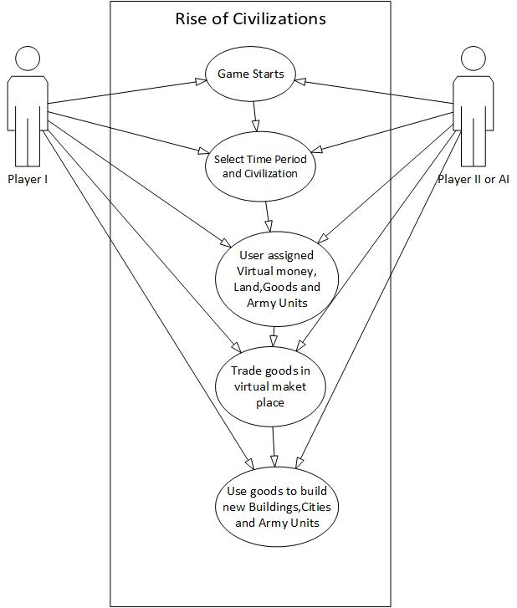

Fig. 2.0: New User and Returning User Gameplays

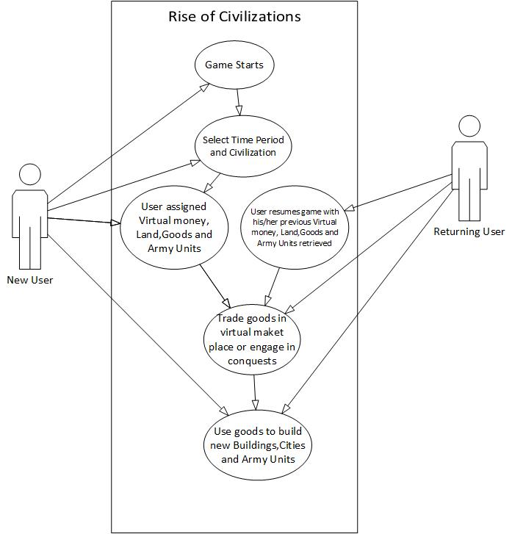

Fig. 3.0: User engages in conquest with opponent

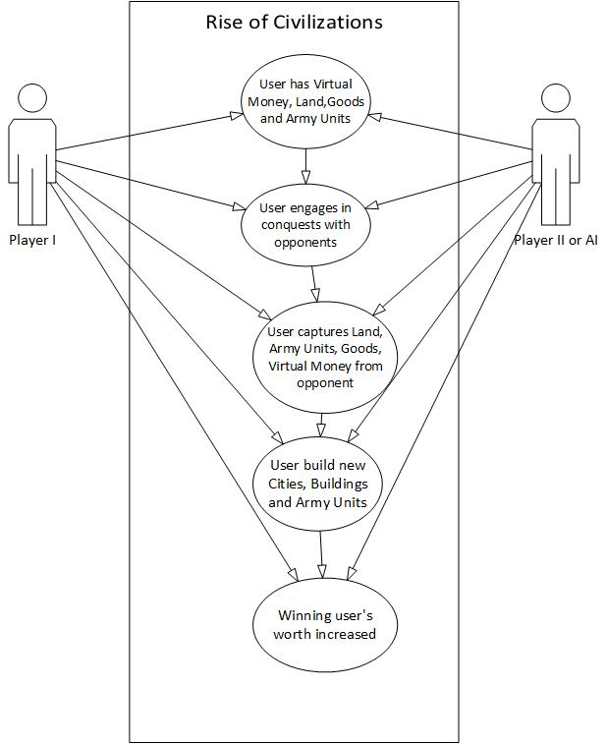

Fig. 4.0: Game summary from start to end of gameplay

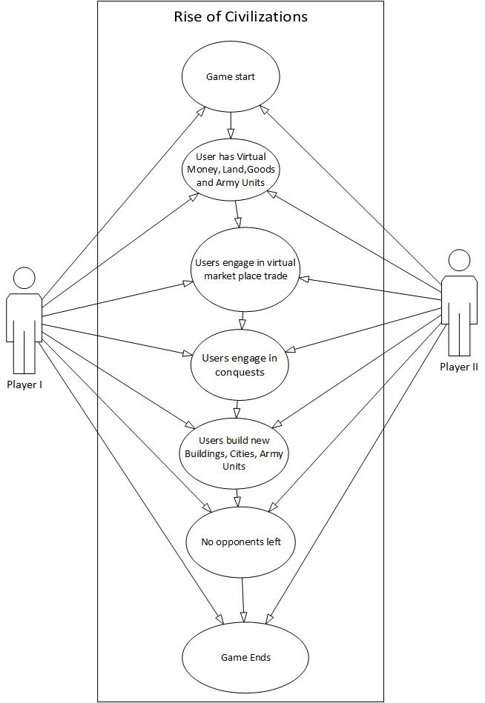

Fig. 4.0: Scenario where multiple users join hands to play collectively

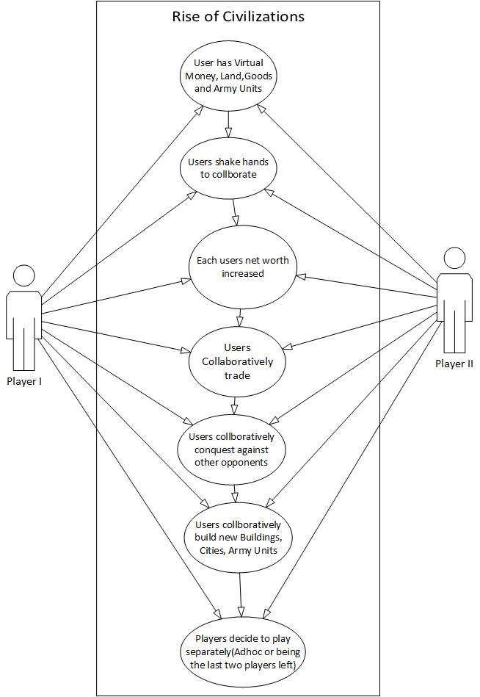

### Product Scenario List

1.     Game Start

2.     Players Engage in Trade

3.     Players Engage in Conquests

4.     Multiple Players Shake Hands

5.     End of Game

### Individual Product Scenarios

(1)  **Game Start:** Rob is a new user and logs into the game for the first time. Rob is a given the option to select the time period and civilization in which he would like to begin his gameplay in. On selecting the time period and civilization, the game will load with the look and feel specific to that time period and civilization and the user is assigned with some virtual money, land, goods and army units specific to that time period. John is a returning user, who when logs into the game, the game retrieves his current holdings in the game and displays the virtual money, goods, land and army units that were owned by him at the end of his last game play.

(2)  **Players Engage in Trade:** Rob and John after beginning their respective games may wish to engage in trade via the virtual market place. This gives the players an opportunity to strategically involve in trade with their opponents who help them build new buildings, cities, army units, expand their current holdings and hence improve their current standing in the game.

(3)  **Players Engage in Conquests:** Rob and John after beginning their respective games, may wish to increase their current holdings by the means of attacking each other and acquire the other person’s holdings. Attacking the other player will be strategic decision and will involve a thorough analysis of not only the player’s own worth in terms of army units and manpower but also a prediction of the opponents power in terms of the same. The game will give Rob and John an opportunity to use their knack in terms of how many and which army units to deploy at appropriate fronts. During a conquest, a user may wish to use his current holding and engage in trade with other players in order to enhance his position in terms of army units and manpower. The winner of the conquest acquires the holdings of the opponent, thereby, increasing his worth in the game.

(4)  **Multiple Players Shake Hands:** During the gameplay, Rob and John may strategically predict the worth of another user Daniel to be much greater than theirs. Rob and John, in case of inability to be able to do any new trades or conquests, may decide to shake hands and use their collective holding from here on to build new cites, buildings, army units or involve in trade collectively with other players. They may also strategically plan to attack Daniel and engage in a conquest with him. From there on, Rob and John may wish to play the game collectively, collaborating in each of their strategic decisions and putting their collective worth to improve their standing the game

**(5)**  **End of Game**: Rob and John can continue playing the game till there are no more opponents or no more lands, goods, army units left to trade or conquer.

## Stakeholders

### The Client

The client for this game will give be anyone who is willing to invest in the gaming arena. The client will be in charge of maintaining the game and enhancing it whenever necessary. They will also be responsible for maintaining the website and ensuring that it runs seamlessly at all times. The client will also be responsibility of marketing the website and making it available to the customers. The onus lies on the developers to ensure that product meets the requirements set out by the client and to ensure a quality product in a timely fashion.

### The Customer

This game will be available to anyone who is willing to purchase the product. It is intended to serve the purpose of enabling people to use their thinking and intelligence and to enhance their knowledge of different civilizations. Whether a person is an adolescent or an adult, this game caters to everyone who has a desire to improve their logical or abstract thinking. A key tenet of game-based learning is it can potentially motivate students to learning by making learning fun. This will be an effective tool in preparing the people to better plan their future and to take critical decisions. This will also inculcate leadership qualities in individuals and they will be better prepared to face-off the challenges. The students will be able to appreciate the geography in historical development, the impact of trade and economics, resource availability and expenditure.

### Hands-On Users of the Product

The Hands-On users of the product can be anyone in the age group 10+.The game offers hours of play, challenging AI, and the ability to play and compete against remote users. The game will enhance people’s knowledge about trade and economics and makes an effort to educate the users about the civilizations and the time periods it cover. It can also include adults who are interested in strategy games and who love adventure. This game can also be included in the college fest as one of the events.

**User name/category:** People in the age group 10+ who like playing strategy games.

**User role:** Actively involved in taking critical decisions, applying strategies and managing resources. They need to wisely utilize their resources and make decisions about which all units to seize in order to gain maximum benefit.

**Subject matter experience:** No prior knowledge is needed. It will be possible to learn the game by playing a few times or by carefully reading the rules.

**Technological experience:** The user must be capable of using a basic web connected computer and web browser.

**Other user characteristics:**

**Physical abilities/disabilities:** Person with weak eye sight is advised not to spend long periods of time in front of the computer as it will strain their eyes. As the game is highly addictive, the users are advised to take breaks after every hour.

**Intellectual abilities/disabilities:** The game is intended to be designed to be played by anyone for education/leisure purpose. Therefore, everyone is free to experience the game. No prior intellectual ability is needed. However, it is advised to see the doctor in case itching is experienced on playing the game for hours together.

**Attitude toward job:**People playing the game should have a positive attitude and should exhibit a desire to learn and improve. As the game is highly competitive, users are advised to curb their anger and not to hold any grudges, as it is just a game after all. They should cherish the opportunity to compete with others and strategically win over their empires.

**Attitude toward technology:**

**Education:** No prior education is required, but people with good logical ability will have an upper hand over their opponents.

**Linguistic skills:** No special linguistic skills are required to play this game at a high level.

**Age group:** This age group will most likely include people in the age group 10+.

**Gender**: This game is for both males and females.

### Priorities Assigned to Users

● **Key users:** This game can be beneficial to all the users who have a desire to learn about different civilizations and the time periods they cover. This game will enhance people’s knowledge about economics and trade. Also, this game can be played by strategy game enthusiasts and people who wish to compete against their friends. Therefore, our key users will comprise of all such people as they will expand and popularize our game worldwide.

### User Participation

One of the things that the users can help with is the testing of the game. This will require the users to play the game for an hour during the day and report any glitches they experience with the functioning and performance of the game. The users can also report any issues with the user interface. This will help the developers in fixing the bugs and improving the quality of the product.

### Maintenance Users and Service Technicians

Maintenance users will include a group of technicians who will work together to fix and remove any defects discovered by the users. They will provide technical support to customers in a timely fashion and ensure that the website is up and running at all times and that there are no obstacles or impediments.

### Other Stakeholders

● **Testers:** Testers will ensure to discover any bugs that may exist in the program. This will help keep the game updated and enhance user’s experience.

● **Technology experts:** This group will include service technicians who will provide technical support to the team.

● **Marketing experts:** This group is extremely important as they will be responsible to market the game throughout the world. Their job will be to advertise the game, whether it is with online ad’s or billboards.

## Mandated Constraints

This section describes constraints on the eventual design of the product. They are the same as other requirements except that constraints are mandated, usually at the beginning of the project.

### Solution Constraints

Content

This program must be solved primarily with Java. The program should be compatible on both Mac-OS and Windows (7, 8, 10). This is so that all users will be able to use this program.

Motivation

The constraints put on this program are too making it as accessible and easy to use as possible. Most of the users of this program will be young students that may not have the greatest ability to navigate difficult to understand user interfaces.

Examples

Constraints are written using the same form as other atomic requirements (refer to the requirements shell for the attributes). It is important for each constraint to have a rationale and a fit criterion, as they help to expose false constraints (solutions masquerading as constraints). Also, you will usually find that a constraint affects the entire product rather than one or more product use cases.

Description: The product shall use Artificial Intelligence technology.

Rationale: The client will be able to play against a machine that is able to compete with the client.

Fit criterion: There shall be levels to the Artificial Intelligence, so all the expected clients will have a suitable level of difficulty.

Description: The product shall operate using Windows 7, 8, and 10 as well as Mac- OS.

Rationale: The client base for this product is wide and this program should be able to run on all of these platforms.

Fit criterion: The product shall be approved as Windows 7, 8 and 10 compliant by the MS testing group as well be approved as Mac-OS compliant.

Description: The product shall be on a laptop and or desktop computer

Rationale: The product is to be marketed to people from all backgrounds looking to be educated in history.

Fit criterion: The product shall be able to run the following platforms, Windows 7, 8 and 10 and Mac-OS.

### Implementation Environment of the Current System

Content

The product should be installed on desktop computers such as a Windows machine or Mac machine. The product should be compatible with Windows 7, 8 and 10 as well as any running version of Mac-OS.

Motivation

The product must be fully maximized on the screen as to not show anything else in the background for the full learning experience. Similar to how Microsoft PowerPoint slideshows are run. Once the client opens the product, the screen will be taken over by the product itself. The only way to get out of the product environment is to exit the program itself. This will allow the clients to get the full learning experience and be presented with challenges that cannot be referenced on the internet.

Considerations

The client should not be able to navigate away from the program as long as the program is running.

### Anticipated Workplace Environment

Content

This product will be used by the clients on computers at schools, homes and libraries. The client crowd is mostly for students looking to learn more about history and this environment correlates with the above.

Motivation

The product must be school appropriate as to not show anything that might not be permissible on school grounds.

The product is to be used in a library or school; it must be extra quiet.

### Scheduled Constraints

Content

This product must be completed by the start of the next summer so that teachers and supervisors may get accustomed to the product before the students.

Motivation

The client wants this product to be ready for the next school year for new students.

Considerations

This product must be finished by May 29th. It is critical for this product to be finished by this date so that the client may get used to it and be able to give it to their students.

If this deadline is not met, then the client will not be able to get accustomed to the software in time.

.

### Budget Constraints

Content

The budget for the project is 1,000,000 USD.

Motivation

The requirements must not exceed the budget. The client fully expects all requirements and constraints to be met within this budget.

## Naming Conventions and Definitions

### Definitions of Key Terms

The glossary produced during requirements is used and extended throughout the project.

Player: The client on the user end of the game.

Computer: The artificial intelligence element of the game.

Simulation: Refers to gameplay situations carried out automatically

Flat: The basic land that takes up the majority of the map. Flat allows any unit or any building to be placed on it or move across it.

Water: Part of the map that only tanks can move pass through

Bridge: A way for units to cross the water terrain. Only marines can move across this terrain

Barracks: The building is used to create soldiers. Only four soldiers can be spawned around the barracks giving preference to the x-axis and then the y-axis

Factory: The building used to create machinery, only four machines can be spawned around the factory.

Soldiers: The basic unit, marines have no limit on how many can be created

Time Limit: The game is a turn based game. There will be 5 minute turns. After this amount of time has ended, the turn will be ended

Day: A day has taken place when all users have clicked the end turn button once

Player Money: This is how much a user has to build new units and buildings.

Current Player: This is the player who is currently playing the game. This is also shown in the team color.

Team Color: This is a reference so a user knows what their team color is.

Forest - Only marines can move across this terrain.

Mountains - Only marines can move across this terrain

.

### Data Dictionary for Any Included Models

*AI (Artificial Intelligence)*

There are three main objectives that that AI attempts to do when it is its turn to play these are to maintain buildings, recruit units and attack enemies. This is the order in which the AI prioritizes its actions, maintaining buildings are top priority because buildings are required to train units and thus maintain an army. Secondary priority goes to unit recruitment so that the AI is always spending money on troops and finally attacking is done last.

When it comes to creating buildings the AI will attempt to maintain a set amount of them. At the start of each turn the number of factories and barracks are checked and if they are below a threshold then they are replaced at the next available opportunity (when money can allow). Each AI player tries to keep 2 barracks and 1 factory in operation so that they can recruit new tanks and marines. The number of each building was decided because of the unit limit on tanks (this being 5) means that a player can quite easily sustain this number through one factory. As marines are effectively unlimited two barracks are enough to create as many as allowed by the players economy. Through testing we concluded that this arrangement was optimal and as such is the strategy that the AI implements.

Unit recruitment is a major part of the game and is something that the AI manages well and therefore effectively maintains and expands its army. Which units the AI recruits are decided by 3 factors. Firstly the amount of money that the AI player has at its disposal, it will check that there is more money available than the cost of the most expensive unit. If it turns out that one particular unit is too expensive for the player at that time then it is not considered. This is also where the AI determines if it has enough money to purchase any units and if not then it will skip to the attacking stage. Secondly the number of limited units on the map is assessed. The current maximum number of tanks allowed by a single player is 5, this is where this is checked and if the maximum number is reached then that unit is removed from consideration by the AI. Thirdly the priority of the individual unit is assessed; tanks are recruited in preference to marines. This is because of their increased strength and durability therefore they are prized higher. Marines are second choice as they are comparably less strong both in attack damage and durability.

Attacking is perhaps the most important aspect of the AI as without it there is no chance of winning the game. Each unit is controlled individually and chooses its own target to attack. This allows the AI to engage multiple targets in one turn which is important when playing a free for all against 3 opponents.

The way that a single unit attacks is as follows, the unit performs a breadth first search in a radial pattern on the map centered at the unit’s position. It looks around it for an enemy unit or building and keeps expanding the search until a unit is found or it exhausts all cells of the map. This search only includes cells that are valid for that unit’s travel, so a marine's search will not take it into a water terrain tile. This means that it only searches tiles that are accessible by that unit, this avoids the situation of a unit selecting an enemy to attack that is unreachable and then getting confused about its route to it.

Once an enemy unit is focused as the target a route is plotted from the AI’s unit to the enemy’s one. The unit then proceeds to advance along this route until one of three states occur. It is possible that the route is blocked (by an allied unit), this can often happen with marines crossing water as the only way for them to do this is via a bridge. If this happens then the unit will move into the closest available cell and cease movement. Another situation is that the unit does not have enough move points to reach the target, if this happens then it just moves as far as it can and then stops. The final situation is that it manages to reach its target. If this happens then the unit attacks the target and then stops movement.

The game has a difficulty setting that gives the AI an advantage over the player. This is implemented through increasing the starting money of the AI player. This means that they have an advantage over the player from the start and as such are able to quickly mass units into an army.

*Human Computer Interaction (HCI)*

There are many strategy games out on the market at the moment, all of which function with similar, if not the same, human-computer interaction principles. This consists of making use of the mouse and keyboard input devices, along with various buttons on the user interface to aid the functionality.

The mouse input device is strategy games is used for the majority of the interactivity. The left-click of the mouse is used for selection, the right-click of the mouse is used for moving or attacking units, depending on whether the right-click was on an enemy unit, and the movement of the mouse is used to pan the map. The keyboard input devices allows the user to pan the map and zoom in and out of the map, if the functionality is there. The buttons on the user interface of the game itself are used to interact with the functionality of the selection. For example, when a unit is selected, the user will have buttons available for moving and attacking.

These principles haven’t changed. They have been the same with the early strategy games compared to the top strategy games today. Rise of Civilization is no different. The user will use the left-click of the mouse to select a unit or a building. If a unit was selected with the left-click, the user can right-click in an empty cell to move a unit, since Rise of Civilization is a grid based strategy game, or the user can right-click on an enemy unit and attack it. The user can pan the map with the movement of the mouse. The user can pan the map left, right, up, down by moving the mouse to the left-most, right-most, up-most, down-most part of the map respectively. As well as using the mouse to pan the map, the user can use the keyboard to pan the map by using the left, right, up, down arrow keys to pan the map left, right, up, down respectively. The keyboard can also be used for zooming in and zooming out of the map to get a wider view of the map. This is done by the + or - keys, which will increment the zoom accordingly.

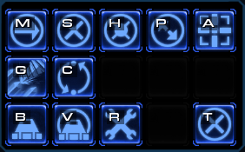 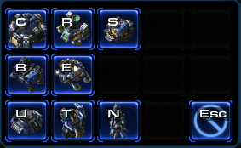

These two images are from the popular strategy game StarCraft 2. The image on the left is the panel which is shown when you select a unit, showing available orders to the unit. The panel on the right is shown when you want to build structures. Again, this is similar, if not the same, across almost all strategy games and Rise of Civilization is no exception.

 

These two images are from Civilization. The image on the left is the panel which is shown when you select a unit, where you can choose to attack or move, and the panel of the right is shown when you select a Base building, which you can choose to build a Barracks or a Factory. Each panel has a help button which will show the instructions and the end day button which will end the turn of that player.

At a first glance, is not clear which building is which in the image on the right of the StarCraft 2 panels. This is why we decided to use text rather than images of the buildings as this is more informative to a user that is not familiar with the game. Although a help button isn’t very popular on the panels in strategy games today, we wanted to make sure the user has access to help options whenever available. The same goes for the end day button, this needs to be available at all times. However, StarCraft 2 is a real-time strategy game and therefore, does not need an end day button!

We have tried to follow the interactive conventions of today’s strategy games to make sure that the human-computer interaction principles are intuitive and easily accessible for users that are familiar with strategy games today.

## Relevant Facts and Assumptions

### Facts

Content

All data in this program must be factually correct backed up by at least three scholarly sources. There shall be no questions or problems in the product where the history is subjective to different cultures. All facts in this game must be objective and as to not offend any culture or religion.

Motivation

The game must be unbiased when it comes to history so as to when the game is created it must be facts that are accepted by mainstream society.

### Assumptions

Content

A list of the assumptions that the developers are making. These assumptions might be about the intended operational environment, but can be about anything that has an effect on the product. As part of managing expectations, assumptions also contain statements about what the product will *not* do.

Motivation

To make people declare the assumptions that they are making. Also, to make everyone on the project aware of assumptions that have already been made.

Examples

Assumptions about which history subjects to cover.

Assumptions about the color scheme of the game.

The software components that will be available to the developers.

The availability and capability of bought-in components.

Dependencies on computer systems or people external to this project

The requirements that will specifically *not* be carried out by the product.

Considerations

The client is not expecting to use the product in any new innovative way.